<https://github.com/jaivikshrestha/codetest>

Created Two instances on RedHat Enterprise :

1. **Puppet Master**
2. **Puppet Node**.

Created module named **html,** and created sub directories for the module.



Created **init.pp** inside the manifests directory.

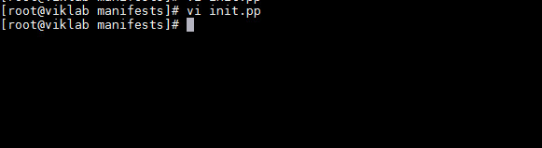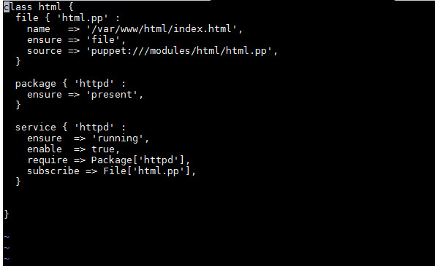

Created html.pp inside the files directory for the deployment of index.html on the client

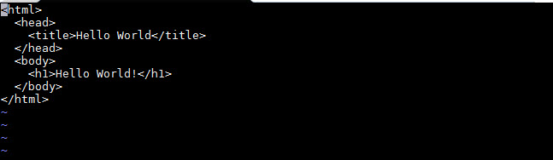

Including the module to **site.pp** to deploy to the nodes.

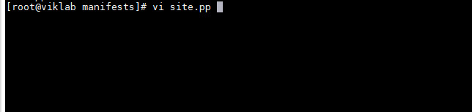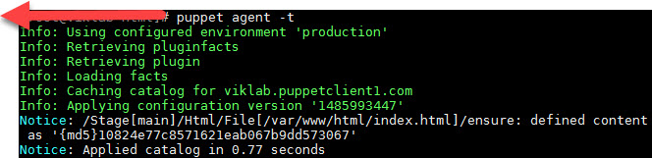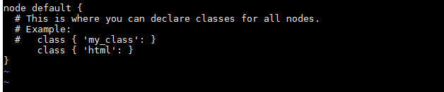

**On the Node running command “puppet agent –t”**

The index.html file is deployed on node



Browsing the webserver

