Q1. Given the scenario of a School Management System, identifyrelations and write SQL to list all students with their class teacher and grade.


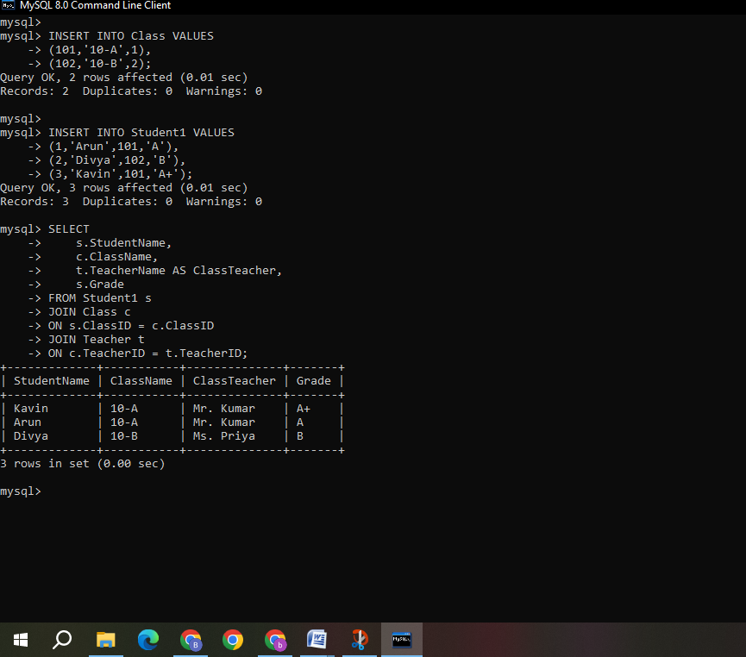

Q2. A hospital wants to track patient appointments. Design the relational schema and write SQL to find doctors with more than 10 appointments this month.


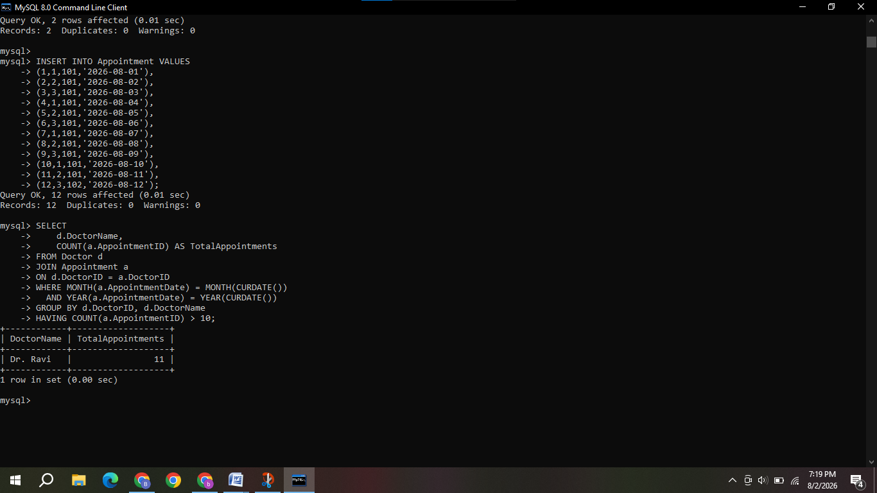

Q3. In an e-commerce scenario, write SQL queries using sub-queries to find products that have never been ordered.




Q4. For a university database, write relational algebra expressions to find students enrolled in both "DBMS" and "OS" courses.

Assume:
STUDENT(SID, Name)
COURSE(CID, CourseName)
ENROLLMENT(SID, CID)
Step 1: Find students enrolled in DBMS
DBMS_Students = π SID (σ CourseName = 'DBMS' (COURSE ⋈ ENROLLMENT))
Step 2: Find students enrolled in OS
OS_Students = π SID (σ CourseName = 'OS' (COURSE ⋈ ENROLLMENT))
Step 3: Find students enrolled in both DBMS and OS
Both_Students = DBMS_Students ∩ OS_Students
Step 4: Display student names
π Name (STUDENT ⋈ Both_Students)
Final Answer
π Name (
STUDENT ⋈
(
π SID (σ CourseName = 'DBMS' (COURSE ⋈ ENROLLMENT))
∩
π SID (σ CourseName = 'OS' (COURSE ⋈ ENROLLMENT))
)
)

Q5. Given a payroll scenario, create a view showing employees whose salary is below department average and write a query to update their salary by 10%.
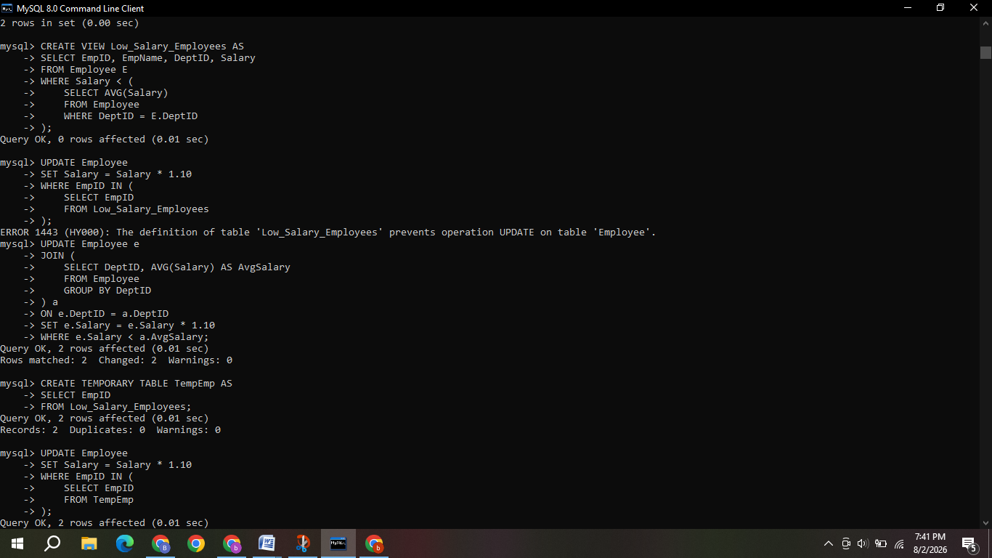
Q6. In a banking scenario, apply JOIN operations to retrieve customer account details, transaction history, and branch information.

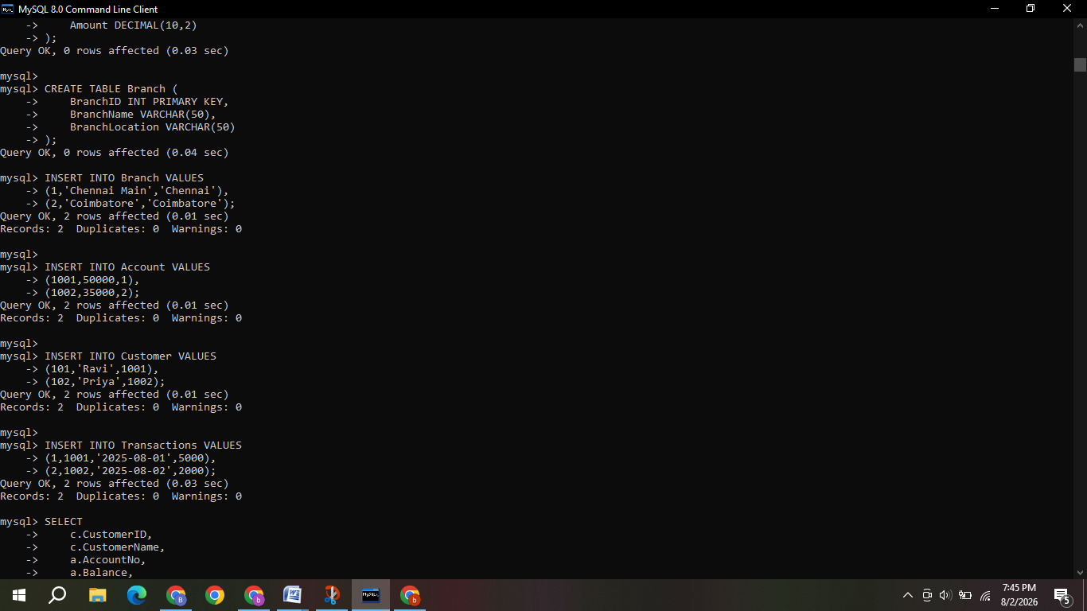
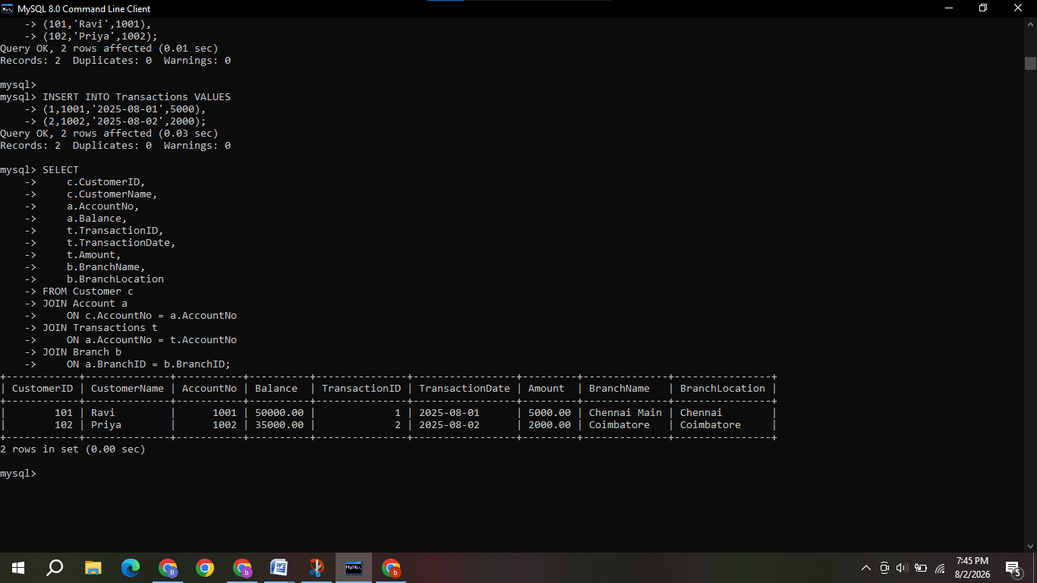

Q7. A retail store needs daily sales summary. Write SQL with GROUP BY and HAVING to report total sales per category exceeding Rs.10,000.


Q8. For a library system scenario, construct tuple relational calculus expressions to find members who borrowed books from all genres.
Assume:
MEMBER(MemberID, MemberName)
BOOK(BookID, Title, Genre)
BORROW(MemberID, BookID)

Step 1: Find member and genre combinations
R = π MemberID, Genre (MEMBER ⋈ BORROW ⋈ BOOK)

Step 2: Find all genres available in the library
G = π Genre (BOOK)

Step 3: Use Relational Division
Find members who borrowed books from all genres:
R ÷ G
This returns the MemberID values of members who have borrowed at least one book from every genre.

Step 4: Display member names
π MemberName (MEMBER ⋈ (R ÷ G))

Final Answer
π MemberName (
MEMBER ⋈
(
π MemberID, Genre (MEMBER ⋈ BORROW ⋈ BOOK)
÷
π Genre (BOOK)
)
)

Q9. Given an inventory management scenario, define CHECK and FOREIGN KEY constraints and demonstrate their enforcement through SQL.
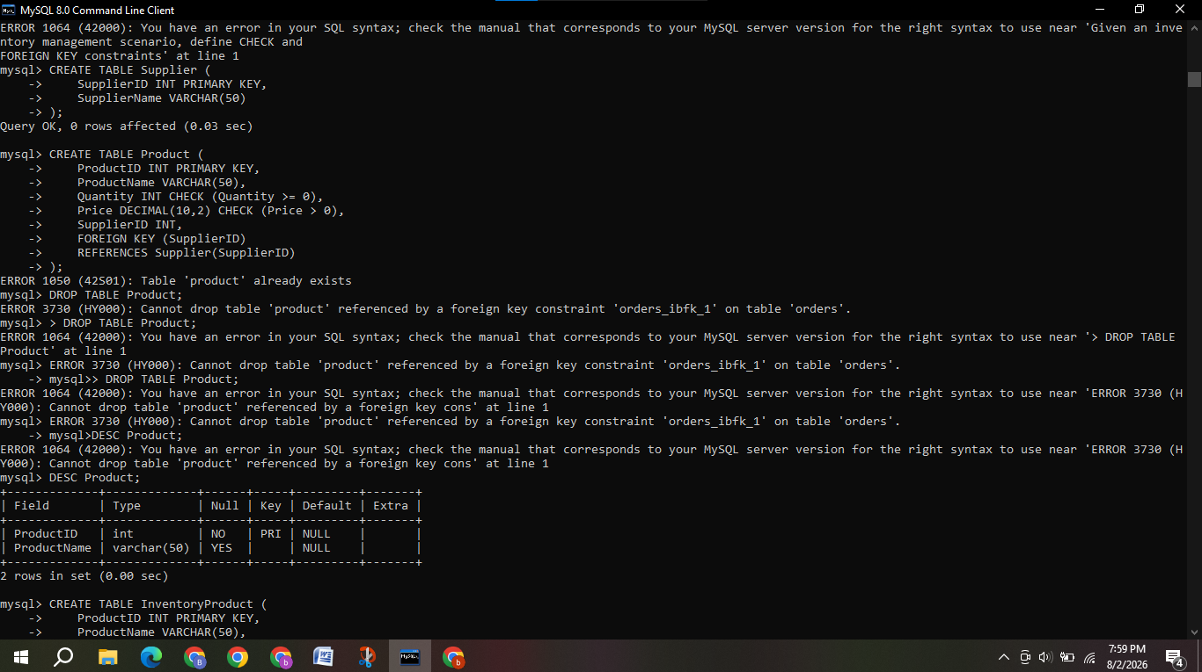
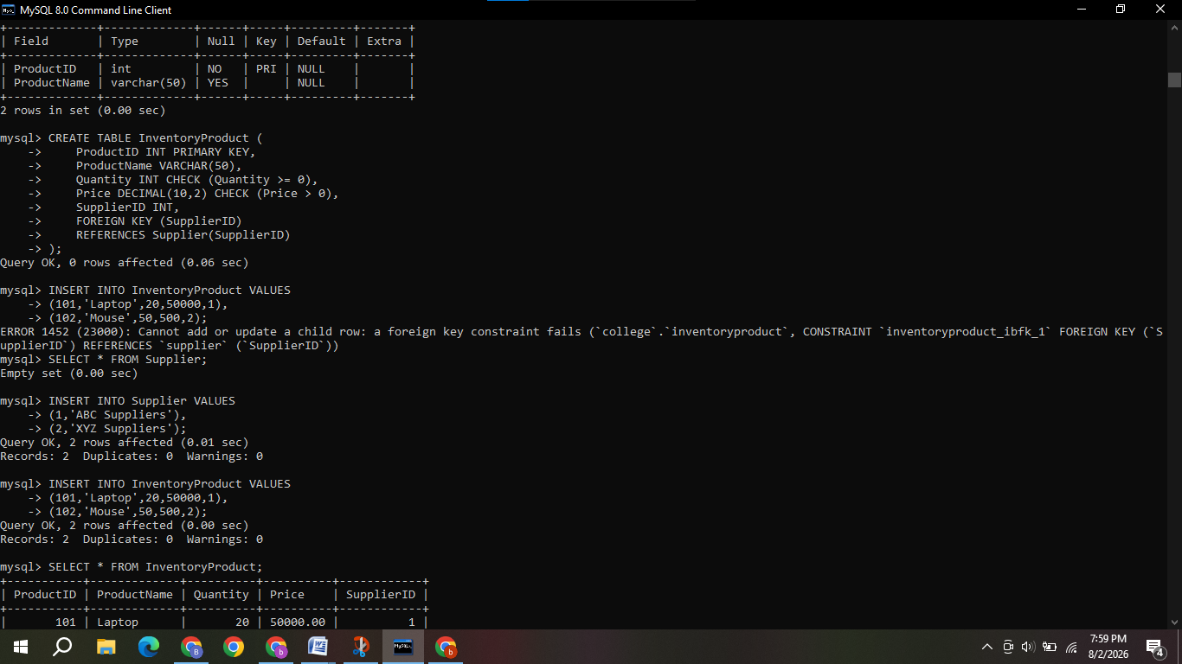
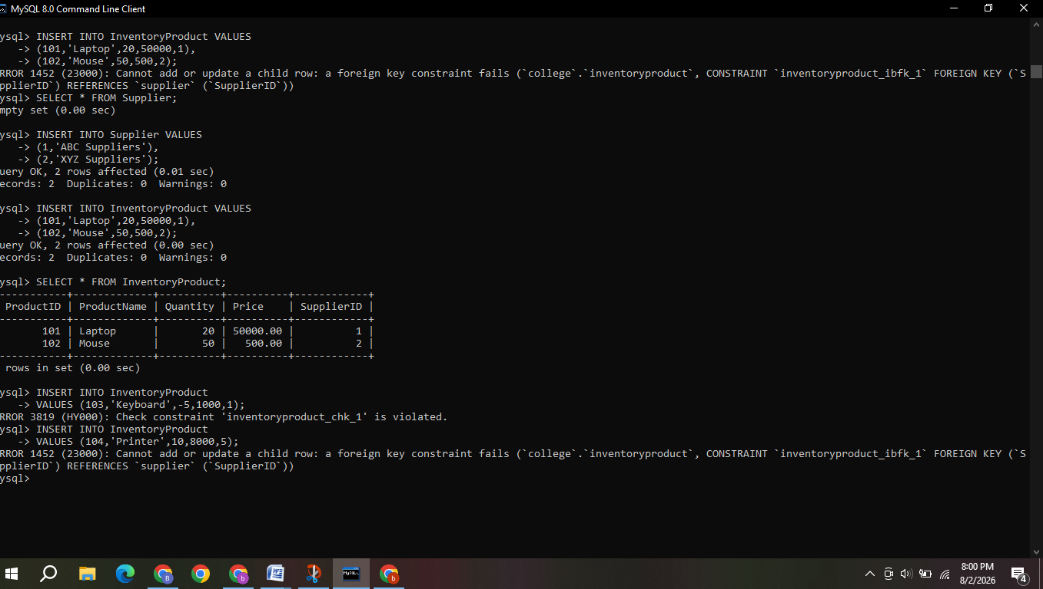

Q10. Design a relational schema for an HR system and create materialized views for monthly attendance and performance summaries.
