- Apply relational algebra operations (σ, π, ∪, -, ×, ⋈) on the give Employee and Department relations to retrieve required records.

Assume:
EMPLOYEE(EmpID, EmpName, DeptID, Salary)
DEPARTMENT(DeptID, DeptName)

a) SELECTION (σ)
Find employees whose salary is greater than 50,000:
σ Salary > 50000 (EMPLOYEE)

b) PROJECTION (π)
Display only employee names:
π EmpName (EMPLOYEE)

c) UNION (∪)
Find employees belonging to either Department 10 or Department 20:
π EmpID (σ DeptID = 10 (EMPLOYEE)) ∪ π EmpID (σ DeptID = 20 (EMPLOYEE))

d) SET DIFFERENCE (-)
Find employees who are not in Department 10:
EMPLOYEE - σ DeptID = 10 (EMPLOYEE)

e) CARTESIAN PRODUCT (×)
Combine every employee with every department:
EMPLOYEE × DEPARTMENT

f) JOIN (⋈)
Display employee names and their department names:
EMPLOYEE ⋈ EMPLOYEE.DeptID = DEPARTMENT.DeptID DEPARTMENT

- Write SQL DDL statements to create STUDENT(SID, Name, DOB, DeptID) and DEPARTMENT(DeptID, DeptName) tables with all
appropriate constraints.

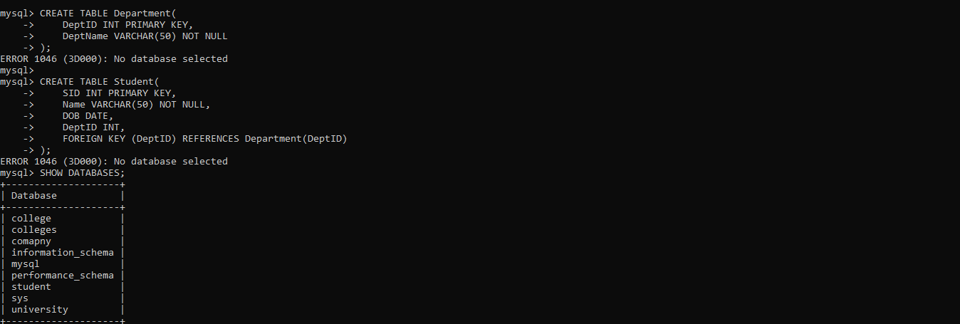
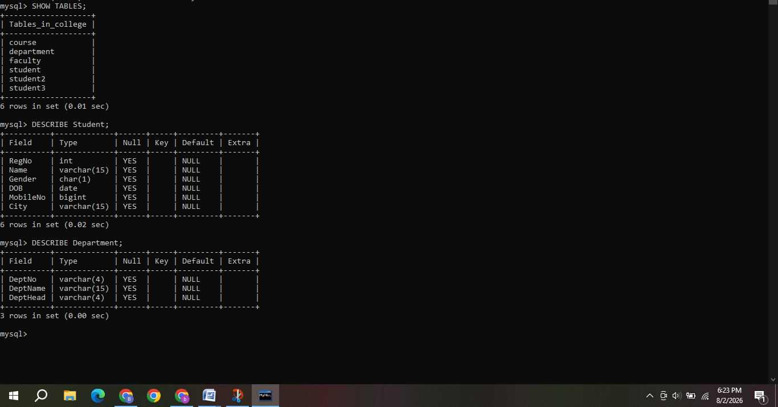
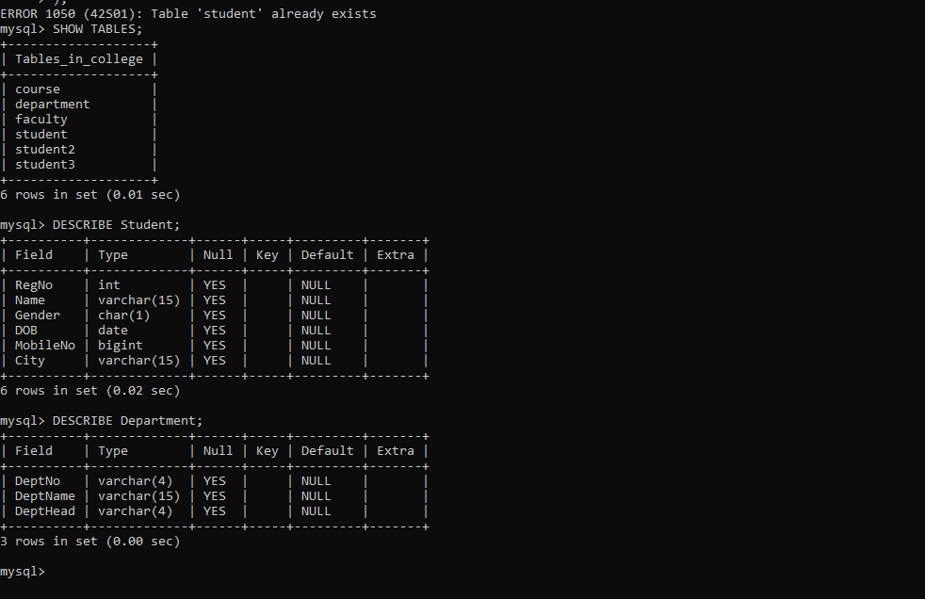

3) Formulate SQL queries using GROUP BY, HAVING, and aggregate
functions (COUNT, SUM, AVG, MAX, MIN) on a given Sales
dataset.
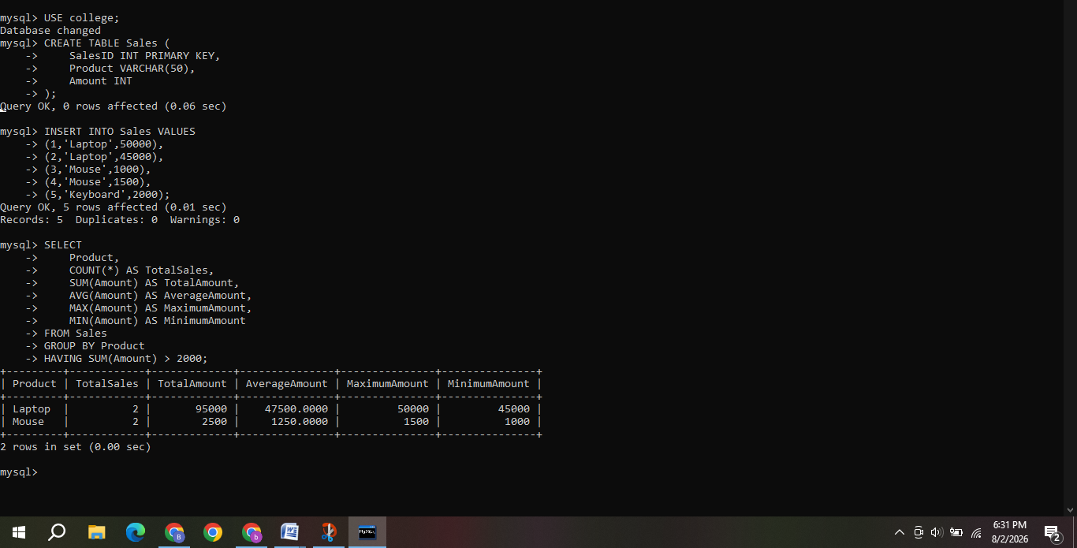
4) Write a correlated sub-query to find employees earning more than the average salary of their own department.\
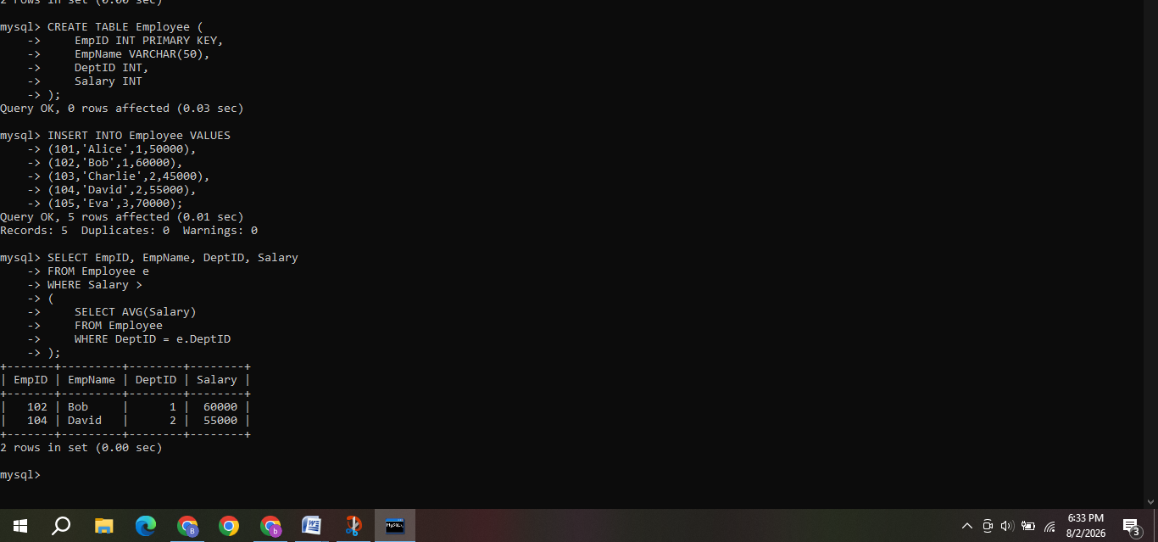
5) Apply all types of JOIN operations (INNER, LEFT OUTER, RIGHT OUTER, FULL OUTER, CROSS) on Employee and Project tables.
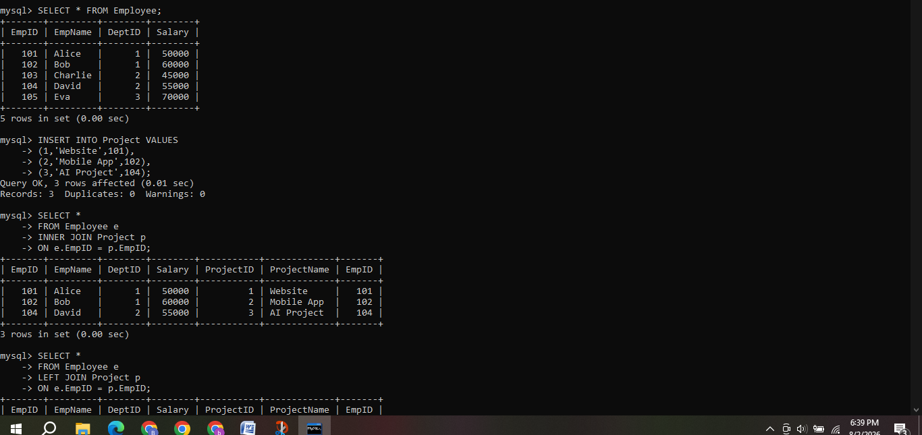
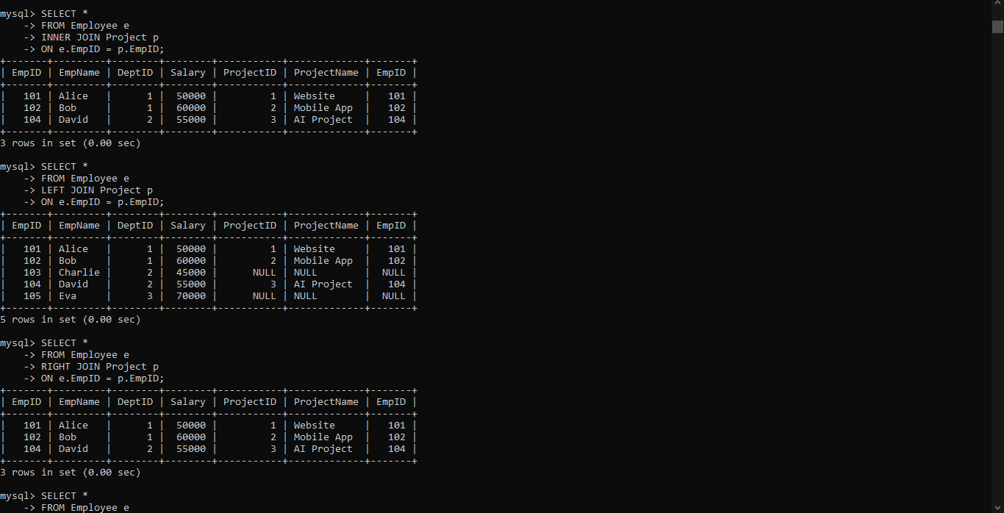
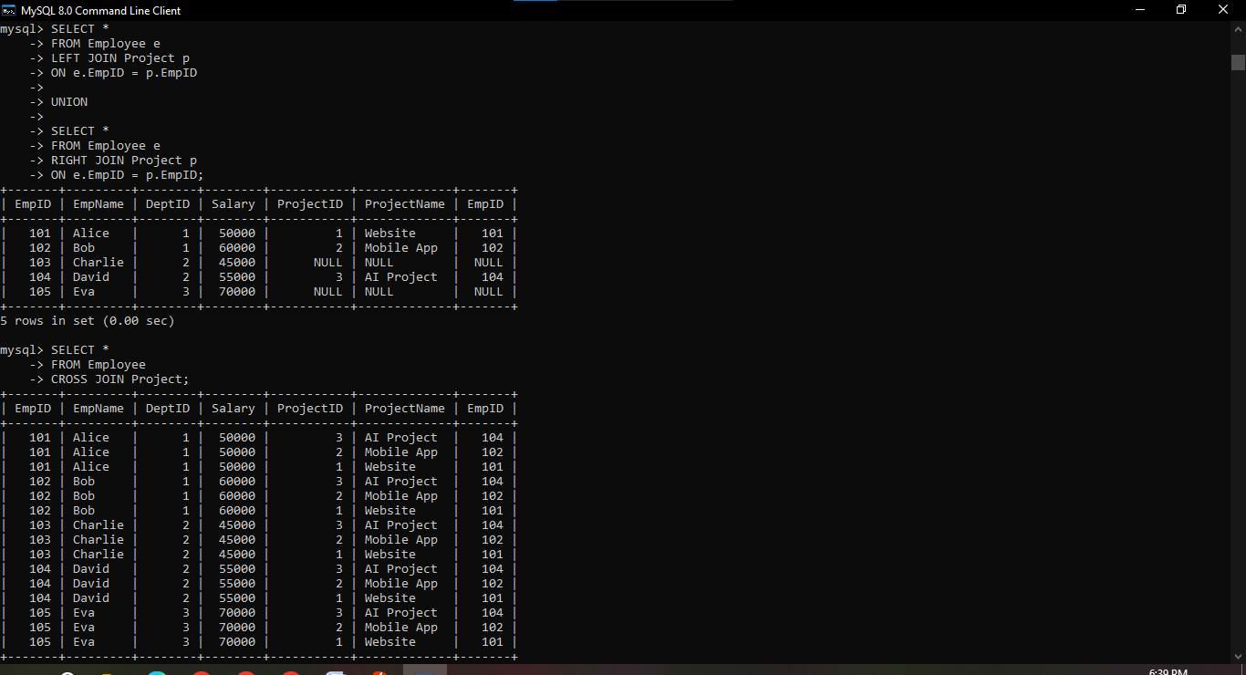

6) Create a view DeptSalaryView that displays department name, total employees, and average salary. Write a query on this view.
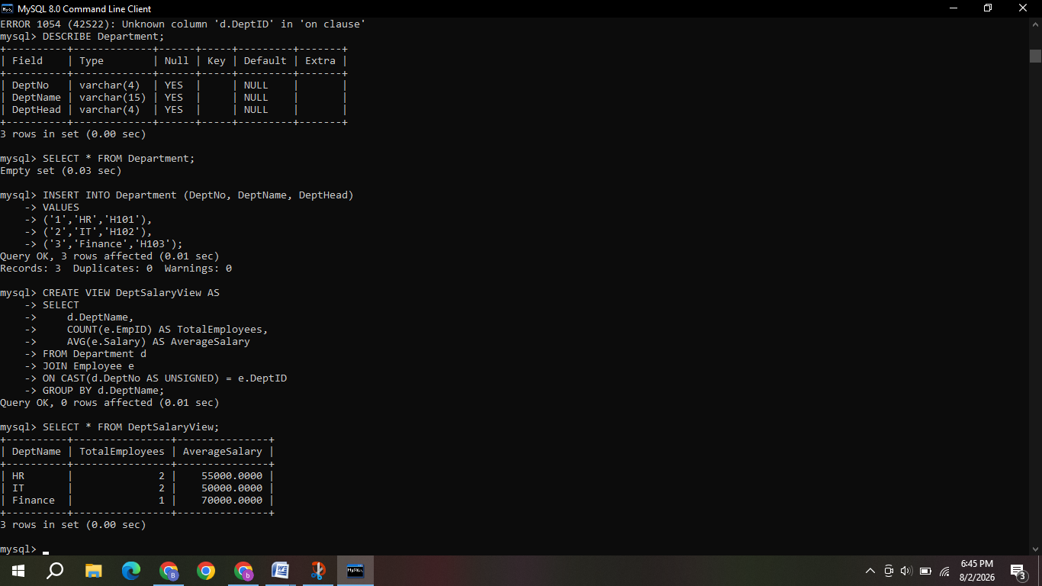

7) Construct a relational algebra expression for the following: Find names of students who are enrolled in all courses offered.

Assume:
STUDENT(SID, Name)
ENROLLMENT(SID, CID)
COURSE(CID, CourseName)

Step 1: Get all course IDs:
π CID (COURSE)

Step 2: Get student-course enrollment pairs:
π SID, CID (ENROLLMENT)

Step 3: Use relational division to find students enrolled in ALL courses:
(π SID, CID (ENROLLMENT)) ÷ (π CID (COURSE))

Step 4: Get the names of those students:
π Name (STUDENT ⋈ (π SID, CID (ENROLLMENT) ÷ π CID (COURSE)))

Final Answer:
π Name (STUDENT ⋈ ((π SID, CID (ENROLLMENT)) ÷ (π CID (COURSE))))

8) Write SQL DML statements (INSERT, UPDATE, DELETE) with integrity constraint enforcement for a given scenario.
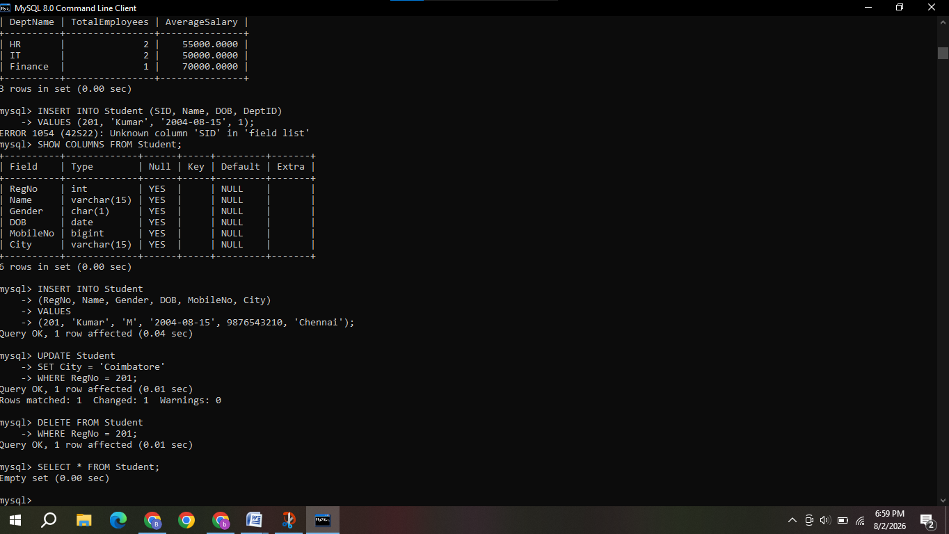
9) Apply tuple relational calculus to express a query: Find all
employees who work in the &#39;IT&#39; department and earn more than
50000.

Assume:
EMPLOYEE(EmpID, EmpName, DeptID, Salary)
DEPARTMENT(DeptID, DeptName)

Tuple Relational Calculus (TRC):
{ e | EMPLOYEE(e) AND
EXISTS d (DEPARTMENT(d) AND
e.DeptID = d.DeptID AND
d.DeptName = 'IT' AND
e.Salary > 50000)
}

Explanation:
e → Employee tuple
d → Department tuple
e.DeptID = d.DeptID → Employee belongs to the department
d.DeptName = 'IT' → Department is IT
e.Salary > 50000 → Salary is greater than 50000

10) Design a relational schema for an Airline Reservation System and
write 5 SQL queries demonstrating joins, sub-queries, and views.
