Importing data
-- STEP 1: Database
CREATE DATABASE IF NOT EXISTS safecon_ops;
USE safecon_ops;

-- STEP 2: Permission for LOAD DATA (once per server)
-- Also needed: in Workbench, Connection - Advanced - Others, add OPT_LOCAL_INFILE=1 on a new line, then restart Workbench
SET GLOBAL local_infile = 1;
SHOW VARIABLES LIKE 'local_infile'; -- expected: ON

-- STEP 3: Final fact table
CREATE TABLE fact_production (
Production_ID VARCHAR(12) PRIMARY KEY,
Batch_ID VARCHAR(25),
Order_ID VARCHAR(20),
Production_Date DATE,
Plant VARCHAR(20),
Department VARCHAR(30),
Product_ID VARCHAR(10),
Client_ID VARCHAR(10),
Machine_ID VARCHAR(15),
Shift VARCHAR(10),
Operator_Count INT,
Planned_Quantity INT,
Produced_Quantity INT,
Accepted_Quantity INT,
Rejected_Quantity INT,
Rework_Quantity INT,
Wastage_Quantity INT,
Production_Start_Time DATETIME,
Production_End_Time DATETIME,
Production_Cycle_Hours DECIMAL(6,2),
Downtime_Hours DECIMAL(6,2),
Downtime_Reason VARCHAR(40),
Ambient_Humidity_Percent DECIMAL(5,1),
Temperature_C DECIMAL(5,1),
Quality_Status VARCHAR(20),
Batch_Failure_Flag TINYINT,
Qty_Valid TINYINT
);

-- STEP 4: Staging table (all text, so the load can never fail on data types)
DROP TABLE IF EXISTS stg_fact_production;
CREATE TABLE stg_fact_production (
Production_ID VARCHAR(50), Batch_ID VARCHAR(50), Order_ID VARCHAR(50),
Production_Date VARCHAR(50), Plant VARCHAR(50), Department VARCHAR(50),
Product_ID VARCHAR(50), Client_ID VARCHAR(50), Machine_ID VARCHAR(50),
Shift VARCHAR(50), Operator_Count VARCHAR(50), Planned_Quantity VARCHAR(50),
Produced_Quantity VARCHAR(50), Accepted_Quantity VARCHAR(50),
Rejected_Quantity VARCHAR(50), Rework_Quantity VARCHAR(50),
Wastage_Quantity VARCHAR(50), Production_Start_Time VARCHAR(50),
Production_End_Time VARCHAR(50), Production_Cycle_Hours VARCHAR(50),
Downtime_Hours VARCHAR(50), Downtime_Reason VARCHAR(50),
Ambient_Humidity_Percent VARCHAR(50), Temperature_C VARCHAR(50),
Quality_Status VARCHAR(50), Batch_Failure_Flag VARCHAR(50), Qty_Valid VARCHAR(50)
);

-- STEP 5: Load the CSV into staging
LOAD DATA LOCAL INFILE '<path>/fact_production_final.csv'
INTO TABLE stg_fact_production
FIELDS TERMINATED BY ','
OPTIONALLY ENCLOSED BY '"'
LINES TERMINATED BY '\n'
IGNORE 1 LINES;

-- STEP 6: Inspect staging BEFORE moving data
SELECT COUNT(*) FROM stg_fact_production; -- expected 60,973
SELECT * FROM stg_fact_production LIMIT 3; -- check columns line up

-- STEP 7: Move to the final table (blank text becomes NULL)
INSERT INTO fact_production
(Production_ID, Batch_ID, Order_ID, Production_Date, Plant, Department, Product_ID,
Client_ID, Machine_ID, Shift, Operator_Count, Planned_Quantity, Produced_Quantity,
Accepted_Quantity, Rejected_Quantity, Rework_Quantity, Wastage_Quantity,
Production_Start_Time, Production_End_Time, Production_Cycle_Hours, Downtime_Hours,
Downtime_Reason, Ambient_Humidity_Percent, Temperature_C, Quality_Status,
Batch_Failure_Flag, Qty_Valid)
SELECT
Production_ID, Batch_ID, Order_ID, Production_Date, Plant, Department, Product_ID,
Client_ID, NULLIF(Machine_ID,''), NULLIF(Shift,''), NULLIF(Operator_Count,''),
Planned_Quantity, Produced_Quantity, Accepted_Quantity, NULLIF(Rejected_Quantity,''),
Rework_Quantity, Wastage_Quantity, Production_Start_Time, NULLIF(Production_End_Time,''),
Production_Cycle_Hours, NULLIF(Downtime_Hours,''), Downtime_Reason,
NULLIF(Ambient_Humidity_Percent,''), NULLIF(Temperature_C,''), Quality_Status,
Batch_Failure_Flag, Qty_Valid
FROM stg_fact_production;

-- STEP 8: Verification
SELECT COUNT(*) FROM fact_production;
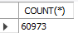
SELECT COUNT(*) - COUNT(Ambient_Humidity_Percent) AS humidity_null FROM fact_production;
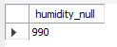
SELECT MIN(Production_Date), MAX(Production_Date) FROM fact_production;
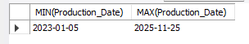
SELECT DISTINCT Plant FROM fact_production;
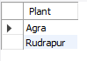
SELECT Quality_Status, COUNT(*) FROM fact_production GROUP BY Quality_Status;
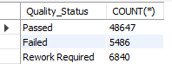
-- STEP 9: Dimension tables
CREATE TABLE dim_client (
Client_ID VARCHAR(10) PRIMARY KEY, Client_Name VARCHAR(60), Client_Type VARCHAR(30),
Region VARCHAR(40), Priority_Level VARCHAR(10));
LOAD DATA LOCAL INFILE '<path>/Dim_Client.csv'
INTO TABLE dim_client
FIELDS TERMINATED BY ','
OPTIONALLY ENCLOSED BY '"'
LINES TERMINATED BY '\n'
IGNORE 1 LINES;

SELECT COUNT(*) FROM dim_client;
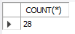
SELECT * FROM dim_client LIMIT 5;
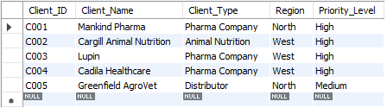
SELECT DISTINCT Priority_Level, LENGTH(Priority_Level) FROM dim_client;
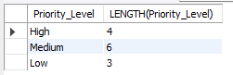
CREATE TABLE dim_product (
Product_ID VARCHAR(10) PRIMARY KEY, Product_Name VARCHAR(80), Product_Category VARCHAR(30),
Dosage_Form VARCHAR(30), Standard_Batch_Size INT);

LOAD DATA LOCAL INFILE '<path>/Dim_Product.csv'
INTO TABLE dim_product
FIELDS TERMINATED BY ','
OPTIONALLY ENCLOSED BY '"'
LINES TERMINATED BY '\n'
IGNORE 1 LINES;

SELECT COUNT(*) FROM dim_product;
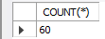
SELECT * FROM dim_product LIMIT 5;
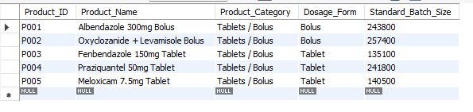
CREATE TABLE dim_machine (
Machine_ID VARCHAR(15) PRIMARY KEY, Machine_Name VARCHAR(60), Plant VARCHAR(20),
Machine_Type VARCHAR(50), Installation_Year INT);

LOAD DATA LOCAL INFILE '<path>/Dim_Machine.csv'
INTO TABLE dim_machine
FIELDS TERMINATED BY ','
OPTIONALLY ENCLOSED BY '"'
LINES TERMINATED BY '\n'
IGNORE 1 LINES;

SELECT COUNT(*) FROM dim_machine;
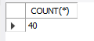
SELECT * FROM dim_machine LIMIT 5;
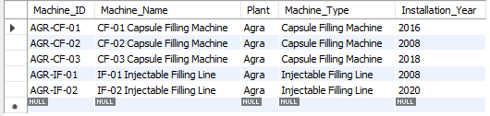
CREATE TABLE dim_date (
`Date` DATE PRIMARY KEY, `Year` INT, Quarter VARCHAR(5), Month_No INT, Month_Name VARCHAR(10),
Month_Year VARCHAR(10), Week_No INT, Day_Name VARCHAR(12), Is_Weekend TINYINT,
Fiscal_Year VARCHAR(10), Season VARCHAR(20));

LOAD DATA LOCAL INFILE "<path>/Dim_Date.csv"
INTO TABLE dim_date
FIELDS TERMINATED BY ','
OPTIONALLY ENCLOSED BY '"'
LINES TERMINATED BY '\n'
IGNORE 1 LINES;
SELECT COUNT(*) FROM dim_date;
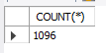
SELECT * FROM dim_date LIMIT 5;
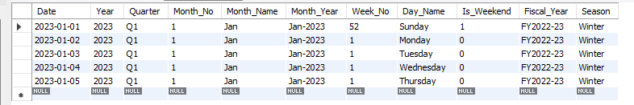

Plant Wise Produced Quantity

SELECT Plant, SUM(Produced_Quantity) AS Total_Produced FROM fact_production
where Qty_Valid = 1
GROUP BY Plant;
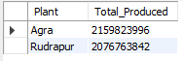

Plant Wise Rejection, Rework, Wastage %
SELECT
Plant,
SUM(Rejected_Quantity) AS Total_Rejected,
ROUND(SUM(Rejected_Quantity) / SUM(Produced_Quantity) * 100, 2) AS Rejection_Rate_Pct,
ROUND(SUM(Rework_Quantity) / SUM(Produced_Quantity) * 100, 2) AS Rework_Rate_Pct,
ROUND(SUM(Wastage_Quantity) / SUM(Produced_Quantity) * 100, 2) AS Wastage_Pct
FROM fact_production
WHERE Qty_Valid = 1
GROUP BY Plant;
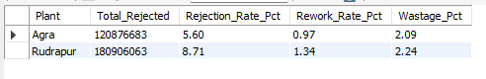

Plant Wise Production Achievement %
SELECT
Plant,
ROUND(SUM(Produced_Quantity) / SUM(Planned_Quantity) * 100, 2) AS Achievement_pct
FROM fact_production
WHERE Qty_Valid = 1
group by Plant;
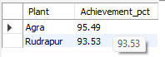

Product Category wise Total produced, Rejected Rate, Batch Failure

SELECT
d.Product_Category,
SUM(f.Produced_Quantity) AS Total_Produced,
ROUND(SUM(f.Rejected_Quantity) / SUM(f.Produced_Quantity) * 100, 2) AS Rejection_Rate_Pct,
ROUND(SUM(f.Batch_Failure_Flag) / COUNT(*) * 100, 2) AS Batch_Failure_Rate_Pct
FROM fact_production f
JOIN dim_product d
ON f.Product_ID = d.Product_ID
WHERE f.Qty_Valid = 1
GROUP BY d.Product_Category
ORDER BY Rejection_Rate_Pct DESC;
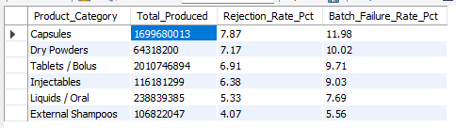
Highest Rejection Rate Products (Minimum 100 Batches)

SELECT
d.Product_Name,
d.Product_Category,
ROUND(SUM(f.Rejected_Quantity) / SUM(f.Produced_Quantity) * 100, 2) AS Rejection_Rate_Pct,
count(*) AS Total_Btaches
FROM fact_production f
JOIN dim_product d
ON f.Product_ID = d.Product_ID
WHERE f.Qty_Valid = 1
GROUP BY d.Product_id, d.Product_Name, d.Product_Category
HAVING COUNT(*) >= 100
ORDER BY Rejection_Rate_Pct DESC
LIMIT 10;
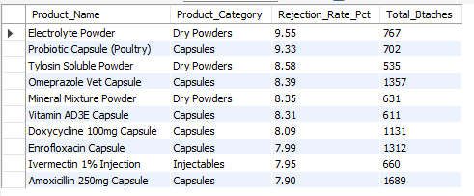
Machine-Wise Downtime

SELECT
m.Machine_ID,
m.Machine_Name,
m.Plant,
m.Machine_Type,
COUNT(*) AS Total_Batches,
ROUND(SUM(f.Downtime_Hours), 2) AS Total_Downtime_Hrs,
ROUND(AVG(f.Downtime_Hours), 2) AS Avg_Downtime_Per_Batch
FROM fact_production f
JOIN dim_machine m
ON f.Machine_ID = m.Machine_ID
GROUP BY m.Machine_ID, m.Machine_Name, m.Plant, m.Machine_Type
ORDER BY Total_Downtime_Hrs DESC
LIMIT 10;

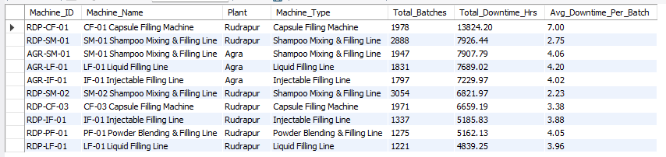

Downtime Reason Analysis
SELECT
Downtime_Reason,
COUNT(*) AS Batches,
ROUND(SUM(Downtime_Hours), 2) AS Total_Downtime_Hrs,
ROUND(SUM(Downtime_Hours) / (SELECT SUM(Downtime_Hours) FROM fact_production) * 100, 2) AS Share_Pct
FROM fact_production
GROUP BY Downtime_Reason
ORDER BY Total_Downtime_Hrs DESC;
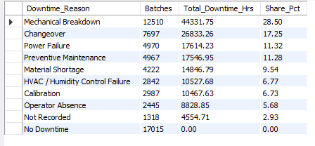

Monthly Production aur Quality Trend
SELECT
dd.`Year`,
dd.Month_No,
dd.Month_Name,
SUM(f.Produced_Quantity) AS Total_Produced,
ROUND(SUM(f.Rejected_Quantity) / SUM(f.Produced_Quantity) * 100, 2) AS Rejection_Rate_Pct,
ROUND(SUM(f.Batch_Failure_Flag) / COUNT(*) * 100, 2) AS Batch_Failure_Rate_Pct
FROM fact_production f
JOIN dim_date dd
ON f.Production_Date = dd.`Date`
WHERE f.Qty_Valid = 1
GROUP BY dd.`Year`, dd.Month_No, dd.Month_Name
ORDER BY dd.`Year`, dd.Month_No;
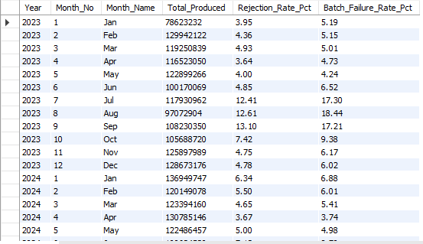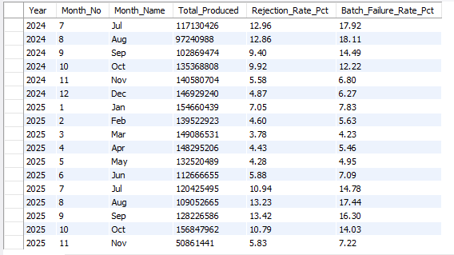

MoM Growth %
WITH monthly AS (
SELECT
dd.`Year` AS Yr,
dd.Month_No AS Mn,
dd.Month_Year AS Month_Label,
SUM(f.Produced_Quantity) AS Total_Produced
FROM fact_production f
JOIN dim_date dd
ON f.Production_Date = dd.`Date`
WHERE f.Qty_Valid = 1
GROUP BY dd.`Year`, dd.Month_No, dd.Month_Year
)
SELECT
Month_Label,
Total_Produced,
LAG(Total_Produced) OVER (ORDER BY Yr, Mn) AS Prev_Month_Produced,
ROUND((Total_Produced - LAG(Total_Produced) OVER (ORDER BY Yr, Mn))
/ LAG(Total_Produced) OVER (ORDER BY Yr, Mn) * 100, 2) AS MoM_Growth_Pct
FROM monthly
ORDER BY Yr, Mn;
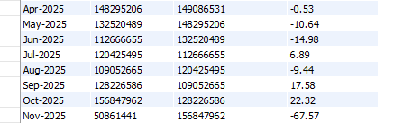
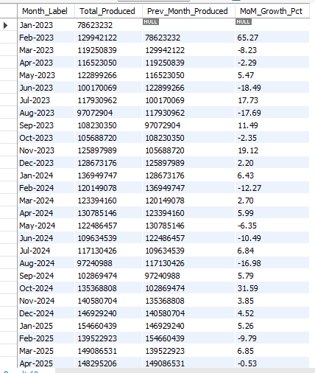

Humidity Band Vs Quality
SELECT
CASE
WHEN Ambient_Humidity_Percent IS NULL THEN 'Unknown'
WHEN Ambient_Humidity_Percent <= 70 THEN '1. Low (<=70)'
WHEN Ambient_Humidity_Percent <= 80 THEN '2. Medium (70-80)'
ELSE '3. High (>80)'
END AS Humidity_Band,
COUNT(*) AS Batches,
ROUND(SUM(Rejected_Quantity) / SUM(Produced_Quantity) * 100, 2) AS Rejection_Rate_Pct,
ROUND(SUM(Rework_Quantity) / SUM(Produced_Quantity) * 100, 2) AS Rework_Rate_Pct,
ROUND(SUM(Wastage_Quantity) / SUM(Produced_Quantity) * 100, 2) AS Wastage_Pct,
ROUND(SUM(Batch_Failure_Flag) / COUNT(*) * 100, 2) AS Batch_Failure_Rate_Pct
FROM fact_production
WHERE Qty_Valid = 1
GROUP BY Humidity_Band
ORDER BY Humidity_Band;
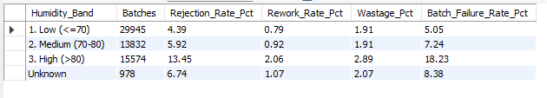

Downtime Band Vs Achievement And Quality
SELECT
CASE
WHEN Downtime_Hours IS NULL THEN 'Unknown'
WHEN Downtime_Hours = 0 THEN '1. None (0)'
WHEN Downtime_Hours <= 2 THEN '2. Low (0-2)'
WHEN Downtime_Hours <= 5 THEN '3. Medium (2-5)'
ELSE '4. High (>5)'
END AS Downtime_Band,
COUNT(*) AS Batches,
ROUND(SUM(Produced_Quantity) / SUM(Planned_Quantity) * 100, 2) AS Achievement_Pct,
ROUND(SUM(Rejected_Quantity) / SUM(Produced_Quantity) * 100, 2) AS Rejection_Rate_Pct,
ROUND(SUM(Batch_Failure_Flag) / COUNT(*) * 100, 2) AS Batch_Failure_Rate_Pct
FROM fact_production
WHERE Qty_Valid = 1
GROUP BY Downtime_Band
ORDER BY Downtime_Band;
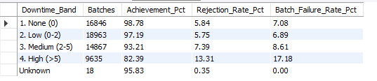

Machine Downtime Ranking within Each Plant
SELECT
m.Plant,
m.Machine_ID,
m.Machine_Name,
ROUND(SUM(f.Downtime_Hours), 2) AS Total_Downtime_Hrs,
RANK() OVER (PARTITION BY m.Plant ORDER BY SUM(f.Downtime_Hours) DESC) AS Downtime_Rank_In_Plant
FROM fact_production f
JOIN dim_machine m
ON f.Machine_ID = m.Machine_ID
GROUP BY m.Plant, m.Machine_ID, m.Machine_Name
ORDER BY m.Plant, Downtime_Rank_In_Plant;
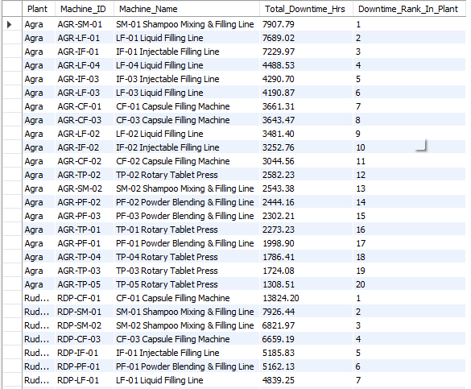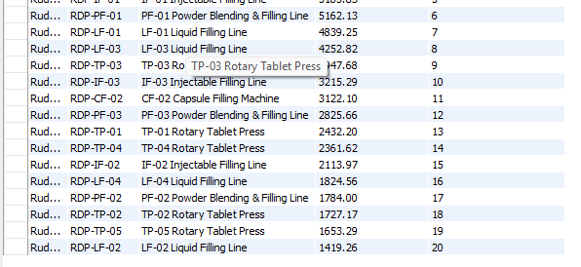

Importing Fact_Order.Csv File
USE safecon_ops;

CREATE TABLE stg_fact_orders (
Order_ID VARCHAR(50),
Order_Date VARCHAR(50),
Client_ID VARCHAR(50),
Client_Name VARCHAR(50),
Plant VARCHAR(50),
Product_ID VARCHAR(50),
Product_Category VARCHAR(50),
Ordered_Quantity VARCHAR(50),
Produced_Quantity VARCHAR(50),
Shipped_Quantity VARCHAR(50),
Promised_Ship_Date VARCHAR(50),
Actual_Ship_Date VARCHAR(50),
Shipment_Status VARCHAR(50),
Delay_Days VARCHAR(50),
On_Time_Flag VARCHAR(50)
);
LOAD DATA LOCAL INFILE "<path>/Fact_Orders_raw.csv"
INTO TABLE stg_fact_orders
FIELDS TERMINATED BY ','
OPTIONALLY ENCLOSED BY '"'
LINES TERMINATED BY '\n'
IGNORE 1 LINES;

SELECT COUNT(*) FROM stg_fact_orders; -- expected 15,045
SELECT * FROM stg_fact_orders LIMIT 5;
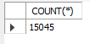

Fact_Orders Data Profiling (Before Cleaning)
USE safecon_ops;

-- A) Duplicate orders
SELECT COUNT(*) AS total_rows,
COUNT(DISTINCT Order_ID) AS unique_orders
FROM stg_fact_orders;
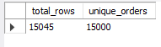

-- B) Values of Plant, Shipment_Status, On_Time_Flag
SELECT 'Plant' AS col, Plant AS value, COUNT(*) AS cnt
FROM stg_fact_orders GROUP BY Plant
UNION ALL
SELECT 'Shipment_Status', Shipment_Status, COUNT(*)
FROM stg_fact_orders GROUP BY Shipment_Status
UNION ALL
SELECT 'On_Time_Flag', On_Time_Flag, COUNT(*)
FROM stg_fact_orders GROUP BY On_Time_Flag;
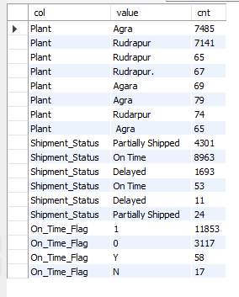

-- C) Order_Date formats
SELECT
SUM(Order_Date REGEXP '^[0-9]{4}-[0-9]{2}-[0-9]{2}$') AS iso_yyyy_mm_dd,
SUM(Order_Date REGEXP '^[0-9]{2}/[0-9]{2}/[0-9]{4}$') AS dd_mm_yyyy,
SUM(Order_Date REGEXP '^[0-9]{2}-[A-Za-z]{3}-[0-9]{4}$') AS dd_mon_yyyy,
COUNT(*) AS total
FROM stg_fact_orders;
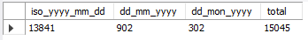

-- D) Extra Spaces in Client_Name
SELECT COUNT(*) AS names_with_extra_spaces
FROM stg_fact_orders
WHERE Client_Name <> TRIM(Client_Name);
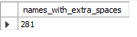

-- E) Formats And Blanks of Promised And Actual Ship Date
SELECT 'Promised_Ship_Date' AS col,
SUM(Promised_Ship_Date REGEXP '^[0-9]{4}-[0-9]{2}-[0-9]{2}$') AS iso,
SUM(Promised_Ship_Date REGEXP '^[0-9]{2}/[0-9]{2}/[0-9]{4}$') AS dd_mm_yyyy,
SUM(Promised_Ship_Date REGEXP '^[0-9]{2}-[A-Za-z]{3}-[0-9]{4}$') AS dd_mon_yyyy,
SUM(Promised_Ship_Date = '' OR Promised_Ship_Date IS NULL) AS blank,
COUNT(*) AS total
FROM stg_fact_orders
UNION ALL
SELECT 'Actual_Ship_Date',
SUM(Actual_Ship_Date REGEXP '^[0-9]{4}-[0-9]{2}-[0-9]{2}$'),
SUM(Actual_Ship_Date REGEXP '^[0-9]{2}/[0-9]{2}/[0-9]{4}$'),
SUM(Actual_Ship_Date REGEXP '^[0-9]{2}-[A-Za-z]{3}-[0-9]{4}$'),
SUM(Actual_Ship_Date = '' OR Actual_Ship_Date IS NULL),
COUNT(*)
FROM stg_fact_orders;
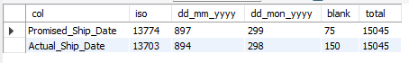

-- F) Shipment_Status aur On_Time_Flag
SELECT TRIM(Shipment_Status) AS status, On_Time_Flag, COUNT(*) AS cnt
FROM stg_fact_orders
GROUP BY TRIM(Shipment_Status), On_Time_Flag
ORDER BY status, On_Time_Flag;
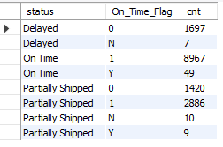
-- G) Proof of DD/MM/YYYY is day/month ( not month/day )
SELECT
SUM(CAST(SUBSTRING(Order_Date,1,2) AS UNSIGNED) > 12) AS first_part_gt_12,
SUM(CAST(SUBSTRING(Order_Date,4,2) AS UNSIGNED) > 12) AS second_part_gt_12
FROM stg_fact_orders
WHERE Order_Date REGEXP '^[0-9]{2}/[0-9]{2}/[0-9]{4}$';
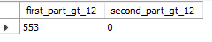

Fact_Orders Cleaning and Load

USE safecon_ops;

CREATE TABLE fact_orders (
Order_ID VARCHAR(20) PRIMARY KEY,
Order_Date DATE,
Client_ID VARCHAR(10),
Plant VARCHAR(20),
Product_ID VARCHAR(10),
Ordered_Quantity INT,
Produced_Quantity INT,
Shipped_Quantity INT,
Promised_Ship_Date DATE,
Actual_Ship_Date DATE,
Shipment_Status VARCHAR(20),
Delay_Days INT,
On_Time_Flag TINYINT
);

INSERT INTO fact_orders
(Order_ID, Order_Date, Client_ID, Plant, Product_ID, Ordered_Quantity, Produced_Quantity,
Shipped_Quantity, Promised_Ship_Date, Actual_Ship_Date, Shipment_Status, Delay_Days, On_Time_Flag)
SELECT Order_ID, Order_Date, Client_ID, Plant, Product_ID, Ordered_Quantity, Produced_Quantity,
Shipped_Quantity, Promised_Ship_Date, Actual_Ship_Date, Shipment_Status, Delay_Days, On_Time_Flag
FROM (
SELECT
UPPER(TRIM(Order_ID)) AS Order_ID,
CASE
WHEN Order_Date REGEXP '^[0-9]{4}-[0-9]{2}-[0-9]{2}$' THEN STR_TO_DATE(Order_Date, '%Y-%m-%d')
WHEN Order_Date REGEXP '^[0-9]{2}/[0-9]{2}/[0-9]{4}$' THEN STR_TO_DATE(Order_Date, '%d/%m/%Y')
WHEN Order_Date REGEXP '^[0-9]{2}-[A-Za-z]{3}-[0-9]{4}$' THEN STR_TO_DATE(Order_Date, '%d-%b-%Y')
END AS Order_Date,
UPPER(TRIM(Client_ID)) AS Client_ID,
CASE
WHEN UPPER(LEFT(TRIM(Plant), 1)) = 'A' THEN 'Agra'
WHEN UPPER(LEFT(TRIM(Plant), 1)) = 'R' THEN 'Rudrapur'
ELSE 'CHECK'
END AS Plant,
UPPER(TRIM(Product_ID)) AS Product_ID,
NULLIF(TRIM(Ordered_Quantity), '') AS Ordered_Quantity,
NULLIF(TRIM(Produced_Quantity), '') AS Produced_Quantity,
NULLIF(TRIM(Shipped_Quantity), '') AS Shipped_Quantity,
CASE
WHEN Promised_Ship_Date REGEXP '^[0-9]{4}-[0-9]{2}-[0-9]{2}$' THEN STR_TO_DATE(Promised_Ship_Date, '%Y-%m-%d')
WHEN Promised_Ship_Date REGEXP '^[0-9]{2}/[0-9]{2}/[0-9]{4}$' THEN STR_TO_DATE(Promised_Ship_Date, '%d/%m/%Y')
WHEN Promised_Ship_Date REGEXP '^[0-9]{2}-[A-Za-z]{3}-[0-9]{4}$' THEN STR_TO_DATE(Promised_Ship_Date, '%d-%b-%Y')
END AS Promised_Ship_Date,
CASE
WHEN Actual_Ship_Date REGEXP '^[0-9]{4}-[0-9]{2}-[0-9]{2}$' THEN STR_TO_DATE(Actual_Ship_Date, '%Y-%m-%d')
WHEN Actual_Ship_Date REGEXP '^[0-9]{2}/[0-9]{2}/[0-9]{4}$' THEN STR_TO_DATE(Actual_Ship_Date, '%d/%m/%Y')
WHEN Actual_Ship_Date REGEXP '^[0-9]{2}-[A-Za-z]{3}-[0-9]{4}$' THEN STR_TO_DATE(Actual_Ship_Date, '%d-%b-%Y')
END AS Actual_Ship_Date,
CASE
WHEN LOWER(TRIM(Shipment_Status)) LIKE 'on%' THEN 'On Time'
WHEN LOWER(TRIM(Shipment_Status)) LIKE 'del%' THEN 'Delayed'
WHEN LOWER(TRIM(Shipment_Status)) LIKE 'part%' THEN 'Partially Shipped'
ELSE 'CHECK'
END AS Shipment_Status,
NULLIF(TRIM(Delay_Days), '') AS Delay_Days,
CASE
WHEN TRIM(On_Time_Flag) IN ('1', 'Y') THEN 1
WHEN TRIM(On_Time_Flag) IN ('0', 'N') THEN 0
END AS On_Time_Flag,
ROW_NUMBER() OVER (PARTITION BY UPPER(TRIM(Order_ID)) ORDER BY Order_ID) AS rn
FROM stg_fact_orders
) t
WHERE rn = 1;

SELECT COUNT(*) AS total_rows, COUNT(DISTINCT Order_ID) AS unique_orders FROM fact_orders;
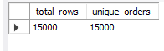
SELECT Plant, COUNT(*) AS cnt FROM fact_orders GROUP BY Plant;
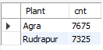

SELECT Shipment_Status, On_Time_Flag, COUNT(*) AS cnt
FROM fact_orders GROUP BY Shipment_Status, On_Time_Flag ORDER BY Shipment_Status, On_Time_Flag;
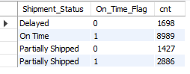

SELECT MIN(Order_Date) AS min_order, MAX(Order_Date) AS max_order,
SUM(Order_Date IS NULL) AS order_date_null,
SUM(Promised_Ship_Date IS NULL) AS promised_null,
SUM(Actual_Ship_Date IS NULL) AS actual_null
FROM fact_orders;

--Delay date vs Actual date difference
SELECT
SUM(Promised_Ship_Date IS NOT NULL AND Actual_Ship_Date IS NOT NULL
AND Delay_Days = GREATEST(DATEDIFF(Actual_Ship_Date, Promised_Ship_Date), 0)) AS delay_consistent,
SUM(Promised_Ship_Date IS NOT NULL AND Actual_Ship_Date IS NOT NULL
AND Delay_Days <> GREATEST(DATEDIFF(Actual_Ship_Date, Promised_Ship_Date), 0)) AS delay_inconsistent,
SUM(Delay_Days IS NULL) AS delay_days_null,
SUM(Promised_Ship_Date IS NULL OR Actual_Ship_Date IS NULL) AS cannot_check_dates_missing,
SUM(Actual_Ship_Date < Order_Date) AS ship_before_order,
SUM(Shipped_Quantity > Ordered_Quantity) AS shipped_gt_ordered
FROM fact_orders;

--On time flag vs Delay days
SELECT On_Time_Flag,
CASE WHEN Delay_Days IS NULL THEN 'Delay_Days NULL'
WHEN Delay_Days > 0 THEN 'Late (>0)'
ELSE 'Not late (0)' END AS delay_group,
COUNT(*) AS cnt
FROM fact_orders
GROUP BY On_Time_Flag, delay_group
ORDER BY On_Time_Flag, delay_group;
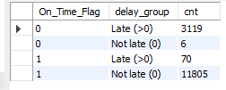

--Delay_Days vs Date Difference Check
SELECT Order_ID, Promised_Ship_Date, Actual_Ship_Date, Delay_Days,
DATEDIFF(Actual_Ship_Date, Promised_Ship_Date) AS date_diff,
On_Time_Flag, Shipment_Status
FROM fact_orders
WHERE Promised_Ship_Date IS NOT NULL AND Actual_Ship_Date IS NOT NULL
AND Delay_Days <> GREATEST(DATEDIFF(Actual_Ship_Date, Promised_Ship_Date), 0)
LIMIT 10;
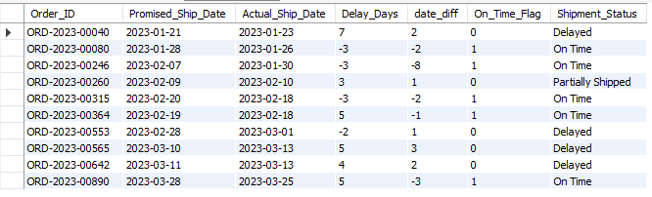

--Ship Date Before Order Date Check
SELECT Order_ID, Order_Date, Promised_Ship_Date, Actual_Ship_Date, Delay_Days
FROM fact_orders
WHERE Actual_Ship_Date < Order_Date;
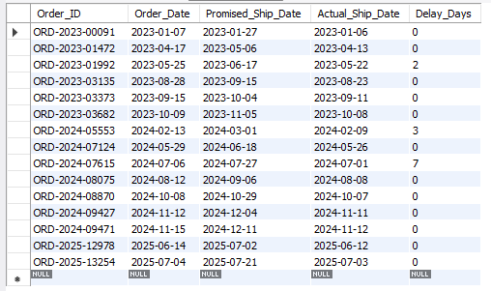

--Shipped > Ordered Check
SELECT Order_ID, Ordered_Quantity, Shipped_Quantity,
Shipped_Quantity - Ordered_Quantity AS excess, Shipment_Status
FROM fact_orders
WHERE Shipped_Quantity > Ordered_Quantity;
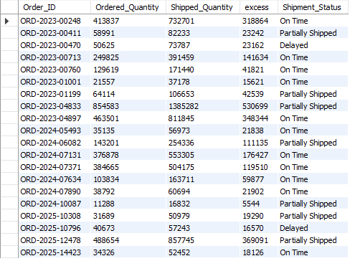

Fact_Orders Data Quality Fixes (Flags and Delay_Days Recalculation)
USE safecon_ops;
SET SQL_SAFE_UPDATES = 0;

ALTER TABLE fact_orders
ADD COLUMN Delay_Days_Clean INT,
ADD COLUMN Date_Valid TINYINT,
ADD COLUMN Qty_Valid TINYINT;

UPDATE fact_orders
SET Date_Valid = CASE
WHEN Promised_Ship_Date IS NULL OR Actual_Ship_Date IS NULL THEN 0
WHEN Actual_Ship_Date < Order_Date THEN 0
ELSE 1 END,
Qty_Valid = CASE
WHEN Ordered_Quantity IS NULL OR Shipped_Quantity IS NULL THEN 0
WHEN Shipped_Quantity > Ordered_Quantity THEN 0
ELSE 1 END;

UPDATE fact_orders
SET Delay_Days_Clean = CASE
WHEN Date_Valid = 1
THEN GREATEST(DATEDIFF(Actual_Ship_Date, Promised_Ship_Date), 0)
ELSE NULL END;

SET SQL_SAFE_UPDATES = 1;

Fact_Orders Data Quality Fixes: Validation
--V1: Flag Counts
SELECT SUM(Date_Valid = 0) AS date_invalid, SUM(Qty_Valid = 0) AS qty_invalid, COUNT(*) AS total
FROM fact_orders;
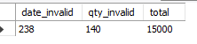

--V2: Delay_Days_Clean Range
SELECT MIN(Delay_Days_Clean) AS min_delay, MAX(Delay_Days_Clean) AS max_delay,
SUM(Delay_Days_Clean IS NULL) AS delay_null
FROM fact_orders;
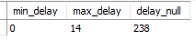

--V3: On_Time_Flag vs Date-based Delay
-- 3) Kya On_Time_Flag asli dates se match karta hai?
SELECT On_Time_Flag,
CASE WHEN Delay_Days_Clean > 0 THEN 'Late by dates' ELSE 'Not late by dates' END AS date_group,
COUNT(*) AS cnt
FROM fact_orders
WHERE Date_Valid = 1
GROUP BY On_Time_Flag, date_group
ORDER BY On_Time_Flag, date_group;
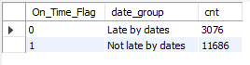

Plant Scorecard (Production, Quality, Downtime and Delivery KPIs)
WITH prod_kpi AS (
SELECT
Plant,
COUNT(*) AS Batches,
SUM(Produced_Quantity) AS Total_Produced,
ROUND(SUM(Produced_Quantity) / SUM(Planned_Quantity) * 100, 2) AS Achievement_Pct,
ROUND(SUM(Rejected_Quantity) / SUM(Produced_Quantity) * 100, 2) AS Rejection_Rate_Pct,
ROUND(SUM(Rework_Quantity) / SUM(Produced_Quantity) * 100, 2) AS Rework_Rate_Pct,
ROUND(SUM(Wastage_Quantity) / SUM(Produced_Quantity) * 100, 2) AS Wastage_Pct,
ROUND(SUM(Batch_Failure_Flag) / COUNT(*) * 100, 2) AS Batch_Failure_Rate_Pct
FROM fact_production
WHERE Qty_Valid = 1
GROUP BY Plant
),
down_kpi AS (
SELECT
Plant,
ROUND(SUM(Downtime_Hours), 2) AS Total_Downtime_Hrs,
ROUND(AVG(Downtime_Hours), 2) AS Avg_Downtime_Per_Batch
FROM fact_production
GROUP BY Plant
),
ord_kpi AS (
SELECT
Plant,
COUNT(*) AS Total_Orders,
ROUND(AVG(CASE WHEN Date_Valid = 1 THEN On_Time_Flag END) * 100, 2) AS On_Time_Pct,
ROUND(AVG(Delay_Days_Clean), 2) AS Avg_Delay_Days,
ROUND(SUM(CASE WHEN Qty_Valid = 1 THEN Shipped_Quantity END)
/ SUM(CASE WHEN Qty_Valid = 1 THEN Ordered_Quantity END) * 100, 2) AS Fulfillment_Pct
FROM fact_orders
GROUP BY Plant
)
SELECT
p.Plant, p.Batches, p.Total_Produced, p.Achievement_Pct,
p.Rejection_Rate_Pct, p.Rework_Rate_Pct, p.Wastage_Pct, p.Batch_Failure_Rate_Pct,
d.Total_Downtime_Hrs, d.Avg_Downtime_Per_Batch,
o.Total_Orders, o.On_Time_Pct, o.Avg_Delay_Days, o.Fulfillment_Pct
FROM prod_kpi p
JOIN down_kpi d ON p.Plant = d.Plant
JOIN ord_kpi o ON p.Plant = o.Plant;

Client-wise Delivery Performance (Fulfillment, On-Time % and Delay)
SELECT
c.Client_Name,
c.Client_Type,
c.Priority_Level,
COUNT(*) AS Total_Orders,
ROUND(SUM(CASE WHEN o.Qty_Valid = 1 THEN o.Shipped_Quantity END)
/ SUM(CASE WHEN o.Qty_Valid = 1 THEN o.Ordered_Quantity END) * 100, 2) AS Fulfillment_Pct,
ROUND(AVG(CASE WHEN o.Date_Valid = 1 THEN o.On_Time_Flag END) * 100, 2) AS On_Time_Pct,
ROUND(AVG(o.Delay_Days_Clean), 2) AS Avg_Delay_Days
FROM fact_orders o
JOIN dim_client c
ON o.Client_ID = c.Client_ID
GROUP BY c.Client_ID, c.Client_Name, c.Client_Type, c.Priority_Level
ORDER BY On_Time_Pct ASC;
