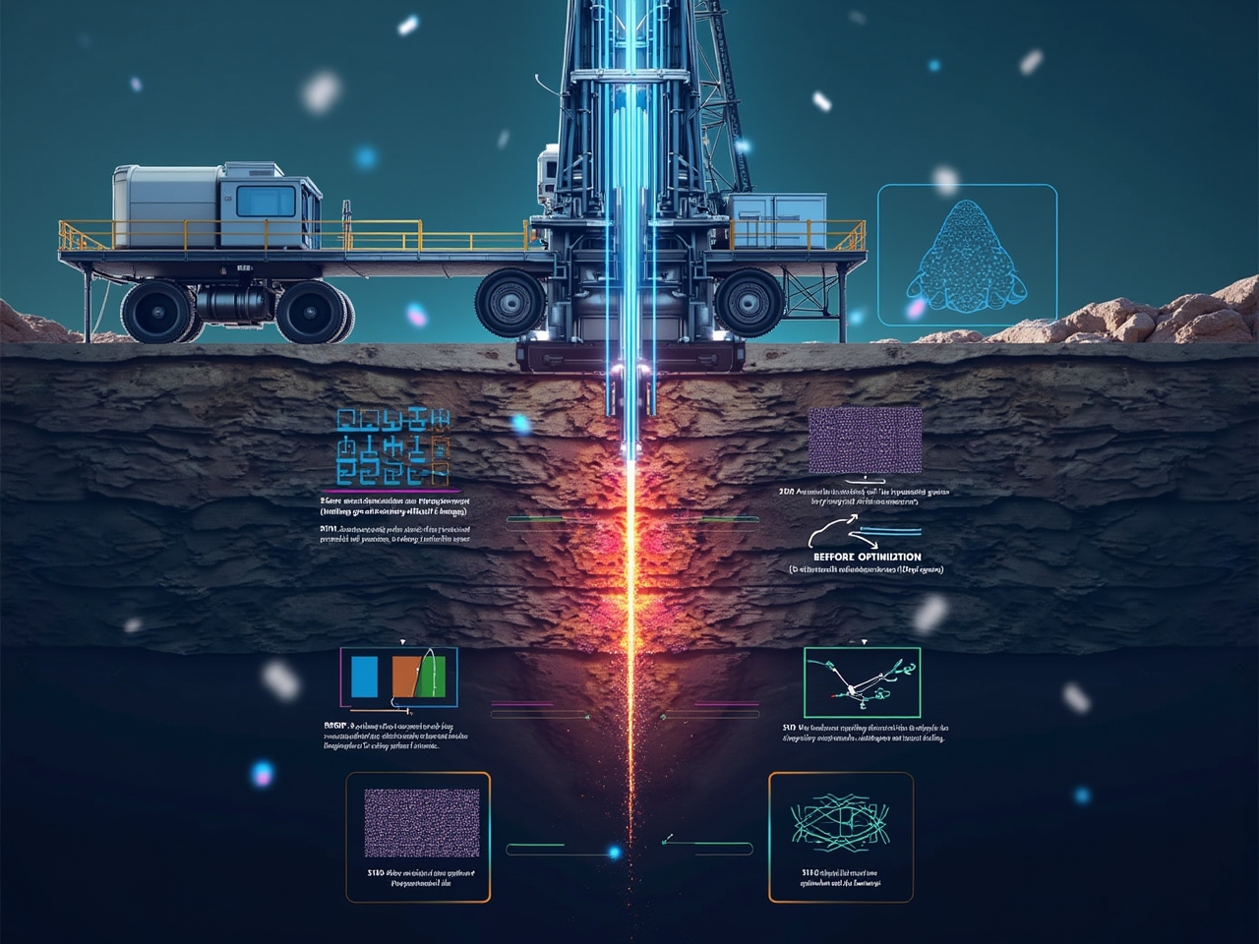

AI-Driven Drilling Optimization Demo Output

1. 1. Generating synthetic drilling data...

Generated 500 data points

1. 2. Training ML models...
2. 3. Setting up parameter optimizer and drilling assistant...
3. 4. Simulating real-time drilling optimization...

Depth: 1865.7 ft, Formation: Dolomite

Current ROP: 14.5 ft/hr

Running parameter optimization...

ML-Optimized Parameters:

* WOB: 30.0 kips
* RPM: 168.0 RPM
* Flow Rate: 860.0 GPM
* Predicted ROP: 135.2 ft/hr
* Bit Failure Probability: 0.36

Getting LLM-enhanced recommendation...

Recommendation:

The machine learning model suggests significant changes to the drilling parameters, which could potentially lead to a substantial improvement in the Rate of Penetration (ROP). Here's why these changes might be effective and the precautions to consider:

### Proposed Changes and Justifications:

1. 1. **Weight on Bit (WOB): 12.1 → 30.0 kips**

* **Justification:** Increasing the WOB can enhance the force applied to the drill bit, improving its cutting efficiency and enabling quicker penetration through the formation.
* **Precautions:**
* **Bit Wear:** A substantial increase in WOB could accelerate bit wear or damage, particularly if the formation is harder or abrasive.
* **Drill String Stress:** Higher WOB can increase stress on the drill string, potentially leading to buckling or fatigue failures. Ensure that the drill string and bottom hole assembly (BHA) are designed to handle the increased load.
* **Vibration:** Monitor for increased vibration, which can lead to mechanical failures or inefficient drilling.

1. 2. **Rotary Speed (RPM): 144.9 → 168.0 RPM**

* **Justification:** Increasing RPM can enhance the bit's ability to cut through the formation, especially with a PDC bit in dolomitic formations, which are typically less abrasive.
* **Precautions:**
* **Heat Generation:** Higher RPM can increase heat generation, potentially leading to bit overheating. This requires effective cooling and lubrication.
* **Vibration and Whirl:** Increased RPM can exacerbate issues like drill string whirl or bit bounce, which should be monitored closely.

1. 3. **Flow Rate: 504.5 → 860.0 GPM**

* **Justification:** A higher flow rate improves cuttings transport from the bit face, reduces bit balling, and cools the bit more effectively, potentially enhancing ROP.
* **Precautions:**
* **Hydraulics:** Ensure that the rig pump capacity and mud system can handle the increased flow rate without exceeding pressure limits.
* **Erosion:** Higher flow rates can cause erosion of the BHA or casing shoe. Monitor for signs of erosion and adjust flow if necessary.

### General Considerations:

* **Formation Characteristics:** The dolomite formation can vary in hardness and abrasiveness. Monitor for changes in formation properties that might affect the optimal parameters.
* **Bit Life and Health:** Regularly inspect the bit for wear and damage, especially under increased WOB and RPM conditions.
* **Data Monitoring:** Continuously monitor key indicators such as ROP, vibration, and bit failure probability to detect any adverse effects early.

By implementing these changes with the outlined precautions, you can potentially achieve the predicted ROP improvement while minimizing risks to equipment and operations.

Depth: 3547.6 ft, Formation: Shale

Current ROP: 34.2 ft/hr

Running parameter optimization...

ML-Optimized Parameters:

* WOB: 25.0 kips
* RPM: 136.0 RPM
* Flow Rate: 1000.0 GPM
* Predicted ROP: 141.2 ft/hr
* Bit Failure Probability: 0.17

Getting LLM-enhanced recommendation...

Recommendation:

The machine learning model suggests adjustments that could potentially lead to a notable improvement in the Rate of Penetration (ROP). Here's the reasoning behind these changes and the precautions necessary when implementing them:

### Proposed Changes and Justifications:

1. 1. **Weight on Bit (WOB): 15.4 → 25.0 kips**

* **Justification:** Increasing the WOB will apply more force to the drill bit, enhancing its penetration capacity into the formation. This is particularly useful in shale, where additional pressure can improve cutting efficiency.
* **Precautions:**
* **Bit Wear and Damage:** Monitor the bit for accelerated wear, which can be exacerbated by higher forces.
* **Drill String Stress:** Ensure that the drill string and bottom hole assembly (BHA) can withstand the increased load to prevent mechanical failures.
* **Vibration:** An increase in WOB can increase vibration levels, which should be continuously monitored.

1. 2. **Rotary Speed (RPM): 192.4 → 136.0 RPM**

* **Justification:** Reducing RPM while increasing WOB may help in stabilizing the bit within the formation, reducing bit whirl and improving cutting efficiency. Lower RPM can also reduce the risk of bit overheating.
* **Precautions:**
* **ROP Dynamics:** Monitor ROP closely to ensure that the decrease in RPM does not adversely affect the expected ROP gain.
* **Vibration Control:** A lower RPM may help reduce vibration, but it’s vital to monitor and ensure that the reduced speed does not lead to inefficient cutting.

1. 3. **Flow Rate: 326.4 → 1000.0 GPM**

* **Justification:** A significant increase in flow rate improves cuttings removal from the wellbore, enhances bit cooling, and reduces the risk of bit balling in shale formations.
* **Precautions:**
* **Hydraulic Constraints:** Check that the rig’s pump and mud systems are capable of handling the increased flow rate without surpassing pressure limits.
* **Erosion and Wear:** Higher flow rates can cause erosion to the BHA, casing, and borehole walls. Monitor for signs of erosion and adjust as necessary.

### General Considerations:

* **Bit Condition and Type:** Ensure that the PDC bit is suitable for the increased WOB and reduced RPM, as different bit designs respond differently to these changes.
* **Formation Properties:** Shale can vary in its response to drilling parameters. Continuously monitor the formation for changes that might necessitate further parameter adjustments.
* **Data Monitoring:** Maintain vigilant monitoring of ROP, vibration levels, and bit health to quickly respond to any unforeseen issues.

By implementing these changes with the outlined precautions, you can aim to achieve the predicted ROP improvement while minimizing the risk of adverse effects on equipment and operations.

Depth: 5218.2 ft, Formation: Dolomite

Current ROP: 6.5 ft/hr

Running parameter optimization...

ML-Optimized Parameters:

* WOB: 30.0 kips
* RPM: 168.0 RPM
* Flow Rate: 860.0 GPM
* Predicted ROP: 137.3 ft/hr
* Bit Failure Probability: 0.45

Getting LLM-enhanced recommendation...

Recommendation:

The machine learning model suggests a set of parameter changes that could lead to a substantial increase in the Rate of Penetration (ROP). Here is an explanation of why these changes would be beneficial and what precautions should be taken:

### Proposed Changes and Justifications:

1. 1. **Weight on Bit (WOB): 7.5 → 30.0 kips**

* **Justification:** Increasing the WOB significantly enhances the amount of force the bit applies to the formation. This can improve penetration efficiency, particularly in harder formations like dolomite by increasing the mechanical energy transferred to the bit.
* **Precautions:**
* **Bit Wear and Damage:** A large increase in WOB can accelerate bit wear or even cause bit damage. Regular inspections of the bit for wear and damage are crucial.
* **Drill String Stress:** Ensure that the drill string and bottom hole assembly (BHA) are structurally capable of handling the increased load to prevent buckling or fatigue failures.
* **Vibration:** Closely monitor vibration levels, as higher WOB can lead to increased vibrations, potentially causing mechanical failures or reducing drilling efficiency.

1. 2. **Rotary Speed (RPM): 180.6 → 168.0 RPM**

* **Justification:** A slight reduction in RPM while increasing WOB can help stabilize the drilling process, reducing bit whirl and improving cutting efficiency. This adjustment can also help manage bit wear and overheating.
* **Precautions:**
* **ROP Dynamics:** Ensure that the reduction in RPM does not negatively impact the drilling efficiency or the expected ROP gain.
* **Vibration Control:** Lower RPM can help reduce vibration but continue to monitor for any unexpected increases in vibration.

1. 3. **Flow Rate: 444.4 → 860.0 GPM**

* **Justification:** Increasing the flow rate significantly enhances cuttings transport from the wellbore, improves bit cooling, and reduces the risk of bit balling. This is especially important in dolomite formations where efficient cuttings removal is critical.
* **Precautions:**
* **Hydraulic System Capacity:** Ensure that the rig’s pump and mud systems can accommodate the increased flow rate without exceeding pressure limitations.
* **Erosion and Wear:** Monitor for any signs of erosion on the BHA, casing, and borehole walls due to the high flow rates.

### General Considerations:

* **Bit Condition:** Regularly check the condition of the diamond bit, as its performance is critical under high WOB and flow rates.
* **Formation Properties:** Dolomite can vary in hardness, so continuous monitoring of formation response to the parameter changes is essential for optimal performance.
* **Data Monitoring:** Maintain vigilant monitoring of key indicators such as ROP, vibration levels, and bit health to quickly respond to any unforeseen issues.

By implementing these changes with the necessary precautions, you can aim to achieve the predicted ROP improvement while minimizing risks to equipment and operations.

1. 5. Generating comprehensive drilling report with LLM...

DRILLING REPORT:

### Daily Drilling Report

**Date:** [Insert Date Here]

**Location:** [Insert Location Here]

**Well Name:** [Insert Well Name Here]

**Report Compiled By:** DrillGPT

#### 1. **Drilling Overview**

* **Current Depth:** 5218.2 ft
* **Formation:** Dolomite
* **Bit Type:** Diamond
* **Bit Hours:** 0.0 hrs

#### 2. **Current Drilling Parameters**

* **Weight on Bit (WOB):** 7.5 kips
* **Rotary Speed (RPM):** 180.6 RPM
* **Flow Rate:** 444.4 GPM

#### 3. **Performance Metrics**

* **Rate of Penetration (ROP):** 6.5 ft/hr
* **Predicted ROP:** 9.5 ft/hr
* **Bit Failure Probability:** 0.06
* **Vibration Level:** 0.46

#### 4. **ML Model Recommendations**

**Parameter Changes:**

* **WOB:** Increase from 7.5 to 30.0 kips
* **RPM:** Reduce from 180.6 to 168.0 RPM
* **Flow Rate:** Increase from 444.4 to 860.0 GPM

**Predicted ROP Improvement:** 130.8 ft/hr

**Justifications:**

* **WOB Increase:** Enhances penetration efficiency by applying more force on the bit.
* **RPM Adjustment:** Reduces bit whirl while maintaining efficient cutting.
* **Flow Rate Increase:** Improves cuttings transport and bit cooling.

**Precautions:**

* Monitor for bit wear and drill string stress.
* Ensure hydraulic capacity and erosion control.
* Continuously monitor vibration levels.

#### 5. **Operational Considerations**

* **Formation Response:** Monitor for changes in formation characteristics that may affect drilling performance.
* **Bit Condition:** Regular inspections are required to assess wear and potential damage.
* **Equipment Monitoring:** Ensure all equipment is operating within design limits to prevent failures.

#### 6. **Health, Safety, and Environment (HSE)**

* No incidents reported today.
* Continue adherence to safety protocols and procedures.
* Ensure all personnel are briefed on current and upcoming operations.

#### 7. **Recommendations and Next Steps**

* Implement the ML model’s recommended parameter changes with outlined precautions.
* Regularly review key performance indicators and adjust parameters as needed.
* Schedule a meeting to discuss further parameter optimization based on real-time data.

**End of Report**

**Note:** This report is based on current data and predictive modeling. Regular updates and monitoring are essential to optimize drilling operations and respond to dynamic conditions.

Demo completed successfully!