DEVELOPMENT OF TUP E – LEARNING WEBSITE

Bañez, Aldwin Joselle S

Boado, Jose Angelo David SG

Embudo, Throy Ross L

Igmasin, Raymund Christian M

Nartea, Emmanuel S

Ramirez, Janine B

Santillan, Raizen Lee L

A Project Proposal Presented to the

Faculty of the College of Science

Technological University of the Philippines

Ayala Blvd., Manila

In Partial Fulfilment of the

Requirements for the Degree

Bachelor of Science in Computer Science

March 2018

**INTRODUCTION**

This project, titled TUP E-Learning Website, is an interactive website exclusively for the Technological University of the Philippines. It aims to create a convenient online learning environment between TUP students and professors. Other universities have their own E-learning website, that provides its’ students with online activities such as quizzes, assignments and projects. E-learning websites also provide students with E-books, modules, and/or lessons. Without having an E-learning website the university will need third party websites to provide for its’ students. Website that will be used as substitute will be not complete as some E-learning website will only provide lessons online and not activities and activities from said third party websites will be not fully official for students and teachers.

The TUP E-Learning Website is intended to initially improve the university’s learning environment by which would address some school-classroom constraints such as inability to access professor’s lecture files, since students need to request it first by which most of the time they forget to.

Moreover, it aims to provide an online learning environment by which professor’s lecture files are available for reading/download all the time for the students. It provides a foundation that facilitates orderly growth for future enhancements.

**STAKEHOLDERS OR USERS**

The following are the target audience of the TUP E – Learning Website:

* **Officially enrolled TUP students.** This website is developed mainly for TUP students for they can use this website as a platform where they can study anytime, anywhere.
* **TUP Professors**. This website is facilitative for TUP Professors for they can use this website in teaching more effectively.

**FUNCTIONAL REQUIREMENTS**

The website will support three types of user privileges: Professor/Instructor, Student and Administrator. Students will have access on student functions, professors/instructors on class management functions and the website administrator would have functions accessing all existing data related to the website, as well as class management functions too with customized properties.

The student should be able to do the following functions:

* Join a class
* Access an existing class
* View lectures/topics
* Take tests/quizzes with given time given to finish
* Participate in discussions via comment section on each topic

The professor should be able to do the following functionalities:

* + Create a class
* Access existing classes made
* Add topics
* Add students to class
* Manage each topic wherein the professor can upload lectures and create tests
* Access Class Settings wherein the professor can customize class preferences, etc.
* View currently online students
* View discussions made by class
* Reply to comments made by students on each topic
* Create polls and initiate discussions through new posts

The administrator should be able to do the following functionalities:

* + Monitor activities and statistics related to the e-learning website
  + Manage student’s or professor’s accounts

**USECASE DIAGRAM**

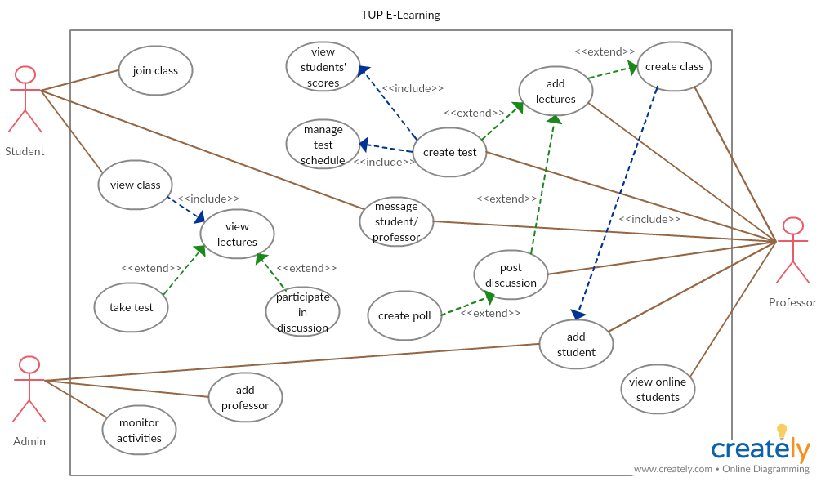

**DATABASE SCHEMA**

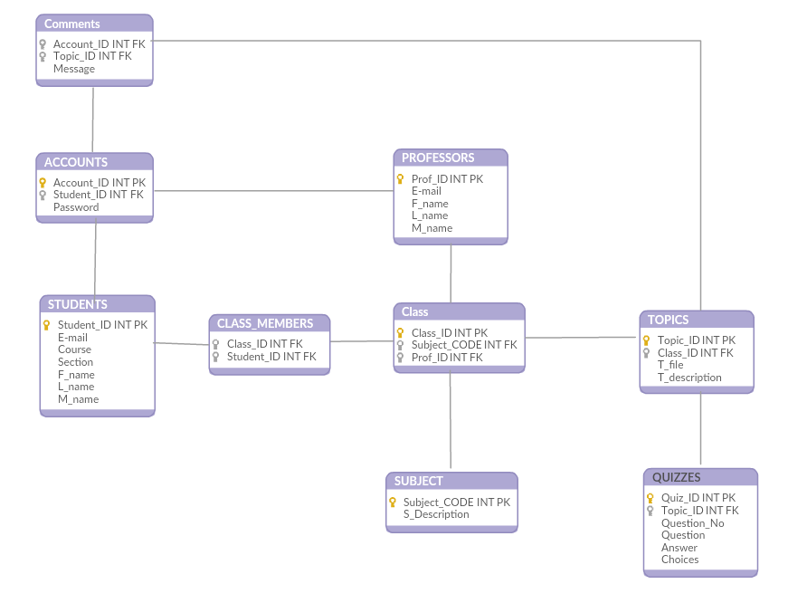

**TESTING PLAN**

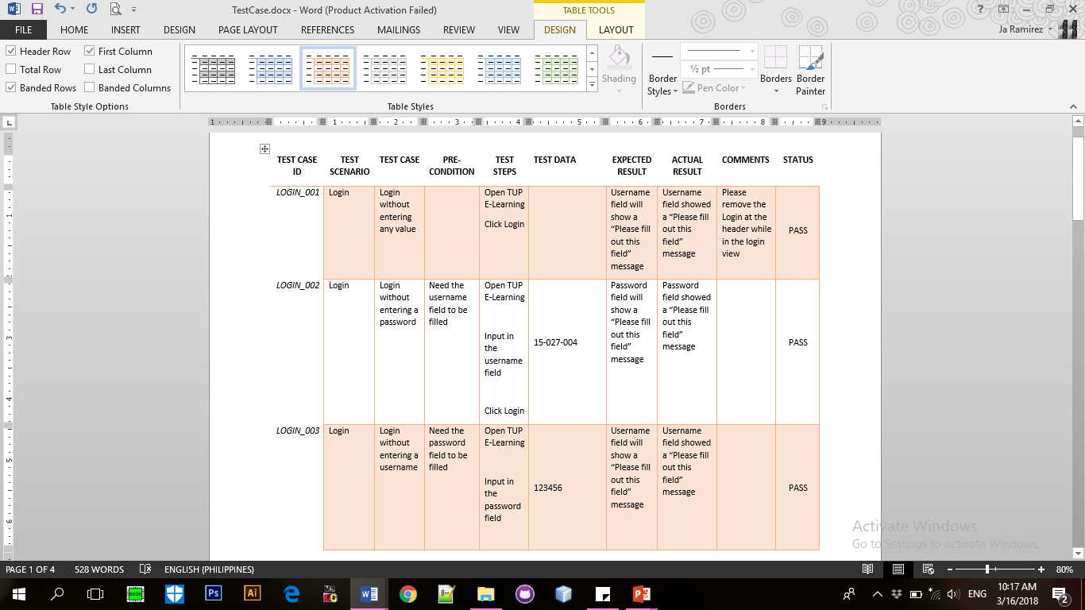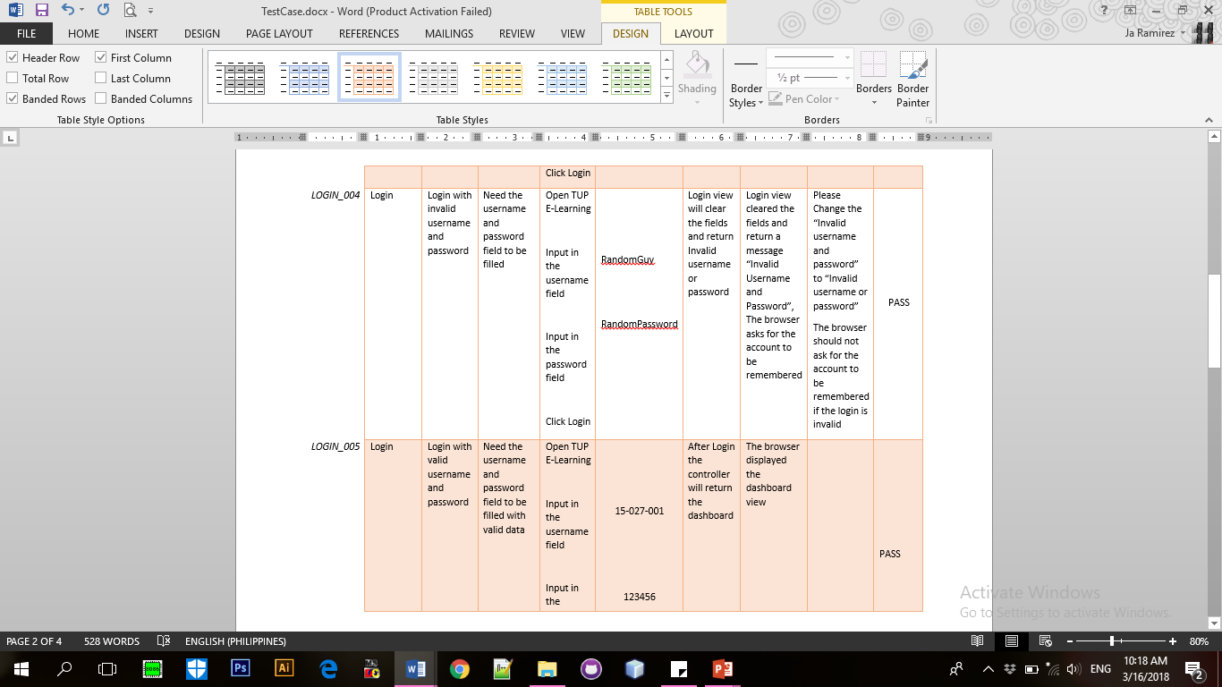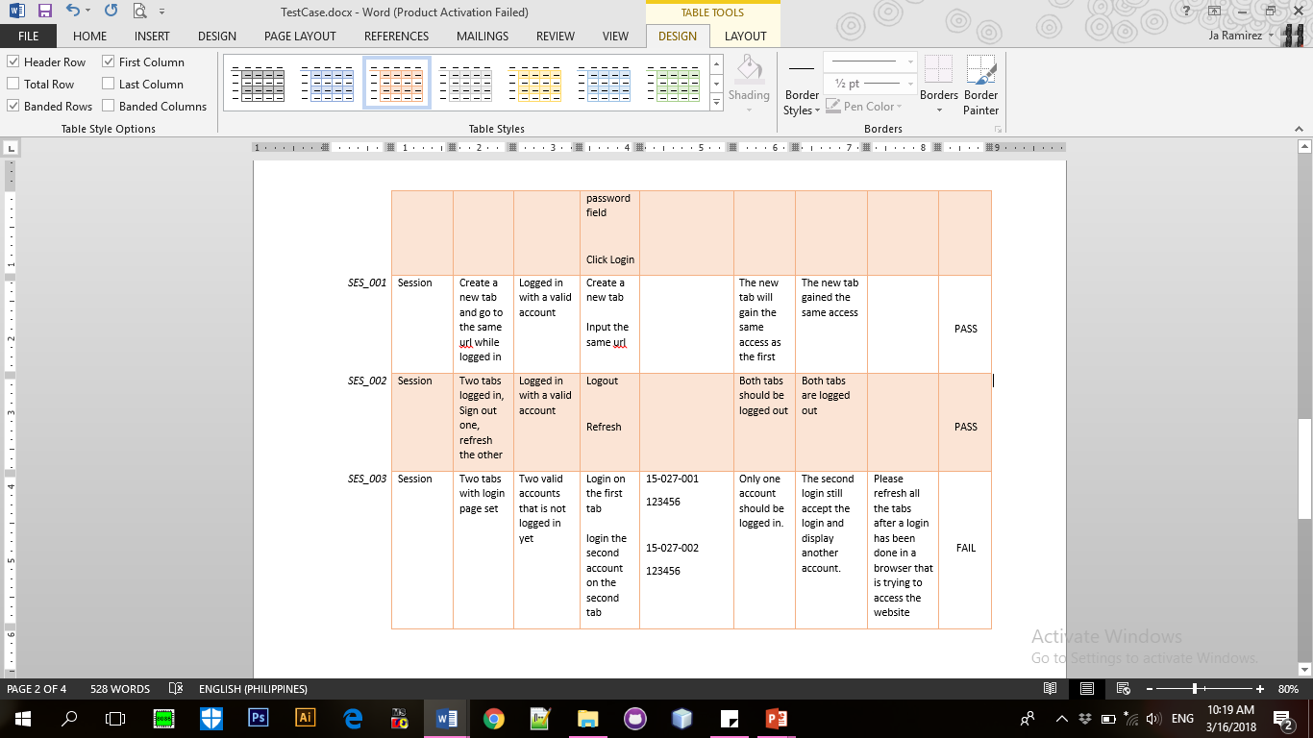**;**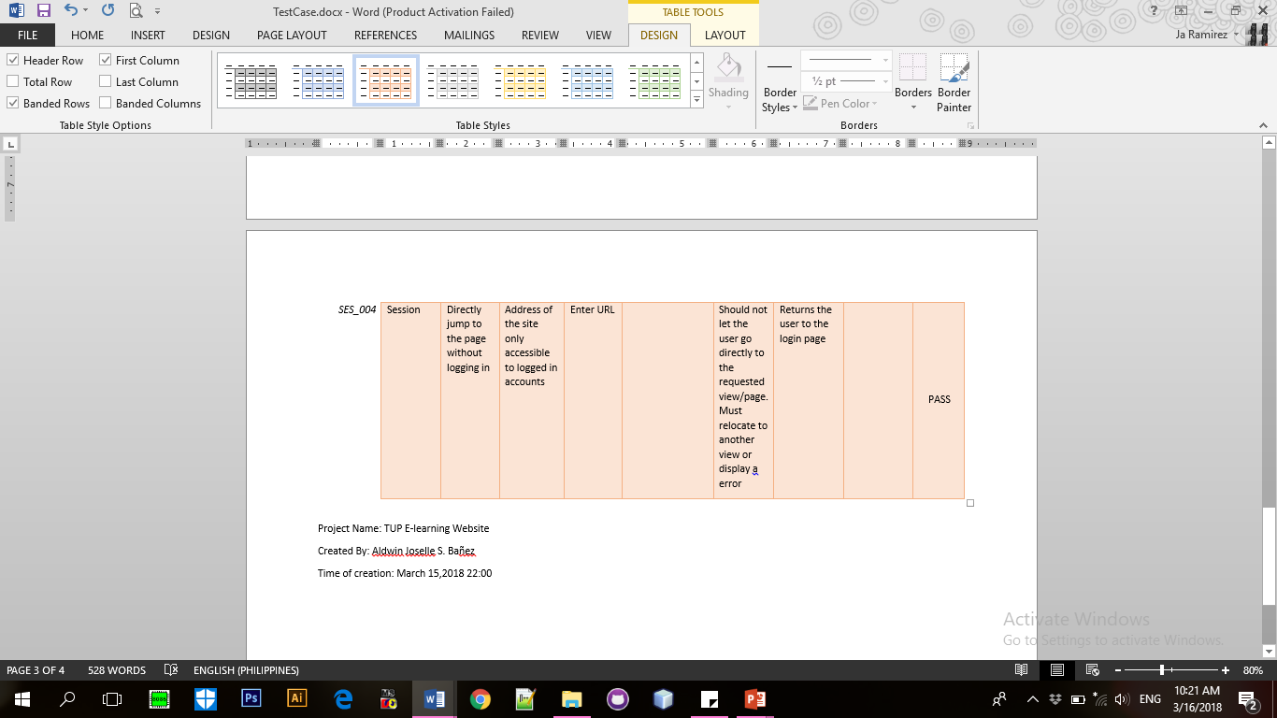

**DEPLOYMENT PLAN******