Resistivity measurement of an Aluminium thin film in linear geometry (2-probe & 4-probe)

Aim
To measure the electrical resistance and determine the resistivity of an Aluminium (Al) thin film using linear 2-probe and 4-probe measurement techniques, and to demonstrate the elimination of contact resistance using the 4-probe method.
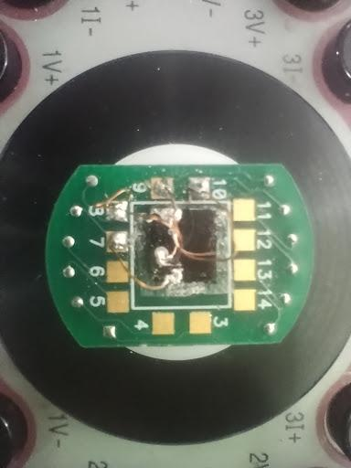
Figure : Aluminium Thin film sample on puck with linear contacts

Apparatus
- Thin Film Sample: Aluminium thin film deposited on an insulating substrate with a linear array of metallic contacts.
- Constant Current Source: Capable of sweeping current in the microampere (μA) to milliampere (mA) range.
- Digital Voltmeter: High input impedance voltmeter (or a combined Source Measure Unit).
- Connecting Leads & Probes: For establishing electrical contact with the film.
- Thickness Measurement Tool: Profilometer or optical interferometer to measure the film thickness (t).

Theory
When measuring the resistance of highly conductive materials like Aluminium thin films, the resistance of the sample is often very small, making the measurement technique critical.
1. The 2-Probe Method:
In a 2-probe setup, the same two probes are used to both inject the current (I) and measure the resulting voltage drop (V). The resistance calculated using Ohm's Law (R = V/I) is the total system resistance, which includes:
R_measured = R_sample + 2R_contact + 2R_lead
Because the contact resistance (R_contact) and lead resistance (R_lead) are often much larger than the resistance of the Al thin film itself, the 2-probe method inherently overestimates the true sample resistance.
2. The 4-Probe Method (Linear Geometry):
To accurately measure the true resistance of the thin film, a linear 4-probe setup is used. Four equally spaced probes are placed in a line across the sample:
- Current (I) is injected through the two outer probes.
- The voltage drop (V) is measured across the two inner probes.
Because the voltmeter has a very high input impedance, practically zero current flows through the inner voltage leads. Consequently, there is no voltage drop across the inner contact points or leads, eliminating R_{contact} and R_{lead} from the measurement. The measured voltage corresponds strictly to the resistance of the thin film material between the inner probes.
Resistivity Calculation:
For a thin film (where thickness t is much less than the probe spacing s) on a semi-infinite plane, the sheet resistance (R_s) and volume resistivity (ρ) are given by:
R_s = (π / ln(2)) * (V / I)
ρ = R_s * t

Procedure

Part A: 2-Probe Measurement
- Connect the current source to two adjacent probes on the sample.
- Connect the voltmeter in parallel across the exact same two probes.
- Sweep the source current across a predefined range (e.g., 2 μA to 10 μA).
- Record the corresponding voltage values.
- Plot a graph of Voltage vs. Current. The slope of this linear fit represents the total resistance (R_2-probe).
Part B: 4-Probe Measurement
- Connect the current source to the outer two probes (Probes 1 and 4).
- Connect the high-impedance voltmeter to the inner two probes (Probes 2 and 3).
- Sweep the source current across a predefined range (e.g., 1 mA to 5 mA).
- Record the corresponding voltage values across the inner probes.
- Plot a graph of Voltage vs. Current. The slope of this linear fit represents the true sample resistance (R = V/I).
- Calculate the sheet resistance (R_s) using the geometric correction factor π/ln(2).
- Multiply by the film thickness (t) to find the final resistivity (ρ).

Observations & Calculations

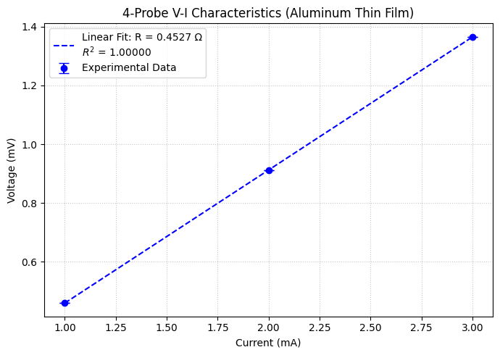
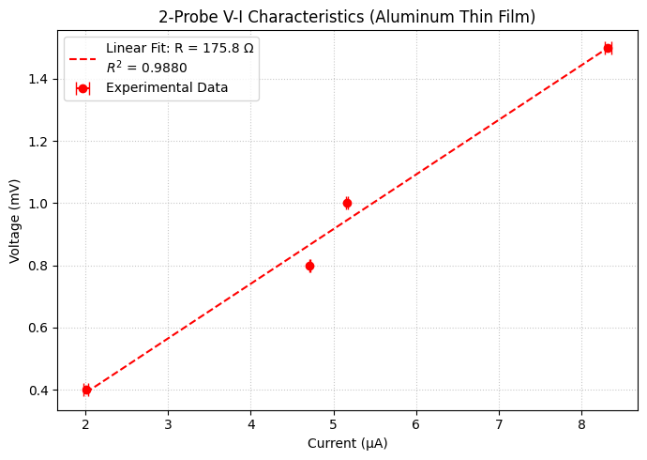

Figure : Plots summarising the resistivity calculations

2-Probe Data
V_2p (mV) | I_2p (μA) | I_err_2p (μA)
0.4 | 2.006 | 0.024
0.8 | 4.713 | 0.007
1.0 | 5.161 | 0.007
1.5 | 8.316 | 0.041
4-Probe Data
I_4p (mA) | V_4p (mV) | V_err_4p (mV)
1 | 0.4596 | 0.0002
2 | 0.9118 | 0.0002
3 | 1.3650 | 0.0007

Results

2-probe
- Calculated Resistance (R): 175.81 Ω
- Standard Error: ±13.68 Ω
4-probe
- Calculated Resistance (R): 0.4527 Ω
- Standard Error: ±0.0003 Ω

Precautions

- Gentle Contact: Probes should be placed gently on the thin film to avoid scratching, puncturing, or damaging the Aluminium layer.
- Ohmic Contacts: Ensure the contacts are ohmic (linear V-I relationship) rather than rectifying. The V-I plots should be perfectly straight lines.
- Thermal Effects: Keep the current relatively low to prevent Joule heating, which alters the intrinsic resistivity of the Aluminium.
- Edge Effects: For the standard geometric correction factor (π/ln(2)) to be valid, the probes must be placed near the center of the sample, far away from the sample boundaries.

