Van der Pauw Resistivity Measurements of Aluminium Thin Films

Aim
To determine the electrical resistivity (ρ) of an aluminium thin film using the van der Pauw measurement method.

Apparatus
- 4200A-SCS Parameter Analyzer
- Four Source Measure Unit (SMU) instruments
- Four preamplifiers (for high resistance material testing, if applicable)
- Low noise shielded triax cables
- Aluminium thin film sample

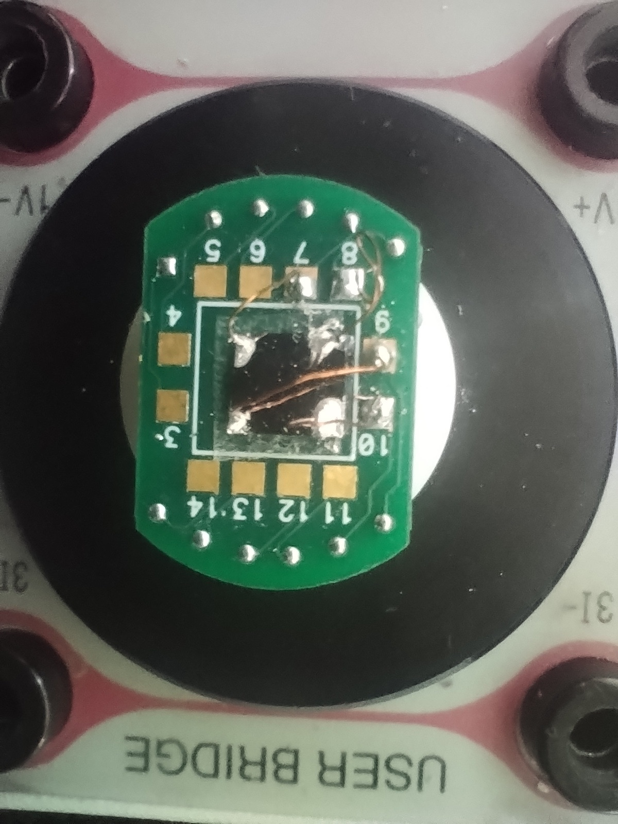
Figure : Aluminium Thin film sample on puck with Van der Pauw contacts

Theory
The van der Pauw method is used to determine the resistivity of a flat, arbitrarily shaped sample of uniform thickness by applying current and measuring voltage through four small contacts located on the sample's circumference. Because the specific geometric spacing of the contacts does not impact the result, this method is highly effective for thin films.
Resistivity is derived from a total of eight voltage measurements taken around the periphery of the sample. These measurements are used to calculate two volume resistivities, ρ_{A} and ρ_{B}:
ρ_{A} = π / ln 2 · f_{A} t_{s} · (V₁ - V₂ + V₃ - V₄) / 4I
ρ_{B} = π / ln 2 · f_{B} t_{s} · (V₅ - V₆ + V₇ - V₈) / 4I
Where:
- t_{s} is the aluminium sample thickness in cm.
- I is the current applied through the sample in amperes.
- V₁ through V₈ represent the specific voltages measured by the voltmeters.
- f_{A} and f_{B} are geometrical factors based on the sample's symmetry (f_{A} = f_{B} = 1 for perfect symmetry).
Once ρ_{A} and ρ_{B} are calculated, the average volume resistivity (ρ_{AVG}) is determined using the equation:
ρ_{AVG} = (ρ_{A} + ρ_{B}) / 2

Procedure

- Sample Connection: Connect each of the four terminals on the aluminium sample to one of the four SMU instruments using shielded triax cables to minimize electrostatic interference. Ensure the inner shield of the triax connector is used as a guard to reduce leakage current.
- Initial Configuration: Configure the instruments for the first test setup. Set one SMU as the current source (using a two-point current list sweep), two SMUs as high-impedance voltmeters (testing with 0 A current), and the fourth SMU as common.
- Current Adjustment: Adjust the source current magnitude based on the film's expected resistance. The applied current should be kept low enough that the resulting voltage difference does not exceed approximately 25 mV to prevent carrier injection from skewing the measurement.
- Measurement & Offset Correction: Source both the positive and negative values of the test current and measure the corresponding voltages. Average these voltage measurements for both polarities to successfully correct for internal voltage offsets or thermoelectric voltages in the circuit.
- Permutation: Rotate the SMU measurement setup around the sample (changing which terminals act as the source, voltmeters, and common) and repeat the procedure until four complete test configurations have been executed.
- Data Processing: Extract the averaged voltage differences. When plugging the measured voltage outputs into the final calculations, verify that all values are explicitly recorded in Volts (rather than millivolts) to ensure the standard units are maintained across the equations.
- Calculation: Use the recorded test current, the measured voltage sums, and the known thickness of the aluminium film to calculate $\rho_A$ and $\rho_B$, and subsequently find the overall $\rho_{AVG}$.

Observations & Calculations

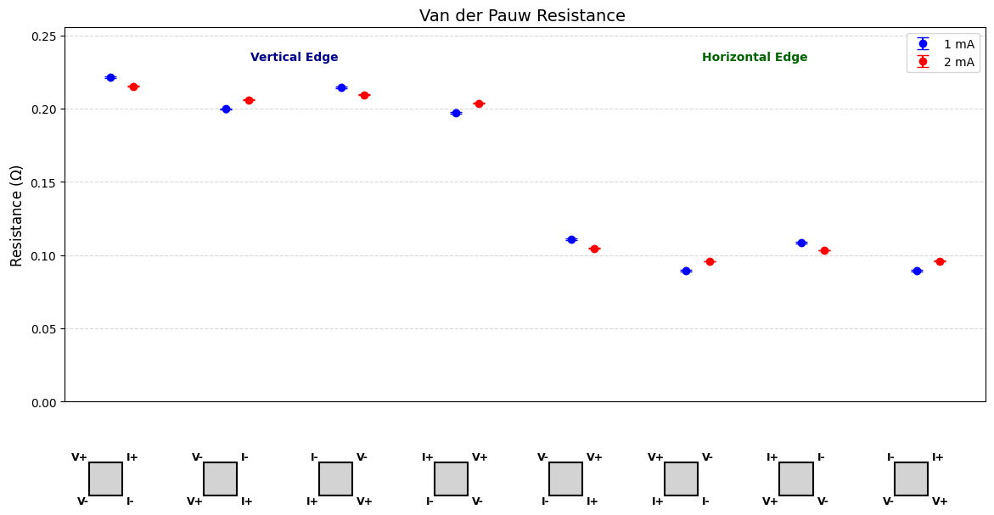
Figure : Calculated Resistances for each configuration

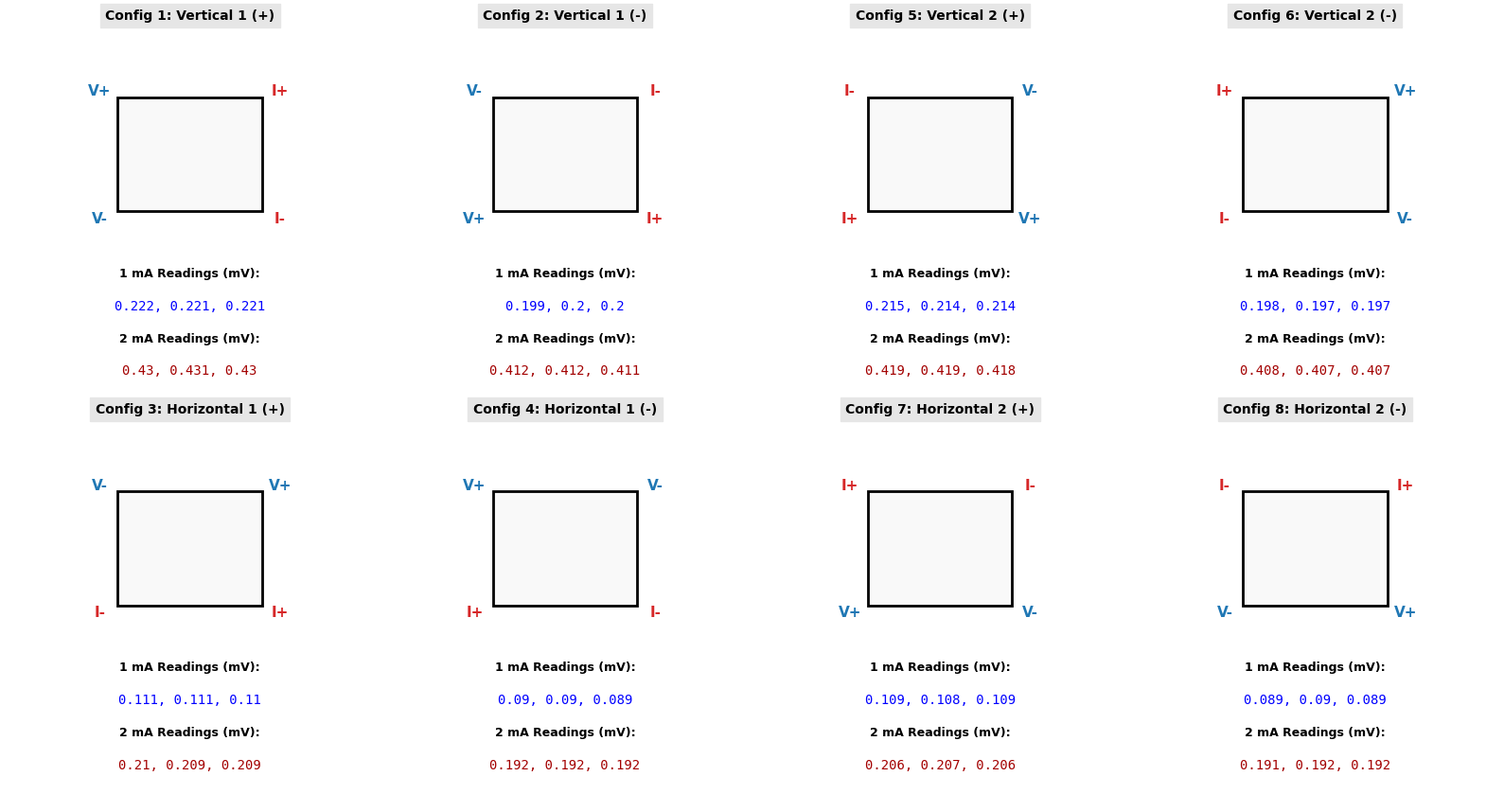 Figure : Raw data for each configuration

Results

Using the raw data from all 8 configurations at both 1mA and 2mA source currents:
- Average Vertical Resistance (RA​): 0.20833±0.00161 Ω
- Average Horizontal Resistance (RB​): 0.09973±0.00161 Ω
By solving the Van der Pauw equation and applying standard error propagation:
- Calculated Sheet Resistance (Rs​): 0.6670 Ω/sq
- Calculated Error: ±0.0056 Ω/sq

Precautions

- Contact Placement: Ensure the four ohmic contacts are as small as possible and placed exactly on the edges or corners of the sample.
- Current Limits: Keep the applied test current low enough that the measured voltage difference does not exceed approximately 25 mV. Higher currents can cause sample heating and carrier injection, which skew results.
- Offset Cancellation: Always measure the voltage using both positive and negative current polarities, then average the readings to cancel out internal thermoelectric voltage offsets.
- Shielding and Guarding: Use low-noise shielded triax cables and ensure the circuit is properly guarded to minimize electrostatic interference and leakage current.
- Light Isolation: Keep the sample in a completely dark environment during testing to prevent light from generating false photoconductive currents.

