Ambient Resistance vs. Temperature experiment for a Germanium sample using a four-probe configuration.

Aim
To study the temperature dependence of the resistivity of a Germanium (Ge) semiconductor from ambient (room) temperature to elevated temperatures (e.g., 315 K to 375 K) using the Four-Probe method, and to determine the energy bandgap (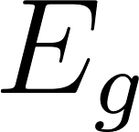) of the material.

Apparatus
- Four-Probe Arrangement: A probe head containing four collinear, equally spaced, spring-loaded contacts.
- Sample: An intrinsic or lightly doped Germanium (Ge) crystal slice.
- Heating Setup: A small electric oven or heater with an embedded sample mount.
- Temperature Sensor: A thermometer, thermocouple, or RTD placed in close proximity to the sample.
- Measurement Electronics: A highly stable constant current power supply and a high-impedance digital millivoltmeter.

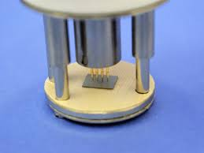
Figure : Spring loaded 3 probe contacts with Ge sample

Theory
In an intrinsic semiconductor like Germanium, electrical conductivity is governed by the thermal excitation of electrons from the valence band to the conduction band. The carrier concentration  (and hole concentration ) depends exponentially on temperature :
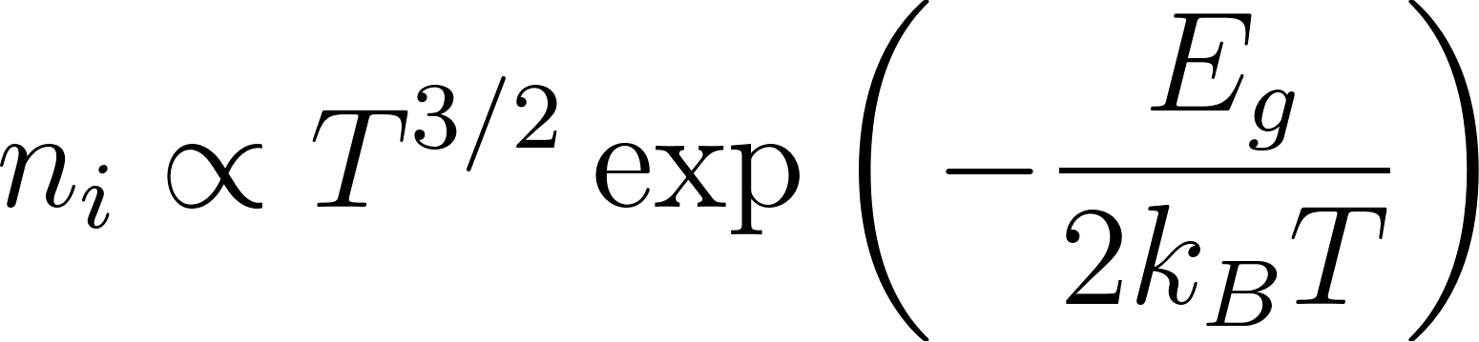
Since electrical resistivity  is inversely proportional to carrier concentration, the temperature dependence of the resistivity can be approximated as:
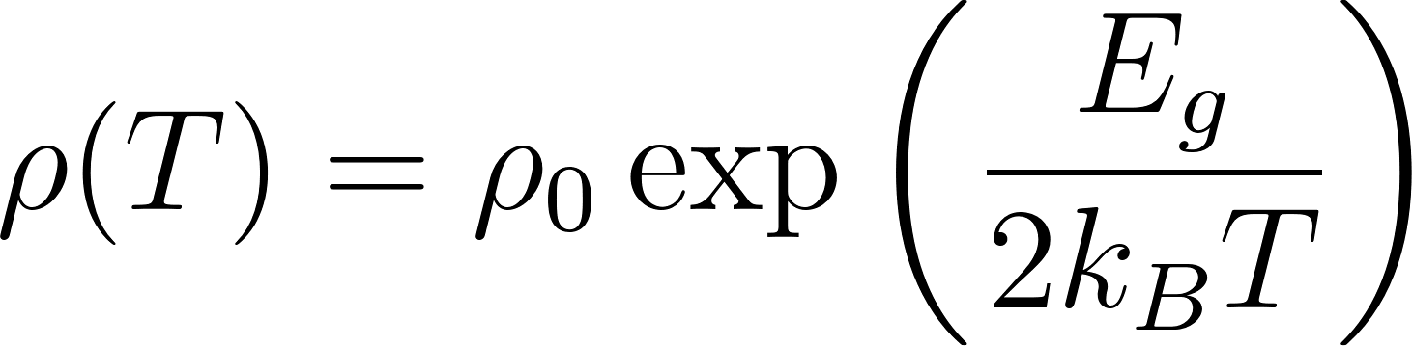
Where:
-  = Bandgap energy of the semiconductor (in eV)
- 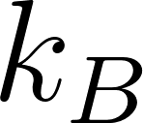 = Boltzmann constant (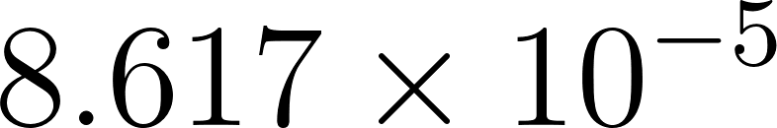 eV/K)
-  = Absolute temperature in Kelvin
Taking the natural logarithm of both sides yields a linear equation (the Arrhenius equation):
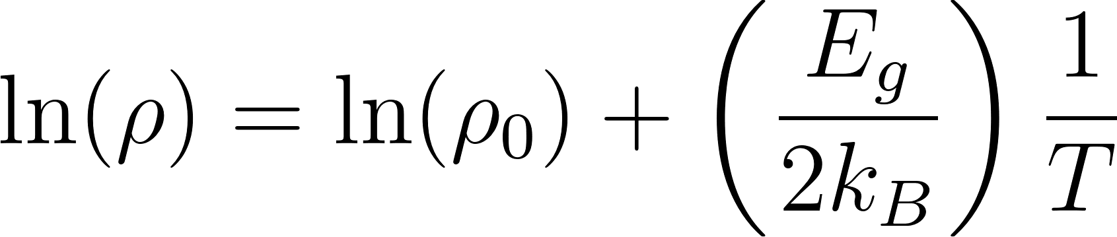
By plotting 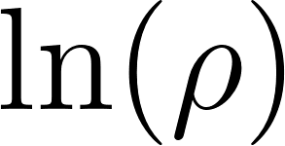 versus 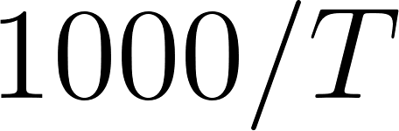, the intrinsic conduction region will form a straight line. The slope  of this line allows us to calculate the bandgap:
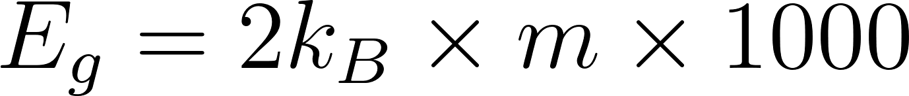
Four-Probe Calculation:
The Four-Probe method eliminates contact resistance errors. A constant current  is passed through the two outer probes, and the voltage drop  is measured across the two inner probes. For a sample resting on a non-conducting base, the resistivity  is calculated as:
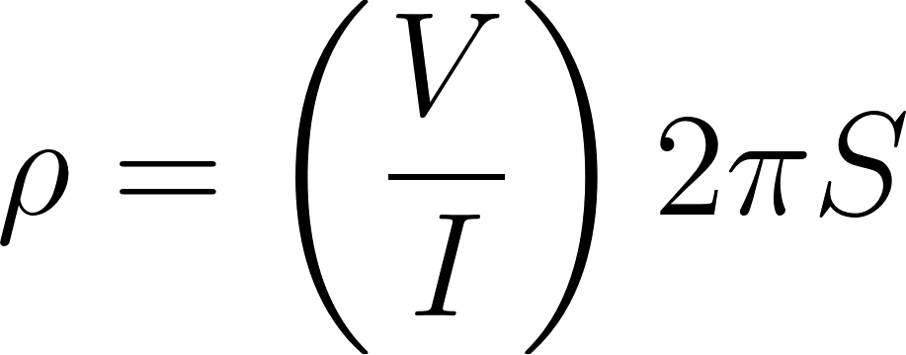
(Where  is the distance between the probes. As seen in your notebook,  is typically around 2 mm).

Procedure
- Mounting: Place the Germanium sample on the baseplate of the four-probe arrangement. Gently lower the probe head until all four pins make firm, collinear contact with the crystal.
- Wiring: Connect the outer two probes to the constant current source. Connect the inner two probes to the digital millivoltmeter.
- Initial Setup: Insert the probe assembly into the oven. Turn on the constant current source and set it to a low, stable value (e.g., 10 mA). Record the initial voltage and ambient temperature.
- Heating Cycle: Turn on the oven. As the temperature rises, record the voltage readings at regular temperature intervals (e.g., every 5 K from 315 K up to roughly 375 K). This will be your "Heating" data set.
- Cooling Cycle: Once the maximum desired temperature is reached, turn off the oven. As the sample cools down to room temperature, record the voltage readings at the exact same temperature intervals. This will be your "Cooling" data set.
- Data Processing: Average the voltage readings from the heating and cooling cycles to minimize thermal lag errors. Convert the millivolt readings to Volts, calculate the resistivity  at each temperature step, and generate your Arrhenius plot to find .

Observations

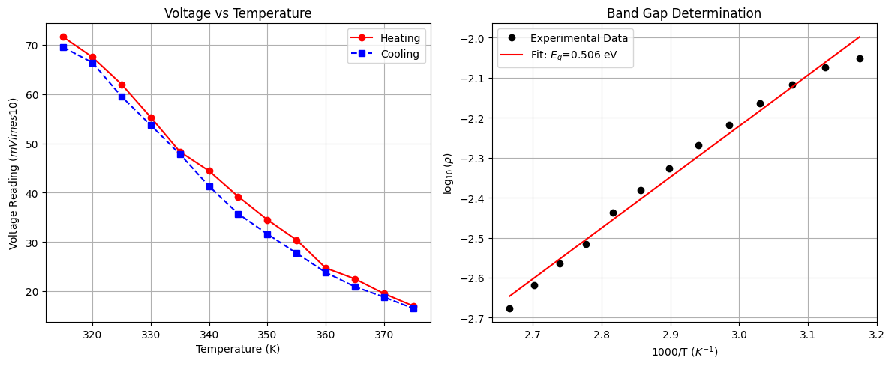
Data in CSV format is available at : https://github.com/jajapuramshivasai/Advanced-Experimental-Techniques-in-Quantum-Materials/

Observations

Energy Band Gap (Eg): 0.5062 eV
Error : σ(Eg)=0.0239 eV

Experimental Data
Temperature (K) | Voltage (Heating, V_up) (mV) | Voltage (Cooling, V_down) (mV)
315 | 71.6 | 69.5
320 | 67.5 | 66.4
325 | 62.0 | 59.5
330 | 55.3 | 53.7
335 | 48.3 | 47.8
340 | 44.4 | 41.3
345 | 39.2 | 35.7
350 | 34.5 | 31.6
355 | 30.4 | 27.7
360 | 24.7 | 23.8
365 | 22.5 | 20.9
370 | 19.5 | 18.8
375 | 17.0 | 16.5

Constants & Physics Parameters:
- Constant Current (): 10 mA (set to a stable value of 0.010 A).
- Probe Spacing (): 2 mm (0.002 m) between the collinear contacts.
- Boltzmann Constant ():  eV/K.

Results

Calculated Energy Band Gap (Eg): 0.5062 eV

standard error σ(E_g)= 0.0145 eV

Precautions

- Constant Current Limit: The supplied current must be kept constant and strictly low (e.g., around 10 mA) throughout the experiment. High current will cause internal Joule heating, making the sample's actual temperature significantly higher than the measured ambient temperature.
- Thermal Equilibrium: Heating and cooling should be done gradually. Rapid temperature changes create a thermal gradient between the Ge crystal and the temperature sensor, leading to mismatched readings and hysteresis between the heating and cooling curves.
- Temperature Bounds: Do not heat the Germanium sample excessively (typically avoid going above 150°C to 200°C) as the contacts can degrade or the sample can suffer thermal damage.
- Probe Placement: Ensure the probes are exactly collinear and placed centrally on the sample to strictly satisfy the theoretical 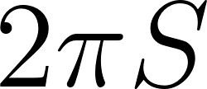 geometry conditions.

