Cryogenic Resistance vs. Temperature experiment for a Germanium sample using a two-probe configuration.

Aim
To study the variation of resistance of a Germanium (Ge) semiconductor sample with temperature at cryogenic levels using a two-probe configuration, and to determine the bandgap energy (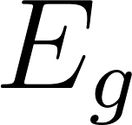) of the material.

Apparatus
- Cryostat: Liquid nitrogen (LN) cryostat or Closed-Cycle Refrigerator (CCR) capable of reaching ~77 K.
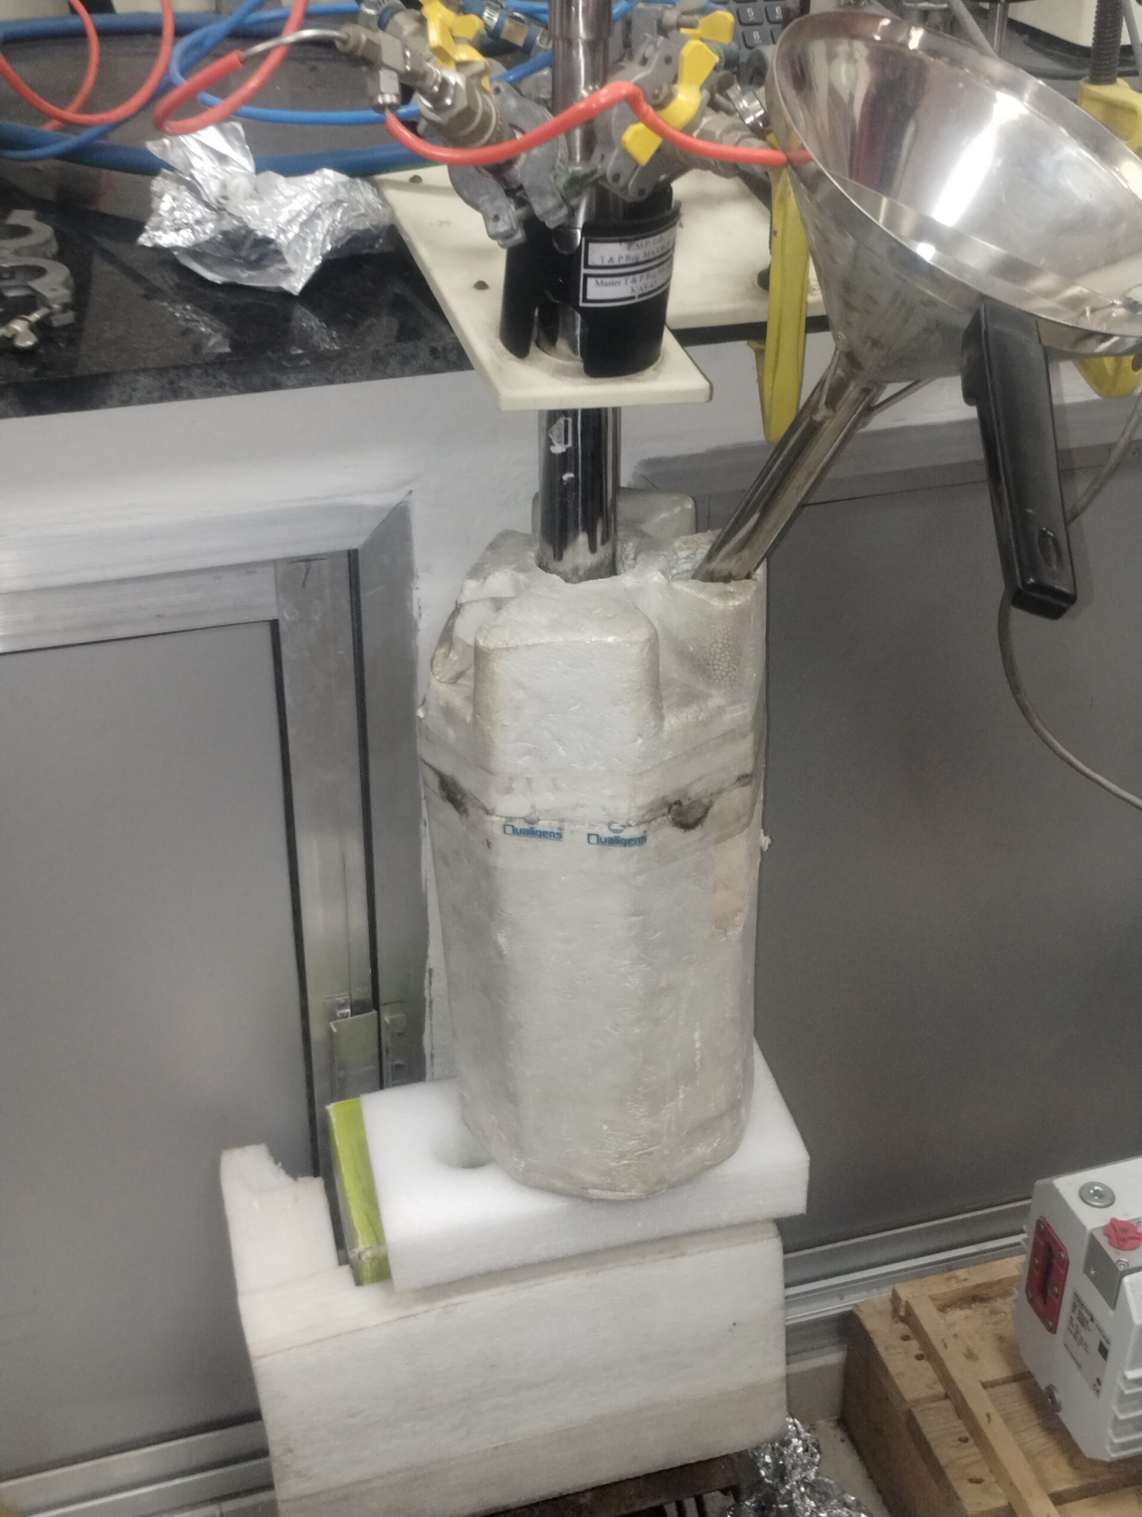
Figure : Liquid Nitrogen cooled cryostat
- Sample: Intrinsic or lightly doped Germanium (Ge) crystal.
- Vacuum System: Rotary backing pump and turbomolecular pump (to evacuate the cryostat and prevent ice formation/thermal leaks).
- Temperature Controller: e.g., Lakeshore temperature controller with a calibrated sensor (Silicon diode or PT100) and embedded sample heater.
- Measurement Electronics: Constant current source and a highly sensitive digital multimeter (or a Source Measure Unit like a Keithley 2400).
- Connections: Two-probe wiring (typically phosphor bronze or manganin wire to minimize thermal conductivity).ß

Theory
Germanium is a semiconductor with a narrow bandgap (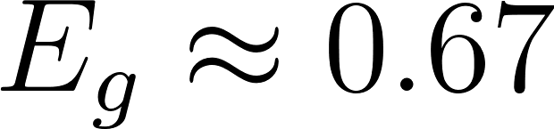 eV at room temperature). The electrical conductivity  (and consequently the resistance ) of a semiconductor is highly dependent on temperature.
At higher temperatures (the intrinsic region), thermal excitation promotes electrons from the valence band across the bandgap into the conduction band. The carrier concentration $n$ in the intrinsic region varies exponentially with temperature according to the Maxwell-Boltzmann approximation:
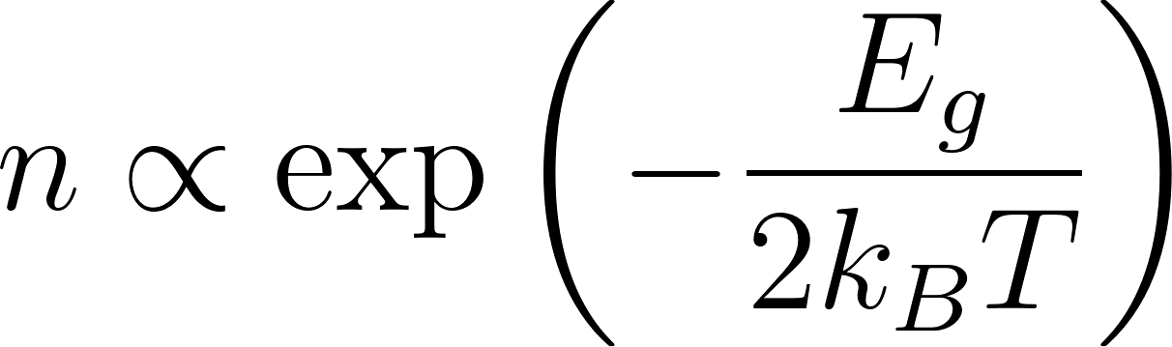
Where:
-  = Bandgap energy of Germanium
- 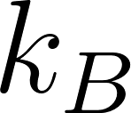 = Boltzmann constant (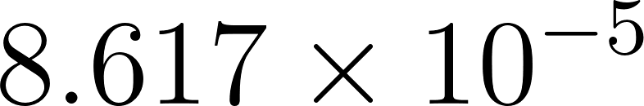 eV/K)
-  = Absolute temperature in Kelvin
Since resistance  is inversely proportional to carrier concentration (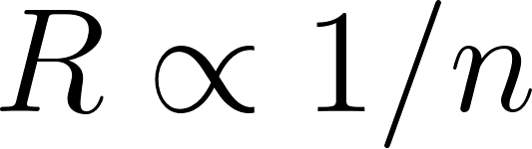), the temperature dependence of the resistance is given by:
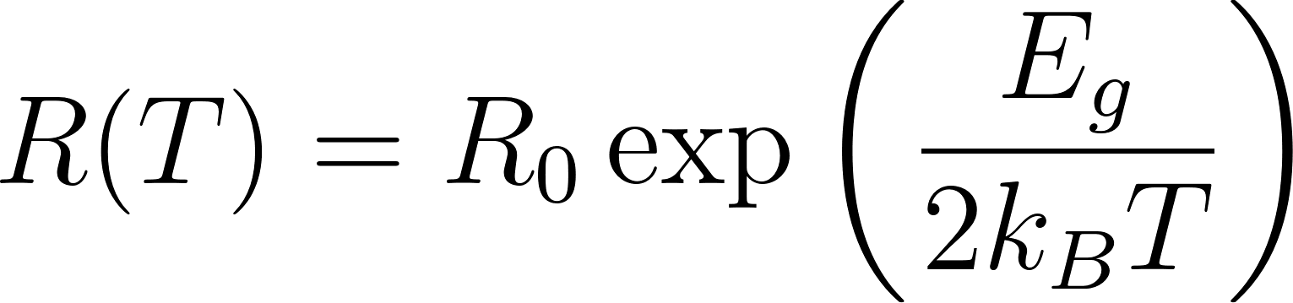
Taking the natural logarithm on both sides yields the Arrhenius equation:
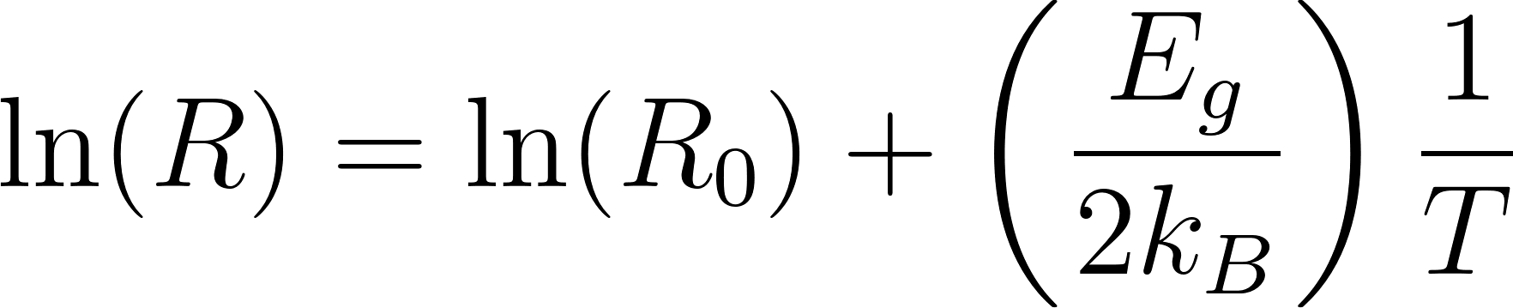
By plotting 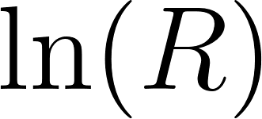 on the y-axis against 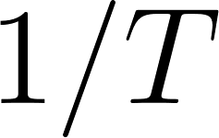 on the x-axis, the intrinsic region will appear as a straight line. The slope  of this line is used to extract the bandgap:
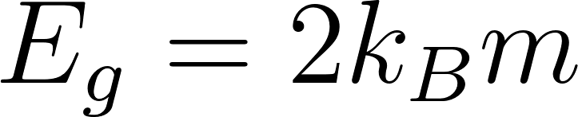
Note on Two-Probe Configuration:
In a two-probe measurement, the multimeter measures the total resistance of the circuit:
While standard precise resistivity measurements utilize a four-probe setup to eliminate contact resistance (), a two-probe setup is sufficient for demonstrating the exponential 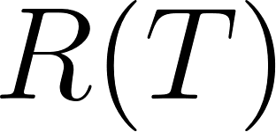 trend, provided that at cryogenic temperatures, the sample resistance 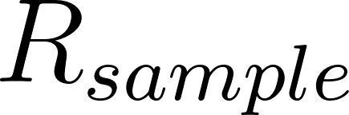 becomes exponentially large and dominates the parasitic contact and lead resistances.

Procedure
- Sample Mounting: Mount the Ge sample securely on the copper cold finger of the cryostat using a thermally conductive but electrically insulating varnish (e.g., GE Varnish or Apiezon N grease).
- Wiring: Connect the two electrical leads to the Ge sample using silver paste or indium solder. Connect the other ends to the measurement feedthroughs.
- Evacuation: Turn on the rotary and turbo pumps to evacuate the cryostat chamber down to a high vacuum (typically 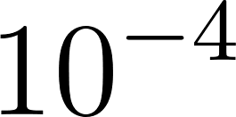 to 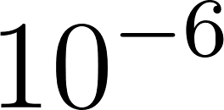 mbar). This is critical to prevent water vapor from condensing on the sample and causing electrical shorting or thermal leaks.
- Cooling: Introduce liquid nitrogen into the cryostat (or turn on the CCR compressor) to cool the sample down to the base temperature (~77 K). Allow the system to reach thermal equilibrium.
- Measurement Setup: Configure the SMU to output a small constant current (e.g., 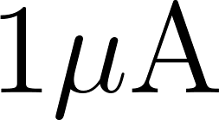 to 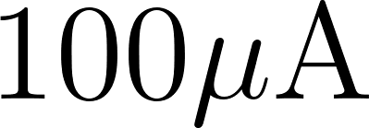). Ensure the current is kept low enough to prevent Joule heating (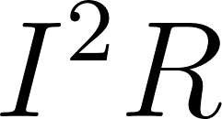) within the highly resistive sample at low temperatures.
- Data Acquisition: Program the temperature controller to slowly warm the sample at a steady sweep rate (e.g., 1 K/min to 2 K/min).
- Recording: Record the Voltage drop () and Temperature () at regular intervals (e.g., every 2 K). Calculate 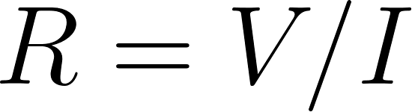. Continue recording until the sample reaches room temperature (~300 K).

Observation and Calculations

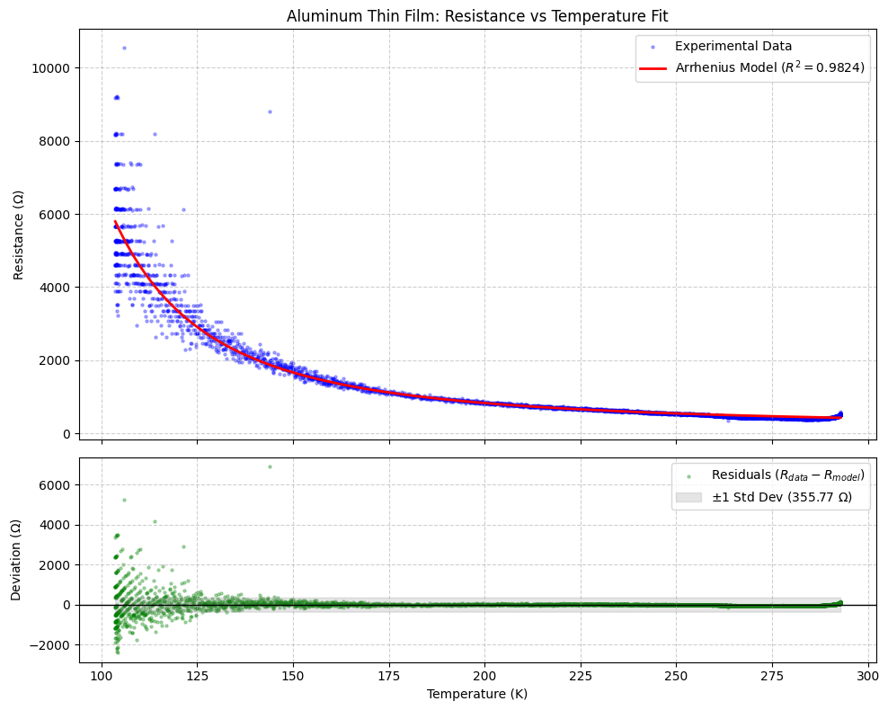

Data in CSV format is available at : https://github.com/jajapuramshivasai/Advanced-Experimental-Techniques-in-Quantum-Materials/

Results

Model Fit : R² = 0.971723
Estimated bandgap Eg ≈ 2*ΔE: 0.7246 eV

Precautions & Sources of Error
- Joule Heating: At cryogenic temperatures (e.g.,  K), Germanium becomes highly resistive. Applying too high a measurement current will cause local  heating, raising the sample temperature above the sensor temperature reading.
- Contact Freezing: The silver paste or solder contacts may become non-ohmic (forming Schottky barriers) at liquid nitrogen temperatures. This is the primary fundamental limitation of the two-probe setup in this experiment.
- Thermal Lag: If the heating/cooling rate is too fast, the temperature sensor (usually mounted on the copper block) and the Ge sample will not be in thermal equilibrium, leading to hysteresis in the  vs.  curve.
- Light Exposure: Ge is a photosensitive material. The cryostat optical windows (if any) must be blocked to prevent electron-hole pair generation via the photoelectric effect, which would artificially lower the resistance.

