Resistivity measurement of a Germanium sample via 2-probe

Aim
To measure the electrical resistance and calculate the resistivity of a semiconductor sample (Germanium - Ge) using a linear two-probe measurement method.

Apparatus Required
- Semiconductor sample (Ge)
- Constant voltage/current source
- Digital voltmeter
- Sensitive ammeter / electrometer
- Two electrical probes with positioning assembly
- Connecting wires
- Vernier caliper or micrometer (for measuring sample dimensions)

Theory
The two-probe method is a direct way to measure the electrical resistance of a sample. Two probes are placed linearly along the sample separated by a distance L. A known voltage (V) is applied across the probes, and the resulting current (I) flowing through the sample is measured.
The resistance ($R$) of the sample is calculated using Ohm's Law:
R = V / I
Once the resistance is found, the electrical resistivity (ρ) of the material can be calculated using the geometric dimensions of the sample:
ρ = (R · A) / L
Where:
- A is the cross-sectional area of the sample (A = length × width).
- L is the distance between the two probes.

Procedure
- Setup: Mount the Germanium sample securely on the testing block. Carefully lower the two electrical probes onto the surface of the sample in a linear arrangement.
- Connections: Connect the probes in series with the ammeter and parallel with the voltmeter to your power source.
- Measurement: Apply a small initial voltage (e.g., 1 mV) across the probes.
- Recording: Record the applied voltage and the corresponding current reading. Take multiple current readings for the same voltage to find an average and minimize random error.
- Iteration: Increase the voltage incrementally (up to 4 mV as per the data) and record the corresponding current for each step.
- Dimensions: Measure the distance between the probes ($L$), as well as the length ($l$) and width ($b$) of the sample to calculate its cross-sectional area.

Observations

Table: Two-Probe V-I Measurements

Voltage (V) | Current (I) | Avg. Current (Iavg​) | Resistance (R=V/Iavg​)
1 mV | 1.88, 1.87, 1.88 μA | 1.876 μA | 533.04 Ω
2 mV | 3.68, 3.67, 3.68 μA | 3.676 μA | 544.04 Ω
3 mV | 5.47, 5.48, 5.48 μA | 5.476 μA | 547.84 Ω
4 mV | 7.28, 7.28, 7.27 μA | 7.276 μA | 549.75 Ω

Calculations & Results

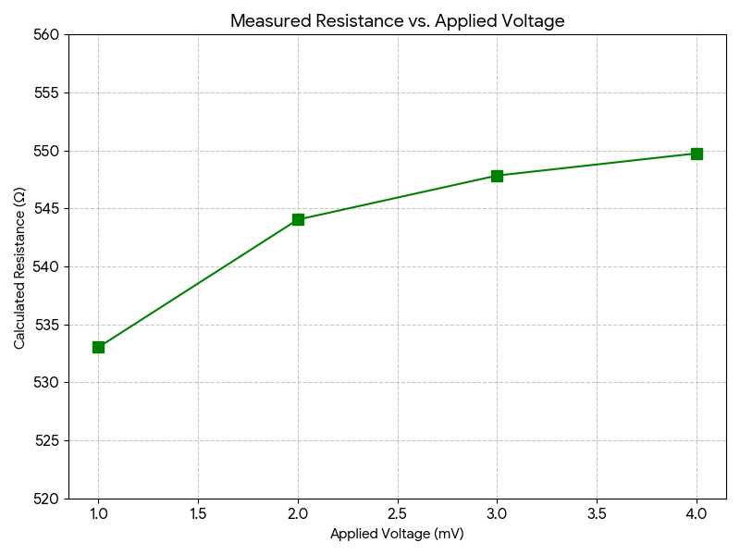
Figure : Mean Resistance vs applied Voltage

1. Average Resistance (Ravg)
Using the first three calculated resistances from your table to find the mean resistance of the sample:
Ravg = (533.04 + 544.04 + 547.84) / 3 = 1624.94 / 3 = 541.65 Ω
2. Sample Dimensions
- Distance between probes (L): 3.55 mm + 2.5 mm = 6.05 mm = 6.05 × 10⁻³ m
- Sample Length (l): 0.95 cm
- Sample Width (b): 0.90 cm
- Cross-sectional Area (A): l × b = 0.95 cm × 0.90 cm = 0.855 cm²
  - Converting Area to standard SI units (m²): 0.855 × 10⁻⁴ m²
3. Resistivity (ρ)
Using the formula ρ = (R · A) / L:
ρ = [541.65 Ω × (0.855 × 10⁻⁴ m²)] / (6.05 × 10⁻³ m)
ρ = 0.046311 / 0.00605 Ω·m
ρ ≈ 7.65 Ω·m

Precautions
- Contact Resistance: Ensure the electrical probes are making firm, clean contact with the semiconductor surface to minimize the effect of contact resistance, which is the primary source of error in a two-probe setup.
- Joule Heating: Keep the applied voltage and resulting current low (in the mV and μA range, as done in this experiment). High currents can cause localized heating (Joule heating) in the semiconductor, which will artificially lower its resistance and skew the results.
- Mechanical Damage: Lower the probes onto the Germanium sample gently to avoid scratching or cracking the brittle crystal surface.
- Alignment: Ensure the probes are aligned perfectly straight along the linear axis of the sample for an accurate measurement of the length (L).

