Hall Effect and Magnetoresistance Measurement of an Aluminum H-Bar

Aim
To measure the Hall resistance (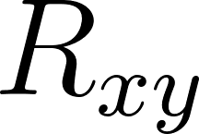) and longitudinal magnetoresistance (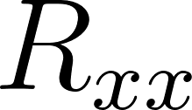) of an Aluminum (Al) thin film at 300 K using an applied magnetic field sweep up to 1 T (10,000 Oe).

Apparatus & Setup
Based on standard transport measurement protocols and the physical layout of your experiment:
- Sample: Aluminum thin film, patterned into an H-bar geometry via lithography and Thermal Vacuum Deposition (TVD).
- Mounting: Resistivity/Hall measurement puck (configured for standard cryostat or PPMS insertion).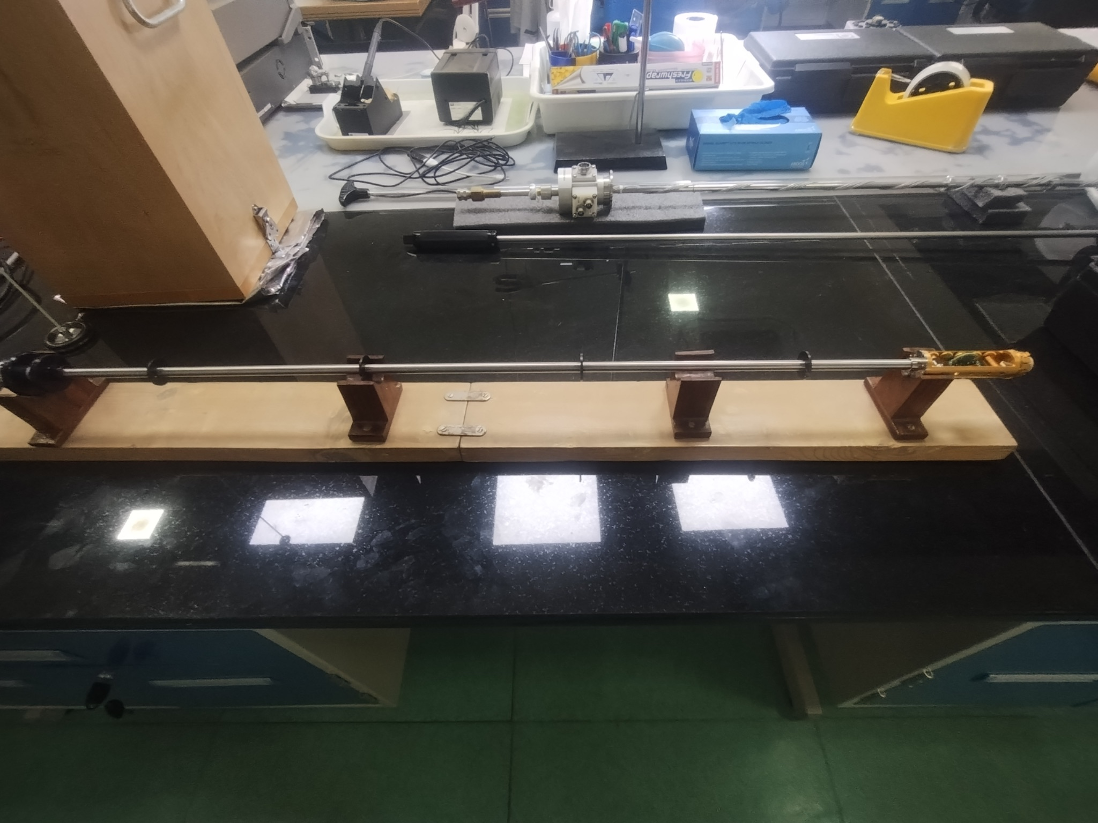
Figure : insertion rod assembly
- Electrical Connections: Fine wire bonds connecting the H-bar pads to the puck's macroscopic terminal pins.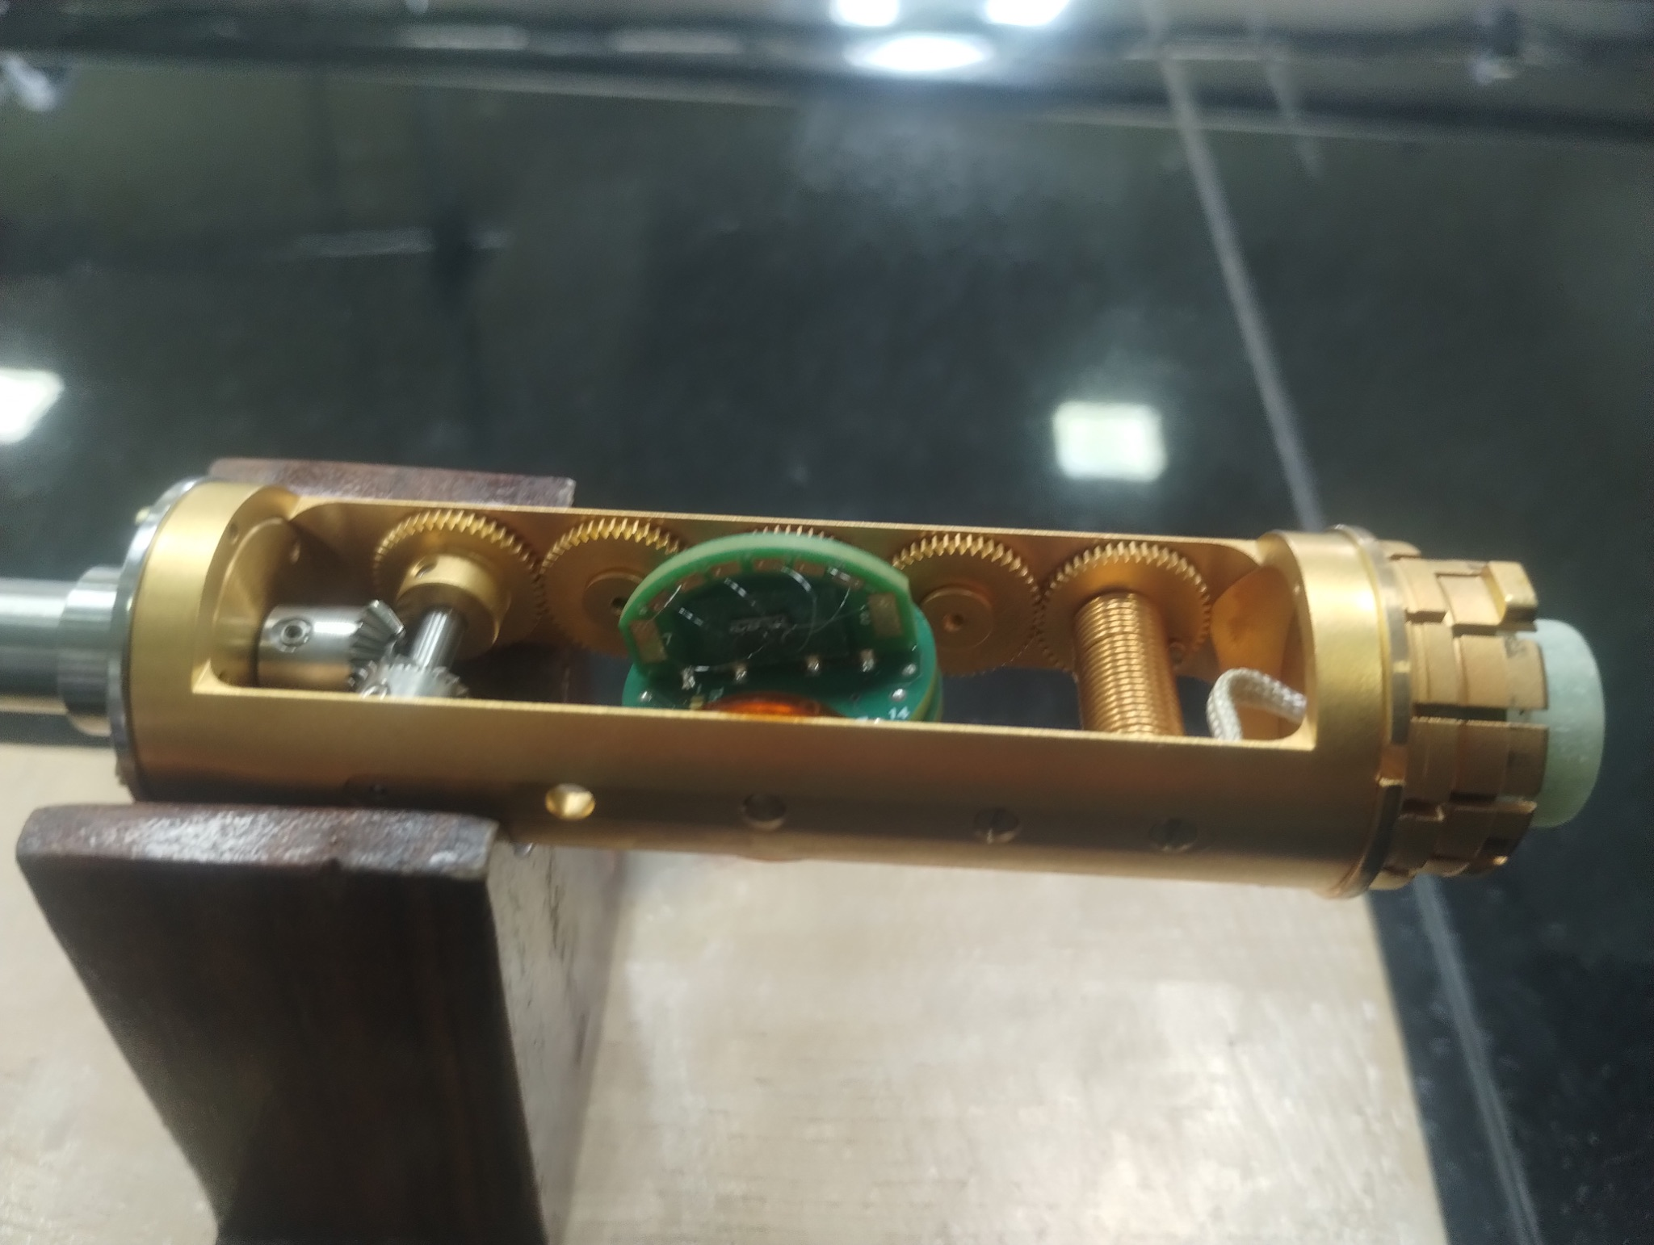
Figure : insertion rod puck mount

- Measurement Electronics: * AC Current Source (supplying 1 mA).
  - Lock-in Amplifier (for high-precision phase-sensitive detection of micro-volt signals, isolating the fundamental harmonic and rejecting noise).
- Magnet System: Electromagnet capable of sweeping fields precisely between +10,000 Oe and -10,000 Oe.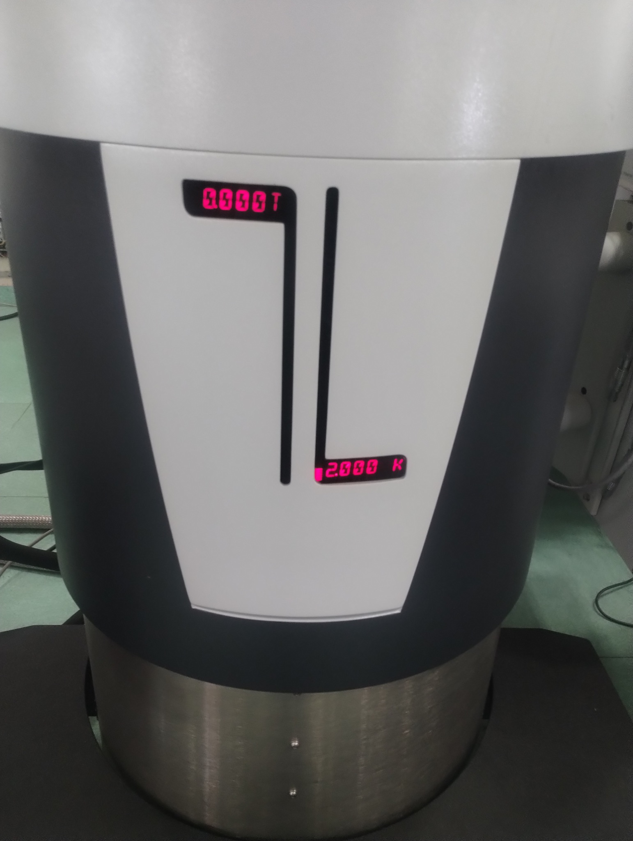
Figure : DynaCool PPMS (Physical Properties Measurement System)

Theory
When a current  flows through a conducting strip of thickness  in the presence of a perpendicular magnetic field , the charge carriers experience a Lorentz force:

This force deflects the carriers to one side of the sample, creating a transverse electric field until the resulting electrostatic force exactly balances the Lorentz force.

3.1 The Hall Coefficient and Carrier Concentration
The accumulation of charge results in a measurable transverse voltage, the Hall Voltage (). For a simple single-band metal, the Hall resistance is perfectly linear with respect to the applied magnetic field:
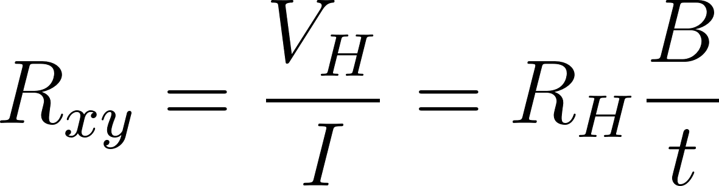
Where 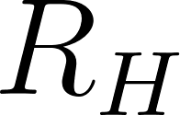 is the Hall coefficient. By measuring the slope of  versus , we can extract . The Hall coefficient is fundamentally linked to the carrier concentration () and the charge of the carriers (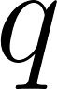):
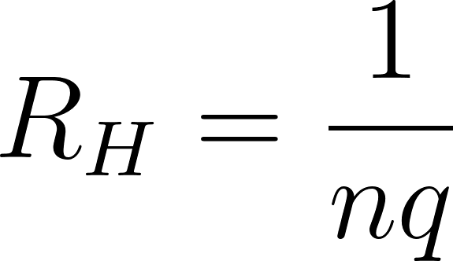
- A negative slope (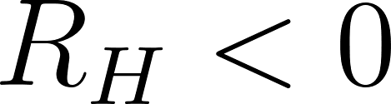) indicates electron-dominated transport.
- A positive slope (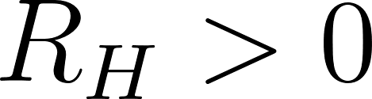) indicates hole-dominated transport.

3.2 Parasitic Voltage and Symmetrization
In a physical H-bar device, it is impossible to align the transverse voltage contacts perfectly. Consequently, the measured voltage contains both the true Hall signal and a parasitic longitudinal voltage drop (from the standard resistance of the material):
Because the Hall effect is an odd (anti-symmetric) function of the magnetic field and magnetoresistance is an even (symmetric) function, they can be mathematically isolated by sweeping the field in both directions:
- Hall Resistance: 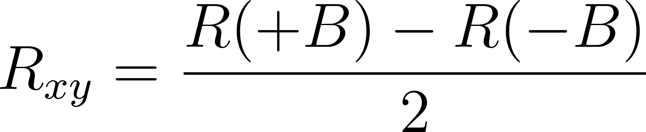
- Magnetoresistance: 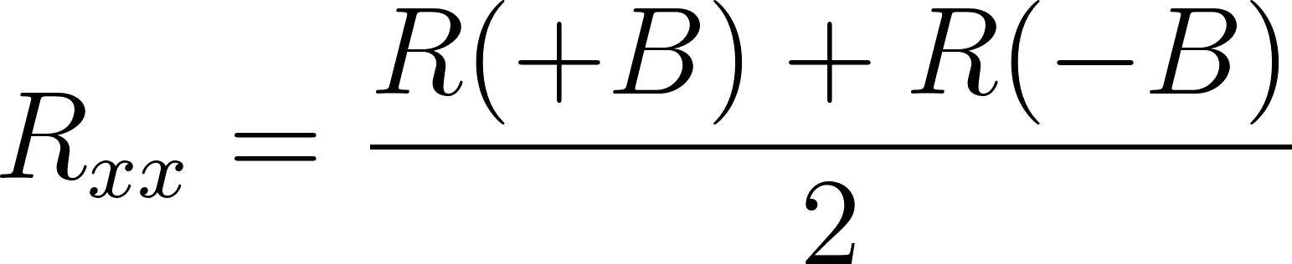

Procedure
- Sample Preparation: Following TVD synthesis and lithographic patterning, clean the Aluminum H-bar sample.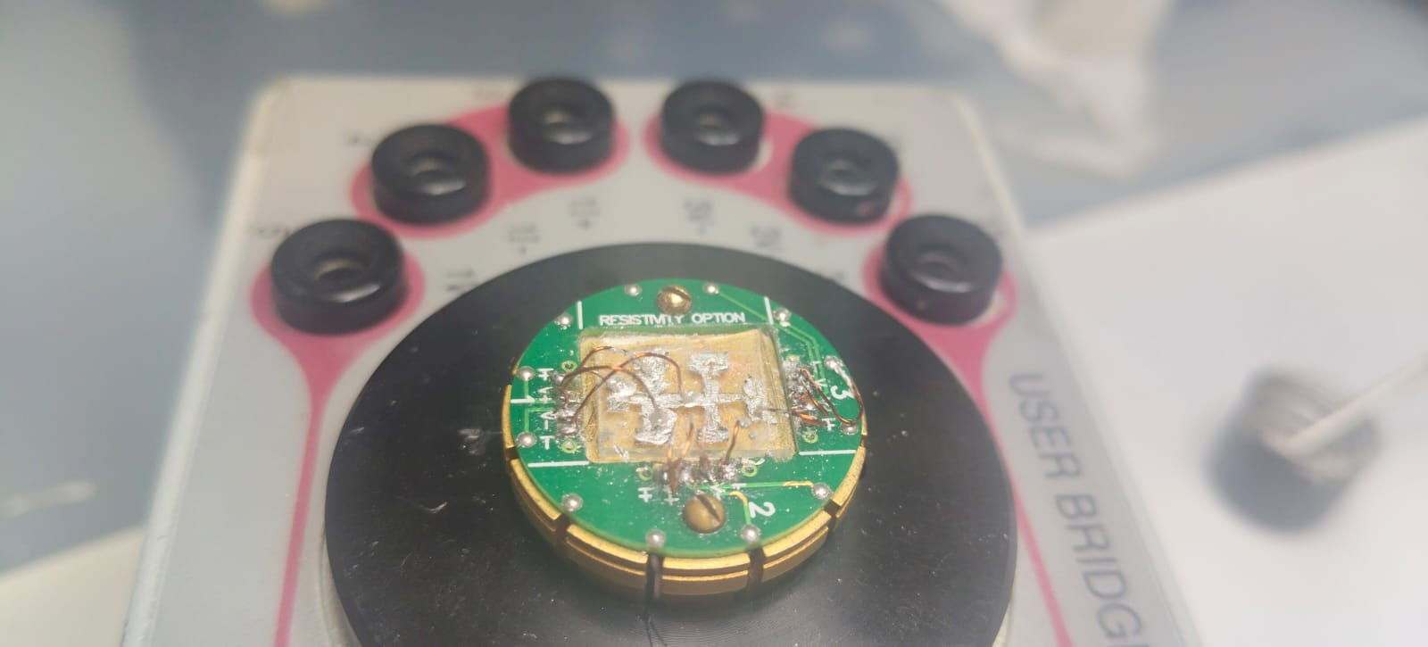
Figure : Hall Bar mounted on puck

- Mounting & Wire Bonding: Secure the sample to the measurement puck. Using a wire bonder, make four-terminal connections:
  - Drive a constant current $I$ along the main longitudinal channel.
  - Connect Channel 1 (Ch1) across two opposite arms of the H-bar to measure the transverse Hall voltage ().
  - Connect Channel 2 (Ch2) across two adjacent arms on the same side to measure the longitudinal voltage () if direct MR measurement is desired.
- Initialization: Insert the puck into the measurement chamber and stabilize the temperature at 300 K.
- Measurement Parameters: Set the lock-in amplifier to supply a 1 mA AC excitation current.
- Field Sweeping: * Sweep the magnetic field from +10,000 Oe to -10,000 Oe (Sweep Down), recording the field, resistance, phase angle, and standard deviation at specified intervals.
  - Sweep the magnetic field back from -10,000 Oe to +10,000 Oe (Sweep Up) to check for magnetic hysteresis or instrument drift.
- Data Extraction: Export the data files for computational analysis to separate  and  using the parity formulas described in the theory section.

Observations
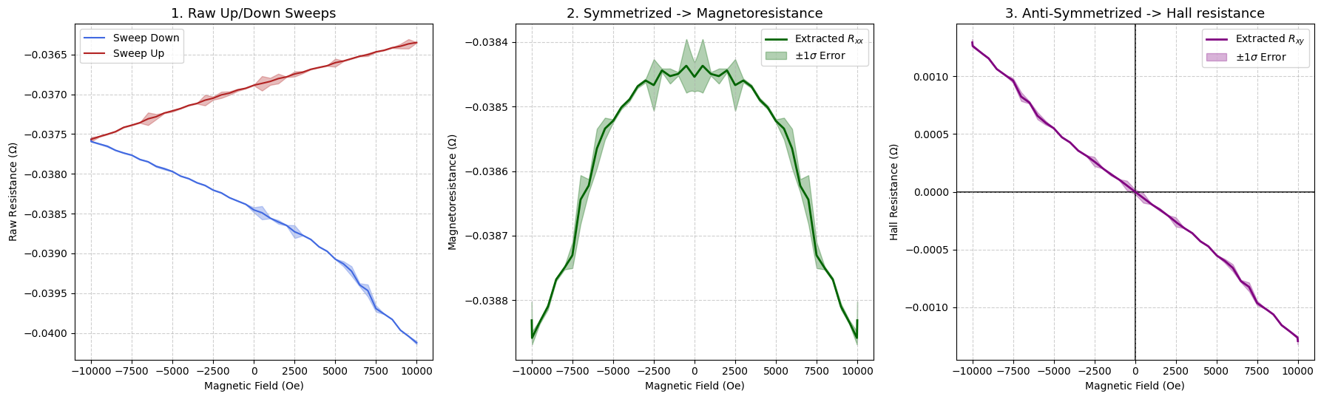

Figure : Plots summarising the observed data

Data in CSV format is available at : https://github.com/jajapuramshivasai/Advanced-Experimental-Techniques-in-Quantum-Materials/

Results

Average Magnetoresistance: 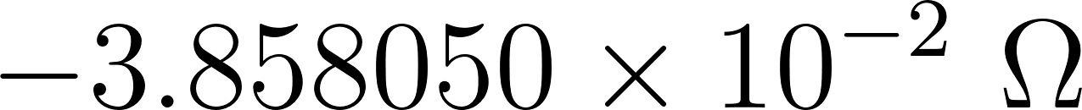
Net MR Error: 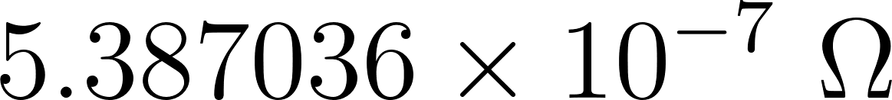
Note : here Magento resistance proportional to applied field squared so its value is not of main interest
Extracted Hall Slope (): 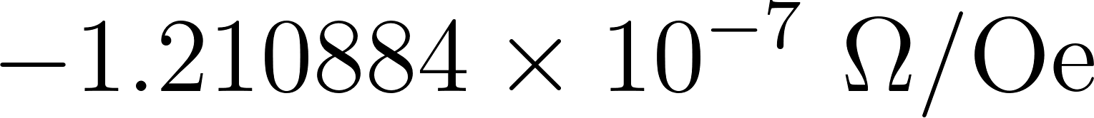
Net Hall Slope Error: 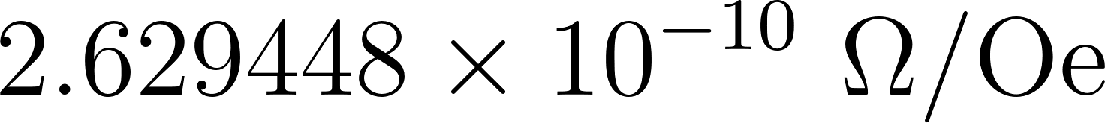

Precautions
- Thermal Stability: Ensure the temperature is perfectly stabilized at 300 K before sweeping, as drifting temperatures will alter the base resistivity, ruining the symmetrization math.
- Phase Angle: Monitor the phase angle on the lock-in amplifier (maintained near 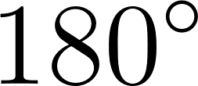 in your data) to ensure the signal is purely resistive and not corrupted by inductive coupling from the wire bonds.
- Contact Resistance: While the H-bar geometry inherently suppresses contact resistance issues compared to two-probe methods, high-resistance wire bonds can still increase the thermal noise floor, necessitating larger lock-in time constants.

