Fabrication of Aluminum Hall Contacts using Photolithography

Aim
To fabricate high-precision aluminum (Al) thin-film Hall bar contacts on a glass substrate using photolithography

Apparatus and Materials
- Substrate: Silicon wafer (with a SiO2​ insulating layer).
- Photoresist: PMMA (typically 950k or 495k molecular weight in Anisole).
- Chemicals: Acetone, Isopropanol (IPA), MIBK:IPA (1:3) developer solution, DI water.
- Equipment:
  - Spin Coater.
  - Hot Plate (capable of 180°C).
  - Mask Aligner (UV Exposure system).
  - Photomask (with Hall bar geometry).
  - Thermal Evaporator or E-beam Evaporator.
  - Ultrasonic Cleaner.

Theory
Photolithography is a high-precision optical process used to transfer complex geometric patterns from a master template, or photomask, onto a thin film of light-sensitive material called photoresist. This technique is the foundational pillar of semiconductor manufacturing, enabling the fabrication of integrated circuits, micro-sensors, and quantum devices such as Hall bar structures.

1. The Physics of Optical Patterning and Resolution
The ability of a lithographic system to resolve fine features is fundamentally limited by the wave nature of light, specifically the phenomenon of diffraction.

A. The Rayleigh Criterion
The Critical Dimension (  ), representing the smallest feature size a system can reliably resolve, is governed by the Rayleigh equation:
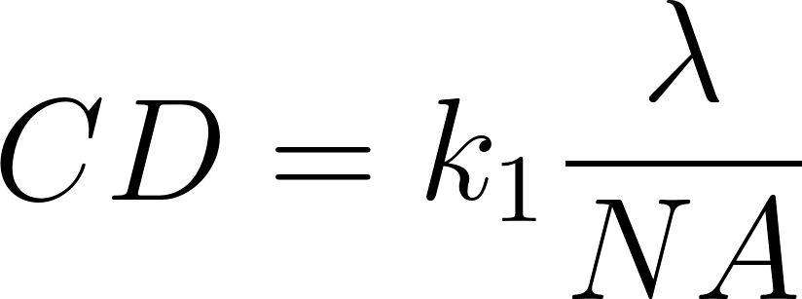
Here,  is the wavelength of the light source and  is the Numerical Aperture (). The constant  represents process capability; while lab scale near UV systems (-line at 365 nm) typically operate with a  around  to , industrial Extreme Ultraviolet (EUV) systems using  nm can achieve resolutions below  nm.

B. Depth of Focus (DOF)
While increasing the  improves resolution, it causes a mathematical decrease in the Depth of Focus:
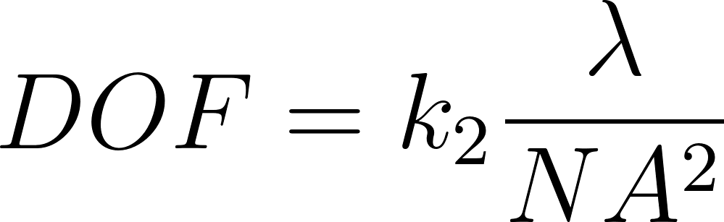
This inverse-square relationship means that as features get smaller, the "window" in which the image remains sharp becomes extremely narrow, requiring substrates to be polished to atomic flatness.

2. Advanced Optical Systems: Magnification, EUV, and Reflective Optics
In modern industrial fabrication, the optical setup has evolved from simple 1:1 contact printing to complex projection systems.

A. Projection and Reduction
Unlike research-grade mask aligners that place the mask in direct contact with the wafer, industrial Steppers and Scanners utilize a 4:1 or 5:1 reduction lens system. The pattern on the reticle (mask) is significantly larger than the final feature on the wafer, which increases defect tolerance and allows for more precise mask manufacturing.

B. EUV Catoptric Systems
At the  nm wavelength used in EUV lithography, traditional refractive glass lenses are unusable because nearly all materials absorb EUV radiation. Instead, these systems utilize all reflective catoptric optics. These mirrors are composed of ultra-smooth, multi-layer stacks of Molybdenum and Silicon that utilize Bragg Reflection to guide light. Similarly, the masks must be reflective rather than transmissive, consisting of a patterned absorber layer atop a reflective multilayer stack.

3. The Chemistry and Kinetics of Photoresists
Photoresists are organic polymers designed to undergo a chemical transformation when exposed to specific wavelengths of radiation.
- Positive Resists (e.g., PMMA, DNQ-Novolac): Exposure causes chain scission, where long polymer bonds break into smaller, more soluble fragments. In the case of PMMA, this reduction in molecular weight allows the exposed regions to dissolve rapidly in a developer.
- Negative Resists (e.g., SU-8): Exposure triggers cross-linking, where polymer chains bond together to form an insoluble network.
The absorption of light through the resist layer is modeled by the Dill Equations, which account for "bleaching" (the change in transparency as the resist reacts):

Where  and  are absorption coefficients and  is the concentration of the unreacted photoactive compound at depth .

4. The Lithographic Pipeline: Process Engineering
The transition from a raw substrate to a patterned device follows a rigorous sequence of controlled steps.

I. Surface Preparation and Coating
The substrate (typically Silicon with an insulating  layer) is cleaned and dehydrated at . A primer like HMDS is often applied to ensure the resist adheres. The resist thickness () is then defined during Spin Coating, governed by the relationship , where  is viscosity and  is angular velocity. A Soft Bake follows to solidify the film.

II. Exposure and Development
The Exposure Dose (), defined as the product of intensity () and time (), is delivered through the mask. Following exposure, the substrate is immersed in a developer solution. The Mack Model describes the dissolution rate (), ensuring a high contrast between the solubility of exposed and unexposed regions, which is critical for achieving sharp, vertical sidewalls in the pattern.

5. Pattern Transfer: Etching vs. Lift-Off
The final stage involves using the resist pattern to define the functional material of the device.
- Etching (Subtractive): A thin film is deposited before the lithography process. The resist acts as a shield, protecting the desired geometry while the unprotected material is removed via chemical acids (Wet Etching) or reactive plasma (Dry Etching).
- Lift-Off (Additive): This is the preferred method for high-resolution Hall contacts. Lithography is performed first to create windows in the resist. Metal is then evaporated over the entire surface. Finally, the substrate is soaked in a solvent like Acetone, which dissolves the resist and "lifts off" the metal on top of it, leaving only the material deposited directly onto the substrate.

Procedure

1. Substrate Cleaning
- Clean the Si/SiO2​ substrate using an ultrasonic bath in Acetone, followed by IPA.
- Blow-dry with Nitrogen (N2​) and perform a dehydration bake at 120°C for 5 minutes.

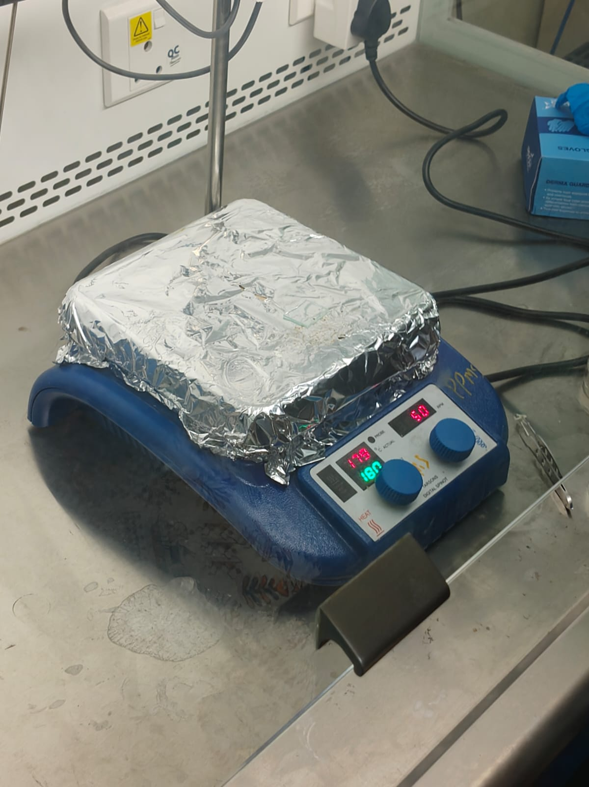
Figure : Hot Plate with parameters 180 c , Heating time:1:35.46

2. Spin Coating
- Dispense PMMA onto the substrate.
- Spin at 3000–5000 RPM for 60 seconds
to achieve the desired thickness.
- Hard Bake: Place on a hot plate at 180°C for 90 seconds.

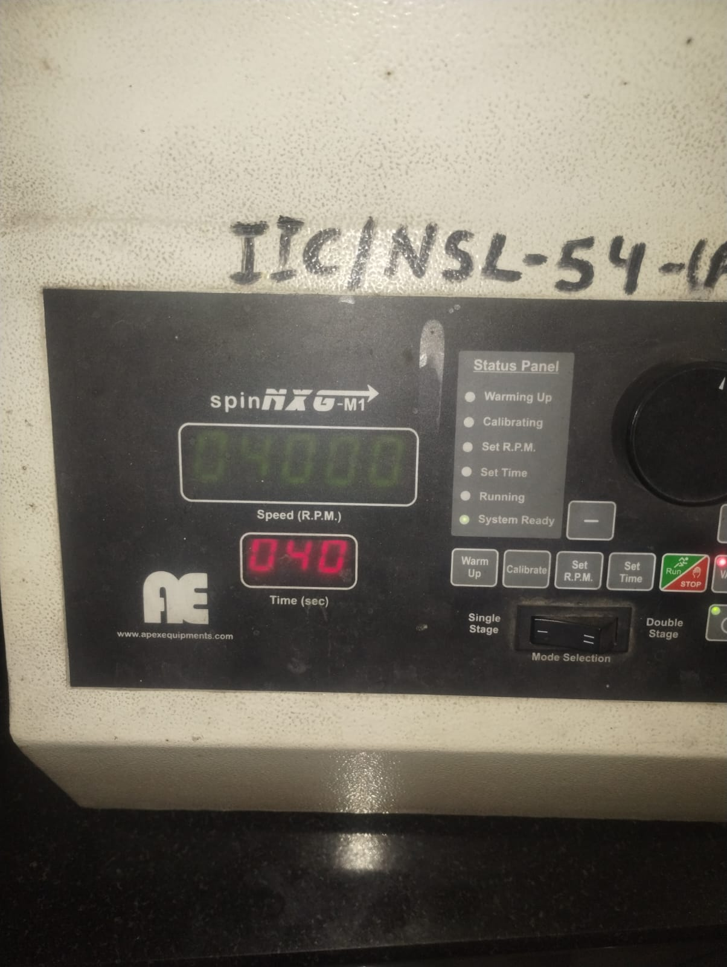

Figure: spin coat parameters: 4000 rpm , 40 seconds

3. Exposure
- Align the Hall bar photomask with the substrate in the Mask Aligner.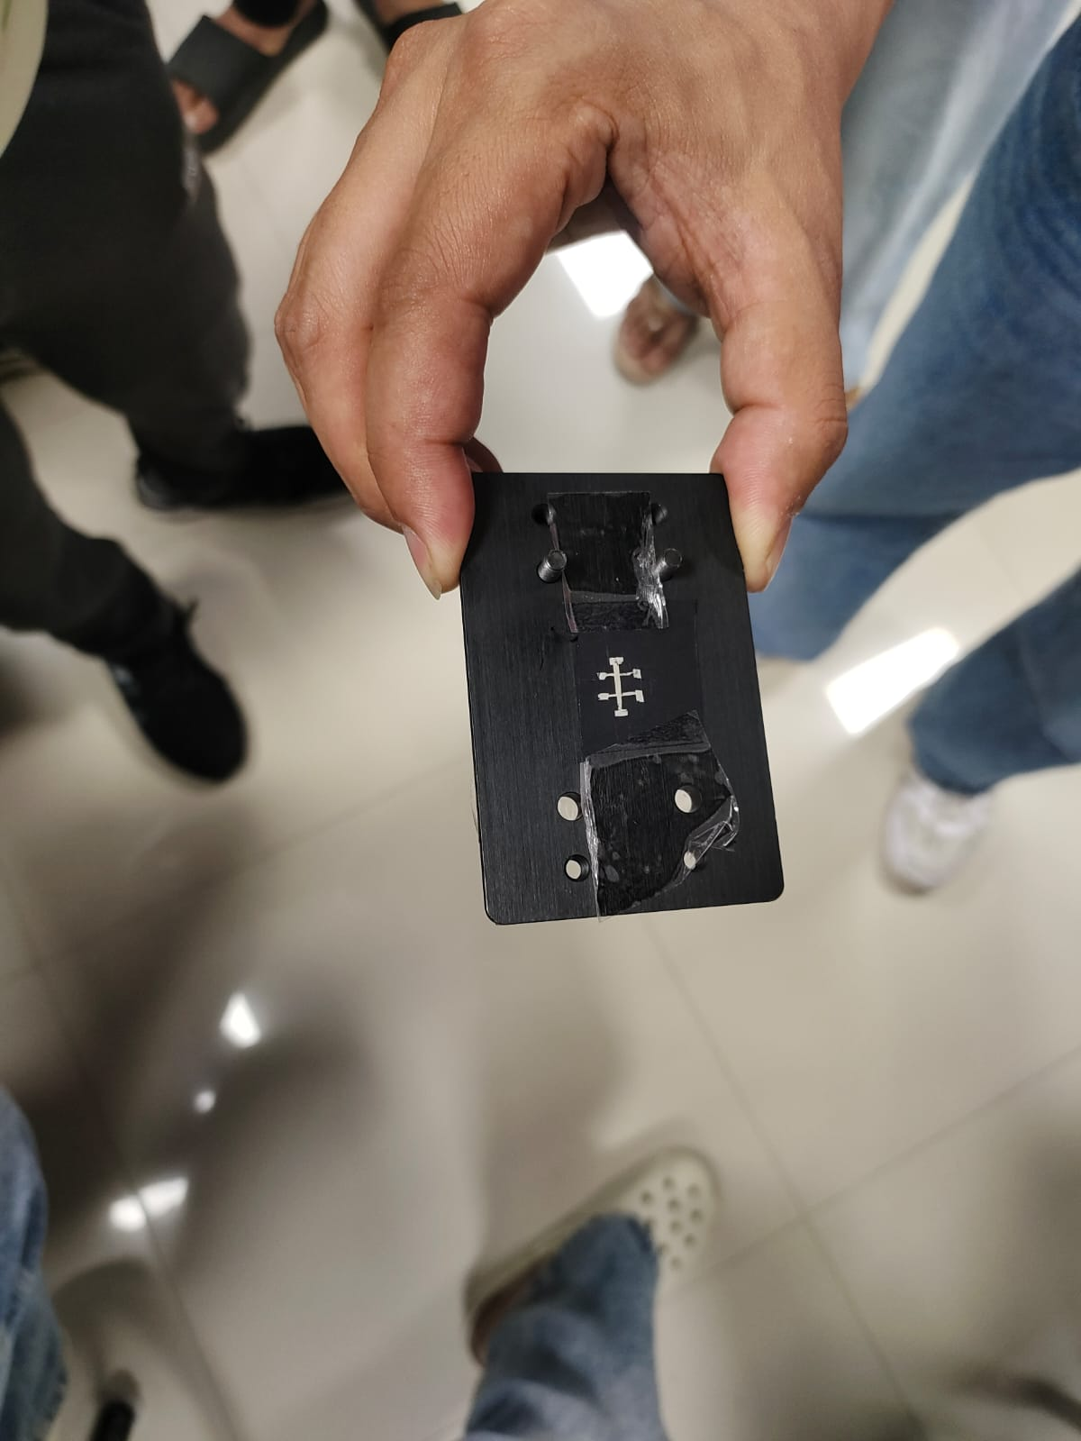
Figure : diy chart photomask mounted on holder / aligner
- Expose to UV light. The UV radiation breaks the PMMA polymer chains in the shape of the Hall bar and contact pads.

4. Development
- Immerse the substrate in MIBK:IPA (1:3) for 60 seconds.
- Rinse in IPA for 30 seconds to stop the development process.
- Dry with N2​. At this stage, the substrate is visible through the "windows" in the PMMA.

5. Metal Deposition
- Load the sample into the Thermal Evaporator.
- Deposit a thin layer of Aluminum (e.g., 50nm – 100nm) under high vacuum (≈10−6 Torr).

6. Lift-Off
- Submerge the sample in a beaker of Acetone.
- Leave for several hours or use a gentle ultrasonic bath to accelerate the process.
- The PMMA dissolves, and the excess aluminum flakes off.
- Rinse with IPA and dry.

Observations and Results

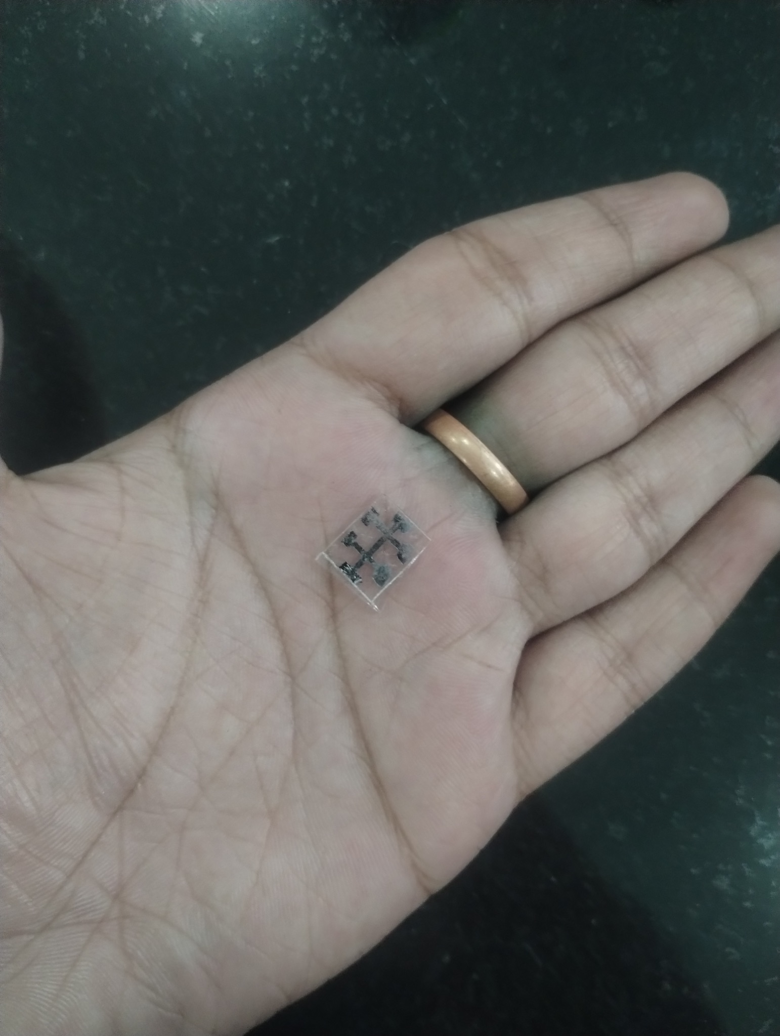
Figure : Final fabricated thin film Al Hall bar contacts on glass substrate (6mm x 6mm)
- Microscopic Inspection: Use an optical microscope to ensure the Hall bar edges are sharp and no residual aluminum "flags" remain at the edges.
- Continuity Check: Use a multimeter or probe station to verify electrical continuity between the contact pads.

Precautions
- Baking Temperature: Ensure the hot plate is exactly at 180°C; under-baking PMMA leads to poor adhesion, while over-baking makes lift-off difficult.
- Environment: Perform the process in a Cleanroom (Yellow light) to prevent premature resist exposure and dust contamination.
- Evaporation Rate: Keep the aluminum deposition rate slow to prevent the PMMA from melting due to radiant heat.

