Thermal Vapour Deposition (TVD) of aluminium (Al) on glass substrate

Aim

To understand the functioning of high-vacuum systems (Rotary and Diffusion pumps) and to achieve precise thin-film coating by thermally evaporating aluminum onto a glass substrate, analyzing the process through the lens of kinetic gas theory and thermodynamics.

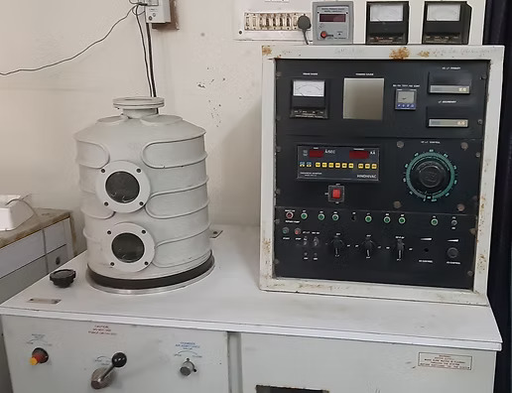
Figure : Hindhivac (Hind High Vacuum Company) Thermal Vapor Deposition (TVD) System

Theory

Thermal vapor deposition is a Physical Vapor Deposition (PVD) process governed by the kinetic theory of gases, thermodynamics, and solid-state physics. The process can be broken down into three physical stages: creation of the vacuum, evaporation of the source, and condensation on the substrate.

1. Vacuum Physics and Mean Free Path
A high vacuum (below 10⁻⁵ mbar) is mandatory to prevent the oxidation of the hot aluminum and to allow the evaporated atoms to reach the substrate without scattering.
The distance an evaporated atom can travel before colliding with a residual gas molecule is its Mean Free Path (λ). According to the kinetic theory of gases, this is defined as:
λ = k_{B} T / √2 π d² p
Where:
- k_{B} is the Boltzmann constant (1.38 × 10⁻²³ J/K)
- T is the absolute temperature in Kelvin
- d is the collision diameter of the residual gas molecules (typically ~ 3 × 10⁻¹⁰ m for air)
- p is the chamber pressure in Pascals
For successful deposition, the condition λ &gt; L must be met, where L is the distance between the evaporation source and the substrate. At atmospheric pressure, λ is mere nanometers. At 10⁻⁵ mbar, λ extends to several meters, ensuring ballistic (straight-line) trajectory of the aluminum atoms.

2. Thermodynamics of Evaporation (Hertz-Knudsen Equation)
For evaporation to occur at a practical rate, the equilibrium vapor pressure of the molten aluminum must exceed the ambient chamber pressure. The maximum theoretical evaporation flux (number of atoms leaving the surface per unit area per unit time) is given by the Hertz-Knudsen equation:
Φ = α_{v} (p_{v} - p_{h}) / √(2 π m k_{B} T)
Where:
- Φ is the evaporation flux
- α_{v} is the evaporation coefficient (empirically close to 1 for clean metals)
- p_{v} is the equilibrium vapor pressure of Aluminum at temperature T
- p_{h} is the hydrostatic pressure of the chamber
- m is the mass of a single Aluminum atom
Because p_{v} increases exponentially with temperature (following the Clausius-Clapeyron relation), a slight increase in the tungsten boat's temperature results in a massive increase in the deposition rate.

3. Deposition Kinetics (Knudsen’s Cosine Law)
The tungsten boat acts as a small-area evaporation source. The emission of vapor is not uniform in all directions but is highly directional. The thickness (t) of the deposited film at any point on the substrate is governed by Knudsen’s Cosine Law:
t = M / (4 π ρ r²) cosθ cosϕ
Where:
- M is the total mass of the evaporated material
- ρ is the density of the film material (Aluminum: 2.70 g/cm³)
- r is the radial distance from the source to the specific point on the substrate
- θ is the emission angle from the normal of the source
- ϕ is the arrival angle from the normal of the substrate
(Note: For a flat substrate positioned directly parallel above the source, θ = ϕ, simplifying the geometry).

4. Film Thickness Monitoring (Sauerbrey Equation)
The Digital Thickness Monitor (DTM) uses a Quartz Crystal Microbalance (QCM). As aluminum deposits onto the oscillating quartz crystal, the added mass lowers the crystal's resonant frequency. This shift in frequency (Δf) is linearly proportional to the mass added (Δm), defined by the Sauerbrey Equation:
Δf = - (2 f₀² / (A √(ρ_{q} μ_{q}))) Δm
Where:
- f₀ is the fundamental resonant frequency of the quartz crystal
- $$A$$ is the piezoelectrically active crystal area
- ρ_{q} is the density of quartz (2.648 g/cm³)
- μ_{q} is the shear modulus of quartz (2.947 × 10¹¹ g cm⁻¹ s⁻²)

Apparatus
- Substrates and Material: Glass slides, high-purity Aluminum wire/pellets, Tungsten/Molybdenum heating boat.
- Vacuum Pumps:
  - Rotary Pump (Roughing/Backing): A mechanical oil-sealed pump used to lower pressure from atmospheric to ~ 10⁻² mbar.
  - Diffusion Pump (DP): A high-vacuum vapor-jet pump that boils silicone oil. High-speed oil vapor jets force stray gas molecules downward into the backing pump line. Requires continuous water cooling.
- Cryogenic Trap: A Liquid Nitrogen (LN₂) Trap situated between the DP and the chamber. It acts as a cryogenic baffle, freezing out condensable gases (water vapor, back-streaming DP oil) to achieve ultra-high vacuum (&lt; 10⁻⁶ mbar).
- Valves: Roughing valve, Backing valve, and Baffle valve.
- Vacuum Gauges: Pirani gauges (thermal conductivity-based, for 10⁻³ to 10 mbar) and a Penning gauge (cold cathode ionization-based, for &lt; 10⁻⁴ mbar).
- Electronics: Low Tension (LT) mains with a step-down transformer and Variac (for high-current resistive heating), and a Digital Thickness Monitor (DTM).

Procedure

Part I: Preparation
- Clean the glass slides via ultrasonication in Acetone, rinse with Isopropyl Alcohol (IPA) and DI water, then dry with nitrogen gas.
- Weigh the slides on an analytical balance to record their initial masses.
- Mount the substrates in the chamber fixture, positioned at a measured distance ($$r$$) directly above the tungsten boat.
- Load a calculated mass of aluminum into the tungsten boat.
- Ensure all cooling water lines (to the DP and DTM) and gauge heads are securely connected.

Part II: Pumping the System
- Roughing: Turn on the main power. Ensure all valves are closed. Start the Rotary pump. Turn on the Pirani gauge. Open the roughing valve to evacuate the main chamber down to ≤ 0.02 mbar. Close the roughing valve.
- Backing: Open the backing valve to evacuate the Diffusion Pump (DP) chamber until the vacuum drops below $0.01$ mbar.
- DP Heating: Turn on the water circulation for the DP. Switch on the Diffusion Pump heater. Wait ~30 minutes for the oil to boil and vapor jets to form.
- Pressure Equalization: Close the backing valve, briefly open the roughing valve (1-2 mins) to equalize pressure between chambers, then close the roughing valve and reopen the backing valve.
- High Vacuum &amp; Cryotrapping: Open the Baffle valve to connect the DP to the main chamber. Fill the LN₂ trap with liquid nitrogen.
- Turn on the Penning gauge. Wait 15-30 minutes until the pressure stabilizes below 10⁻⁵ mbar, ensuring λ is significantly greater than the source-to-substrate distance.

Part III: Deposition
- Start cooling water flow to the DTM and turn the unit on.
- Input Aluminum parameters into the DTM: Density = 2.70 g/cm³ and Acoustic Impedance = 8.83 × 10⁵ g cm⁻²s⁻¹. Zero the monitor.
- Turn on the LT MAIN switch. Slowly increase the Variac voltage. The high current will pass through the tungsten boat, generating resistive heat (P = I² R).
- Observe the aluminum melting and wetting the boat. Increase current until evaporation begins (indicated by a rising deposition rate on the DTM).
- Once the desired thickness is achieved on the DTM display, press stop, and smoothly dial the variac current back to zero.

Part IV: Shut Down & Venting
- Turn off the DP heater, but keep the backing valve open and water circulating for 30 minutes to cool the DP oil.
- Once cooled, close the backing valve, turn off the Rotary Pump, shut off the water, and power down the mains.
- Ensure the Baffle is closed. Open the chamber vent valve to equalize with atmospheric pressure.
- Carefully open the chamber, remove the coated substrates, and immediately perform a roughing cycle to store the empty chamber under medium vacuum.

Part V: Film Characterisation
Once the aluminum film is successfully deposited, its physical, electrical, and optical properties are analyzed to evaluate the quality of the deposition process.
1. Surface Morphology & Thickness (SEM):
Scanning Electron Microscopy (SEM) is utilized to inspect the surface topography and grain structure of the aluminum film. Aluminum films deposited at room temperature typically exhibit a highly granular, polycrystalline structure. By viewing a cleaved cross-section of the glass substrate under the SEM, the physical thickness of the film can be directly measured and compared against the values recorded by the Quartz Crystal Microbalance.
2. Electrical Conductivity (Four-Point Probe):
A Four-Point Probe setup is used to measure the sheet resistance (R_{s}) of the thin film. This method is preferred because it eliminates errors caused by contact resistance between the probes and the film. A direct current (I) is passed through the outer two probes, and the voltage drop (V) is measured across the inner two probes. The sheet resistance is given by:
R_{s} = (π / ln(2)) (V / I) ≈ 4.532 (V / I)
Once the sheet resistance is determined, the bulk resistivity (ρ) of the aluminum film can be calculated by multiplying it by the film's thickness (t): ρ = R_{s} · t. This value is then compared to the theoretical bulk resistivity of pure aluminum (2.65 × 10⁻⁸ Ω · m) to assess film purity and continuity.
3. Optical Reflectivity (UV-Vis-NIR Spectroscopy):
Aluminum is highly prized for its broad-spectrum reflectivity, making it the standard material for telescope mirrors and optical coatings. Using a UV-Vis-NIR spectrophotometer equipped with a specular reflectance accessory, the reflectance percentage of the film is measured across varying wavelengths (typically 300 nm to 1000 nm). A high-quality, unoxidized vacuum-deposited aluminum film should yield &gt;90% reflectance in the visible spectrum.

Results

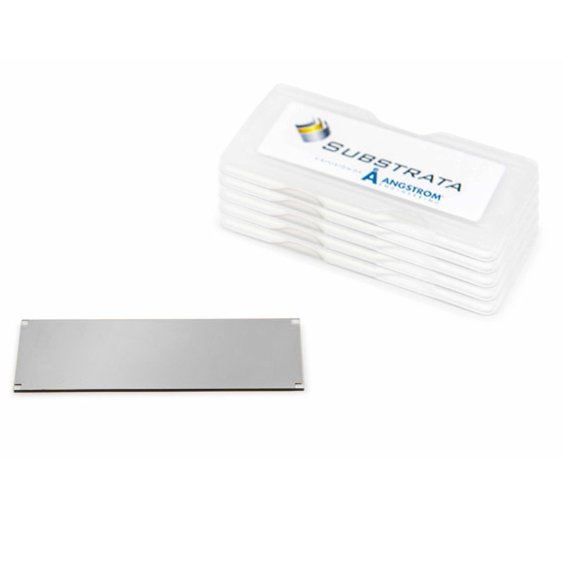
Figure : Aluminium Thin Film deposited on glass slide

