Hall Effect and Magnetoresistance Measurement of an Aluminum H-Bar

Aim
To measure the Hall resistance (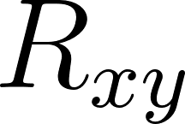) and longitudinal magnetoresistance (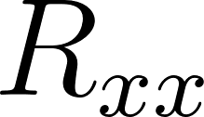) of an Aluminum (Al) thin film at 300 K using an applied magnetic field sweep up to 1 T (10,000 Oe).

Apparatus & Setup
Based on standard transport measurement protocols and the physical layout of your experiment:
- Sample: Aluminum thin film, patterned into an H-bar geometry via lithography and Thermal Vacuum Deposition (TVD).
- Mounting: Resistivity/Hall measurement puck (configured for standard cryostat or PPMS insertion).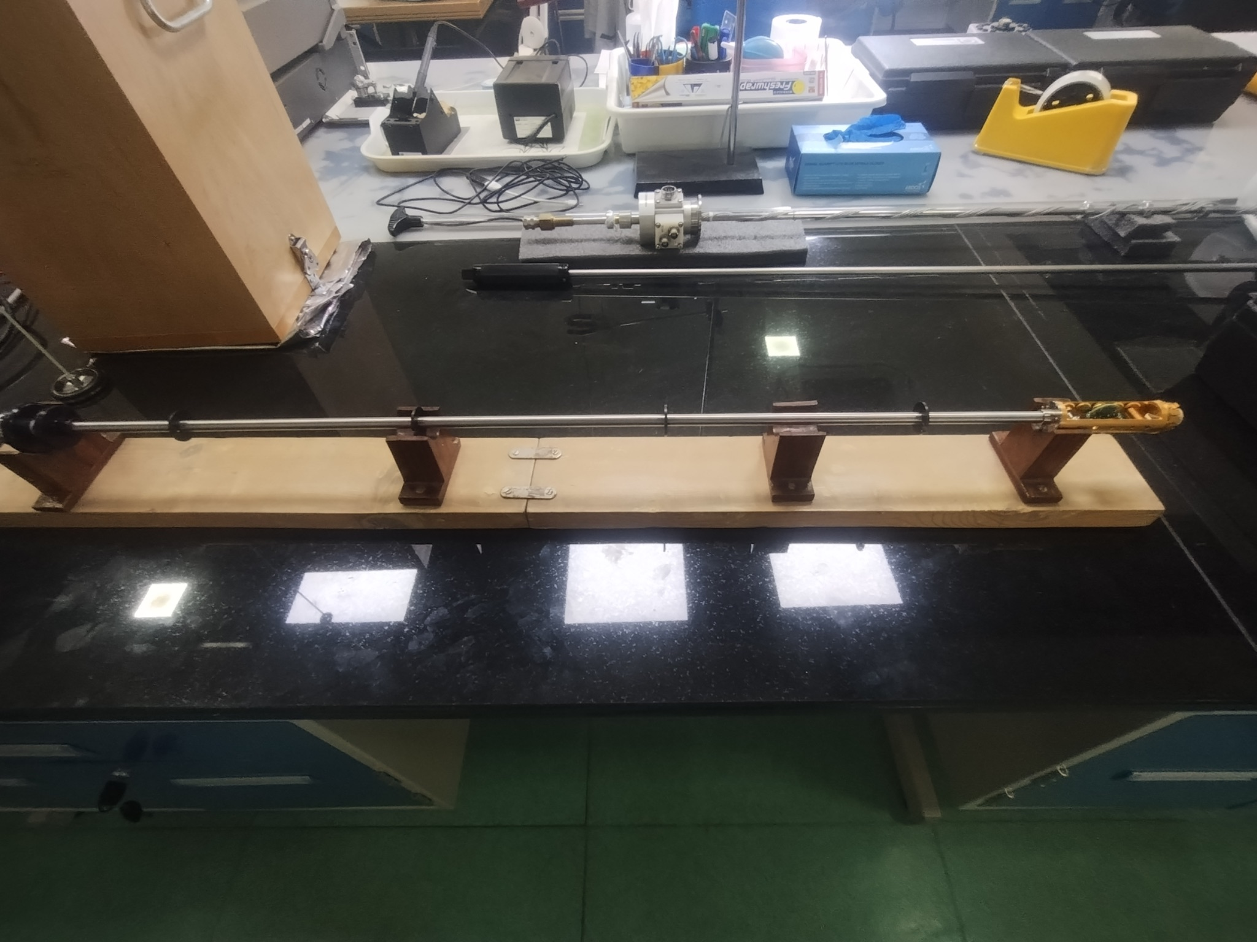
Figure : insertion rod assembly
- Electrical Connections: Fine wire bonds connecting the H-bar pads to the puck's macroscopic terminal pins.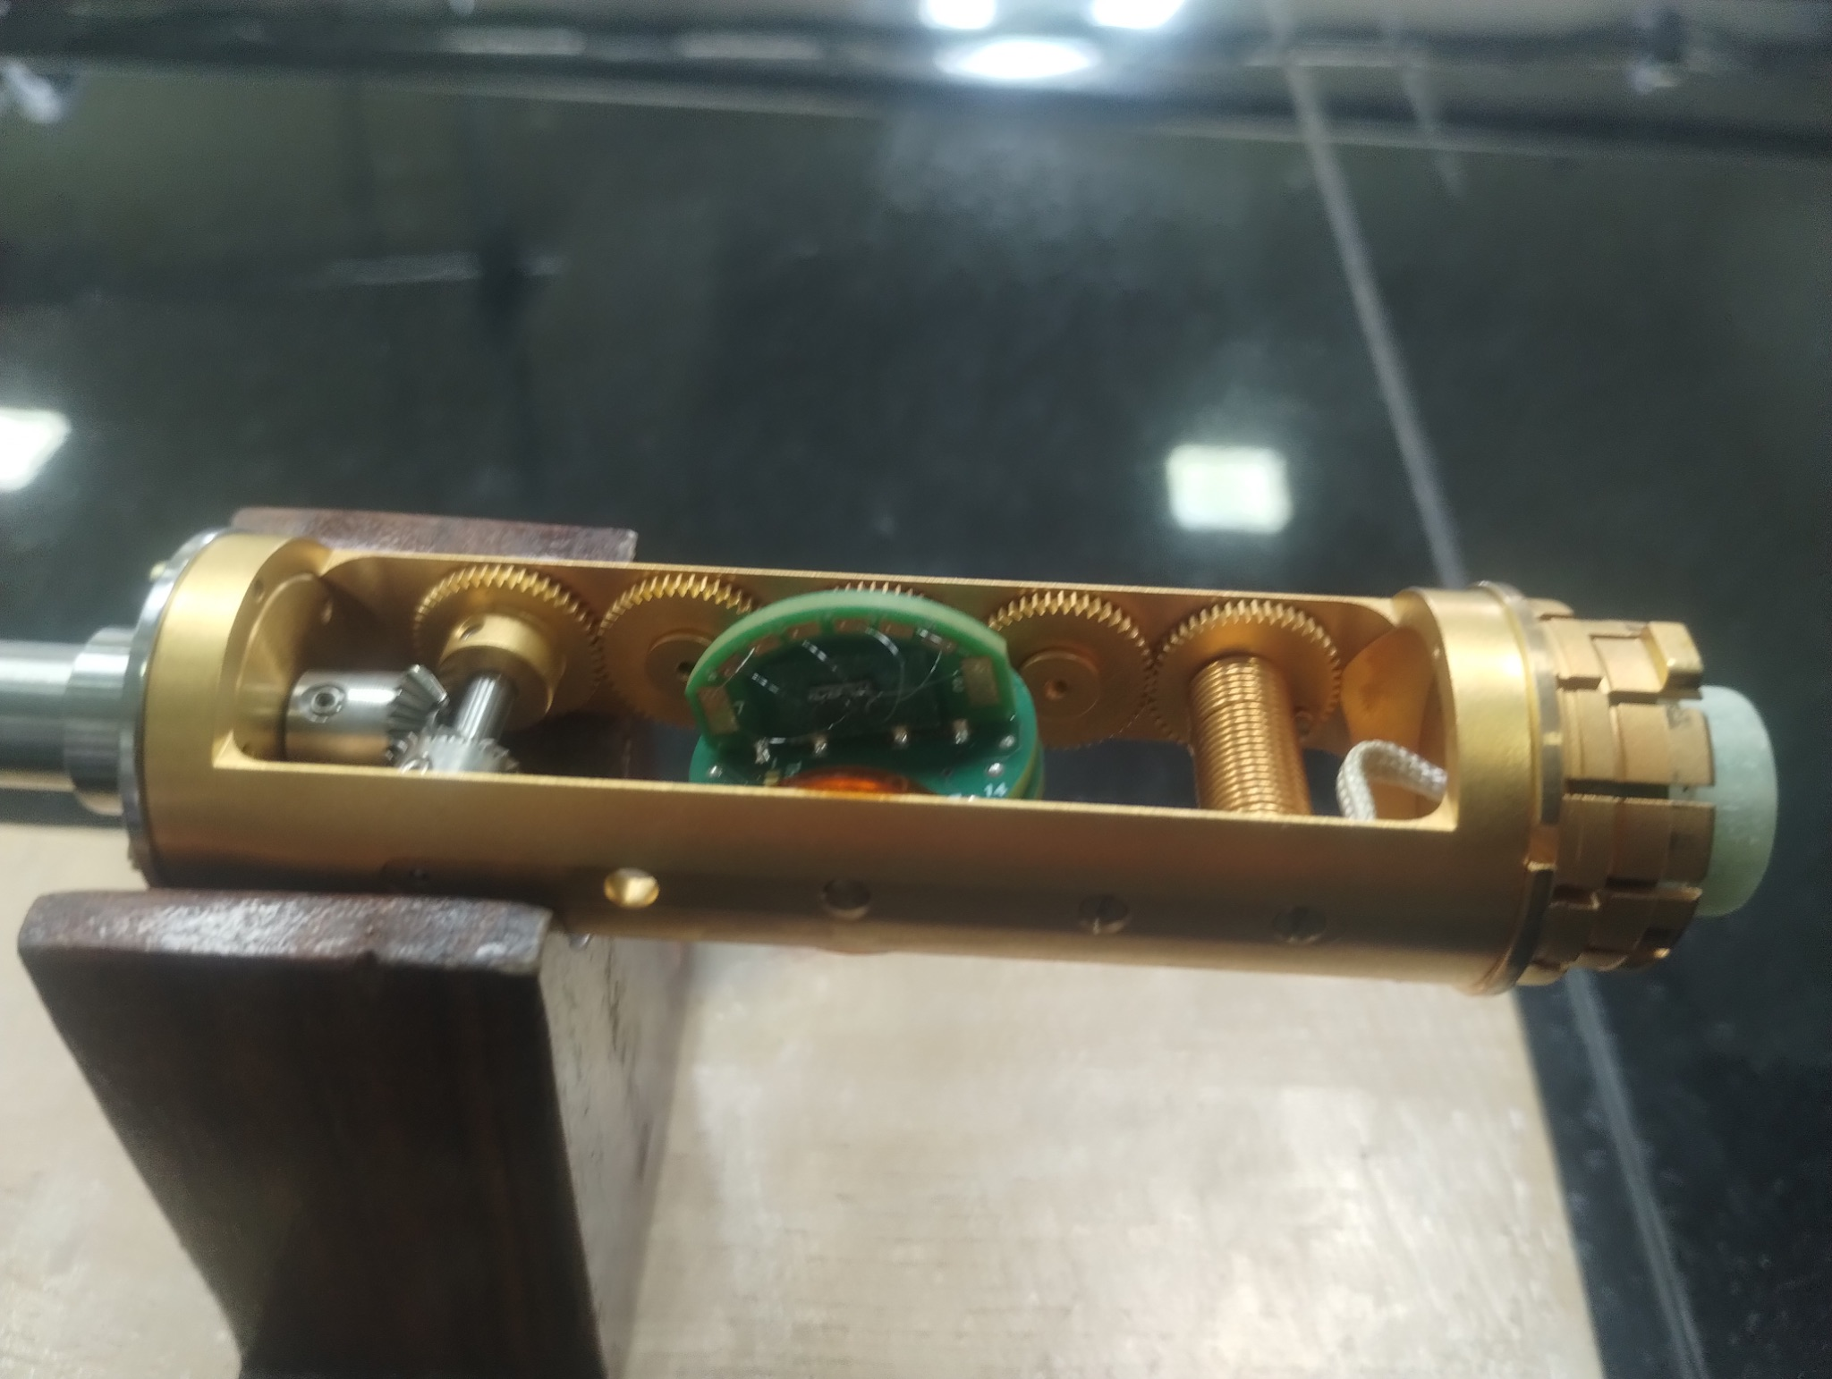
Figure : insertion rod puck mount
- Measurement Electronics: * AC Current Source (supplying 1 mA).
  - Lock-in Amplifier (for high-precision phase-sensitive detection of micro-volt signals, isolating the fundamental harmonic and rejecting noise).
- Magnet System: Electromagnet capable of sweeping fields precisely between +10,000 Oe and -10,000 Oe.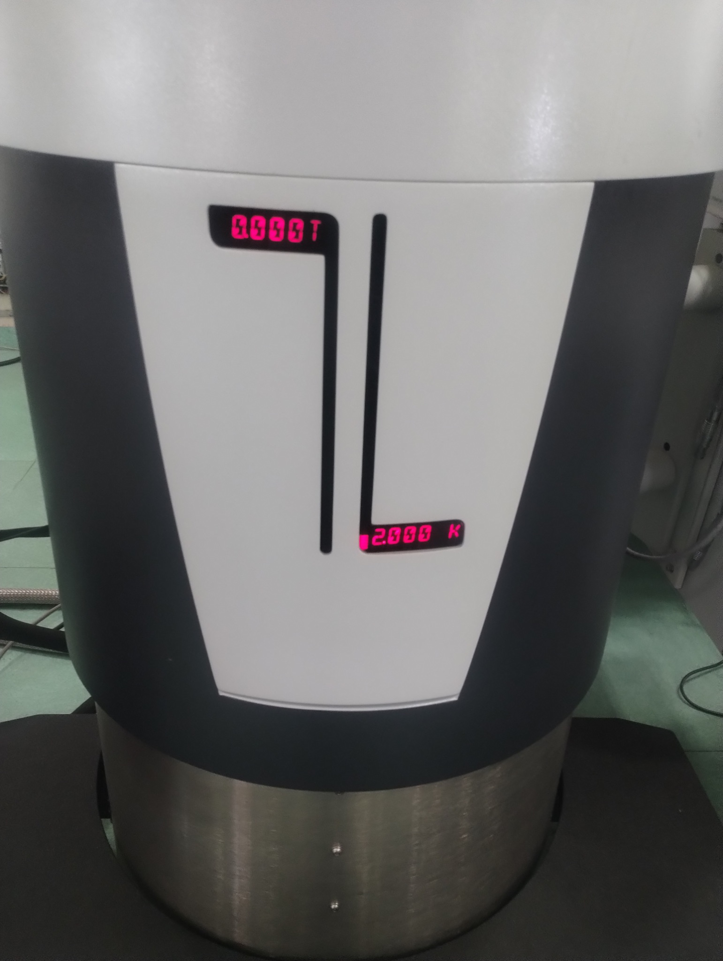
Figure : DynaCool PPMS (Physical Properties Measurement System)

Theory
When a current 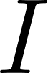 flows through a conducting strip of thickness 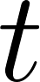 in the presence of a perpendicular magnetic field , the charge carriers experience a Lorentz force:

This force deflects the carriers to one side of the sample, creating a transverse electric field until the resulting electrostatic force exactly balances the Lorentz force.

3.1 The Hall Coefficient and Carrier Concentration
The accumulation of charge results in a measurable transverse voltage, the Hall Voltage (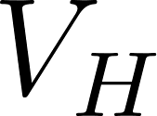). For a simple single-band metal, the Hall resistance is perfectly linear with respect to the applied magnetic field:
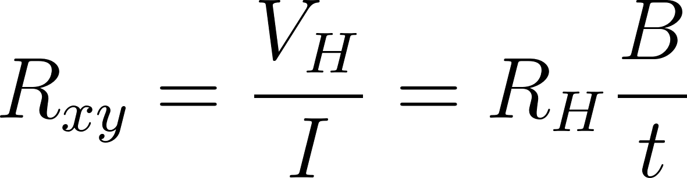
Where 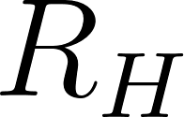 is the Hall coefficient. By measuring the slope of  versus , we can extract . The Hall coefficient is fundamentally linked to the carrier concentration (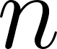) and the charge of the carriers (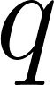):
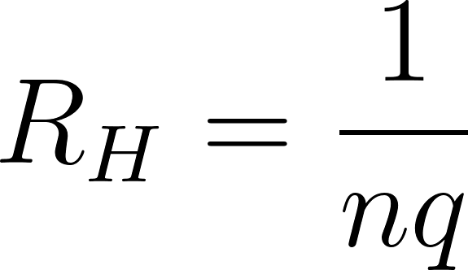
- A negative slope (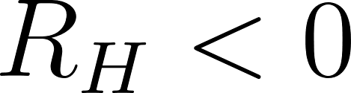) indicates electron-dominated transport.
- A positive slope (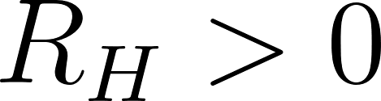) indicates hole-dominated transport.

3.2 Parasitic Voltage and Symmetrization
In a physical H-bar device, it is impossible to align the transverse voltage contacts perfectly. Consequently, the measured voltage contains both the true Hall signal and a parasitic longitudinal voltage drop (from the standard resistance of the material):
Because the Hall effect is an odd (anti-symmetric) function of the magnetic field and magnetoresistance is an even (symmetric) function, they can be mathematically isolated by sweeping the field in both directions:
- Hall Resistance: 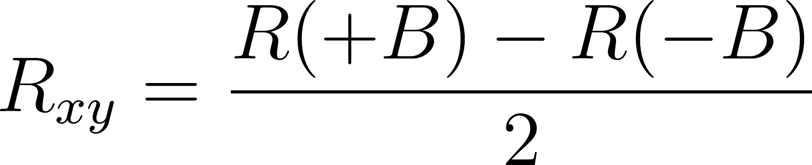
- Magnetoresistance: 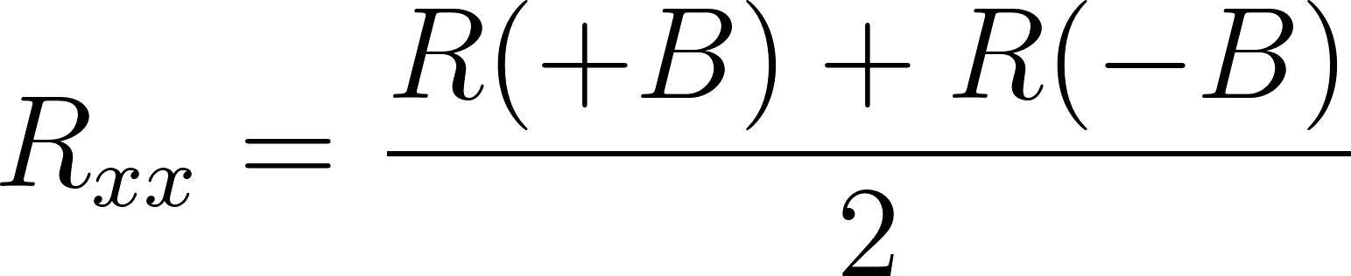

Procedure
- Sample Preparation: Following TVD synthesis and lithographic patterning, clean the Aluminum H-bar sample.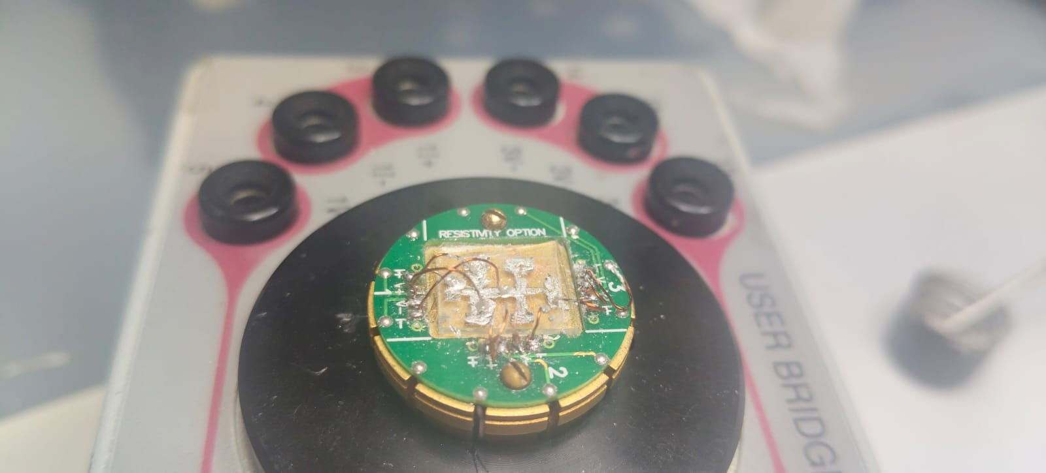
Figure : Hall Bar mounted on puck

- Mounting & Wire Bonding: Secure the sample to the measurement puck. Using a wire bonder, make four-terminal connections:
  - Drive a constant current $I$ along the main longitudinal channel.
  - Connect Channel 1 (Ch1) across two opposite arms of the H-bar to measure the transverse Hall voltage ().
  - Connect Channel 2 (Ch2) across two adjacent arms on the same side to measure the longitudinal voltage () if direct MR measurement is desired.
- Initialization: Insert the puck into the measurement chamber and stabilize the temperature at 300 K.
- Measurement Parameters: Set the lock-in amplifier to supply a 1 mA AC excitation current.
- Field Sweeping: * Sweep the magnetic field from +10,000 Oe to -10,000 Oe (Sweep Down), recording the field, resistance, phase angle, and standard deviation at specified intervals.
  - Sweep the magnetic field back from -10,000 Oe to +10,000 Oe (Sweep Up) to check for magnetic hysteresis or instrument drift.
- Data Extraction: Export the data files for computational analysis to separate  and  using the parity formulas described in the theory section.

Observations

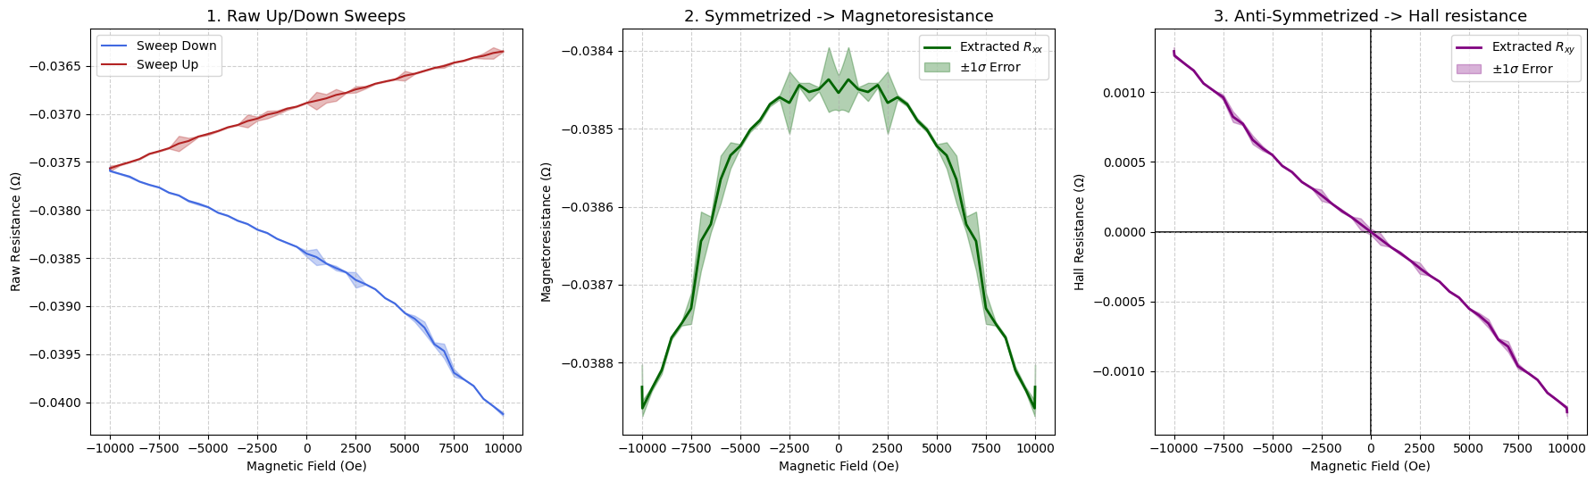

Figure : Plots summarising the observed data

 | Field (Oe) | Resistance Ch1 (Ohms) | Resistance Std. Dev. Ch1 (Ohms) | Phase Angle Ch1 (deg) | AC Current Ch1 (mA) | 2nd Harmonic Ch1 (dB)
0 | 10000.566406 | -0.040124 | -0.000020 | 180.0412 | 1.0 | -77.21645
1 | 9500.222656 | -0.040042 | -0.000004 | 180.0410 | 1.0 | -78.02535
2 | 9000.138672 | -0.039965 | -0.000004 | 180.0411 | 1.0 | -79.21428
3 | 8500.480469 | -0.039831 | -0.000004 | 180.0383 | 1.0 | -89.57012
4 | 8000.528320 | -0.039762 | -0.000003 | 180.0395 | 1.0 | -80.35796
5 | 7500.395996 | -0.039695 | -0.000040 | 180.0383 | 1.0 | -82.60512
6 | 7000.558594 | -0.039468 | -0.000076 | 180.0384 | 1.0 | -87.58522
7 | 6500.246582 | -0.039397 | -0.000020 | 180.0423 | 1.0 | -77.69395
8 | 6000.522949 | -0.039224 | -0.000061 | 180.0387 | 1.0 | -90.97642
9 | 5500.423340 | -0.039132 | -0.000032 | 180.0406 | 1.0 | -80.33044
10 | 5000.455078 | -0.039073 | -0.000003 | 180.0391 | 1.0 | -81.83244
11 | 4500.241211 | -0.038974 | -0.000004 | 180.0383 | 1.0 | -89.95012
12 | 4000.141602 | -0.038917 | -0.000004 | 180.0392 | 1.0 | -83.56449
13 | 3500.140381 | -0.038826 | -0.000003 | 180.0403 | 1.0 | -85.77003
14 | 3000.187988 | -0.038773 | -0.000004 | 180.0385 | 1.0 | -88.72321
15 | 2500.333252 | -0.038728 | -0.000081 | 180.0405 | 1.0 | -86.48843
16 | 2000.217773 | -0.038648 | -0.000004 | 180.0370 | 1.0 | -96.10050
17 | 1500.494019 | -0.038605 | -0.000023 | 180.0402 | 1.0 | -82.70789
18 | 1000.476257 | -0.038557 | -0.000004 | 180.0384 | 1.0 | -84.20845
19 | 500.458557 | -0.038490 | -0.000084 | 180.0397 | 1.0 | -88.82802
20 | 0.195932 | -0.038454 | -0.000032 | 180.0393 | 1.0 | -83.73759
21 | -500.344269 | -0.038383 | -0.000003 | 180.0370 | 1.0 | -88.17389
22 | -1000.312988 | -0.038342 | -0.000004 | 180.0387 | 1.0 | -100.67150
23 | -1500.428711 | -0.038300 | -0.000003 | 180.0392 | 1.0 | -89.45184
24 | -2000.234131 | -0.038240 | -0.000004 | 180.0398 | 1.0 | -87.97391
25 | -2500.464111 | -0.038205 | -0.000004 | 180.0388 | 1.0 | -80.87924
26 | -3000.400146 | -0.038146 | -0.000004 | 180.0410 | 1.0 | -82.64751
27 | -3500.107666 | -0.038112 | -0.000004 | 180.0400 | 1.0 | -87.46560
28 | -4000.321289 | -0.038061 | -0.000004 | 180.0387 | 1.0 | -90.31750
29 | -4500.338867 | -0.038029 | -0.000004 | 180.0424 | 1.0 | -80.06992
30 | -5000.111816 | -0.037971 | -0.000004 | 180.0383 | 1.0 | -87.70529
31 | -5500.357910 | -0.037937 | -0.000011 | 180.0398 | 1.0 | -90.22721
32 | -6000.408691 | -0.037907 | -0.000008 | 180.0430 | 1.0 | -84.23131
33 | -6500.360840 | -0.037849 | -0.000004 | 180.0392 | 1.0 | -88.56675
34 | -7000.427734 | -0.037820 | -0.000004 | 180.0391 | 1.0 | -86.31097
35 | -7500.265625 | -0.037766 | -0.000004 | 180.0415 | 1.0 | -86.18661
36 | -8000.495605 | -0.037738 | -0.000004 | 180.0425 | 1.0 | -78.51411
37 | -8500.366211 | -0.037705 | -0.000003 | 180.0396 | 1.0 | -82.79366
38 | -9000.416992 | -0.037654 | -0.000008 | 180.0387 | 1.0 | -87.99190
39 | -9500.630859 | -0.037625 | -0.000004 | 180.0435 | 1.0 | -79.75259
40 | -10000.501953 | -0.037594 | -0.000004 | 180.0393 | 1.0 | -86.33773
41 | -10000.533203 | -0.037567 | -0.000028 | 180.0383 | 1.0 | -84.77370
42 | -9500.614258 | -0.037532 | -0.000005 | 180.0424 | 1.0 | -77.76138
43 | -9000.416992 | -0.037503 | -0.000004 | 180.0410 | 1.0 | -82.99696
44 | -8500.545898 | -0.037470 | -0.000004 | 180.0406 | 1.0 | -87.28745
45 | -8000.512207 | -0.037416 | -0.000004 | 180.0384 | 1.0 | -88.65508
46 | -7500.510254 | -0.037389 | -0.000004 | 180.0415 | 1.0 | -78.12436
47 | -7000.264160 | -0.037357 | -0.000004 | 180.0380 | 1.0 | -82.89295
48 | -6500.376953 | -0.037309 | -0.000079 | 180.0384 | 1.0 | -85.13896
49 | -6000.637207 | -0.037283 | -0.000033 | 180.0418 | 1.0 | -79.44728
50 | -5500.309082 | -0.037236 | -0.000003 | 180.0393 | 1.0 | -89.95769
51 | -5000.405762 | -0.037209 | -0.000011 | 180.0436 | 1.0 | -77.92937
52 | -4500.371582 | -0.037179 | -0.000003 | 180.0385 | 1.0 | -85.44273
53 | -4000.468262 | -0.037140 | -0.000005 | 180.0402 | 1.0 | -87.75812
54 | -3500.319824 | -0.037116 | -0.000004 | 180.0381 | 1.0 | -83.12565
55 | -3000.155273 | -0.037075 | -0.000066 | 180.0395 | 1.0 | -85.54188
56 | -2500.513184 | -0.037050 | -0.000020 | 180.0424 | 1.0 | -78.95612
57 | -2000.315674 | -0.037008 | -0.000039 | 180.0389 | 1.0 | -84.23312
58 | -1500.444946 | -0.036986 | -0.000022 | 180.0385 | 1.0 | -86.62030
59 | -1000.296692 | -0.036947 | -0.000013 | 180.0383 | 1.0 | -87.53625
60 | -500.605499 | -0.036925 | -0.000004 | 180.0389 | 1.0 | -81.53104
61 | -0.277570 | -0.036887 | -0.000004 | 180.0392 | 1.0 | -83.98181
62 | 500.229950 | -0.036863 | -0.000091 | 180.0386 | 1.0 | -87.12241
63 | 1000.427307 | -0.036839 | -0.000044 | 180.0386 | 1.0 | -89.12813
64 | 1500.249146 | -0.036804 | -0.000061 | 180.0370 | 1.0 | -90.00886
65 | 2000.462769 | -0.036782 | -0.000003 | 180.0399 | 1.0 | -85.47955
66 | 2500.529541 | -0.036746 | -0.000033 | 180.0385 | 1.0 | -84.78992
67 | 3000.530762 | -0.036723 | -0.000013 | 180.0420 | 1.0 | -77.90039
68 | 3500.385010 | -0.036686 | -0.000003 | 180.0396 | 1.0 | -86.84037
69 | 4000.207031 | -0.036663 | -0.000003 | 180.0413 | 1.0 | -82.93782
70 | 4500.257324 | -0.036642 | -0.000004 | 180.0435 | 1.0 | -78.07266
71 | 5000.291504 | -0.036604 | -0.000050 | 180.0363 | 1.0 | -85.37413
72 | 5500.456055 | -0.036583 | -0.000003 | 180.0414 | 1.0 | -86.41324
73 | 6500.475098 | -0.036522 | -0.000004 | 180.0407 | 1.0 | -84.03621
74 | 7000.329590 | -0.036503 | -0.000018 | 180.0398 | 1.0 | -85.82150
75 | 7500.347168 | -0.036467 | -0.000004 | 180.0373 | 1.0 | -87.56441
76 | 8000.267090 | -0.036447 | -0.000004 | 180.0395 | 1.0 | -88.70266
77 | 8500.431641 | -0.036415 | -0.000003 | 180.0397 | 1.0 | -83.81337
78 | 9000.531250 | -0.036397 | -0.000028 | 180.0414 | 1.0 | -79.06133
79 | 9500.467773 | -0.036367 | -0.000059 | 180.0385 | 1.0 | -90.23697
80 | 10000.093750 | -0.036350 | -0.000003 | 180.0387 | 1.0 | -88.46396

Results

Average Magnetoresistance: 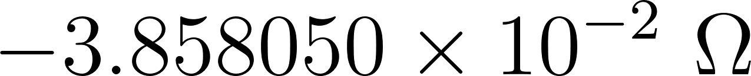
Net MR Error: 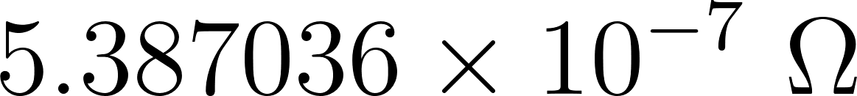
Note : here Magento resistance proportional to applied field squared so its value is not of main interest
Extracted Hall Slope (): 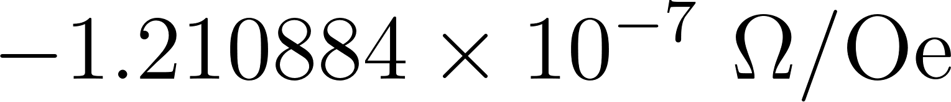
Net Hall Slope Error: 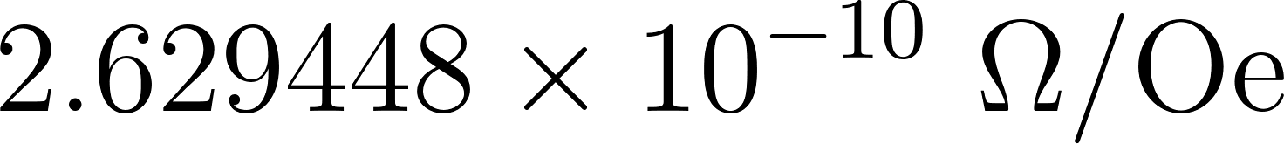

Precautions
- Thermal Stability: Ensure the temperature is perfectly stabilized at 300 K before sweeping, as drifting temperatures will alter the base resistivity, ruining the symmetrization math.
- Phase Angle: Monitor the phase angle on the lock-in amplifier (maintained near 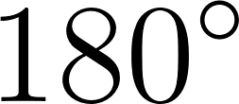 in your data) to ensure the signal is purely resistive and not corrupted by inductive coupling from the wire bonds.
- Contact Resistance: While the H-bar geometry inherently suppresses contact resistance issues compared to two-probe methods, high-resistance wire bonds can still increase the thermal noise floor, necessitating larger lock-in time constants.

