Measurement of Aluminum Thin Film Thickness using Field Emission Scanning Electron Microscopy (FESEM)

Aim

To determine the thickness and analyze the cross section thickness of a deposited aluminum (Al) thin film using high resolution Field Emission Scanning Electron Microscopy (FESEM)

Theory

Scanning Electron Microscopy utilizes a focused beam of high-energy electrons to generate topographical and compositional signals from a solid specimen. For this experiment, a Field Emission Scanning Electron Microscope (FESEM) is utilized rather than a traditional thermionic SEM. FESEMs employ a field emission gun (FEG) operating under ultra-high vacuum conditions (typically 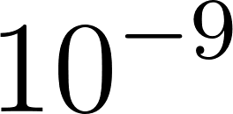 mbar). This generates an electron beam with higher brightness and a significantly smaller spot size, allowing for superior resolution at high magnifications (e.g., 100,000x). This high resolution, combined with an In-Lens secondary electron detector, is critical for accurately resolving the fine, nanoscale columnar grain structures typical of deposited aluminum thin films.
To measure the film thickness, the sample is imaged in cross-section. By viewing the sample edge-on, the interface between the substrate and the deposited aluminum layer is exposed. The measured thickness on the micrograph () is related to the true thickness () by the tilt angle () of the sample relative to the electron beam:
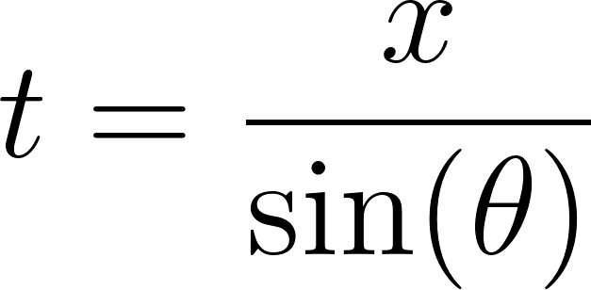
For samples mounted perfectly perpendicular to the beam (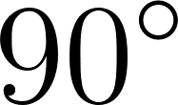 cross-section), 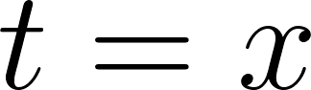.

Apparatus
- Field Emission Scanning Electron Microscope (FESEM): Equipped with an In-Lens secondary electron detector and capable of ultra-high gun vacuum ( mbar).
- Sample: Substrate coated with an aluminum thin film.
- Sample Preparation Tools: Diamond scribe for cleaving, compressed nitrogen gun.
- Mounting Supplies:  cross-section SEM stub, conductive double-sided carbon tape, and conductive silver paint (for grounding).
- Data: Six distinct high-resolution cross-sectional micrographs taken at different locations along the sample edge.

Procedure

Part A: Sample Preparation
- Cleaving: Score and cleave the substrate using a diamond scribe to create a sharp, vertical fracture, exposing the cross-section of the aluminum film without smearing the interface.
- Cleaning: Clear away any substrate particulate from the cleaved edge using a gentle stream of compressed nitrogen gas.
- Mounting: Secure the cleaved sample onto a  cross-section SEM stub using conductive carbon tape, ensuring the exposed cross-section faces directly upward.
- Grounding: Apply a small bead of conductive silver paint from the top aluminum surface to the metal stub to mitigate electron charging artifacts. Allow to dry.

Part B: FESEM Operation and Image Acquisition
- Loading and Vacuum: Load the sample stub into the FESEM chamber and initiate the pump-down sequence until ultra-high gun vacuum (approximately 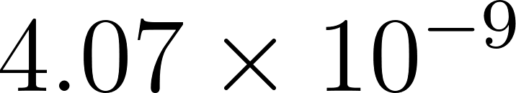 mbar) and adequate system vacuum are achieved.
- Beam Alignment: Activate the field emission gun. Set the accelerating voltage (EHT) to 15.00 kV to balance surface resolution with adequate signal yield.
- Detector Configuration: Select the In-Lens secondary electron detector (Signal A = InLens) to capture high-resolution surface topology.
- Focusing and Magnification: Navigate to the cleaved edge. Adjust the working distance (WD  7.7 mm), focus, and stigmation to achieve a sharp image of the substrate-film interface. Increase the magnification to 100,000x (100.00 K X) to clearly resolve the columnar structure of the aluminum film.
- Image Capture: Capture high-resolution, slow-scan micrographs. Move the stage to distinct, non-overlapping regions along the cleaved edge and repeat the capture process until six separate representative images are acquired.

Part C: Thickness Measurement and Statistical Analysis
- Calibration: Open the six micrographs in the integrated SEM measurement software or an image analysis tool (e.g., ImageJ), ensuring the measurement scale is calibrated to the 200 nm databar provided on the images.
- Measurement Extraction: On each of the six images, draw perpendicular lines from the substrate-film interface to the top surface of the aluminum film. Take multiple thickness readings (e.g., 3 to 5) per image to account for localized surface roughness.
- Data Aggregation: Compile all measurements from the six micrographs.
- Calculation: Calculate the global average thickness of the aluminum film and compute the standard deviation to quantify the uniformity of the deposition across the sample.
Here are the essential precautions to add to your laboratory report, categorized for safety and equipment protection. You can append this as "Section 5" of your report.

Observations

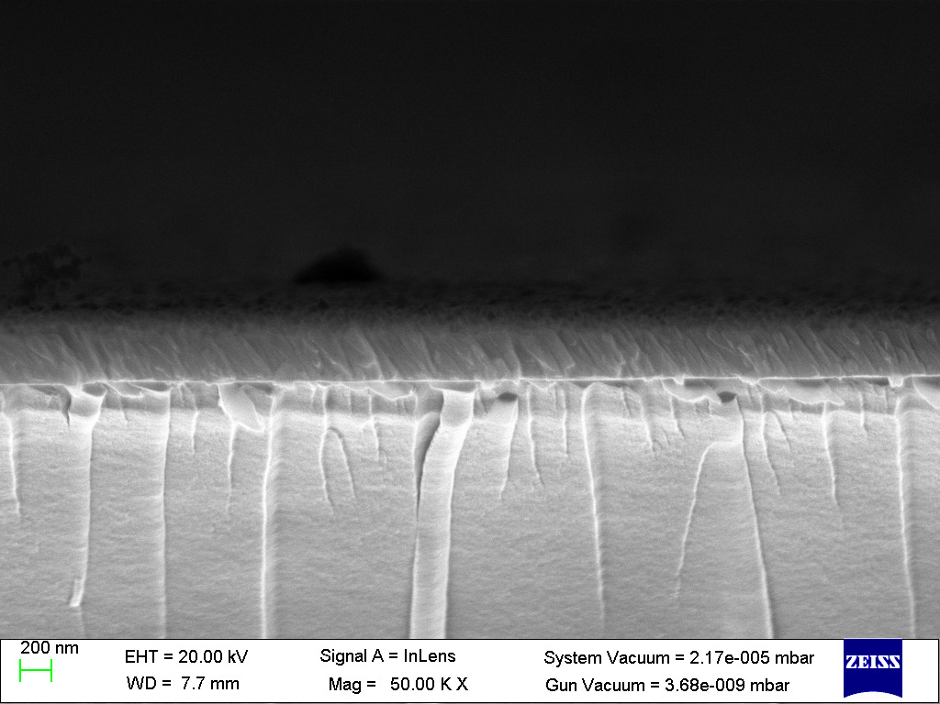

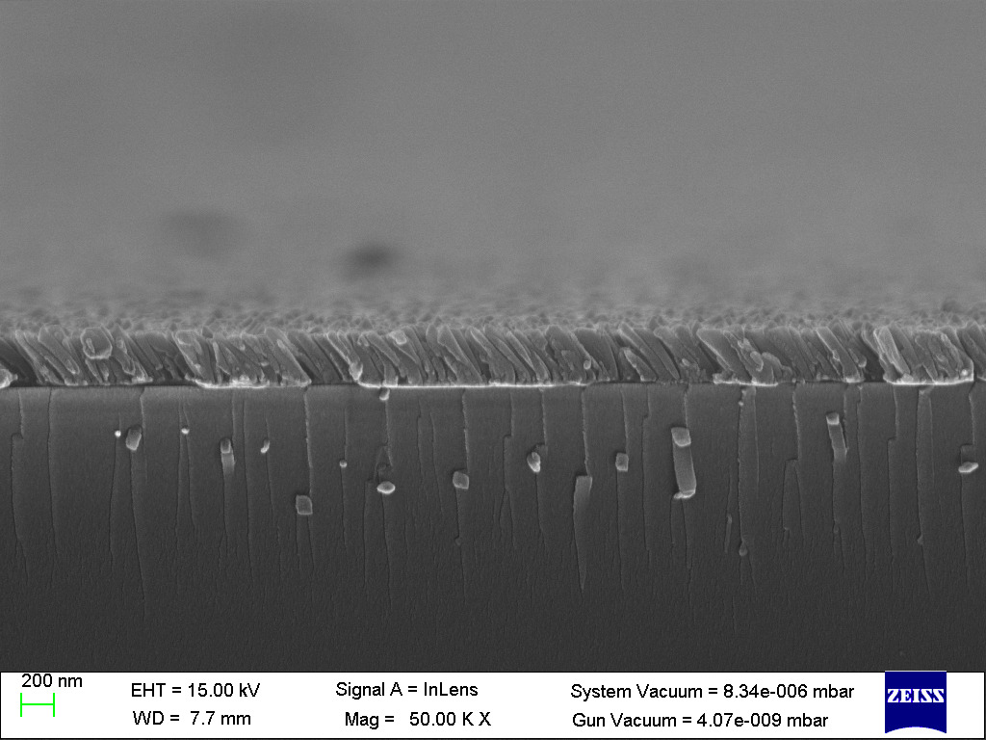

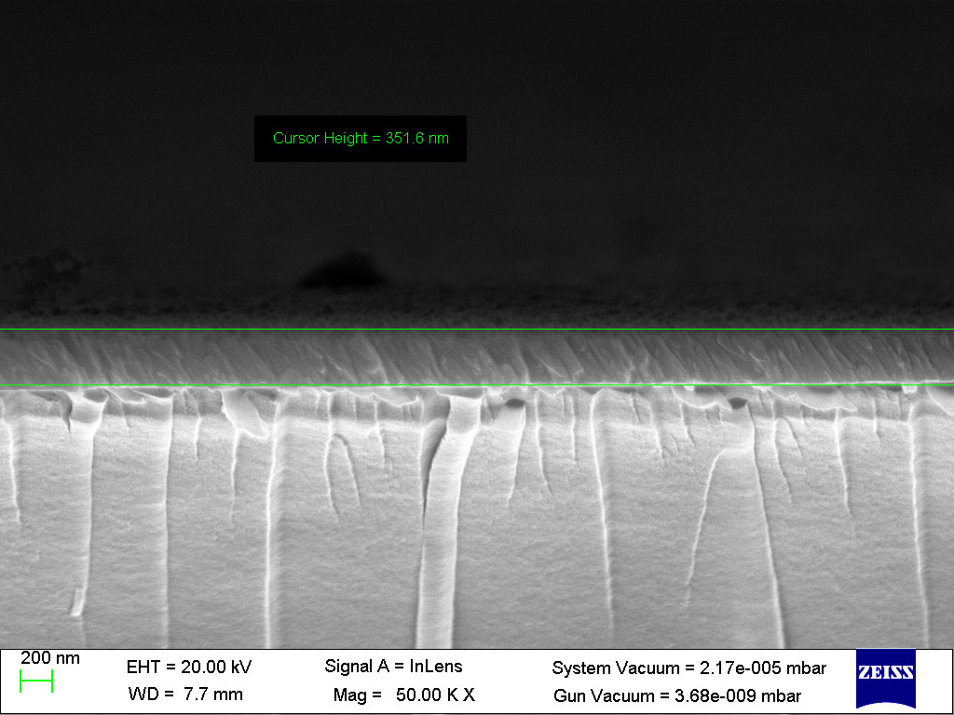

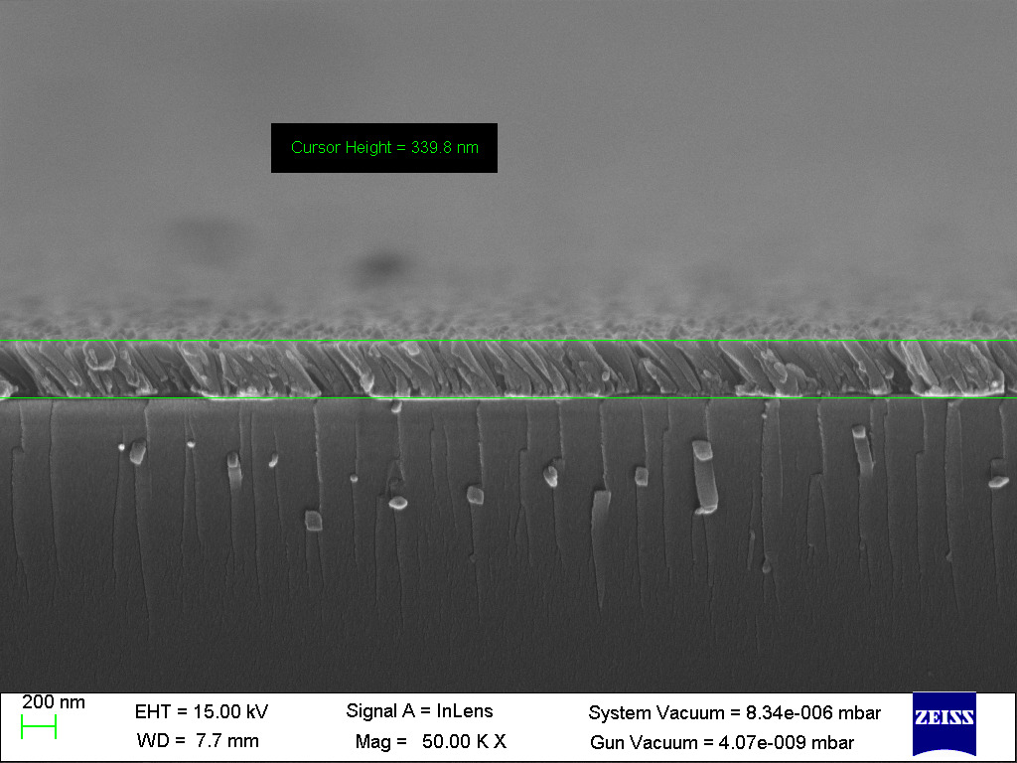

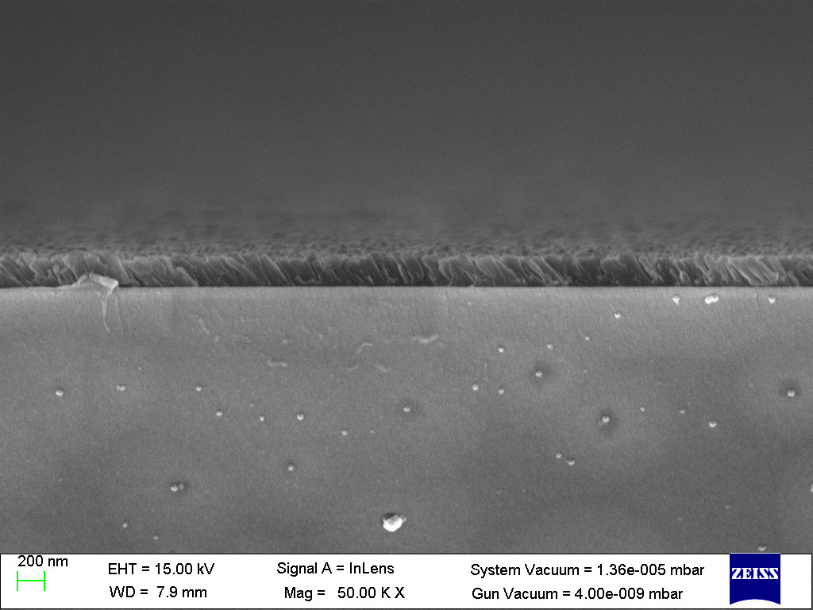

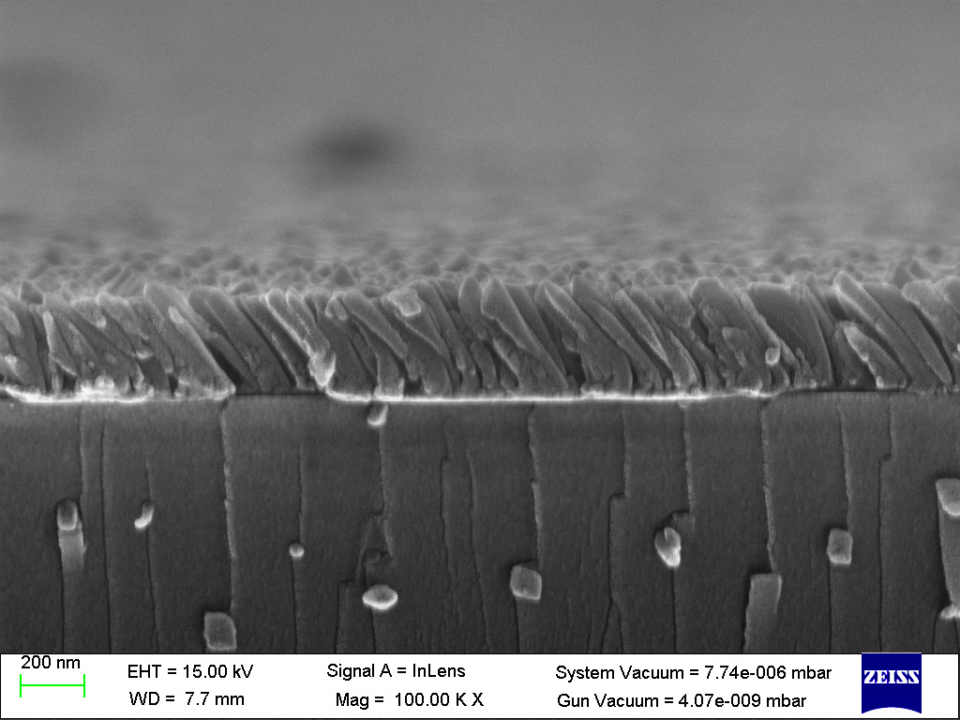

Calculations & Results

Image File | Measured Thickness (nm)
1.jpg | 351.6
0.jpg | 351.6
01.jpg | 339.8
00.jpg | 339.8
2.jpg | 320.0
02.jpg | 335.0

Average Thickness μ(T) ​≈ 339.6 nm
Error s(T) ​≈ 11.8 nm

Precautions

Sample Handling and Preparation
- Personal Protective Equipment (PPE): Always wear safety goggles when cleaving substrates (especially glass or silicon wafers), as brittle materials can produce sharp, microscopic flying shards.
- Contamination Control: FESEMs operate under ultra-high vacuum ( mbar) and are highly sensitive to contamination. Always wear clean, powder-free nitrile gloves when handling the sample, stubs, and any tools that will enter the chamber. Oils from bare skin will outgas, degrading the vacuum and potentially damaging the field emission tip.
- Solvent Evaporation: Ensure that the conductive silver paint used for grounding is completely dry before loading the sample into the SEM chamber. Wet paint will severely outgas and contaminate the column.

Equipment Operation
- Z-Height / Working Distance: Exercise extreme caution when adjusting the sample height (Z-axis) or tilting the stage. Because high-resolution imaging requires a short working distance (e.g., 7.7 mm), there is a significant risk of crashing the sample into the pole piece or the delicate In-Lens detector, which can cause catastrophic and expensive damage to the microscope.
- Sample Security: Ensure the sample is firmly adhered to the carbon tape. A loose sample can fall off inside the vacuum chamber, obstructing mechanisms or altering the electric fields.
- Beam Damage Mitigation: While aluminum is relatively robust, extended exposure to a high-energy electron beam (15 kV) at a single spot on a thin film can cause localized heating, melting, or carbon deposition (contamination buildup). Focus quickly and avoid leaving the beam parked on one tiny area for too long.
- Vacuum Sequences: Never force the chamber door open before the venting cycle is completely finished, and ensure the O-rings are clean of dust or hairs before pumping down to prevent vacuum leaks.

