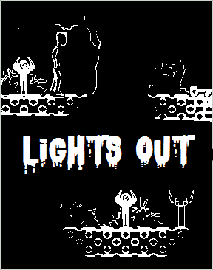

THAI TEAM | GAMES COURSE | 02/07/2016

**sTORY LINE**

1. Introduction

Lights Out is a 2D Adventure Puzzle game based on the main concept of light and dark, build with Unity. As the game progresses, story of a family of three uncovers, unveiling the reason behind their mysterious deaths and their ongoing struggle in Grim Reaper’s Dark World.

1. Setting/World

Various levels in 3 stages:

1. Factory of the Forgotten
2. Forest in the Mist
3. Cannibal Carnival

All of the stages are in the Grim Reaper’s Dark World.

1. Characters

The main character is a little demon in the Dark World who explores the stories of three human characters, a factory worker, a woman and a girl.

1. Game Story

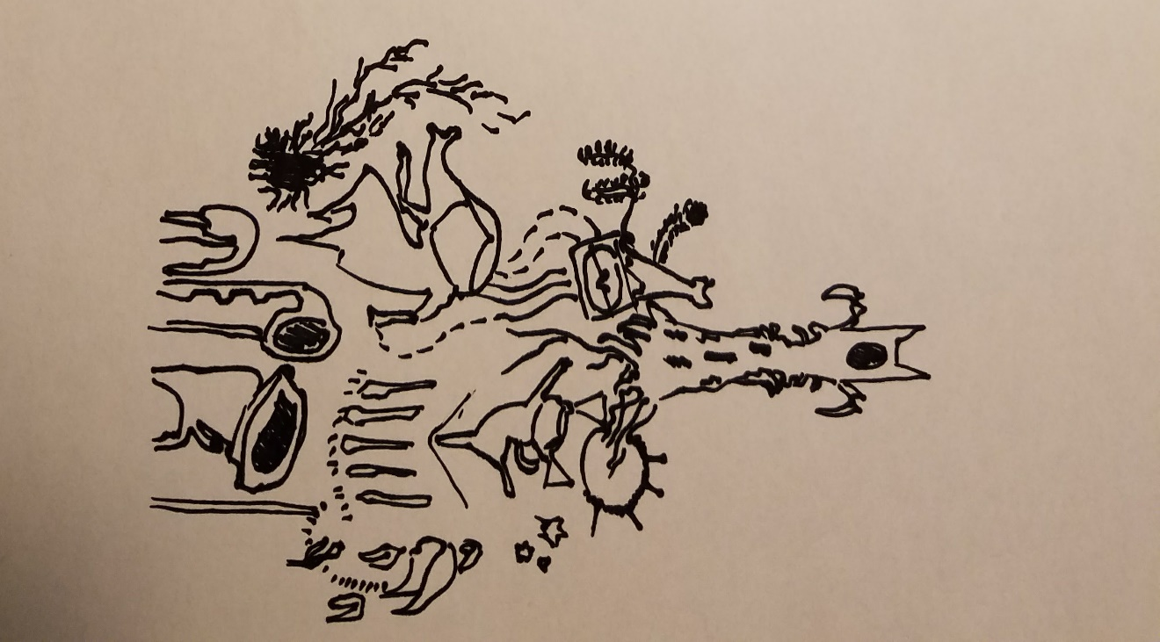All the three characters are dead. The Demon after had discovered their story decided to guide the three characters to the afterlife.

Figure 1. Concept Art

The factory worker’s story: he died of working too hard and can’t go to the afterlife because his heart keeps telling him that he forgot something. Throughout the first stage (with many levels), the worker’s story will reveal the cause of his death and the moments he missed in his lifetime.

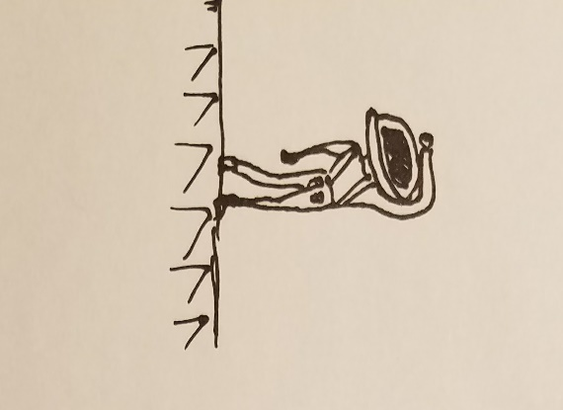

Figure 2. Rough design

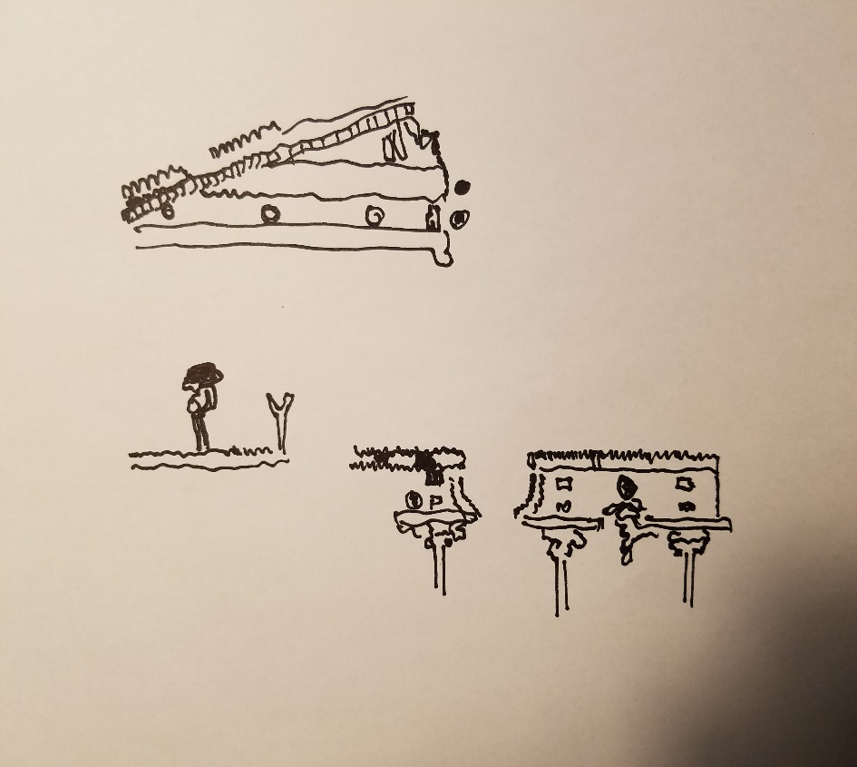

Figure 3. Concept art – Factory worker

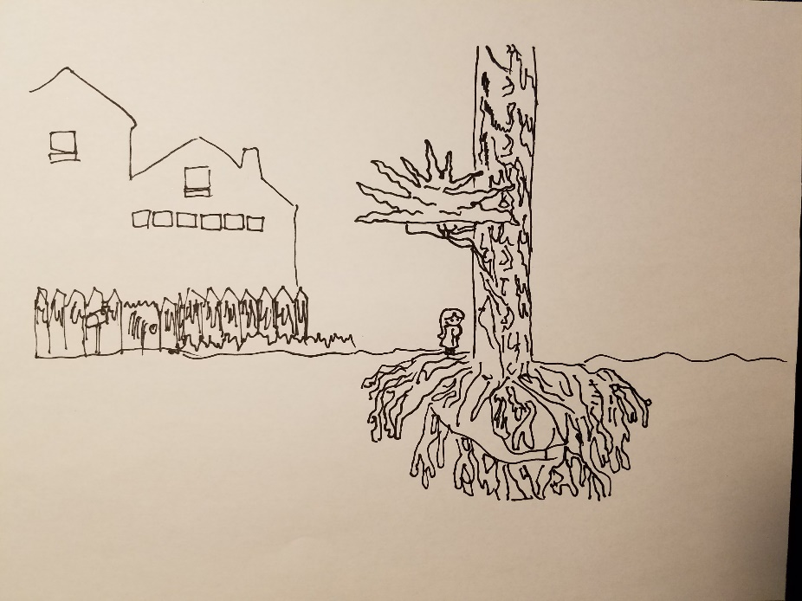The woman’s story: Her husband was never at home, left her alone to raise their daughter. She was miserable and her only joy in life is her daughter. One day she returned home and found her daughter’s dead body. She committed suicide and try to find her daughter soul in the Dark World. Until then, she stays stuck in the afterlife.

Figure 4. Concept art - The woman

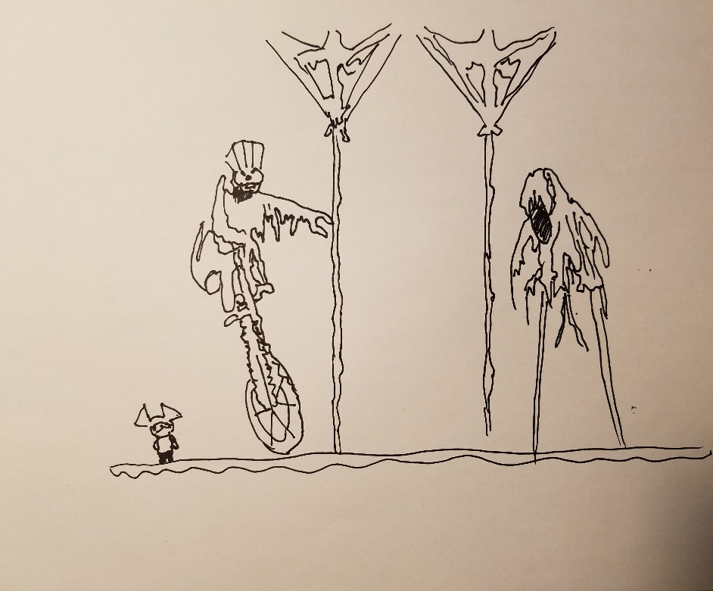

Figure 5. Concept art - The girl in Grim Reaper's Dark World

The girl’s story: She lives in an unhappy family with a negligible father and a miserable mother. Her only friend was a doll, which turned out to be a gift from The Grim Reaper. The doll killed her and she was held in the Grim Reaper’s Dark World.

Player will get the whole point of the game story through stage 3: The Grim Reaper is a bad guy who haunted the family life and try to capture 3 little souls, as it is the Reaper’s job to gather as many souls as possible. Through each level, player will discover parts of the story: the worker regrets working too hard without being around his family, which makes their souls vulnerable to the Grim. The factory worker tries to find the way back to his family. The woman realizes she needs to be stronger and fights hard against the mental trap od the Grim to find her daughter and husband. The daughter fights back the evil Grim, prevents her from being trapped in the Dark World. In the end, with the help of the demon they find each other in the Dark World defeat the Grim and live happily ever after in the afterlife.

1. Mechanics

Basic mechanic of the game: What is not seen, does not exist.

* Platform not lit by light sources will not be path-able.
* Obstacles not lit can be easily overcome.

Also, each character has a unique set of abilities and basic manipulation of light sources to help players maneuver through levels.

1. Conclusion

Lights Out, being an adventure puzzle game, has not only an entertainment aspect but also a moral value. The simple pixel art design and eerie sound effect of the game will definitely stay indelible, even upon completion.