Game rules:

Terms definitions:

- Move – unit moves from one tile to another one
- Fight – When fight is done all remaining action points are lost. Fight is composed from following actions:
  - unit move to neighborhood of attacked unit. When at attacked location is more than one enemy unit than attacked unit is selected TODO
  - unit perform fight
  - depending of fight result move to opponent’s tile or disappears
- Embark – unit move to neighborhood of unit and perform embark to unit. When unit embark all remaining action points are lost.
- Disembark – When unit is ship.
  - TODO: jak zohlednit cyklovani jednotek, asi se v cyklu nema objevit kdyz se nemuze vylodit. Ale kdyz lod prirazi ke brehu, pak se jednotka objevi v cyklu. Na jakem miste?
- Action – general term containing move, fight and embark.
- Active unit – Player can perform some action with this unit.

General rules:
- Just some units can embark and just some units can hold cargo.
- Unit can move until at least 1 action is remaining.

Game modes:
- Normal mode – game doesn’t expect that will perform any action. Any tile could be focused.
- Action mode - Unit that could perform some action is focused. Game expect that user will immediately mark some target location. To target location will unit move fight or embark.

Player can switch to action mode by focusing unit and:
- pressing M
- start dragging with left mouse button

Player can switch back to normal mode by:
- press ESC
- select some available tile. Selection could be done by left click or stop dragging of by pressing enter.

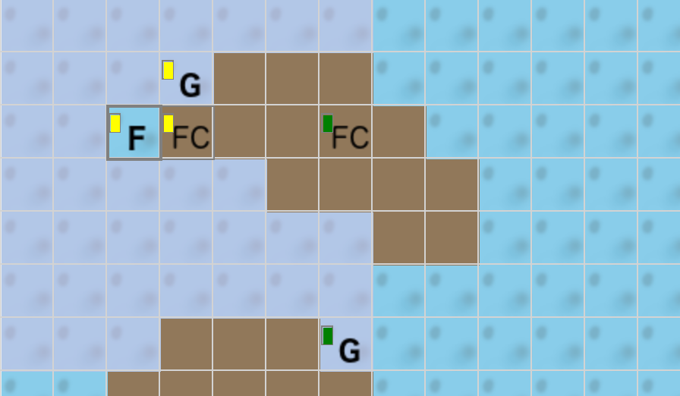
One-turn highlight
In action mode some tiles is highlighted. Highlighted tiles show locations where player can perform some action in current turn. It’s:
- location to move
- enemy unit to fight
- player’s unit to embark

Path highlighting
When player move cursor in action mode than there is always shown path from focused unit to tile where is mouse cursor. When user move cursor to some location than depending on target location path change view to notify user about operation. It’s at following picture
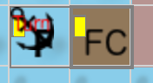
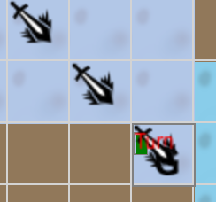
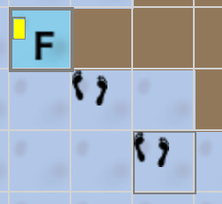
embark/disembark move fight

Multi turn movement
When user select some action outside of one-turn highlighted are that action will be perform in next turns. There is no guaranteed that requested action will be performed. It’s because map could change.
In multi turn move whole path is highlighted. In highlighted path will be market locations when player have to wait for next turn.

Unit Cycling
Player can automatically skip focus from one unit to another one. Units are ordered in fixed way. When player finish some action with one unit focus automatically move to another unit in row. Player can skip focused unit by pressing space. When use reach last unit than next turn button should be offered (I don’t know how). Player should be notified that all active units was checked. When player choose to continue all active unit will be cycled again.
TODO: How to ordering of units.

Scrolling
When full screen view in enabled and action mode is enabled than scrolling screen by mouse move should be supported.

TODO
- disembark how to show and perform
-

