Game rules:

Terms definitions:

- Move – unit moves from one tile to another one
- Fight – unit move to neighborhood of attacked unit perform fight and than depending of fight result move to opponent’s tile or disappears.
- Embark – unit move to neighborhood of unit and perform embark to unit
- Action – general term containing move, fight and embark.

General rules:
- Just some units can to be embark and just some unit’s can hold cargo.
- Unit can move until at least 1 action is remaining.

Game modes:
- Normal mode – game doesn’t expect that will perform any action. Any tile could be focused.
- Action mode - Unit that could perform some action is focused. Game expect that user will immediately mark some target location. To target location will unit move fight or embark.

Player can switch to action mode by focusing unit and:
- pressing M
- start dragging with left mouse button

Player can switch back to normal mode by:
- press ESC
- select some available tile. Selection could be done by left click or stop dragging of by pressing enter.

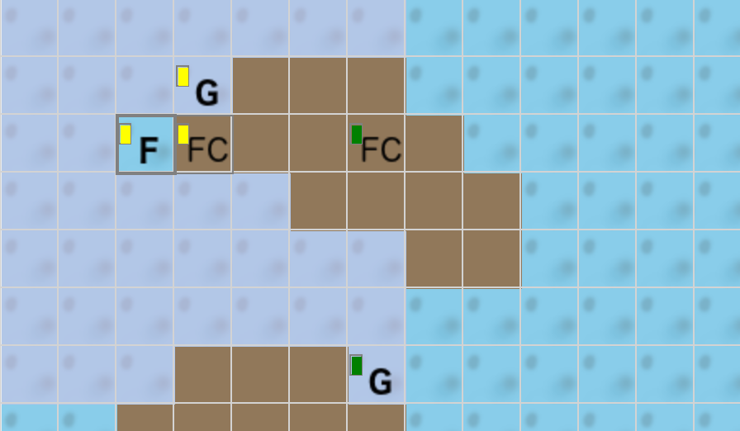
One-turn highlight
In action mode some area is highlighted. Highlighted tiles show locations where can user perform some action in one turn. It’s:
- location to move
- enemy unit to fight
- player’s unit to embark

Path highlighting
When player move cursor in action mode than there is always shown path from focused unit to tile where is mouse cursor. When user move cursor to some location than depending on target location path change view to notify user about operation. It’s at following picture
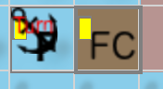
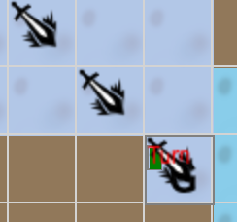
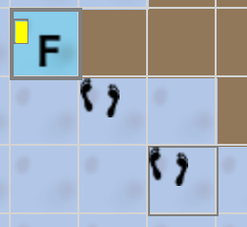
embark/disembark move fight

During multi turn action there will marked when turn ends. It helps player to plan when action will be done.

Multi turn movement
When user select some action outside of one-turn highlighted are that action will be perform in next turns. There is no guaranteed that requested action will be performed. It’s because map could change.
In multi turn move whole path is highlighted.

TODO
- screen scrolling in full screen in action mode
-

