**RESULT**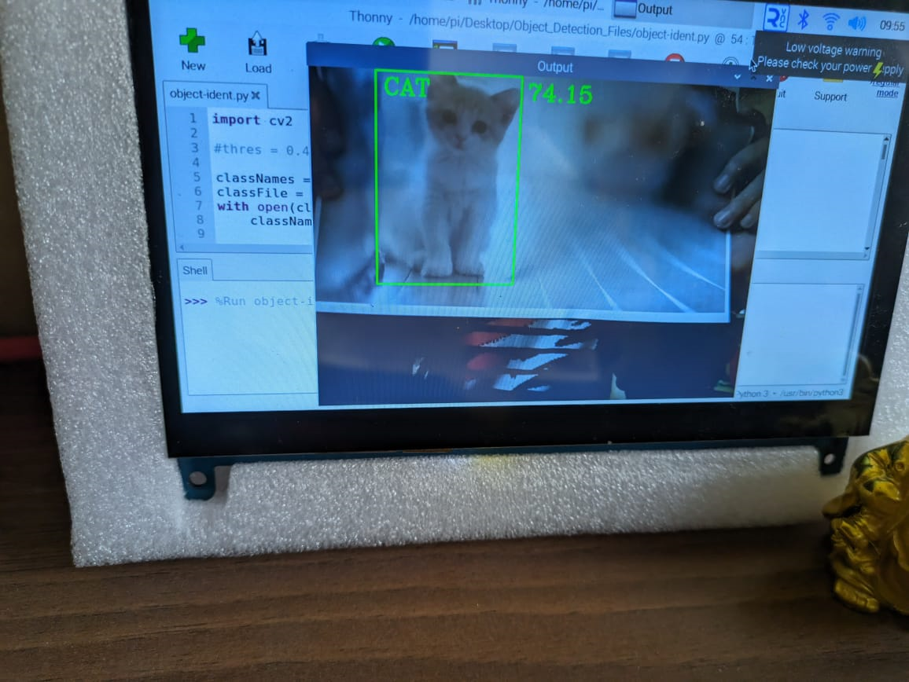

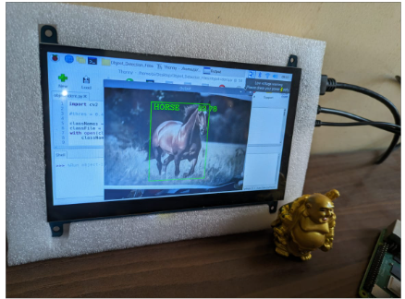

**BUDGET ANALYSIS OF THE PROTOTYPE**

|  |  |  |  |
| --- | --- | --- | --- |
| **PRODUCT** | **RATE** | **QTY** | **TOTAL** |
| RASPBERRY PI CASE | 250 | 1 | 250 |
| RASPBERRY PI 4B | 5500 | 1 | 5500 |
| 7” INCH HD DISPLAY | 5500 | 1 | 5500 |
| RASPBERRY PI CAMERA | 1500 | 1 | 1500 |
| SD CARD | 550 | 1 | 550 |
| 5V CHARGER | 200 | 2 | 400 |
| HDMI CABLE | 100 | 1 | 100 |
| **GRAND TOTAL** |  |  | 13800 |