When working with Claude, writing a good prompt is just the beginning. To build reliable AI applications, you need to understand two critical concepts: prompt engineering and prompt evaluation. Prompt engineering gives you techniques for writing better prompts, while prompt evaluation helps you measure how well those prompts actually work.
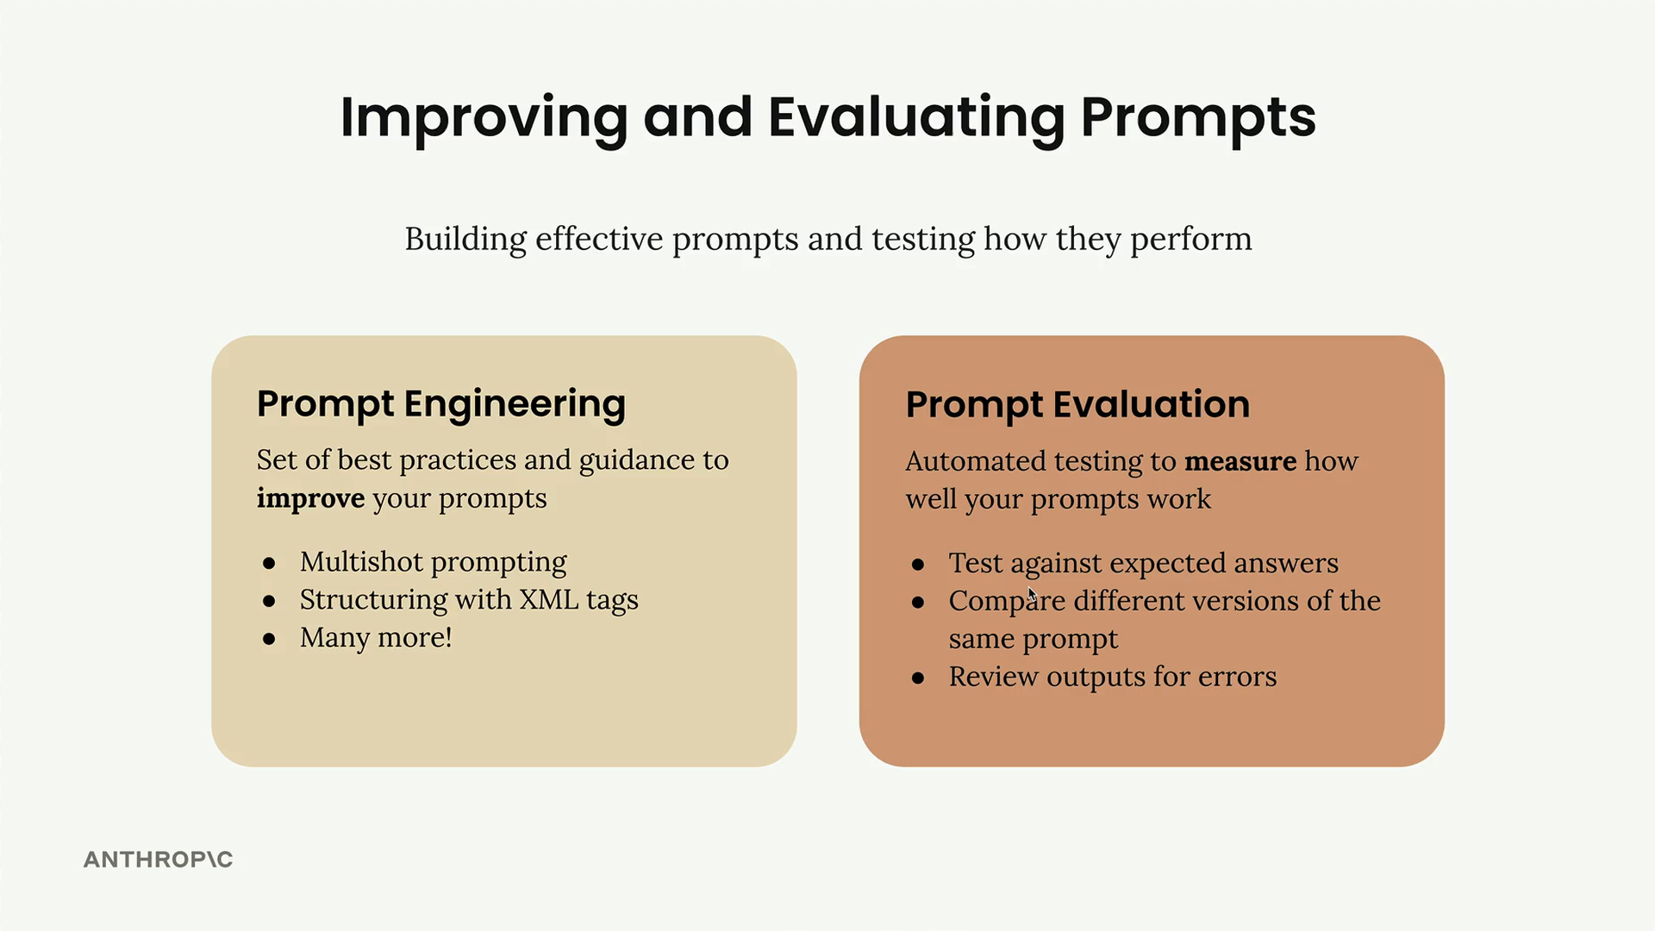

Prompt Engineering vs Prompt Evaluation
Prompt engineering is your toolkit for crafting effective prompts. It includes techniques like:
- Multishot prompting
- Structuring with XML tags
- Many other best practices
These techniques help Claude understand exactly what you're asking for and how you want it to respond.
Prompt evaluation takes a different approach. Instead of focusing on how to write prompts, it's about measuring their effectiveness through automated testing. You can:
- Test against expected answers
- Compare different versions of the same prompt
- Review outputs for errors

Three Paths After Writing a Prompt
Once you've drafted a prompt, you typically face three options for what to do next:
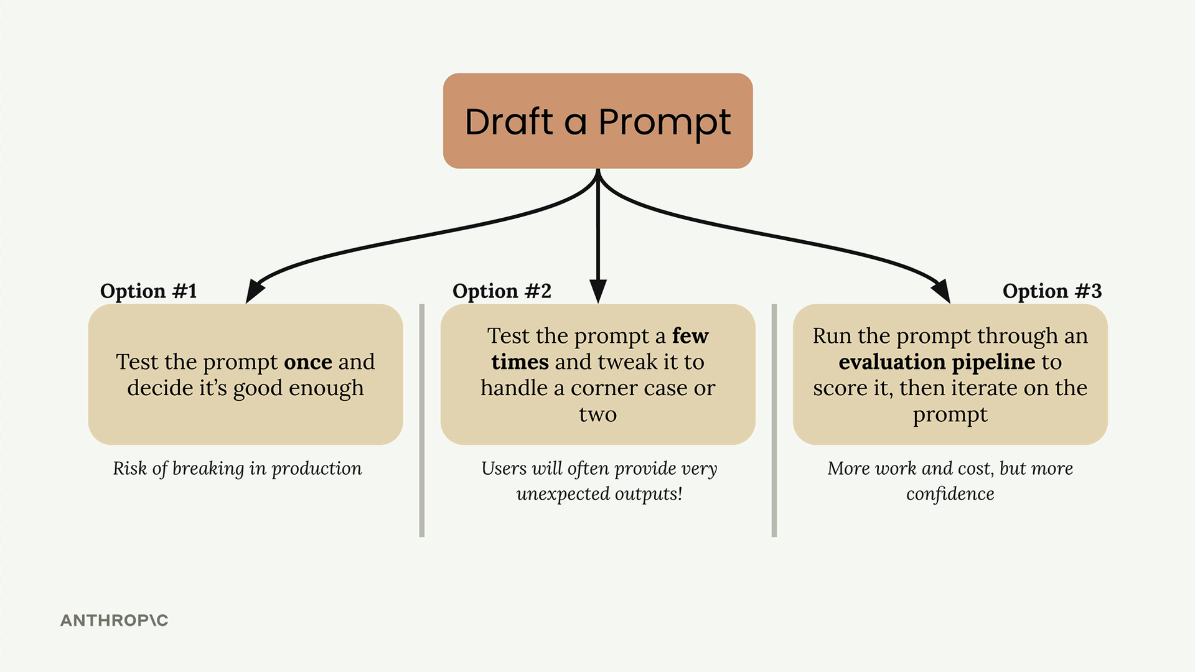
Option 1: Test the prompt once and decide it's good enough. This carries a significant risk of breaking in production when users provide unexpected inputs.
Option 2: Test the prompt a few times and tweak it to handle a corner case or two. While better than option 1, users will often provide very unexpected outputs that you haven't considered.
Option 3: Run the prompt through an evaluation pipeline to score it, then iterate on the prompt based on objective metrics. This approach requires more work and cost, but gives you much more confidence in your prompt's reliability.

Why Most Engineers Fall Into Testing Traps
Options 1 and 2 are common traps that all engineers fall into, myself included. It's natural to write a prompt for a serious application and not test it thoroughly enough. We tend to underestimate how many edge cases real users will encounter.
The reality is that when you deploy a prompt to production, users will interact with it in ways you never anticipated. What seemed like a solid prompt during your limited testing can quickly break down when faced with the full variety of real-world inputs.

The Evaluation-First Approach
Option 3 represents a more systematic approach to prompt development. By running your prompt through an evaluation pipeline, you get objective metrics about its performance across a broader range of test cases. This data-driven approach lets you:
- Identify weaknesses before they become production issues
- Compare different prompt versions objectively
- Iterate with confidence based on measurable improvements
- Build more reliable AI applications
While this approach requires more upfront investment in time and testing infrastructure, it pays dividends in the reliability and robustness of your final application. The goal is to catch problems during development rather than after your users encounter them.

Eval Flow

A typical prompt evaluation workflow follows five key steps that help you systematically improve your prompts through objective measurement. While there are many different ways to assemble these workflows and various open source and paid tools available, understanding the core process helps you start small and scale up as needed.
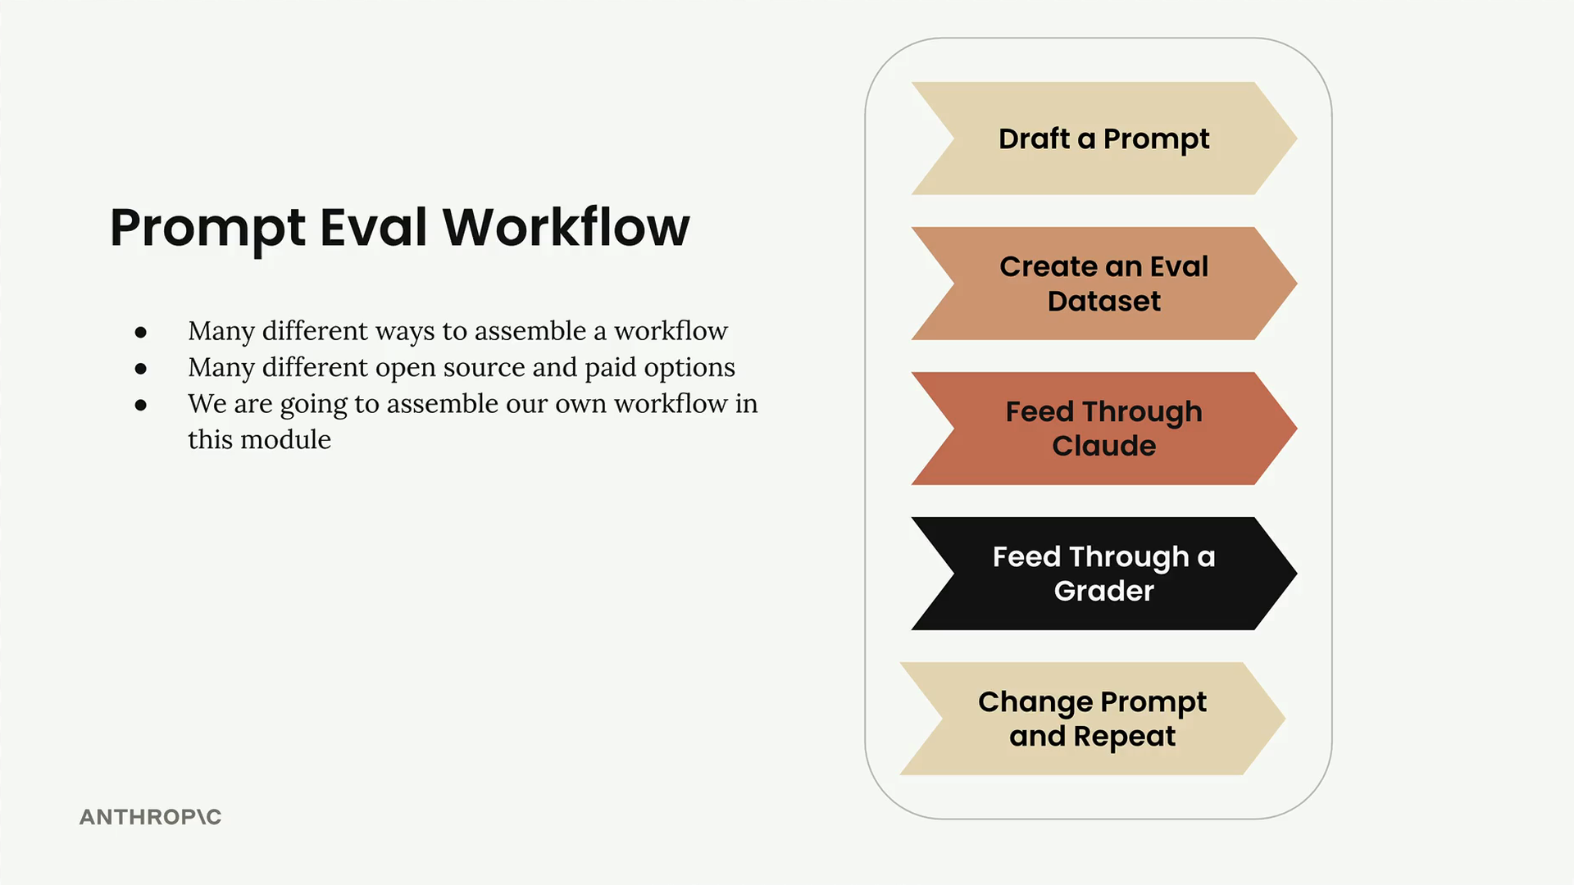

Step 1: Draft a Prompt
Start by writing an initial prompt that you want to improve. For this example, we'll use a simple prompt:
prompt = f"""
Please answer the user's question:

{question}
"""
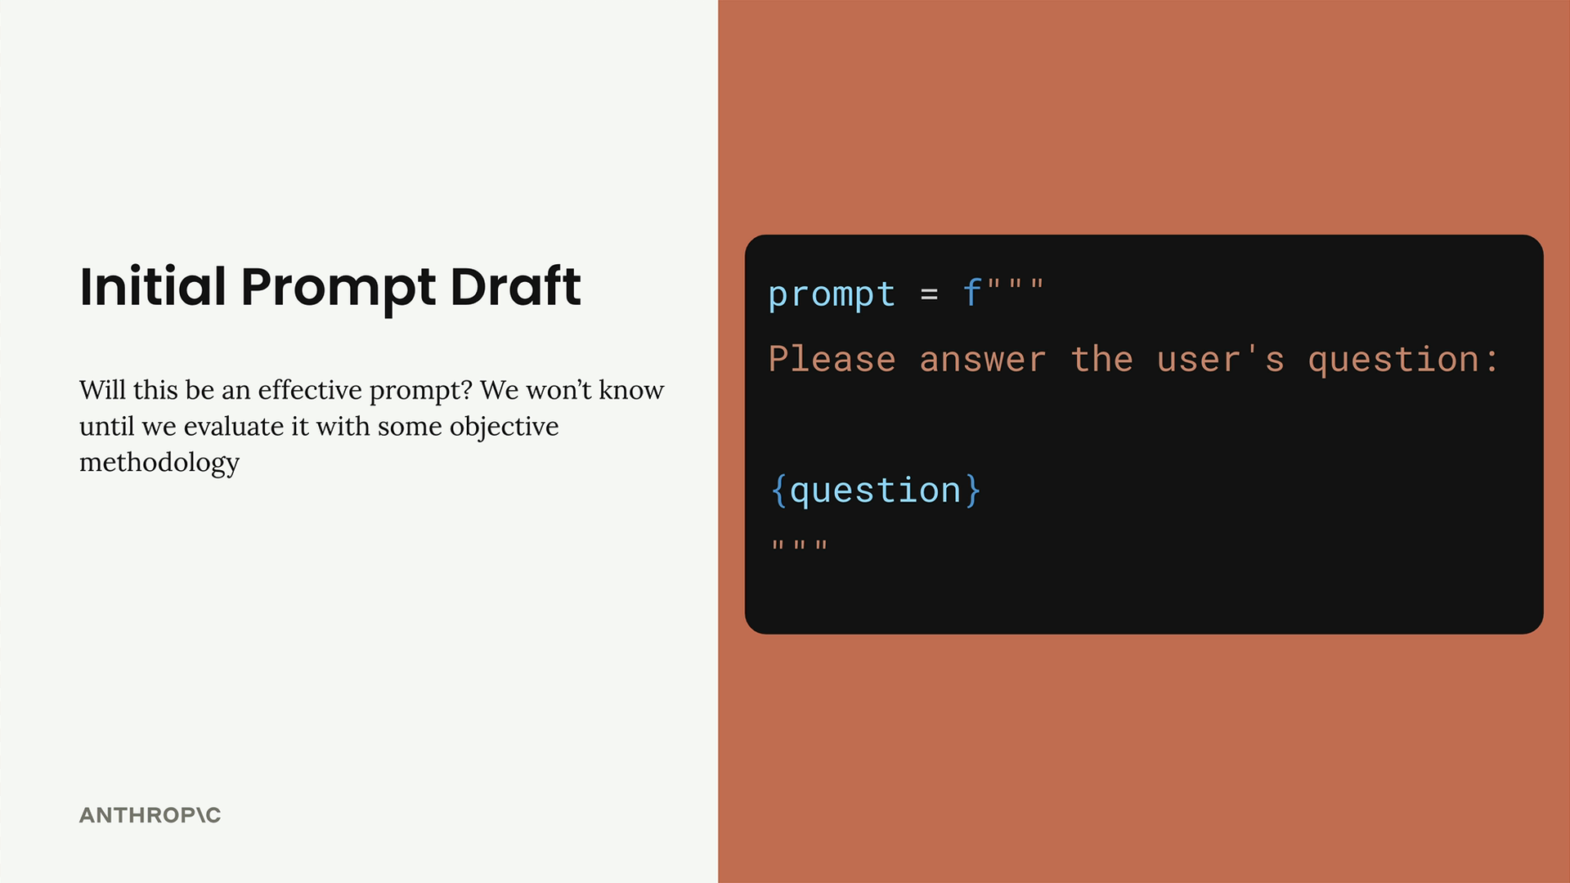
This basic prompt will serve as our baseline for testing and improvement.

Step 2: Create an Eval Dataset
Your evaluation dataset contains sample inputs that represent the types of questions or requests your prompt will handle in production. The dataset should include questions that will be interpolated into your prompt template.
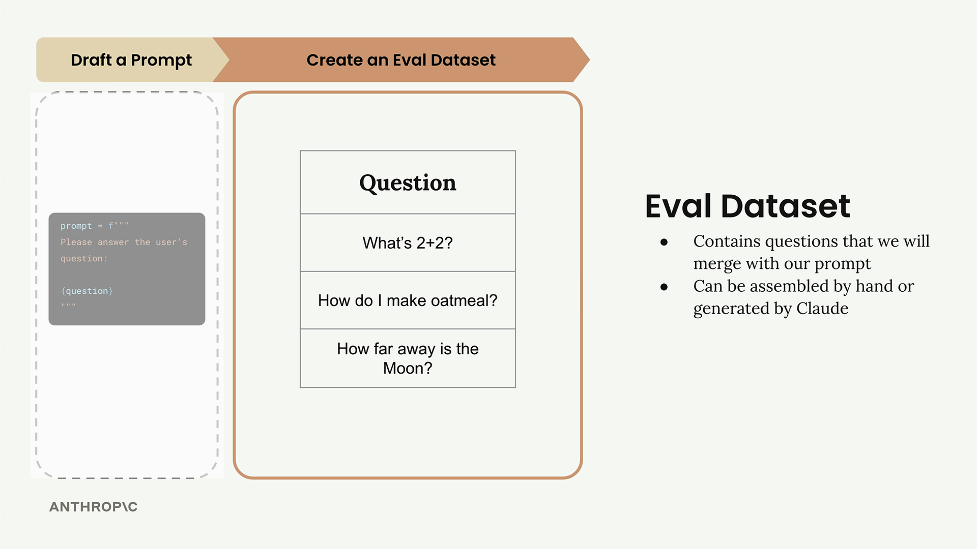
For this example, our dataset includes three questions:
- "What's 2+2?"
- "How do I make oatmeal?"
- "How far away is the Moon?"
In real-world evaluations, you might have tens, hundreds, or even thousands of records. You can assemble these datasets by hand or use Claude to generate them for you.

Step 3: Feed Through Claude
Take each question from your dataset and merge it with your prompt template to create complete prompts. Then send each one to Claude to get responses.
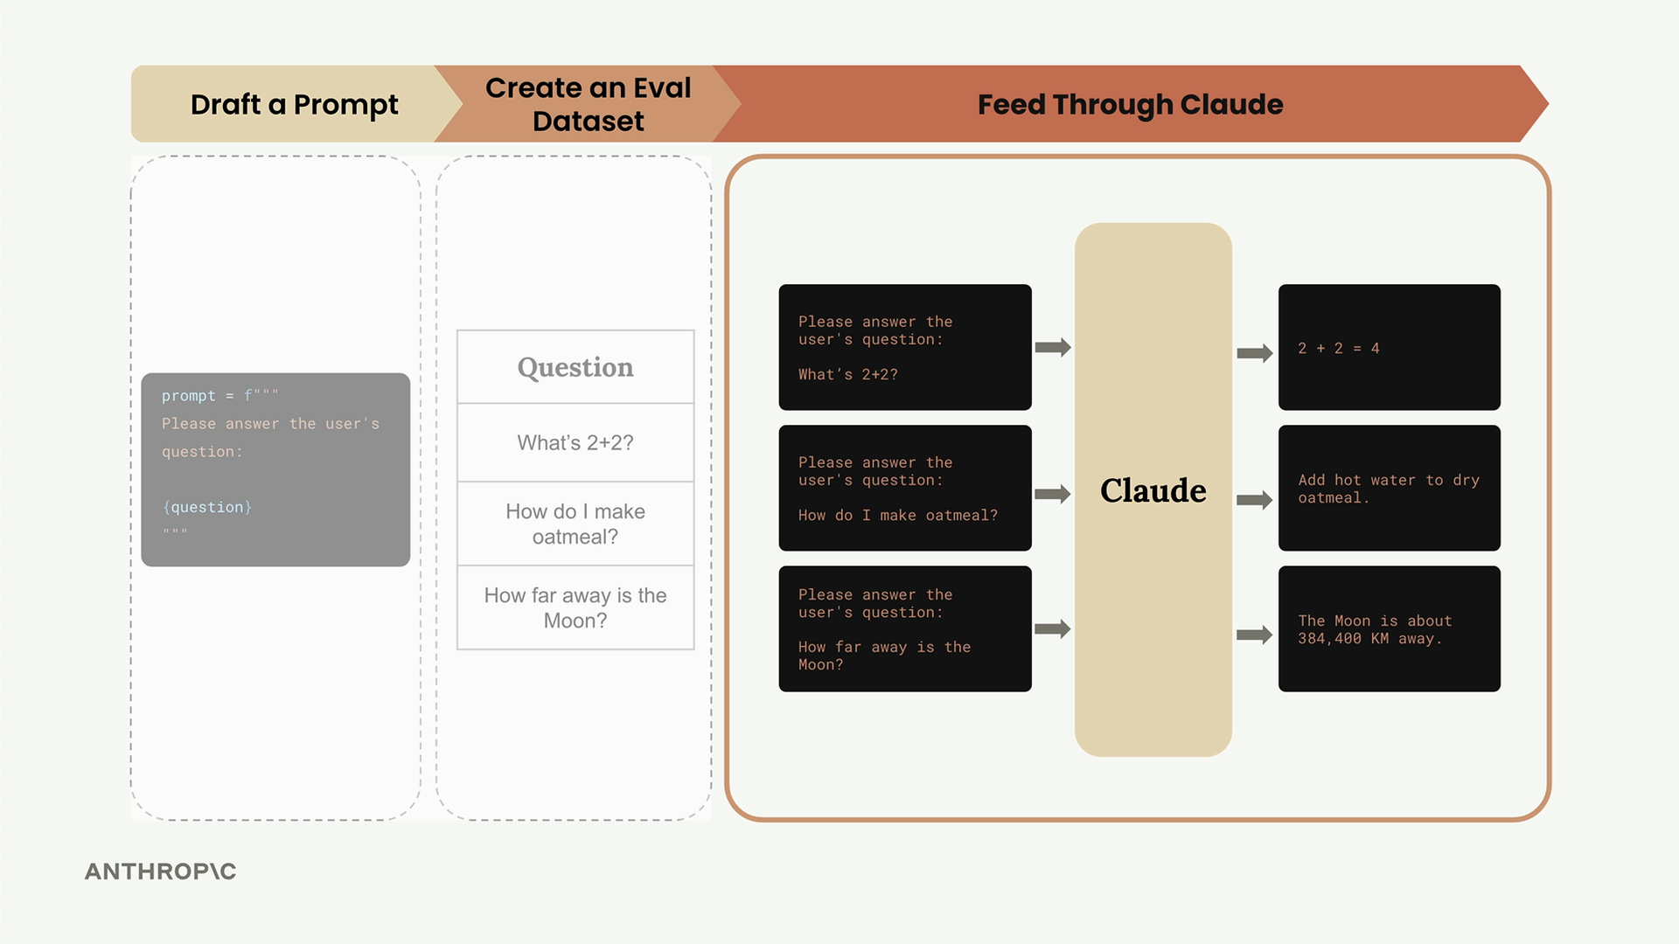
For example, the first question becomes:
Please answer the user's question:
What's 2+2?
Claude might respond with "2 + 2 = 4" for the math question, provide oatmeal cooking instructions for the second question, and give the distance to the Moon for the third.

Step 4: Feed Through a Grader
The grader evaluates the quality of Claude's responses by examining both the original question and Claude's answer. This step provides objective scoring, typically on a scale from 1 to 10, where 10 represents a perfect answer and lower scores indicate room for improvement.
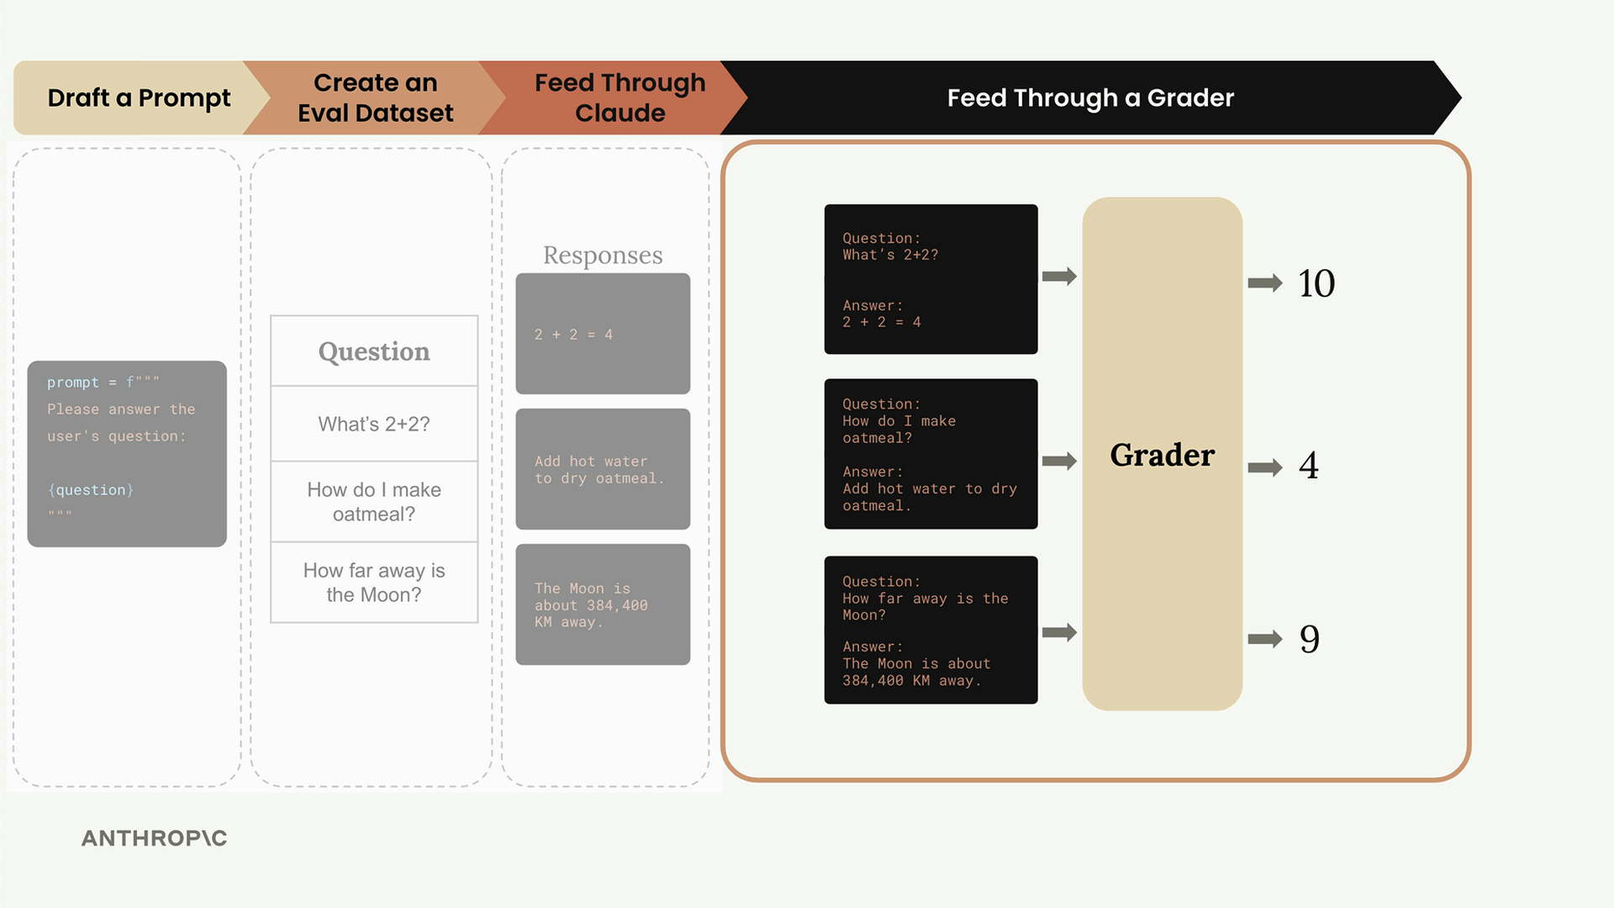
In our example, the grader might assign:
- Math question: 10 (perfect answer)
- Oatmeal question: 4 (needs improvement)
- Moon question: 9 (very good answer)
The average score across all questions gives you an objective measurement: (10 + 4 + 9) ÷ 3 = 7.66

Step 5: Change Prompt and Repeat
Now that you have a baseline score, you can modify your prompt and run the entire process again to see if your changes improve performance.
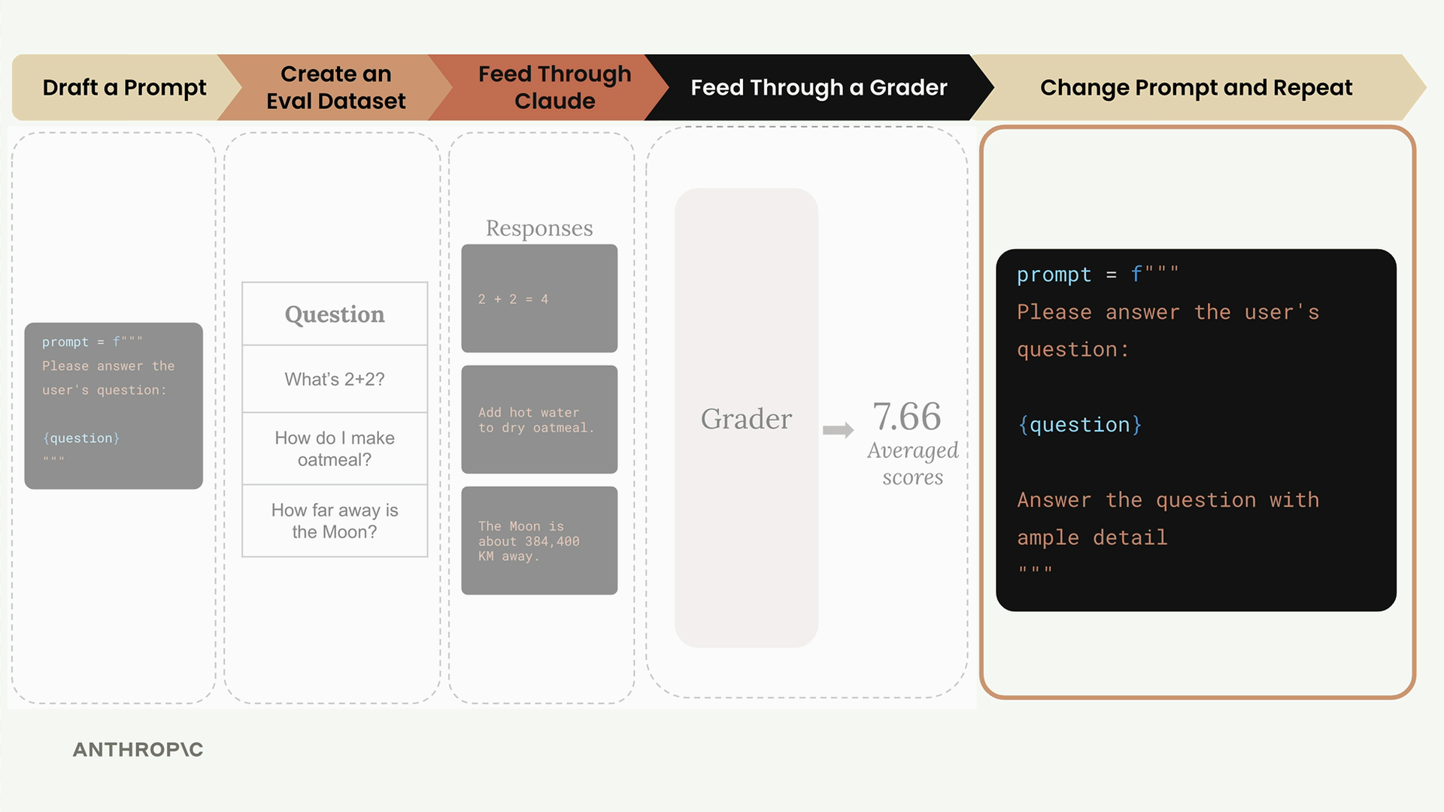
For example, you might add more guidance to your prompt:
prompt = f"""
Please answer the user's question:

{question}

Answer the question with ample detail
"""
After running this improved prompt through the same evaluation process, you might get a higher average score of 8.7, indicating that the additional instruction helped Claude provide better responses.

Prompt Scoring
The key benefit of this workflow is getting objective measurements of prompt performance. You can:
- Compare different prompt versions numerically
- Use the version with the best score
- Continue iterating to find even better approaches
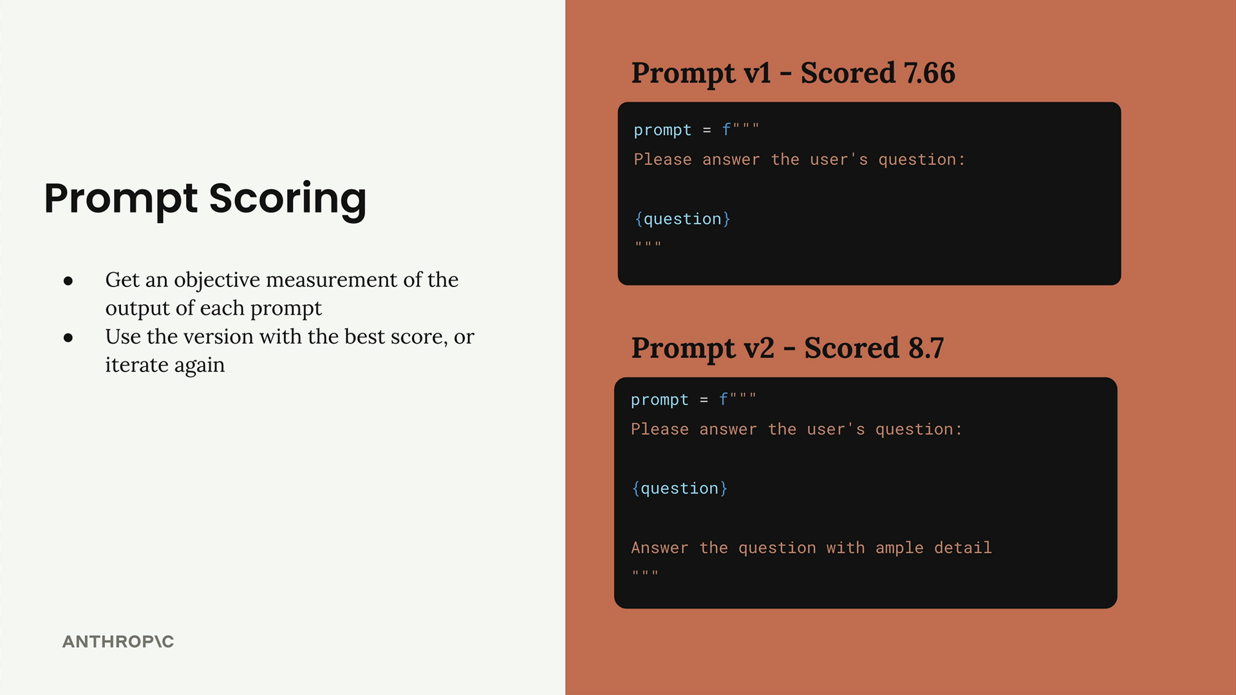
This systematic approach removes guesswork from prompt engineering and gives you confidence that your changes are actually improvements rather than just different variations.

Generating Dataset
Building a custom prompt evaluation workflow starts with creating a solid prompt and then generating test data to see how well it performs. Let's walk through setting up an evaluation system for a prompt that helps users write AWS-specific code.

Setting Up the Goal
Our prompt needs to assist users in writing three specific types of output for AWS use cases:
- Python code
- JSON configuration files
- Regular expressions
The key requirement is that when a user requests help with a task, we return clean output in one of these formats without any extra explanations, headers, or footers.
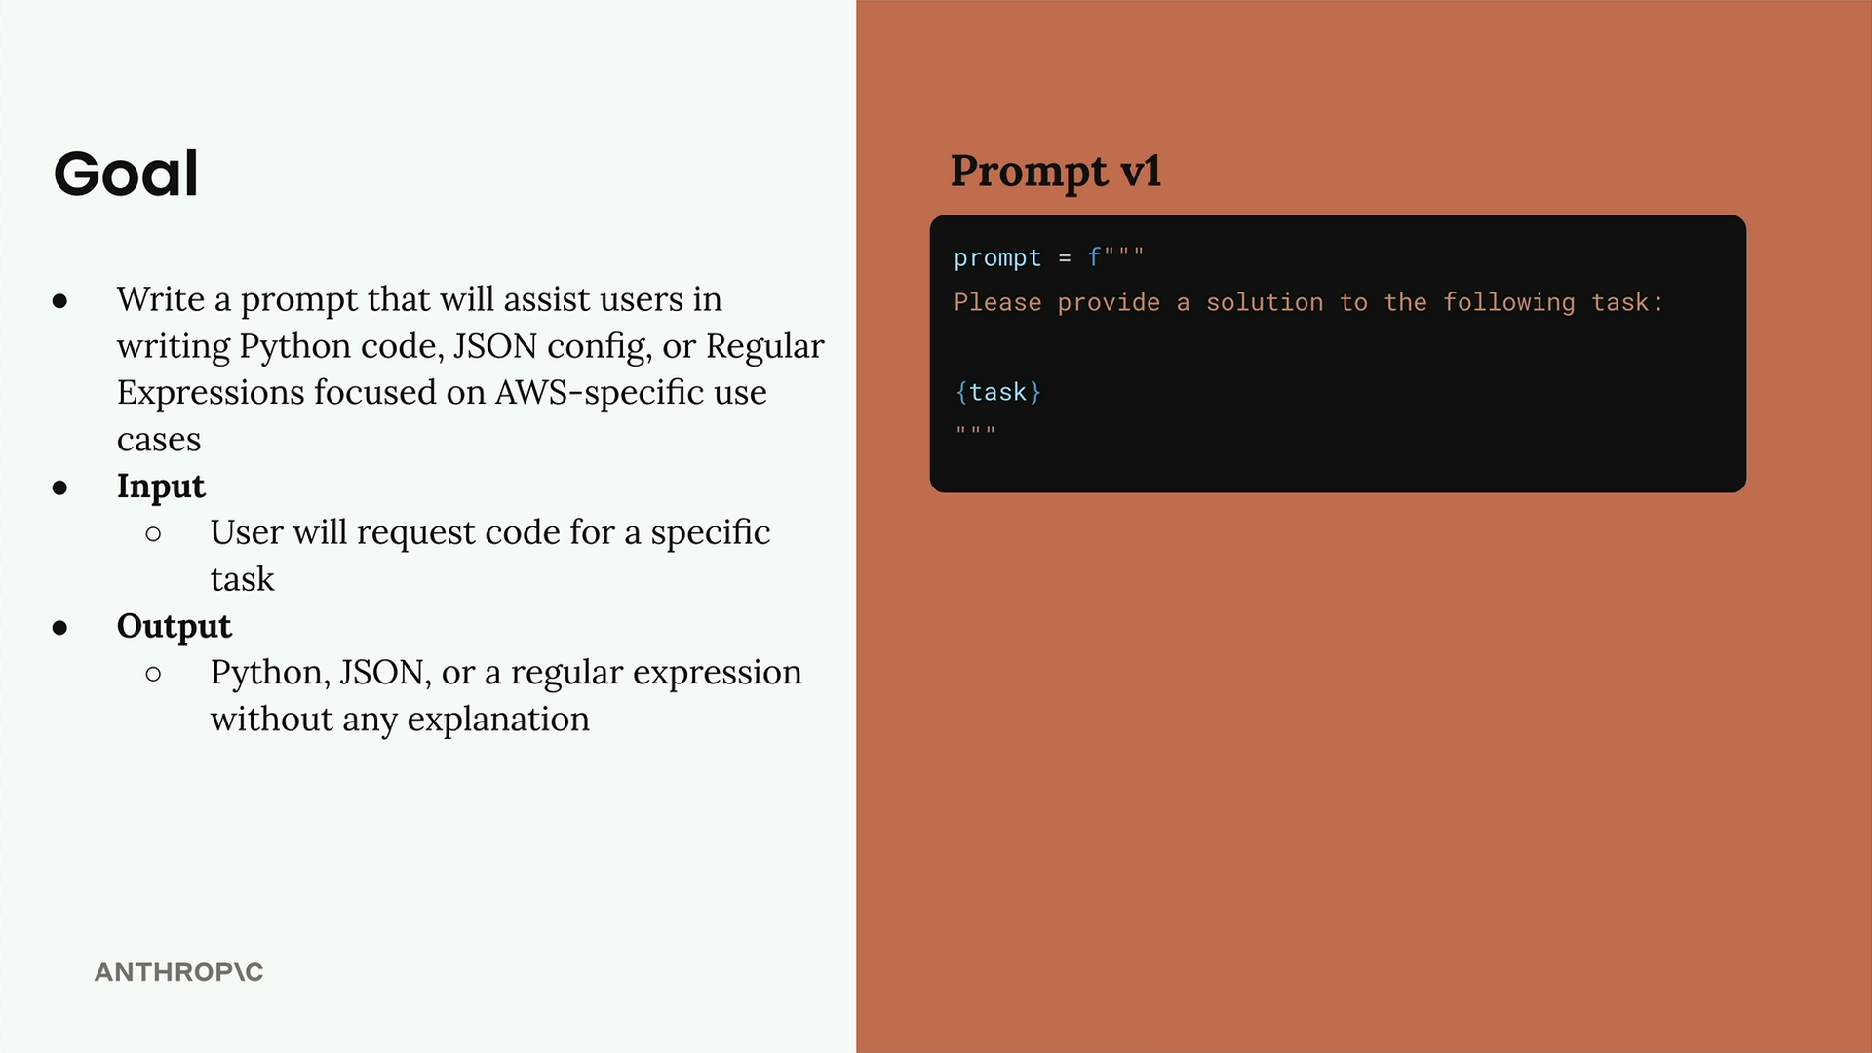
Here's our starting prompt (version 1):
prompt = f"""
Please provide a solution to the following task:
{task}
"""

Creating an Evaluation Dataset
An evaluation dataset contains inputs that we'll feed into our prompt. For each combination of prompt and input, we'll run the prompt and analyze the results.
Our dataset will be an array of JSON objects, where each object contains a "task" property describing what we want Claude to accomplish. We can either create this dataset by hand or generate it automatically using Claude.
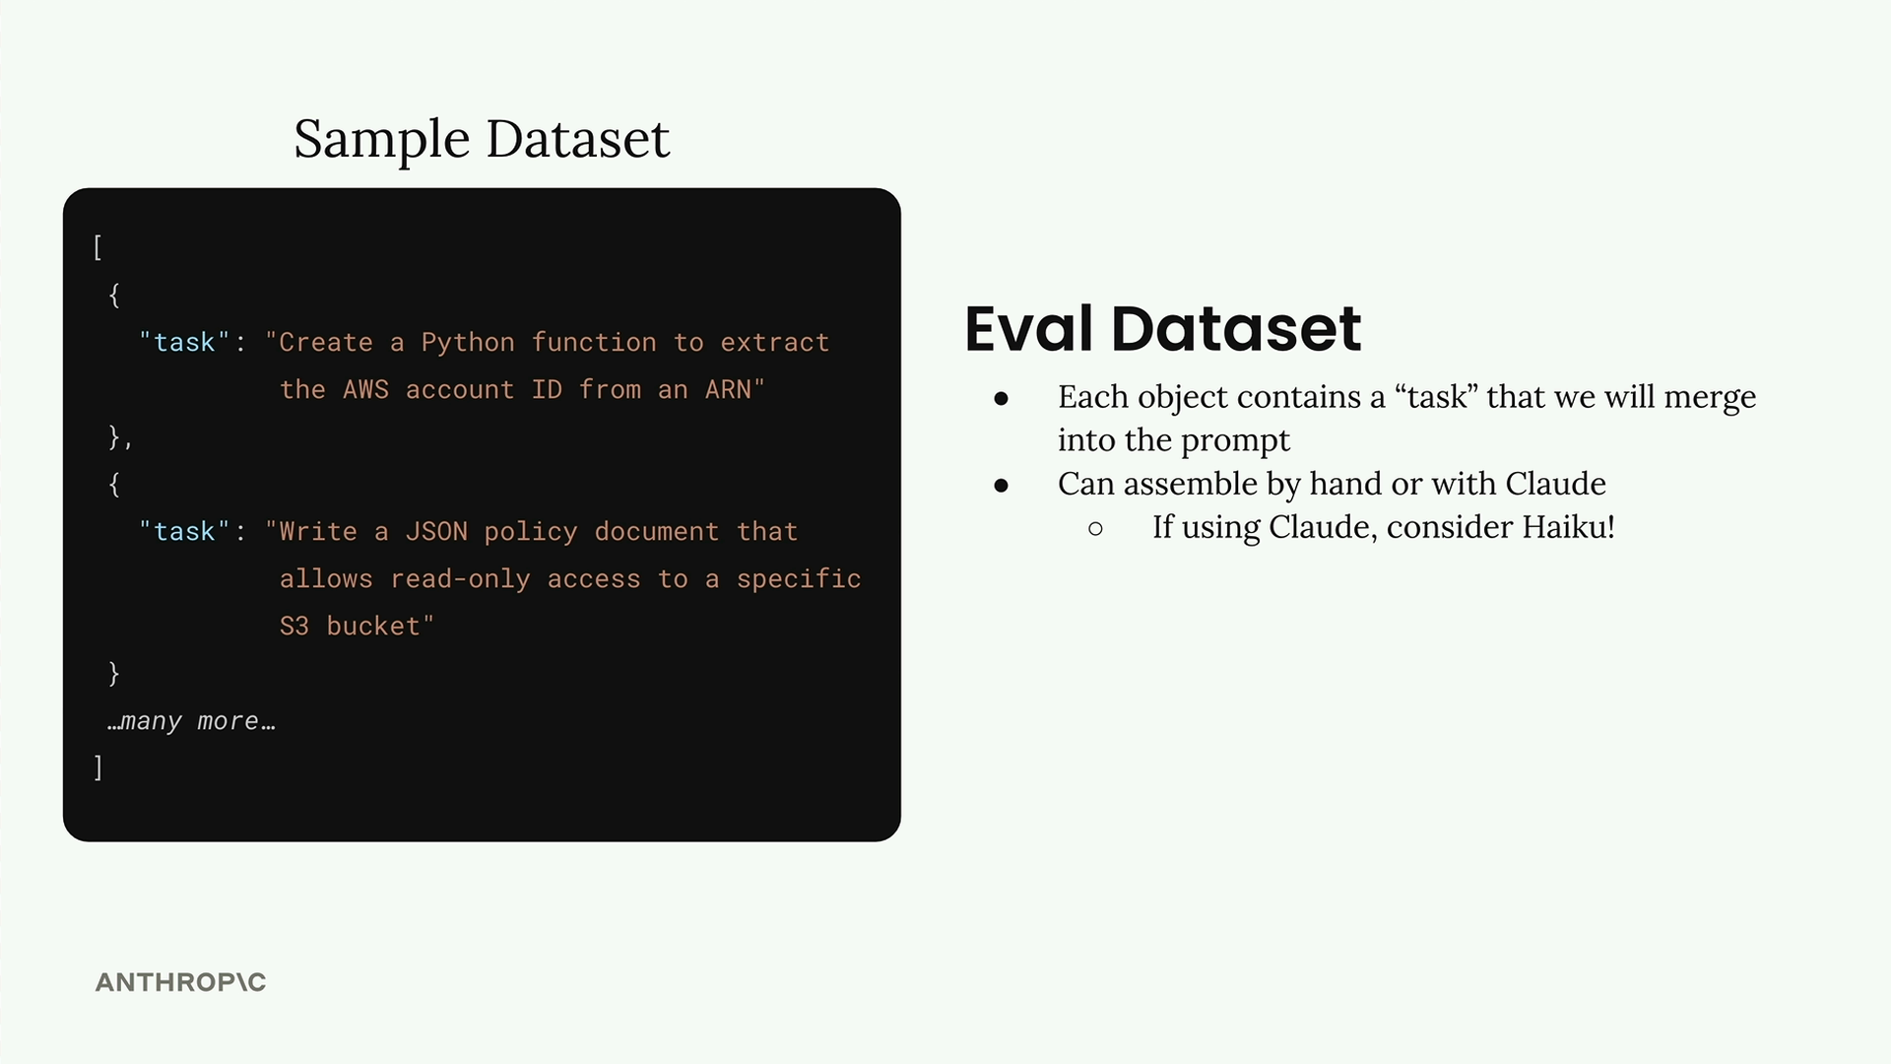
Since we're generating test data, this is a perfect opportunity to use a faster model like Haiku instead of the full Claude model.

Generating Test Data with Code
Let's create a function that automatically generates our test dataset. First, we'll need our helper functions for working with Claude:
def add_user_message(messages, text):
user_message = {"role": "user", "content": text}
messages.append(user_message)

def add_assistant_message(messages, text):
assistant_message = {"role": "assistant", "content": text}
messages.append(assistant_message)

def chat(messages, system=None, temperature=1.0, stop_sequences=[]):
params = {
"model": model,
"max_tokens": 1000,
"messages": messages,
"temperature": temperature
}
if system:
params["system"] = system
if stop_sequences:
params["stop_sequences"] = stop_sequences

response = client.messages.create(**params)
return response.content[0].text
Now we'll create our dataset generation function:
def generate_dataset():
prompt = """
Generate an evaluation dataset for a prompt evaluation. The dataset will be used to evaluate prompts that generate Python, JSON, or Regex specifically for AWS-related tasks. Generate an array of JSON objects, each representing task that requires Python, JSON, or a Regex to complete.

Example output:
```json
[
{
"task": "Description of task",
},
...additional
]
```

* Focus on tasks that can be solved by writing a single Python function, a single JSON object, or a single regex
* Focus on tasks that do not require writing much code

Please generate 3 objects.
"""
To properly parse the JSON response, we'll use prefilling and stop sequences:
messages = []
add_user_message(messages, prompt)
add_assistant_message(messages, "```json")
text = chat(messages, stop_sequences=["```"])
return json.loads(text)

Testing the Dataset Generation
Let's run our function and see what kind of test cases we get:
dataset = generate_dataset()
print(dataset)
This should return three different test cases covering our target outputs - Python functions, JSON configurations, and regular expressions for AWS-specific tasks.

Saving the Dataset
Once we have our dataset, we'll save it to a file so we can easily load it later during evaluation:
with open('dataset.json', 'w') as f:
json.dump(dataset, f, indent=2)
This creates a dataset.json file in the same directory as your notebook, containing your list of tasks ready for prompt evaluation.
With this foundation in place, you now have a systematic way to generate test data for evaluating how well your prompts perform across different types of AWS-related coding tasks.

Running the eval

Now that we have our evaluation dataset ready, it's time to build the core evaluation pipeline. This involves taking each test case, merging it with our prompt, feeding it to Claude, and then grading the results.
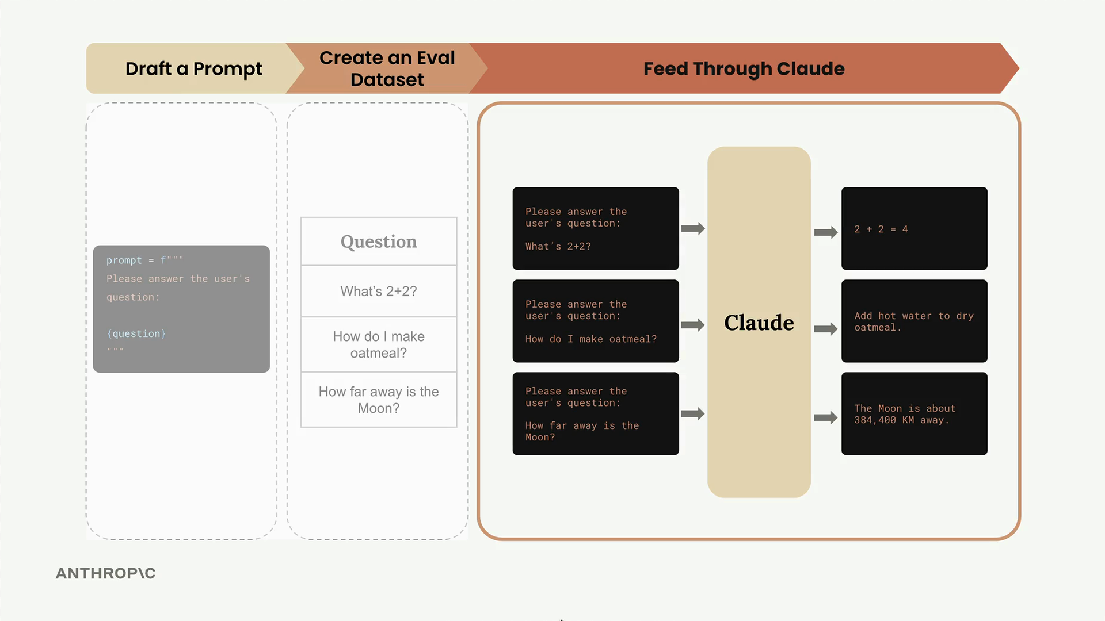
The evaluation process follows a clear workflow: we take our dataset of test cases, combine each one with our prompt template, send it to Claude for processing, and then evaluate the output using a grader system.

Building the Core Functions
The evaluation pipeline consists of three main functions, each with a specific responsibility. Let's start with the simplest one - the function that handles individual prompt execution.

The run_prompt Function
This function takes a test case and merges it with our prompt template:
def run_prompt(test_case):
"""Merges the prompt and test case input, then returns the result"""
prompt = f"""
Please solve the following task:

{test_case["task"]}
"""

messages = []
add_user_message(messages, prompt)
output = chat(messages)
return output

Right now, we're keeping the prompt extremely simple. We're not including any formatting instructions, which means Claude will likely return more verbose output than we need. We'll refine this later as we iterate on our evaluation process.

The run_test_case Function
This function orchestrates running a single test case and grading the result:
def run_test_case(test_case):
"""Calls run_prompt, then grades the result"""
output = run_prompt(test_case)

# TODO - Grading
score = 10

return {
"output": output,
"test_case": test_case,
"score": score
}

For now, we're using a hardcoded score of 10. The grading logic is where we'll spend significant time in upcoming sections, but this placeholder lets us test the overall pipeline structure.

The run_eval Function
This is the main orchestrator that processes the entire dataset:
def run_eval(dataset):
"""Loads the dataset and calls run_test_case with each case"""
results = []

for test_case in dataset:
result = run_test_case(test_case)
results.append(result)

return results

This function loops through every test case in our dataset, processes each one, and collects all the results into a single list.

Running the Evaluation
To execute our evaluation pipeline, we load the dataset and call our main function:
with open("dataset.json", "r") as f:
dataset = json.load(f)

results = run_eval(dataset)

The first time you run this, expect it to take some time - even with Claude Haiku, processing a full dataset can take 30+ seconds. We'll cover optimization techniques later, but for now, patience is key.

Examining the Results
Once the evaluation completes, you can inspect the results with formatted JSON output:
print(json.dumps(results, indent=2))

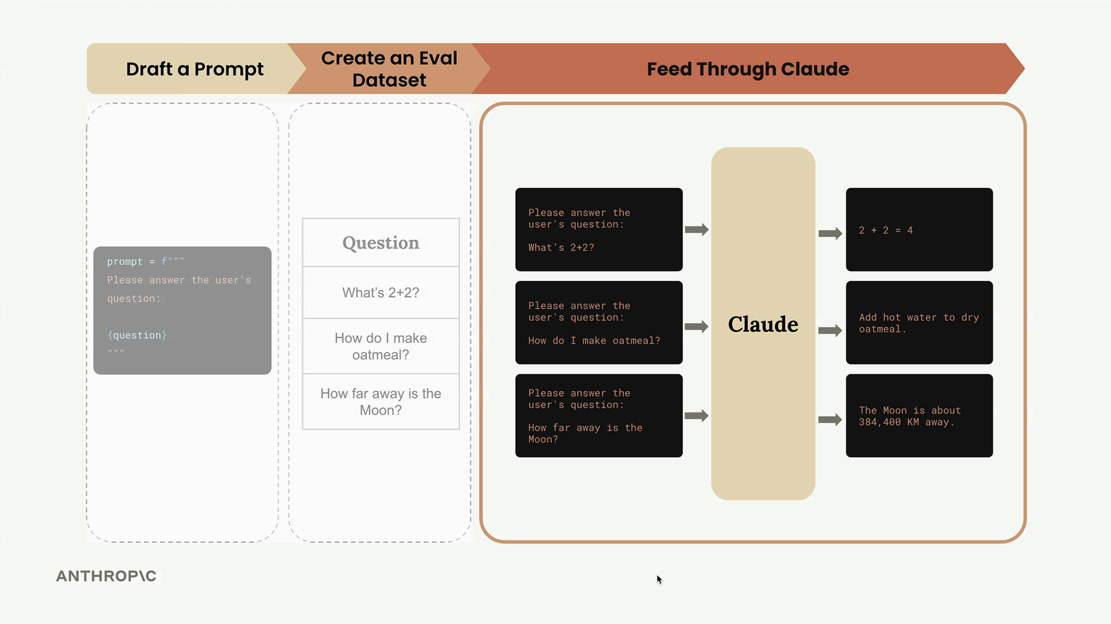
The results structure contains an array of objects, where each object represents one test case execution. You'll see the Claude output (which tends to be quite verbose without formatting constraints), the original test case definition, and the score.
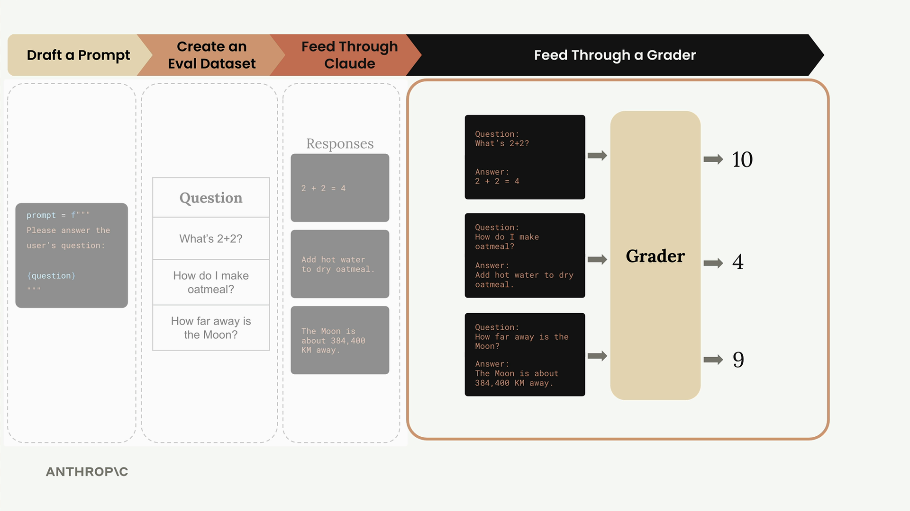

What We've Accomplished
At this point, we've successfully implemented the core evaluation pipeline. We can:
- Take test cases from our dataset
- Merge them with prompt templates
- Get responses from Claude
- Collect and organize all the results
The missing piece is intelligent grading - right now we're just assigning a fixed score to every response. The next step is building graders that can actually evaluate whether Claude's outputs are correct, which is where the real sophistication of evaluation systems comes into play.
This pipeline structure might seem simple, but it represents the foundation that most AI evaluation systems are built on. The complexity comes in the grading logic and prompt optimization, not in the basic orchestration of running tests.

Model based grading
When building prompt evaluation workflows, grading systems provide objective signals about output quality. A grader takes model output and returns some kind of measurable feedback - typically a number between 1 and 10, where 10 represents high quality and 1 represents poor quality.

Types of Graders
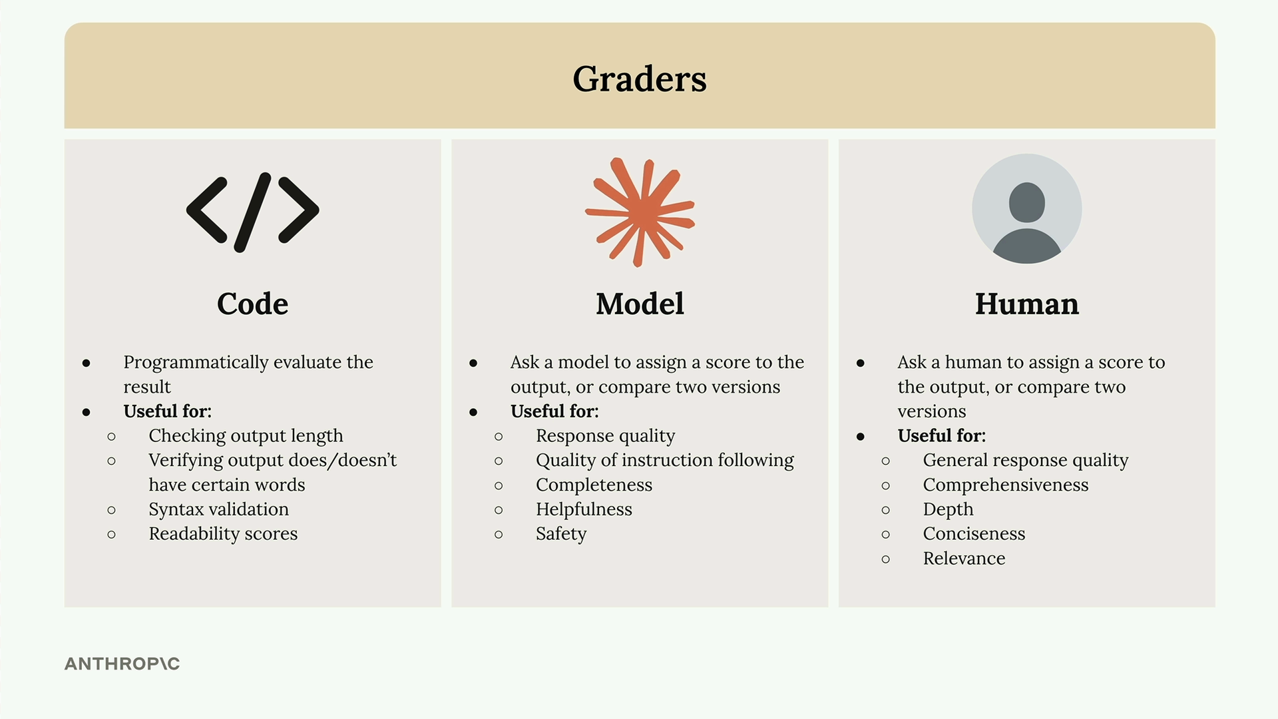
There are three main approaches to grading model outputs:
- Code graders - Programmatically evaluate outputs using custom logic
- Model graders - Use another AI model to assess the quality
- Human graders - Have people manually review and score outputs

Code Graders
Code graders let you implement any programmatic check you can imagine. Common uses include:
- Checking output length
- Verifying output does/doesn't have certain words
- Syntax validation for JSON, Python, or regex
- Readability scores
The only requirement is that your code returns some usable signal - usually a number between 1 and 10.

Model Graders
Model graders feed your original output into another API call for evaluation. This approach offers tremendous flexibility for assessing:
- Response quality
- Quality of instruction following
- Completeness
- Helpfulness
- Safety

Human Graders
Human graders provide the most flexibility but are time-consuming and tedious. They're useful for evaluating:
- General response quality
- Comprehensiveness
- Depth
- Conciseness
- Relevance

Defining Evaluation Criteria
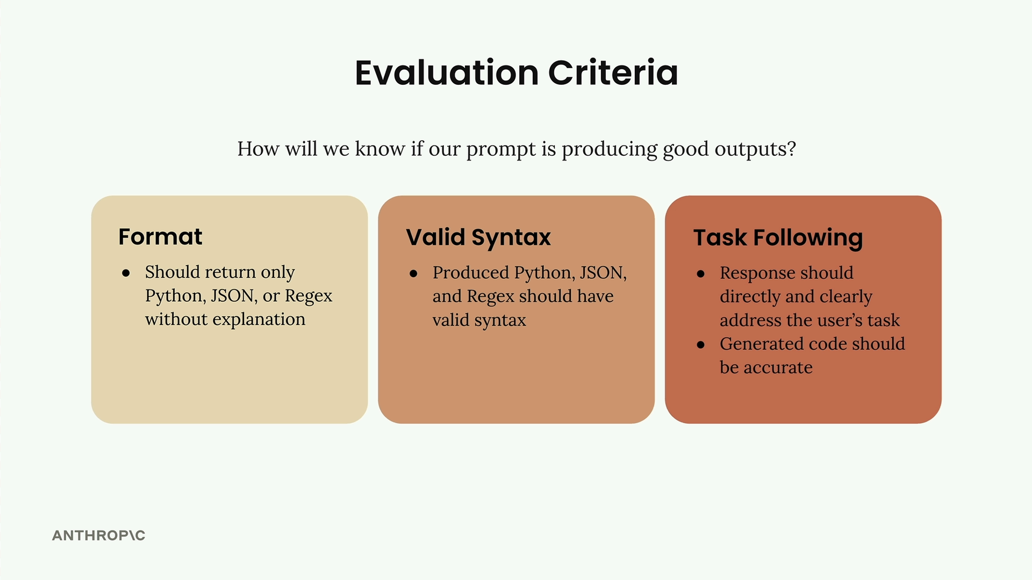
Before implementing any grader, you need clear evaluation criteria. For a code generation prompt, you might focus on:
- Format - Should return only Python, JSON, or Regex without explanation
- Valid Syntax - Produced code should have valid syntax
- Task Following - Response should directly address the user's task with accurate code
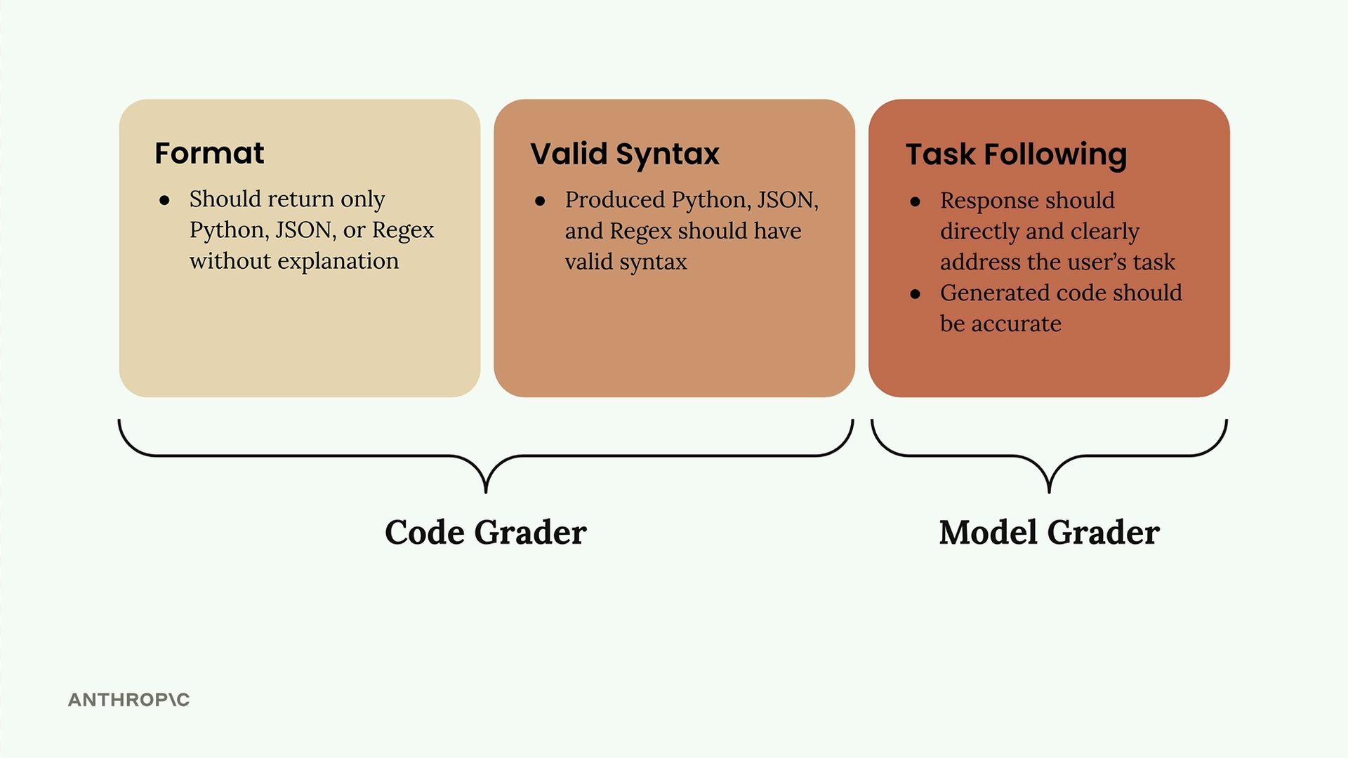
The first two criteria work well with code graders, while task following is better suited for model graders due to their flexibility.

Implementing a Model Grader
Here's how to build a model grader function:
def grade_by_model(test_case, output):
# Create evaluation prompt
eval_prompt = """
You are an expert code reviewer. Evaluate this AI-generated solution.

Task: {task}
Solution: {solution}

Provide your evaluation as a structured JSON object with:
- "strengths": An array of 1-3 key strengths
- "weaknesses": An array of 1-3 key areas for improvement
- "reasoning": A concise explanation of your assessment
- "score": A number between 1-10
"""

messages = []
add_user_message(messages, eval_prompt)
add_assistant_message(messages, "```json")

eval_text = chat(messages, stop_sequences=["```"])
return json.loads(eval_text)

The key insight is asking for strengths, weaknesses, and reasoning alongside the score. Without this context, models tend to default to middling scores around 6.

Integrating Grading into Your Workflow
Update your test case runner to call the grader:
def run_test_case(test_case):
output = run_prompt(test_case)

# Grade the output
model_grade = grade_by_model(test_case, output)
score = model_grade["score"]
reasoning = model_grade["reasoning"]

return {
"output": output,
"test_case": test_case,
"score": score,
"reasoning": reasoning
}

Finally, calculate an average score across all test cases:
from statistics import mean

def run_eval(dataset):
results = []

for test_case in dataset:
result = run_test_case(test_case)
results.append(result)

average_score = mean([result["score"] for result in results])
print(f"Average score: {average_score}")

return results

This gives you an objective metric to track as you iterate on your prompt. While model graders can be somewhat capricious, they provide a consistent baseline for measuring improvements.

Code based grading
Code-based grading adds an extra layer of validation to your prompt evaluations by checking whether the model's output follows the correct format and has valid syntax. This is especially useful when you're asking models to generate code, JSON, or regular expressions.

How Code Grading Works
The code grader evaluates two main criteria:
- Format compliance - Does the output contain only the requested format (Python, JSON, or regex) without explanations?
- Valid syntax - Can the output actually be parsed or compiled successfully?
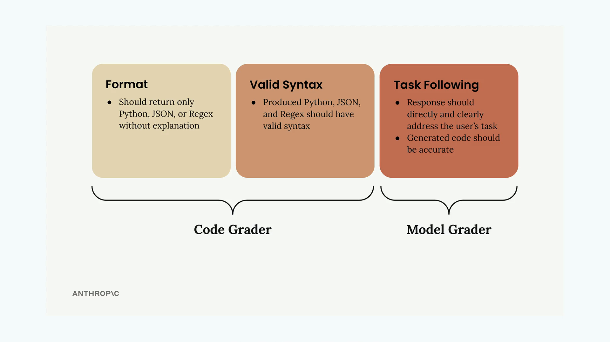
The system uses separate validation functions for each format type. If the code parses successfully, it gets a perfect score of 10. If parsing fails with an error, it gets a score of 0.

Setting Up Validation Functions
You'll need three helper functions to validate different output types:
def validate_json(text):
try:
json.loads(text.strip())
return 10
except json.JSONDecodeError:
return 0

def validate_python(text):
try:
ast.parse(text.strip())
return 10
except SyntaxError:
return 0

def validate_regex(text):
try:
re.compile(text.strip())
return 10
except re.error:
return 0
These functions use Python's built-in parsing capabilities to check syntax validity. The json.loads() function validates JSON, ast.parse() creates a Python abstract syntax tree, and re.compile() validates regular expressions.

Adding Format Information to Test Cases
Your test dataset needs to specify the expected output format for each task. Update your dataset generation prompt to include a format field:
{
"task": "Description of task",
"format": "python"
}
The format field should contain "json", "python", or "regex" depending on what type of output you expect from that particular task.

Improving Your Prompt
To get better results from the code grader, make your prompt instructions more specific:
* Respond only with Python, JSON, or a plain Regex
* Do not add any comments or commentary or explanation
You can also use a pre-filled assistant message with code blocks and stop sequences to ensure clean output formatting.

Combining Scores
The final step is merging your model grader score with the syntax grader score. A simple approach is to take the average of both scores:
model_grade = grade_by_model(test_case, output)
model_score = model_grade["score"]
syntax_score = grade_syntax(output, test_case)

score = (model_score + syntax_score) / 2
This gives equal weight to both content quality (from the model grader) and technical correctness (from the code grader). You can adjust this weighting based on what matters more for your specific use case.

Interpreting Results
Once you run your evaluation, you'll get a combined score that reflects both the semantic quality and technical correctness of the generated code. Remember that a single score in isolation doesn't tell you much - the real value comes from comparing scores as you iterate on your prompt design.
Use this baseline score to test prompt improvements and see if your changes actually lead to better, more reliable code generation.

