Joshua Kephart

GitHub username: jak243

Repository: https://github.com/jak243/CS1632_d4.git

CS 1632 – DELIVERABLE 4: Automated Web Testing

CS 1632 – DELIVERABLE 4: Automated Web Testing

Summary:

I ran into multiple issues, one of them being that using the Katalon plugin I could not directly access the script to make changes and at times the UI for Katalon Automation Recorder was slow.

I expected it to be difficult to sort out what implicit requirements I should test for. For example, the welcome page includes the sentence “THE WORLD IS YOUR OYSTER”. It’s not in the requirements, but also the requirements do not seem to restrict the page from having other information. I did not create tests to enforce that only the welcome message and used for message were displayed.

I did not figure out a way to enforce that the cathedral images were being displayed.

In the test suite I made 4 of my 23 tests failed:

Failed FIBONACCI-ONE-HUNDRED-TEST

Failed FIBONACCI-THIRTY-TEST

Failed FIBONACCI-FLOAT-TEST

Failed FACTORIAL-FLOAT-TEST

Here is the log from the test suite run:

[info] Playing test case CS1632_d4_TEST_SUITE / HOMEPAGE-WELCOME-TEST

[info] Time: Mon Mar 26 2018 07:18:47 GMT-0400 (Eastern Daylight Time) Timestamp: 1522063127461

[info] OS: Windows Version: 10

[info] Browser: Chrome Version: 65.0

[info] If the test cannot start, please refresh the active browser tab

[info] Executing: | open | https://cs1632ex.herokuapp.com/ | |

[info] Executing: | assertTextPresent | *Welcome,*friend,*to*a*land*of*pure*calculation* | |

[info] Time: Mon Mar 26 2018 07:18:49 GMT-0400 (Eastern Daylight Time) Timestamp: 1522063129026

[info] Test case passed

[info] Playing test case CS1632_d4_TEST_SUITE / HOMEPAGE-PURPOSE-TEST

[info] Time: Mon Mar 26 2018 07:18:49 GMT-0400 (Eastern Daylight Time) Timestamp: 1522063129982

[info] OS: Windows Version: 10

[info] Browser: Chrome Version: 65.0

[info] If the test cannot start, please refresh the active browser tab

[info] Executing: | open | https://cs1632ex.herokuapp.com/ | |

[info] Executing: | assertTextPresent | *Used*for*CS1632*Software*Quality*Assurance,*taught*by*Bill*Laboon* | |

[info] Time: Mon Mar 26 2018 07:18:51 GMT-0400 (Eastern Daylight Time) Timestamp: 1522063131461

[info] Test case passed

[info] Playing test case CS1632_d4_TEST_SUITE / HOME-LINKS-TEST

[info] Time: Mon Mar 26 2018 07:18:52 GMT-0400 (Eastern Daylight Time) Timestamp: 1522063132005

[info] OS: Windows Version: 10

[info] Browser: Chrome Version: 65.0

[info] If the test cannot start, please refresh the active browser tab

[info] Executing: | open | https://cs1632ex.herokuapp.com/ | |

[info] Executing: | assertElementPresent | link=CS1632 D3 Home | |

[info] Executing: | assertElementPresent | link=Factorial | |

[info] Executing: | assertElementPresent | link=Fibonacci | |

[info] Executing: | assertElementPresent | link=Hello | |

[info] Executing: | assertElementPresent | link=Cathedral Pics | |

[info] Executing: | click | link=CS1632 D3 Home | |

[info] Executing: | assertLocation | https://cs1632ex.herokuapp.com/ | |

[info] Executing: | open | https://cs1632ex.herokuapp.com/ | |

[info] Executing: | click | link=Factorial | |

[info] Executing: | assertLocation | https://cs1632ex.herokuapp.com/fact | |

[info] Executing: | open | https://cs1632ex.herokuapp.com/ | |

[info] Executing: | click | link=Fibonacci | |

[info] Executing: | assertLocation | https://cs1632ex.herokuapp.com/fib | |

[info] Executing: | open | https://cs1632ex.herokuapp.com/ | |

[info] Executing: | click | link=Hello | |

[info] Executing: | assertLocation | https://cs1632ex.herokuapp.com/hello | |

[info] Executing: | open | https://cs1632ex.herokuapp.com/ | |

[info] Executing: | click | link=Cathedral Pics | |

[info] Executing: | assertLocation | https://cs1632ex.herokuapp.com/cathy | |

[info] Time: Mon Mar 26 2018 07:19:06 GMT-0400 (Eastern Daylight Time) Timestamp: 1522063146957

[info] Test case passed

[info] Playing test case CS1632_d4_TEST_SUITE / FACTORIAL-LINKS-TEST

[info] Time: Mon Mar 26 2018 07:19:07 GMT-0400 (Eastern Daylight Time) Timestamp: 1522063147543

[info] OS: Windows Version: 10

[info] Browser: Chrome Version: 65.0

[info] If the test cannot start, please refresh the active browser tab

[info] Executing: | open | https://cs1632ex.herokuapp.com/fact | |

[info] Executing: | assertElementPresent | link=CS1632 D3 Home | |

[info] Executing: | assertElementPresent | link=Factorial | |

[info] Executing: | assertElementPresent | link=Fibonacci | |

[info] Executing: | assertElementPresent | link=Hello | |

[info] Executing: | assertElementPresent | link=Cathedral Pics | |

[info] Executing: | click | link=CS1632 D3 Home | |

[info] Executing: | assertLocation | https://cs1632ex.herokuapp.com/ | |

[info] Executing: | open | https://cs1632ex.herokuapp.com/fact | |

[info] Executing: | click | link=Factorial | |

[info] Executing: | assertLocation | https://cs1632ex.herokuapp.com/fact | |

[info] Executing: | open | https://cs1632ex.herokuapp.com/fact | |

[info] Executing: | click | link=Fibonacci | |

[info] Executing: | assertLocation | https://cs1632ex.herokuapp.com/fib | |

[info] Executing: | open | https://cs1632ex.herokuapp.com/fact | |

[info] Executing: | click | link=Hello | |

[info] Executing: | assertLocation | https://cs1632ex.herokuapp.com/hello | |

[info] Executing: | open | https://cs1632ex.herokuapp.com/fact | |

[info] Executing: | click | link=Cathedral Pics | |

[info] Executing: | assertLocation | https://cs1632ex.herokuapp.com/cathy | |

[info] Time: Mon Mar 26 2018 07:19:22 GMT-0400 (Eastern Daylight Time) Timestamp: 1522063162156

[info] Test case passed

[info] Playing test case CS1632_d4_TEST_SUITE / FIBONACCI-LINKS-TEST

[info] Time: Mon Mar 26 2018 07:19:23 GMT-0400 (Eastern Daylight Time) Timestamp: 1522063163102

[info] OS: Windows Version: 10

[info] Browser: Chrome Version: 65.0

[info] If the test cannot start, please refresh the active browser tab

[info] Executing: | open | https://cs1632ex.herokuapp.com/fib | |

[info] Executing: | assertElementPresent | link=CS1632 D3 Home | |

[info] Executing: | assertElementPresent | link=Factorial | |

[info] Executing: | assertElementPresent | link=Fibonacci | |

[info] Executing: | assertElementPresent | link=Hello | |

[info] Executing: | assertElementPresent | link=Cathedral Pics | |

[info] Executing: | click | link=CS1632 D3 Home | |

[info] Executing: | assertLocation | https://cs1632ex.herokuapp.com/ | |

[info] Executing: | open | https://cs1632ex.herokuapp.com/fib | |

[info] Executing: | click | link=Factorial | |

[info] Executing: | assertLocation | https://cs1632ex.herokuapp.com/fact | |

[info] Executing: | open | https://cs1632ex.herokuapp.com/fib | |

[info] Executing: | click | link=Fibonacci | |

[info] Executing: | assertLocation | https://cs1632ex.herokuapp.com/fib | |

[info] Executing: | open | https://cs1632ex.herokuapp.com/fib | |

[info] Executing: | click | link=Hello | |

[info] Executing: | assertLocation | https://cs1632ex.herokuapp.com/hello | |

[info] Executing: | open | https://cs1632ex.herokuapp.com/fib | |

[info] Executing: | click | link=Cathedral Pics | |

[info] Executing: | assertLocation | https://cs1632ex.herokuapp.com/cathy | |

[info] Time: Mon Mar 26 2018 07:19:36 GMT-0400 (Eastern Daylight Time) Timestamp: 1522063176958

[info] Test case passed

[info] Playing test case CS1632_d4_TEST_SUITE / HELLO-LINKS-TEST

[info] Time: Mon Mar 26 2018 07:19:37 GMT-0400 (Eastern Daylight Time) Timestamp: 1522063177633

[info] OS: Windows Version: 10

[info] Browser: Chrome Version: 65.0

[info] If the test cannot start, please refresh the active browser tab

[info] Executing: | open | https://cs1632ex.herokuapp.com/hello | |

[info] Executing: | assertElementPresent | link=CS1632 D3 Home | |

[info] Executing: | assertElementPresent | link=Factorial | |

[info] Executing: | assertElementPresent | link=Fibonacci | |

[info] Executing: | assertElementPresent | link=Hello | |

[info] Executing: | assertElementPresent | link=Cathedral Pics | |

[info] Executing: | click | link=CS1632 D3 Home | |

[info] Executing: | assertLocation | https://cs1632ex.herokuapp.com/ | |

[info] Executing: | open | https://cs1632ex.herokuapp.com/hello | |

[info] Executing: | click | link=Factorial | |

[info] Executing: | assertLocation | https://cs1632ex.herokuapp.com/fact | |

[info] Executing: | open | https://cs1632ex.herokuapp.com/hello | |

[info] Executing: | click | link=Fibonacci | |

[info] Executing: | assertLocation | https://cs1632ex.herokuapp.com/fib | |

[info] Executing: | open | https://cs1632ex.herokuapp.com/hello | |

[info] Executing: | click | link=Hello | |

[info] Executing: | assertLocation | https://cs1632ex.herokuapp.com/hello | |

[info] Executing: | open | https://cs1632ex.herokuapp.com/hello | |

[info] Executing: | click | link=Cathedral Pics | |

[info] Executing: | assertLocation | https://cs1632ex.herokuapp.com/cathy | |

[info] Time: Mon Mar 26 2018 07:19:51 GMT-0400 (Eastern Daylight Time) Timestamp: 1522063191353

[info] Test case passed

[info] Playing test case CS1632_d4_TEST_SUITE / CATHY-LINKS-TEST

[info] Time: Mon Mar 26 2018 07:19:52 GMT-0400 (Eastern Daylight Time) Timestamp: 1522063192171

[info] OS: Windows Version: 10

[info] Browser: Chrome Version: 65.0

[info] If the test cannot start, please refresh the active browser tab

[info] Executing: | open | https://cs1632ex.herokuapp.com/cathy | |

[info] Executing: | assertElementPresent | link=CS1632 D3 Home | |

[info] Executing: | assertElementPresent | link=Factorial | |

[info] Executing: | assertElementPresent | link=Fibonacci | |

[info] Executing: | assertElementPresent | link=Hello | |

[info] Executing: | assertElementPresent | link=Cathedral Pics | |

[info] Executing: | click | link=CS1632 D3 Home | |

[info] Executing: | assertLocation | https://cs1632ex.herokuapp.com/ | |

[info] Executing: | open | https://cs1632ex.herokuapp.com/cathy | |

[info] Executing: | click | link=Factorial | |

[info] Executing: | assertLocation | https://cs1632ex.herokuapp.com/fact | |

[info] Executing: | open | https://cs1632ex.herokuapp.com/cathy | |

[info] Executing: | click | link=Fibonacci | |

[info] Executing: | assertLocation | https://cs1632ex.herokuapp.com/fib | |

[info] Executing: | open | https://cs1632ex.herokuapp.com/cathy | |

[info] Executing: | click | link=Hello | |

[info] Executing: | assertLocation | https://cs1632ex.herokuapp.com/hello | |

[info] Executing: | open | https://cs1632ex.herokuapp.com/cathy | |

[info] Executing: | click | link=Cathedral Pics | |

[info] Executing: | assertLocation | https://cs1632ex.herokuapp.com/cathy | |

[info] Time: Mon Mar 26 2018 07:20:06 GMT-0400 (Eastern Daylight Time) Timestamp: 1522063206227

[info] Test case passed

[info] Playing test case CS1632_d4_TEST_SUITE / FACTORIAL-ONE-TEST

[info] Time: Mon Mar 26 2018 07:20:07 GMT-0400 (Eastern Daylight Time) Timestamp: 1522063207216

[info] OS: Windows Version: 10

[info] Browser: Chrome Version: 65.0

[info] If the test cannot start, please refresh the active browser tab

[info] Executing: | open | https://cs1632ex.herokuapp.com/fact | |

[info] Executing: | click | name=value | |

[info] Executing: | type | name=value | 1 |

[info] Executing: | click | //input[@value='Submit'] | |

[info] Executing: | assertTextPresent | *Factorial of 1 is 1* | |

[info] Time: Mon Mar 26 2018 07:20:10 GMT-0400 (Eastern Daylight Time) Timestamp: 1522063210001

[info] Test case passed

[info] Playing test case CS1632_d4_TEST_SUITE / FACTORIAL-ONE-HUNDRED-TEST

[info] Time: Mon Mar 26 2018 07:20:10 GMT-0400 (Eastern Daylight Time) Timestamp: 1522063210734

[info] OS: Windows Version: 10

[info] Browser: Chrome Version: 65.0

[info] If the test cannot start, please refresh the active browser tab

[info] Executing: | open | https://cs1632ex.herokuapp.com/fact | |

[info] Executing: | click | name=value | |

[info] Executing: | type | name=value | 100 |

[info] Executing: | click | //input[@value='Submit'] | |

[info] Executing: | assertTextPresent | *Factorial of 100 is 93326215443944152681699238856266700490715968264381621468592963895217599993229915608941463976156518286253697920827223758251185210916864000000000000000000000000* | |

[info] Time: Mon Mar 26 2018 07:20:13 GMT-0400 (Eastern Daylight Time) Timestamp: 1522063213662

[info] Test case passed

[info] Playing test case CS1632_d4_TEST_SUITE / FACTORIAL-THIRTY-TEST

[info] Time: Mon Mar 26 2018 07:20:14 GMT-0400 (Eastern Daylight Time) Timestamp: 1522063214252

[info] OS: Windows Version: 10

[info] Browser: Chrome Version: 65.0

[info] If the test cannot start, please refresh the active browser tab

[info] Executing: | open | https://cs1632ex.herokuapp.com/fact | |

[info] Executing: | click | name=value | |

[info] Executing: | type | name=value | 30 |

[info] Executing: | click | //input[@value='Submit'] | |

[info] Executing: | assertTextPresent | *Factorial of 30 is 265252859812191058636308480000000* | |

[info] Time: Mon Mar 26 2018 07:20:17 GMT-0400 (Eastern Daylight Time) Timestamp: 1522063217005

[info] Test case passed

[info] Playing test case CS1632_d4_TEST_SUITE / FIBONACCI -ONE-TEST

[info] Time: Mon Mar 26 2018 07:20:17 GMT-0400 (Eastern Daylight Time) Timestamp: 1522063217767

[info] OS: Windows Version: 10

[info] Browser: Chrome Version: 65.0

[info] If the test cannot start, please refresh the active browser tab

[info] Executing: | open | https://cs1632ex.herokuapp.com/fib | |

[info] Executing: | click | id=tb1 | |

[info] Executing: | type | id=tb1 | 1 |

[info] Executing: | click | id=sub | |

[info] Executing: | assertTextPresent | *Fibonacci of 1 is 1!* | |

[info] Time: Mon Mar 26 2018 07:20:20 GMT-0400 (Eastern Daylight Time) Timestamp: 1522063220516

[info] Test case passed

[info] Playing test case CS1632_d4_TEST_SUITE / FIBONACCI -ONE-HUNDRED-TEST

[info] Time: Mon Mar 26 2018 07:20:21 GMT-0400 (Eastern Daylight Time) Timestamp: 1522063221286

[info] OS: Windows Version: 10

[info] Browser: Chrome Version: 65.0

[info] If the test cannot start, please refresh the active browser tab

[info] Executing: | open | https://cs1632ex.herokuapp.com/fib | |

[info] Executing: | click | id=tb1 | |

[info] Executing: | type | id=tb1 | 100 |

[info] Executing: | click | id=sub | |

[info] Executing: | assertTextPresent | *Fibonacci of 100 is 573147844013817084101!* | |

[error] false

[info] Time: Mon Mar 26 2018 07:20:24 GMT-0400 (Eastern Daylight Time) Timestamp: 1522063224099

[info] Test case failed

[info] Playing test case CS1632_d4_TEST_SUITE / FIBONACCI-THIRTYFIVE-TEST

[info] Time: Mon Mar 26 2018 07:20:24 GMT-0400 (Eastern Daylight Time) Timestamp: 1522063224799

[info] OS: Windows Version: 10

[info] Browser: Chrome Version: 65.0

[info] If the test cannot start, please refresh the active browser tab

[info] Executing: | open | https://cs1632ex.herokuapp.com/fib | |

[info] Executing: | click | id=tb1 | |

[info] Executing: | type | id=tb1 | 35 |

[info] Executing: | click | id=sub | |

[info] Executing: | assertTextPresent | *Fibonacci of 35 is 14930352!* | |

[error] false

[info] Time: Mon Mar 26 2018 07:20:27 GMT-0400 (Eastern Daylight Time) Timestamp: 1522063227512

[info] Test case failed

[info] Playing test case CS1632_d4_TEST_SUITE / FIBONACCI-FLOAT-TEST

[info] Time: Mon Mar 26 2018 07:20:28 GMT-0400 (Eastern Daylight Time) Timestamp: 1522063228321

[info] OS: Windows Version: 10

[info] Browser: Chrome Version: 65.0

[info] If the test cannot start, please refresh the active browser tab

[info] Executing: | open | https://cs1632ex.herokuapp.com/fib | |

[info] Executing: | click | id=tb1 | |

[info] Executing: | type | id=tb1 | 1.1 |

[info] Executing: | click | id=sub | |

[info] Executing: | assertTextPresent | *Fibonacci of 1.1 is 1!* | |

[error] false

[info] Time: Mon Mar 26 2018 07:20:31 GMT-0400 (Eastern Daylight Time) Timestamp: 1522063231001

[info] Test case failed

[info] Playing test case CS1632_d4_TEST_SUITE / FACTORIAL-ZERO-TEST

[info] Time: Mon Mar 26 2018 07:20:31 GMT-0400 (Eastern Daylight Time) Timestamp: 1522063231846

[info] OS: Windows Version: 10

[info] Browser: Chrome Version: 65.0

[info] If the test cannot start, please refresh the active browser tab

[info] Executing: | open | https://cs1632ex.herokuapp.com/fact | |

[info] Executing: | click | name=value | |

[info] Executing: | type | name=value | 0 |

[info] Executing: | click | //input[@value='Submit'] | |

[info] Executing: | assertTextPresent | *Factorial of 0 is 1* | |

[info] Time: Mon Mar 26 2018 07:20:34 GMT-0400 (Eastern Daylight Time) Timestamp: 1522063234607

[info] Test case passed

[info] Playing test case CS1632_d4_TEST_SUITE / FACTORIAL-FLOAT-TEST

[info] Time: Mon Mar 26 2018 07:20:35 GMT-0400 (Eastern Daylight Time) Timestamp: 1522063235380

[info] OS: Windows Version: 10

[info] Browser: Chrome Version: 65.0

[info] If the test cannot start, please refresh the active browser tab

[info] Executing: | open | https://cs1632ex.herokuapp.com/fact | |

[info] Executing: | click | name=value | |

[info] Executing: | type | name=value | 1.1 |

[info] Executing: | click | //input[@value='Submit'] | |

[info] Executing: | assertTextPresent | *Factorial of 1.1 is 1* | |

[error] false

[info] Time: Mon Mar 26 2018 07:20:38 GMT-0400 (Eastern Daylight Time) Timestamp: 1522063238163

[info] Test case failed

[info] Playing test case CS1632_d4_TEST_SUITE / FACTORIAL-ONE-HUNDERD-ONE-TEST

[info] Time: Mon Mar 26 2018 07:20:38 GMT-0400 (Eastern Daylight Time) Timestamp: 1522063238903

[info] OS: Windows Version: 10

[info] Browser: Chrome Version: 65.0

[info] If the test cannot start, please refresh the active browser tab

[info] Executing: | open | https://cs1632ex.herokuapp.com/fact | |

[info] Executing: | click | name=value | |

[info] Executing: | type | name=value | 101 |

[info] Executing: | click | //input[@value='Submit'] | |

[info] Executing: | assertTextPresent | *Factorial of 101 is 1* | |

[info] Time: Mon Mar 26 2018 07:20:41 GMT-0400 (Eastern Daylight Time) Timestamp: 1522063241719

[info] Test case passed

[info] Playing test case CS1632_d4_TEST_SUITE / FIBONACCI-ZERO-TEST

[info] Time: Mon Mar 26 2018 07:20:42 GMT-0400 (Eastern Daylight Time) Timestamp: 1522063242427

[info] OS: Windows Version: 10

[info] Browser: Chrome Version: 65.0

[info] If the test cannot start, please refresh the active browser tab

[info] Executing: | open | https://cs1632ex.herokuapp.com/fib | |

[info] Executing: | click | id=tb1 | |

[info] Executing: | type | id=tb1 | 0 |

[info] Executing: | click | id=sub | |

[info] Executing: | assertTextPresent | *Fibonacci of 0 is 1!* | |

[info] Time: Mon Mar 26 2018 07:20:45 GMT-0400 (Eastern Daylight Time) Timestamp: 1522063245242

[info] Test case passed

[info] Playing test case CS1632_d4_TEST_SUITE / FIBONACCI-ONE-HUNDERD-ONE-TEST

[info] Time: Mon Mar 26 2018 07:20:45 GMT-0400 (Eastern Daylight Time) Timestamp: 1522063245951

[info] OS: Windows Version: 10

[info] Browser: Chrome Version: 65.0

[info] If the test cannot start, please refresh the active browser tab

[info] Executing: | open | https://cs1632ex.herokuapp.com/fib | |

[info] Executing: | click | id=tb1 | |

[info] Executing: | type | id=tb1 | 101 |

[info] Executing: | click | id=sub | |

[info] Executing: | assertTextPresent | *Fibonacci of 101 is 1!* | |

[info] Time: Mon Mar 26 2018 07:20:49 GMT-0400 (Eastern Daylight Time) Timestamp: 1522063249141

[info] Test case passed

[info] Playing test case CS1632_d4_TEST_SUITE / HELLO-MESSAGE-TEST

[info] Time: Mon Mar 26 2018 07:20:49 GMT-0400 (Eastern Daylight Time) Timestamp: 1522063249969

[info] OS: Windows Version: 10

[info] Browser: Chrome Version: 65.0

[info] If the test cannot start, please refresh the active browser tab

[info] Executing: | open | https://cs1632ex.herokuapp.com/hello | |

[info] Executing: | assertTextPresent | *Hello CS1632, from Prof. Laboon!* | |

[info] Time: Mon Mar 26 2018 07:20:51 GMT-0400 (Eastern Daylight Time) Timestamp: 1522063251269

[info] Test case passed

[info] Playing test case CS1632_d4_TEST_SUITE / HELLO-JOSH-TEST

[info] Time: Mon Mar 26 2018 07:20:51 GMT-0400 (Eastern Daylight Time) Timestamp: 1522063251992

[info] OS: Windows Version: 10

[info] Browser: Chrome Version: 65.0

[info] If the test cannot start, please refresh the active browser tab

[info] Executing: | open | https://cs1632ex.herokuapp.com/hello/josh | |

[info] Executing: | assertTextPresent | *Hello CS1632, from josh!* | |

[info] Time: Mon Mar 26 2018 07:20:53 GMT-0400 (Eastern Daylight Time) Timestamp: 1522063253344

[info] Test case passed

[info] Playing test case CS1632_d4_TEST_SUITE / HELLO-NUMBER-TEST

[info] Time: Mon Mar 26 2018 07:20:54 GMT-0400 (Eastern Daylight Time) Timestamp: 1522063254014

[info] OS: Windows Version: 10

[info] Browser: Chrome Version: 65.0

[info] If the test cannot start, please refresh the active browser tab

[info] Executing: | open | https://cs1632ex.herokuapp.com/hello/123 | |

[info] Executing: | assertTextPresent | *Hello CS1632, from 123!* | |

[info] Time: Mon Mar 26 2018 07:20:55 GMT-0400 (Eastern Daylight Time) Timestamp: 1522063255387

[info] Test case passed

[info] Playing test case CS1632_d4_TEST_SUITE / CATHEDRAL-PAGE-NUMBERED-LIST-TEST

[info] Time: Mon Mar 26 2018 07:20:56 GMT-0400 (Eastern Daylight Time) Timestamp: 1522063256032

[info] OS: Windows Version: 10

[info] Browser: Chrome Version: 65.0

[info] If the test cannot start, please refresh the active browser tab

[info] Executing: | open | https://cs1632ex.herokuapp.com/cathy | |

[info] Executing: | assertXpathCount | //ol | 1 |

[info] Executing: | assertXpathCount | //ol//li | 3 |

[info] Executing: | assertXpathCount | //ol//li//img | 3 |

[info] Time: Mon Mar 26 2018 07:20:57 GMT-0400 (Eastern Daylight Time) Timestamp: 1522063257518

[info] Test case passed

Traceability Matrix

|  |  |  |  |  |  |  |
| --- | --- | --- | --- | --- | --- | --- |
| 1. The homepage shall display the text "Welcome, friend, to a land of pure calculation" as well as "Used for CS1632 Software Quality Assurance, taught by Bill Laboon". There may or may not be carriage returns ("\n") in either of these texts. | HOMEPAGE-WELCOME-TEST | HOMEPAGE-PURPOSE-TEST |  |  |  |  |
| 2. Every page shall include five links at the top, to "CS1632 D3 Home", "Factorial", "Fibonacci", "Hello", and "Cathedral Pics". These shall link to /, /fact, /fib, /hello, and /cathy, respectively. | HOME-LINKS-TEST | FACTORIAL-LINKS-TEST | FIBONACCI-LINKS-TEST | HELLO-LINKS-TEST | CATHY-LINKS-TEST |  |
| 3. The factorial page (/fact) shall allow a user to enter a positive integer from 1 to 100, and upon pressing submit, shall show to the user the factorial of the value (e.g. "Factorial of 5 is 120!"). | FACTORIAL-ONE-TEST | FACTORIAL-ONE-HUNDRED-TEST | FACTORIAL-THIRTY-TEST |  |  |  |
| 4. The Fibonacci page (/fib) shall allow a user to enter a positive integer from 1 to 100, and upon pressing submit, shall show to the user the Fibonacci of the value (e.g. "Fibonacci of 5 is 8!"). | FIBONACCI -ONE-TEST | FIBONACCI -ONE-HUNDRED-TEST | FIBONACCI-THIRTYFIVE-TEST |  |  |  |
| 5. For both the Fibonacci and Factorial pages, if a user enters an invalid value of any kind, they shall be informed that the value is 1 (e.g., "Fibonacci of -100 is 1!") | FACTORIAL-ZERO-TEST | FIBONACCI-ZERO-TEST | FIBONACCI-ONE-HUNDERD-ONE-TEST | FACTORIAL-ONE-HUNDERD-ONE-TEST | FIBONACCI-FLOAT-TEST | FACTORIAL-FLOAT-TEST |
| 6. Accessing the hello page (/hello) with no trailing values in the URL shall display the message "Hello CS1632, from Prof. Laboon!". | HELLO-MESSAGE-TEST |  |  |  |  |  |
| 7. If a trailing value is provided in the URL when accessing the /hello page, then the message shall display hello from that trailing value. For example, when accessing /hello/Jazzy, the system shall display "Hello CS1632, from Jazzy!". This shall work for all input values. | HELLO-JOSH-TEST | HELLO-NUMBER-TEST |  |  |  |  |
| 8. The Cathedral page (/cathy) shall display three images of the Cathedral of Learning in a numbered list. | CATHEDRAL-PAGE-NUMBERED-LIST-TEST |  |  |  |  |  |

DEFECT REPORT

SUMMARY: Fibonacci page gives incorrect output for an input of 100

DESCRIPTION: Failed FIBONACCI-ONE-HUNDRED-TEST

PRODUCTION STEPS: Open <https://cs1632ex.herokuapp.com/fib>, enter 100 into the textbox and click submit

EXPECTED BEHAVIOR: “Fibonacci of 100 is 573147844013817084101!” is displayed on the webpage

OBSERVED BEHAVIOR: Fibonacci of 100 is 1!” is displayed on the webpage

SCREENSHOT:

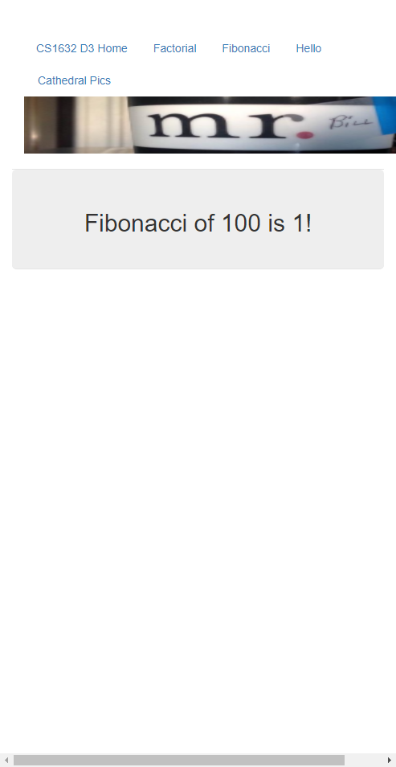

SUMMARY: Fibonacci page gives incorrect output for an input of 35

DESCRIPTION: Failed FIBONACCI-THIRTY-TEST

PRODUCTION STEPS: Open <https://cs1632ex.herokuapp.com/fib>, enter 35 into the textbox and click submit

EXPECTED BEHAVIOR: “Fibonacci of 35 is 14930352!” is displayed on the webpage

OBSERVED BEHAVIOR: Fibonacci of 35 is 1!” is displayed on the webpage

SCREENSHOT:

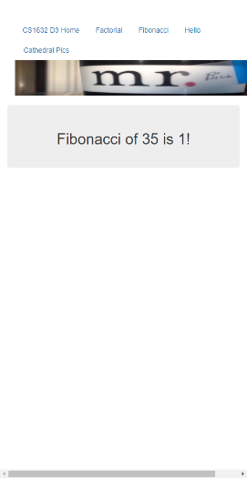

SUMMARY: Fibonacci page gives incorrect output for a floating-point input

DESCRIPTION: Failed FIBONACCI-FLOAT-TEST

PRODUCTION STEPS: Open <https://cs1632ex.herokuapp.com/fib>, enter 1.1 into the textbox and click submit

EXPECTED BEHAVIOR: “Fibonacci of 1.1 is 1!” is displayed on the webpage

OBSERVED BEHAVIOR: “Internal server error” is displayed on the webpage

SCREENSHOT:

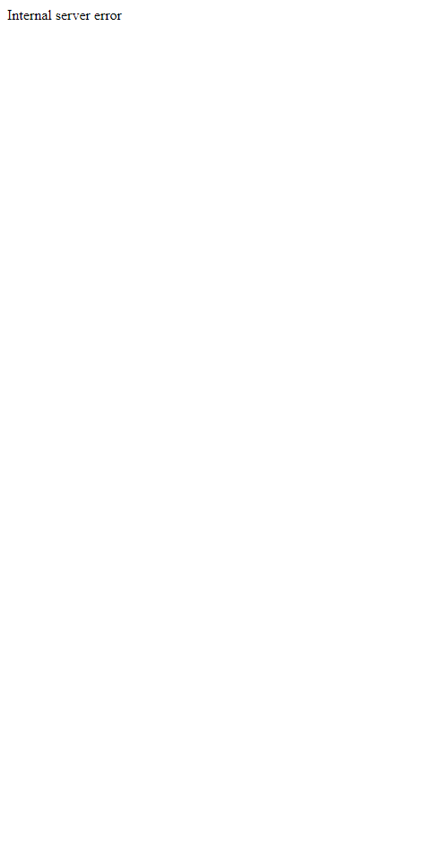

SUMMARY: Factorial page gives incorrect output for a floating-point input

DESCRIPTION: Failed FACTORIAL-FLOAT-TEST

PRODUCTION STEPS: Open [https://cs1632ex.herokuapp.com/fact](https://cs1632ex.herokuapp.com/fib), enter 1.1 into the textbox and click submit

EXPECTED BEHAVIOR: “Factorial of 1.1 is 1!” is displayed on the webpage

OBSERVED BEHAVIOR: “Internal server error” is displayed on the webpage

SCREENSHOT:

