Pripravite spletno stran, kot prikazuje spodnja slika! Nalogo najdete tudi na spletnem naslovu <http://www.sedh.gr/tutorials/web_dev/XHTMLAssignments/default.htm> pod številko 5-2.

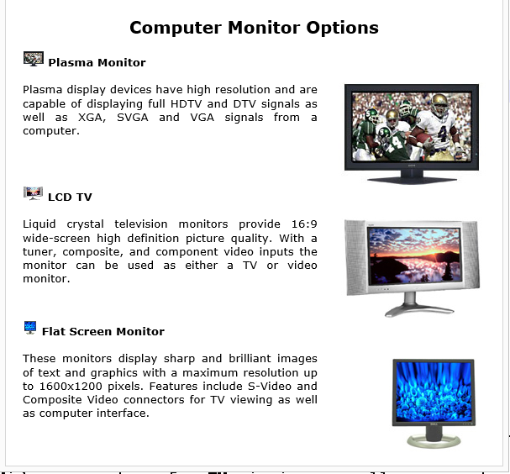

1. Za oblikovanje elementov uporabi vgrajene sloge
   * Telo dokumenta ima margin nastavljen na 20px. Slog teksta je verdana. Tekst je poravnan z obeh strani in visok 10pt.
   * Naslov strani oblikujte s <h2>. Tekst v naslovu je centriran.
   * Miniaturne slike so visoke 18px. Za oblikovanje uporabite class slog
   * Velike slike se nahajajo znotraj elementa <div>, ki ima fiksno širino 200px in se nahajajo na desnem robu strani. Slog določite s class selektorjem.

Tekst na spletni strani:

Computer Monitor Options

Plasma Monitor

Plasma display devices have high resolution and are capable of displaying

full HDTV and DTV signals as well as XGA, SVGA and VGA signals from a

computer.

LCD TV

Liquid crystal television monitors provide 16:9 wide-screen high definition

picture quality. With a tuner, composite, and component video inputs the

monitor can be used as either a TV or video monitor.

Flat Screen Monitor

These monitors display sharp and brilliant images of text and graphics with

a maximum resolution up to 1600x1200 pixels. Features include S-Video and

Composite Video connectors for TV viewing as well as computer interface.

Slike:

