Pripravite spletno stran, ki prikaže tekst in slike v dveh kolonah na spletni strani. Spletno stran prikazuje spodnja slike. Opis naloge najdete tudi na spletnem naslovu http://www.sedh.gr/tutorials/web_dev/XHTMLAssignments/default.htm pod številko 6-3.

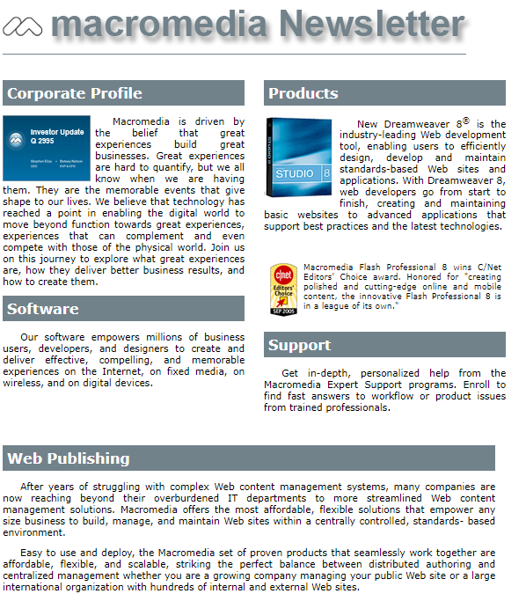

**Navodila**

Za oblikovanje spletne strani uporabite vgrajene sloge.

* + Telo dokumenta je široko 550px in ima margin 0px. Privzeta pisava je Verdana velikost pisave je 8pt, tekst je obojestransko poravnan.
  + Zgornji naslov strani je škatla, ki je nameščena absolutno z naslednjimi lastnostmi: width:560px, height:70px, left:0px in top:0px.
  + Levi stolpec je škatla, ki je nameščena absolutno z naslednjimi lastnostmi: width:275px, left:0px, top:75px, padding:10px, prva vrstica odstavka je zamaknjena za 20px.
  + Desni stolpec je škatla, ki je nameščena absolutno z naslednjimi lastnostmi: width:275px, left: 297px, top:75px, padding:10px, prva vrstica odstavka je zamaknjena za 20px.
  + Spodnja del je škatla, ki je nameščena absolutno, z naslednjimi lastnostmi:width:560px, left:0px, top:490px; padding:10px, prva vrstica odstavka je zamaknjena za 20px.
  + Komentar v drugem stolpcu je škatla z lastnostmi: velikost pisave je7pt, padding je 5px, zgornji margin je 10px in zamik prve vrstice je 0px.
  + Vsi naslovi imajo tekst visok 12p, so poudarjeni, z zamikom besedila 0px, padding je širok 5px, zgornji in spodnji margin je širok 10px, barva ozadja je #72828B, tekst je v beli barvi.
  + Za oblikovanje škatel uporabite id selektor.
  + Vsi odstavki se nahajajo znotraj škatel.

**Tekst na strani**

Corporate Profile

Macromedia is driven by the belief that great experiences build great

businesses. Great experiences are hard to quantify, but we all know when

we are having them. They are the memorable events that give shape to our

lives. We believe that technology has reached a point in enabling the

digital world to move beyond function towards great experiences,

experiences that can complement and even compete with those of the

physical world. Join us on this journey to explore what great experiences

are, how they deliver better business results, and how to create them.

Software

Our software empowers millions of business users, developers, and designers

to create and deliver effective, compelling, and memorable experienceson

the Internet, on fixed media, on wireless, and on digital devices.

Products

New Dreamweaver 8� is the industry-leading Web development tool, enabling

users to efficiently design, develop and maintain standards-based Web sites

and applications. With Dreamweaver 8, web developers go from start to

finish, creating and maintaining basic websites to advanced applications

that support best practices and the latest technologies.

Macromedia Flash Professional 8 wins C/Net Editors' Choice award. Honored

for "creating polished and cutting-edge online and mobile content, the

innovative Flash Professional 8 is in a league of its own."

Support

Get in-depth, personalized help from the Macromedia Expert Support programs.

Enroll to find fast answers to workflow or product issues from trained

professionals.

Web Publishing

After years of struggling with complex Web content management systems, many

companies are now reaching beyond their overburdened IT departments to more

streamlined Web content management solutions. Macromedia offers the most

affordable, flexible solutions that empower any size business to build,

manage, and maintain Web sites within a centrally controlled, standards-

based environment.

Easy to use and deploy, the Macromedia set of proven products that

seamlessly work together are affordable, flexible, and scalable, striking

the perfect balance between distributed authoring and centralized management

whether you are a growing company managing your public Web site or a large

international organization with hundreds of internal and external Web sites.

**Uporabljene slike**

  
  
  
C/Net Award  
