Ustvari spletno stran z notranjimi povezavami. Stran prikazuje spodnja slike. Nalogo najdete tudi na spletnem naslovu [http://www.sedh.gr/tutorials/web_dev/XHTMLAssignments/default.htm](http://www.sedh.gr/tutorials/web_dev/XHTMLAssignments/default.htm%20pod%20oznako%207-2) pod oznako 7-2.

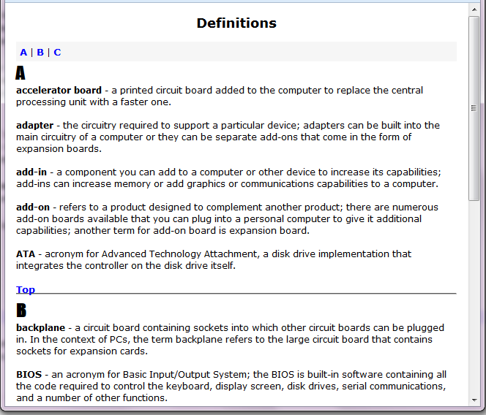

**Navodila:**

Za oblikovanje uporabite vgrajene sloge.

* Telo dokumenta ima margin 15 pikslov. Privzeta pisava je Verdana 9pt.
* Naslov je označen s <h2> označevalcem in je centriran.
* Črke na vrhu spletne strani so povezave na ustrezno poglavje na spletni strani. Črke pripadajo škatli, ki ima padding nastavljen na 5px in bravo ozadja #F6F6F6. Uporabite označevalec a za oblikovanje ne obiskane povezave, povezave v stanju hover, aktivne povezave in že obiskane povezave. Povezave so visoke 10pt, poudarjene, ne podčrtane in modre barve. Izjema je povezava v stanju hover. Tu je povezava rdeča in podčrtana.
* Velike črke, ki označujejo začetek poglavje so ciljne lokacije povezav. Velike so 18pt v pisavi Impact in niso podčrtane.
* Povezave, ki kažejo na začetek strani so kodirane kot <a href="#"> .
* Vodoravna črte (hr) imajo zgornji margin -3px. Na ta način zmanjšamo presledek do teksta povezave, ki nas poveže z začetkom spletne strani.

Tekst na strani:

Definitions

A | B | C

A

accelerator board - a printed circuit board added to the

computer to replace the central processing unit with a faster one.

adapter - the circuitry required to support a particular

device; adapters can be built into the main circuitry of a computer

or they can be separate add-ons that come in the form of expansion

boards.

add-in - a component you can add to a computer or other

device to increase its capabilities; add-ins can increase memory or add

graphics or communications capabilities to a computer.

add-on - refers to a product designed to complement another

product; there are numerous add-on boards available that you can plug

into a personal computer to give it additional capabilities; another

term for add-on board is expansion board.

ATA - acronym for Advanced Technology Attachment, a disk drive

implementation that integrates the controller on the disk drive itself.

Top

B

backplane - a circuit board containing sockets into which other

circuit boards can be plugged in. In the context of PCs, the term backplane

refers to the large circuit board that contains sockets for expansion cards.

BIOS - an acronym for Basic Input/Output System; the BIOS is

built-in software containing all the code required to control the keyboard,

display screen, disk drives, serial communications, and a number of other

functions.

blog - A frequent, chronological publication of personal thoughts

and Web links; often a mixture of what is happening in a person's life

and what is happening on the Web, a kind of hybrid diary/guide site.

boot sequence - The order of drives that a systems BIOS follows

when looking for the operating system (OS) to boot start the computer.

>bus - a collection of wires through which data is transmitted

from one part of a computer to another.

Top

C

chassis - a metal frame that serves as the structural support for

electronic components; very computer system requires at least one chassis to

house the circuit boards and wiring.

chip - a small piece of semiconducting material (usually silicon)

on which an integrated circuit is embedded.

chipset - a number of integrated circuits designed to perform one

or more related functions; newer chipsets generally include functions

provided by two or more older chipsets; the term is often used to refer

to the core functionality of a motherboard.

CMOS - abbreviation of Complementary Metal Oxide Semiconductor; a

widely used type of semiconductor.

COTS - short for Commercial Off-The-Shelf, an adjective that describes

software or hardware products that are ready-made and available for sale

to the general public.

Top