Pripravite spletno stran, kot je prikazano na sliki spodaj!

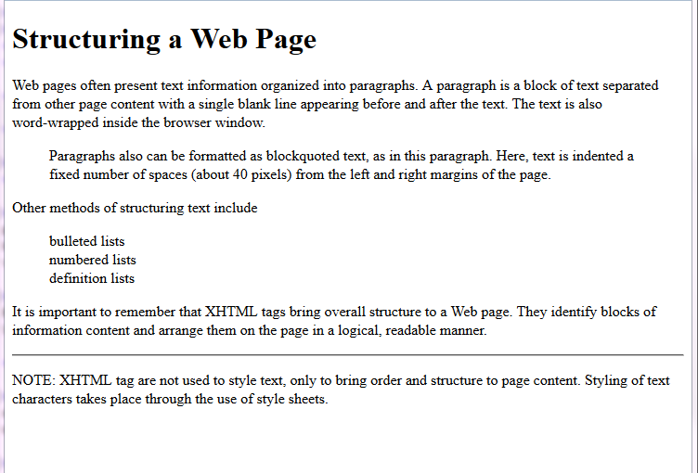

Za oblikovanje uporabite značke <p>, <blockquote>, <br/>, <h1> in<hr/>.

**Besedilo**

Structuring a Web Page

Web pages often present text information organized into paragraphs. A

paragraph is a block of text separated from other page content with a single

blank line appearing before and after the text. The text is also word-wrapped

inside the browser window.

Paragraphs also can be formatted as blockquoted text, as in this paragraph.

Here, text is indented a fixed number of spaces (about 40 pixels) from the

left and right margins of the page.

Other methods of structuring text include

bulleted lists

numbered lists

definition lists

It is important to remember that XHTML tags bring overall structure to a Web

page. They identify blocks of information content and arrange them on the

page in a logical, readable manner.

NOTE: XHTML tag are not used to style text, only to bring order and structure

to page content. Styling of text characters takes place through the use of

style sheets.