Pripravite spletno stran z razporeditvijo elementov v tabeli. Spletno stran prikazuje spodnja slika. Najdete jo tudi na spletni strani <http://www.sedh.gr/tutorials/web_dev/XHTMLAssignments/default.htm> pod oznako 8-5.

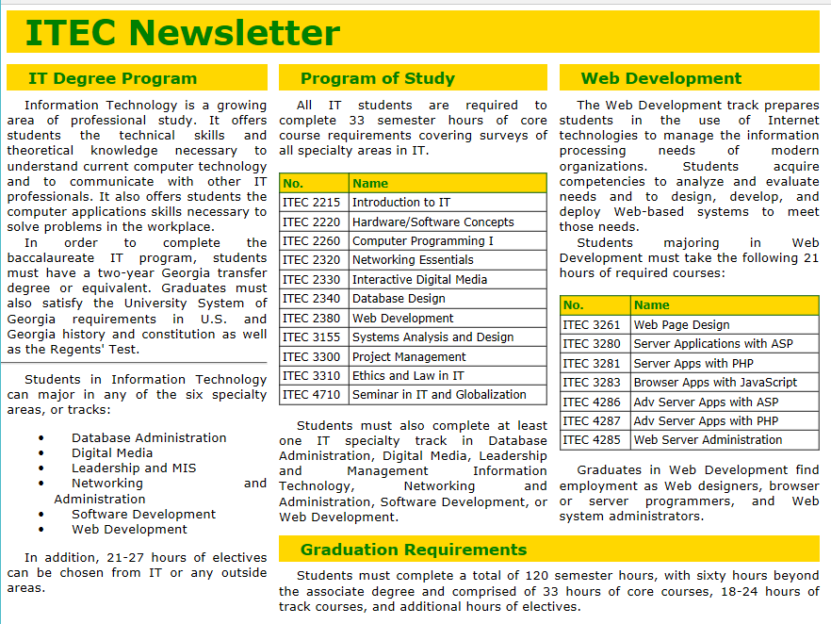

**Navodila:**

1. Za oblikovanje uporabite vgrajene sloge.
2. Telo dokumenta ima margin širok 10px.
3. Celotna razporeditev v tabeli je definirana na sledeč način:

<table id="LAYOUT">

<tr>

<th colspan="3">

</th>

</tr>

<tr>

<td width="33%" rowspan="2">

</td>

<td width="34%">

</td>

<td width="33%">

</td>

</tr>

<tr>

<td colspan="2">

</td>

</tr>

</table>

1. Tabela je široka 700px. Celicam določajo obliko naslednje lastnosti: font-family:verdana; font-size:8pt; padding:5px; vertical-align:top; text-align:justify; text-indent:15px.
2. Zgornji naslov ima pisavo visoko 22pt, je poudarjen, barva črk je green, barva ozadja je gold.
3. Naslovi stolpcev imajo poudarjeno pisavo visoko10pt. Barva pisave je green, barva ozadja je gold. Tekst je od robov odmaknjen za 3px, spodnji margin je 5px.
4. Manjši tabeli sta oblikovani na sledeč način: širina tabele je nastavljena na 100%. Zunanja meja je zlita z mejami celic. Spodnji margin tabele je 10 pikslov. Za celice velja: velikost pisave je 7px, tekst je od robov odmaknjen 2px, prva vrstica ni zamaknjena oz. text-indent je postavljen na 0px.
5. Ker imamo opravka s temi tabelami, jih oblikujmo s pomočjo ID selektorja npr.:

table#LAYOUT {*nastavitve sloga*}

table#LAYOUT tr {*nastavitve sloga*}

table#LAYOUT td {*nastavitve sloga*}

**Tekst na strani**

ITEC Newsletter

IT Degree Program

Information Technology is a growing area of professional study. It offers

students the technical skills and theoretical knowledge necessary to

understand current computer technology and to communicate with other IT

professionals. It also offers students the computer applications skills

necessary to solve problems in the workplace.

In order to complete the baccalaureate IT program, students must have a

two-year Georgia transfer degree or equivalent. Graduates must also satisfy

the University System of Georgia requirements in U.S. and Georgia history

and constitution as well as the Regents' Test.

Students in Information Technology can major in any of the six specialty

areas, or tracks:

Database Administration

Digital Media

Leadership and MIS

Networking and Administration

Software Development

Web Development

In addition, 21-27 hours of electives can be chosen from IT or

any outside areas.

Program of Study

All IT students are required to complete 33 semester hours of core course

requirements covering surveys of all specialty areas in IT.

No. Name

ITEC 2215 Introduction to IT

ITEC 2220 Hardware/Software Concepts

ITEC 2260 Computer Programming I

ITEC 2320 Networking Essentials

ITEC 2330 Interactive Digital Media

ITEC 2340 Database Design

ITEC 2380 Web Development

ITEC 3155 Systems Analysis and Design

ITEC 3300 Project Management

ITEC 3310 Ethics and Law in IT

ITEC 4710 Seminar in IT and Globalization

Students must also complete at least one IT specialty track in Database

Administration, Digital Media, Leadership and Management Information

Technology, Networking and Administration, Software Development, or Web

Development.

Web Development

The Web Development track prepares students in the use of Internet

technologies to manage the information processing needs of modern

organizations. Students acquire competencies to analyze and evaluate

needs and to design, develop, and deploy Web-based systems to meet those

needs.

Students majoring in Web Development must take the following 21 hours of

required courses:

No. Name

ITEC 3261 Web Page Design

ITEC 3280 Server Applications with ASP

ITEC 3281 Server Apps with PHP

ITEC 3283 Browser Apps with JavaScript

ITEC 4286 Adv Server Apps with ASP

ITEC 4287 Adv Server Apps with PHP

ITEC 4285 Web Server Administration

Graduates in Web Development find employment as Web designers, browser or

server programmers, and Web system administrators.

Graduation Requirements

Students must complete a total of 120 semester hours, with sixty hours beyond

the associate degree and comprised of 33 hours of core courses, 18-24 hours

of track courses, and additional hours of electives.