Pripravite spletno stran (na sliki spodaj), ki nas poveže s spletnimi stranmi na katerih so neoštevilčen seznam, oštevilčen seznam, seznam definicij in ugnezden seznam. Pripravite tudi te strani, kot je razvidno iz slik, ki sledijo skozi tekst. (Return povezava nas vrne na začetno spletno stran)

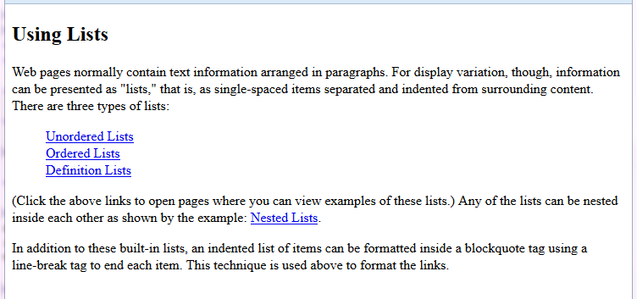

**Ime spletne strani: povezaveNaSezname.htm**

**Besedilo na spletni strani**

Using Lists

Web pages normally contain text information arranged in paragraphs. For

display variation, though, information can be presented as "lists," that

is, as single-spaced items separated and indented from surrounding content.

There are three types of lists:

Unordered Lists

Ordered Lists

Definition Lists

(Click the above links to open pages where you can view examples of these

lists.) Any of the lists can be nested inside each other as shown by the

example: Nested Lists.

In addition to these built-in lists, an indented list of items can be

formatted inside a blockquote tag using a line-break tag to end each item.

This technique is used above to format the links.

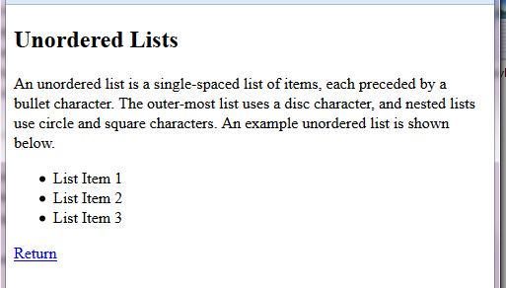

**Ime spletne strani:ULPage.htm**

**Besedilo na spletni strani**

Unordered Lists

An unordered list is a single-spaced list of items, each preceded by a bullet

character. The outer-most list uses a disc character, and nested lists use

circle and square characters. An example unordered list is shown below.

List Item 1

List Item 2

List Item 3

Return

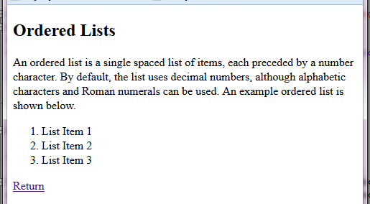

**Ime spletne strani:OLPage.htm**

**Besedilo na spletni strani**

**OLPage.htm**

Ordered Lists

An ordered list is a single spaced list of items, each preceded by a number

character. By default, the list uses decimal numbers, although alphabetic

characters and Roman numerals can be used. An example ordered list is shown

below.

List Item 1

List Item 2

List Item 3

Return

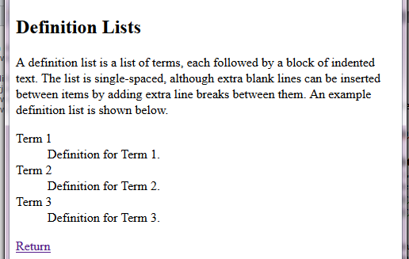

**Ime spletne strani:DLPage.htm**

**Besedilo na spletni strani**

Definition Lists

A definition list is a list of terms, each followed by a block of indented

text. The list is single-spaced, although extra blank lines can be inserted

between items by adding extra line breaks between them. An example definition

list is shown below.

Term 1

Definition for Term 1.

Term 2

Definition for Term 2.

Term 3

Definition for Term 3.

Return

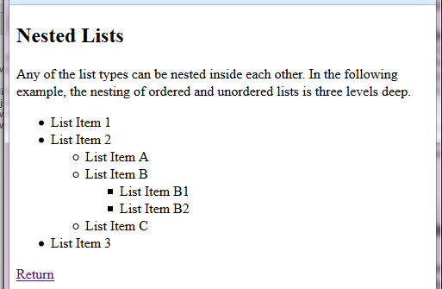

**Ime spletne strani:NLPage.htm**

**Besedilo na spletni strani**

Nested Lists

Any of the list types can be nested inside each other. In the following

example, the nesting of ordered and unordered lists is three levels deep.

List Item 1

List Item 2

List Item A

List Item B

List Item B1

List Item B2

List Item C

List Item 3

Return