Pripravite spodnjo spletno stran!

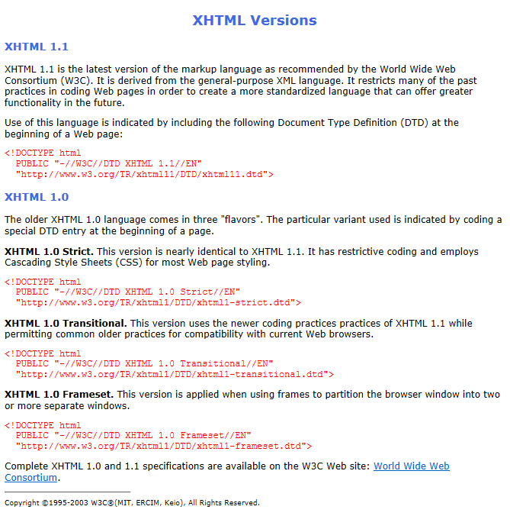

Oblikujte z vgrajenim slogom v glavi dokumenta!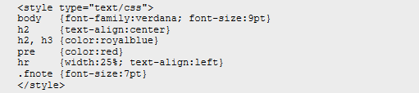

Za naslove uporabite označevalce h2 in h3. Tekst oblikujte z označevalci p, b, pre in div!

Uporabljen tekst:

XHTML Versions

XHTML 1.1

XHTML 1.1 is the latest version of the markup language as recommended by

the World Wide Web Consortium (W3C). It is derived from the general-purpose

XML language. It restricts many of the past practices in coding Web pages in

order to create a more standardized language that can offer greater

functionality in the future.

Use of this language is indicated by including the following Document Type

Definition (DTD) at the beginning of a Web page:

&lt;!DOCTYPE html

PUBLIC "-//W3C//DTD XHTML 1.1//EN"

"http://www.w3.org/TR/xhtml11/DTD/xhtml11.dtd"&gt;

XHTML 1.0

The older XHTML 1.0 language comes in three "flavors". The particular

variant used is indicated by coding a special DTD entry at the beginning of a

page.

XHTML 1.0 Strict. This version is nearly identical to XHTML 1.1. It

has restrictive coding and employs Cascading Style Sheets (CSS) for most Web

page styling.

&lt;!DOCTYPE html

PUBLIC "-//W3C//DTD XHTML 1.0 Strict//EN"

"http://www.w3.org/TR/xhtml1/DTD/xhtml1-strict.dtd"&gt;

XHTML 1.0 Transitional. This version uses the newer coding practices

practices of XHTML 1.1 while permitting common older practices for

compatibility with current Web browsers.

&lt;!DOCTYPE html

PUBLIC "-//W3C//DTD XHTML 1.0 Transitional//EN"

"http://www.w3.org/TR/xhtml1/DTD/xhtml1-transitional.dtd"&gt;

XHTML 1.0 Frameset. This version is applied when using frames to

partition the browser window into two or more separate windows.</p>

&lt;!DOCTYPE html

PUBLIC "-//W3C//DTD XHTML 1.0 Frameset//EN"

"http://www.w3.org/TR/xhtml1/DTD/xhtml1-frameset.dtd"&gt;

Complete XHTML 1.0 and 1.1 specifications are available on the W3C Web

site: World Wide Web

Consortium

Copyright &copy;1995-2003 W3C &reg;(MIT, ERCIM, Keio), All Rights

Reserved.