Pripravite spletno stran, kot je razvidno iz slike spodaj.

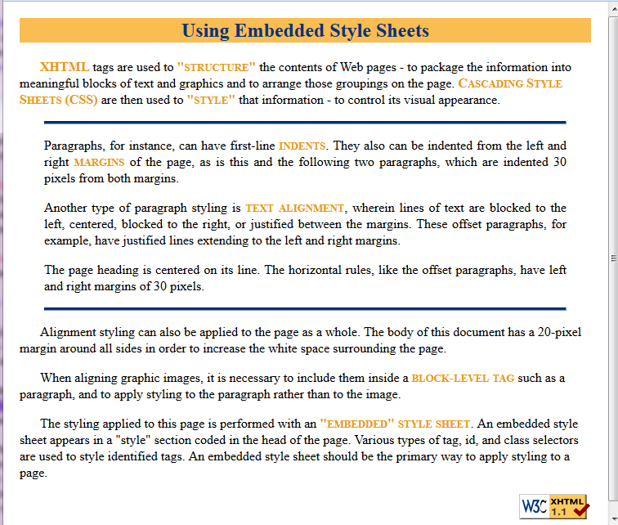

**Navodila:**

* Spletno stran oblikujte izključno z vgrajenimi slogi.
  + Telo dokumenta ima margin 20 pikslov na vseh štirih stranicah. (Oblikujte z **body** značko.)
* Naslov označen z značko <h2> je centriran. Tekst je v modri barvi rgb(3,52,123), ozadje pa v oranžni barvi rgb(249,189,81). (Oblikujte s **h2** značko.)
  + Običajni odstavki imajo prvo vrstico zamaknjeno za 25 pikslov in so levo poravnani. (Oblikujte s **p** značko.)
  + Zamaknjeni odstavki nimajo zamaknjene prve vrstice, so pa od levega in desnega roba odmaknjeni za dodatnih 30 pikslov. Tekst je tu obojestransko poravnan. (Za oblikovanje teh odstavkov določite class **.Offset** z ustreznimi lastnostmi. Tu moramo postaviti tudi zamik prve vrstice na 0 pikslov, da prekličemo zamik določeno z značko **p**)
* Vodoravni črti sta prav tako zamaknjeni od levega in desnega roba za dodatnih 30 pikslov. Visoki sta 4 piksle in v barvi rgb(3,52,123) (Oblikujte s **hr** značko.)
* Poudarjen tekst uporablja small caps in je v barvi rgb(234,153,8). (Oblikujte s class selektorjem)
  + Slika je poravnana desno. Sliko moramo vključiti znotraj block-level elementa, npr. odstavka <p>. Za poravnavo slike na desni rob uporabite id selektor za ta odstavek.

Using Embedded Style Sheets

XHTML tags are used to "structure" the contents of Web pages - to package

the information into meaningful blocks of text and graphics and to arrange

those groupings on the page. Cascading Style Sheets (CSS) are then used to

"style" that information - to control its visual appearance.

-- *insert horizontal rule*

Paragraphs, for instance, can have first-line indents. They also can be

indented from the left and right margins of the page, as is this and the

following two paragraphs, which are indented 30 pixels from both margins.

Another type of paragraph styling is text alignment, wherein lines of text

are blocked to the left, centered, blocked to the right, or justified between

the margins. These offset paragraphs, for example, have justified lines

extending to the left and right margins.

The page heading is centered on its line. The horizontal rules, like the

offset paragraphs, have left and right margins of 30 pixels.

-- *insert horizontal rule*

Alignment styling can also be applied to the page as a whole. The body of

this document has a 20-pixel margin around all sides in order to increase

the white space surrounding the page.

When aligning graphic images, it is necessary to include them inside a

block-level tag such as a paragraph, and to apply styling to the paragraph

rather than to the image.

The styling applied to this page is performed with an "embedded" style

sheet. An embedded style sheet appears in a "style" section coded in the

head of the page. Various types of tag, id, and class selectors are used

to style identified tags. An embedded style sheet should be the primary

way to apply styling to a page.

-- *insert image*

**Slika:**

