Pripravite spodnjo spletno stran. Navodila najdete tudi pod številko 3-4 na spletni strani <http://www.sedh.gr/tutorials/web_dev/XHTMLAssignments/default.htm>

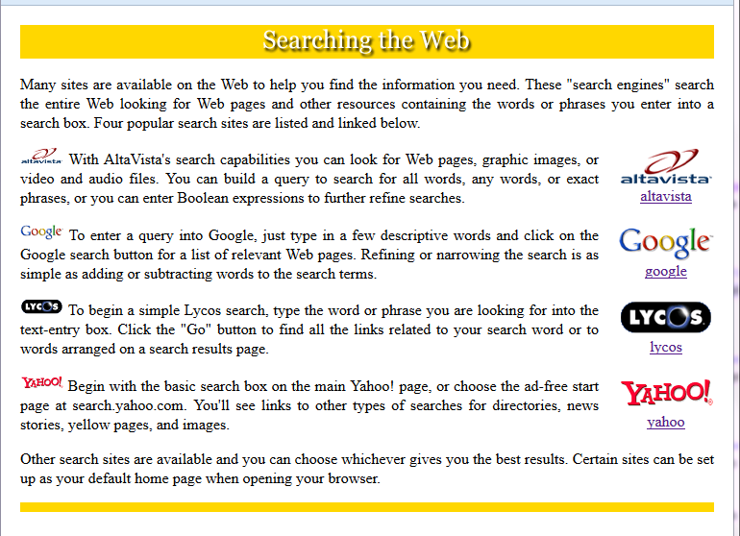

**Navodila:**

Za oblikovanje spletne strani uporabite vgrajene sloge.

* Telo spletne strani ima margin širok 20pikslov, na vseh stranicah. (Oblikuj z značko **body**.)
* Vsi odstavki so obojestransko poravnani. (Oblikuj z značko **p**.)
* Del, v katerem se nahaja naslov , je sestavljen iz slike in rumenega ozadja z barvo, ki je enaka barvi na ozadju sike. Šestnajstiška vrednost barve je #FFD700. (Odstavek oblikuj z **#id** izbirnikom.)
* Majhnim slikam na levi strani odstavkov morate določiti velikost, ki je manjša od velikosti originalne slike. (Oblikujte s **.Tiny** class izbirnikom, širina slik je tu 45 pikslov.)
* Slike na desni so vključene znotraj značke division, ki plava desno od odstavka s tekstom. (Oblikuj division z izbirnikom class, ki centrira vsebino. Division ima levi margin širok 20pikslov.)
* Črta na dnu strani je široko 10 pikslov in je iste barve, kot je barva ozadja v naslovu. (Oblikuj z div značko z id selektorjem.)

**Povezave:**

http://search.yahoo.com/?fr=altavista  
https://www.google.si  
http://www.lycos.com/  
<https://www.yahoo.com/>

**Slike:**



 

 

**Tekst na spletni strani**

[*slika*]

Many sites are available on the Web to help you find the information you

need. These "search engines" search the entire Web looking for Web pages and

other resources containing the words or phrases you enter into a search box.

Four popular search sites are listed and linked below.

[*slika*] With AltaVista's search capabilities you can look for Web pages,

graphic images, or video and audio files. You can build a query to search

for all words, any words, or exact phrases, or you can enter Boolean

expressions to further refine searches.

[*slika*] To enter a query into Google, just type in a few descriptive words

and click on the Google search button for a list of relevant Web pages.

Refining or narrowing the search is as simple as adding or subtracting words

to the search terms.

[*slika*] To begin a simple Lycos search, type the word or phrase you are

looking for into the text-entry box. Click the "Go" button to find all the

links related to your search word or to words arranged on a search results

page.

[*slika*] Begin with the basic search box on the main Yahoo! page, or choose

the ad-free start page at search.yahoo.com. You'll see links to other types

of searches for directories, news stories, yellow pages, and images.

Other search sites are available and you can choose whichever gives you the

best results. Certain sites can be set up as your default home page when

opening your browser.