Pripravito spletno stran, kot je prikazano na sliki spodaj. Obliko elementom določitez vgrajenimi slogi. Nalogo najdete tudi pod številko 4-3 na povezavi http://www.sedh.gr/tutorials/web_dev/XHTMLAssignments/default.htm

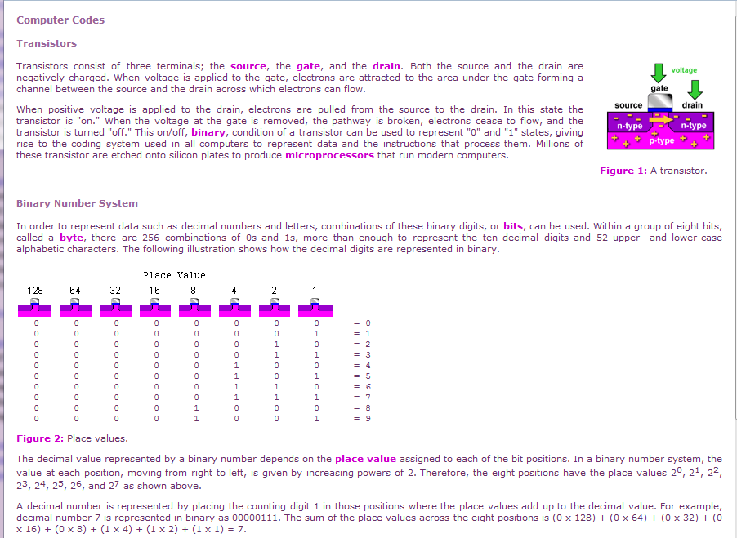

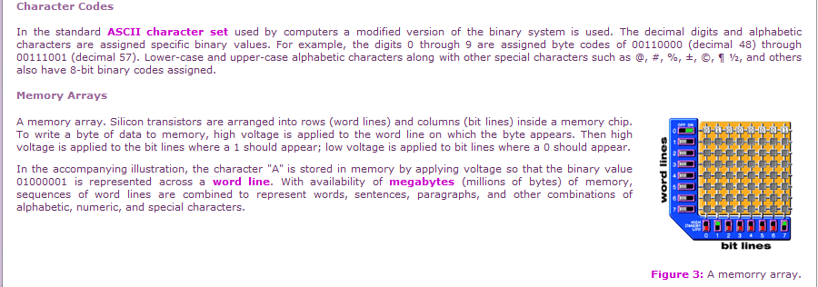

* Elementi na spletni strani so od robov okna brskalnika oddaljeni za 15 pikslov. Tekst je visok 8pt v pisavi Verdana. Poravnava teksta je justify. Barva teksta je v RGB prostoru določen z vrednostmi 102,51,102.
* Glavni naslov na strani je določen z značko <h3>, podnaslovi z značko <h4>. Barva naslovov je RGB(153,102,153).
* Povdarjen tekst je določen z značko <b> in je v barvi RGB(204,0,204).
* 0-le in 1-nice se morajo biti nameščene skladno s sliko tranzistorja, uporabi označevalec <pre>. Top margin značke <pre> je -5px, kar omogoči namestitev števk takoj pod sliko, slika je nameščena znotraj <div> elementa
* Nadpisane vrednosti (20, 21, 22, itd.) so določene z značko <sup>
* Plavajoče slike so nameščene v enoti <div>. Elementi (tekst) so od levega roba škatle odmaknjeni za 20px in od spodnjega roba za 15px. Za določitev sloga uporabite class selector.

**Tekst na spletni strani**

Computer Codes

Transistors

[*graphic*]

Transistors consist of three terminals; the source, the gate, and the drain.

Both the source and the drain are negatively charged. When voltage is applied

to the gate, electrons are attracted to the area under the gate forming a

channel between the source and the drain across which electrons can flow.

When positive voltage is applied to the drain, electrons are pulled from the

source to the drain. In this state the transistor is "on." When the voltage

at the gate is removed, the pathway is broken, electrons cease to flow, and

the transistor is turned "off." This on/off, binary, condition of a

transistor can be used to represent "0" and "1" states, giving rise to the

coding system used in all computers to represent data and the instructions

that process them. Millions of these transistor are etched onto silicon

plates to produce microprocessors that run modern computers.

Binary Number System

In order to represent data such as decimal numbers and letters, combinations

of these binary digits, or bits, can be used. Within a group of eight bits,

called a byte, there are 256 combinations of 0s and 1s, more than enough to

represent the ten decimal digits and 52 upper- and lower-case alphabetic

characters. The following illustration shows how the decimal digits are

represented in binary.

[*graphic*]

0 0 0 0 0 0 0 0 = 0

0 0 0 0 0 0 0 1 = 1

0 0 0 0 0 0 1 0 = 2

0 0 0 0 0 0 1 1 = 3

0 0 0 0 0 1 0 0 = 4

0 0 0 0 0 1 0 1 = 5

0 0 0 0 0 1 1 0 = 6

0 0 0 0 0 1 1 1 = 7

0 0 0 0 1 0 0 0 = 8

0 0 0 0 1 0 0 1 = 9

The decimal value represented by a binary number depends on the place value

assigned to each of the bit positions. In a binary number system, the value

at each position, moving from right to left, is given by increasing powers

of 2. Therefore, the eight positions have the place values 20, 21, 22, 23,

24, 25, 26, and 27 as shown above.

A decimal number is represented by placing the counting digit 1 in those

positions where the place values add up to the decimal value. For example,

decimal number 7 is represented in binary as 00000111. The sum of the place

values across the eight positions is (0 x 128) + (0 x 64) + (0 x 32) +

(0 x 16) + (0 x 8) + (1 x 4) + (1 x 2) + (1 x 1) = 7.

Character Codes

In the standard ASCII character set used by computers a modified version of

the binary system is used. The decimal digits and alphabetic characters are

assigned specific binary values. For example, the digits 0 through 9 are

assigned byte codes of 00110000 (decimal 48) through 00111001 (decimal 57).

Lower-case and upper-case alphabetic characters along with other special

characters such as @, #, % ,±, ©, ¶ ½, and others also have 8-bit binary

codes assigned.

Memory Arrays

[*graphic*]

A memory array. Silicon transistors are arranged into rows (word lines) and

columns (bit lines) inside a memory chip. To write a byte of data to memory,

high voltage is applied to the word line on which the byte appears. Then high

voltage is applied to the bit lines where a 1 should appear; low voltage is

applied to bit lines where a 0 should appear.

In the accompanying illustration, the character "A" is stored in memory by

applying voltage so that the binary value 01000001 is represented across a

word line. With availability of megabytes (millions of bytes) of memory,

sequences of word lines are combined to represent words, sentences,

paragraphs, and other combinations of alphabetic, numeric, and special

characters.

**Slike**

