Jude Juma CV
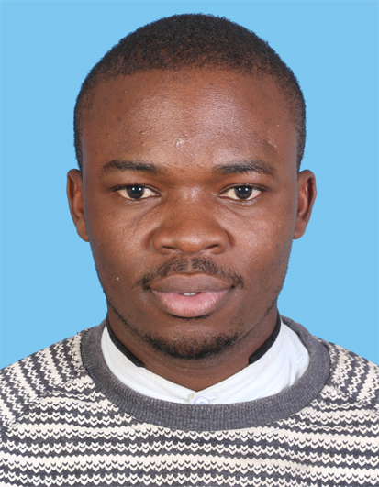

PERSONAL INFORMATION
Name: Jude Juma
Date of Birth: 28-4-1991.
Nationality: Kenyan
Languages: English, Kiswahili, Luo
Mobile: +254713751628
E-mail: jude.juma@yahoo.com/judejuma@gmail.com
LinkedIn Profile: https://www.linkedin.com/feed/

PROFILE
I am an enterprising young professional interested in continuing my development as a researcher. I am a result-oriented and I love to work as part of a team. I have a proactive attitude and excellent emotional intelligence.

EDUCATION
2017 May-Present: Bachelor of Information Technology
- Jomo Kenyatta University of Agriculture &Technology (JKUAT)
- Relevant Courses:
- Computer Application
- Computer systems and Organizations
- Introduction to Operating System
- Introduction to networking
- System analysis and design
- Introduction to databases management
- Introduction to programming (Using C language)
2011-2015: Bachelor of Science in Laboratory Medicine
- University of Nairobi (UoN)
- Second Class Upper Division
- Relevant Courses: Research methodology, public health, Report writing
2005-2009: Kenya Certificate of Secondary Education
- Scored 78/84 points (A-)

PROFESSIONAL EXPERIENCE
- Kenyatta National Referral Hospital/University of Nairobi Lab
  - Laboratory rotations
Rotated for three months every year from 2012 to 2015
(Total of 12 months)
- Assisted hospital physicians in the diagnosis and treatment of illnesses and medical conditions by providing clinical testing and specimen analysis.
- Helped in report writing and record keeping of laboratory research findings.
- Community Medical Camps
2015 January-2015 March
- Team Leader
- Led a team of students in a qualitative needs-assessment research to find out the health needs of selected slums in Nairobi.
- Roles: Collecting data from the community members, writing reports on the findings of the research.
- Well Told Story Limited
2016 January-2016 July
- Worked as a research assistant
- Roles: Data collection and Report writing.
- Samuel Hall
- Enumerator
- Contract ending on 14/11/2017
- Roles: Data collection through interview of questionnaires
- As an enumertaor I interviewed 10 people per day, on average using the KoboCollect software
- Skills Learned: intercultural communication skills, how to estblish good personal relationship with potetial respondents, lisening skills and good report writing skills.

Extra Curriculum Activities
2011-2015: Chairman, Association of Medical Laboratory Science Students
- Led a team of 6 student leaders
- Organized for student orientation programs and peer counseling programs in campus
2009-2011: Volunteer Work
- Omboga Mixed Secondary School
- Taught Mathematics, Geography and Business studies

Skills
Computer Skills
- Microsoft windows 7, 8 & 10, Microsoft Office and Internet Application
Communication skills
- Can communicate fluently in both English and Kiswahili
- Have excellent report writing skills
Counseling skills
- APHIA II Nyanza trained me as a peer counselor in conjunction with the Vintage Consultancy Services and USAID.
- I participated in a training program organized by Engender Health in collaboration with Men as Partners. The training, which took place in 2008, focused on HIV & Gender Based Violence prevention for youths in school.
- Roles: Data collection and Report writing.

Referees
Dr. Nyagol Joshua Akelo, Senior Lecturer  Department of Pathology,  University of Nairobi.  Cell phone: +254-711351955  Email: Joshua.nyagol@uonbi.ac.ke | Caren Namalenya  Research Coordinator  Well Told Story Limited  cnamalenya@gmail.com  +254726882622 | Mr. Aol Jared  Project Coordinator  Samuel Hall.  Cell: +254-728981663

