SCENARIO BASED MODELING OF
“BAZARHQ”
Complete Hierarchical Use Case Diagram Report
Reference-style Level-0, Level-1 and Decomposed Subsystem Diagrams
54 Use Case Diagrams
Designed By Jakaria Hasan

1 SCENARIO BASED MODELING OF “BAZARHQ”
This report models BazarHQ from the final updated story-based scenario. It follows the supplied reference structure: the complete system is shown first, then major subsystems, and then each important subsystem is decomposed into smaller use case diagrams.
1.1 ACTORS
Primary actors: Merchant, Customer / Guest Visitor, and Super Admin. Secondary actors are included where the scenario explicitly needs them: Google OAuth, Email Service, SMS Service, Payment Gateway, Cloudinary, and Second Super Admin.
1.2 USE CASE DIAGRAMS
Each figure uses a centered system/subsystem boundary, non-overlapping blue use-case ovals, external actors, complete straight association lines, consistent font sizing, a figure caption, and a short scenario-grounded description. Total diagrams: 54.

1.3.1 LEVEL-0 USE CASE DIAGRAM - BAZARHQ
BazarHQ
Version 1.0
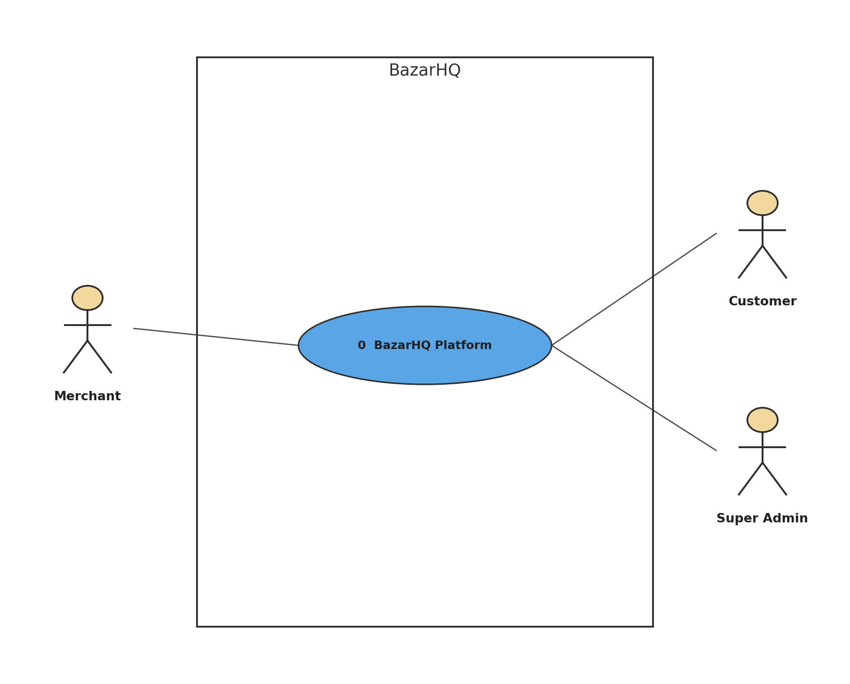
Figure 1: BazarHQ
Description of 1.3.1 use case diagram:
Level-0 presents BazarHQ as one system and identifies the three main actors defined by the scenario: Merchant, Customer, and Super Admin.
Actors: Merchant, Customer, Super Admin

1.3.2 LEVEL-1 USE CASE DIAGRAM - SUB SYSTEMS
BazarHQ
Version 1.0
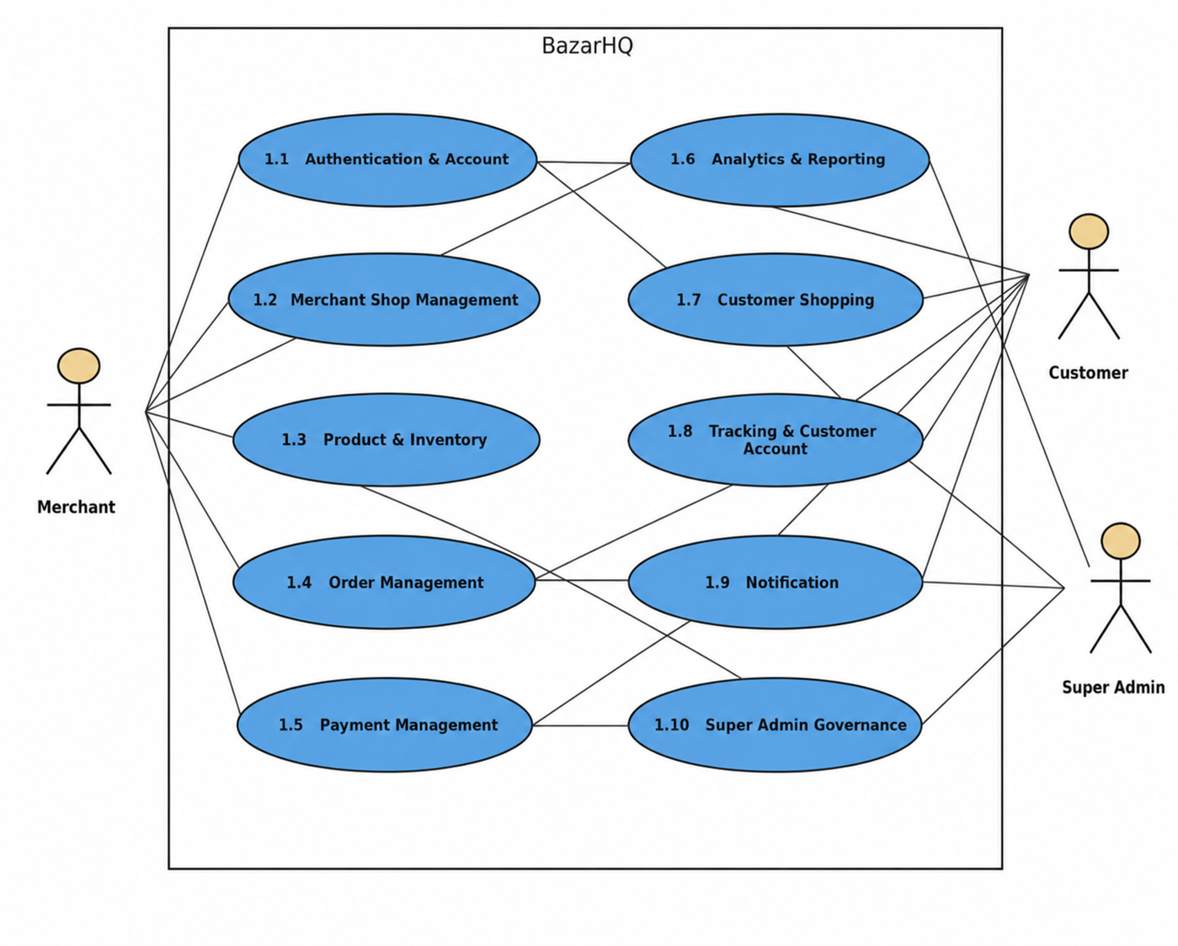
Figure 2: BazarHQ
Description of 1.3.2 use case diagram:
Level-1 decomposes BazarHQ into the major functional subsystems supported by the scenario. These subsystems are further decomposed in the following diagrams.
Actors: Merchant, Customer, Super Admin

1.3.3 LEVEL-1.1 USE CASE DIAGRAM - AUTHENTICATION & ACCOUNT
1.1 Authentication & Account
Version 1.0
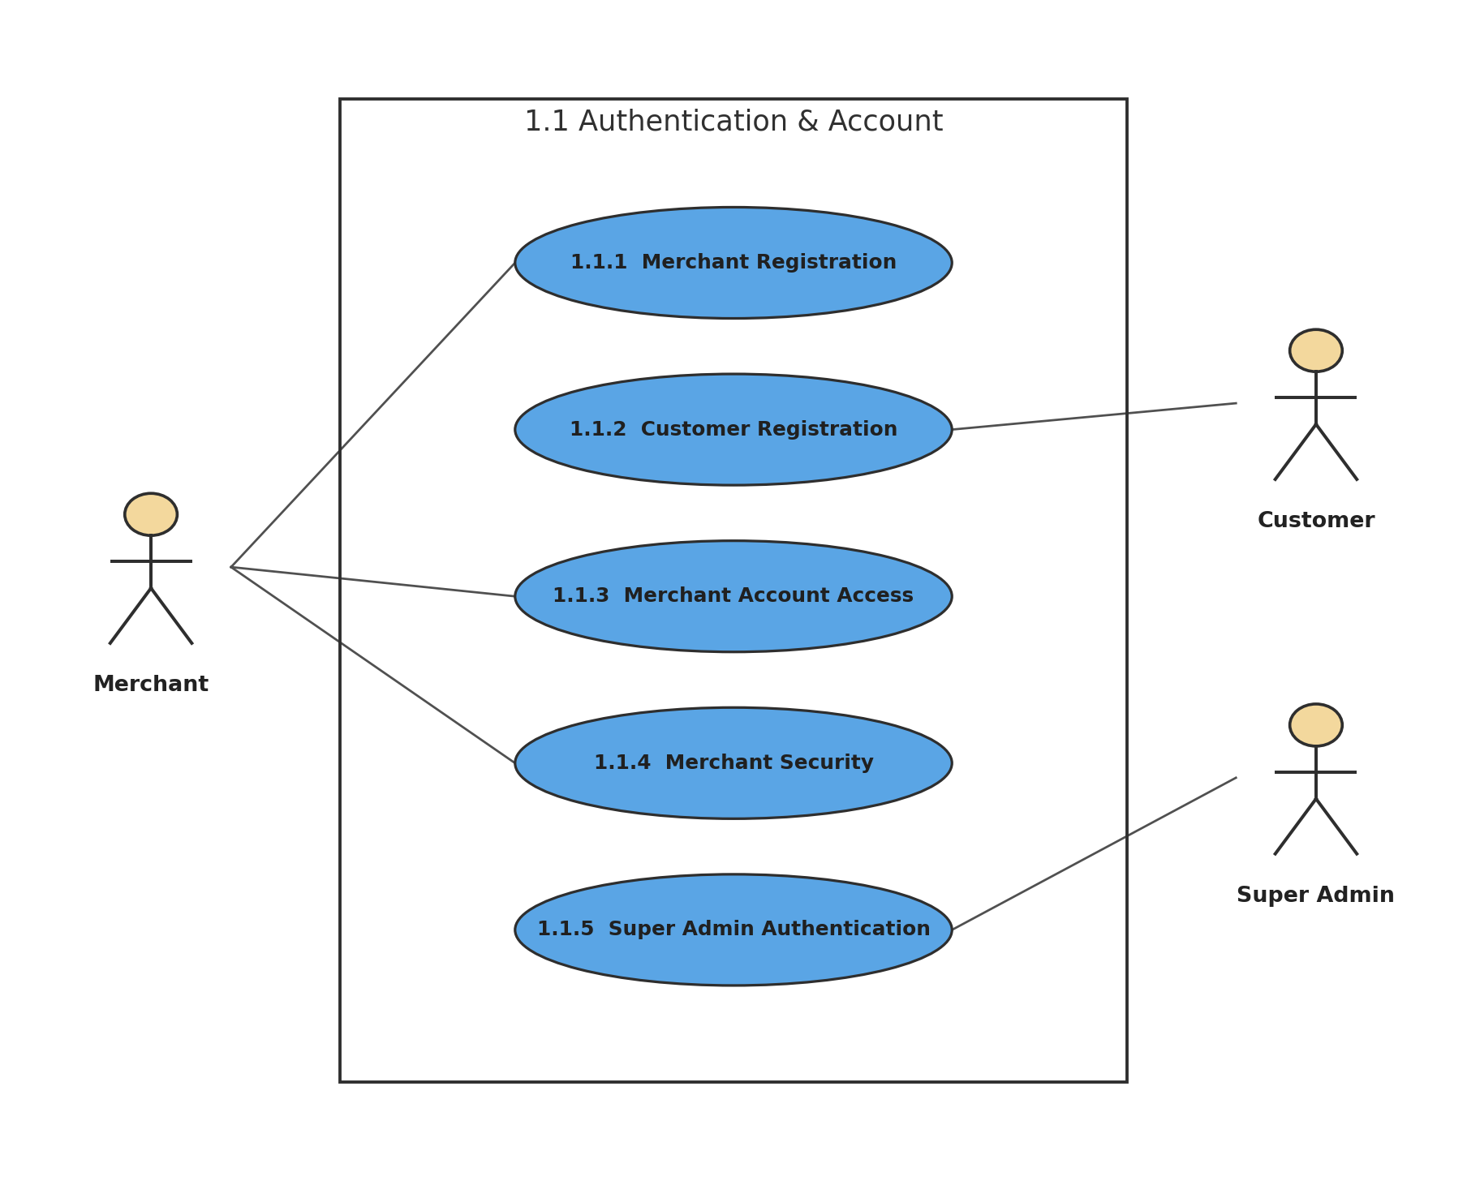
Figure 3: 1.1 Authentication & Account
Description of 1.3.3 use case diagram:
This subsystem covers account creation, access verification, merchant account security, and privileged Super Admin authentication.
Actors: Merchant, Customer, Super Admin

1.3.4 LEVEL-1.1.1 USE CASE DIAGRAM - MERCHANT REGISTRATION
1.1.1 Merchant Registration
Version 1.0
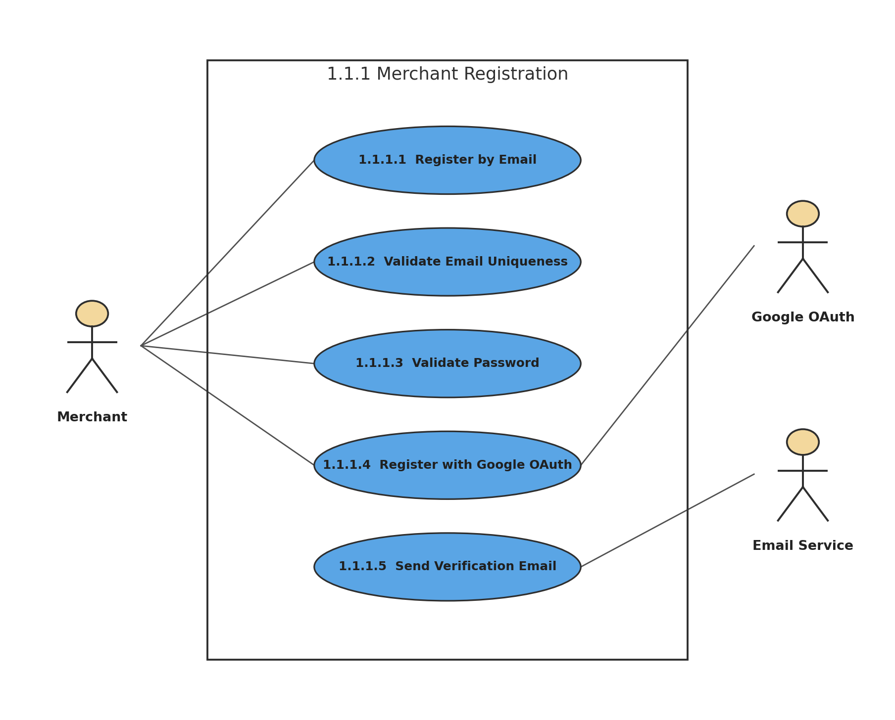
Figure 4: 1.1.1 Merchant Registration
Description of 1.3.4 use case diagram:
Merchant registration supports email/password and Google OAuth. Email registration validates uniqueness and password rules, then sends a verification email.
Actors: Merchant, Google OAuth, Email Service

1.3.5 LEVEL-1.1.2 USE CASE DIAGRAM - CUSTOMER REGISTRATION
1.1.2 Customer Registration
Version 1.0
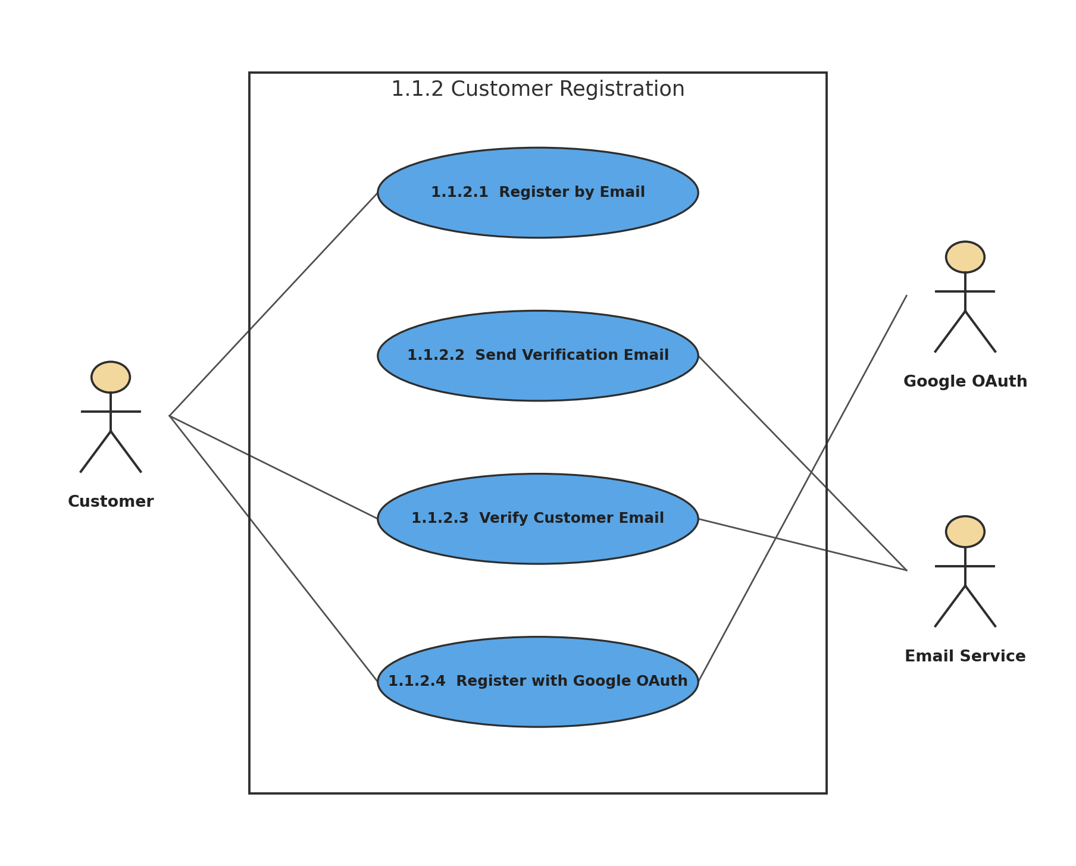
Figure 5: 1.1.2 Customer Registration
Description of 1.3.5 use case diagram:
Customers can create an account using email/password or Google OAuth. Email registration requires verification before the verified email is used for account features.
Actors: Customer, Google OAuth, Email Service

1.3.6 LEVEL-1.1.3 USE CASE DIAGRAM - MERCHANT ACCOUNT ACCESS
1.1.3 Merchant Account Access
Version 1.0
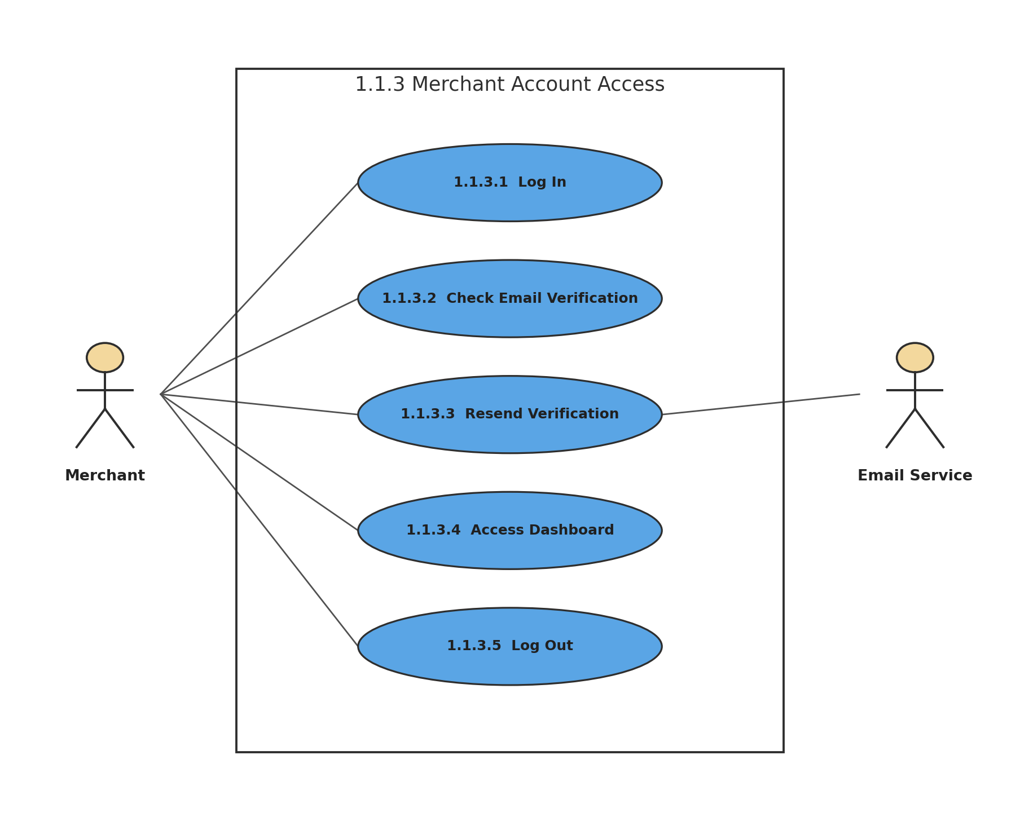
Figure 6: 1.1.3 Merchant Account Access
Description of 1.3.6 use case diagram:
Dashboard access is allowed only after the merchant email is verified. The login page provides a resend-verification option when needed.
Actors: Merchant, Email Service

1.3.7 LEVEL-1.1.4 USE CASE DIAGRAM - MERCHANT SECURITY
1.1.4 Merchant Security
Version 1.0
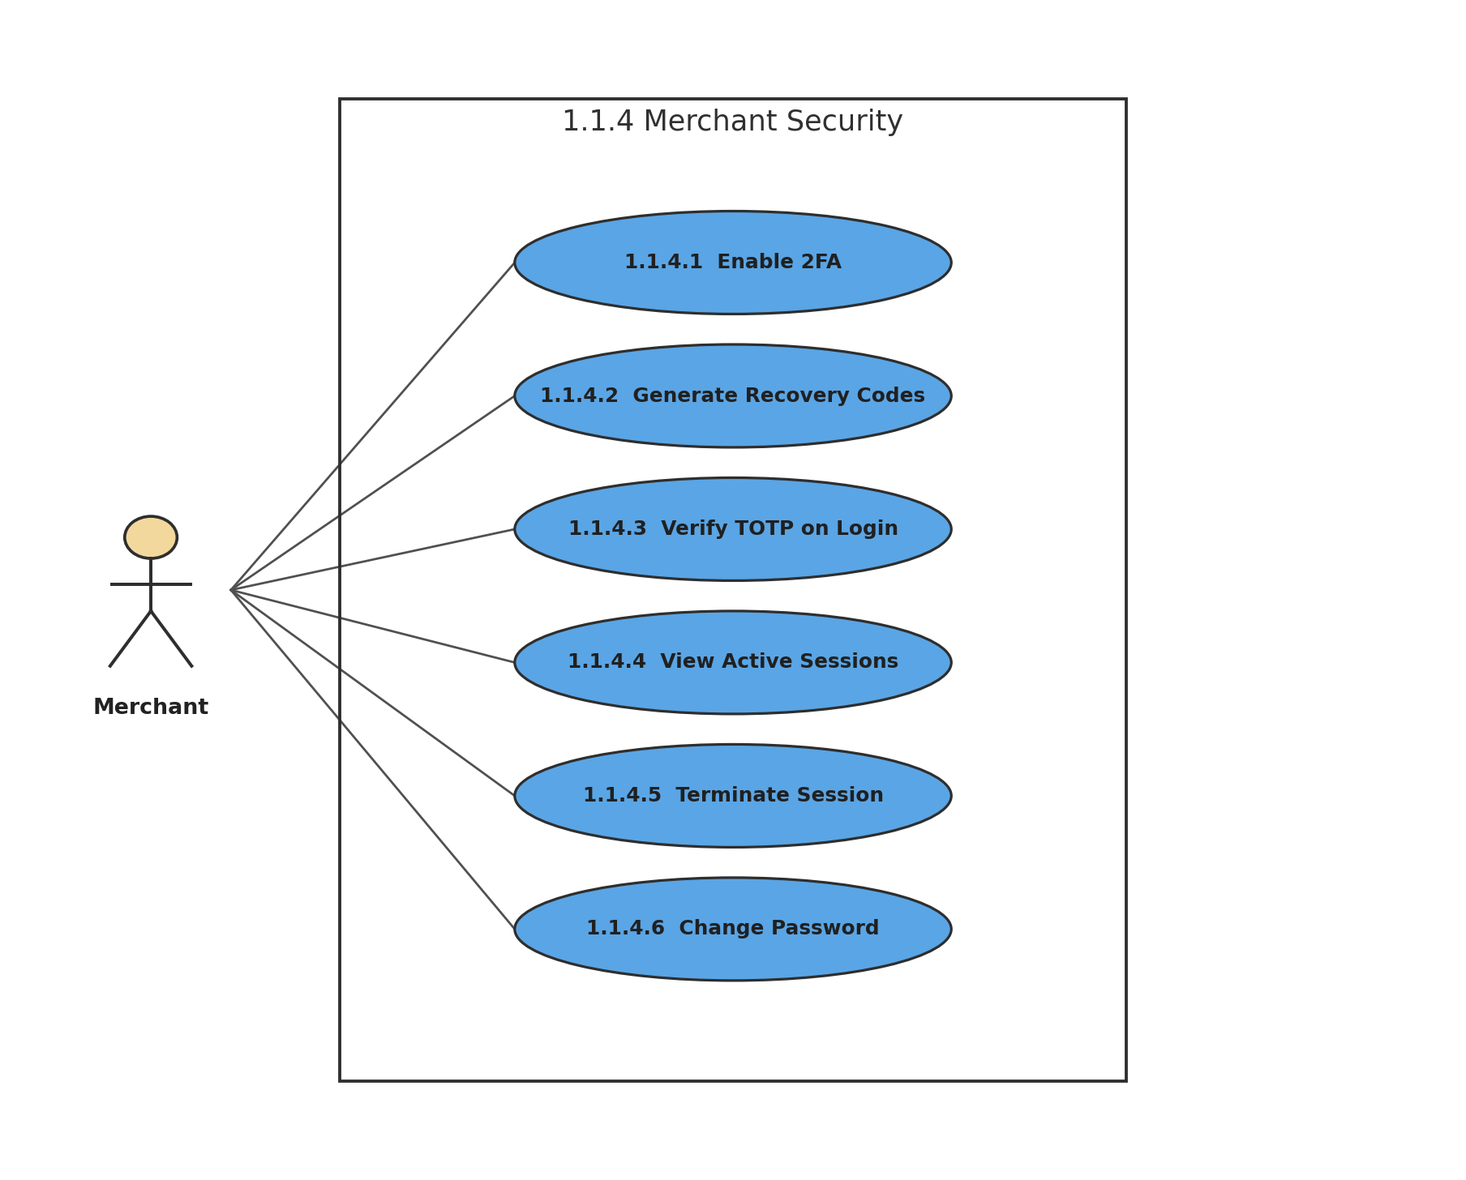
Figure 7: 1.1.4 Merchant Security
Description of 1.3.7 use case diagram:
Merchant security includes authenticator-based 2FA, backup recovery codes, device/session control, and password changes that terminate other active sessions.
Actors: Merchant

1.3.8 LEVEL-1.1.5 USE CASE DIAGRAM - SUPER ADMIN AUTHENTICATION
1.1.5 Super Admin Authentication
Version 1.0
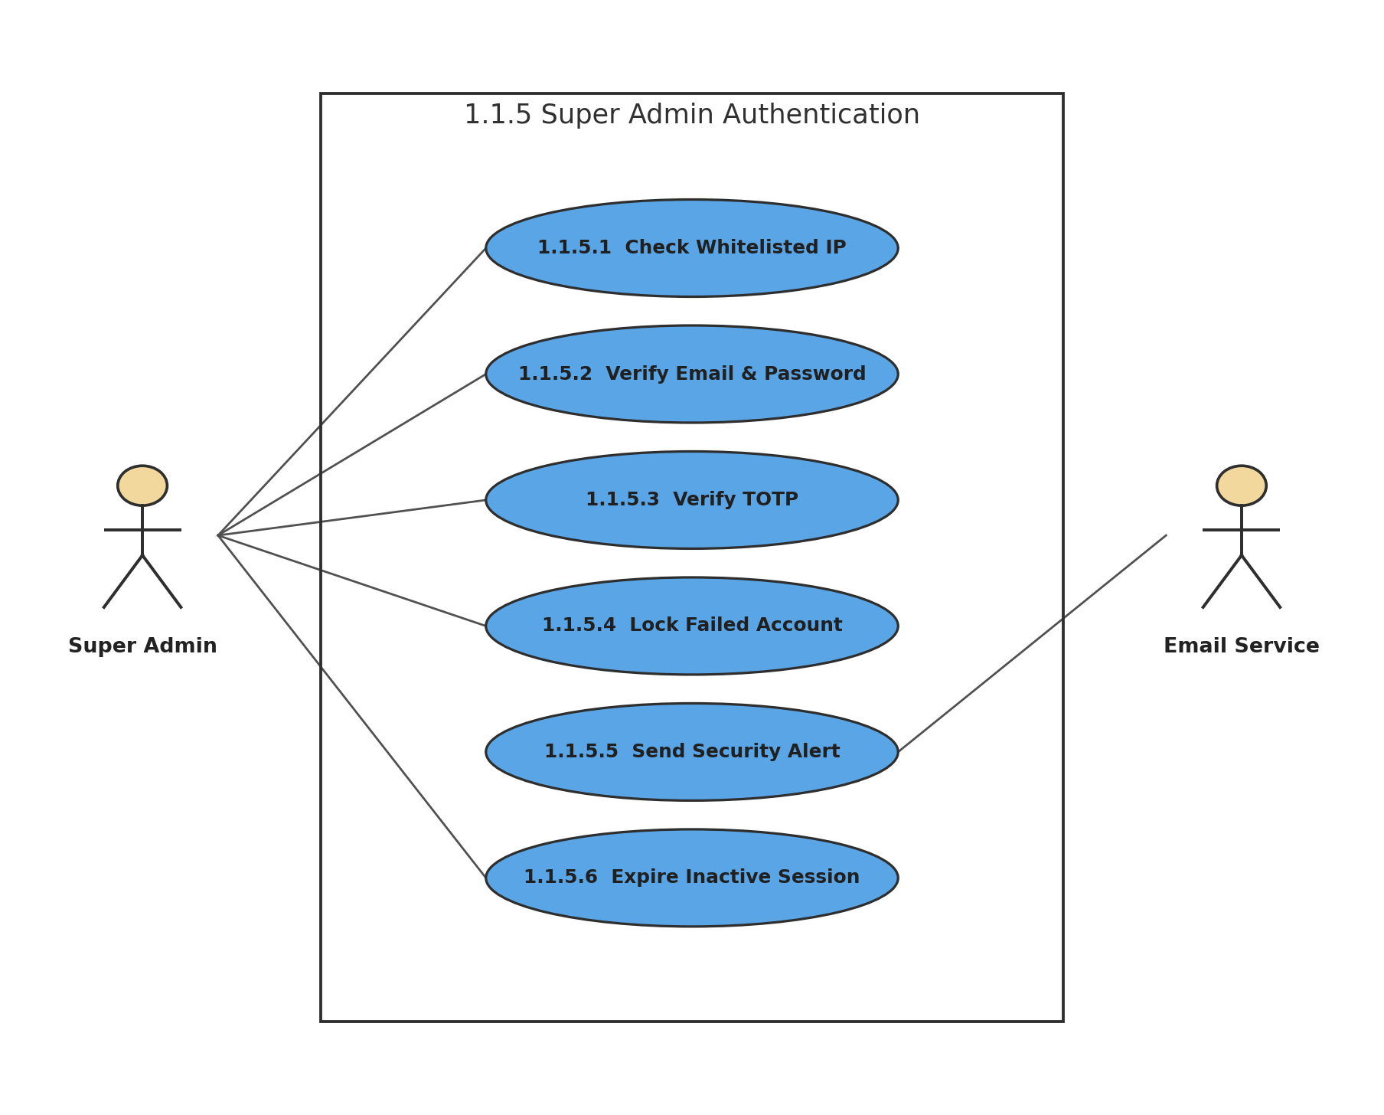
Figure 8: 1.1.5 Super Admin Authentication
Description of 1.3.8 use case diagram:
Super Admin access is restricted to whitelisted IP addresses and requires password plus RFC 6238 TOTP. Failed attempts can trigger lockout and email alerts, and inactive sessions expire.
Actors: Super Admin, Email Service

1.3.9 LEVEL-1.2 USE CASE DIAGRAM - MERCHANT SHOP MANAGEMENT
1.2 Merchant Shop Management
Version 1.0
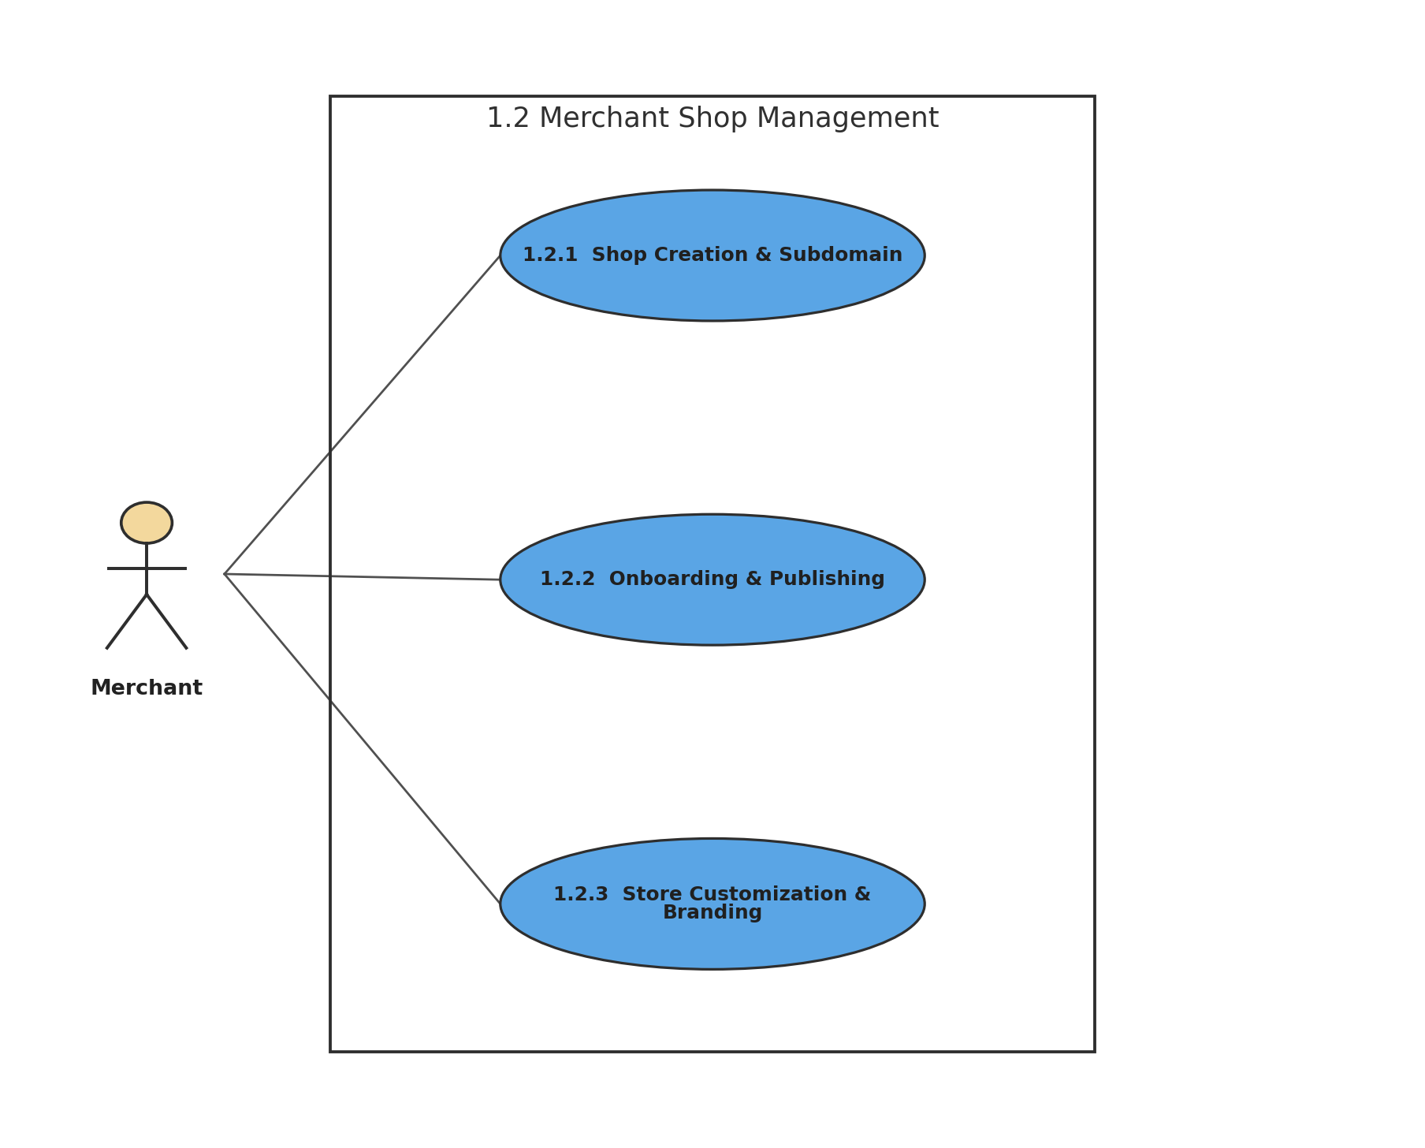
Figure 9: 1.2 Merchant Shop Management
Description of 1.3.9 use case diagram:
Merchant shop management covers creation of the merchant storefront, required onboarding, publishing readiness, and visual branding.
Actors: Merchant

1.3.10 LEVEL-1.2.1 USE CASE DIAGRAM - SHOP CREATION & SUBDOMAIN
1.2.1 Shop Creation & Subdomain
Version 1.0
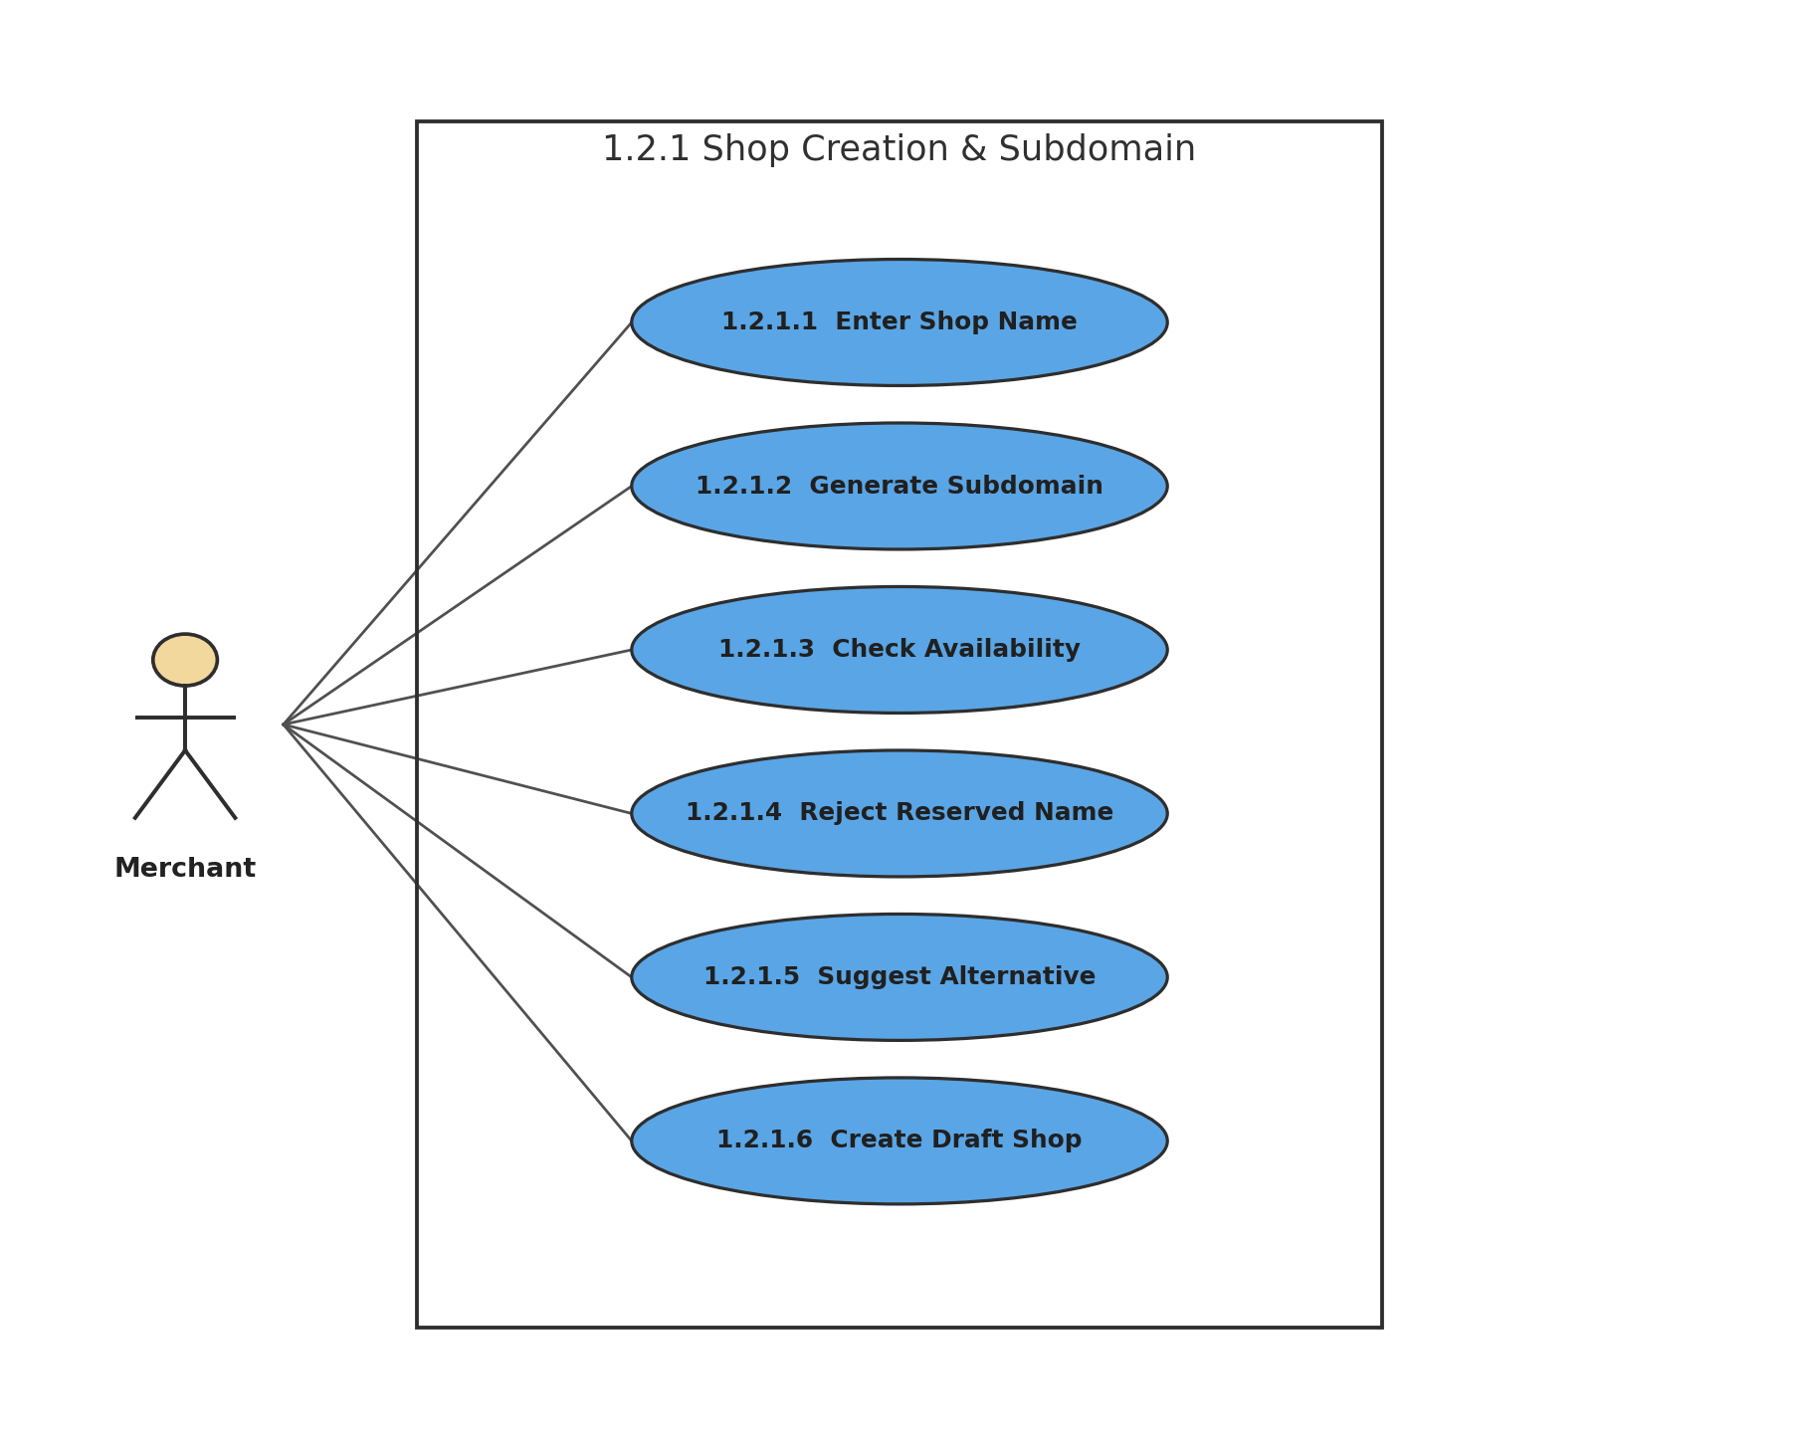
Figure 10: 1.2.1 Shop Creation & Subdomain
Description of 1.3.10 use case diagram:
BazarHQ generates a shop subdomain, validates uniqueness and reserved names, suggests alternatives when necessary, and creates the accepted shop in Draft status.
Actors: Merchant

1.3.11 LEVEL-1.2.2 USE CASE DIAGRAM - ONBOARDING & PUBLISHING
1.2.2 Onboarding & Publishing
Version 1.0
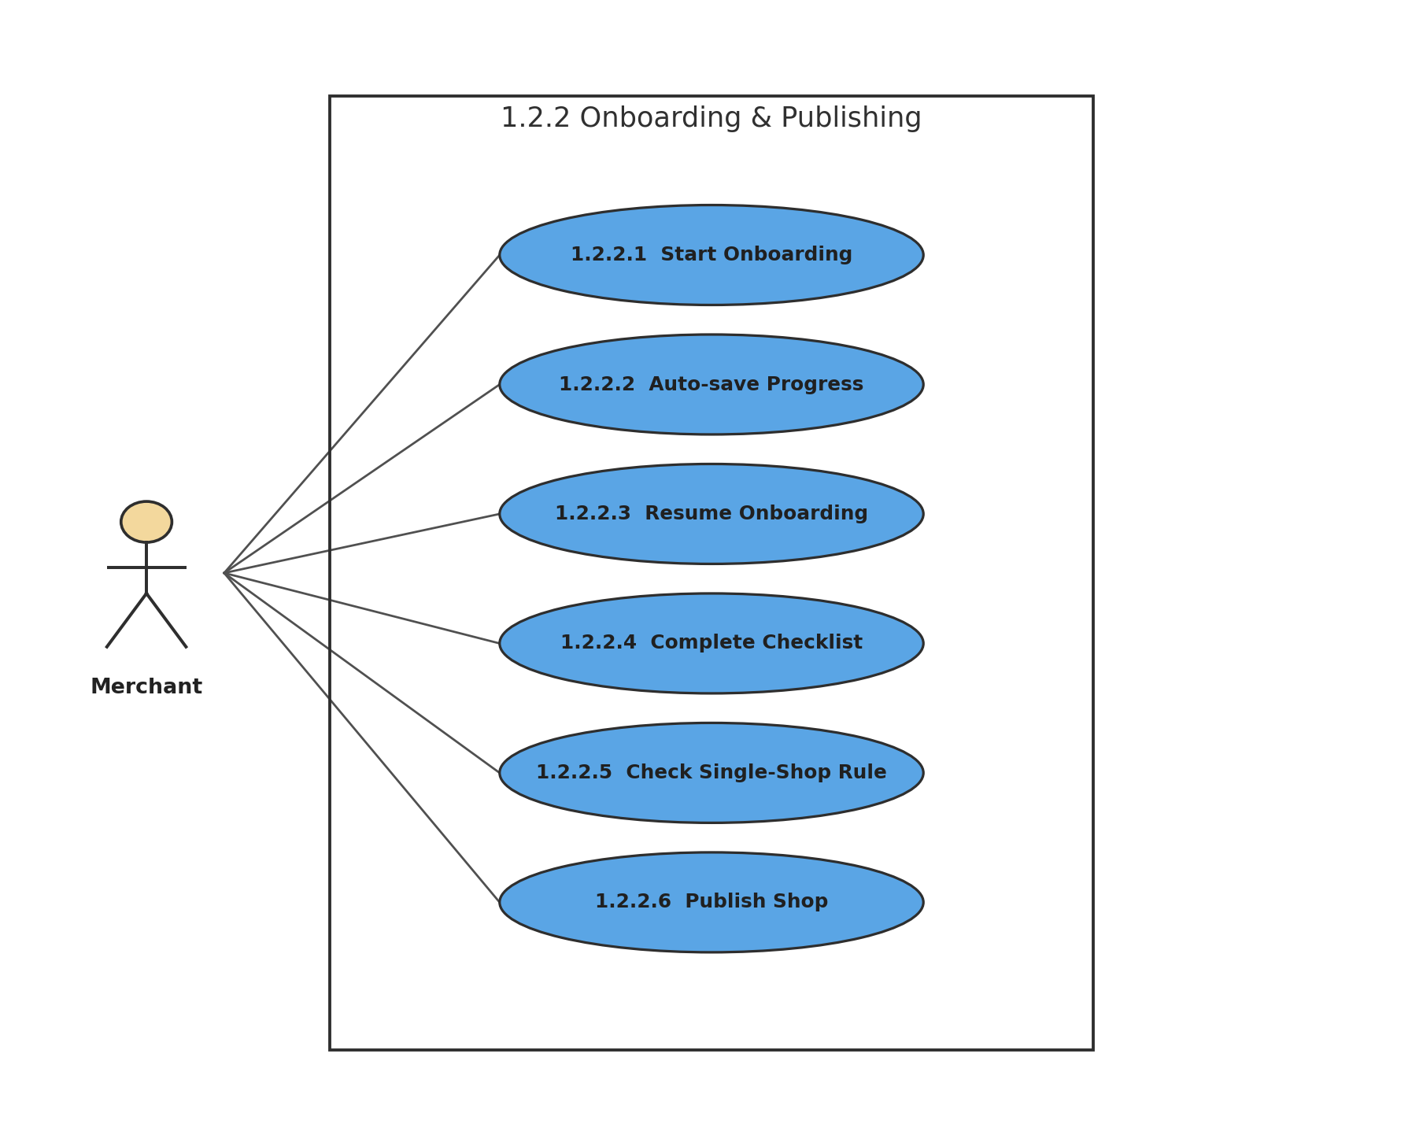
Figure 11: 1.2.2 Onboarding & Publishing
Description of 1.3.11 use case diagram:
Onboarding progress is saved so the merchant can resume after interruption. Version 1 restricts each merchant to one shop, and publication follows completion of the required setup.
Actors: Merchant

1.3.12 LEVEL-1.2.3 USE CASE DIAGRAM - STORE CUSTOMIZATION & BRANDING
1.2.3 Store Customization & Branding
Version 1.0
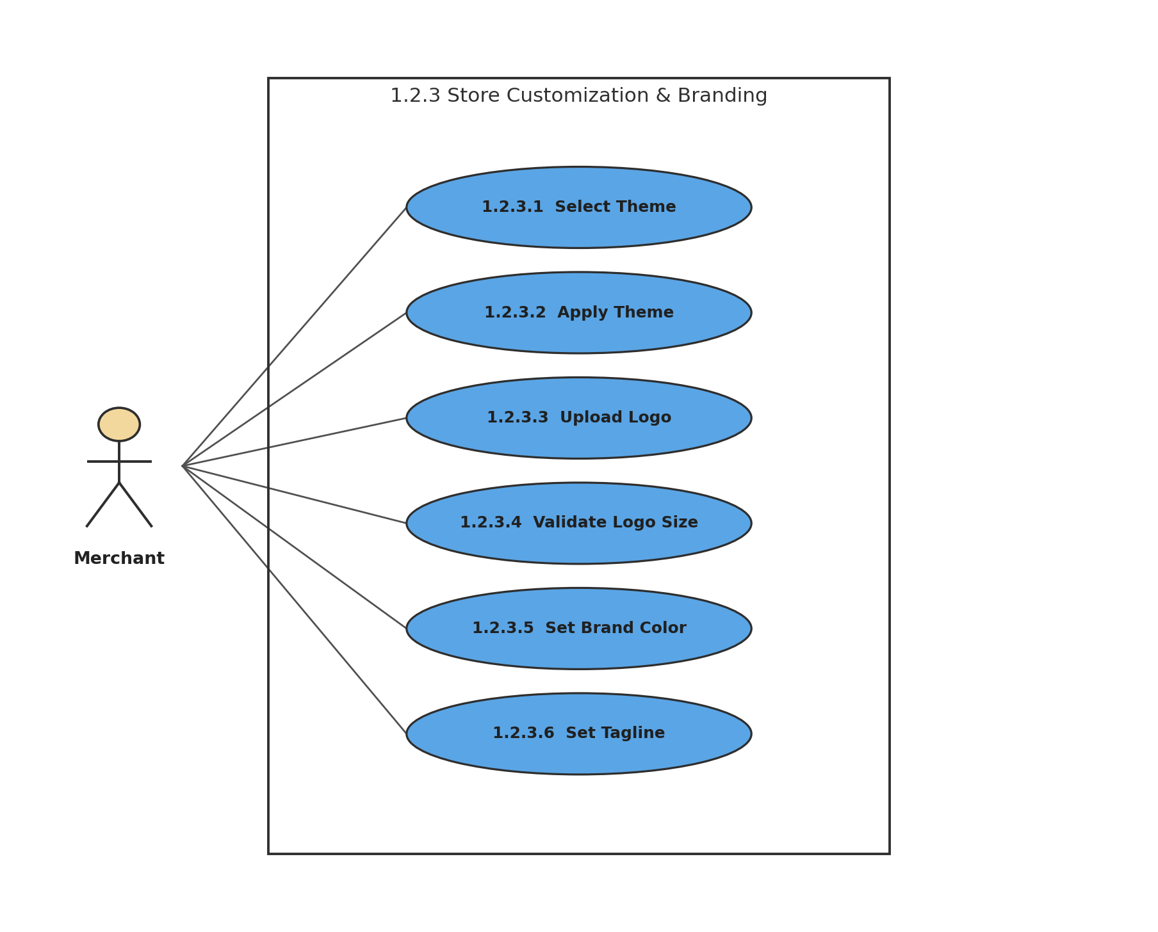
Figure 12: 1.2.3 Store Customization & Branding
Description of 1.3.12 use case diagram:
The merchant can select a theme, upload a logo under the size limit, and set brand color and tagline. Changes are reflected on the live storefront.
Actors: Merchant

1.3.13 LEVEL-1.3 USE CASE DIAGRAM - PRODUCT & INVENTORY
1.3 Product & Inventory
Version 1.0
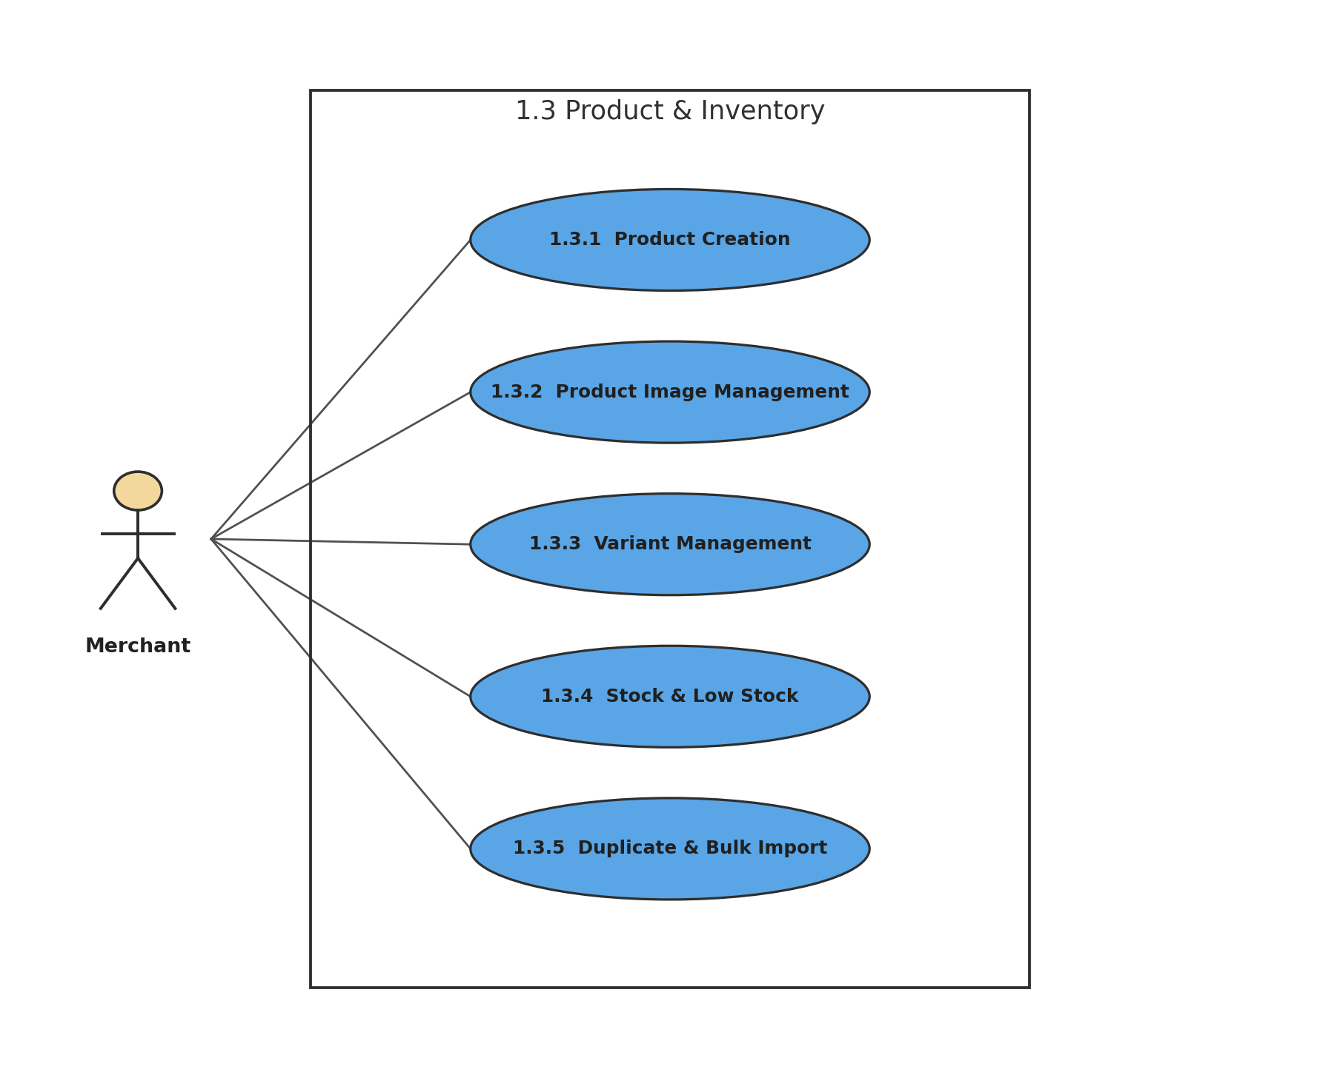
Figure 13: 1.3 Product & Inventory
Description of 1.3.13 use case diagram:
The product subsystem manages catalog creation, images, variants, variant-level inventory, duplication, and CSV bulk import.
Actors: Merchant

1.3.14 LEVEL-1.3.1 USE CASE DIAGRAM - PRODUCT CREATION
1.3.1 Product Creation
Version 1.0
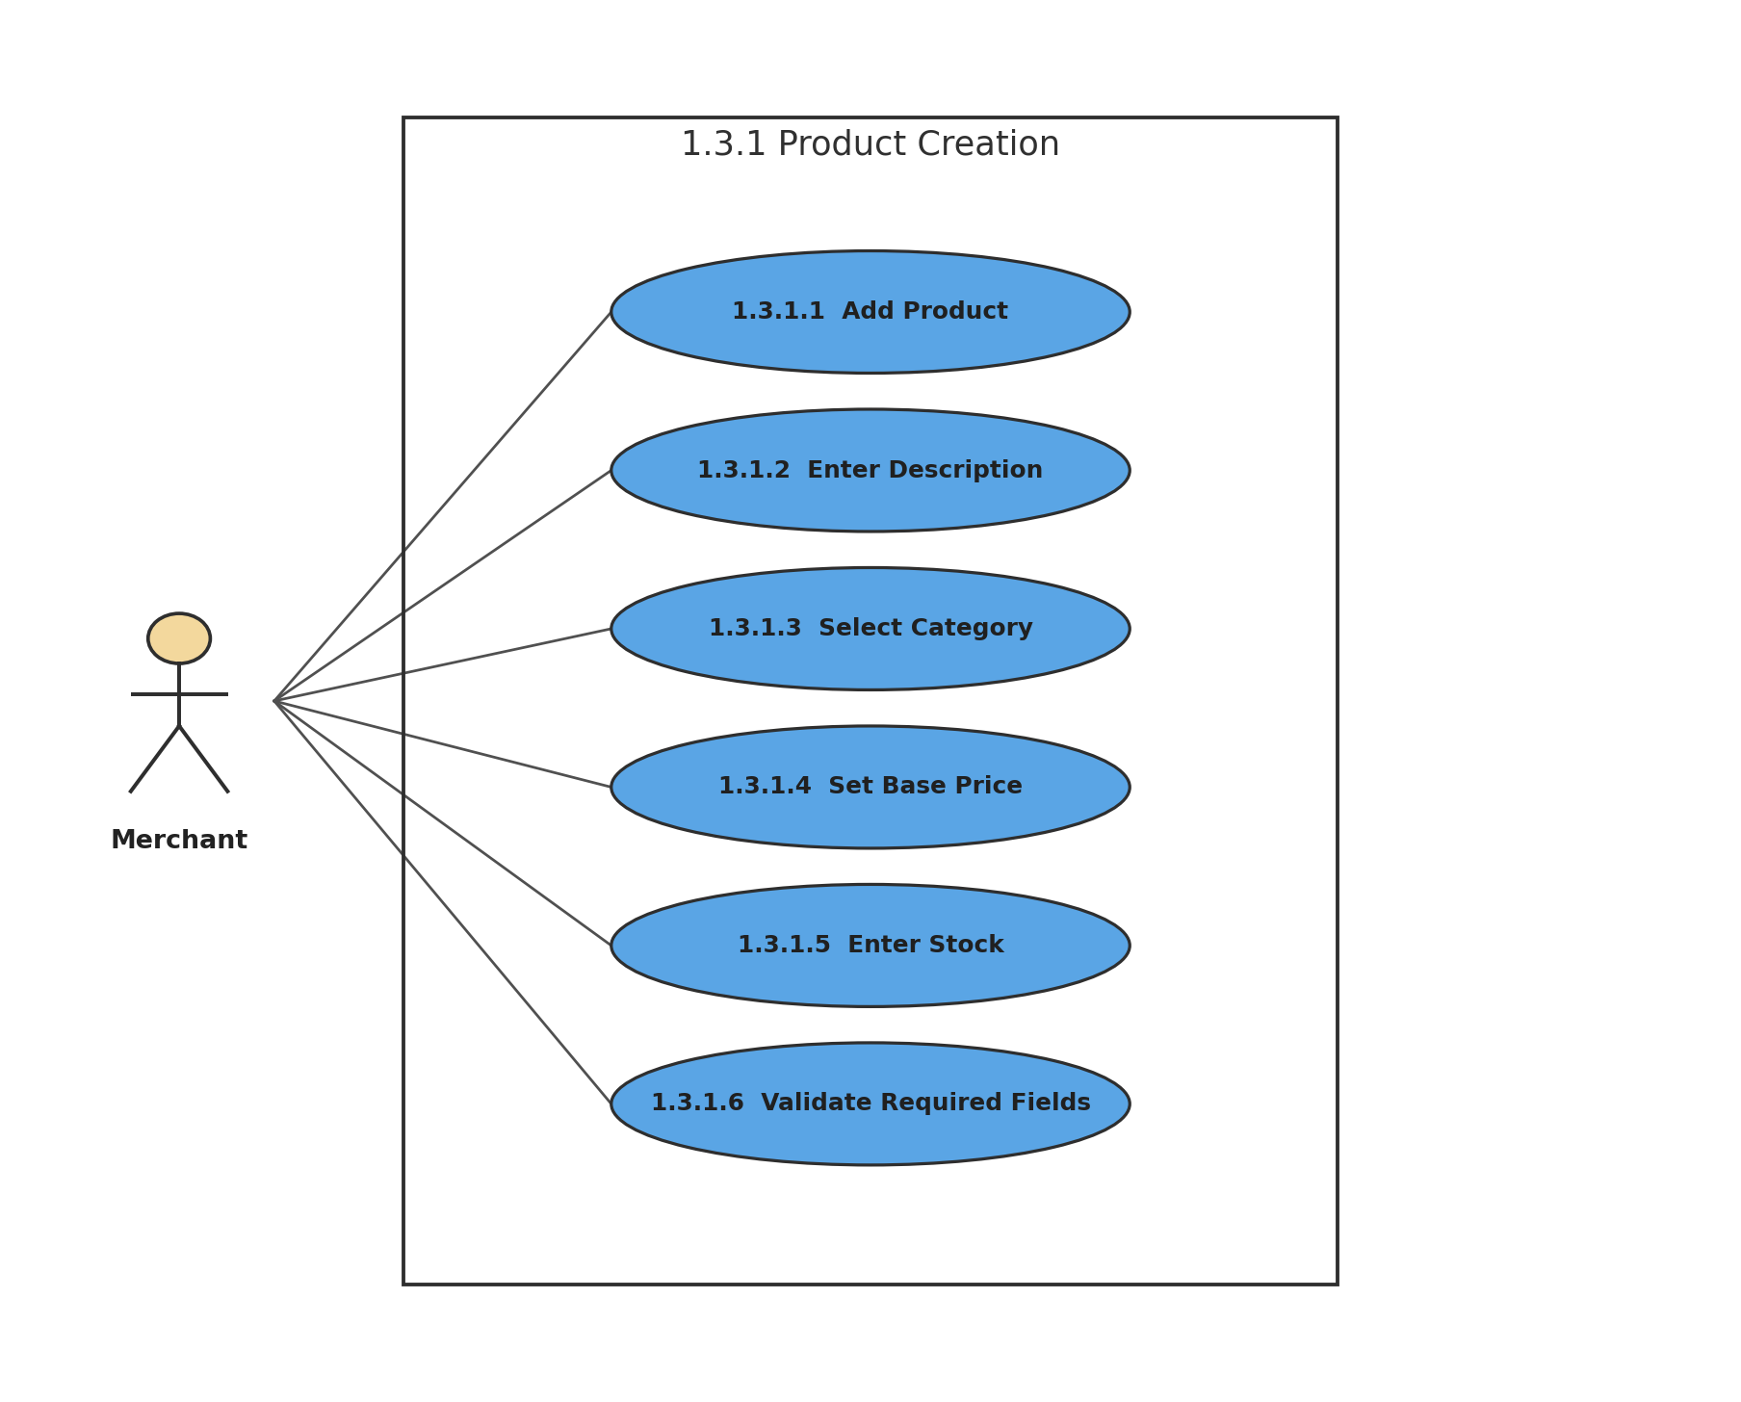
Figure 14: 1.3.1 Product Creation
Description of 1.3.14 use case diagram:
A merchant creates a product by providing all mandatory information. Missing required fields block saving until corrected.
Actors: Merchant

1.3.15 LEVEL-1.3.2 USE CASE DIAGRAM - PRODUCT IMAGE MANAGEMENT
1.3.2 Product Image Management
Version 1.0
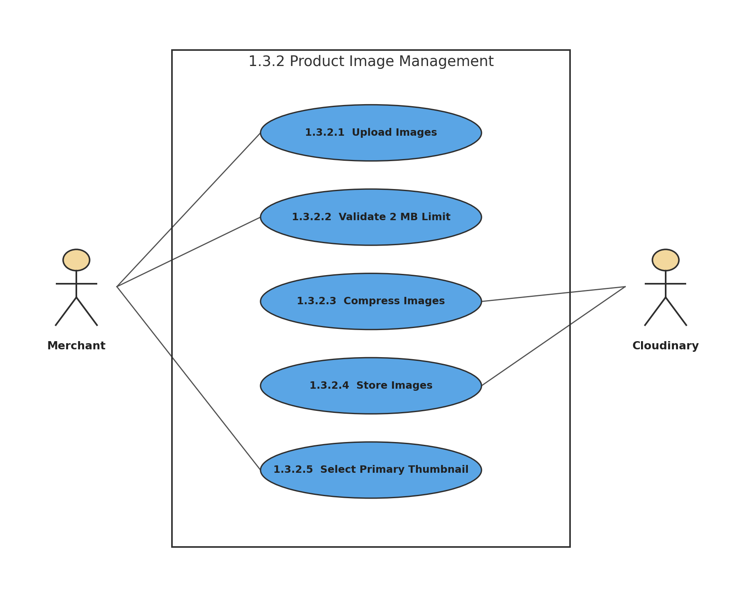
Figure 15: 1.3.2 Product Image Management
Description of 1.3.15 use case diagram:
Product images are validated before transmission, compressed and stored through Cloudinary, and one image can be chosen as the primary thumbnail.
Actors: Merchant, Cloudinary

1.3.16 LEVEL-1.3.3 USE CASE DIAGRAM - PRODUCT VARIANT MANAGEMENT
1.3.3 Variant Management
Version 1.0
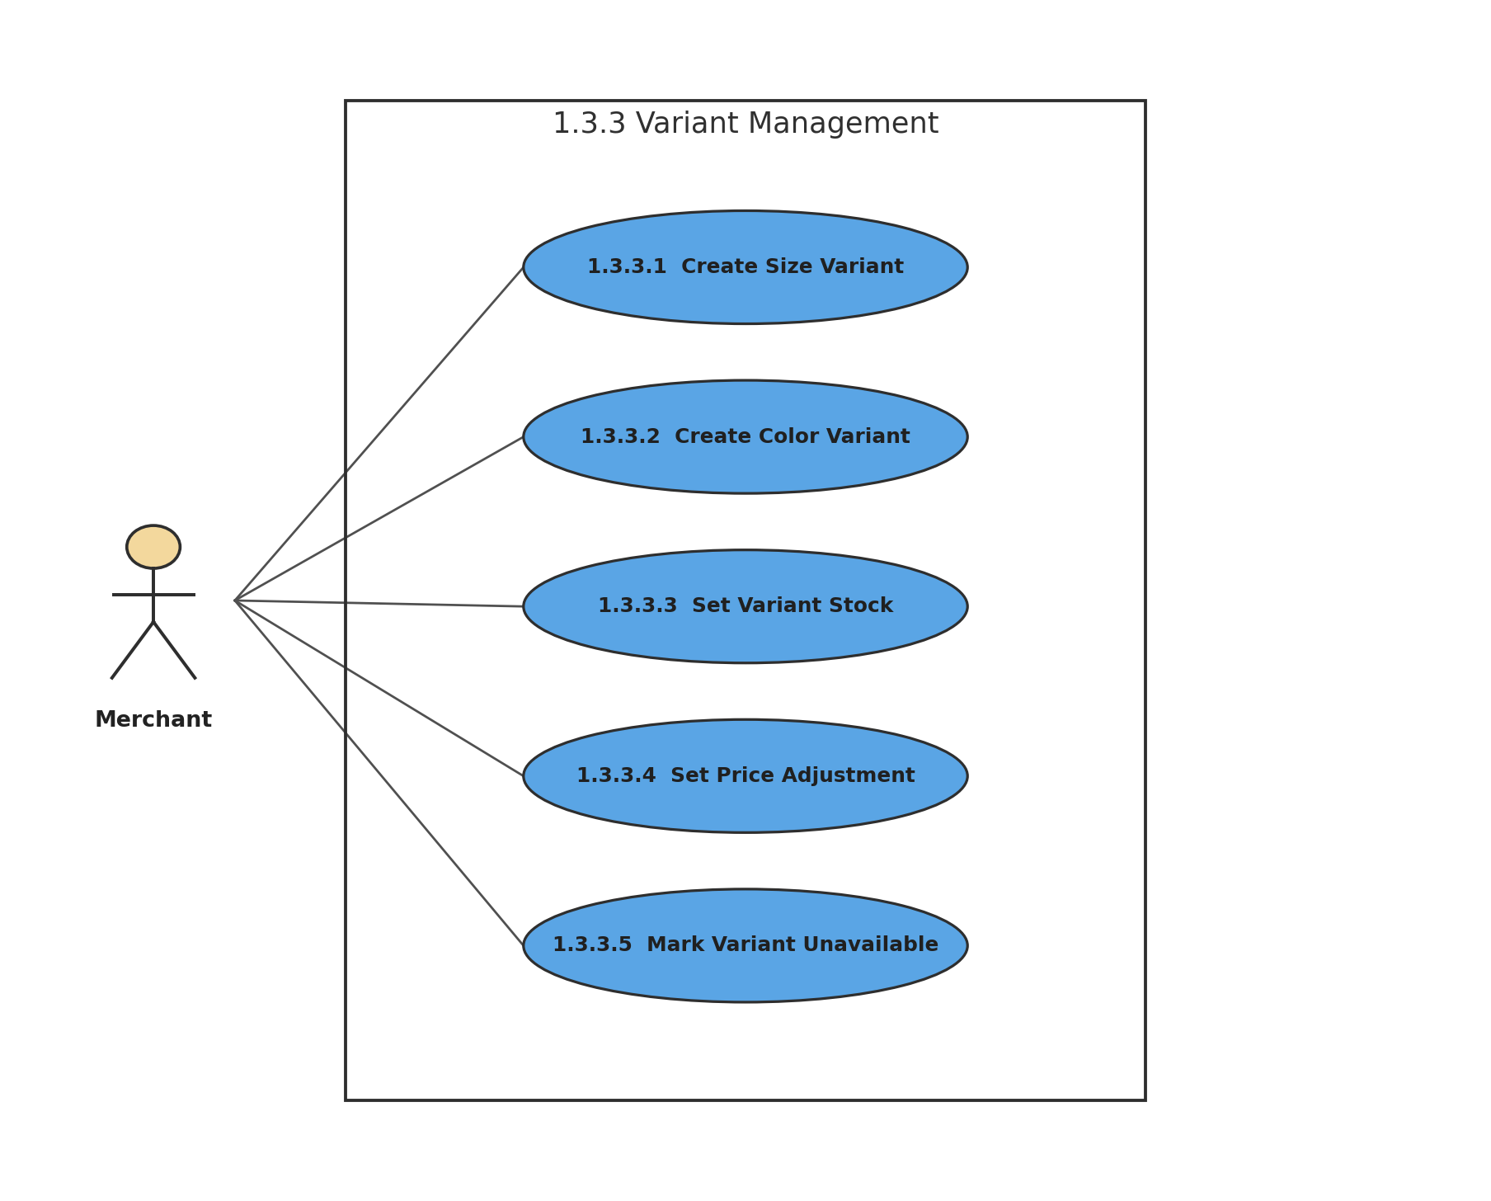
Figure 16: 1.3.3 Variant Management
Description of 1.3.16 use case diagram:
Size and color variants may maintain independent stock and optional price adjustments. A depleted variant becomes unavailable without disabling other variants.
Actors: Merchant

1.3.17 LEVEL-1.3.4 USE CASE DIAGRAM - STOCK & LOW STOCK
1.3.4 Stock & Low Stock
Version 1.0
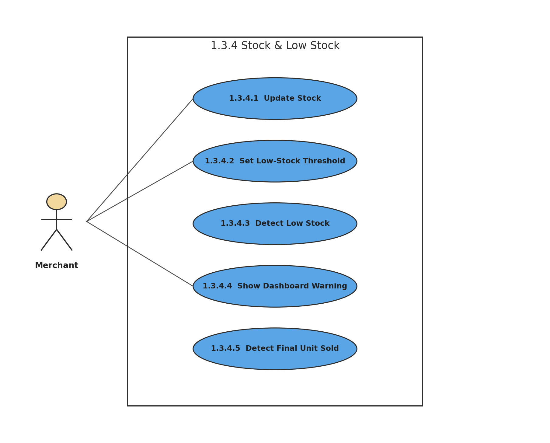
Figure 17: 1.3.4 Stock & Low Stock
Description of 1.3.17 use case diagram:
The merchant can maintain stock and thresholds. When inventory crosses the threshold, BazarHQ warns the merchant; selling the final unit makes that variant unavailable.
Actors: Merchant

1.3.18 LEVEL-1.3.5 USE CASE DIAGRAM - DUPLICATE & BULK IMPORT
1.3.5 Duplicate & Bulk Import
Version 1.0
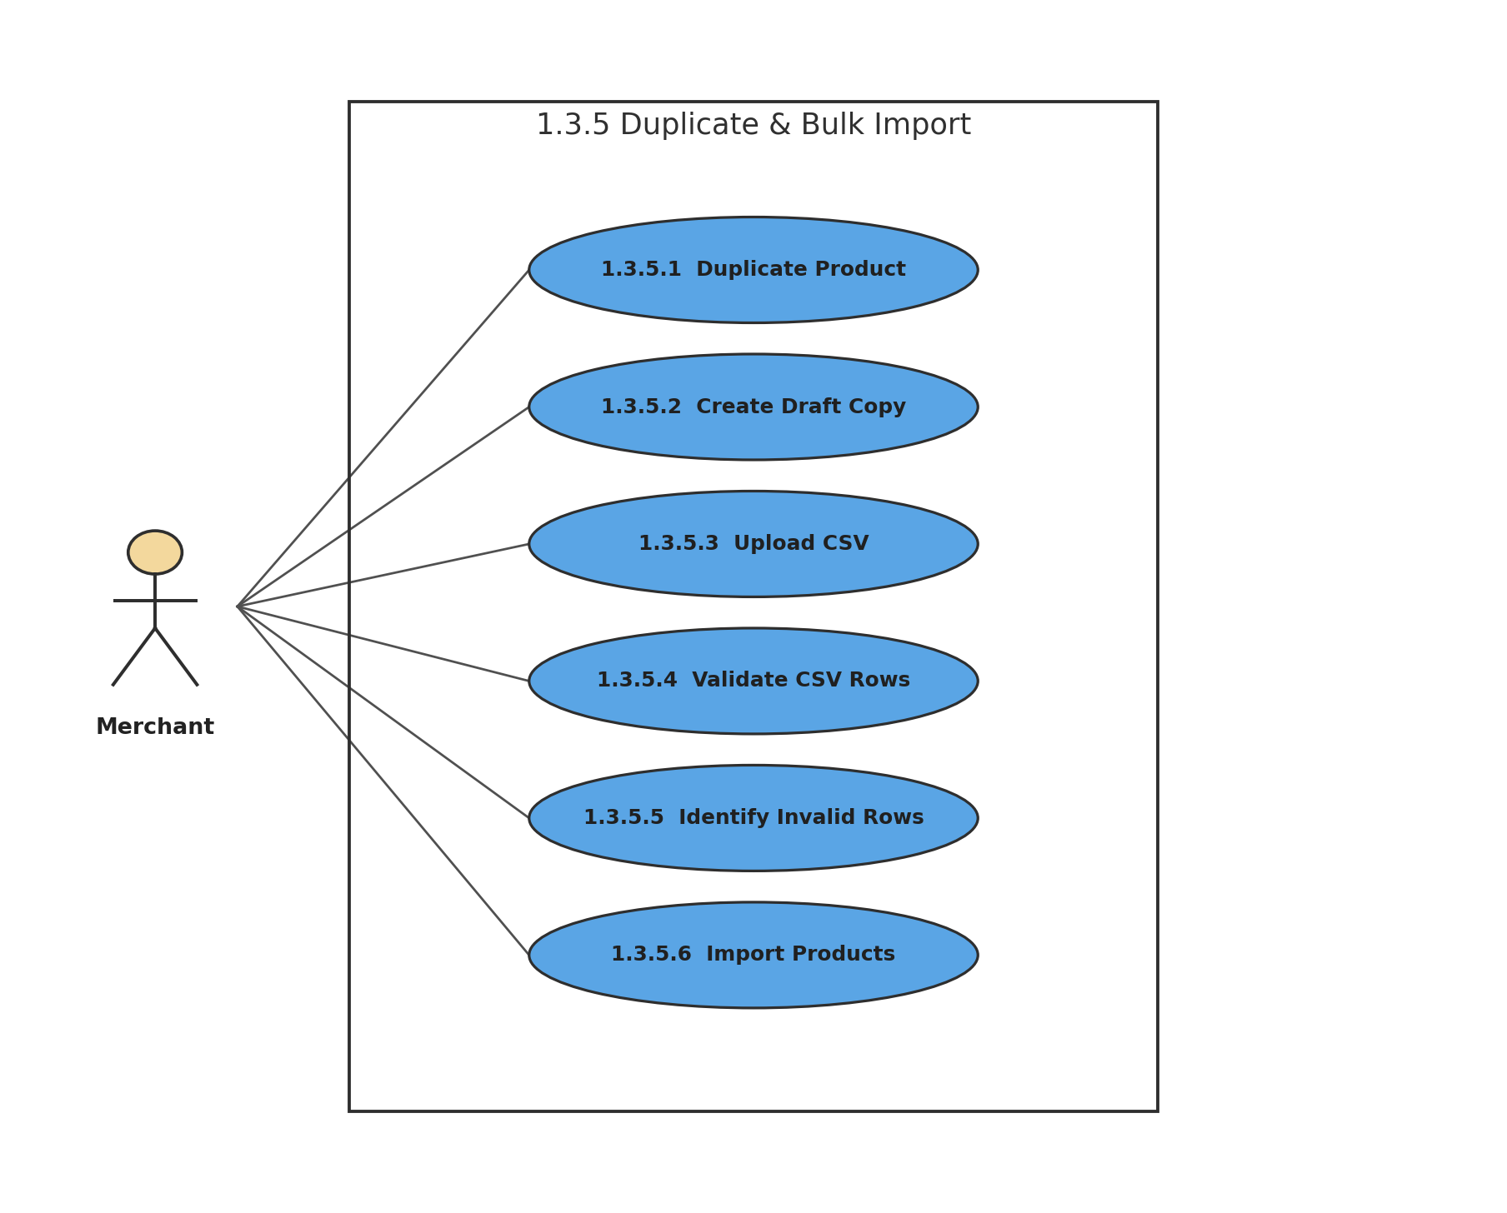
Figure 18: 1.3.5 Duplicate & Bulk Import
Description of 1.3.18 use case diagram:
Merchants can clone a product into a new draft or bulk-import products using CSV. Invalid rows are identified and must be corrected before import.
Actors: Merchant

1.3.19 LEVEL-1.4 USE CASE DIAGRAM - ORDER MANAGEMENT
1.4 Order Management
Version 1.0
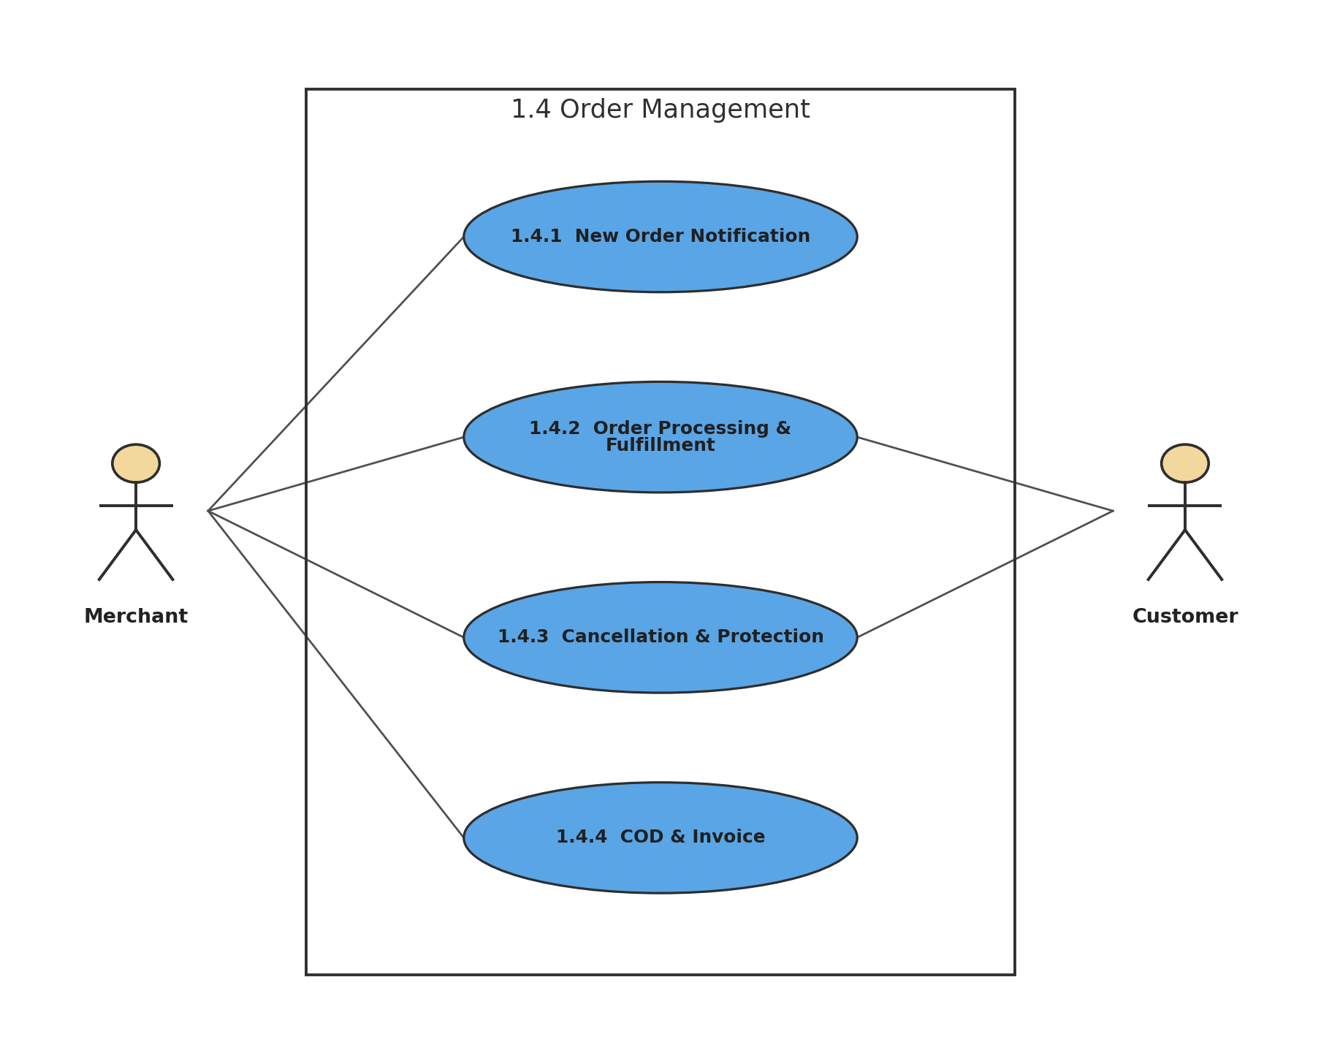
Figure 19: 1.4 Order Management
Description of 1.3.19 use case diagram:
Order management covers new-order alerts, merchant confirmation and fulfillment, cancellation rules, COD collection, and invoice generation.
Actors: Merchant, Customer

1.3.20 LEVEL-1.4.1 USE CASE DIAGRAM - NEW ORDER NOTIFICATION
1.4.1 New Order Notification
Version 1.0
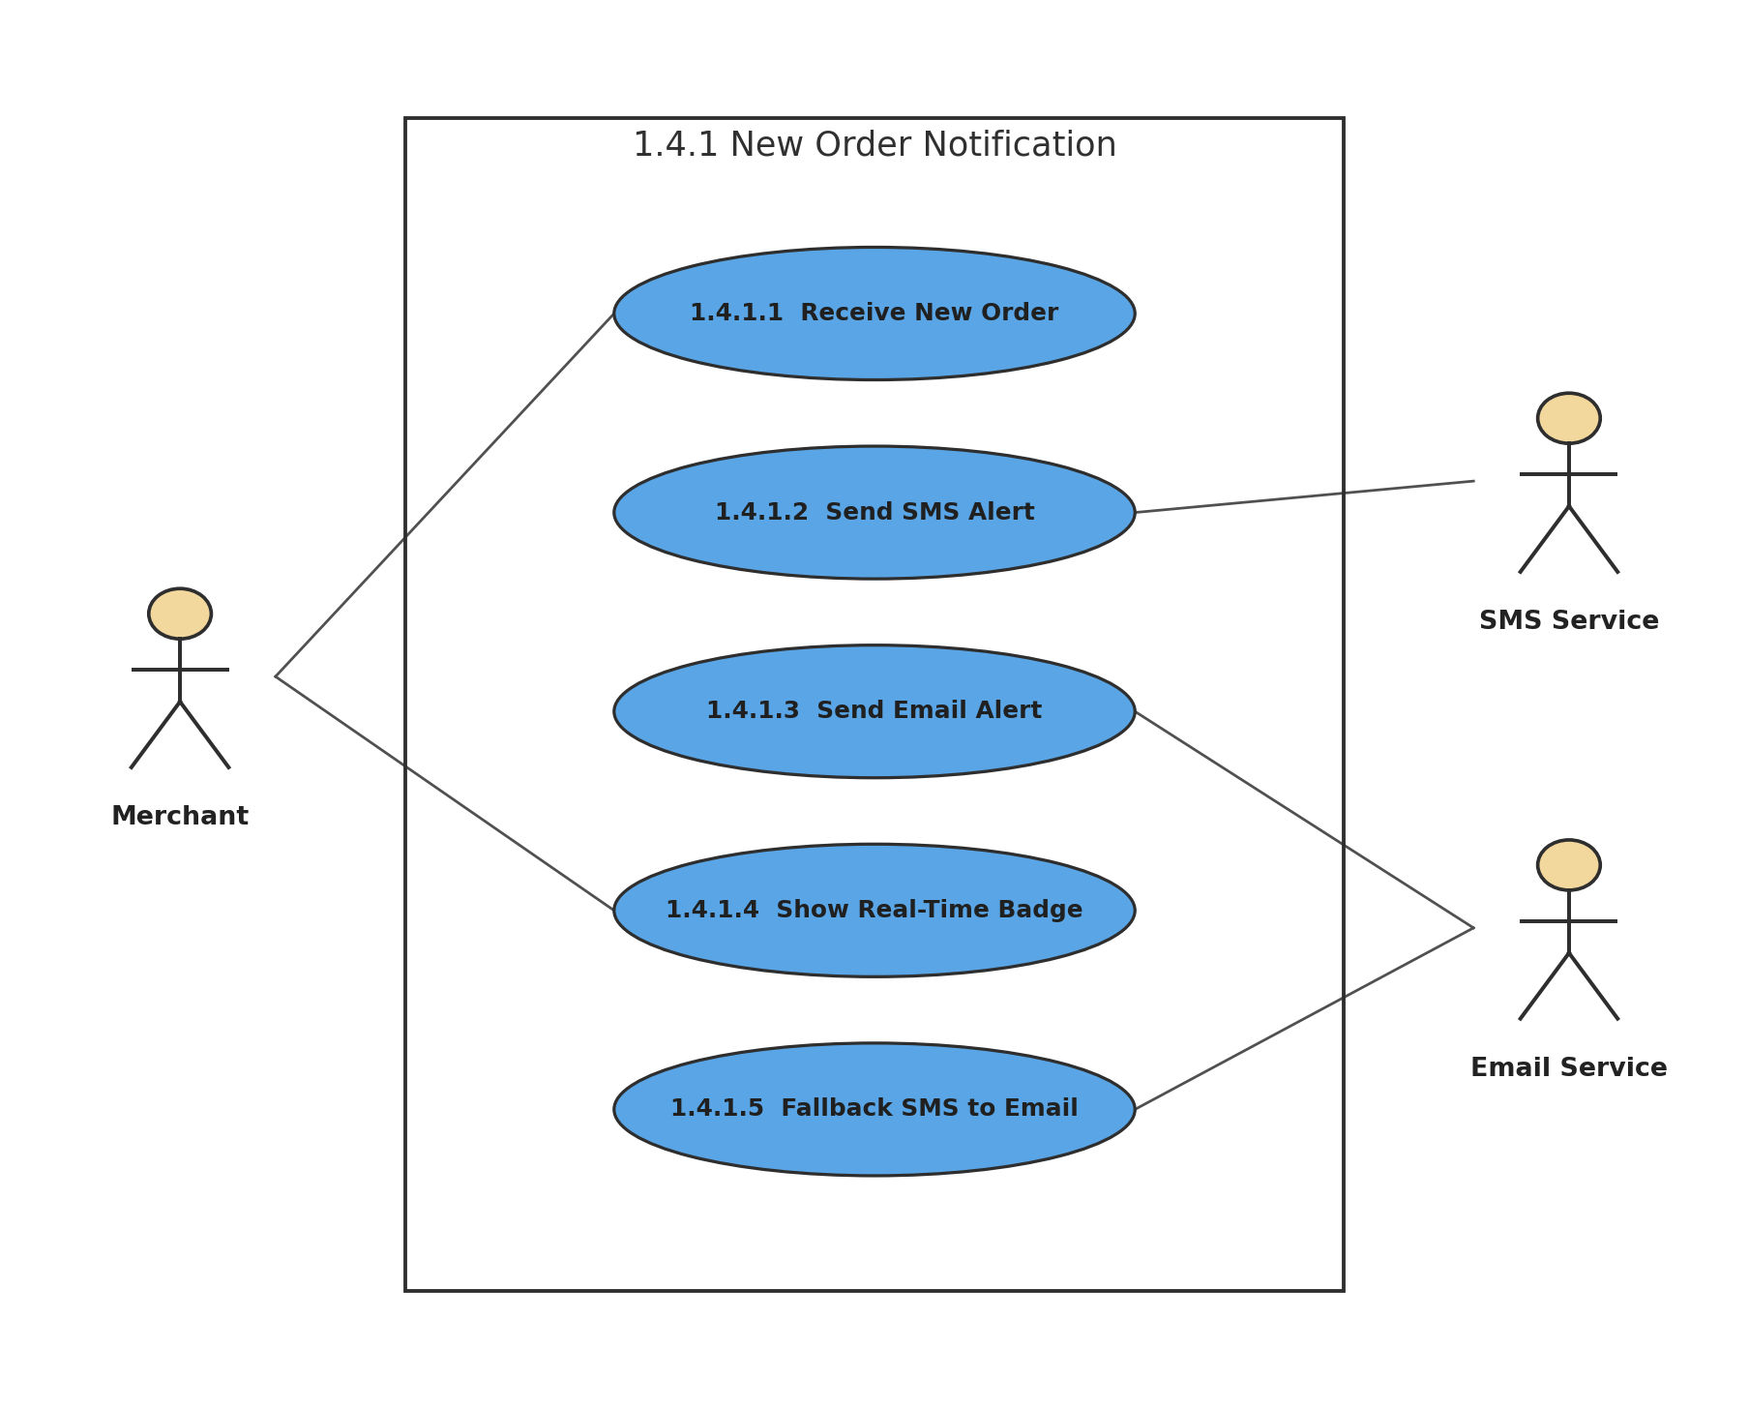
Figure 20: 1.4.1 New Order Notification
Description of 1.3.20 use case diagram:
When an authenticated order arrives, BazarHQ alerts the merchant by SMS and email and shows a real-time dashboard badge. Email acts as fallback when the SMS gateway fails.
Actors: Merchant, SMS Service, Email Service

1.3.21 LEVEL-1.4.2 USE CASE DIAGRAM - ORDER PROCESSING & FULFILLMENT
1.4.2 Order Processing & Fulfillment
Version 1.0
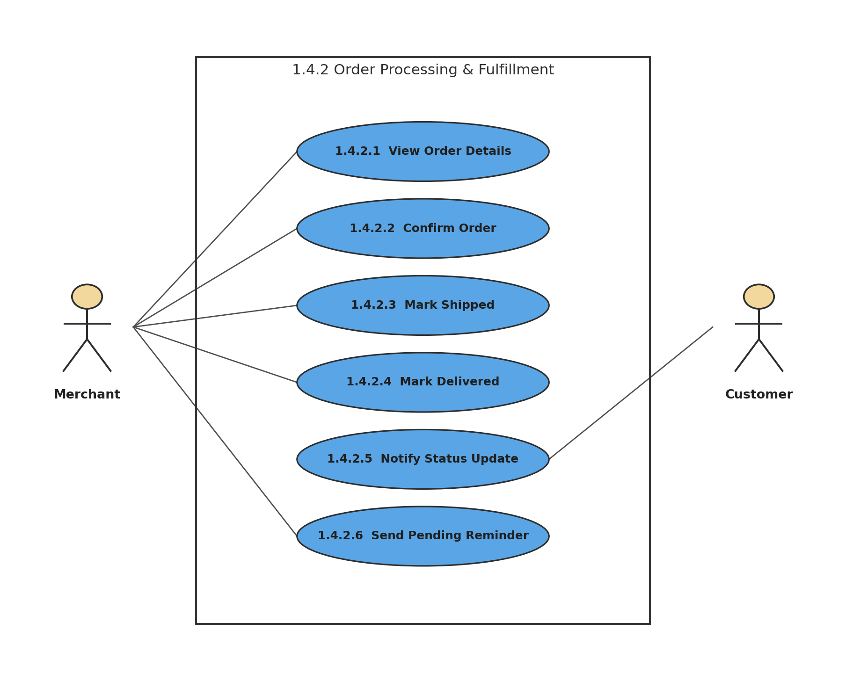
Figure 21: 1.4.2 Order Processing & Fulfillment
Description of 1.3.21 use case diagram:
The merchant reviews and confirms the order, then updates it to Shipped and Delivered. Customers receive automatic status notifications, and pending orders can trigger reminders after 48 hours.
Actors: Merchant, Customer

1.3.22 LEVEL-1.4.3 USE CASE DIAGRAM - ORDER CANCELLATION & PROTECTION
1.4.3 Cancellation & Protection
Version 1.0
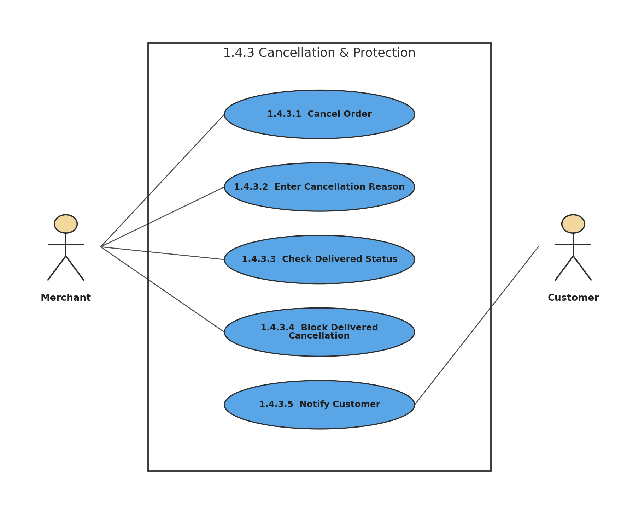
Figure 22: 1.4.3 Cancellation & Protection
Description of 1.3.22 use case diagram:
Cancellation requires a reason. BazarHQ blocks cancellation of already delivered orders and notifies the customer of valid cancellations and their reason.
Actors: Merchant, Customer

1.3.23 LEVEL-1.4.4 USE CASE DIAGRAM - COD & INVOICE
1.4.4 COD & Invoice
Version 1.0
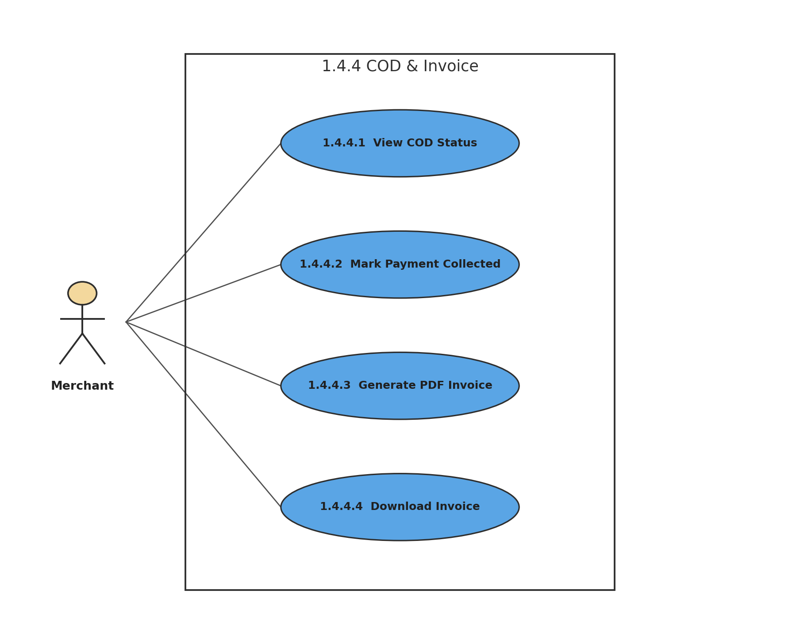
Figure 23: 1.4.4 COD & Invoice
Description of 1.3.23 use case diagram:
Cash on Delivery remains pending until the merchant marks the money as collected. The merchant can generate and download a PDF invoice for an order.
Actors: Merchant

1.3.24 LEVEL-1.5 USE CASE DIAGRAM - PAYMENT MANAGEMENT
1.5 Payment Management
Version 1.0
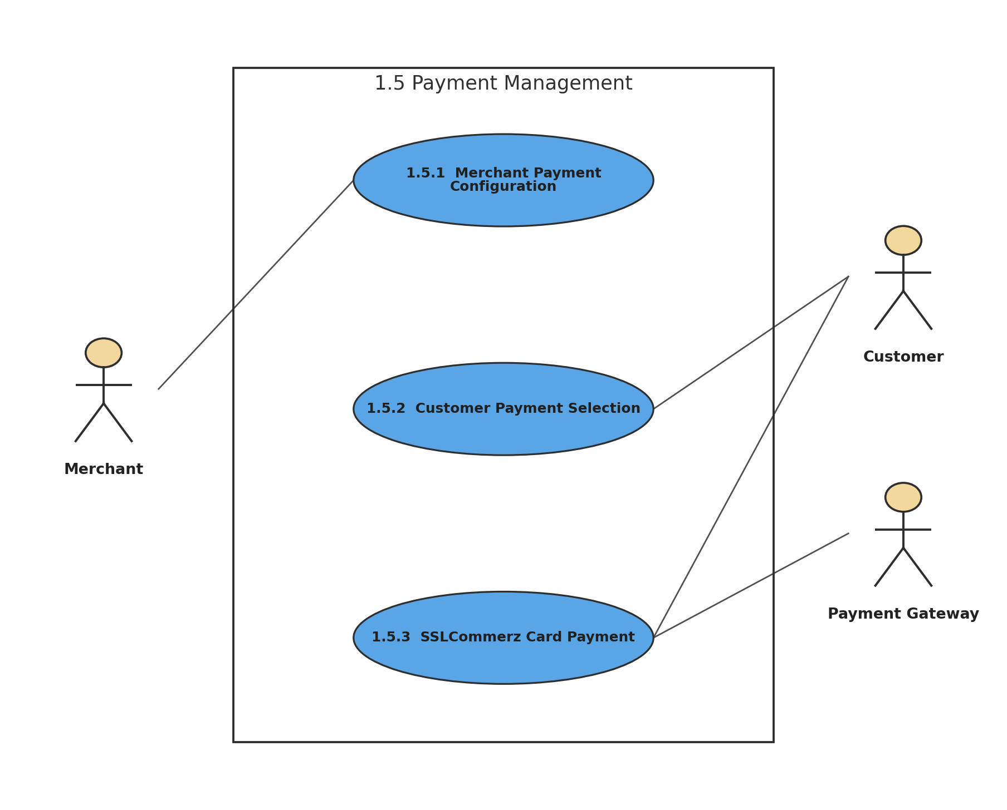
Figure 24: 1.5 Payment Management
Description of 1.3.24 use case diagram:
Payment management includes merchant configuration of accepted methods and authenticated customer selection and processing of payments.
Actors: Merchant, Customer, Payment Gateway

1.3.25 LEVEL-1.5.1 USE CASE DIAGRAM - MERCHANT PAYMENT CONFIGURATION
1.5.1 Merchant Payment Configuration
Version 1.0
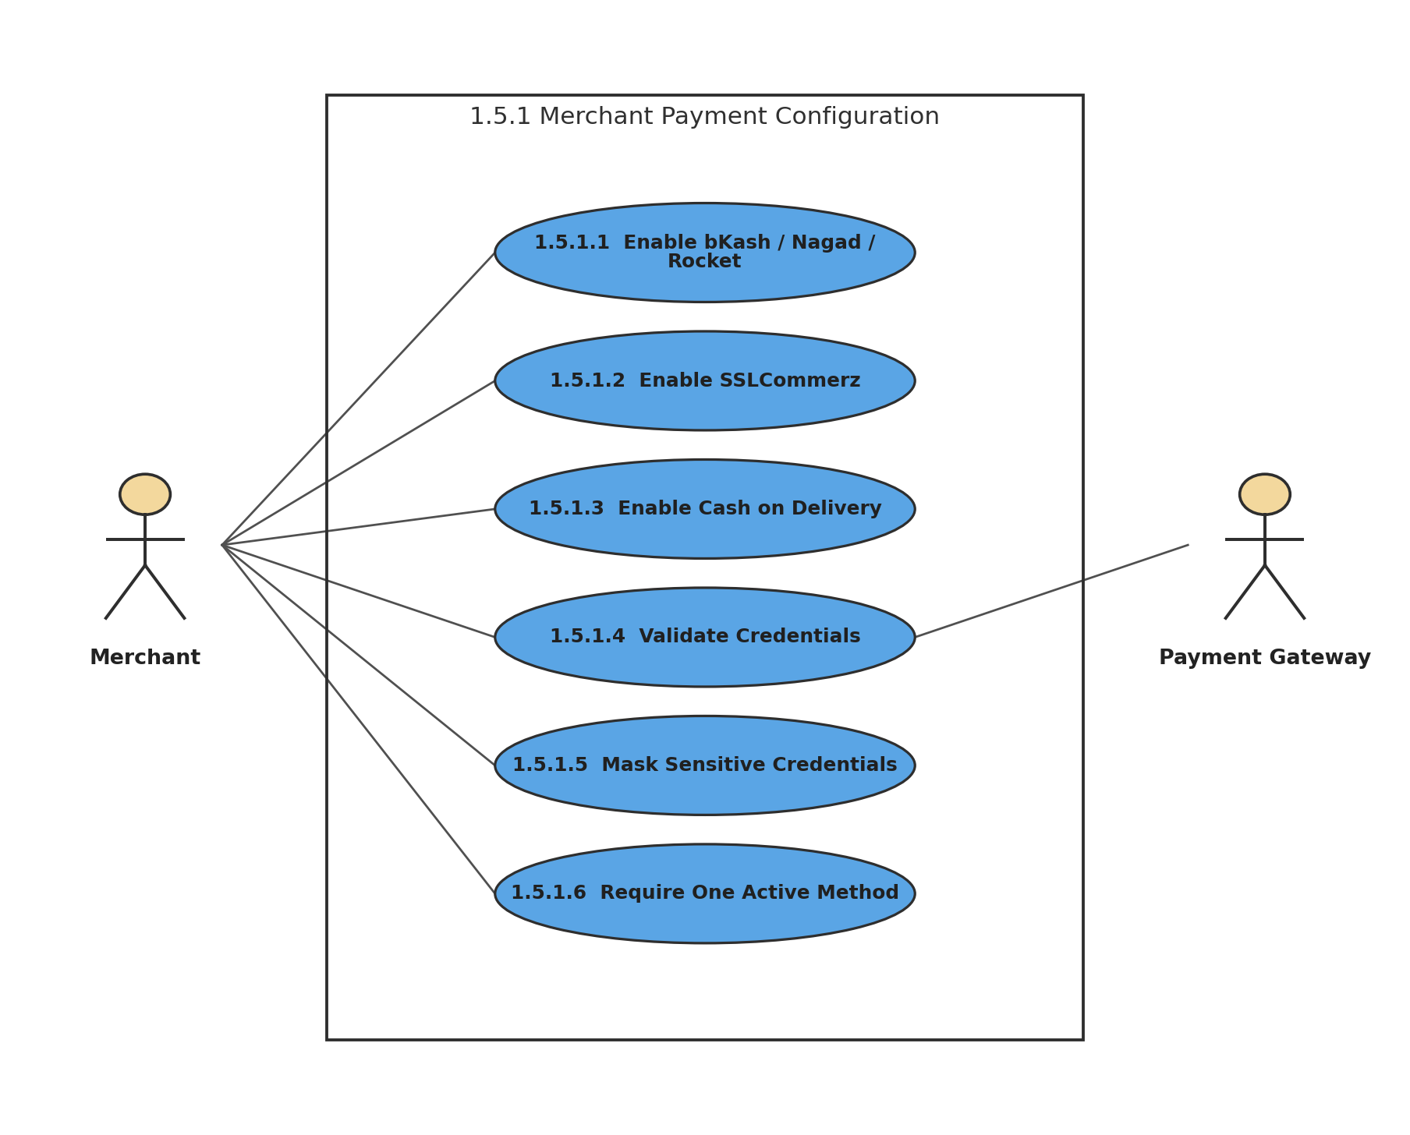
Figure 25: 1.5.1 Merchant Payment Configuration
Description of 1.3.25 use case diagram:
The merchant enables supported payment methods. Credentials are validated and masked, invalid SSLCommerz configuration disables card payment, and a store cannot publish with all payment methods disabled.
Actors: Merchant, Payment Gateway

1.3.26 LEVEL-1.5.2 USE CASE DIAGRAM - CUSTOMER PAYMENT SELECTION
1.5.2 Customer Payment Selection
Version 1.0
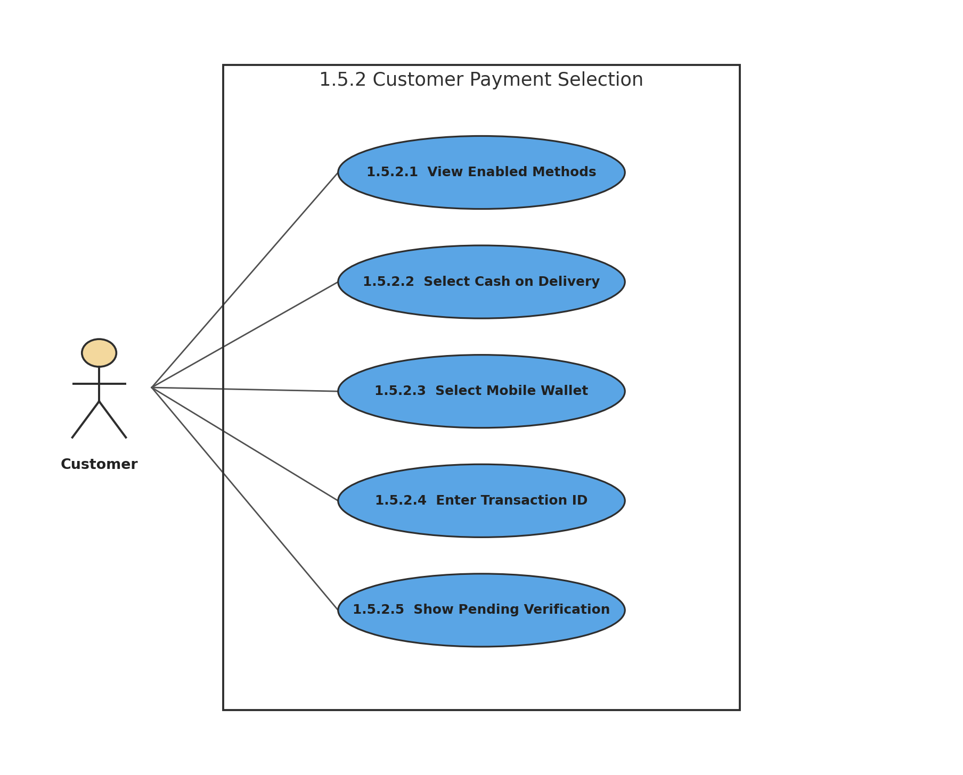
Figure 26: 1.5.2 Customer Payment Selection
Description of 1.3.26 use case diagram:
After authentication, the customer sees only methods enabled by the merchant. Mobile-wallet payments can require a transaction ID and remain pending merchant verification.
Actors: Customer

1.3.27 LEVEL-1.5.3 USE CASE DIAGRAM - SSLCOMMERZ CARD PAYMENT
1.5.3 SSLCommerz Card Payment
Version 1.0
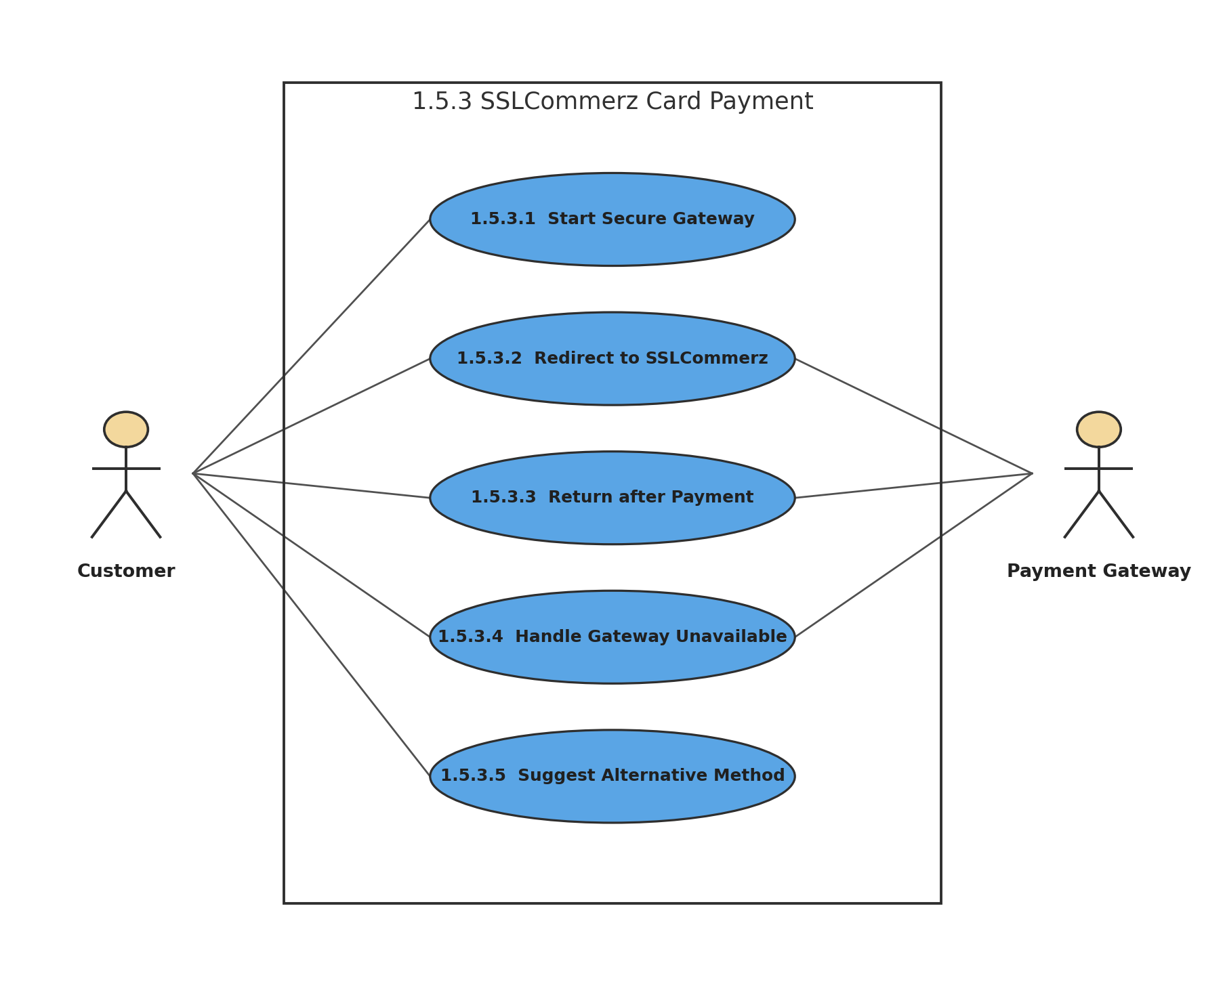
Figure 27: 1.5.3 SSLCommerz Card Payment
Description of 1.3.27 use case diagram:
SSLCommerz processing begins only after customer authentication and order review. Gateway outages are hidden behind a user- friendly error with alternative payment suggestions.
Actors: Customer, Payment Gateway

1.3.28 LEVEL-1.6 USE CASE DIAGRAM - ANALYTICS & REPORTING
1.6 Analytics & Reporting
Version 1.0
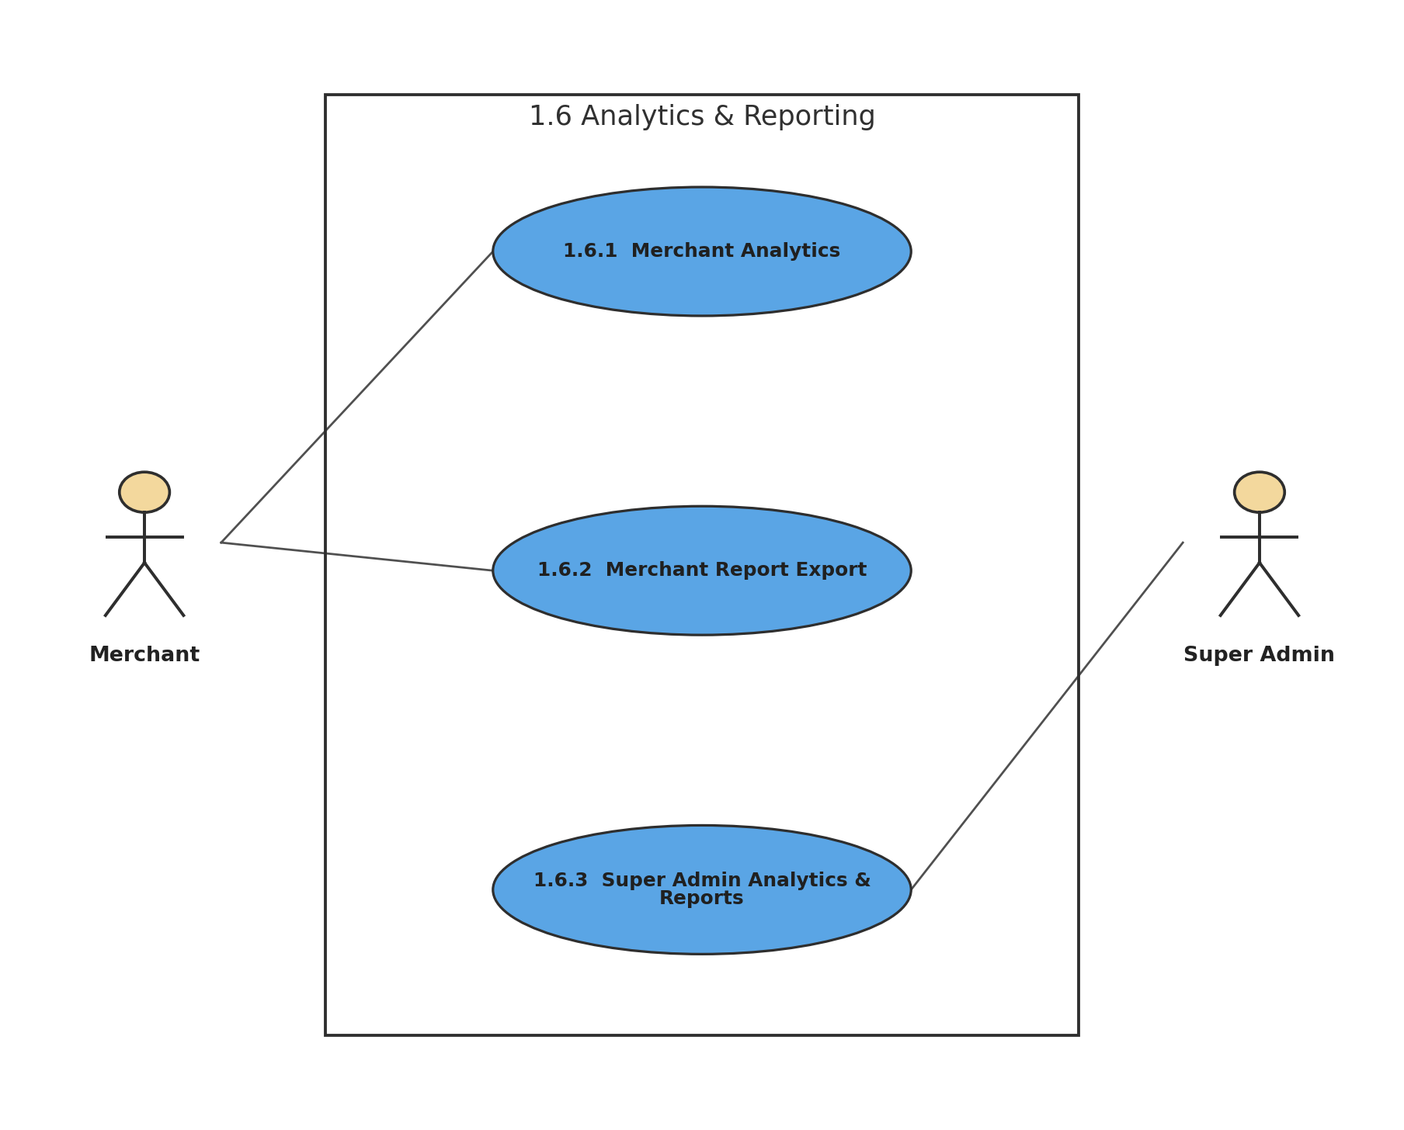
Figure 28: 1.6 Analytics & Reporting
Description of 1.3.28 use case diagram:
Analytics and reporting provide merchant business metrics and platform-wide read-only administrative statistics and exports.
Actors: Merchant, Super Admin

1.3.29 LEVEL-1.6.1 USE CASE DIAGRAM - MERCHANT ANALYTICS
1.6.1 Merchant Analytics
Version 1.0
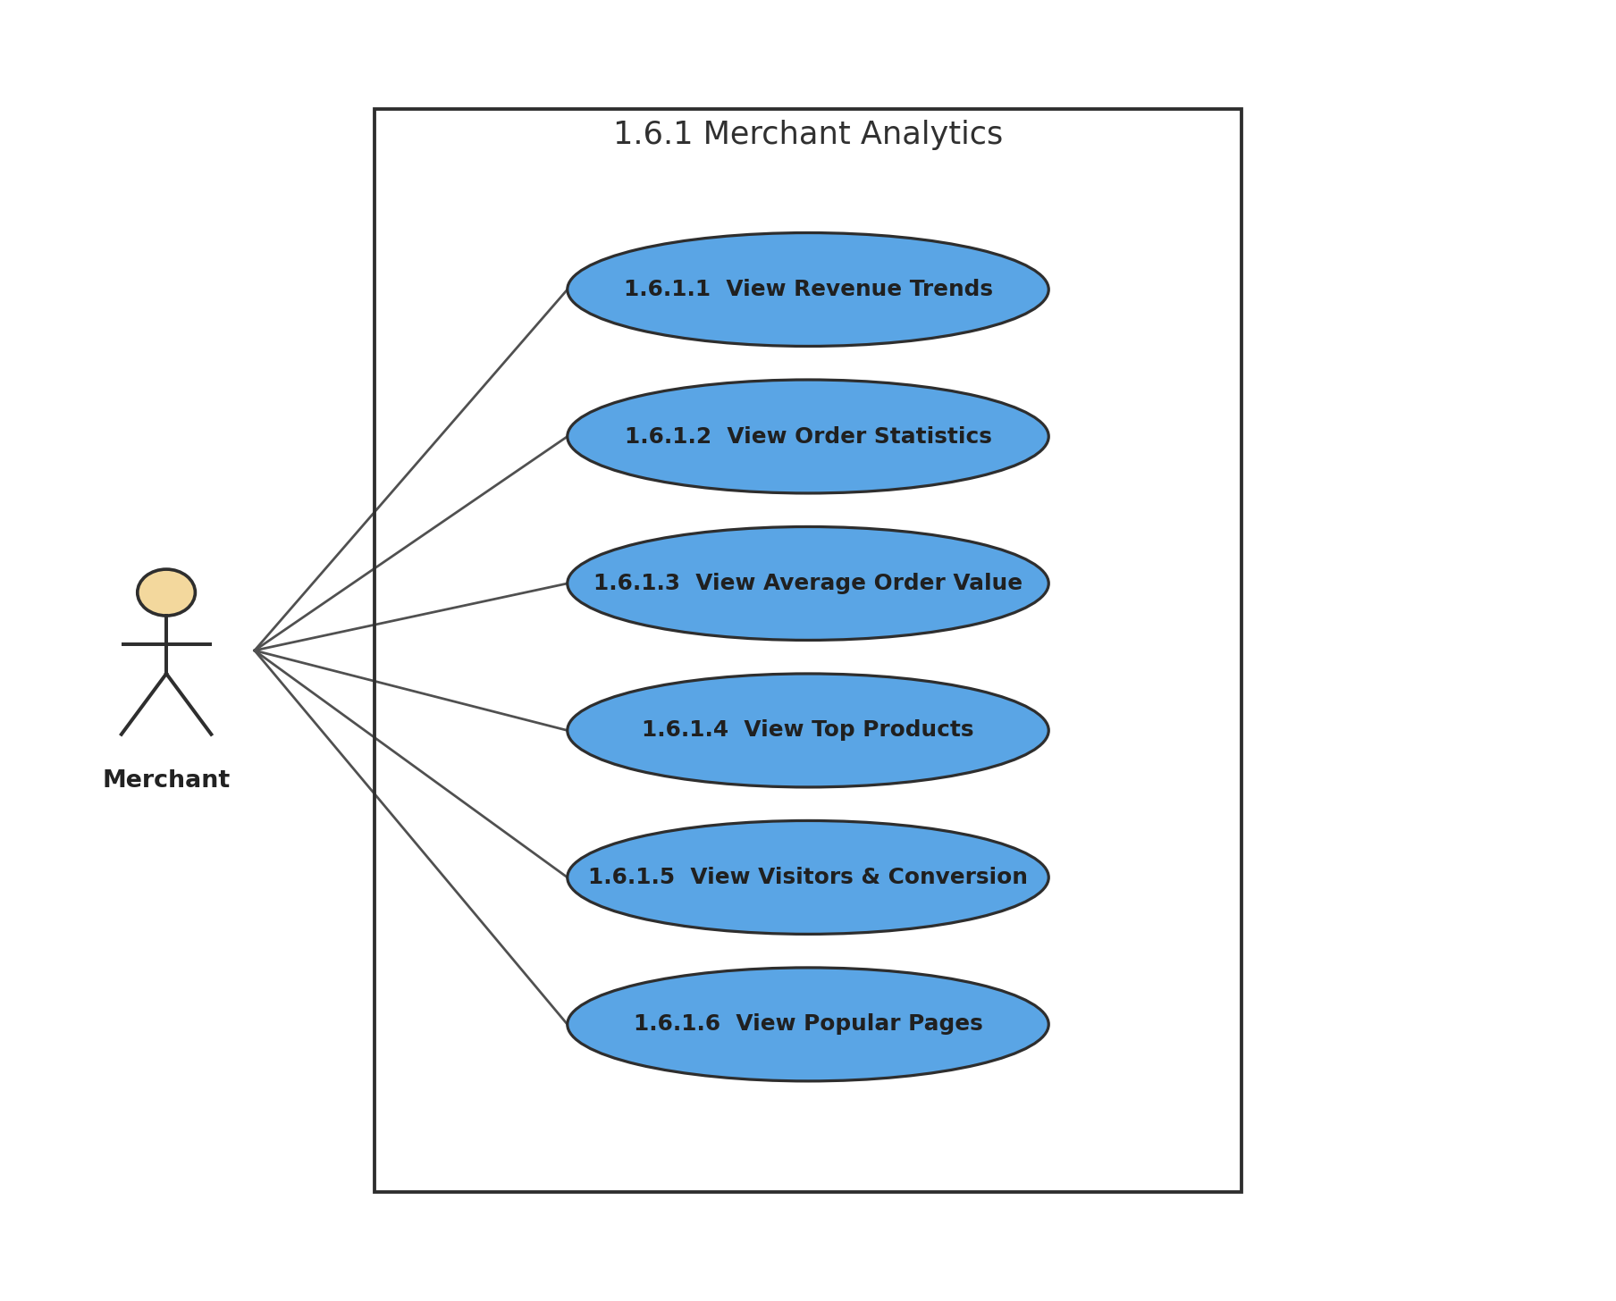
Figure 29: 1.6.1 Merchant Analytics
Description of 1.3.29 use case diagram:
The merchant analytics dashboard shows revenue, orders, average order value, top products, unique-session visitor counts, conversion rates, and popular pages. Cancelled orders are excluded from revenue.
Actors: Merchant

1.3.30 LEVEL-1.6.2 USE CASE DIAGRAM - MERCHANT REPORT EXPORT
1.6.2 Merchant Report Export
Version 1.0
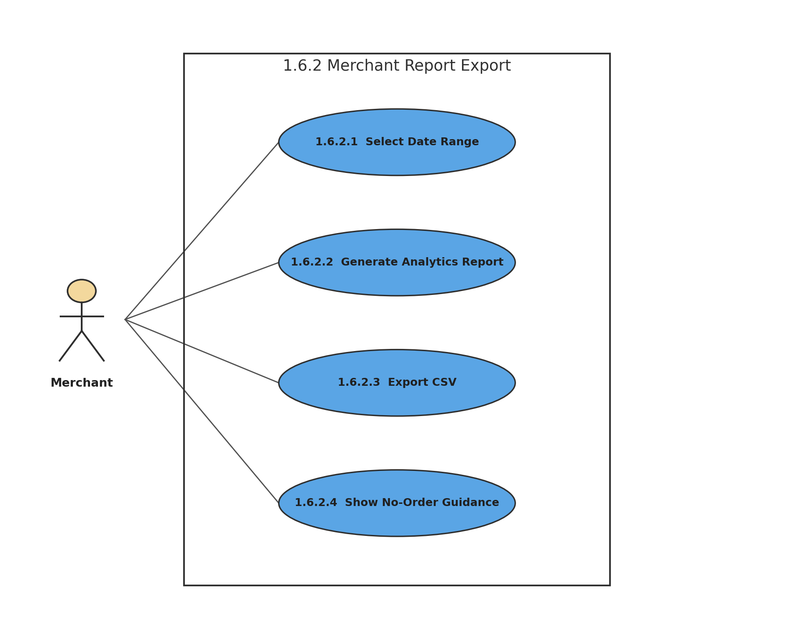
Figure 30: 1.6.2 Merchant Report Export
Description of 1.3.30 use case diagram:
Merchants can select a date range and export analytics as CSV. When no orders exist, the system displays guidance rather than meaningless empty charts.
Actors: Merchant

1.3.31 LEVEL-1.6.3 USE CASE DIAGRAM - SUPER ADMIN ANALYTICS & REPORTS
1.6.3 Super Admin Analytics & Reports
Version 1.0
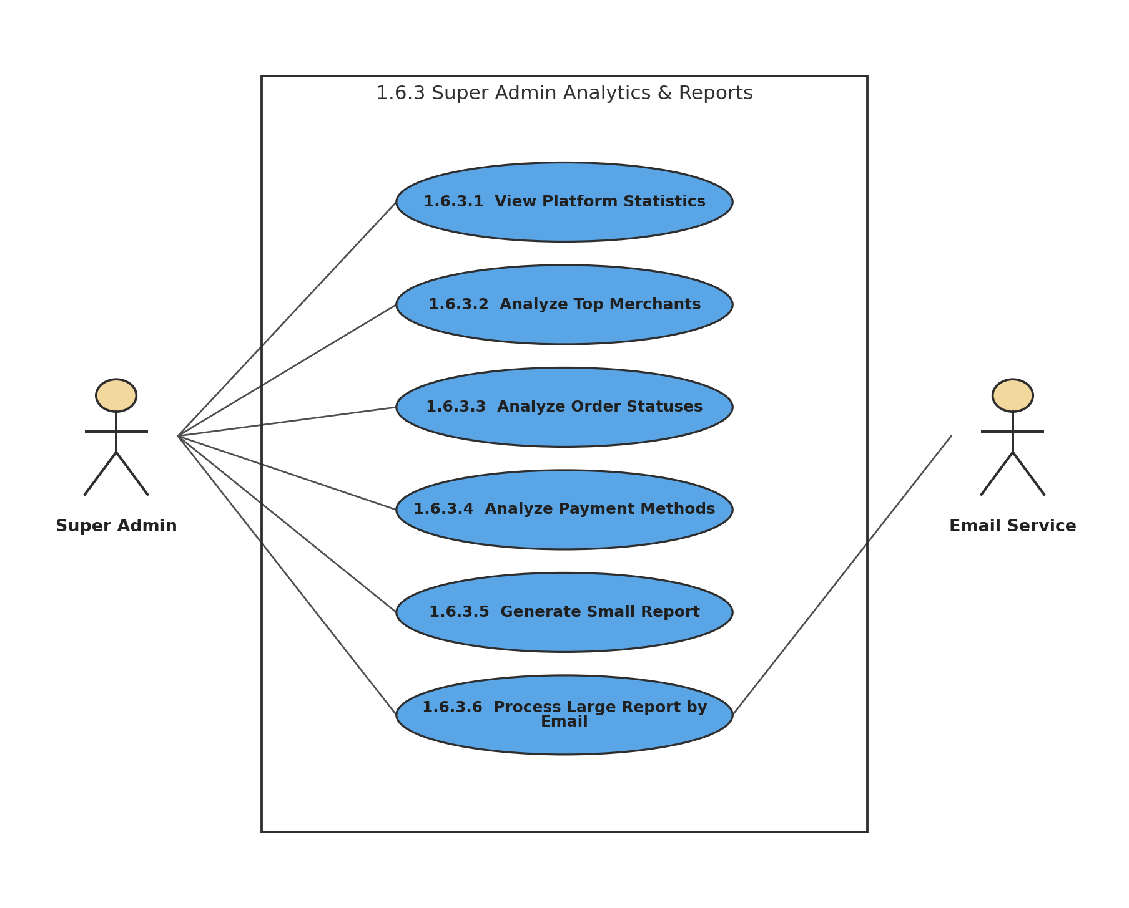
Figure 31: 1.6.3 Super Admin Analytics & Reports
Description of 1.3.31 use case diagram:
Super Admin analytics are read-only. Small reports are produced immediately, while large reports are processed in the background and delivered as CSV by email.
Actors: Super Admin, Email Service

1.3.32 LEVEL-1.7 USE CASE DIAGRAM - CUSTOMER SHOPPING
1.7 Customer Shopping
Version 1.0
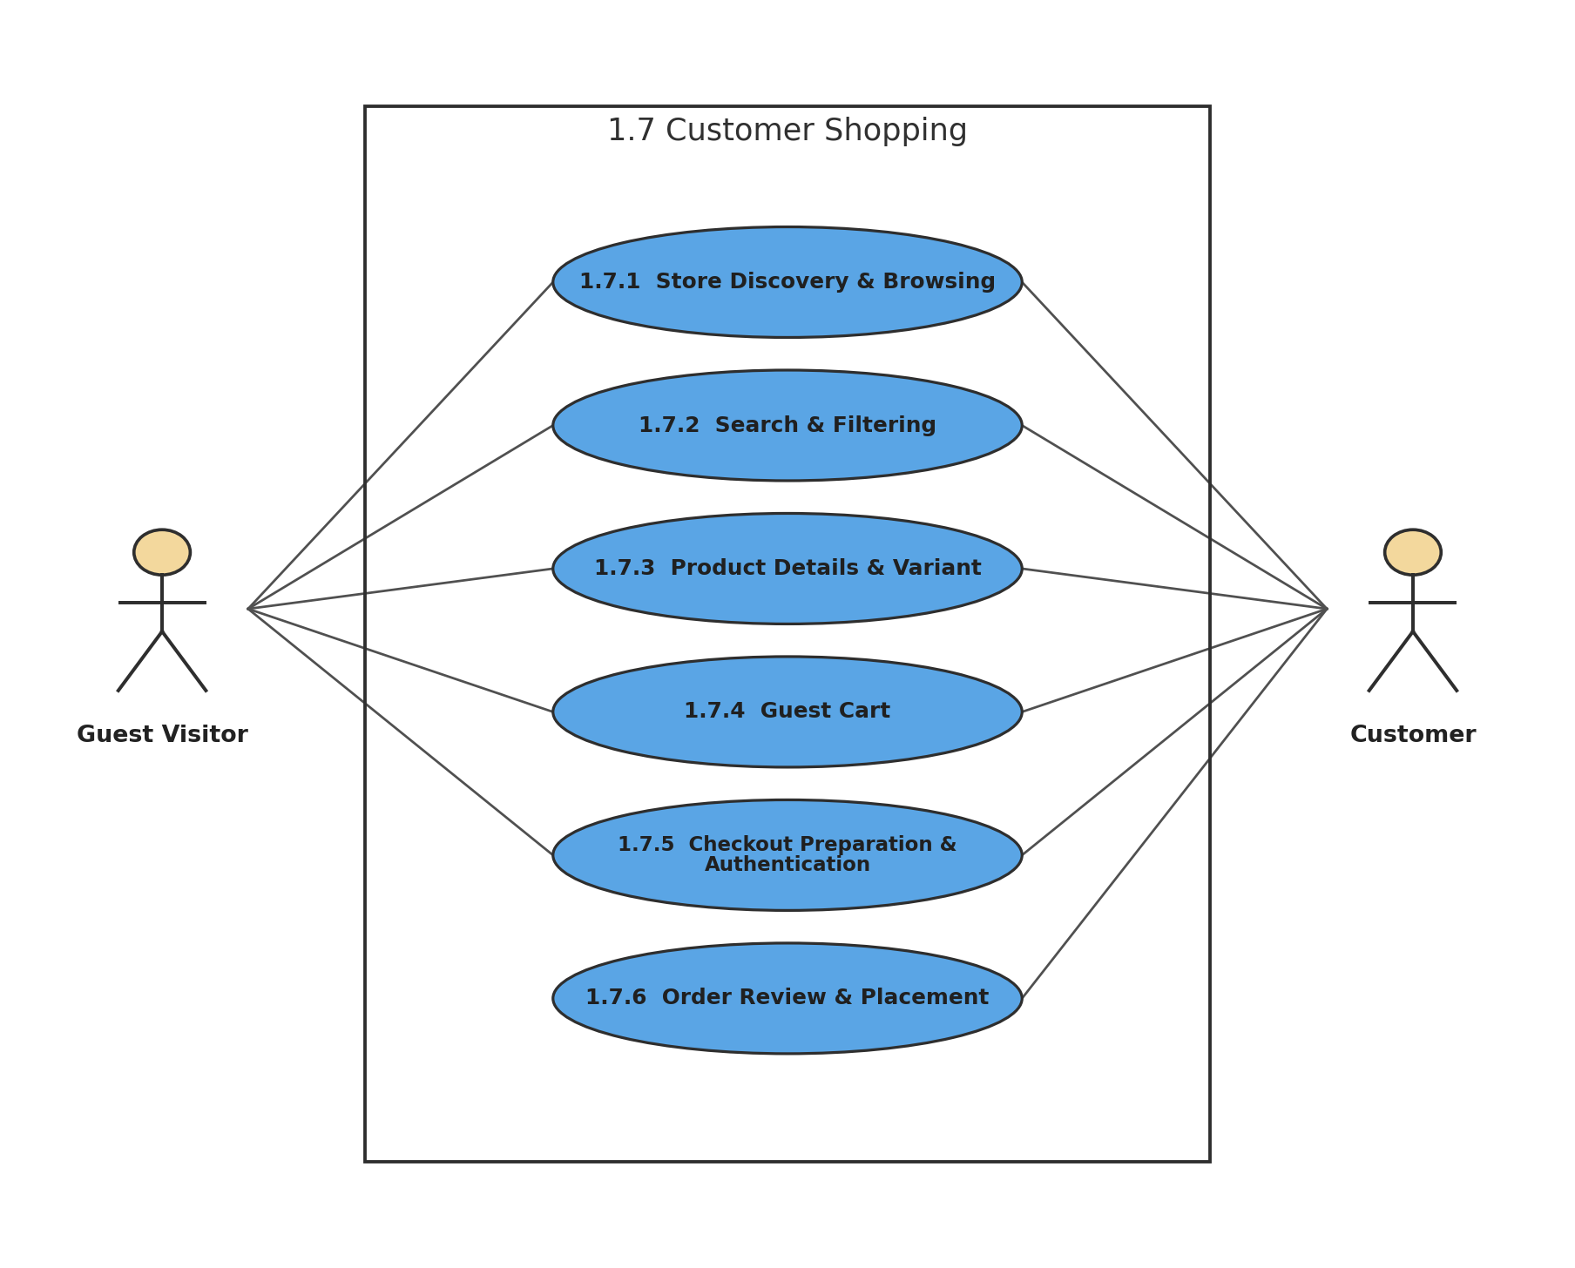
Figure 32: 1.7 Customer Shopping
Description of 1.3.32 use case diagram:
The customer-shopping subsystem preserves the scenario rule: guests may browse, manage a cart, and prepare checkout, but payment and final order placement require authentication.
Actors: Guest Visitor, Customer

1.3.33 LEVEL-1.7.1 USE CASE DIAGRAM - STORE DISCOVERY & BROWSING
1.7.1 Store Discovery & Browsing
Version 1.0
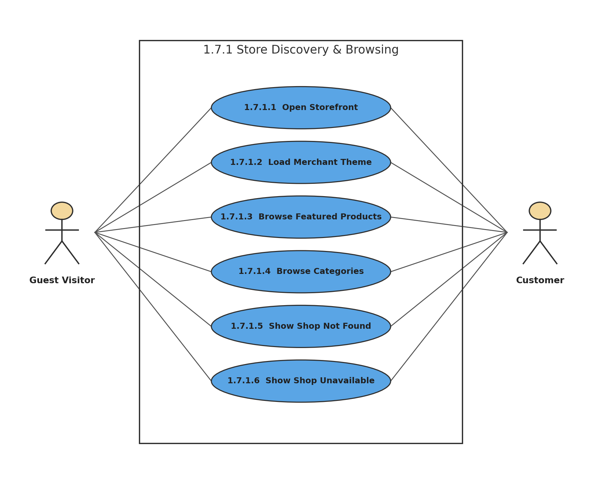
Figure 33: 1.7.1 Store Discovery & Browsing
Description of 1.3.33 use case diagram:
Visitors can immediately browse a published shop. Invalid subdomains show Shop Not Found, while unpublished stores hide content behind a Shop Currently Unavailable page.
Actors: Guest Visitor, Customer

1.3.34 LEVEL-1.7.2 USE CASE DIAGRAM - PRODUCT SEARCH & FILTERING
1.7.2 Search & Filtering
Version 1.0
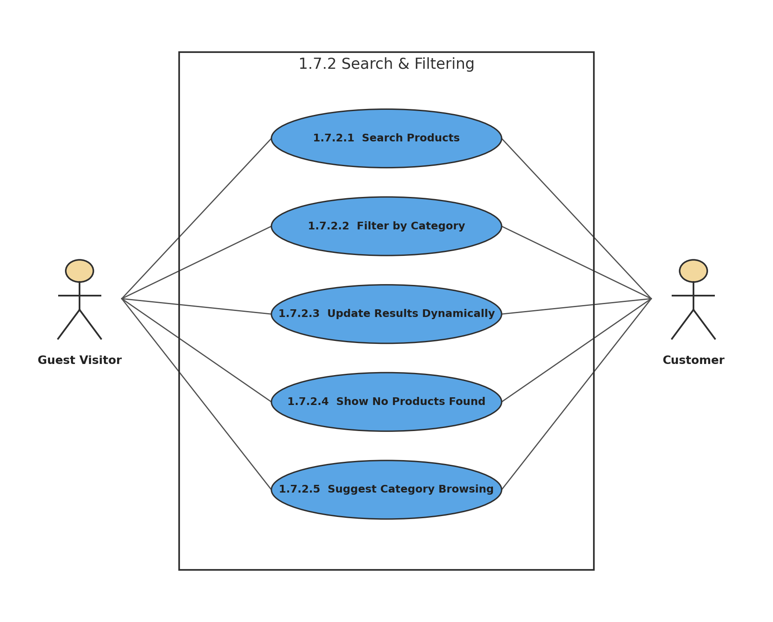
Figure 34: 1.7.2 Search & Filtering
Description of 1.3.34 use case diagram:
Search and category filtering update the catalog dynamically. When no products match, BazarHQ provides a clear no-results state and suggests category browsing.
Actors: Guest Visitor, Customer

1.3.35 LEVEL-1.7.3 USE CASE DIAGRAM - PRODUCT DETAILS & VARIANT
1.7.3 Product Details & Variant
Version 1.0
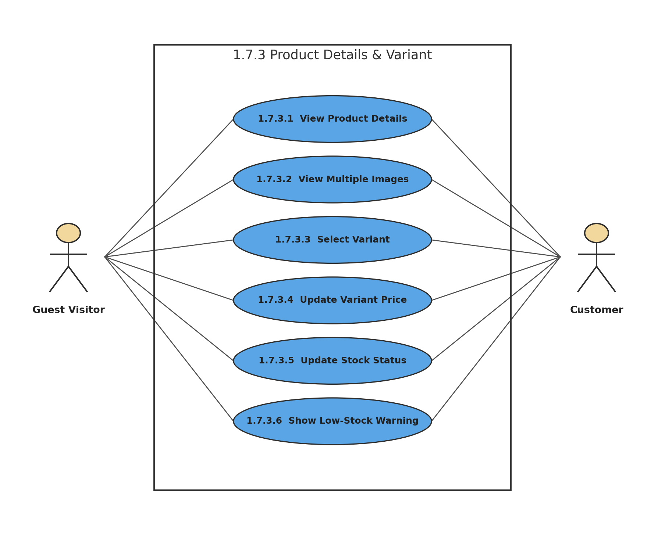
Figure 35: 1.7.3 Product Details & Variant
Description of 1.3.35 use case diagram:
The product page presents images, description, price, variants, and availability. Selecting a variant updates price and stock immediately, and low stock can trigger a warning.
Actors: Guest Visitor, Customer

1.3.36 LEVEL-1.7.4 USE CASE DIAGRAM - GUEST CART
1.7.4 Guest Cart
Version 1.0
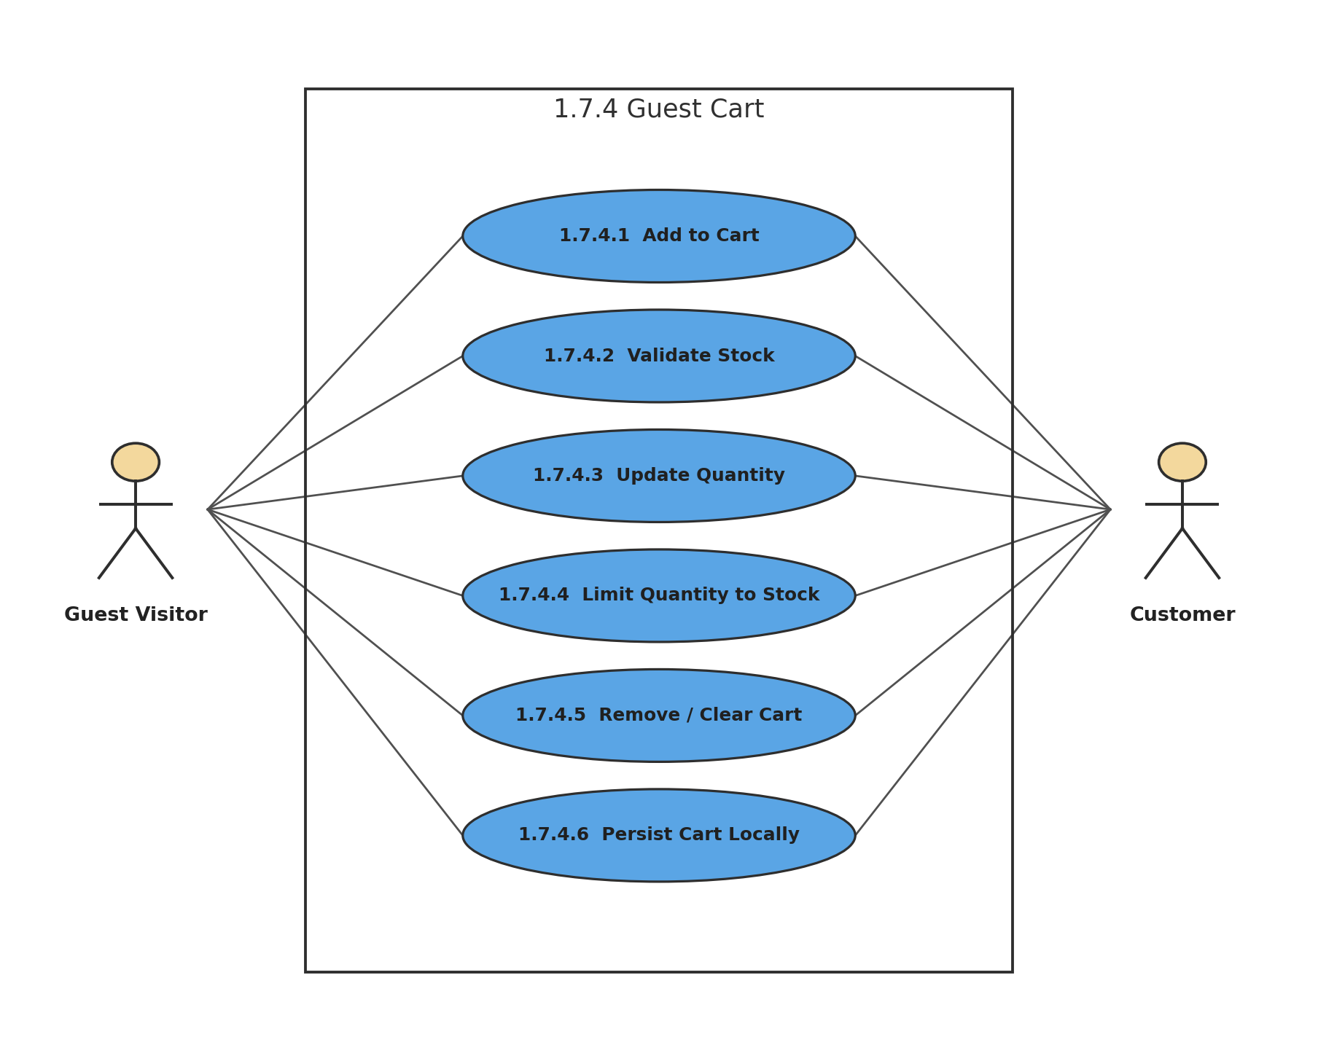
Figure 36: 1.7.4 Guest Cart
Description of 1.3.36 use case diagram:
Cart operations are available to guests. The system prevents out-of-stock additions, limits requested quantity to available stock, and preserves the cart locally across refreshes or browser reopening.
Actors: Guest Visitor, Customer

1.3.37 LEVEL-1.7.5 USE CASE DIAGRAM - CHECKOUT PREPARATION & AUTHENTICATION
1.7.5 Checkout Preparation & Authentication
Version 1.0
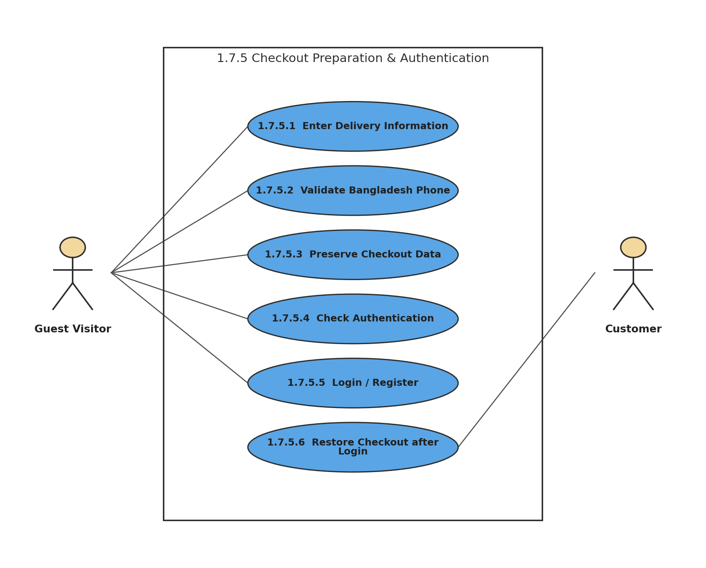
Figure 37: 1.7.5 Checkout Preparation & Authentication
Description of 1.3.37 use case diagram:
Guests may enter delivery information and prepare checkout. Before payment or final order placement, BazarHQ requires login/registration while preserving cart, variant, quantity, and delivery information.
Actors: Guest Visitor, Customer

1.3.38 LEVEL-1.7.6 USE CASE DIAGRAM - ORDER REVIEW & PLACEMENT
1.7.6 Order Review & Placement
Version 1.0
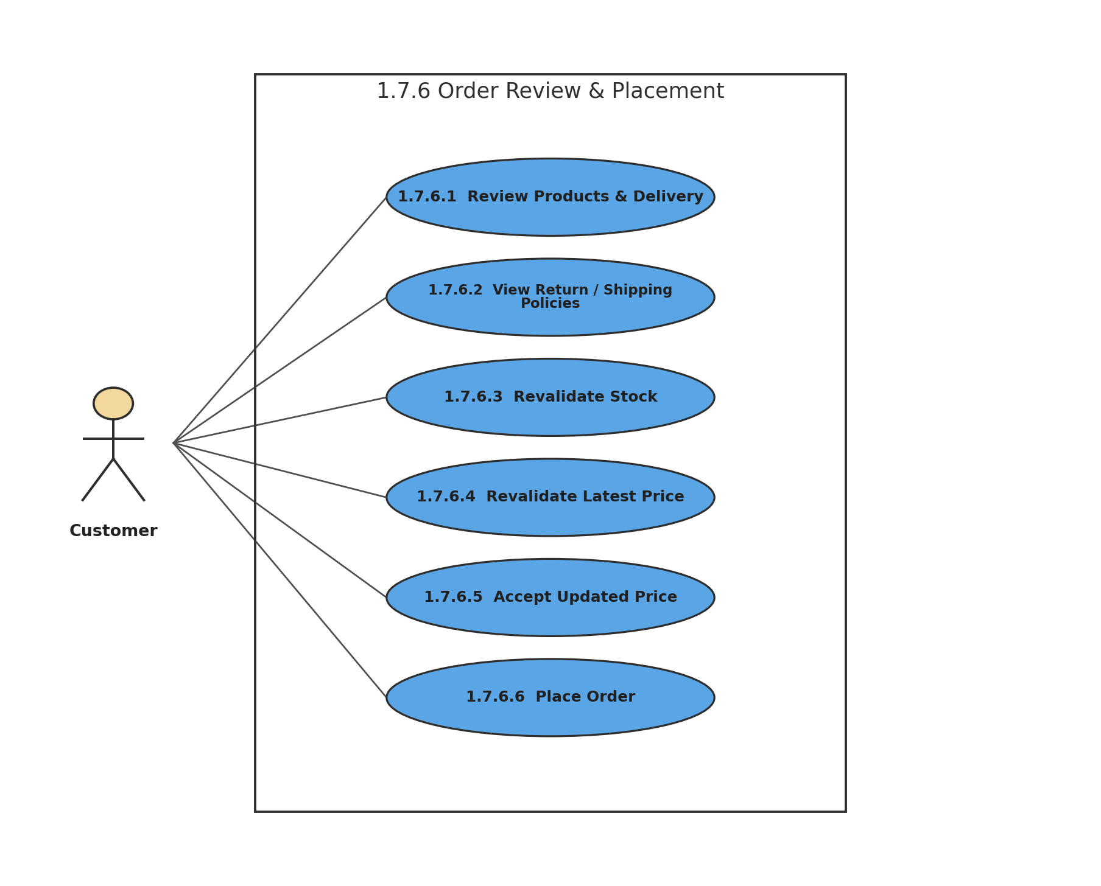
Figure 38: 1.7.6 Order Review & Placement
Description of 1.3.38 use case diagram:
Authenticated customers review the final order and policies. BazarHQ revalidates stock and price before placement; stock conflicts block the order and price changes require customer acceptance.
Actors: Customer

1.3.39 LEVEL-1.8 USE CASE DIAGRAM - TRACKING & CUSTOMER ACCOUNT
1.8 Tracking & Customer Account
Version 1.0
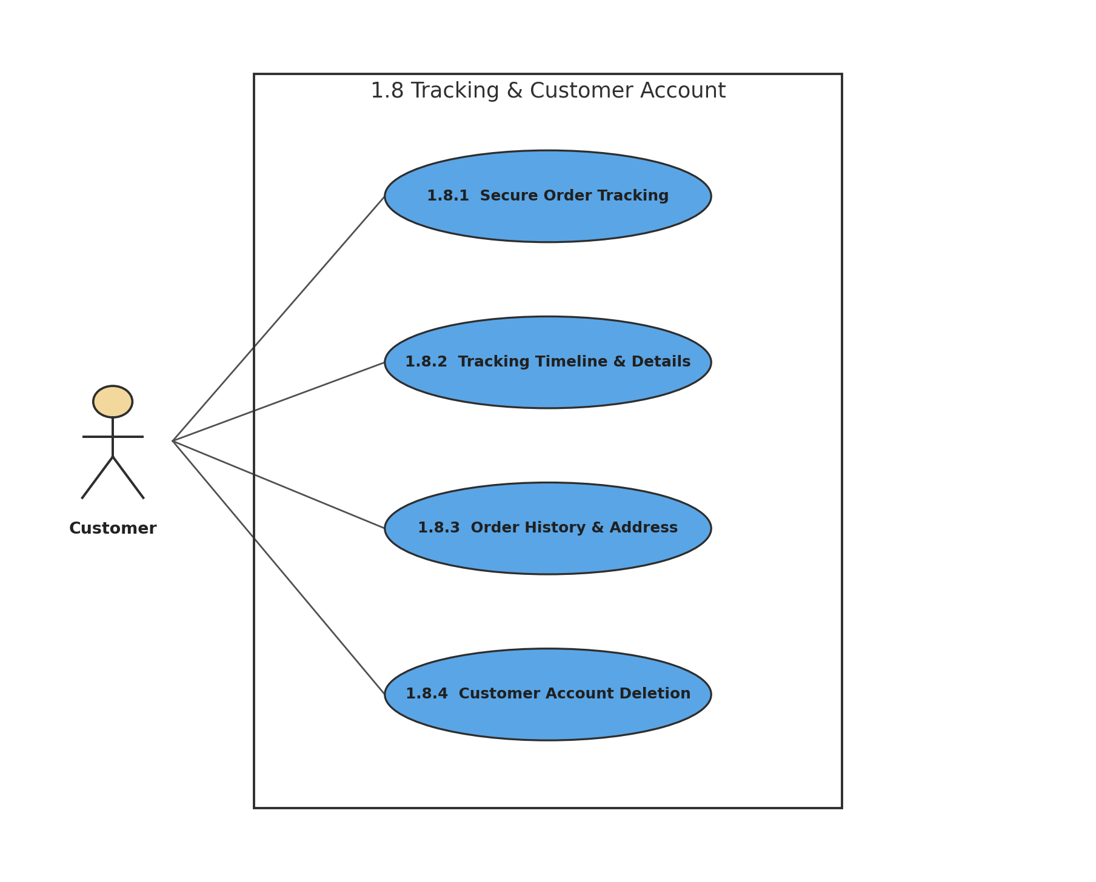
Figure 39: 1.8 Tracking & Customer Account
Description of 1.3.39 use case diagram:
After purchase, the customer can securely track orders, review history, manage up to three delivery addresses, and delete the customer account.
Actors: Customer

1.3.40 LEVEL-1.8.1 USE CASE DIAGRAM - SECURE ORDER TRACKING
1.8.1 Secure Order Tracking
Version 1.0
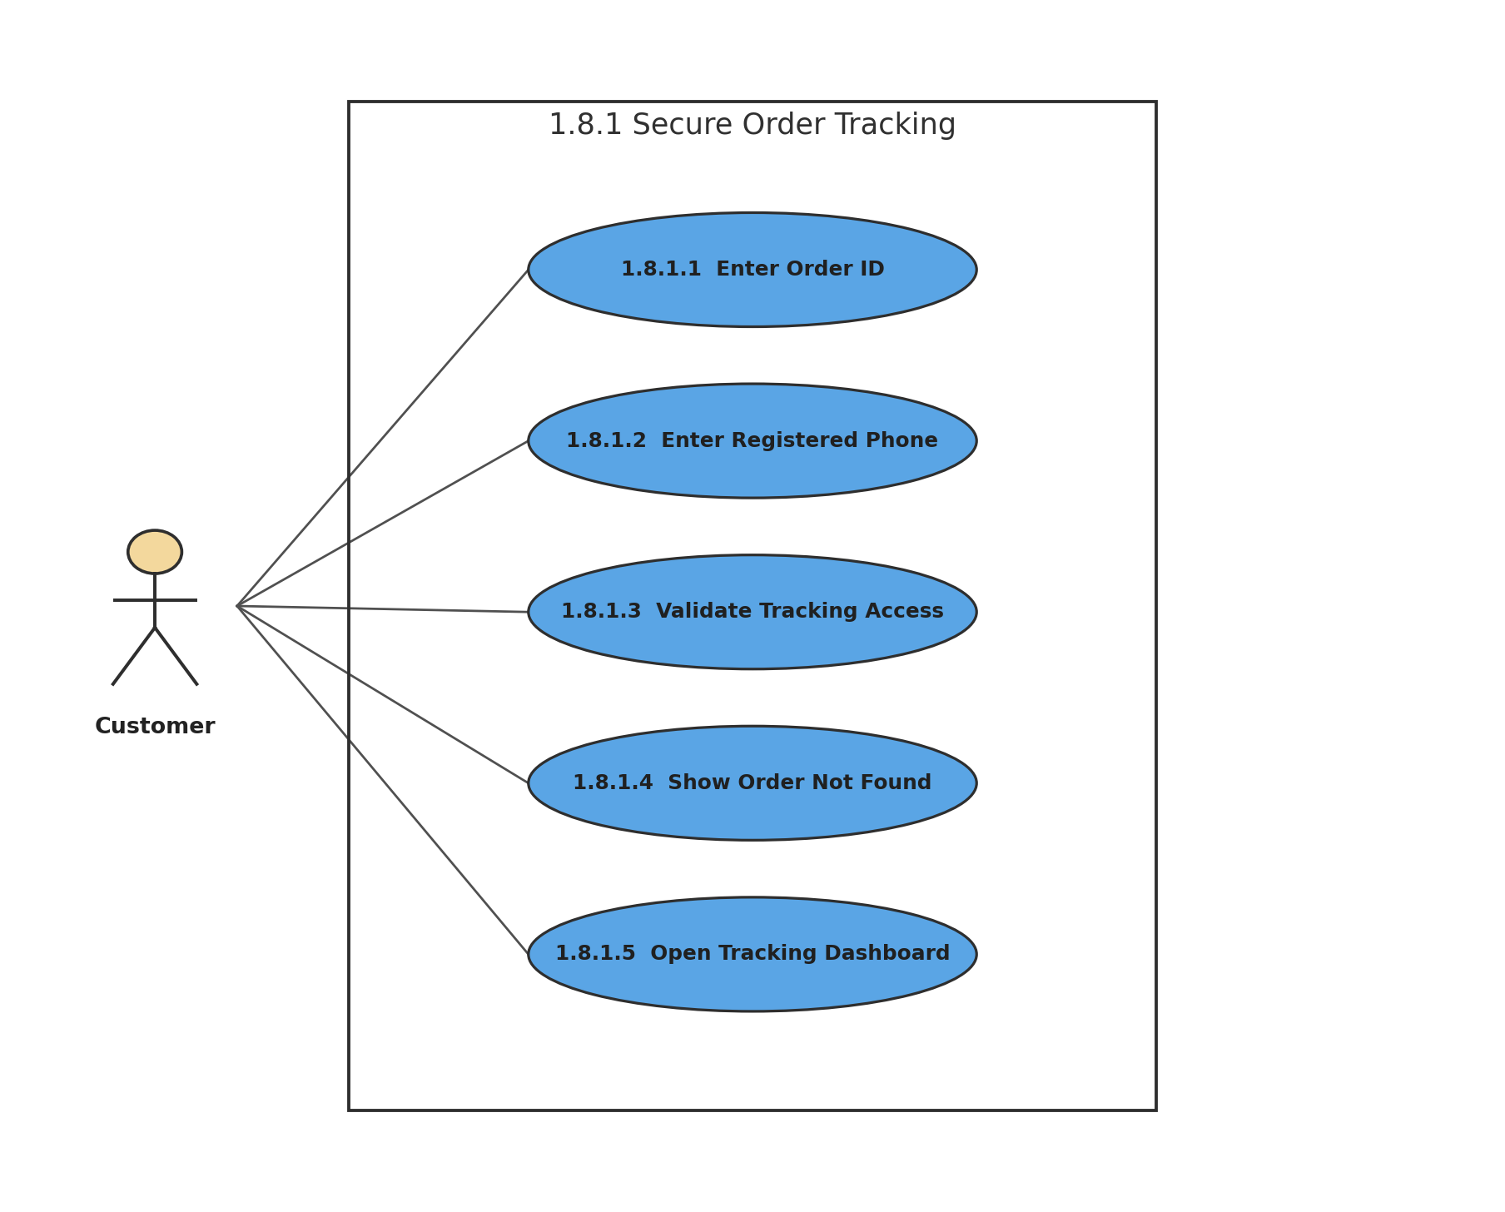
Figure 40: 1.8.1 Secure Order Tracking
Description of 1.3.40 use case diagram:
Tracking access requires the Order ID and registered phone number to match. Invalid attempts return only the generic message Order not found, protecting order existence and customer privacy.
Actors: Customer

1.3.41 LEVEL-1.8.2 USE CASE DIAGRAM - TRACKING TIMELINE & DETAILS
1.8.2 Tracking Timeline & Details
Version 1.0
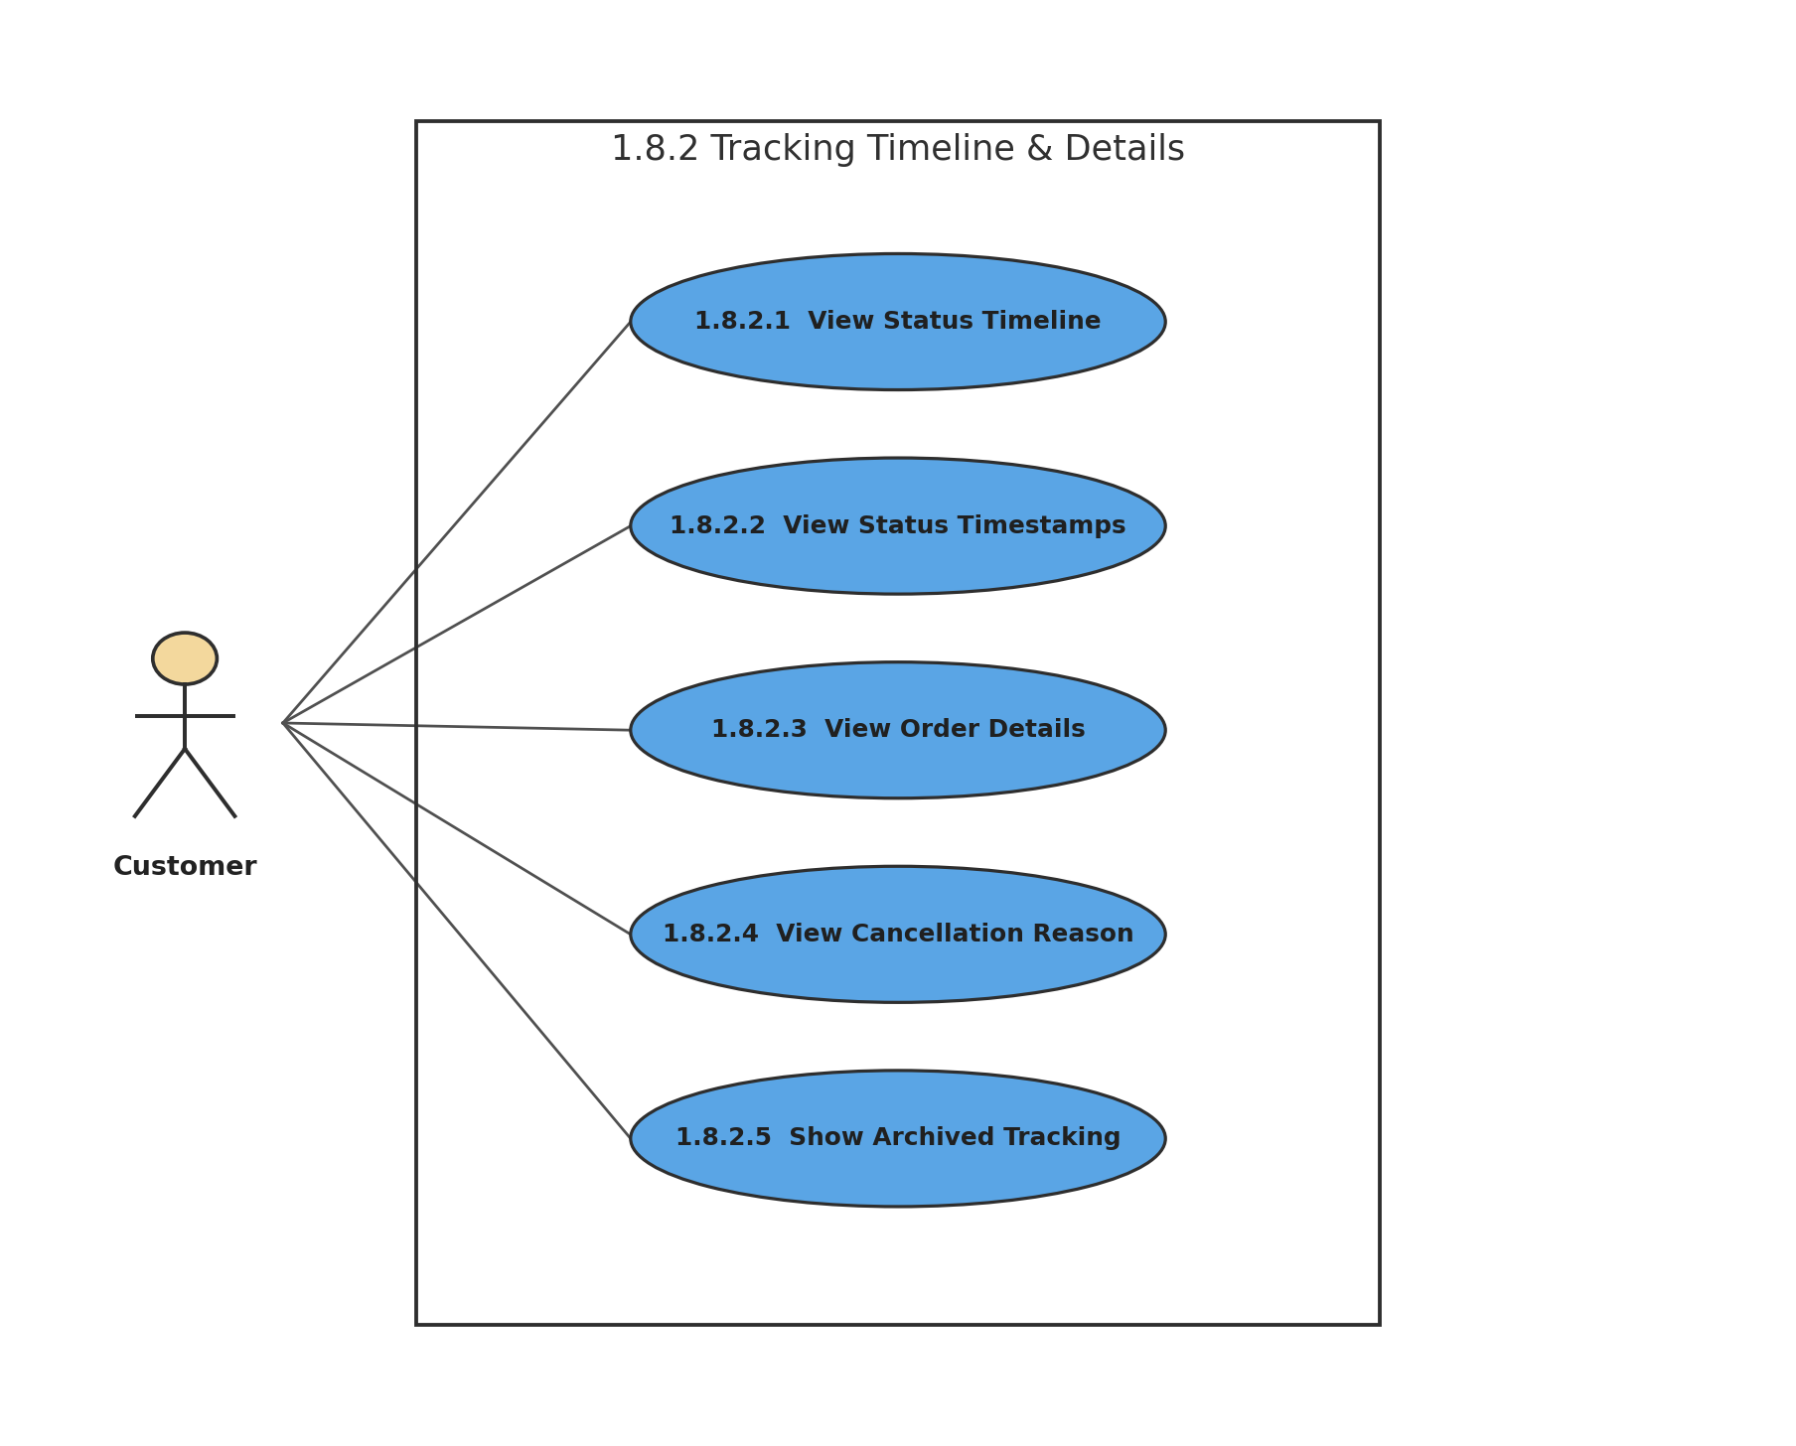
Figure 41: 1.8.2 Tracking Timeline & Details
Description of 1.3.41 use case diagram:
The tracking dashboard shows completed stages and timestamps, order and merchant information, cancellation reason when applicable, and archived status for old delivered orders.
Actors: Customer

1.3.42 LEVEL-1.8.3 USE CASE DIAGRAM - ORDER HISTORY & ADDRESS
1.8.3 Order History & Address
Version 1.0
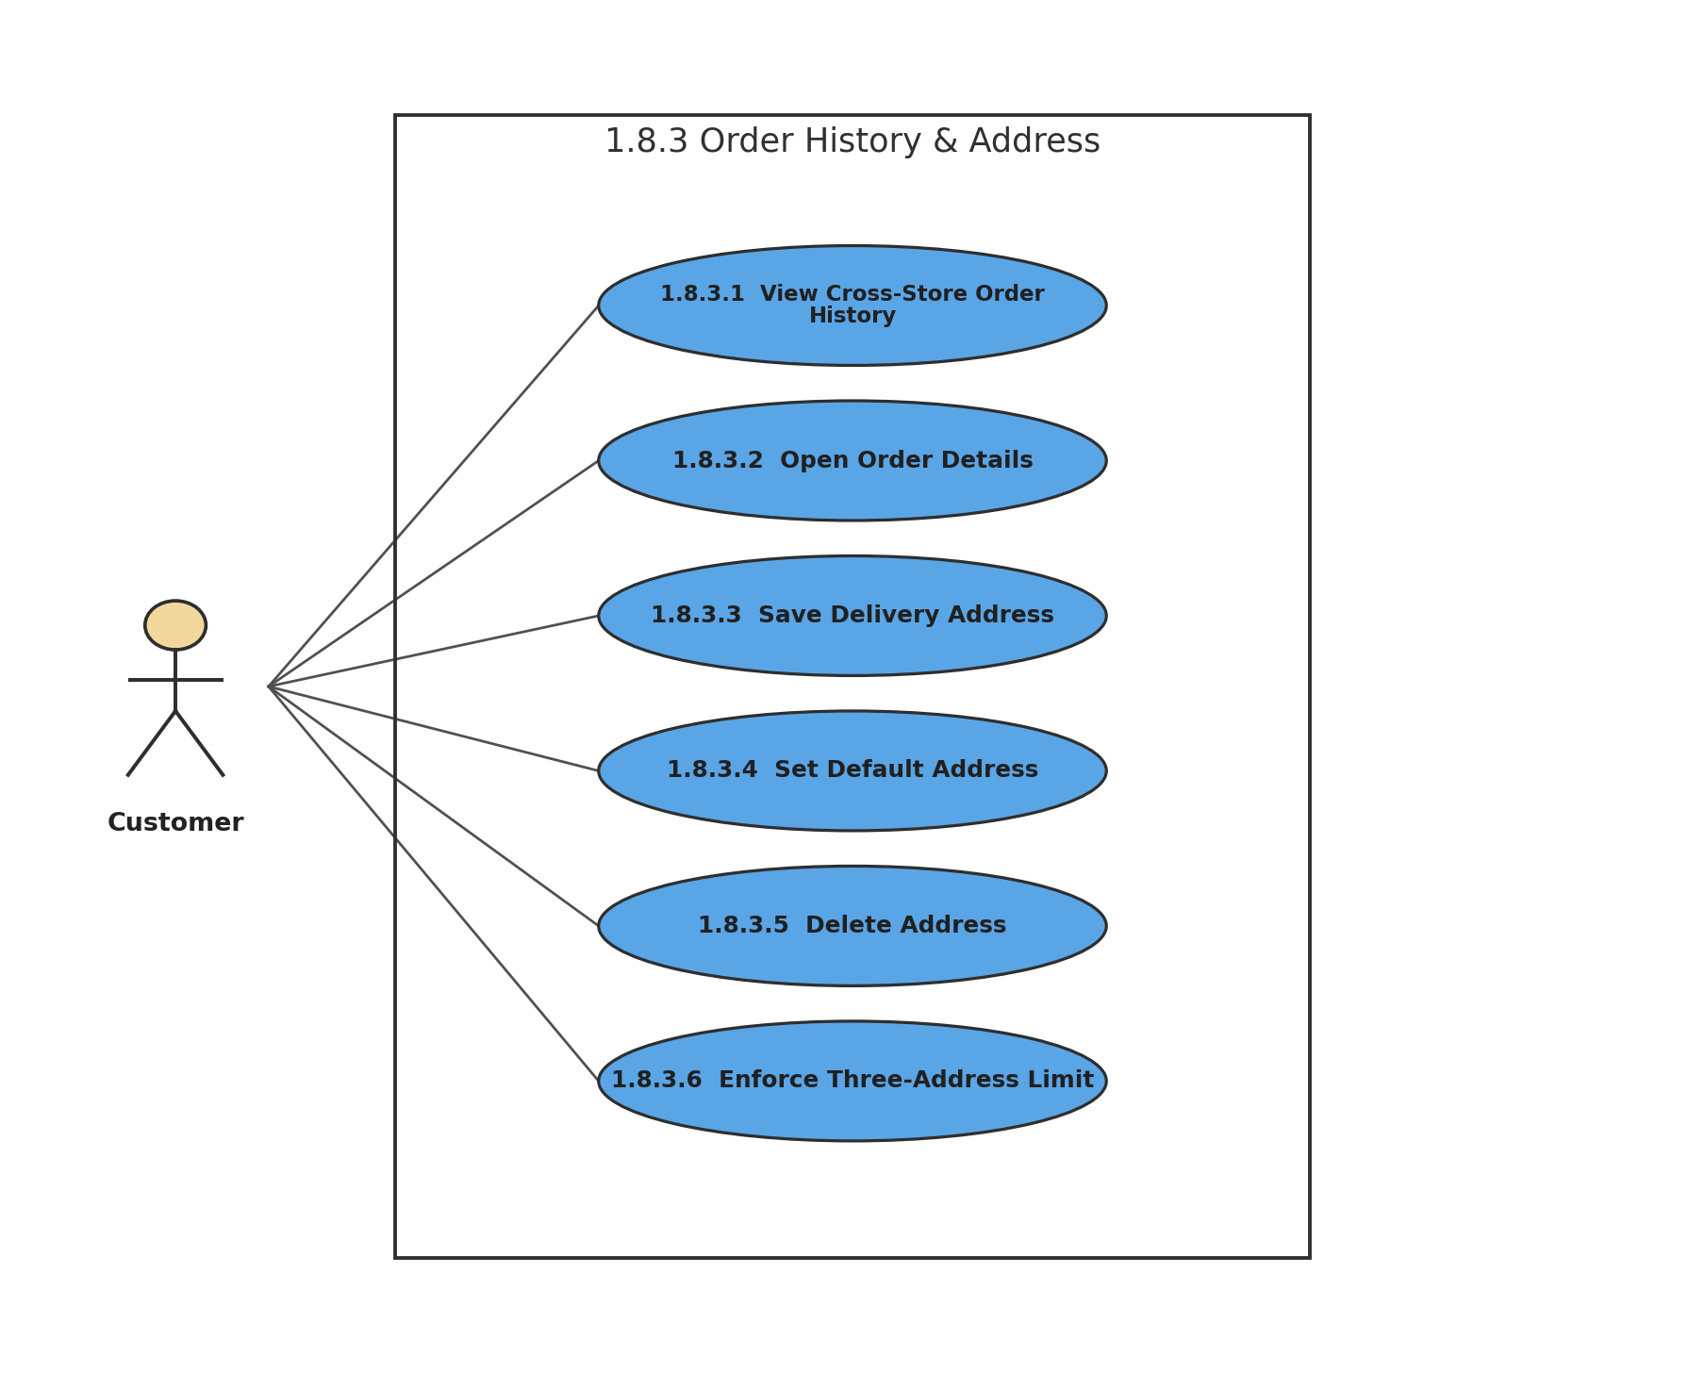
Figure 42: 1.8.3 Order History & Address
Description of 1.3.42 use case diagram:
The customer dashboard stores order history across BazarHQ shops and allows up to three saved addresses, including one default address for future checkout.
Actors: Customer

1.3.43 LEVEL-1.8.4 USE CASE DIAGRAM - CUSTOMER ACCOUNT DELETION
1.8.4 Customer Account Deletion
Version 1.0
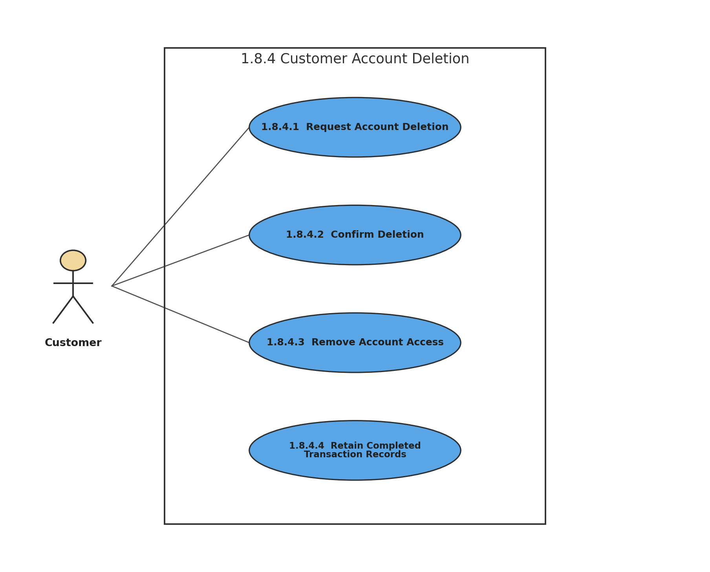
Figure 43: 1.8.4 Customer Account Deletion
Description of 1.3.43 use case diagram:
Deleting a customer account removes access to order history and account features, while completed transaction records remain with merchants as required for business records.
Actors: Customer

1.3.44 LEVEL-1.9 USE CASE DIAGRAM - NOTIFICATION
1.9 Notification
Version 1.0
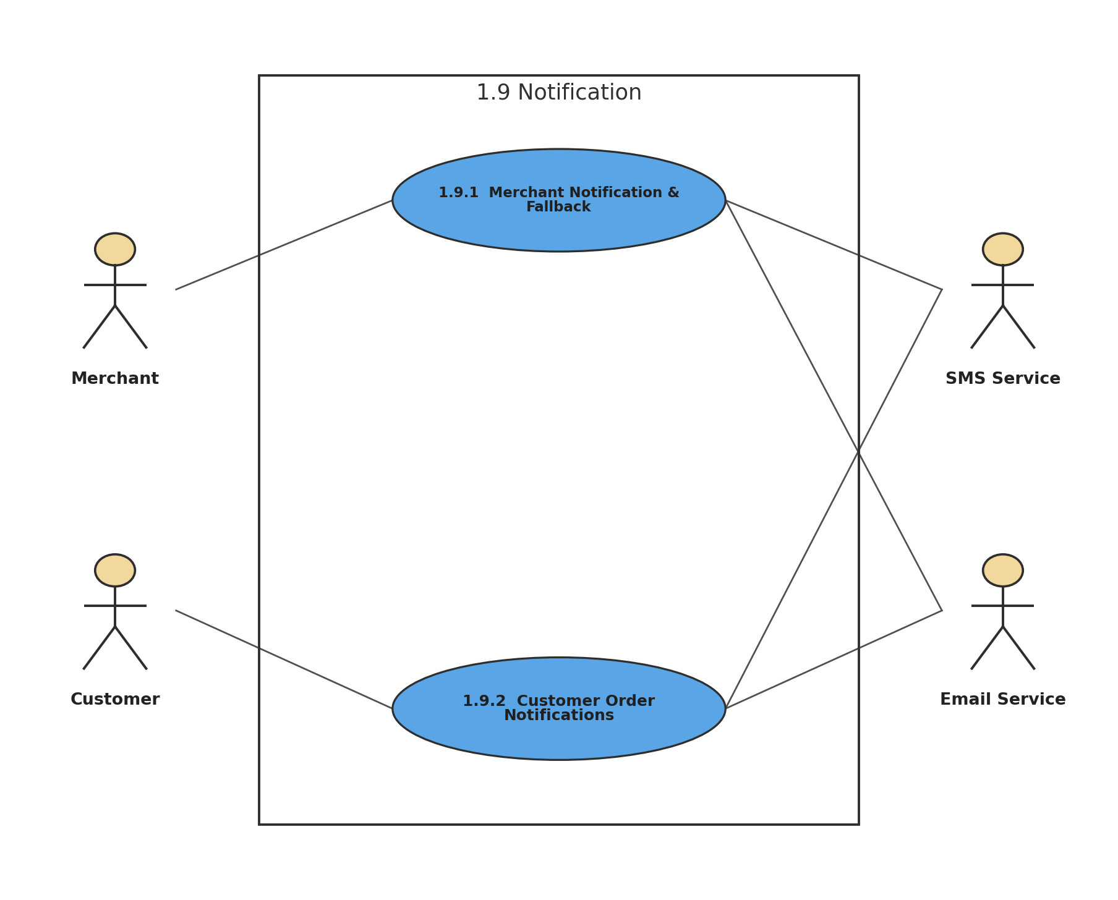
Figure 44: 1.9 Notification
Description of 1.3.44 use case diagram:
The notification subsystem communicates new orders and order-status changes through dashboard, SMS, and email channels with fallback behavior where specified.
Actors: Merchant, Customer, SMS Service, Email Service

1.3.45 LEVEL-1.9.1 USE CASE DIAGRAM - MERCHANT NOTIFICATION & FALLBACK
1.9.1 Merchant Notification & Fallback
Version 1.0
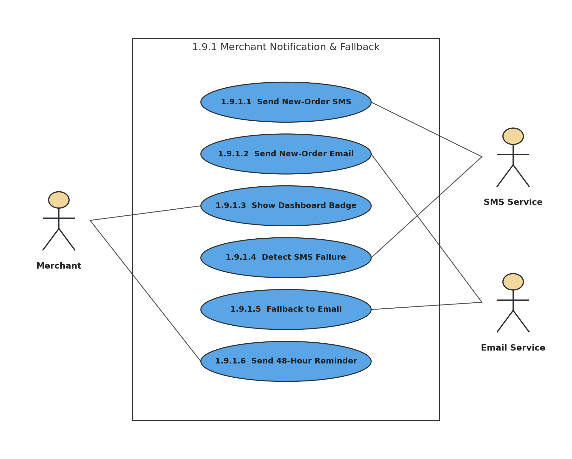
Figure 45: 1.9.1 Merchant Notification & Fallback
Description of 1.3.45 use case diagram:
New orders generate merchant alerts within the specified time. If SMS delivery fails, BazarHQ falls back to email, and pending orders can generate a reminder after 48 hours.
Actors: Merchant, SMS Service, Email Service

1.3.46 LEVEL-1.9.2 USE CASE DIAGRAM - CUSTOMER ORDER NOTIFICATIONS
1.9.2 Customer Order Notifications
Version 1.0
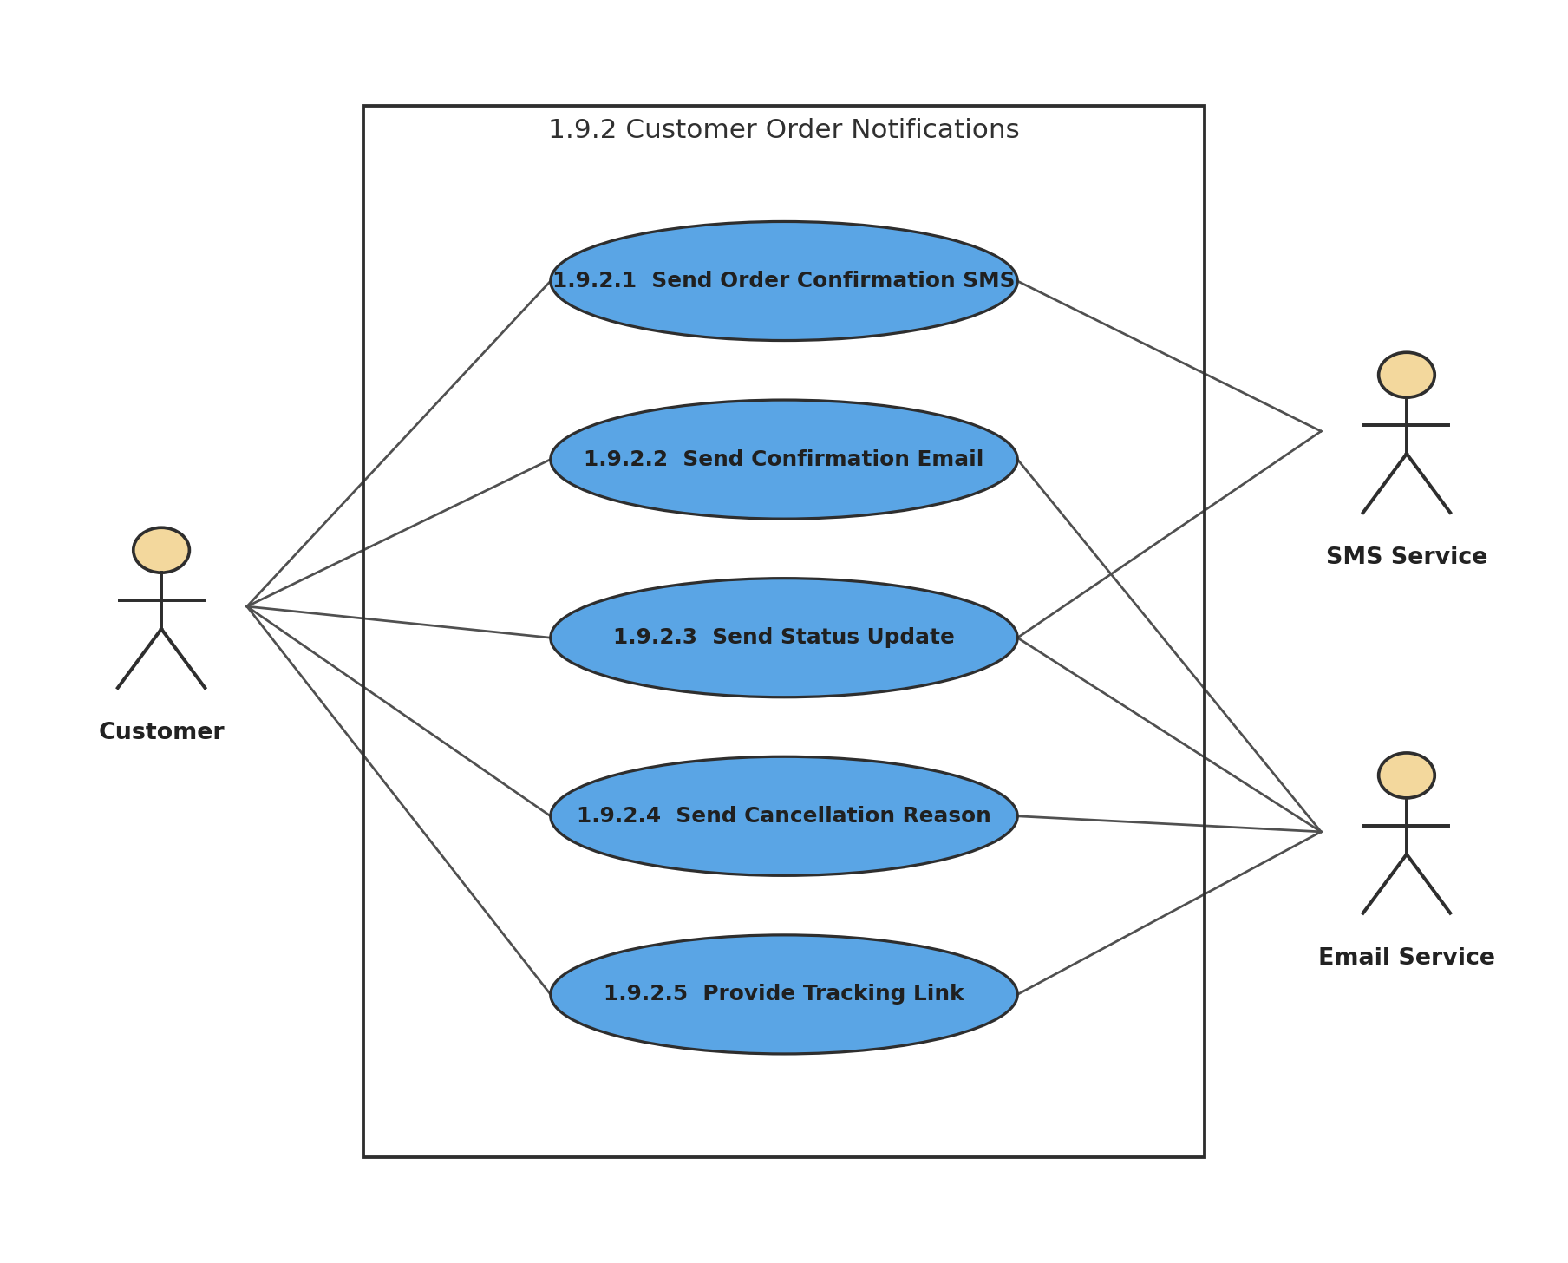
Figure 46: 1.9.2 Customer Order Notifications
Description of 1.3.46 use case diagram:
Customers receive order confirmation, tracking information, status updates, and cancellation information through the configured notification channels.
Actors: Customer, SMS Service, Email Service

1.3.47 LEVEL-1.10 USE CASE DIAGRAM - SUPER ADMIN GOVERNANCE
1.10 Super Admin Governance
Version 1.0
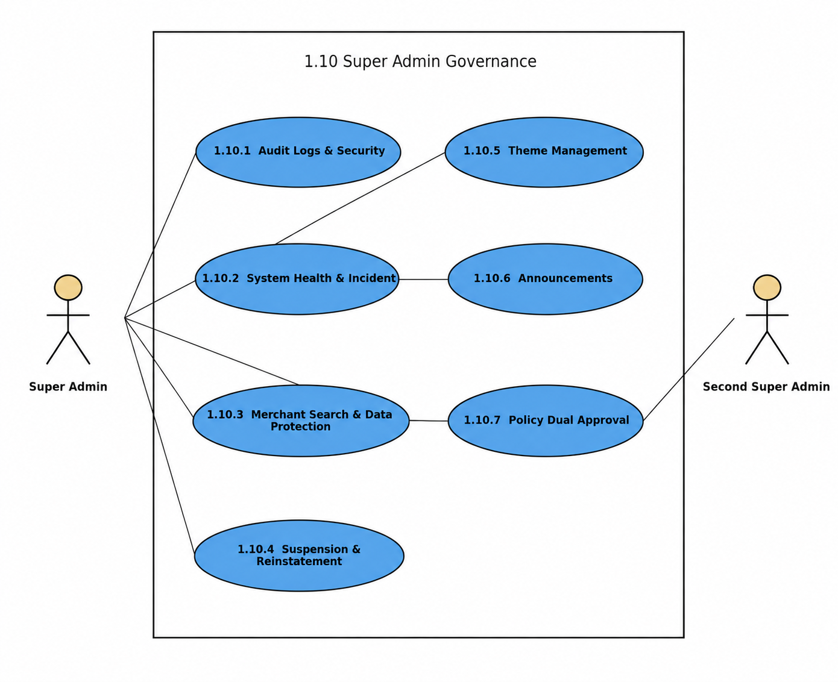
Figure 47: 1.10 Super Admin Governance
Description of 1.3.47 use case diagram:
Super Admin governance covers platform security, operational monitoring, merchant administration, content management, and dual-approval policy publication.
Actors: Super Admin, Second Super Admin

1.3.48 LEVEL-1.10.1 USE CASE DIAGRAM - AUDIT LOGS & SECURITY
1.10.1 Audit Logs & Security
Version 1.0
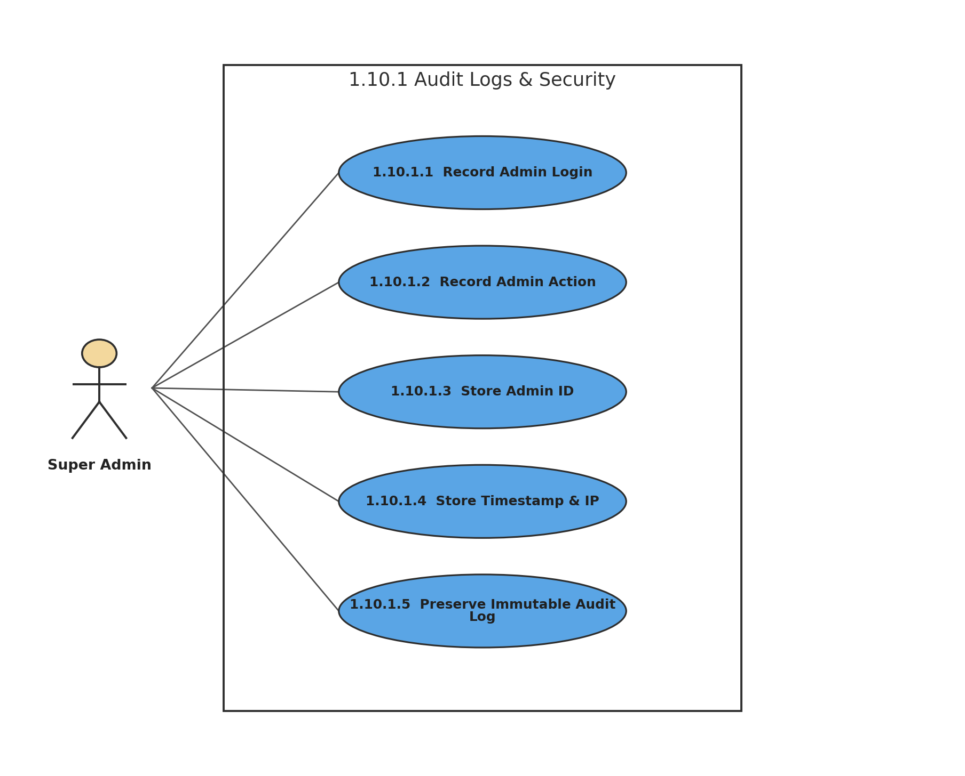
Figure 48: 1.10.1 Audit Logs & Security
Description of 1.3.48 use case diagram:
Important Super Admin logins and system actions are stored as immutable audit records containing administrator identity, timestamp, and IP address.
Actors: Super Admin

1.3.49 LEVEL-1.10.2 USE CASE DIAGRAM - SYSTEM HEALTH & INCIDENT
1.10.2 System Health & Incident
Version 1.0
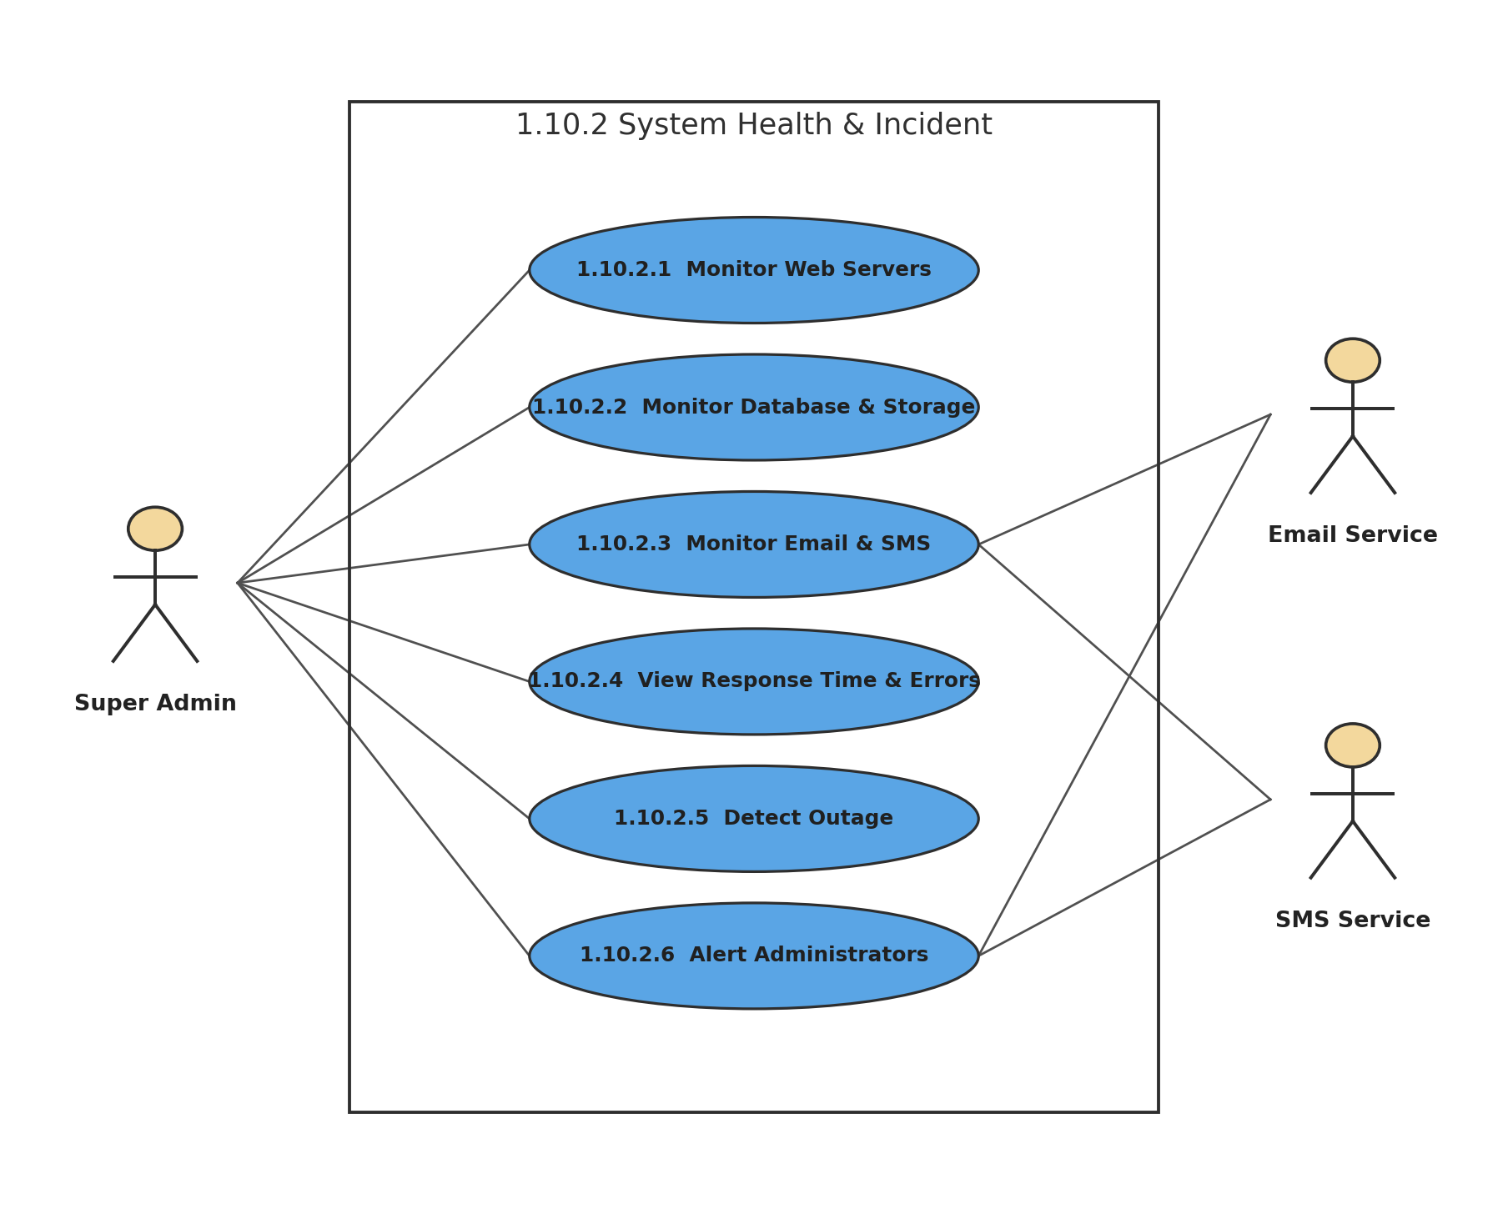
Figure 49: 1.10.2 System Health & Incident
Description of 1.3.49 use case diagram:
System Health displays the condition of infrastructure and communication services. Outages update the dashboard and trigger alerts to administrators.
Actors: Super Admin, Email Service, SMS Service

1.3.50 LEVEL-1.10.3 USE CASE DIAGRAM - MERCHANT SEARCH & DATA PROTECTION
1.10.3 Merchant Search & Data Protection
Version 1.0
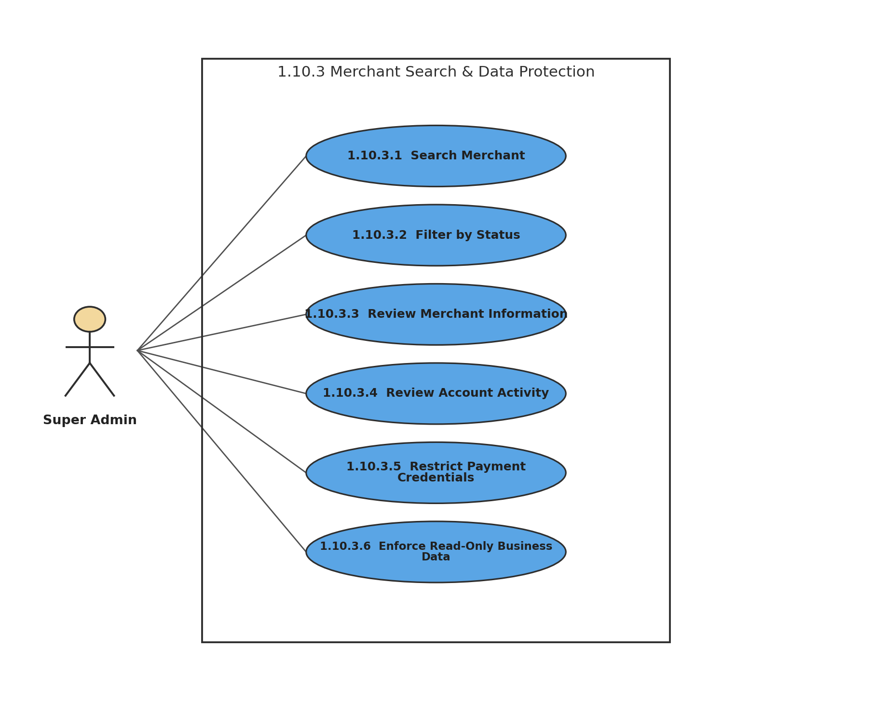
Figure 50: 1.10.3 Merchant Search & Data Protection
Description of 1.3.50 use case diagram:
Super Admin can search and review merchants and account activity, but cannot access sensitive payment credentials or modify products, prices, or store content.
Actors: Super Admin

1.3.51 LEVEL-1.10.4 USE CASE DIAGRAM - SUSPENSION & REINSTATEMENT
1.10.4 Suspension & Reinstatement
Version 1.0
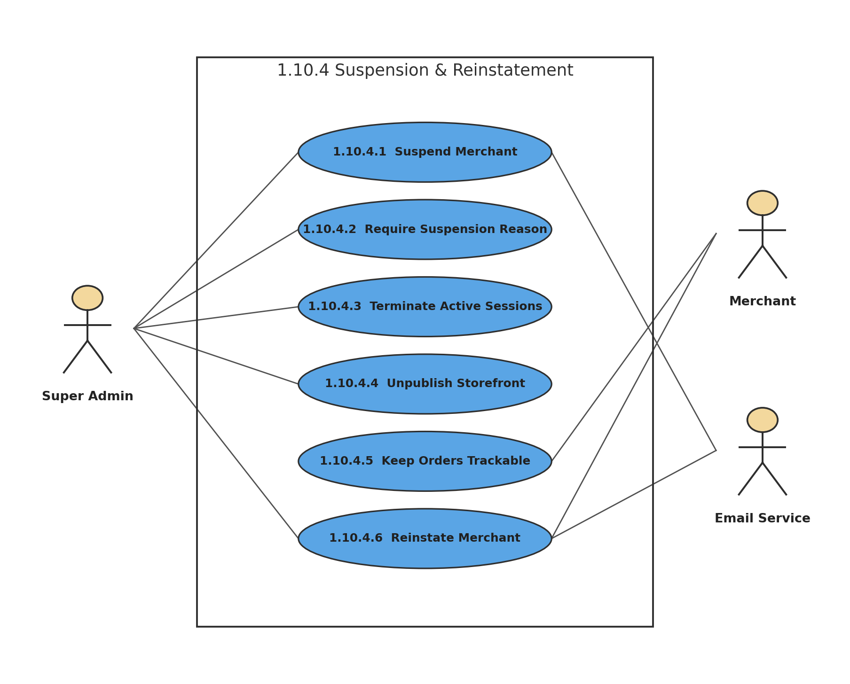
Figure 51: 1.10.4 Suspension & Reinstatement
Description of 1.3.51 use case diagram:
Suspension requires a reason, terminates merchant sessions, and unpublishes the storefront while preserving customer order tracking. Approved merchants can later be reinstated and notified.
Actors: Super Admin, Merchant, Email Service

1.3.52 LEVEL-1.10.5 USE CASE DIAGRAM - THEME MANAGEMENT
1.10.5 Theme Management
Version 1.0
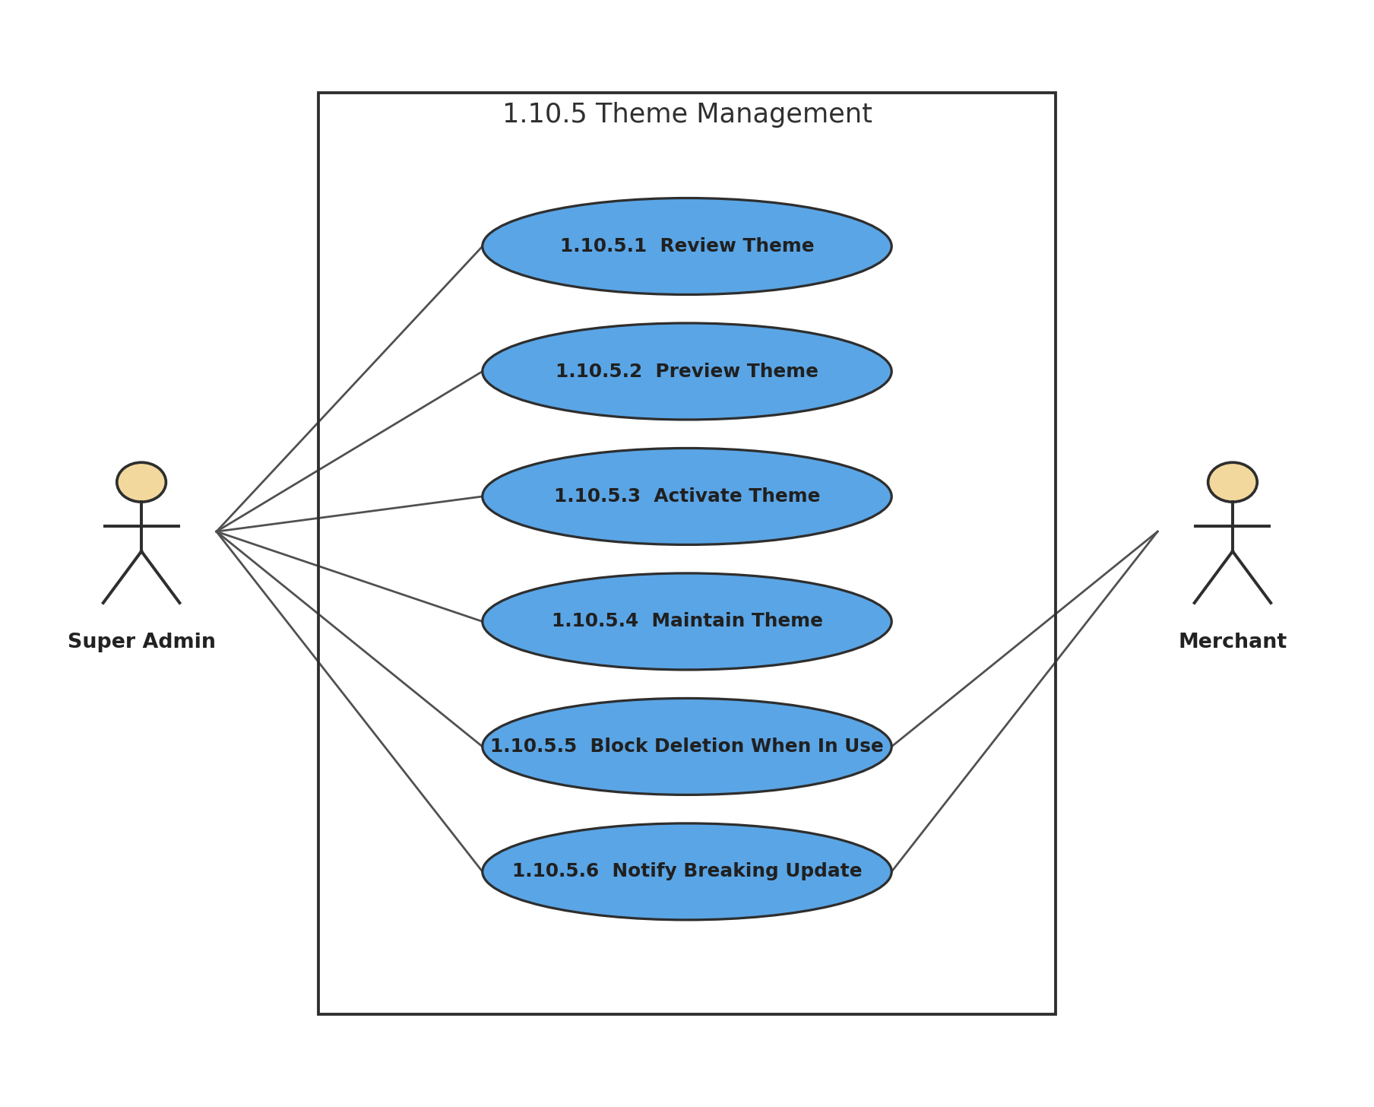
Figure 52: 1.10.5 Theme Management
Description of 1.3.52 use case diagram:
Super Admin manages storefront themes. Themes currently in use cannot be deleted, and breaking updates require merchant notification at least seven days in advance.
Actors: Super Admin, Merchant

1.3.53 LEVEL-1.10.6 USE CASE DIAGRAM - ANNOUNCEMENTS
1.10.6 Announcements
Version 1.0
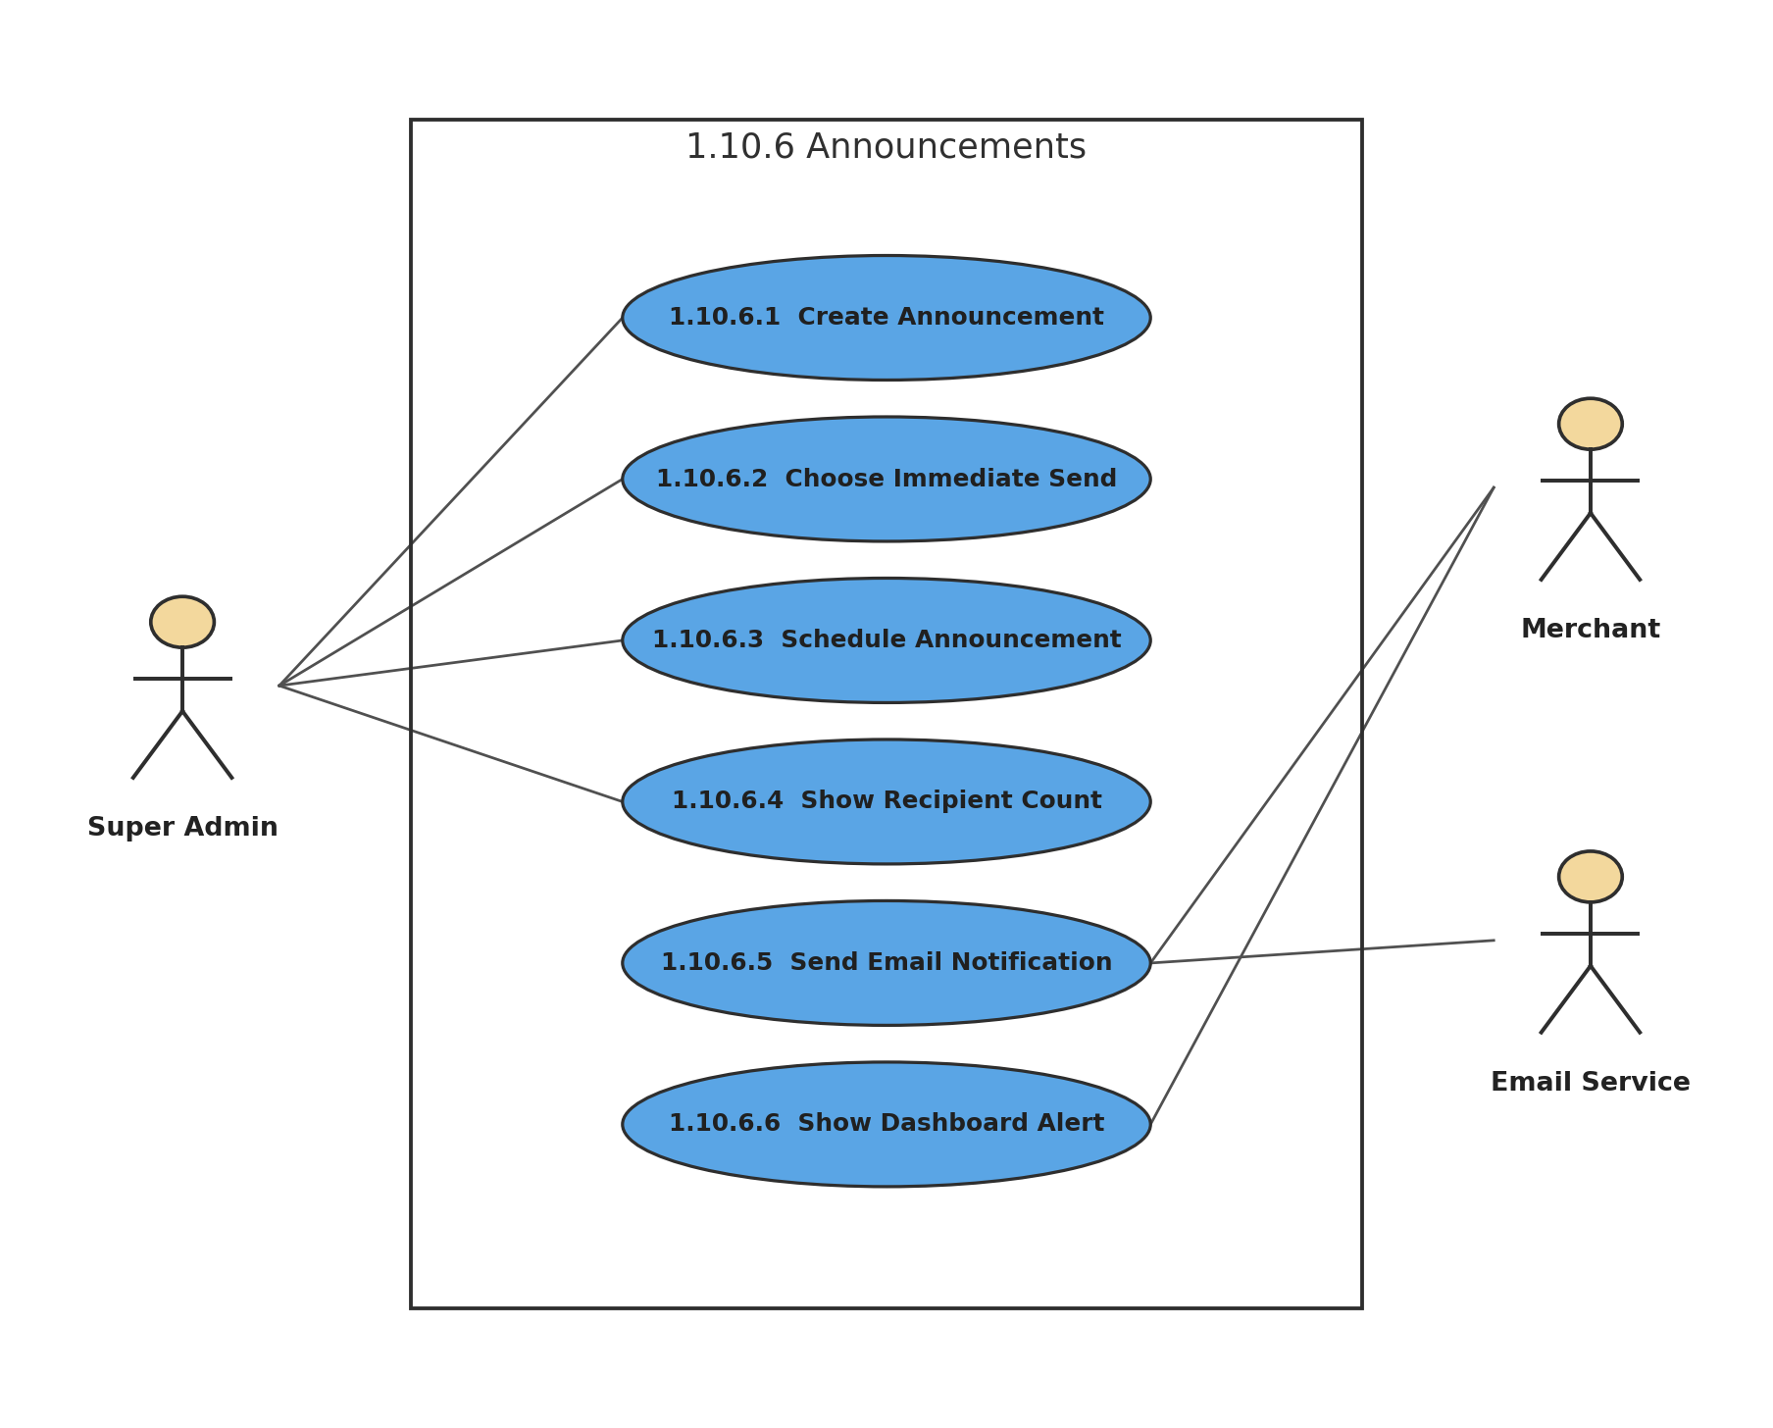
Figure 53: 1.10.6 Announcements
Description of 1.3.53 use case diagram:
Platform announcements can be sent immediately or scheduled. The system confirms recipient counts before sending; delivered announcements cannot be recalled.
Actors: Super Admin, Merchant, Email Service

1.3.54 LEVEL-1.10.7 USE CASE DIAGRAM - POLICY DUAL APPROVAL
1.10.7 Policy Dual Approval
Version 1.0
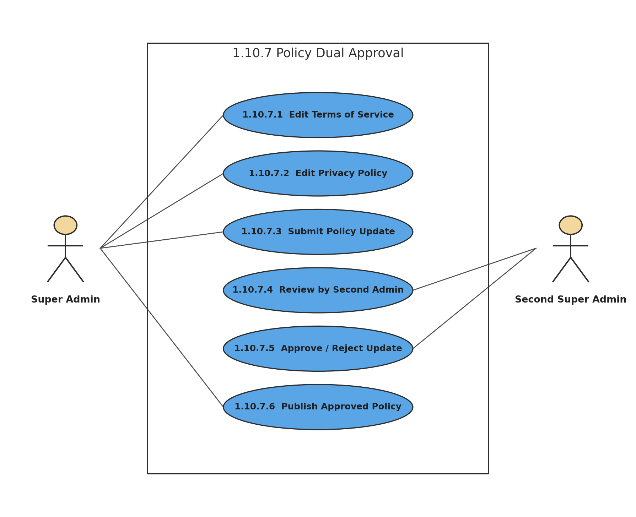
Figure 54: 1.10.7 Policy Dual Approval
Description of 1.3.54 use case diagram:
Terms of Service and Privacy Policy changes follow dual approval: one Super Admin submits the change and a second Super Admin must approve it before publication.
Actors: Super Admin, Second Super Admin

