Dev Documentation for

Cafe21

Restaurant Management System App

|  |
| --- |
| **Author**: Brain Storm 21  **Framework**: Flutter  **Version**: 1.0.0 |

— Index —

### 1. **Prerequisites**: Configure your system

### 2. **Run Project**: Android Studio (recommended)

### 3. **Run Project:** VS code (not recommended)

### 4. Configure The Launcher Icon

### 5. Change The Package Name

### 6. **Configure Database**: Connect the App to the Firebase

### 7. **Build Test App:** Generate an ‘apk’ file for Android

### 8. **Build Test App:** Generate an ‘ipa’ file for iPhone

### 9. **Play Store Upload**: Generate play store content for release

### 10. **App Store Upload:** Generate app store content for release

### 

1. Prerequisites

Configure Your System:

To run any flutter project on your computer first you have to prepare your computer. Your system needs some necessary files and software like Flutter SDK, Android SDK, Code Editor, and an Android device. To prepare your computer, follow the step below.

1. Go to the official flutter documentation here: [*https://flutter.dev/docs/get-started/install*](https://flutter.dev/docs/get-started/install)
2. Select your operating system
3. And follow the steps as described in official doc
4. After successfully configuring your computer follow the next chapter

Note that: Your downloaded Flutter SDK and Dart version must be

* **Flutter version**: 3.3.9 (channel stable)
* **Dart version**: 2.18.5

*\*\*\* Make sure your flutter and dart versions are correct*

2. Run Project:

Android Studio (recommended)

If you successfully configure your computer as described in the previous chapter you already installed Android Studio in your system.

a. Open Android Studio and select the Plugins option

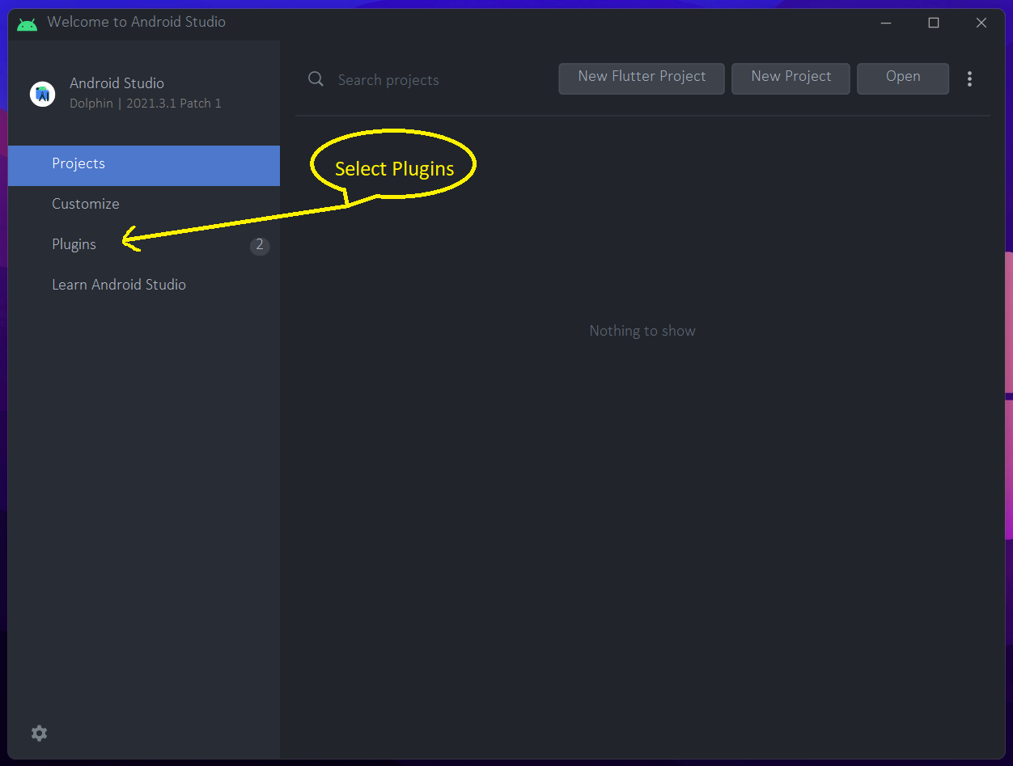

b. Then select “Marketplace”, then search for the “Flutter” plugin and install it. After that restart Android Studio.

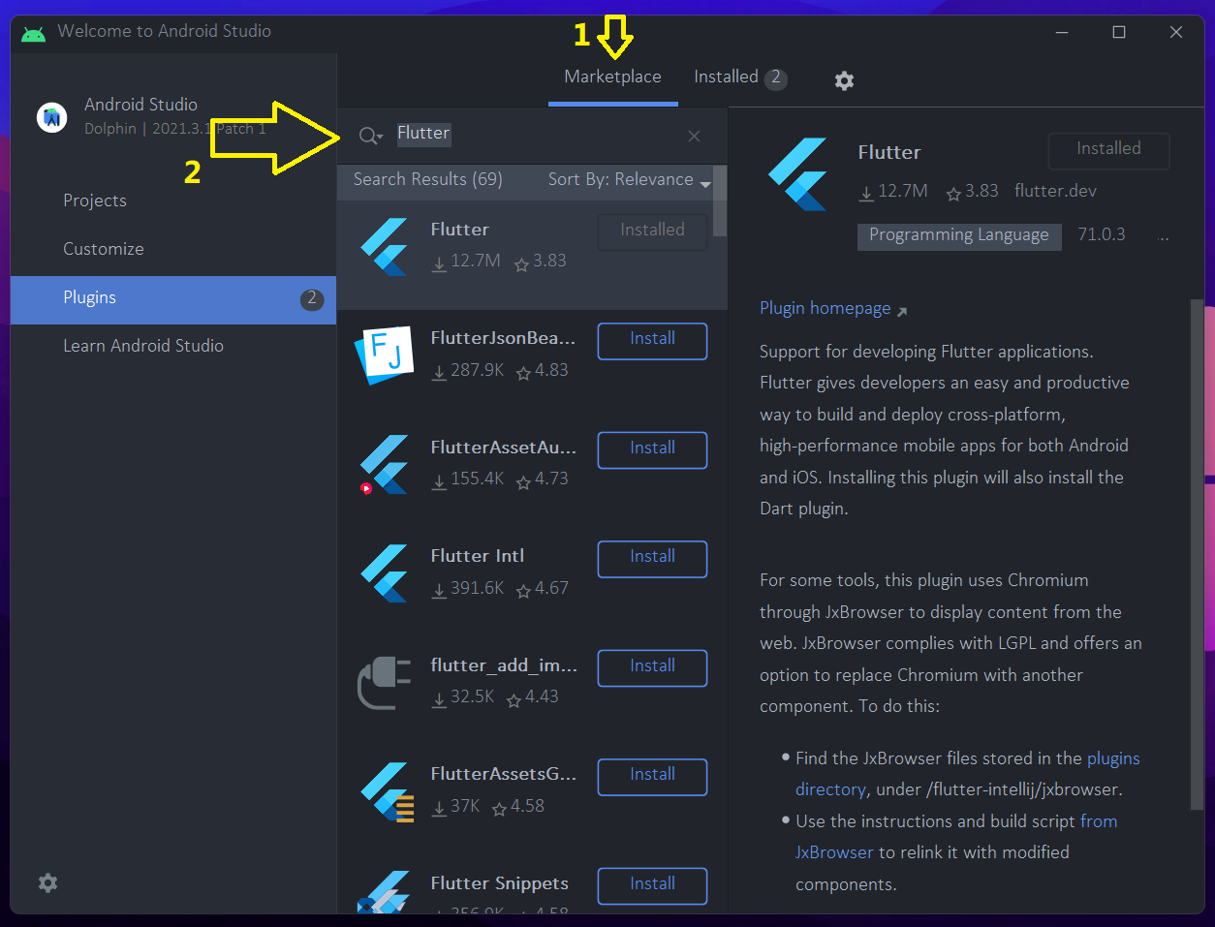

c. Extract the scource_code.zip. Open the folder in your android studio.

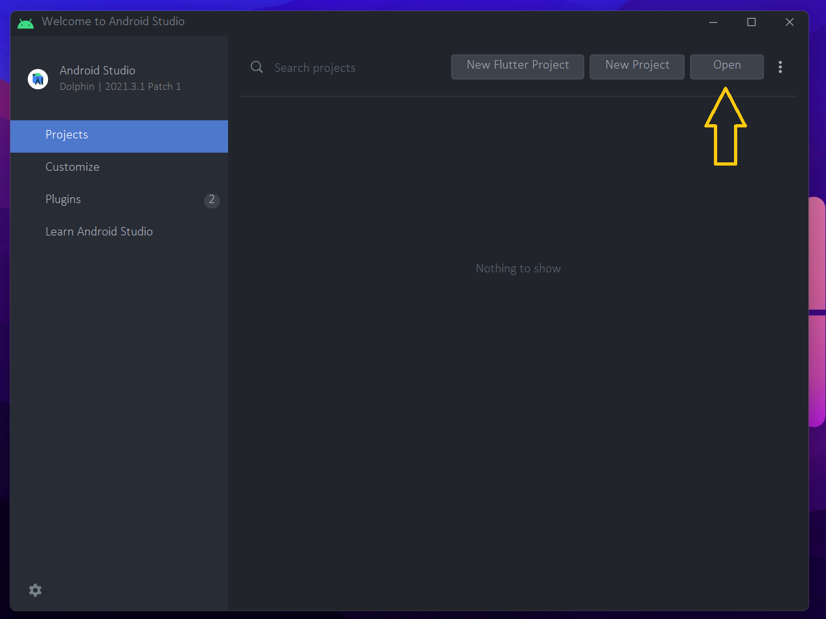

d. - Even if you are building an app for ios, use android studio for the build. 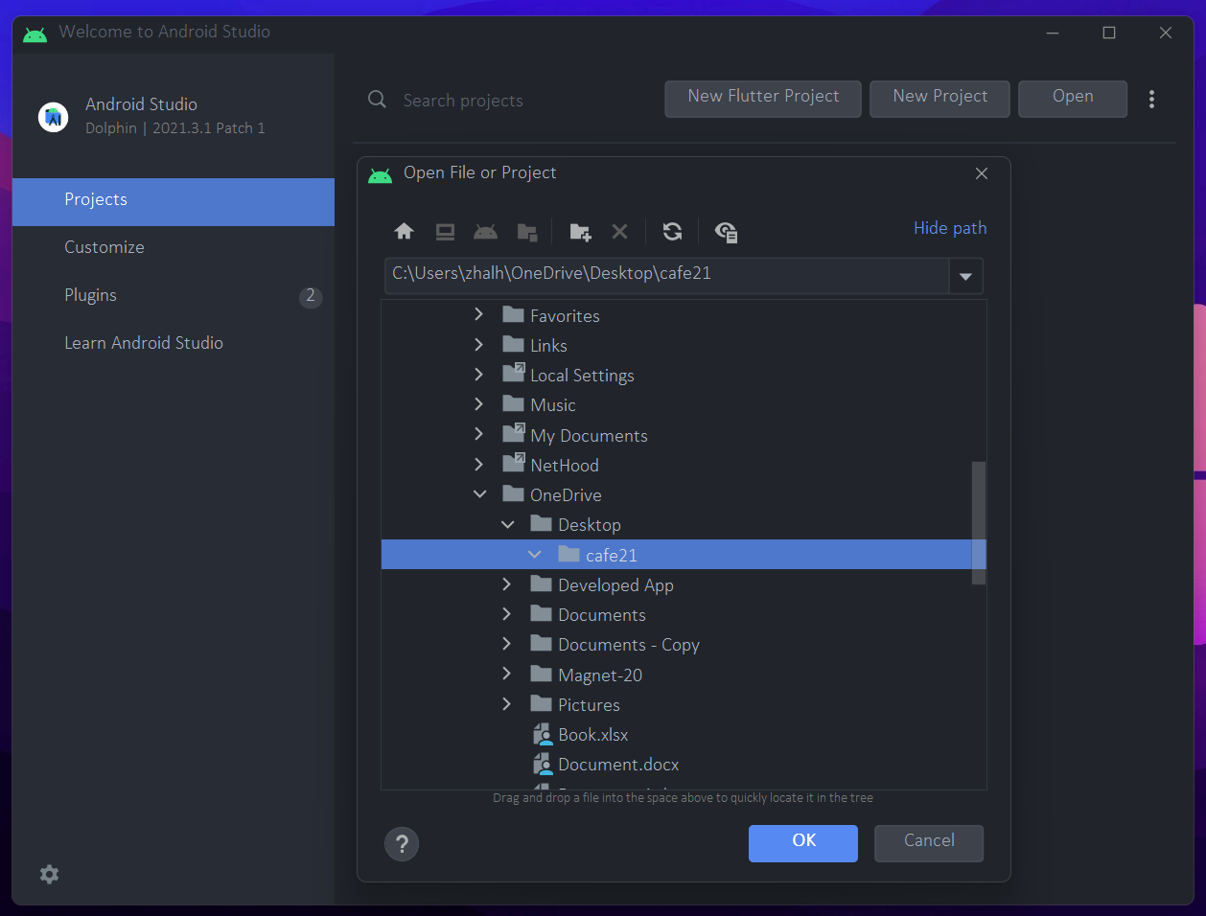

e. In the Android Studio Terminal type flutter pub get command and press enter. Make sure you are connected to the internet.

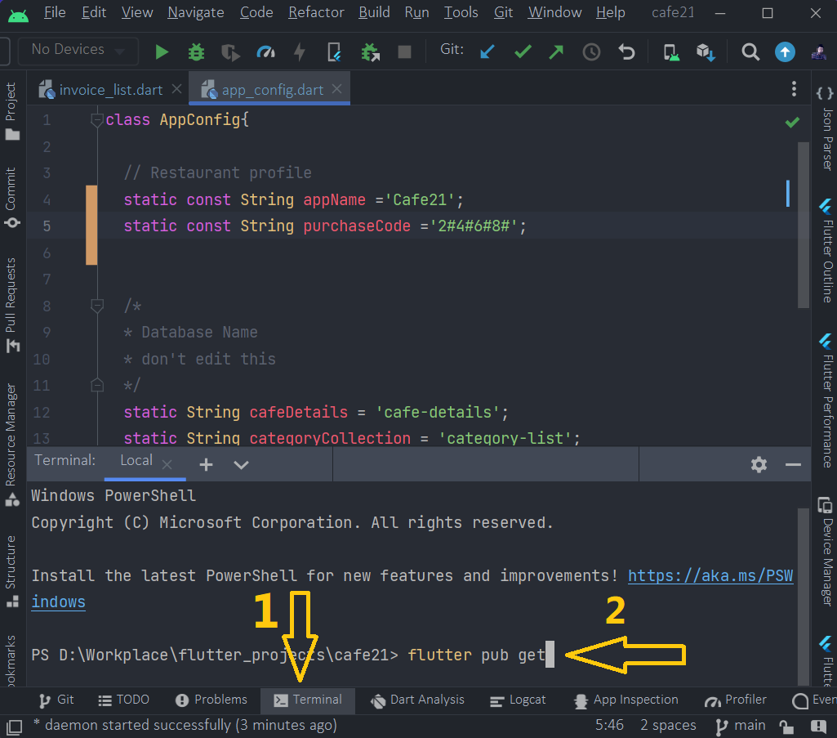

*\*\*\* You need to run this command to get all 3rd party packages from www.pub.dev*

3. Run Project:

VS Code (not recommended)

a. Download VS code and install it from here: [*https://code.visualstudio.com*](https://code.visualstudio.com)

b. From the Extention section, install the flutter extension and restart VS Code

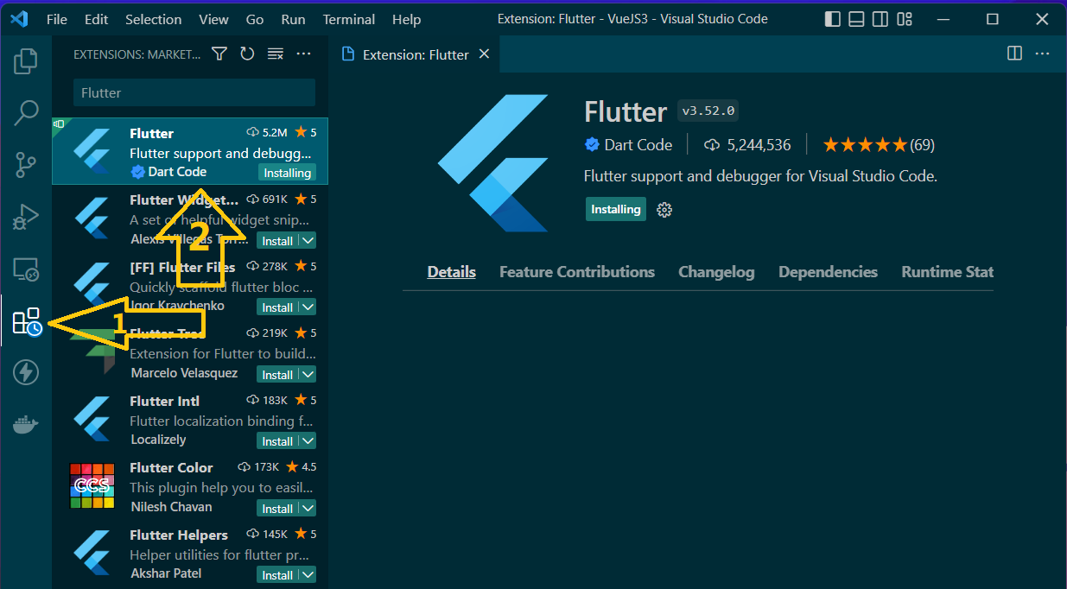

c. Open the folder in your VS Code. Then in your VS Code terminal

Run: flutter pub get command

Make sure you are connected to the internet.

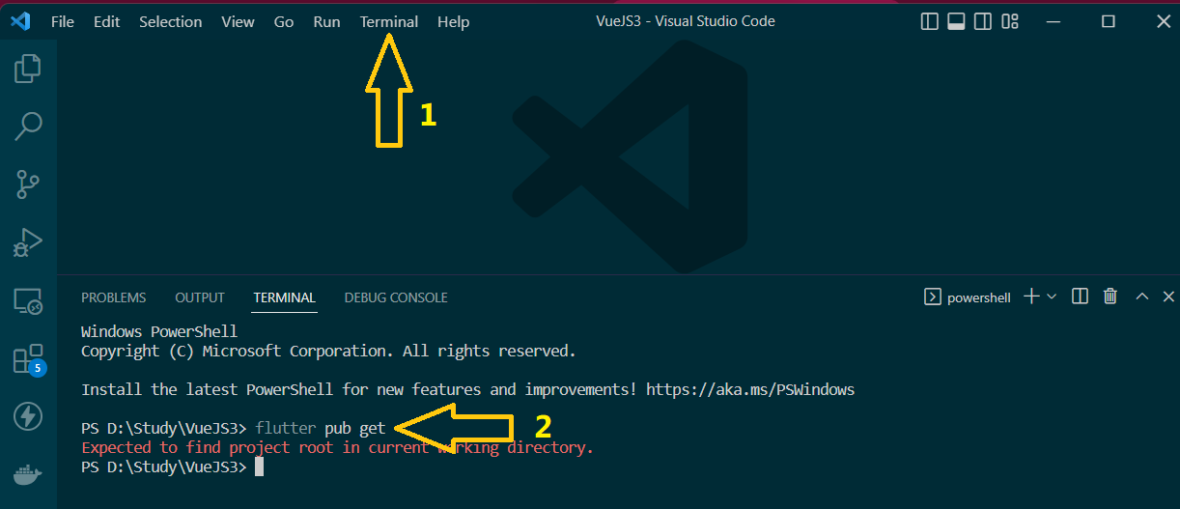

*\*\*\* You need this to get all 3rd party packages from pub.dev*

4. Configure The Launcher Icon:

A Launcher icon is a graphic that represents your application on the device's Home screen and in the Launcher window. The user opens the Launcher by touching the icon.

To change your app’s launcher icon. Change the *app_logo.png* in the assets folder with your own logo. Make sure:

* Your file name should also be app_logo.png
* Size should be 512 x 512
* The image should be in PNG format.

After replacing the logo, uninstall your old app from your emulator or physical device. Otherwise, the logo will not be shown.

Then in your android studio or VS Code terminal

* Run the: **flutter pub get** command
* Then run the: **flutter pub run flutter_launcher_icons** command

Then run the **flutter run** command in the terminal. The app will be installed with your given launcher icon.

Ref. Link: [*https://pub.dev/packages/flutter_launcher_icons*](https://pub.dev/packages/flutter_launcher_icons)

5. Change The Package Name:

The package name is significant for your app. It is a unique id of an app. Your app cannot have the same package name as another app. So have to rename your **app name** and your **Package Name** according to your business/brand name. Make sure your app package name is unique.

Naming convention:

[*https://docs.oracle.com/javase/tutorial/java/package/namingpkgs.html*](https://docs.oracle.com/javase/tutorial/java/package/namingpkgs.html)

**For example**

* Let’s say your app name is: *"ABC Cafe"*
* And your package name is: “*com.mydoamin.abc_cafe”*

Then, Run this command inside your flutter project root.

Run the command in the android studio terminal:

**flutter pub run rename --appname "ABC Cafe"**

**flutter pub run rename --bundleId com.mydomain.abc_cafe**

Uninstall the app from the emulator or physical device, then run the app again.

*\*\*\*If it does not work, first uninstall, then restart the app then run the commands.*

*Ref. Link:* [*https://pub.dev/packages/rename*](https://pub.dev/packages/rename)

In case the above does not work, you do the same thing manually:

1. **For Android**

for the package name just change in app level *build.gradle* file. (anddroid/app/build.gradle)

**defaultConfig {**

**applicationId "bundleId com.maydomain.cafe21"**

**………….**

**}**

1. **For iOS:**

Change the bundle identifier from your ***info.plist*** file inside your ***ios/Runner*** directory.

**<key>CFBundleIdentifier</key>**

**<string>bundleId com.maydomain.cafe21</string>**6. Configure Database:

Connect the App to Firebase

For connecting the database you have to just create a Firebase project and connect it to your flutter project. Rest of the work we already did for you. Follow these steps

1. **Create a Firebase project**
2. Log in to the Firebase console, From here: [*https://console.firebase.google.com/*](https://console.firebase.google.com/)
3. Then click Add project.

**C. Create a Database**

1. Then go to the *Firestore Database* tab
2. Create a Cloud Firestore Database
3. **Enable *Email/Password* Authentication**
4. Then go to the Sign-in Method tab.
5. Enable Email/Password authentication.
6. **Connect the Firebase project to the Flutter project**

After completing all the above steps now you can add firebase to your flutter project. Read the doc carefully and implement the method.

See the full ref:

[*https://firebase.google.com/docs/flutter/setup?authuser=0&hl=en&platform=android*](https://firebase.google.com/docs/flutter/setup?authuser=0&hl=en&platform=android)

7. Build Test App:

Generate an ‘apk’ file for Android

In Andro Studio or VS Code terminal run: **flutter build apk** command

It will build an apk and show the folder. You can then install it on your phone to test, or share it with multiple users for testing.

**See the official documentation for reference:**

[*https://flutter.dev/docs/deployment/android*](https://flutter.dev/docs/deployment/android)

8. Build Test App:

Generate an ‘ipa’ file for iPhone

In Andro Studio or VS Code terminal run: **flutter build ipa** command

It will build an ipa file and show the folder. You can then install it on your phone to test, or share it with multiple users for testing.

*\*\*\* Make sure your project running on the mac operating system for iOS development*.

**See the official documentation for reference:**

[*https://docs.flutter.dev/deployment/ios*](https://docs.flutter.dev/deployment/ios)

9. Play Store Upload:

Generate play store content for release

Follow the step from here:

[*https://developer.apple.com/ios/submit/*](https://play.google.com/console/about/guides/releasewithconfidence/)

10. App Store Upload:

Generate app store content for release

Follow the step from here:

[*https://developer.apple.com/ios/submit/*](https://play.google.com/console/about/guides/releasewithconfidence/)