User Documentation for

Cafe21

Restaurant Management System App

|  |
| --- |
| **Author**: Brain Storm 21  **Version**: 1.0.0 |

### 

### Follow the visual instruction

Step by Step

### 

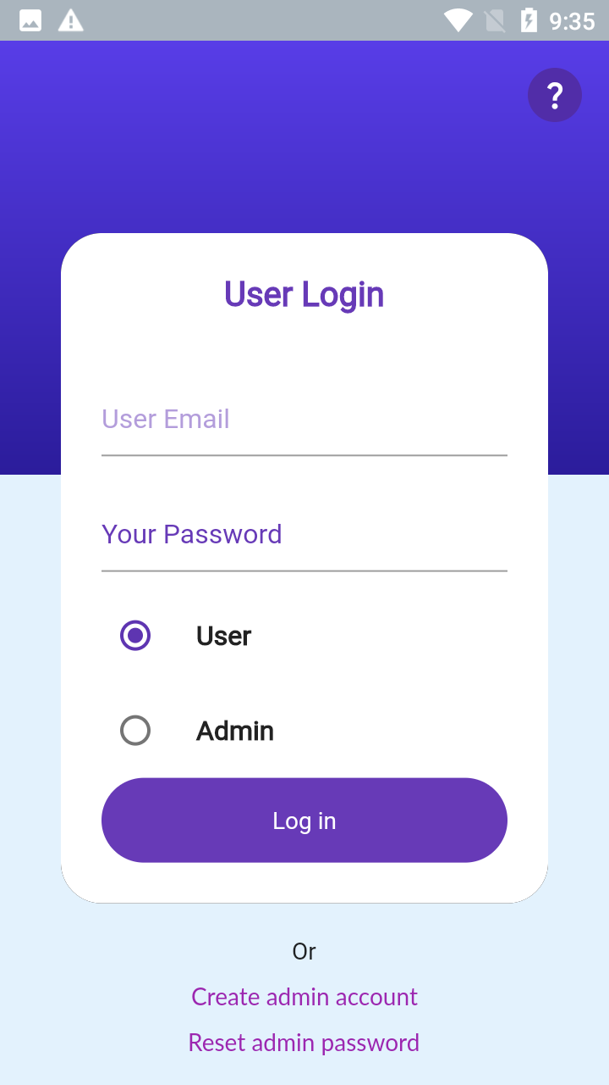

PURCHASE CODE IS *2#4#6#8#*

*If you haven’t changed!*

If already have an account login with credential

After first install create an admin account

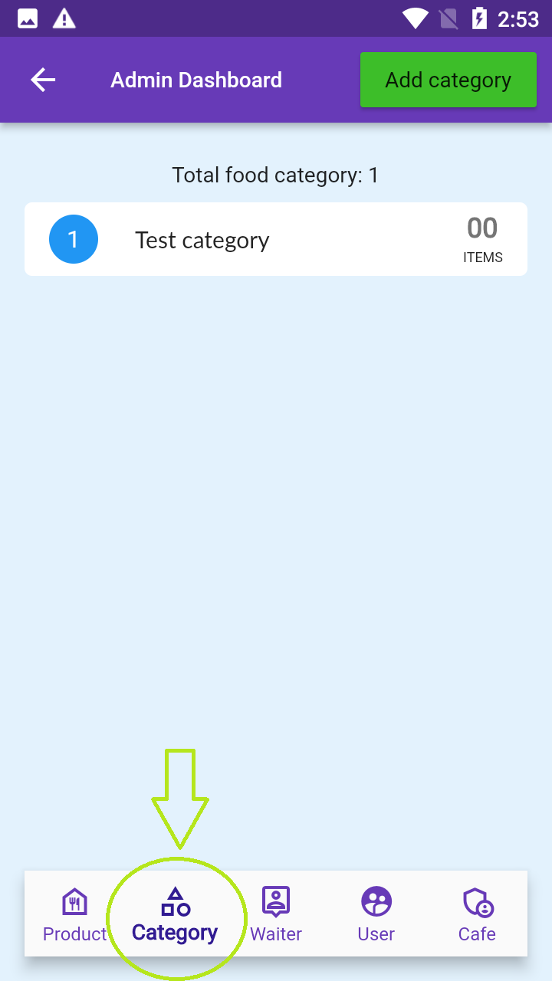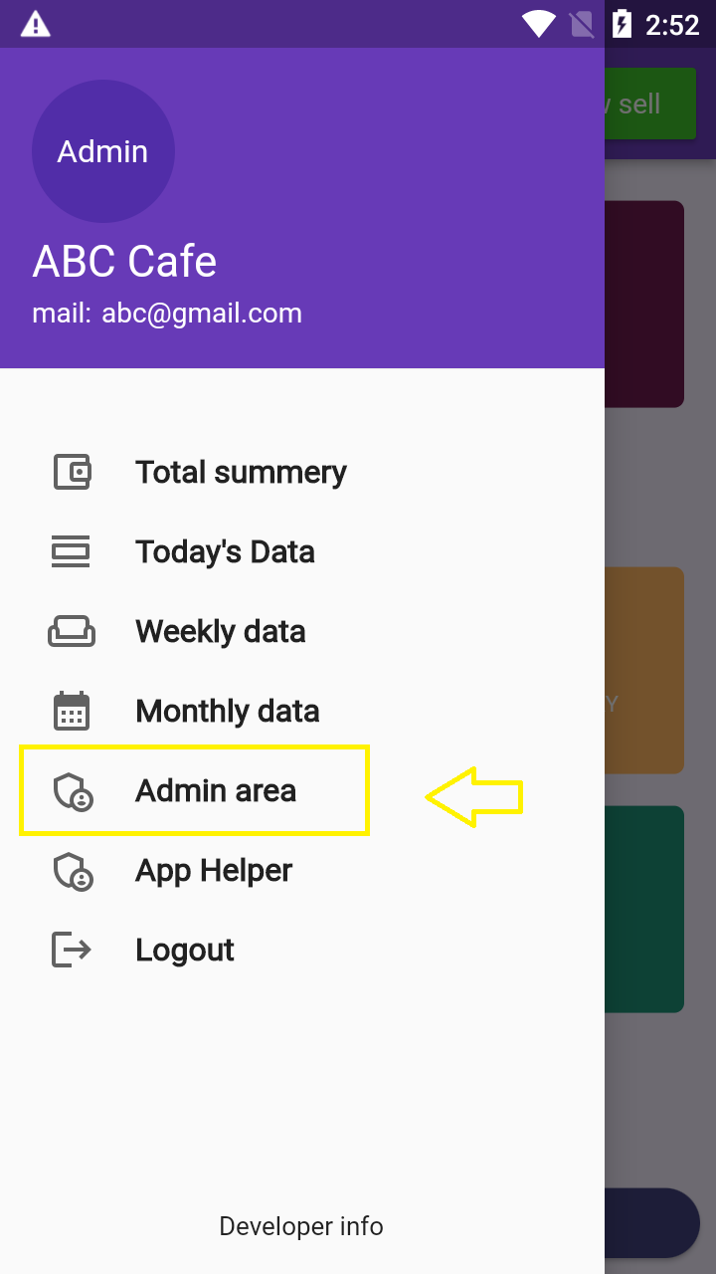

First add some **Category Name.**

Go to category section

Click the Left Drawer Section. Go to **Admin Area**

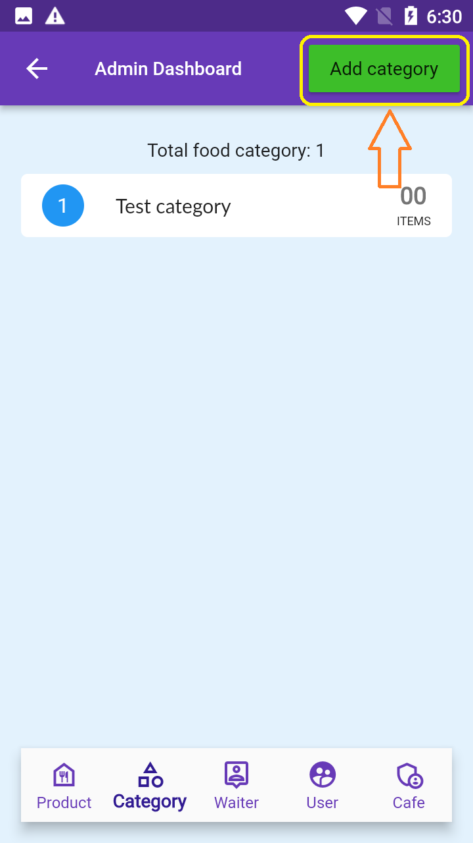

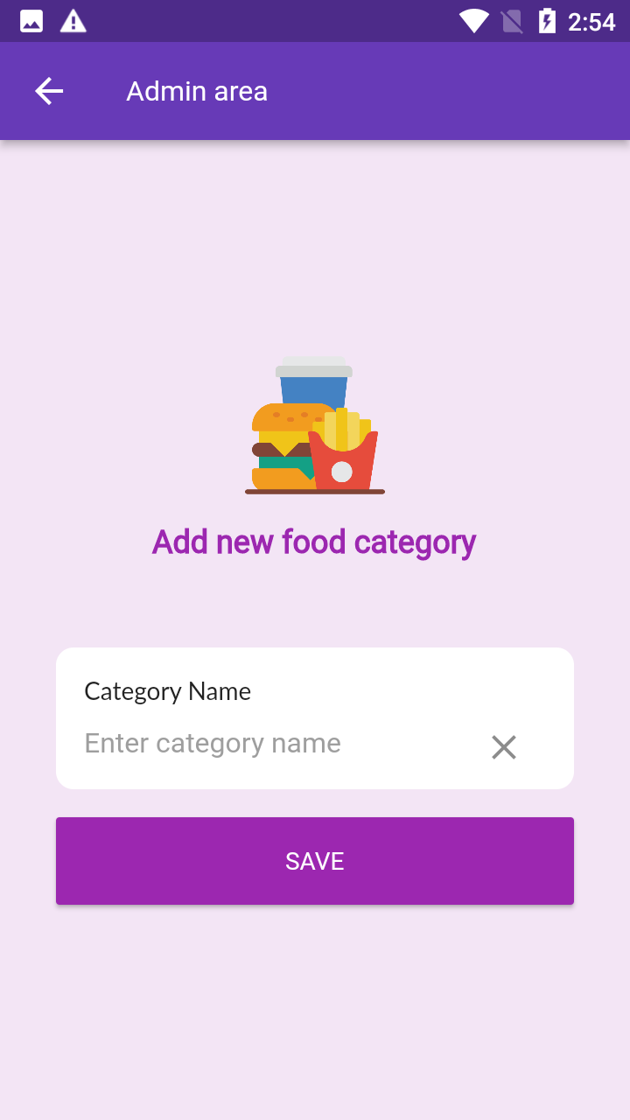

Enter **Category** Name. and save it

Click the Add Category Button

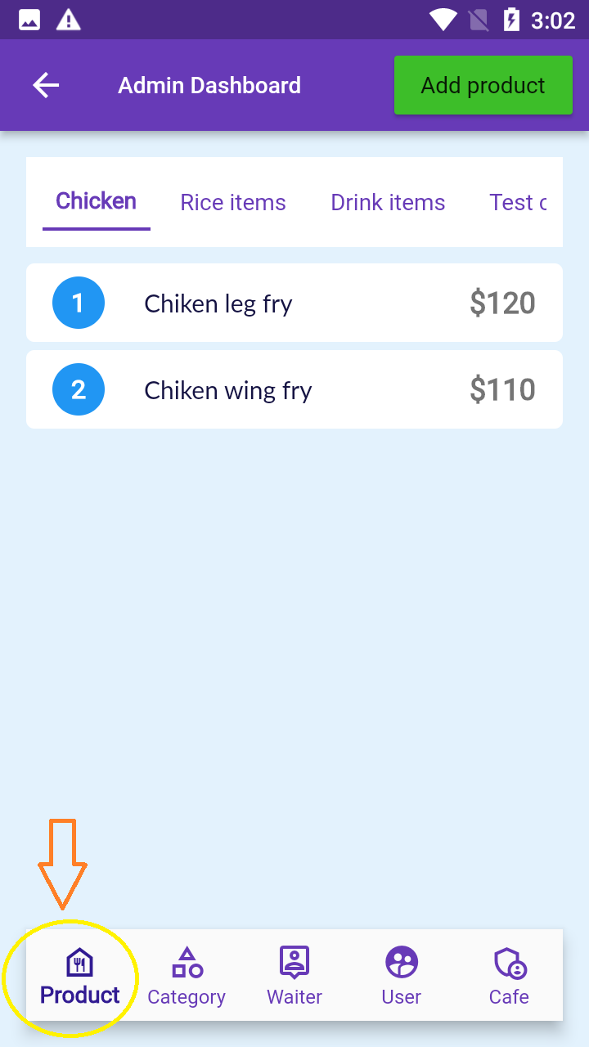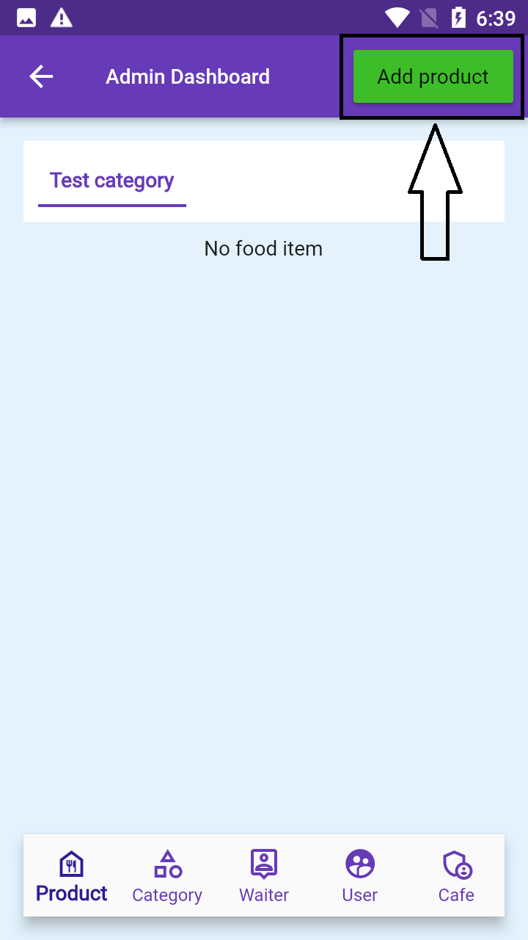

Click **Add product** Button

Then add your product. For that go to **Product** Section

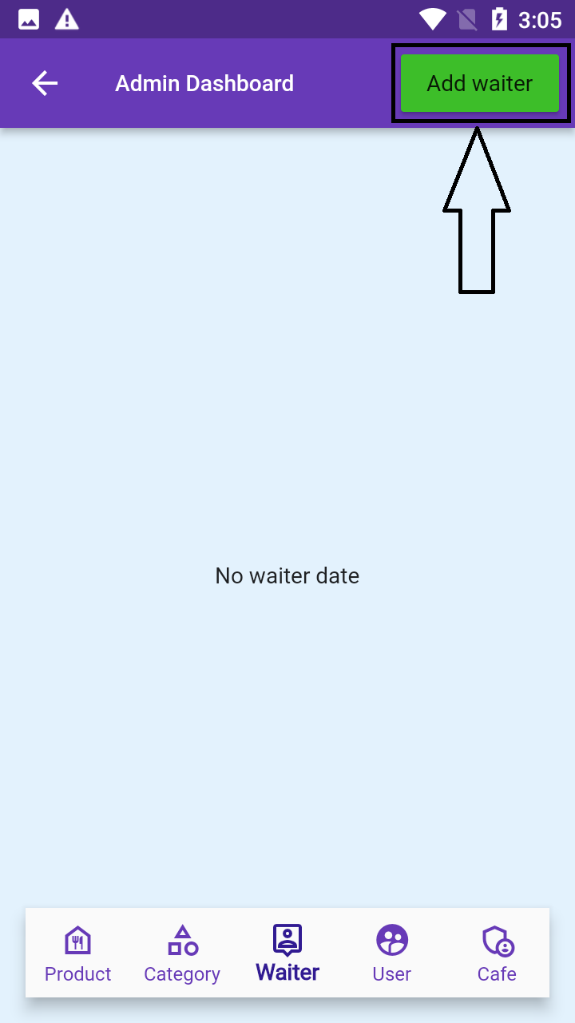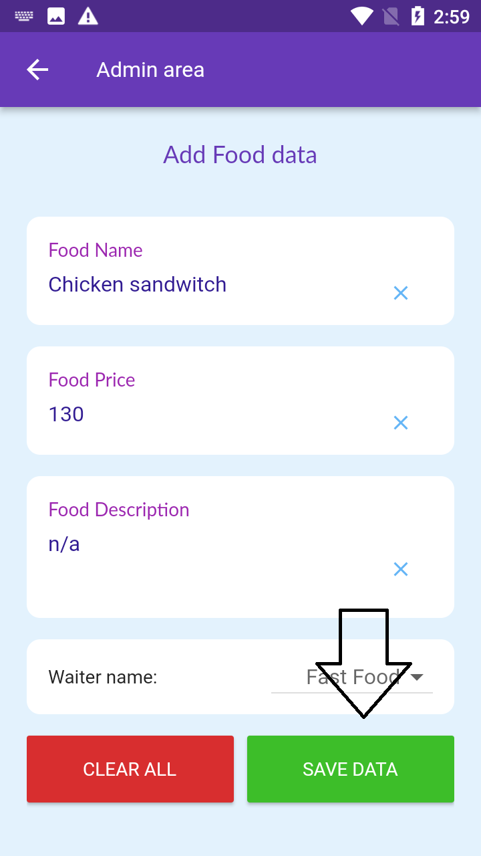

For add your waiter details go to waiter section and click **Add waiter** button

Fill product details and save it

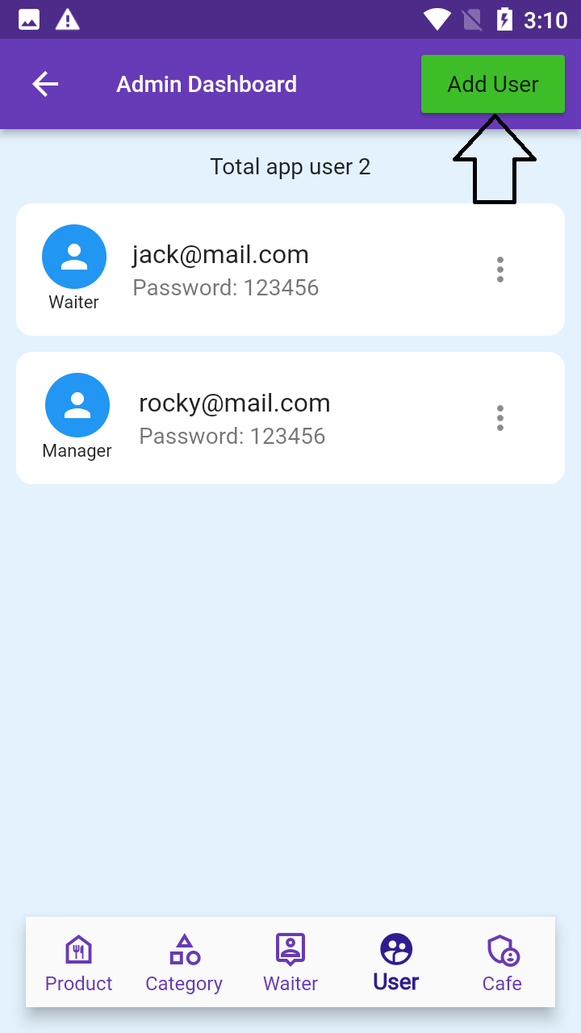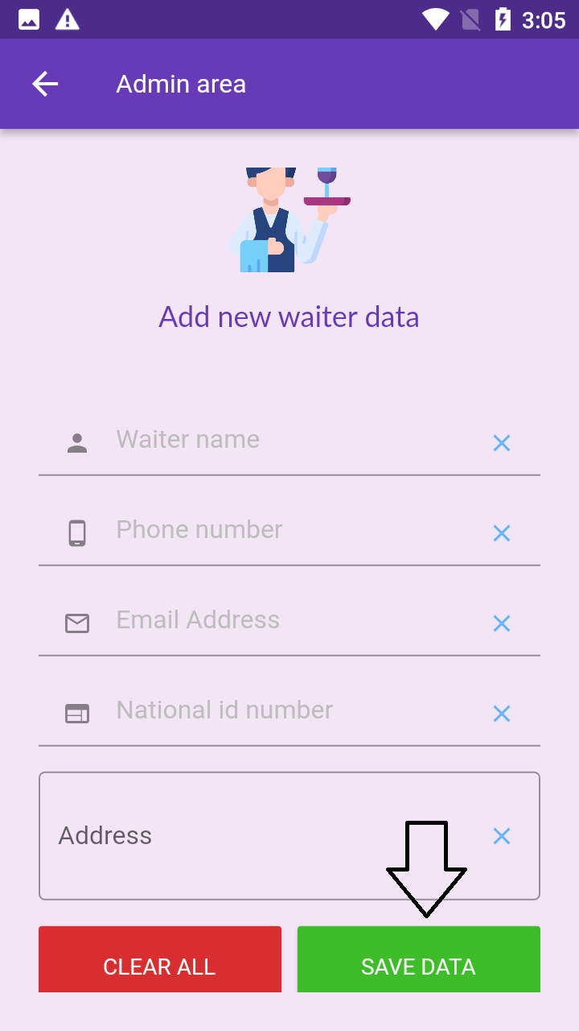

You can add multiple user for App. Go to User section and click **Add User**

Fill waiter details add save it

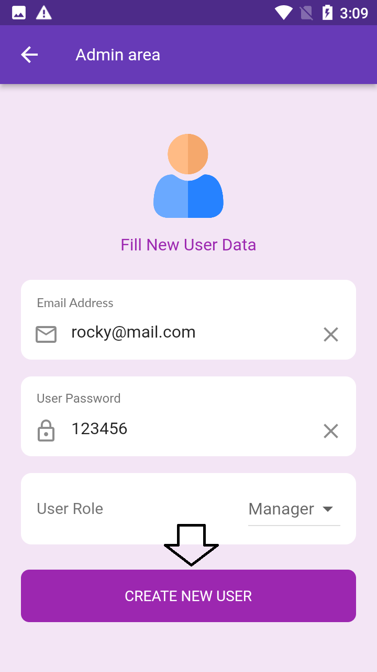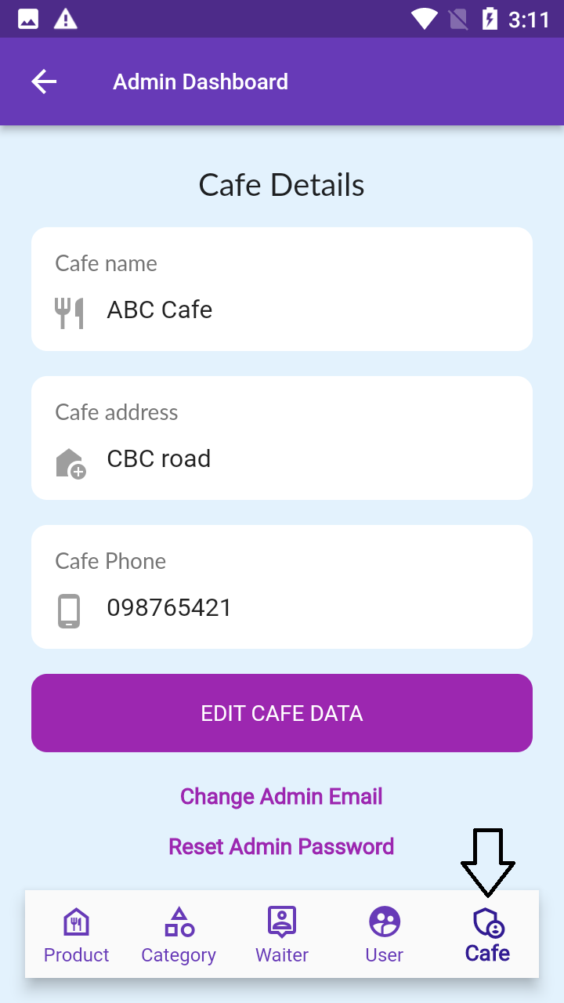

You can update café details from **Café** Section

Add user data and save it

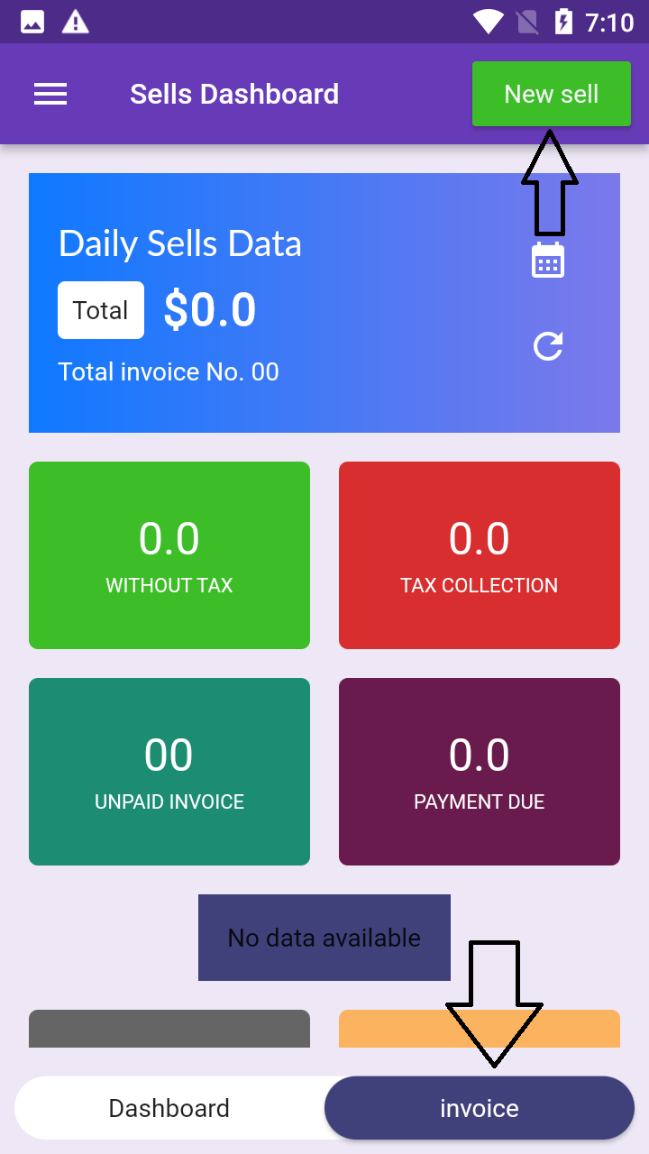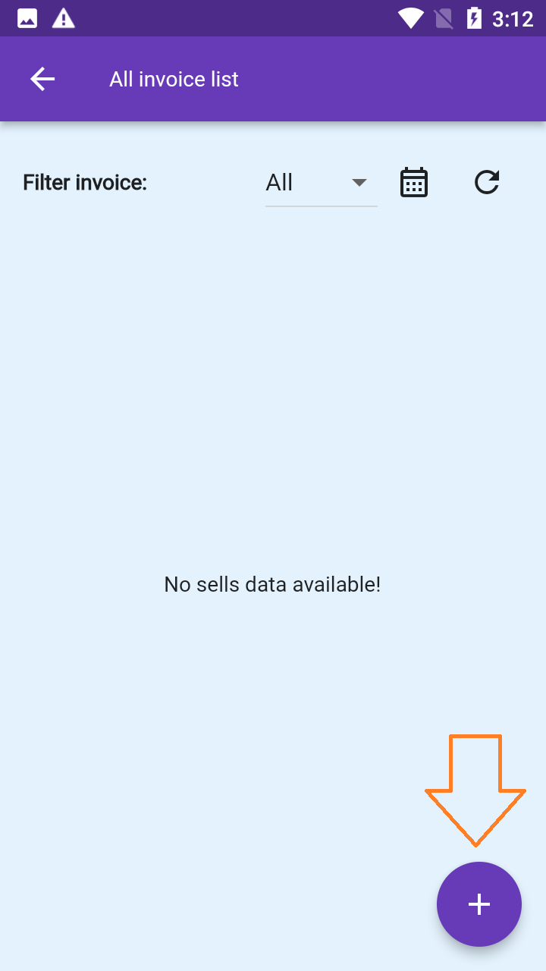

Click the plus button for new invoice

Now you are ready for create invoice. Click **New sell** or **invoice** button

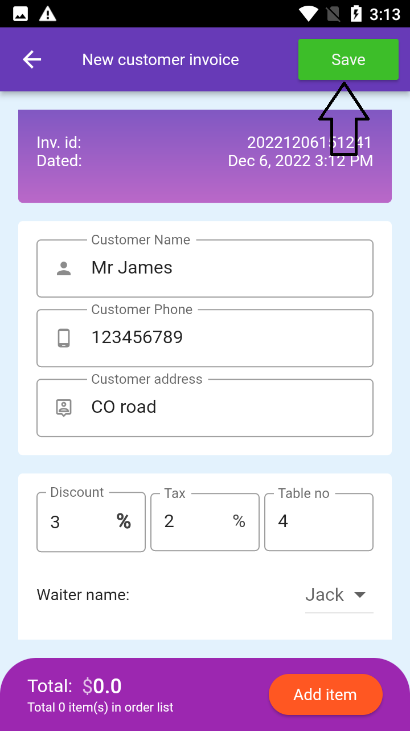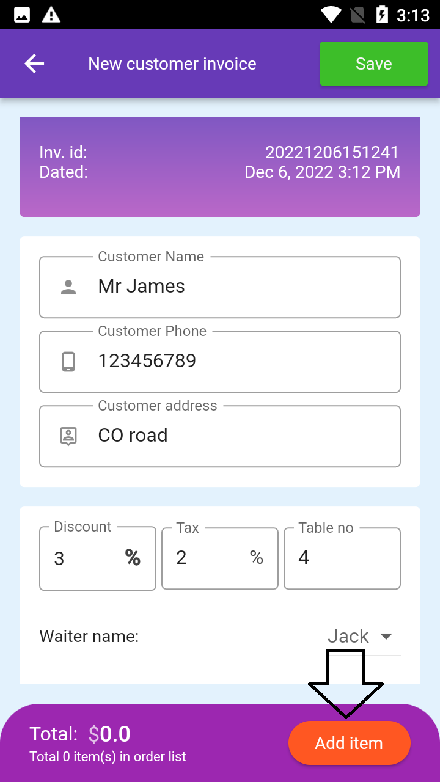

Save the

invoice

Fill all details and from the bottom add product item

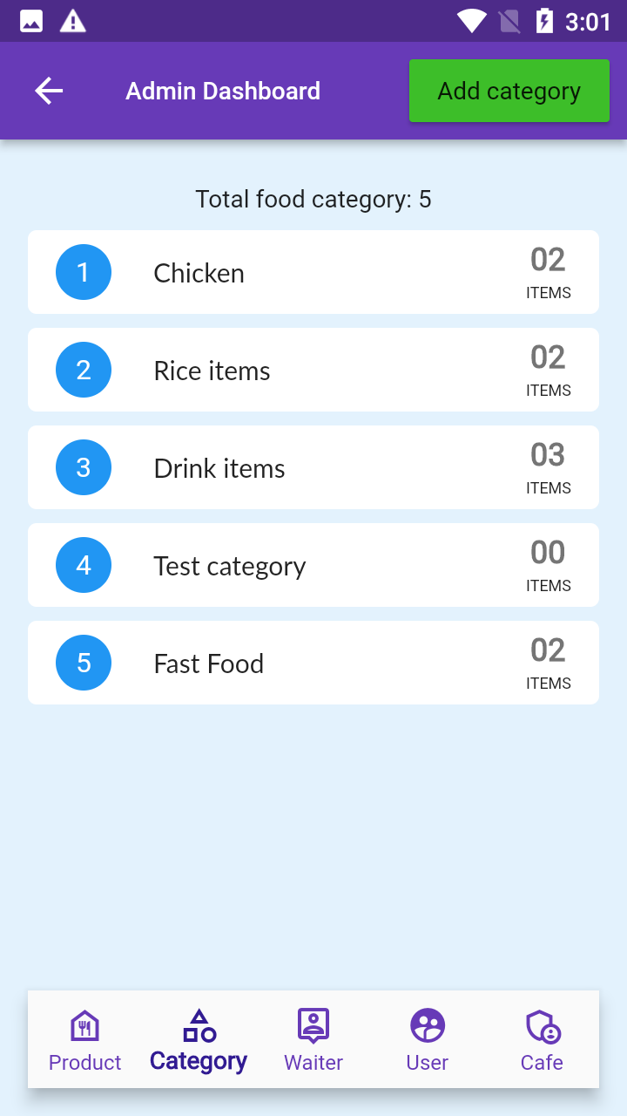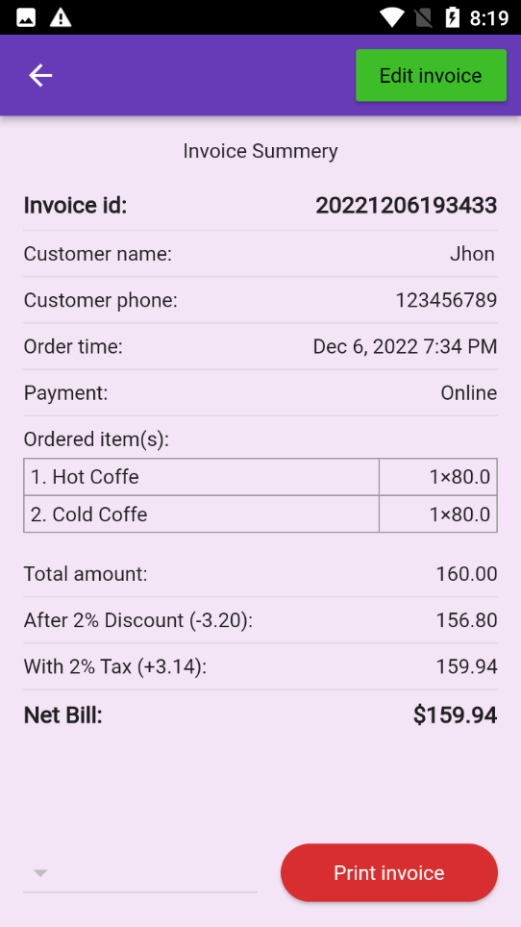

If doesn’t work close the apps and reopen it

For edit any item single tap on the item and to delete item long tap on the item

For print invoice with POS printer, connect your printer with your phone. Then select your printer from bottom left arrow icon and print the invoice