Microsoft Fabric

Session Content
Section | What to cover
1. Intro to Fabric | What is Fabric
2. Dennis Project Architecture | Medallion architecture (Bronze/Silver/Gold), full data flow diagram, pipelines used, how Fabric connects to Power BI
3. Demo | Live walkthrough: workspace, lakehouse, pipelines, report

1. Intro to Fabric

What is Fabric?
- Fabric is Microsoft's newer, all-in-one data platform.
- Before Fabric, we used separate Azure services: ADLS (storage) + Azure Data Factory / ADF (moving & cleaning data) + Azure SQL Database (storing clean data) + Power BI (reporting).
- Fabric combines all of these into one workspace, with one login and one bill.

Why did we move to Fabric?
- Using separate Azure services caused three problems: dependency (Power BI reports depended on ADF finishing first), double billing (pay for Azure + pay for Power BI), and delay (waiting for the ADF pipeline before refreshing reports).
- Fabric removes these problems by putting everything under one roof.
 | Azure | Microsoft Fabric
Number of services | 200+ general-purpose cloud services | ~7 focused data & analytics workloads (Data Factory, Data Engineering, Data Warehouse, Power BI, Data Science, Real-Time Intelligence, Data Activator)
Scope / purpose | General-purpose cloud platform — compute, networking, security, AI, web/mobile apps, IoT, everything | Specialized SaaS platform — purely for data, analytics & reporting
Storage model | Multiple separate stores: Blob, ADLS Gen2, Azure SQL DB, Cosmos DB — each provisioned and billed on its own | One unified storage layer: OneLake — shared automatically by every Fabric item
Setup & provisioning | Manually create each resource: storage account, ADF instance, SQL DB, resource group, subscription | Create one Workspace — everything (Lakehouse, Warehouse, Pipelines) lives inside it immediately
Billing / licensing | Pay separately for each Azure service + a separate Power BI Pro/Premium license | One consolidated, capacity-based bill (F-SKU) covering storage, compute, and BI together
Connecting services together | Manual — Linked Services, Integration Runtime, connection strings between ADF, ADLS, SQL DB, Power BI | Native — all items share the same workspace and OneLake storage, no linked services needed
On-prem connectivity | Self-hosted Integration Runtime | Gateway (same idea, different name)
Maturity | ~15 years in market; mature, stable, enterprise-proven | GA since Nov 2023 (~2–3 years); many features still in preview, evolving quickly

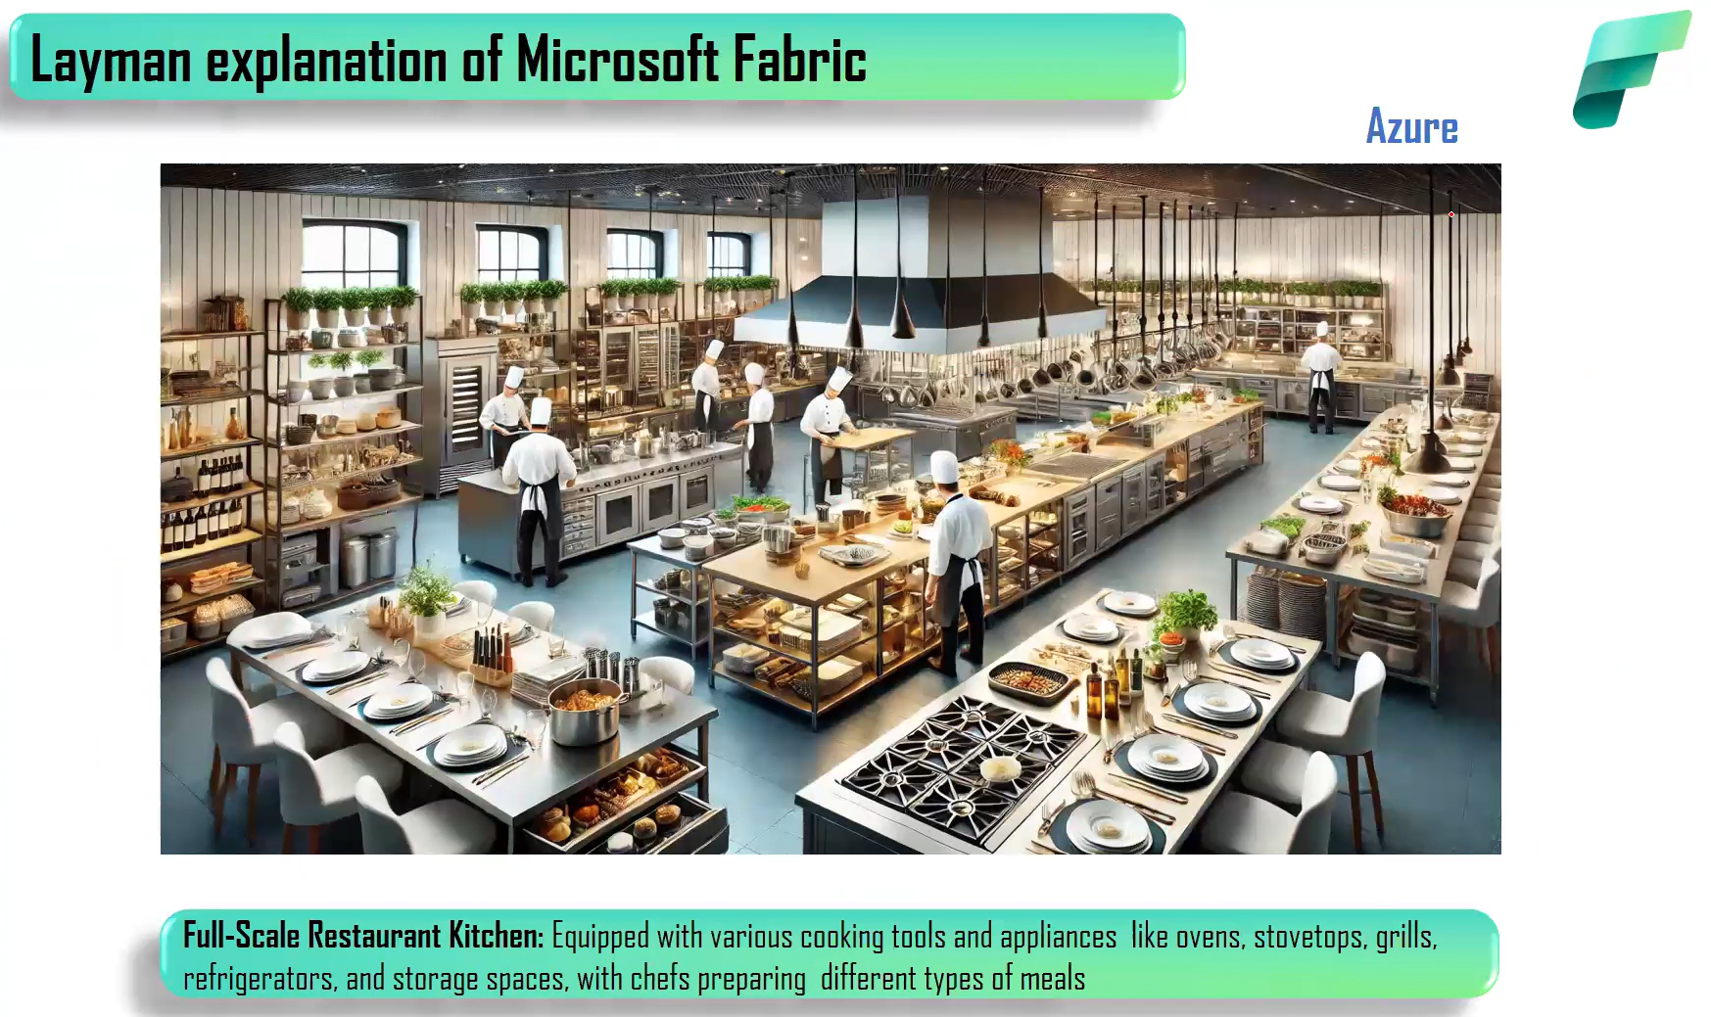

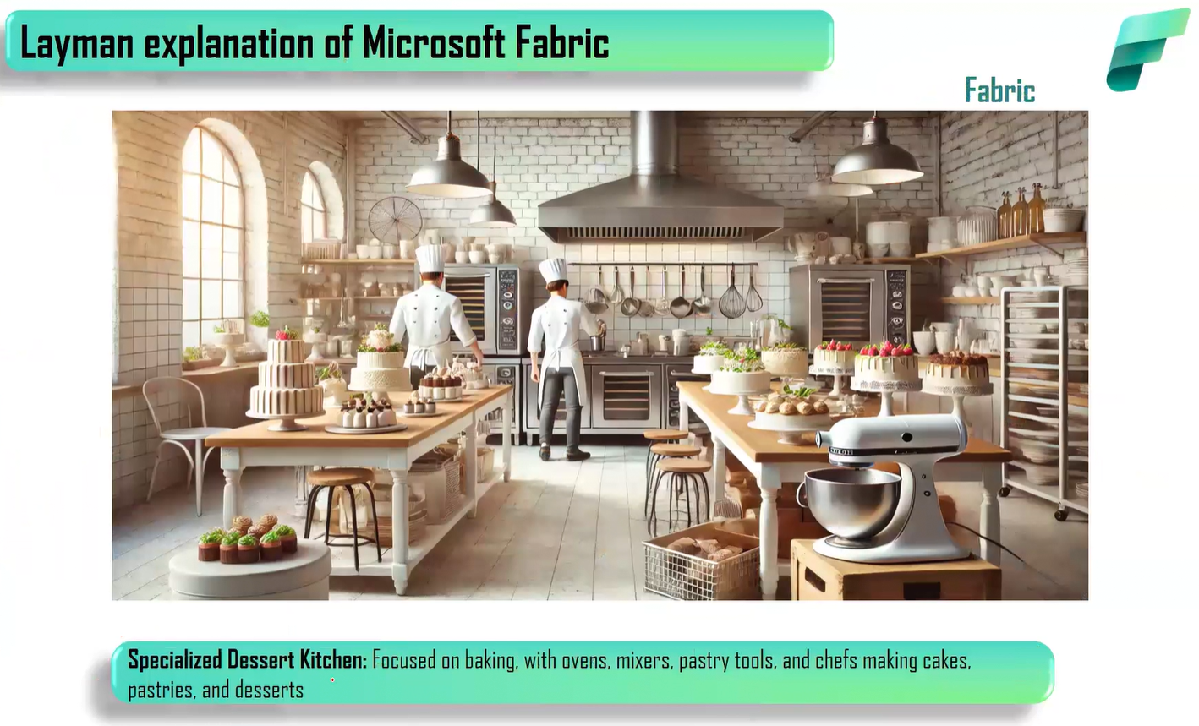

2. Dennis Project Architecture

What is Dennis

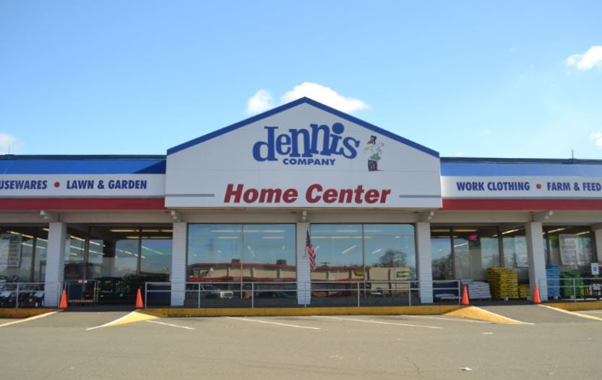

Architecture Diagram
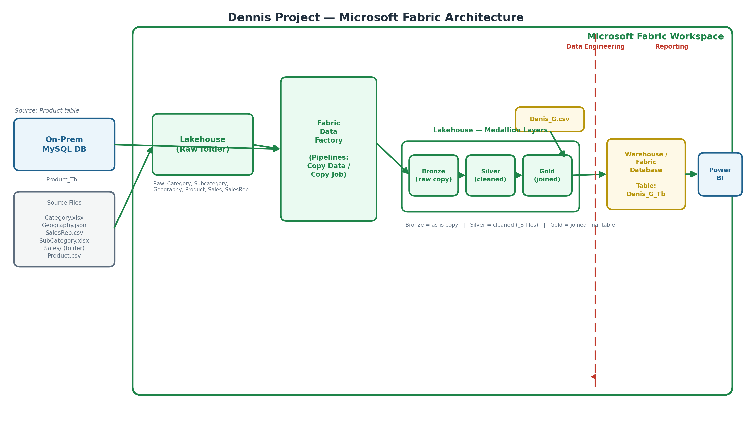

1) On-Prem MySQL Database
- This is our local/on-premises database, sitting outside the cloud. It holds the Product table.
- Because it is on-prem, Fabric needs a Gateway installed to reach it securely — the same idea as the Integration Runtime we used in Azure ADF.

2) Source Files
- These are the raw business files we start with: Category.xlsx, Geography.json, SalesRep.csv, SubCategory.xlsx, the Sales/ folder, and Product.csv.
- They come in different formats on purpose (Excel, JSON, CSV)

3) Lakehouse — Raw Folder
- The Lakehouse is Fabric's storage layer. The Raw folder is where these source files land first, exactly as received, with no changes.
- Think of the Lakehouse as our version of Azure Data Lake Storage (ADLS), but built into the Fabric workspace.

4) Fabric Data Factory
- This is the pipeline engine that moves data around. It pulls the Product table from on-prem MySQL (through the Gateway) and pulls the raw files from the Lakehouse.
- It then copies everything into the Bronze layer.

5) Medallion Layers — Bronze, Silver, Gold (inside the Lakehouse)
- Bronze — an exact, "as-is" copy of every source (MySQL table + all files). Nothing is cleaned yet; this is our safety copy of the raw data.
- Silver — the cleaned version of each dataset, produced using Dataflow Gen2 (Power Query). Here we remove duplicates, trim extra spaces, fix special characters, split columns, and correct data types.
- Gold — the final, business-ready layer. A Dataflow Gen2 joins all the Silver tables together (Category → SubCategory → Product → Sales → SalesRep) into one combined file, Denis_G.csv, with extra calculated columns like Total Revenue, Total Cost, and Profit.

6) Data Engineering zone vs. Reporting zone
- The dashed red line in the diagram marks a useful mental split: everything to its left (Lakehouse, Bronze/Silver/Gold, Fabric Data Factory) is data engineering — preparing and cleaning the data.
- Everything to its right (Warehouse, Power BI) is reporting — where business users actually consume the data.

7) Warehouse / Fabric Database
- The final Gold file (Denis_G.csv) is loaded into a Warehouse table called Denis_G_Tb.
- We use a Warehouse here (instead of just a Lakehouse file) because Power BI connects far more easily and efficiently to tables than to loose files.

8) Power BI
- Power BI connects to the Denis_Tb table in the Warehouse and is used to build the final report/dashboard — visuals like Revenue, Profit, and Sales by Category.
- Because Power BI lives inside the same Fabric workspace, the report can be built directly there — no separate Power BI Desktop step is required.

