NASA/TM-20220011974

Lunar Transport Vehicle Occupant Protection Requirements

Kevin R. Dolick, GCS
Johnson Space Center, Houston, Texas

Jeffrey T. Somers, NASA

Nathaniel J. Newby, KBR

Teresa M. Reiber, KBR

Bernard D. Adelstein, NASA

Leeland Stone, NASA

September 2022

NASA STI Program Report Series

The NASA STI Program collects, organizes, provides for archiving, and disseminates NASA’s STI. The NASA STI program provides access to the NTRS Registered and its public interface, the NASA Technical Reports Server, thus providing one of the largest collections of aeronautical and space science STI in the world. Results are published in both non-NASA channels and by NASA in the NASA STI Report Series, which includes the following report types:  - TECHNICAL PUBLICATION. Reports of completed research or a major significant phase of research that present the results of NASA Programs and include extensive data or theoretical analysis. Includes compila-  tions of significant scientific and technical data and information deemed to be of continuing reference value. NASA counter-part of peer-reviewed formal professional papers but has less stringent limitations on manuscript length and extent of graphic presentations.  - TECHNICAL MEMORANDUM.  Scientific and technical findings that are preliminary or of specialized interest,  e.g., quick release reports, working  papers, and bibliographies that contain minimal annotation. Does not contain extensive analysis.  - CONTRACTOR REPORT. Scientific and technical findings by NASA-sponsored contractors and grantees. | - CONFERENCE PUBLICATION.  Collected papers from scientific and technical conferences, symposia, seminars, or other meetings sponsored or  co-sponsored by NASA.  - SPECIAL PUBLICATION. Scientific, technical, or historical information from NASA programs, projects, and missions, often concerned with subjects having substantial public interest.  - TECHNICAL TRANSLATION.  English-language translations of foreign scientific and technical material pertinent to  NASA’s mission.  Specialized services also include organizing  and publishing research results, distributing specialized research announcements and feeds, providing information desk and personal search support, and enabling data exchange services.  For more information about the NASA STI program, see the following:  - Access the NASA STI program home page at http://www.sti.nasa.gov  - Help desk contact information:  https://www.sti.nasa.gov/sti-contact-form/  and select the “General” help request type.

INTRODUCTION

The National Aeronautics and Space Administration (NASA) is preparing for future Artemis missions that will return humans to the lunar surface. A critical piece of these future missions is the Lunar Transport Vehicle (LTV), a transportation device to be used on the lunar surface. A vehicular method of transportation will allow for longer duration missions with increased capabilities to conduct research and transport soil, geological samples, or other materials of interest.

Multiple missions to the lunar surface throughout the Apollo program also deployed the use of a lunar vehicle, known as the Lunar Roving Vehicle (LRV). The LRV was used during three of the six Apollo missions that successfully landed humans on the moon. Unfortunately, the LRV did not have any onboard instrumentation, and a large portion of the lunar performance evaluation relied on photographic documentation and crew reports. Therefore, we do not know the actual accelerations and vibrations experienced by the crew when driving on the lunar surface.

The objective of this document is to provide occupant protection guidance when designing the LTV. Acceleration, vibration, and jerk metrics imparted by the vehicle relative to the occupant shall not exceed those listed in this document. At the time of writing of these requirements, much of the LTV design is unknown. This document details requirements based on multiple possible restraint configurations and crew orientations.

CONSIDERATIONS AND ASSUMPTIONS

When addressing the sustained translational acceleration limits, several considerations and general assumptions have been made. These limits in Table 1 assume no intra-suit restraints other than a standard harness as seen in previous iterations of the EMU-style suit configurations. Additional occupant restraints in the form of inserts and suit modifications were not considered. With the existing suit designs at NASA, there are insufficient head and neck restraints to qualify for NASA Category 4 acceleration limits.

In addition to crew health limits, the accelerations must permit the occupant to meet performance requirements. The occupant must be able to interface with the LTV to operate the vehicle and read any instrumentation while traversing the Lunar surface.

It is assumed that the vehicle shall provide proper foot restraints and back support in the proposed design and shall have an occupant envelope to restrict the crew from contacting each other laterally.

The limits in Table 1 represent safe levels of sustained translational acceleration under nominal and off-nominal conditions. Exposure to accelerations above these limits could create a risk of occupant injury and significantly affect human performance for maneuvering and interacting with the LTV. The physics of the lunar environment will limit the exposure duration to Gz making the specified limits acceptable. The Gx and Gy limits must be met by a combination of vehicle design and con-ops (planned time versus distance of vehicle transits taking into consideration the traversed lunar/Martian terrain) which will limit exposure magnitude and duration.

These limits cover all accelerations imposed on the crewmember both directly by the LTV as well as indirectly by the LTV through the suit. The sign convention is crew centric and shall be oriented to the configuration of the crewmember.

X-Direction (Longitudinal, Forward/Aft)
- +X: Body accelerations forward/Eyes back
- -X: Body accelerations backwards/Eyes forward

Y-Direction (Lateral, Side to Side)
- +Y: Body accelerations left/Eyes right
- -Y: Body accelerations right/Eyes left

Z-Direction (Vertical, Up/Down)
- +Z: Body accelerations up/Eyes down
- -Z: Body accelerations down/Eyes up

The vectors in this document are assumed to be occupant centric and follow the coordinate system normally associated with humans or passenger coordinate systems (Figure 1).

Figure 1. Occupant-centric coordinate system used in the definition of the requirements herein.

This coordinate system shall be relative to the occupant, not the LTV. If the occupant is in a prone or supine position, the X and Z vectors would change relative to the LTV, but not relative to the occupant. This is applicable to any poses the occupant shall be configured in.

The LTV is assumed to be an unpressurized vehicle and will require the occupant to be wearing an EVA suit at all times. The metrics in this document are put forward under the assumption that the occupant, regardless of configuration, will have foot restraints and a seat back to prevent the body from shifting due to imparted loads and dynamics. Additional lateral supports may be needed based on design to limit the crewmembers’ lateral motion.

Design solutions are expected to contain energy attenuation to mitigate the accelerations the crewmember is subjected to.

Any induced linear acceleration from rotation are subject to this requirement and shall be verified.

ACCELERATION LIMITS

When designing the LTV, it is critical to consider the accelerations the occupant will be exposed to while operating the vehicle. There are baseline accelerations such as lunar gravity that the occupant will be exposed to even while not in motion.

The design of the restraint system shall dictate the maximum accelerations as shown in Table 1. Limits have been given for a lap and shoulder restraint and for a fixed rigid attachment to the suit’s Hard Upper Torso (HUT). A rigid hut attachment is the only sufficient method of restraint to permit a standing position. If the restraint system relies on belts or harnesses, the occupant should be in a seated position or other configuration that would not allow the occupant to fall.

In order to define seated and standing requirements with multiple restraint configurations, previously defined requirements for NASA’s Emergency Egress System (EES) were utilized. These requirements, in turn, are largely based off ASTM F2291 Standard Practice for Design of Amusement Rides and Devices. These are well documented and researched requirements to ensure human safety and comfortability in dynamic environments that address multiple restraint configurations. The different configurations outlined in NASA’s EES requirements are outlined below:

NASA Category 1 - Assumptions are that passengers are seated with seatback and headrest.
General guidance derived from ASTM F2291 Area 1. Supplemental material from: 1) Hoberock, LL (1976) A survey of longitudinal acceleration comfort studies in ground transportation vehicles, US Dept. of Transportation, Office of University Research, Research Report 40. 2) Abernethy, CN, Plank, GR, & Sussman, EO (1977) Effects of deceleration and rate of deceleration on live seated human subjects. US Dept. of Transportation, REPORT NO. UMTA-MA-06-004S-77-3.
NASA Category 2 - Plus sufficient support aids are neck support with molded headrest and lateral supports/dividers.
General guidance derived from ASTM F2291 Area 2.
NASA Category 3 - Plus restraints are snug and padded for torso and shoulders.
NASA Category 4 - Plus restraints hold neck secure with full body stabilization fore/aft and lateral.
Given the restraint configurations outlined in Table 1, the design shall adhere to the NASA Category 3 metrics. The standing requirements in ±Gz were adjusted to account for lunar gravity. If sufficient head and neck support are added to the design of the restraint system, NASA Category 4 metrics may be followed.

Table 1. Acceleration limits based on restraint configuration and crew orientation.
Acceleration Vector | Lap & Shoulder Restraint | Rigid HUT Attachment
 | Seated | Seated | Standing
+x | Gx ≤ 39.24m/s² | Gx ≤ 39.24m/s² | Gx ≤ 39.24m/s²
-x | Gx ≥ -19.62m/s² | Gx ≥ -19.62m/s² | Gx ≥ -19.62m/s²
±y | |Gy| ≤ 9.81m/s² | |Gy| ≤ 9.81m/s² | |Gy| ≤ 9.81m/s²
+z | Gz ≤ 19.62m/s² | Gz ≤ 19.62m/s² | Gz ≤ 9.81m/s² *
-z | Gz ≥ -4.9m/s² if time < 30s Gz > 0m/s² if time ≥ 30s | Gz ≥ -4.9m/s² if time < 30s Gz > 0m/s² if time ≥ 30s | Gz ≥ -1.57m/s² *
* Assumes occupant has had time to adjust to lunar gravity

It is also important to consider how these requirements would apply in incapacitated crew scenarios. For the -Gx and +/-Gy requirements of NASA Category 1 and the -Gx requirement of NASA Category 2, it is assumed that the seat-suit interface has sufficient stiction and friction. When incapacitated personnel are placed in the vehicle, if they are restrained in a secured Stokes-type litter, then Category 3 acceleration limits apply. When incapacitated personnel are placed in the vehicle in a seated position, if Category 4 restraints are used, then Category 4 acceleration limits apply. In all other scenarios for incapacitated personnel, Category 0 acceleration limits apply, and appropriate methods should be used to minimize their motion during the ride.

JERK LIMITS

The rate of change of acceleration, or jerk, must also be considered in the LTV design. NASA’s EES jerk requirements for Category 3 restraints are also used to define these requirements.
Table 2. Jerk limits based on restraint configuration and crew orientation.
Jerk Vector | Lap & Shoulder Restraint | Rigid HUT Attachment
 | Seated | Seated | Standing
dGx/dt | 294m/s³ | 294m/s³ | 294m/s³
dGy/dt | 98m/s³ | 98m/s³ | 98m/s³
dGz/dt | 196m/s³ | 196m/s³ | 98m/s³

VIBRATION LIMITS

The system shall limit vibration to the crew such that the vectorial sum of the X, Y,
and Z frequency-weighted accelerations, as computed according to ISO 2631-1:1997(E), do not
exceed the minimum health guidance caution zone level defined by Figure B.1 in ISO 2631-
1:1997(E), Annex B.

Rationale: Biodynamic and epidemiological research provides evidence of elevated health risk
related to long-term exposure to high-intensity whole-body vibration. According to ISO 2631-
1:1997(E) Annex B.3.1, “[f]or exposures below the [health guidance caution] zone, health
effects have not been clearly documented and/or objectively observed.”

BLUNT TRAUMA LIMITS

In addition to the above requirements, blunt trauma limits are needed to prevent injury to the crew. The response of the crew is not only dependent on the restraint interface between the suit and the vehicle, but the relative motion of the occupant within the suit must be considered. A restraint system must be employed to prevent injurious relative motion in the suit. The purpose of these blunt trauma limits is to prevent injury from rigid elements of the suit impacting the occupant during dynamic events.

As stated in the assumptions section above, these blunt trauma limits consider an unpressurized crewed rover with the occupants wearing EVA spacesuits. The occupants will also have some level of deconditioning before operating the vehicle. The first Artemis missions with Lunar surface operations are projected to be 7-10 days with 5-7 days of EVA. This frequency will increase to 30+ days of Lunar surface operations with EVA frequency and duration increasing. LTV must not harm the crew to the point where they are unable to repeatedly use the vehicle, nor can it cause lingering comfort or health issues that will impact operations. Given these assumptions, Soft-tissue injuries, including contusions, are not acceptable given interaction with the suit will cause lingering pain and restrict operations.

In the field of Injury Biomechanics or Injury Due to Blunt Impact, past research has focused almost solely on Abbreviated Injury Scale (AIS) injuries of 2+, which equates to a fracture of a long bone at a minimum. AIS 1 injuries have been largely ignored as the majority of research has been focused on car crash analysis. Injury research typically uses post-mortem human subjects (PMHS), which cannot be tested easily for contusions as the heart is no longer circulating blood through the cardiovascular system.

NASA recently completed a study through the Anthropometry & Biomechanics Facility (ABF) using 12 volunteers to determine acceptable compression depth and force at 65 locations along the upper torso and upper limb. Given the testing was kept below the threshold of pain and did not result in bruising, the calculated values are acceptable for use. That being said, these values are censored given they did not cause a contusion, thus they might be much lower than the injury threshold of each location. The rate of loading during blunt impacts is a critical variable that can alter injury threshold values, so it is critical to consider the potential rate of interaction between the occupant and the EVA suit. The ABF loading rate was quasi-static, but it is likely that the loading rate during LTV transport will be a more dynamic event. ABF Findings (locations w/least amount of recorded displacement and lowest applied forces) point to a number of superficial boney locations of concern listed below in Figure 3:

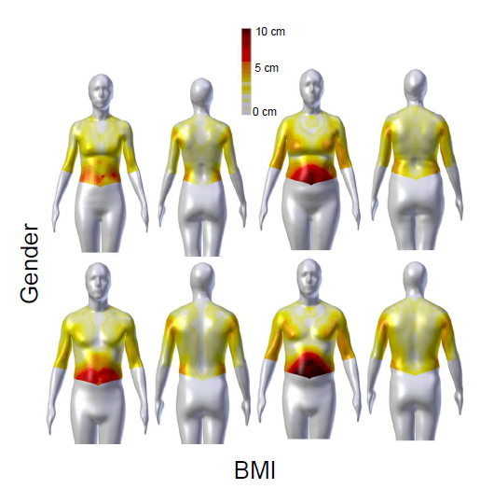
Figure 2: Lunar Transport Vehicle Blunt Force Maximum Allowable Depth of Compression Limits (Seated or Standing Vehicle Occupants)

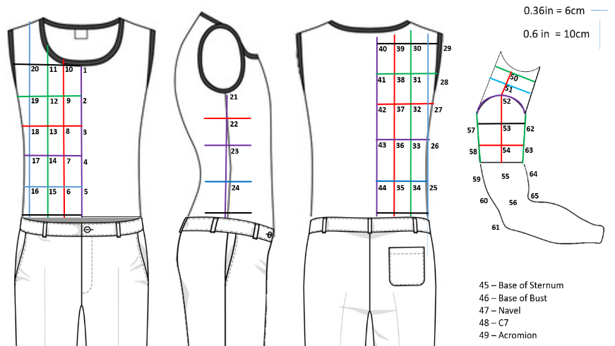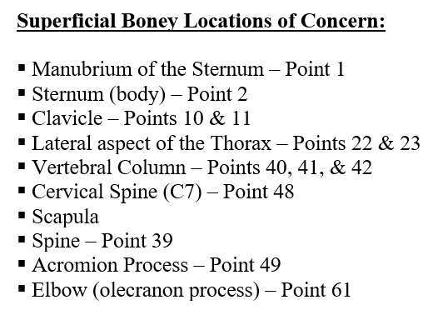
Figure 3: Anthropometric Locations for Blunt Trauma Limits & Boney Locations of Concern

Several past PMHS studies, which focused on AIS 2+ skeletal injuries, could be used to define an extreme upper threshold of injury that would equate to AIS=2. Bolte et al, Shoulder Impact Response and Injury Due to Lateral and Oblique Loading, Stapp Car Crash Journal, 03S-16, 2003 notes lateral and oblique impacts conducted to the center of the shoulder joint at 4.4 m/sec. [1] Lateral tests resulted in distal clavicle fractures – Impact Force ~2,500 N. 3 Pt-Bend tests were conducted on excised clavicles. Clavicle failure loads ranged from 160 N to 1,000 N. Due to considering deconditioning of astronauts, 36 lbs (160 N) should be used as a potential injury threshold for the clavicle Acromion process injuries are extremely rare and only occur during high-energy, high-rate loading events, thus an upper-level fracture threshold is not known.

Two studies focused on impacting 18 PMHS, both laterally and at an oblique angle at speeds of 2.5, 4.4, and 5.5 m/sec. [2][3] Several rib fractures were recorded during impacts to the thorax at a low speed of 2.5 m/sec. Impact forces of 806 N (183 lbs) & 998 N (224 lbs). Deflections of 24 – 30 mm (1” – 1.2”)

Non-published work at the IBRC includes a recent 11 PMHS sled series using small, frail female occupants, in a real-world side impact scenario. PMHS are roughly 5 %ile females with osteopenia. Test include, seatbelt pretensioner, airbag, and intruding vehicle door. Numerous rib fractures have been documented. Impact force is unknown due to loading conditions. Chest deflections at the time of fracture (defined by strain gages) ranged from 3-22 mm of thoracic deflection (0.1” – 0.9”)

3 PMHS impacted to the lumbar spine with a simulated suit ring closure device. [4] Impacts were conducted at both 10 g and 20g. Vertebral body fractures and transverse process fractures were recorded. Impact forces were fairly large 3,000 – 5,000 N as were deflections ~ 44 – 112 mm. AIS 2+ injuries to the spinal column are typically from whole body kinematics and not direct blunt trauma. These injuries only occur under very large direct impacts and could probably be ignored for the LTV requirements.

REFERENCES

[1] Bolte et al, Shoulder Impact Response and Injury Due to Lateral and Oblique Loading, Stapp Car Crash Journal, 03S-16, 2003
[2] Shaw et al, Oblique and Lateral Impact Response of the PMHS Thorax, Stapp Car Crash Journal, 06S-13, 2006
[3] Rhule et al, Response of PMHS to High- and Low-Speed Oblique and Lateral Pneumatic Ram Impacts, Stapp Car Crash Journal, 11S-17, 2011
[4] Bolte et al, Injuries due to Lower Spine Blunt Force Impacts Associated with the Planetary Suit Body Seal Closure (BSC), IRCOBI, 2018

