Matched Correlator

# Task 1

1. *Derive the distribution of V and v = V=oV , where oV is the standard deviation of*

*RV V . Use the parametrization in terms of S*

1. ***Describe fully what you are simulating.***
2. *Show figure*
3. ***Chi squared result and explanation***
4. *Erfc stuff at the end?*

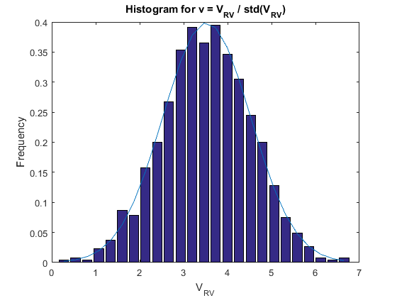

Figure 1: Deriving V distribution

Chi Squared test result: h = 0

# Task 2

1. *For your system scaling, construct a table of threshold values giving the pairs* (Pfa; v0).
2. *Construct some type of a graphical display of this table and* ***comment on the increase in v0 with the decrease in Pfa.***
3. *Using these thresholds, derive Pd and plot Pd versus S in dB over a reasonable range*
4. ***Explain the offsets of the plots****, that is, why each plot is roughly a shift or offset from the others. These results only apply to a fixed scaling, changing the variance will require changing he threshold.*

|  |  |
| --- | --- |
| Pfa | v0 |
| 0.1 | 1.281552 |
| 0.01 | 2.326348 |
| 0.001 | 3.090232 |
| 0.0001 | 3.719016 |

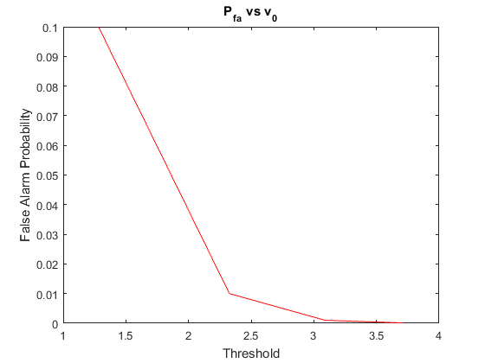

Figure 2: Probability of False Alarm vs Threshold, v0

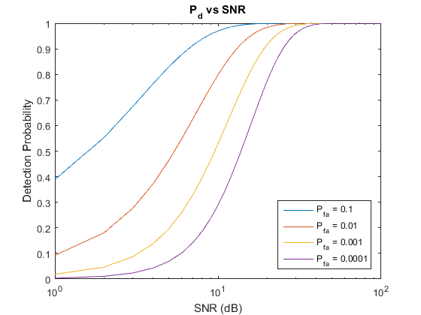

Figure 3: Probability of Detection vs SNR in dB

# Task 3

1. *PLEASE construct a plot of the (auto)-correlation function of the following 3 sequences.*
2. *Determine the PSL, the peak sidelobe level.*
3. ***Why are the Barker codes so good****?*

|  |  |
| --- | --- |
| Code | PSL |
| 1 | 10 |
| 2 | 1 |
| 3 | 1 |

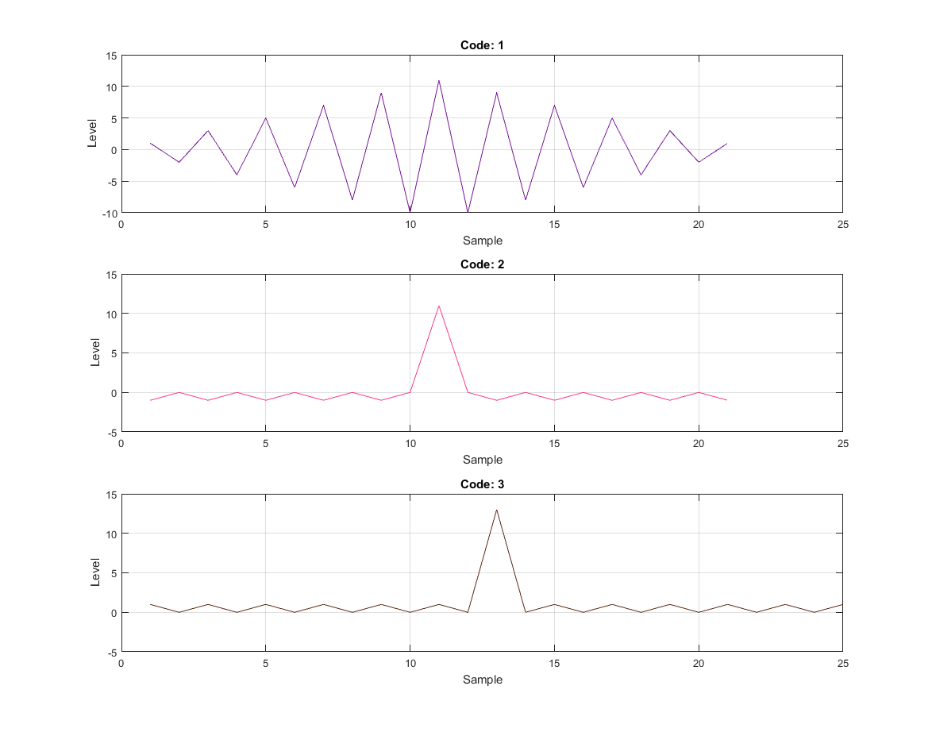

Figure 4: Auto-Correlation for given codes

# Task 3.5

1. *Create a table that provides the code Identification, mainlobe maximum in dB, the average sidelobe, and the peak max sidelobe; all in dB re the max value.*
2. ***Discuss the tradeoffs*** *and which code you might recommend for a particular application. Vehicular radar is a good current one. These codes aren't perfect, in particular, how they handle distortion due to Doppler or multipath can be an issue.*

|  |  |  |  |
| --- | --- | --- | --- |
| Code | Peak (dB) | Peak Sidelobe (dB) | Mean Sidelobe (dB) |
| 1 | 26.848 | 20.828 | 3.383 |
| 2 | 30.370 | 20.828 | 1.023 |
| 3 | 32.869 | 20.828 | 3.178 |
| 4 | 34.807 | 20.828 | 1.874 |
| 5 | 37.730 | 20.828 | 2.208 |
| 6 | 41.656 | 20.828 | 2.499 |
| 7 | 43.107 | 22.279 | 2.575 |

# Task 4

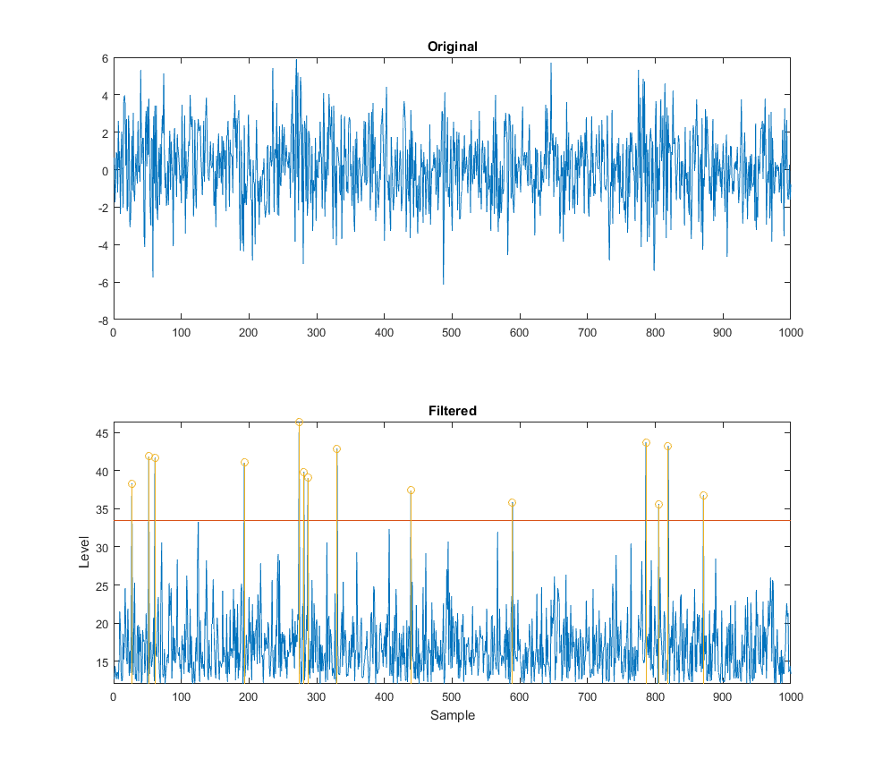

Figure 5: Detected signals at threshold