**CONV_M FUNCTION**

function [y, ny] = conv_m(x, nx, h, nh)

nyb = nx(1) + nh(1);

nye = nx(length(x)) + nh(length(h));

ny = [nyb:nye];

y = conv(x,h);

end

**PZ FUNCTION**

function [ z, p, k ] = pz( b, a )

fvtool(b,a,'polezero')

[b,a] = eqtflength(b,a);

[z,p,k] = tf2zp(b,a);

text(real(z)+.1,imag(z),'Zero')

text(real(p)+.1,imag(p),'Pole')

end

**CODE AND PLOTS**

%% Part 1

figure(1)

n = 0:20;

x = (0.9).^n;

n = -20:0;

y = (0.8).^-n;

% rxx

rxx = conv_m(x, n, fliplr(x), n);

plot(rxx); hold on

% rxy

ryy = conv_m(x, n, fliplr(y), n);

plot(ryy)

title('r_x_x and r_y_y correlation')

xlabel('n')

ylabel('correlation')

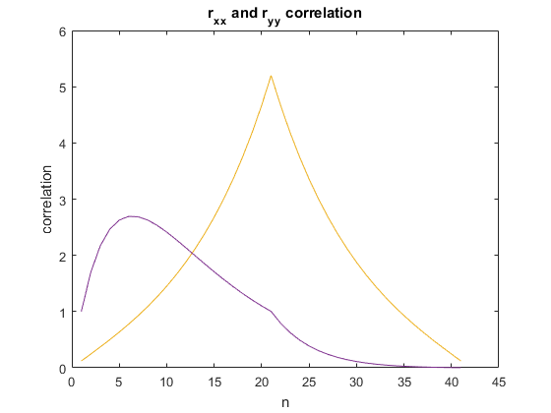

%% Part 2

figure(2)

w = -pi:0.00001:pi;

H = 0.9*exp(1i*w)./(1-0.9*exp(1i*w)) + 1./(1-0.9*exp(-1i*w));

subplot(2,1,1); plot(abs(H), 'b')

title('Magnitude and Phase of H(e^j^w))')

ylabel('Magnitude')

subplot(2,1,2); plot(angle(H), 'r')

ylabel('Phase')

xlabel('Frequency (rad/sec)')

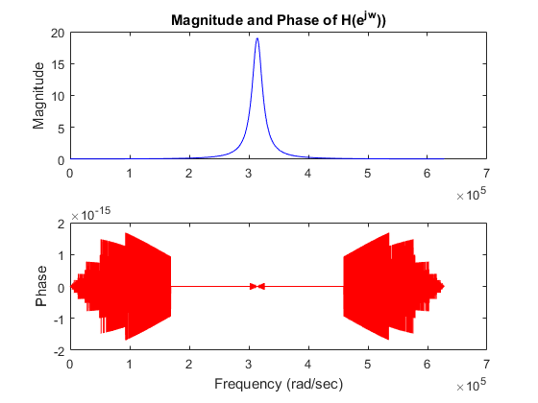

%% Part 3

syms n

z_tran = ztrans(2*dirac(n-2) + 3*heaviside(n-3));

N = [0 0 2 1];

D = [1 -1 0 0]

[ z, p, k ] = pz(N, D)

% Using ztrans, the transfer function was verified. Also using my pz (pole zero) function, I verified the pole zero plot

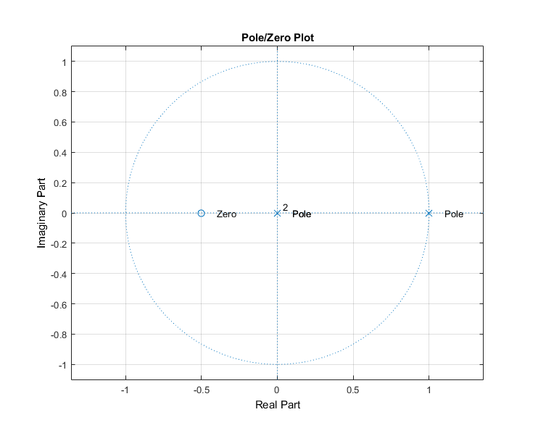

%% Part 4

N = [1 1];

D = [1 -0.5];

[ z, p, k ] = pz(N, D)

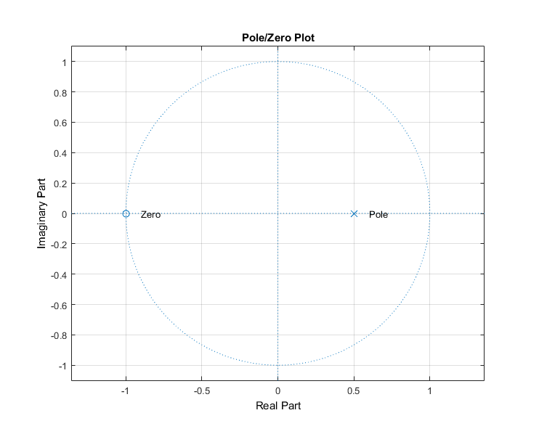

%% Part 5

figure(3)

n= -100:0.1:100;

w = 100*n*2*pi/length(n);

x = heaviside(n)-heaviside(n-50);

x_shif = x.*exp(1i*pi/3*n);

x_shif2 = x.*exp(1i*pi/3*n);

% plots

subplot(5,1,1); plot(n, x)

title('Shifting rect in frequency domain')

xlabel('n')

ylabel('Magnitude')

subplot(5,1,2); plot(n, x_shif)

xlabel('n (times exp)')

ylabel('Magnitude')

X = fftshift(fft(x));

X_shif = fftshift(fft(x_shif));

X_shif2 = fftshift(fft(x_shif2));

% plots

subplot(5,1,3); plot(w, abs(X))

xlabel('w')

xlim([-2*pi, 2*pi])

ylabel('Magnitude')

subplot(5,1,4); plot(w, abs(X_shif));

xlabel('w (shifted pi/3')

xlim([-2*pi, 2*pi])

ylabel('Magnitude')

subplot(5,1,5); plot(w, abs(X_shif));

xlabel('w (shifted 11*pi/3)')

xlim([-2*pi, 2*pi])

ylabel('Magnitude')

