end

**CODE AND PLOTS**

%% Question 1

n = -10:0.1:10;

x = (0.6).^(abs(n));

X = fft(x, length(n));

% Plot

subplot(3,1,1); plot(n, x)

title('FFT of x(n)')

ylabel('Amplitude x(n)'); xlabel('n (time)');

subplot(3,1,2); plot(n, fftshift(abs(X)))

ylabel('Magnitude X(n)'); xlabel('n');

subplot(3,1,3); plot(n, fftshift(angle(X)))

ylabel('Phase X(n)'); xlabel('n');

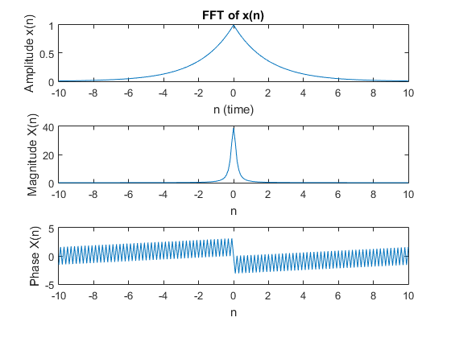

%% Question 3

N = 5;

x1 = [1 -1 1 -1];

x2 = [1 0 -1 0];

x3 = cconv(x1,x2,N);

x4 = conv(x1,x2);

% e = x3 - x4;

x = {x1 x2 x3 x4};

titl = ['x1' 'x2' 'x3' 'x4']

for i = 1:length(x)

str = sprintf('Plot of x%s',titl(i));

subplot(length(x),1,i); stem(x{i})

title(str); xlabel('n'); ylabel('value'); xlim([0, 10])

end

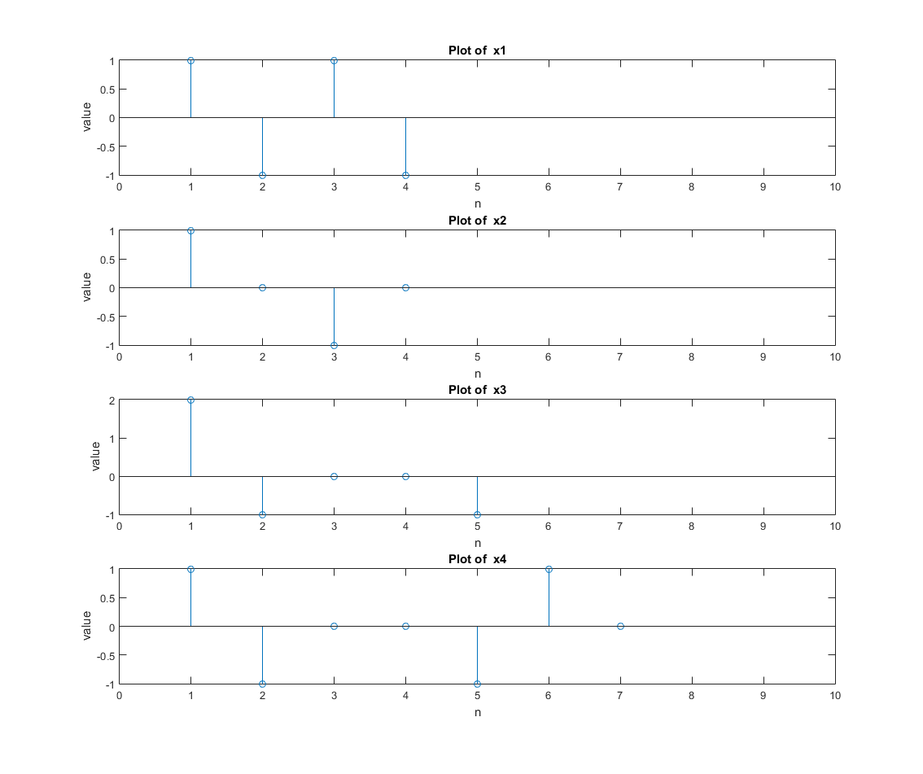

%% Question 5

n = 0:639; length(n)

bin = 1024;

x = 3*sin(0.12*pi*n)+0.4*sin(0.39*pi*n)+0.6*sin(0.72*pi*n);

h = [-0.033505 , 0.056152, 0.055155, 0.066329, 0.081606, 0.097049, ...

0.11043, 0.1204, 0.12551, 0.12551, 0.1204, 0.11043, 0.097049, ...

0.081606, 0.066329, 0.055155, 0.056152, - 0.033505];

y_conv = conv(x,h);

diff = bin - length(x);

if (bin > 0)

x = [x zeros(1, diff)];

end

N = length(x);

y = zeros(1, length(h) + N - 1);

for i = 1:N/bin

tmp = conv(x((i*bin-bin+1):i*bin), h);

tmp_fpad = [zeros(1, (i*bin-bin)) tmp];

tmp_bpad = [tmp_fpad zeros(1, length(y) - length(tmp_fpad))];

y = y + tmp_bpad;

end

% Plot Results

figure(3)

y = y(1:length(y_conv));

subplot(3,1,1); plot(y)

title('Comparison of convolution methods')

xlabel('n (using overlap and add)')

ylabel('Signal')

subplot(3,1,2); plot(y_conv)

xlabel('n (using conv)')

ylabel('Signal')

subplot(3,1,3); plot(abs(y_conv - y))

xlabel('n')

ylabel('Error')

