**CODE AND PLOTS**

**%% Question 1**

ls = 0.3*pi; us = 0.7*pi;

lp = 0.4*pi; up = 0.6*pi;

Fs = (lp - ls)/2;

BW = (up - lp)/Fs +1;

M = ceil(2*pi/(Fs));

alpha = (M-1)/2;

l = 0:M-1; wl = (2*pi/M)*l;

T1 = 0.405;

Hrs = [zeros(1,ls/Fs+1), T1, ones(1, BW), T1];

Hrs = repmat([Hrs, zeros(1, (M/2 - length(Hrs)))], [1,2]);

Hdr = [0,0,1,1,0,0]; wdl = [0,0.3,0.4,0.6,0.7,1];

% check

k1 = 0:floor((M-1)/2); k2 = floor((M-1)/2)+1:M-1;

angH = [-alpha*(2*pi)/M*k1, alpha*(2*pi)/M*(M-k2)];

H = Hrs.*exp(1i*angH); h = real(ifft(H,M));

[db,mag,pha,grd,w] = freqz_m(h,1);

[Hr,ww,a,L] = hr_type2(h);

% Check Properties

delta_w = 2*pi/1000;

Rp = -min(db(lp/delta_w + 1:up/delta_w)) % Actual Passband Ripple

As = -round(max(db(us/delta_w+1:501))) % Min Stopband Attenuation

**%% Plot**

subplot(4,1,1);plot(wl(1:M/2 +1)/pi,Hrs(1:M/2 +1),'o',wdl,Hdr);

axis([0,1,-0.1,1.1]); title('Bandpass Filter')

xlabel('frequency (pi)'); ylabel('Hr(k)')

set(gca,'XTickMode','manual','XTick',[0,0.2,0.35,0.65,0.8,1])

subplot(4,1,2); stem(l,h); axis([-1,M,-0.4,0.4])

title('Impulse Response'); xlabel('n'); ylabel('h(n)');

subplot(4,1,3); plot(ww/pi,Hr,wl(1:M/2 +1)/pi,Hrs(1:M/2 +1),'o');

axis([0,1,-0.1,1.1]); title('Amplitude Response')

xlabel('frequency (pi)'); ylabel('Hr(w)')

set(gca,'XTickMode','manual','XTick',[0,0.2,0.35,0.65,0.8,1])

% set(gca,'YTickMode','manual','YTick',[0,0.59,0.109,1]); grid

subplot(4,1,4);plot(w/pi,db); hold on;

plot([0 1], -1.*[As As], '--r'); axis([0,1,-100,10]); grid

title('Magnitude Response'); xlabel('frequency (pi)');

ylabel('Decibels');

str1 = 'As = 39'; text(0.1,-30,str1);

set(gca,'XTickMode','Manual','XTick',[0,0.2,0.35,0.65,0.8,1]);

set(gca,'YTickMode','Manual','YTick',[-60;0]);

set(gca,'YTickLabelMode','manual','YTickLabels',['60';' 0'])

**As = 39**

Further tweaking of T1 and M could get it at or above 40 which would be ideal

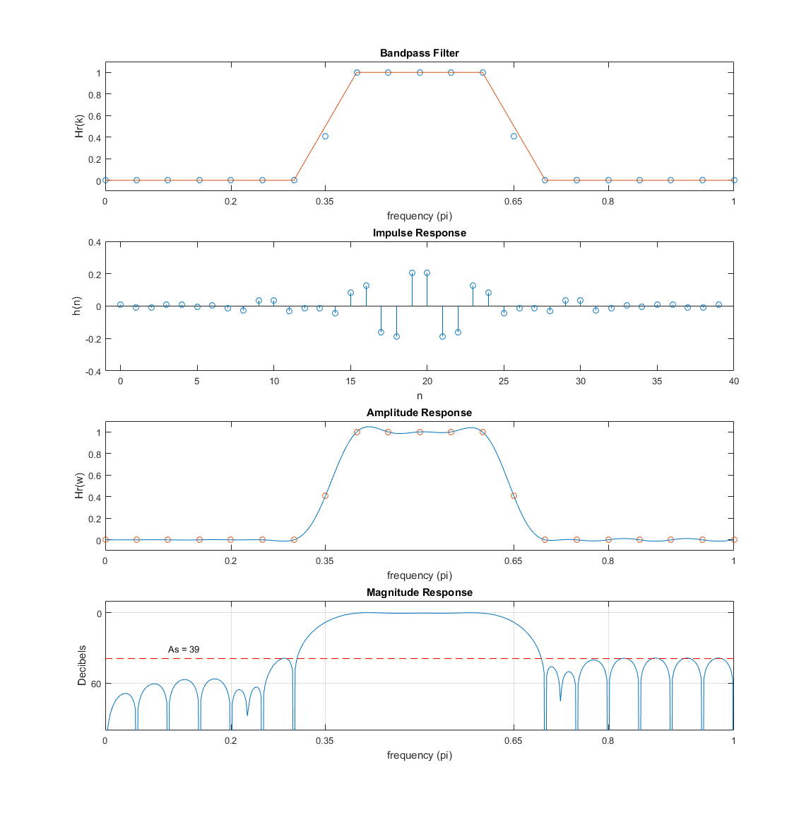

**%% Question 2**

ws1=0.8*pi; wp1=0.4*pi; wp2=0.5*pi; wp3=0.7*pi;

M = 40; alpha = (M-1)/2; l = 0:M-1; wl = (2*pi/M)*l;

d1 = 0.1; d2 = 0.05;

[Rp,As] = delta2db(d1,d2);

weights = [d2/d1 d2/d1 1];

delta_f = min(abs(wp1-wp2)/(2*pi), abs(wp3-ws1)/(2*pi));

M = ceil((-20*log10(sqrt(d1*d2))-13)/(14.6*delta_f)+1); M = 60;

f = [0 wp1 wp2 wp3 ws1 1*pi]./pi;

m = [0.45 0.45 1 1 0 0]; l = 0:M-1;

h = remez(M-1,f,m,weights);

[db,mag,pha,grd,w] = freqz_m(h,1);

[Hr,ww,a,L] = hr_type1(h);

delta_w = 2*pi/1000;

M

**%% Plots**

subplot(4,1,1);plot(f,m);

axis([0,1,-0.1,1.1]); title('Multi Band Filter');

xlabel('frequency (pi)'); ylabel('Hr(k)'); grid;

subplot(4,1,2); stem(l,h); axis([-1,M,-0.3,0.8])

title('Impulse Response'); xlabel('n'); ylabel('h(n)');

subplot(4,1,3); plot(ww/pi,Hr);

axis([0,1,-0.1,1.1]); title('Amplitude Response');

xlabel('frequency (pi)'); ylabel('Hr(w)'); grid;

subplot(4,1,4);plot(w/pi,db); axis([0,1,-100,10]); grid;

title('Magnitude Response'); xlabel('frequency (pi)');

ylabel('Decibels');

**M = 15**

Using the eq in the slides for M, I got 15, manually setting it to a higher value (around 25) gave better results

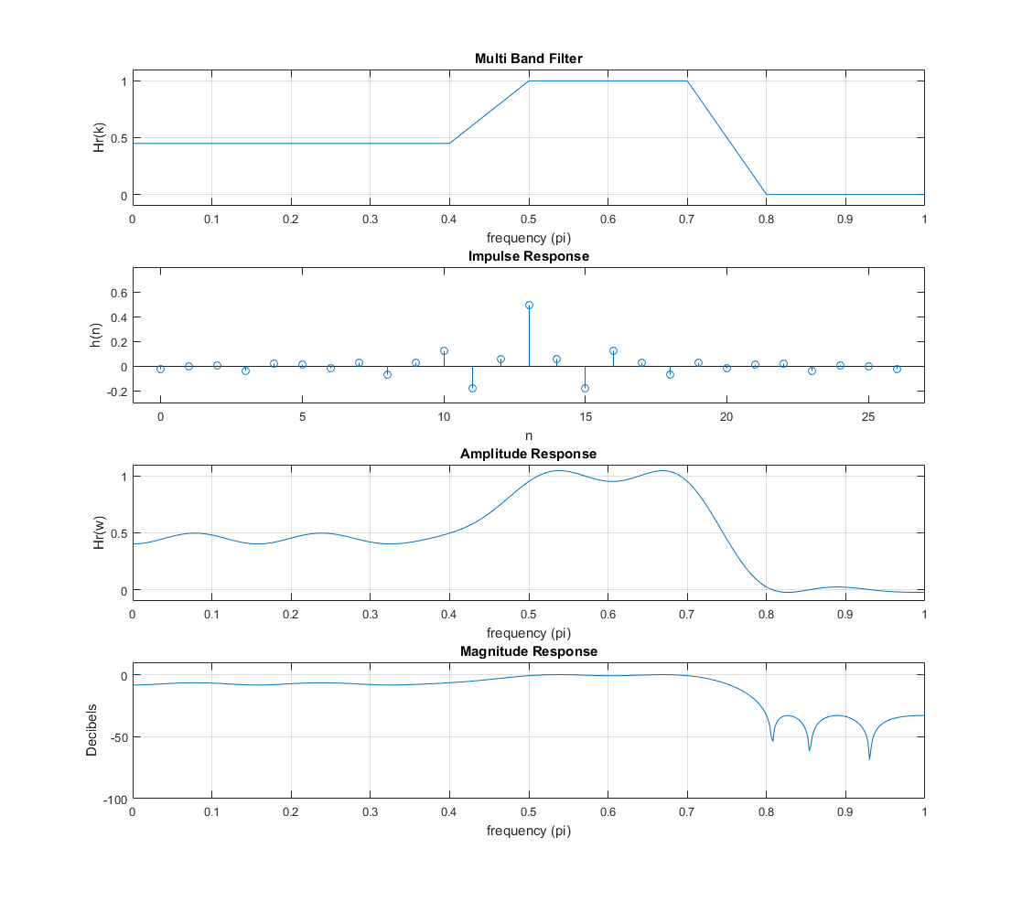

**%% Question 3**

**%% Hamming LP Filter (Question 3a)**

wp = 0.48*pi; ws = 0.54*pi;

tr_width = abs(ws - wp);

M = ceil(6.6*pi/tr_width) + 1;

n = 0:M-1;

wc = (ws+wp)/2;

% Create Filter

hd = ideal_lp(wc,M);

w_ham = hamming(M)';

h = hd .* w_ham;

[db,mag,pha,grd,w] = freqz_m(h,1);

delta_w = 2*pi/1000;

% Check Properties

Rp = -(min(db(1:wp/delta_w+1))) % Passband Ripple

As = -round(max(db(ws/delta_w+1:501))) % Min Stopband attenuation

**%% Plots**

figure

subplot(3,1,1); stem(n, h); title('Impulse Response')

xlabel('n'); ylabel('h(n)')

subplot(3,1,2); plot(w/pi,db);

title('Magnitude Response (Hamming Window)'); grid;

xlabel('Frequency (rad/s)'); ylabel('dB')

subplot(3,1,3); plot(angle(h(1:40)));

title('Phase Response'); xlabel('phase (rad)'); ylabel('phase h(n)');

**%% Sampling method (Question 3b)**

M = 33; alpha = (M-1)/2;

l = 0:M-1; wl = (2*pi/M)*l;

T1 = 0.39039917;

% Create filter

Hrs = [ones(1,8),T1,zeros(1,16),T1,ones(1,7)];

Hdr = [1,1,0,0]; wdl = [0,0.48,0.54,1];

k1 = 0:floor((M-1)/2); k2 = floor((M-1)/2)+1:M-1;

angH = [-alpha*(2*pi)/M*k1, alpha*(2*pi)/M*(M-k2)];

H = Hrs.*exp(1i*angH); h = real(ifft(H,M));

[db,mag,pha,grd,w] = freqz_m(h,1);

[Hr,ww,a,L] = hr_type1(h);

**%% Plots**

figure

subplot(3,1,1); stem(l,h);

title('Impulse Response'); xlabel('n'); ylabel('h(n)');

subplot(3,1,2);plot(w/pi,db); grid;

title('Magnitude Response (Sampling)'); xlabel('frequency in pi units');

ylabel('Decibels');

subplot(3,1,3); plot(angle(h));

title('Phase Response'); xlabel('phase (rad)'); ylabel('phase h(n)');

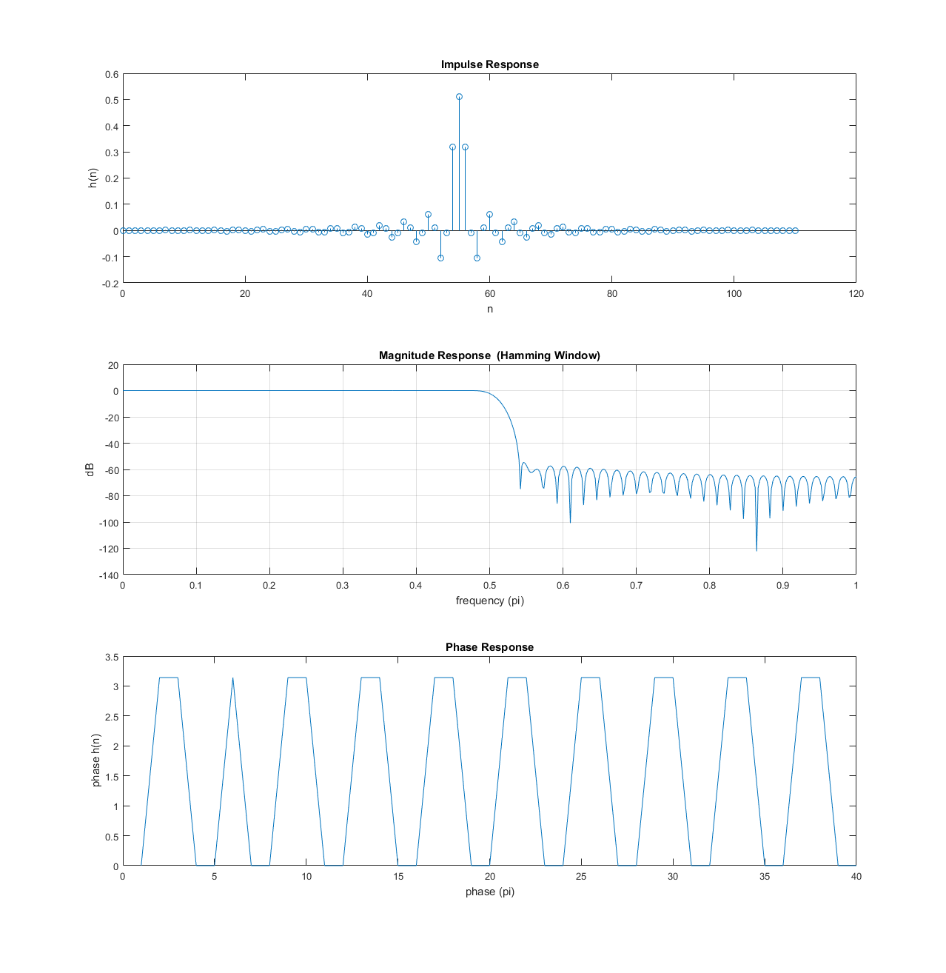

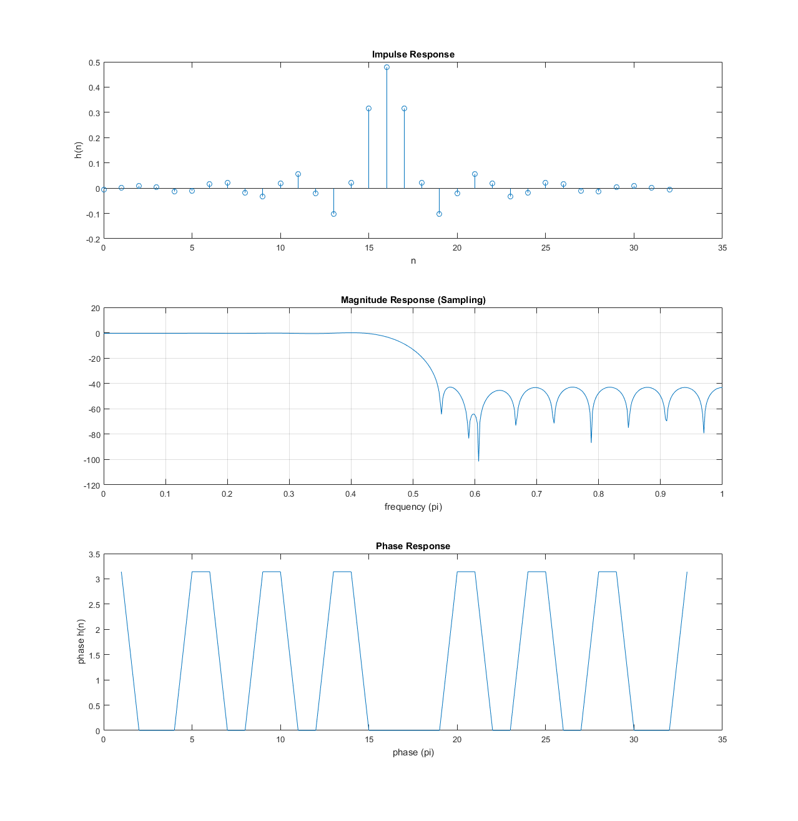

**Question 3 (Part 3)**

In the plots above, I used the same M value of 33 (computed from the slides equation). As you can see, the ripples in both aren’t really uniform, but they are more uniform in the sampling method. The windowing method, however, achieves more stopband attenuation for the same M length. Adjusting T1 or maybe sampling two points in the transition band, could yield more stopband attenuation, also there are many adjustments to M that could optimize each filter individually.

**%% Question 4**

Rp=1.1; As=51;

wp1 = 0.5*pi; ws1 = 0.56*pi; ws2 = 0.82*pi; wp2 = 0.88*pi;

[d1,d2] = db2delta(Rp,As);

weights = [d2/d1 1 d2/d1];

delta_f = min(abs(ws2-wp2)/(2*pi), abs(wp1-ws1)/(2*pi));

M = ceil((-20*log10(sqrt(d1*d2))-13)/(14.6*delta_f)+1);

M = 60;

l = 0:M;

f = [0 wp1 ws1 ws2 wp2 1*pi]./pi;

m = [1 1 0 0 1 1];

% Create Filter

h = firpm(M-1,f,m, weights);

[db,mag,pha,grd,w] = freqz_m(h,1);

[Hr,ww,a,L] = hr_type1(h);

% Check specs

delta_w = 2*pi/1000;

RpImpl = -min(db(1:1:wp1/delta_w)) % Actual Passband Ripple

AsImpl = -round(max(db(ws1/delta_w+1:1:ws2/delta_w))) % Min Stopband Attenuation

**%% Plots**

subplot(4,1,1);plot(f,m);

axis([0,1,-0.1,1.1]); title('Bandstop');

xlabel('frequency (pi)'); ylabel('Hr(k)'); grid;

subplot(4,1,2); stem(l,h);

title('Impulse Response'); xlabel('n'); ylabel('h(n)');

subplot(4,1,3); plot(ww/pi,Hr); title('Amplitude Response');

xlabel('frequency in pi units'); ylabel('Hr(w)'); grid;

subplot(4,1,4);plot(w/pi,db); grid;

title('Magnitude Response'); xlabel('frequency (pi)'); ylabel('dB');

%% Error Function

hrw = [ones(1,251) zeros(1,190) ones(1,60)]';

error = Hr-hrw; error(252:1:281) = NaN; error(411:1:441) = NaN;

figure; plot(ww/pi,error); hold on

axis([0,1,-0.1,0.1]); title('Error');

xlabel('frequency (pi)'); ylabel('H_d_r(w) - H_r(w)'); grid;

**M = 60; As = 52**

