**CODE AND PLOTS**

**%% Question 1**

fs = 8000; % sampling rate

f0 = (1:3).*1000; % notch frequency

fr = f0/fs; % ratio of notch freq. to Nyquist freq.

nw = 0.2; % width of the notch

zeros = [exp( 2*1i*pi*fr ), exp( -2*1i*pi*fr )]; % Compute zeros

poles = (1- nw) * zeros; % Compute poles

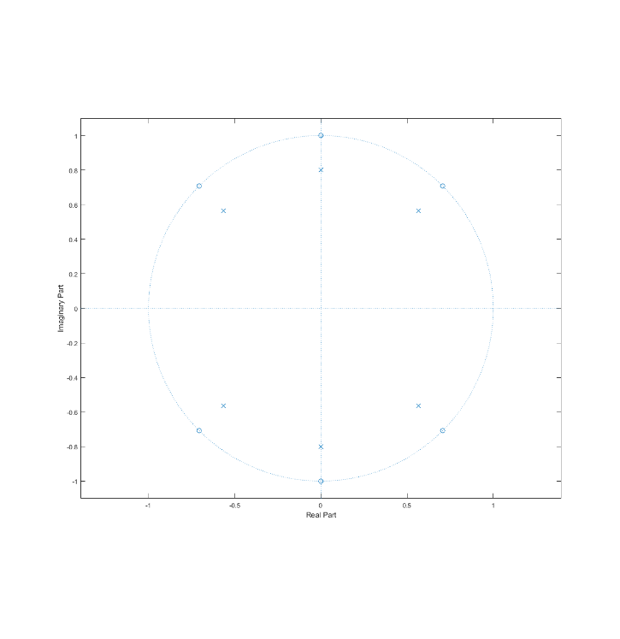b = poly(zeros); % average filter coefficients

a = poly(poles); % autoregressive filter coefficients

[H, w] = freqz(b,a,fs);

mag = abs(H);

db = 20*log10((mag+eps)/max(mag))+1;

pha = angle(H);

max(db)

%% Plot Zeros and Magnitude and Phase

figure; % zero plot

zplane(zeros.', poles.');

figure; % mag, phase plot

subplot(211); plot(w/pi,db)

title('Magnitude Response'); xlabel('n'); ylabel('|h(n)|');

ylim([-50, 10])

subplot(212); plot(w/pi, pha)

title('Phase Response'); xlabel('n'); ylabel('<h(n)');

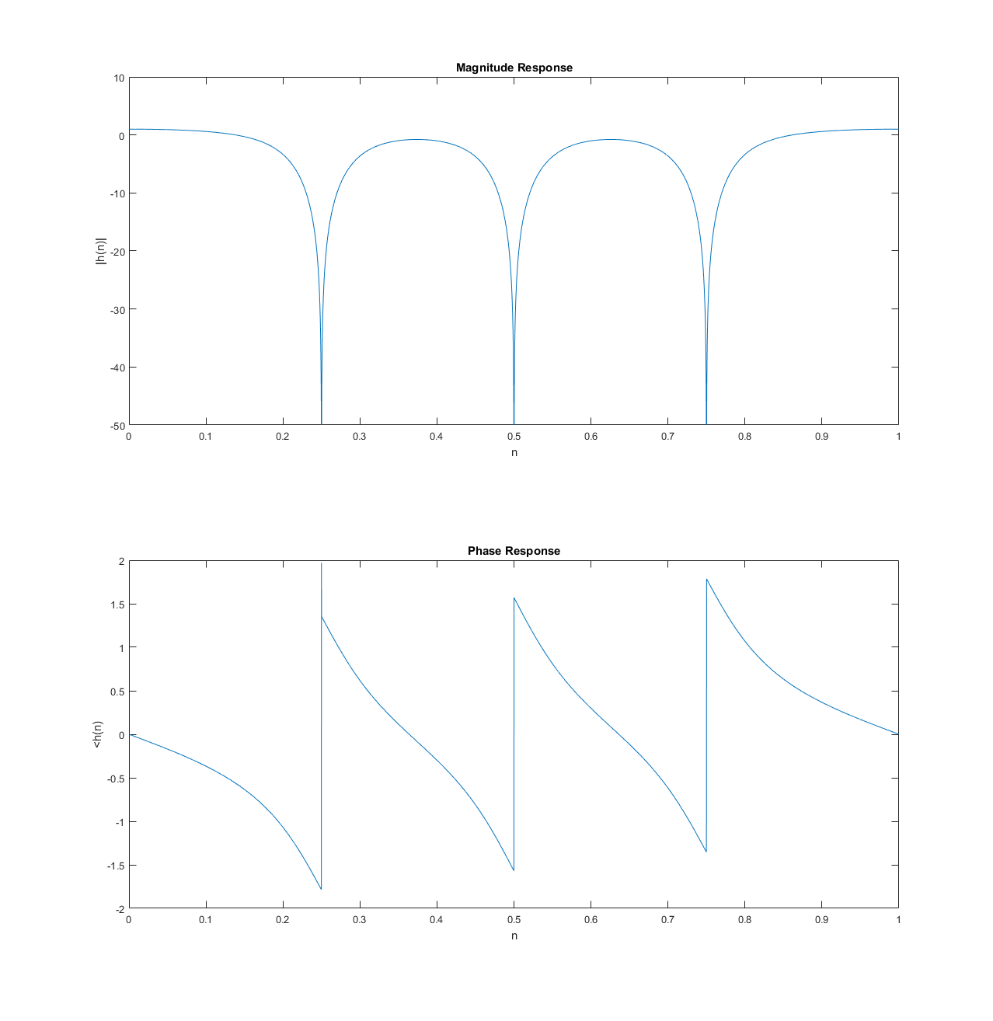

%% Filter Signal

load handel

%load splat

%load laughter

%load train

%load gong

% load chirp

% Add Spectral Noise

t= (1:1:length(y));

spectral = sum(cos(2*pi*fr(:)*t));

y_noise = y + spectral.';

filtered = filter(b,a,y_noise);

figure

subplot(311); plot(y)

title('Original'); xlabel('hz'); ylabel('h(n)'); ylim([-1, 1]);

subplot(312); plot(y_noise)

title('Added Noise'); xlabel('hz'); ylabel('h(n)');

subplot(313); plot(filtered)

title('Filtered'); xlabel('hz'); ylabel('h(n)'); ylim([-1, 1]);

%% Play Sound

% soundsc(y, Fs); pause() % original

soundsc(y_noise, Fs); pause() % dirty

soundsc(filtered, Fs); % clean

%% Spectral Plot

nwin = 512; % samples

noverlap = 256; %samples

nfft = 512; %samples

figure

subplot(311); spectrogram(y, nwin, noverlap, nfft); colormap(cool);

title('Original'); xlabel('hz'); ylabel('h(n)');

subplot(312); spectrogram(y_noise, nwin, noverlap, nfft); colormap(cool);

title('Added Noise'); xlabel('hz'); ylabel('h(n)');

subplot(313); spectrogram(filtered, nwin, noverlap, nfft); colormap(cool);

title('After Filtering'); xlabel('hz'); ylabel('h(n)');

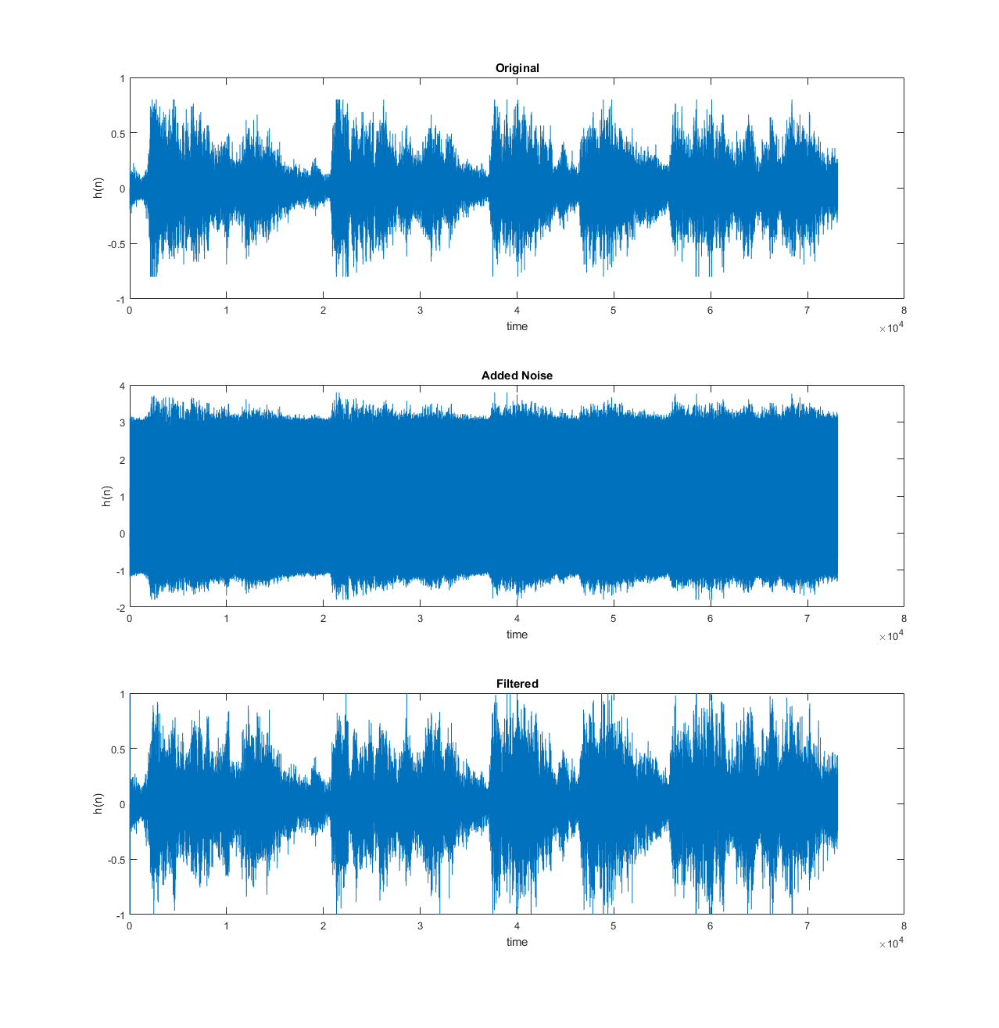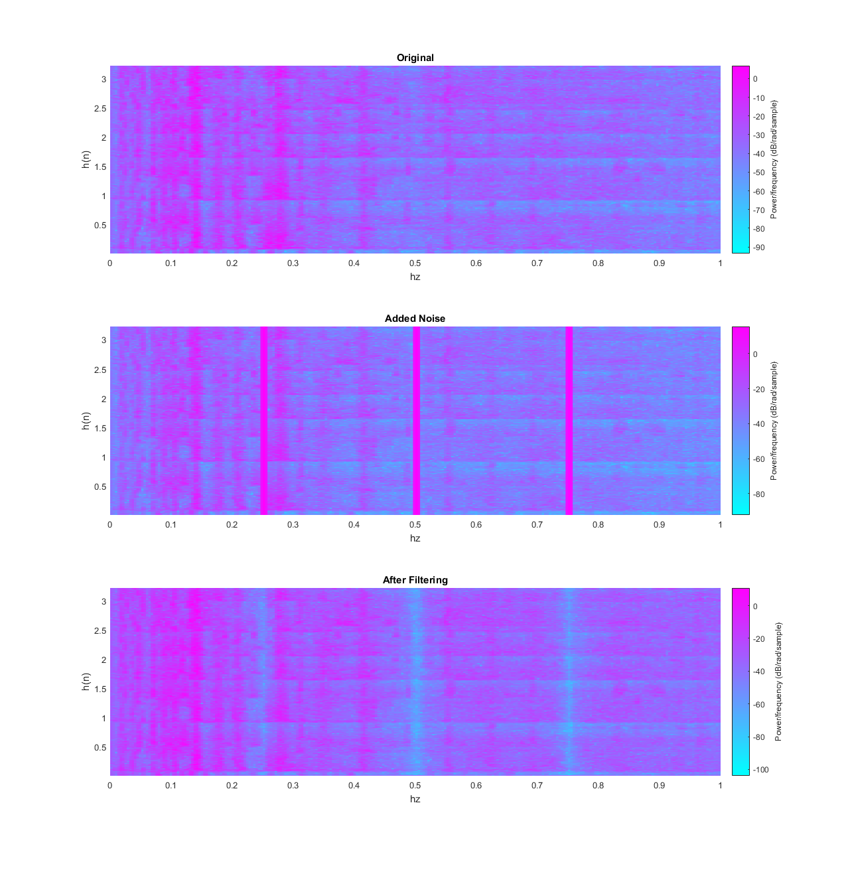

**Adding the sines with amplitude 1 completely overtakes the signal. Removing these spectral peaks with the notch filter restores the original sound, although it is slightly quieter and missing the narrow bands that are filtered. At equal amplitude, The original and filtered signals sound the same.**

**%% Question 2**

Os = 2000; Op = 500; As = 50; Rp = 0.25;

[N, Om_c] = buttord(Op, Os, Rp, As, 's')

[b, a] = u_buttap(N, Om_c);

% Calculation of Frequency Response:

[db,mag,pha,w] = freqs_m(b,a, Os);

%% Plots

subplot(4,1,1); plot(mag);title('Magnitude Response')

**Rational form:**

Numerator: 1.0e+17 * [ 0.0000 -2.0239 ]

Denominator: 1.0e+64 * [ 0.0000 -0.0000 0.0000 -0.0000 0.0000 -0.0010 2.8364 -2.8355 ]

xlabel('Frequency (pi)'); ylabel('|H|'); xlim([0, 500])

subplot(4,1,2); plot(db);title('Magnitude in dB')

xlabel('Frequency (pi)'); ylabel('dB'); ; xlim([0, 500])

subplot(4,1,3); plot(pha); title('Phase Response')

xlabel('Frequency (pi)'); ylabel('rad'); ; xlim([0, 500])

subplot(4,1,4); impulse(b,a); title('Impulse Response')

xlabel('time (s)'); ylabel('ha(t)');

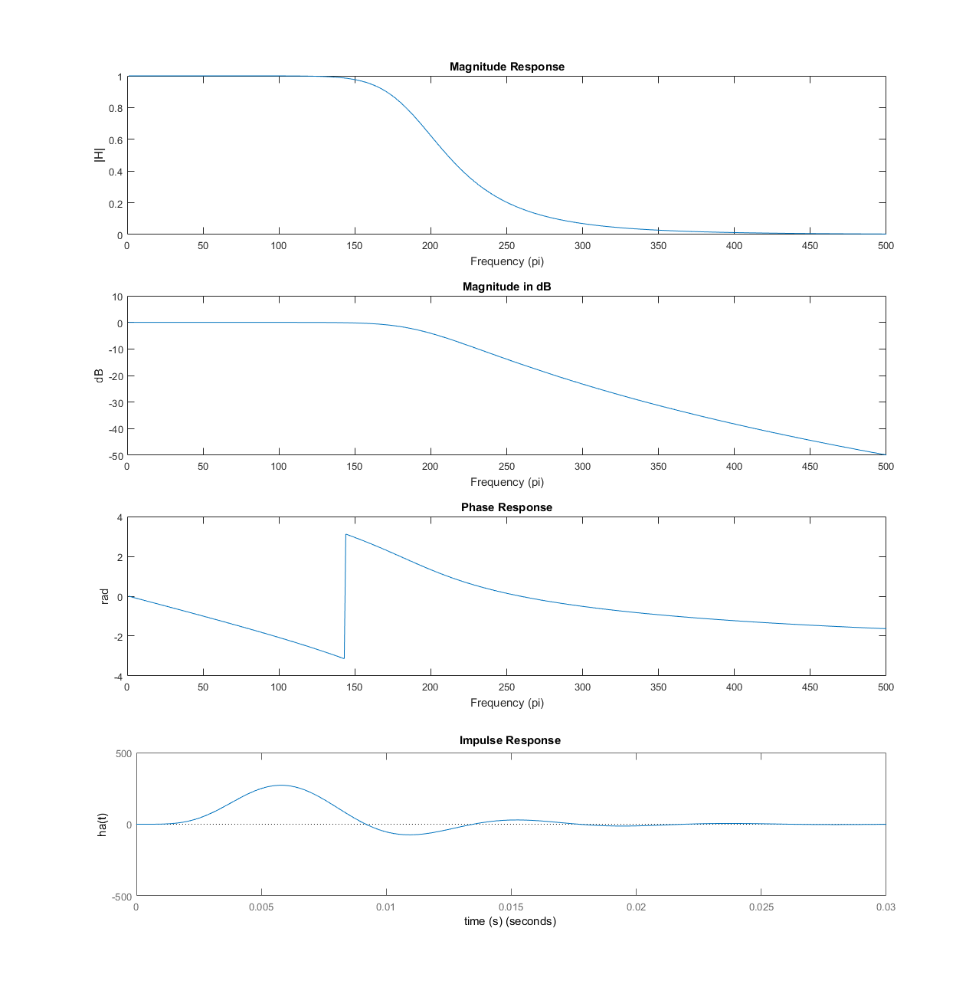

**%% Question 3**

Rp = 1; As = 50; Op = 10; Os = 15;

e = sqrt((10^0.1*Rp)-1); A = 10 ^ (As/20);

Or = Os/Op; g = sqrt((A^2 - 1)/(e^2));

N = ceil(log10(g + sqrt((g^2) - 1))/log10(Or + sqrt((Or^2) -1)));

[b, a]=u_chb1ap(N,Rp, Op);

[db,mag,pha,w] = freqs_m(b,a, Os);

[gd, wd] = grpdelay(b, a, N);

%% Plots

**Rational form:**

Numerator: 1.5353e+06

Denominator: 1.0e+64 * 1.0e+06 * [0 0 0.0002 0.0017 0.0184 0.0847 0.4478 1.0734 1.7227]

subplot(4,1,1); plot(mag);title('Magnitude Response')

xlabel('Frequency (pi)'); ylabel('|H|'); xlim([0, 500])

subplot(4,1,2); plot(db);title('Magnitude in dB')

xlabel('Frequency (pi)'); ylabel('dB'); xlim([0, 500])

subplot(4,1,3); plot(wd, gd); title('Group Delay')

xlabel('Frequency (pi)'); ylabel('rad');

subplot(4,1,4); impulse(b,a); title('Impulse Response')

xlabel('time (s)'); ylabel('ha(t)');

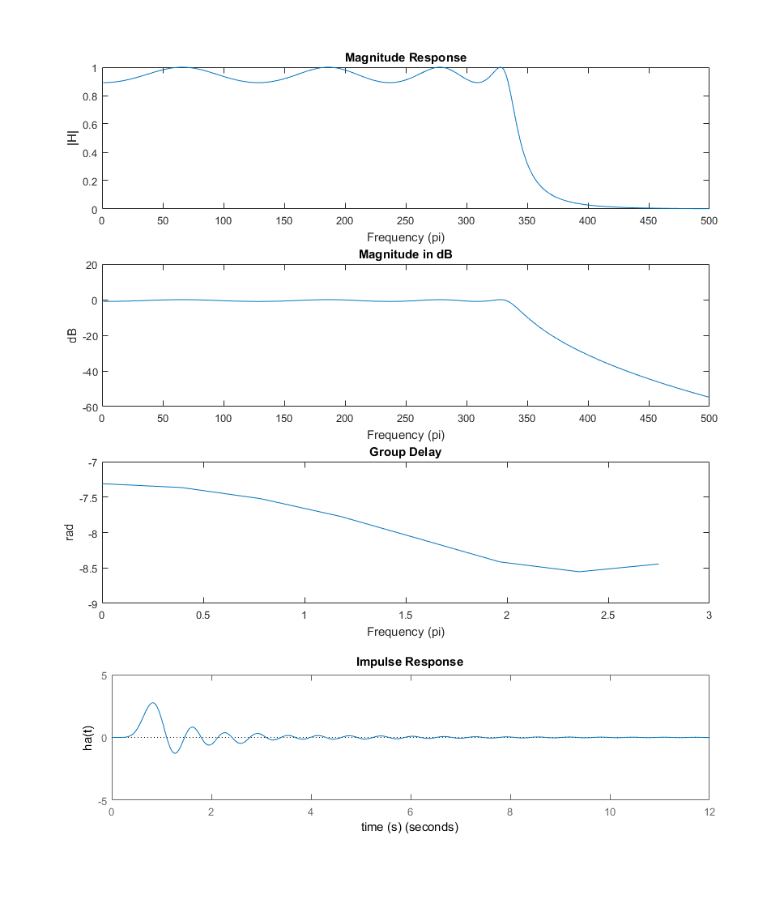

**%% Question 4**

Op = 4000*pi; Os = 6000*pi; Rp = 0.8; As = 25;

e = sqrt((10^(0.1*Rp))-1); A = 10 ^ (As/20);

Or = Os/Op; g = sqrt((A^2 - 1)/(e^2));

N = ceil(log10(g + sqrt((g^2) - 1))/log10(Or + sqrt((Or^2) -1)));

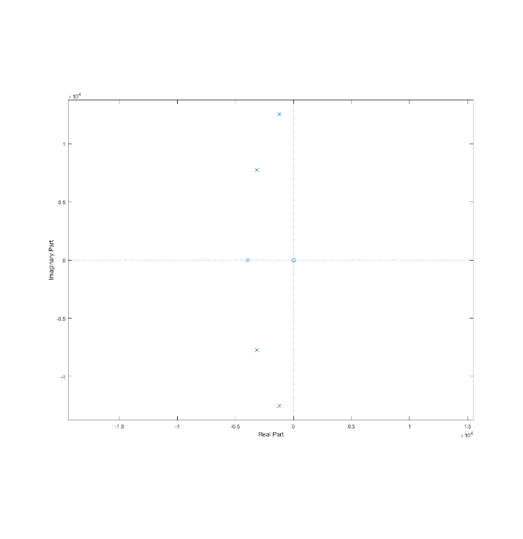al = 1/e + (1 + 1/e^2)^(1/2)

min = 1/2*(al^(1/N) - al^(-1/N));

maj = 1/2*(al^(1/N) + al^(-1/N));

k = (0:N-1)';

ok(:,1) = min*Op*cos((pi/2)+(2*k+1)*pi/(2*N))

ok(:,2) = maj*Op*sin((pi/2)+(2*k+1)*pi/(2*N))

p = ok(:,1) + 1i*ok(:,2)

zplane(0,p)

a = poly(p);

b = prod(p); % N is odd so K = product of poles

[db,mag,pha,w] = freqs_m(b, a, Os);

% Plot results

figure;

subplot(2,1,1);plot(db); grid; axis([0, 500, -30, 2]);

title('Log Magnitude Response'); xlabel('frequency (pi)');

ylabel('Decibels');

subplot(2,1,2); plot(pha/pi); axis([0, 500, -pi, pi]);

title('Phase Response'); grid

xlabel('frequency (pi)'); ylabel('Radians')

