**CODE AND PLOTS**

**%% Question 1**

%Impulse Invariance

% Initialize

T = [1 1/8000]; % part 1 and part 2

fs = 8000;

wp = 3200*2*pi/fs;

ws = 3800*2*pi/fs;

Rp = 0.5;

As = 45;

% loop through different T values

for i = 1:length(T)

Op = wp/T(i);

Os = ws/T(i);

% Build cheb filter and bilinear transformation

[cs, ds] = afd_chb1(Op, Os, Rp, As);

[b, a] = imp_invr(cs, ds, T(i));

[db, mag, pha, grd, w] = freqz_m(b, a);

% Plot

figure;

subplot(3,1,1); plot(mag);

title('Magnitude Response'); grid;

xlabel('frequency (pi)'); ylabel('Magnitude');

subplot(3,1,2); plot(pha);

title('Phase Response'); grid

xlabel('w'); ylabel('Rad')

subplot(3,1,3);plot(db); axis([0 500 -50 5]); grid;

title('Log Magnitude Response'); xlabel('frequency (pi)');

ylabel('Decibels');

end

**Q1 Part 3:**

Using a T value smaller than one increased the magnitude of the filter significantly. This is not surprising as T is the numerical integration step size for trapezoidal integration, and a smaller T results in more partitioning of the data

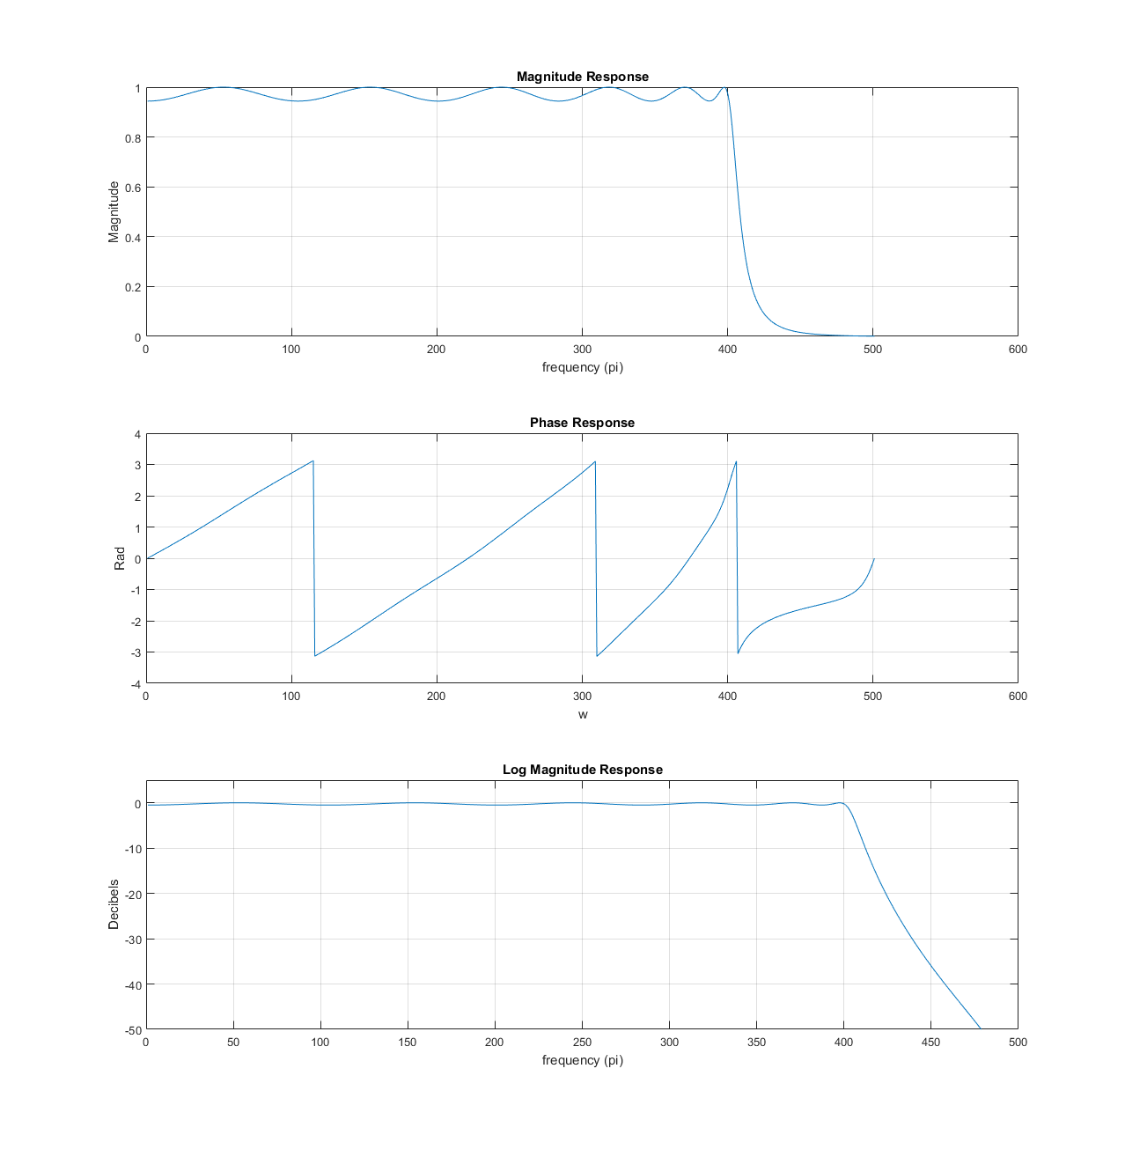

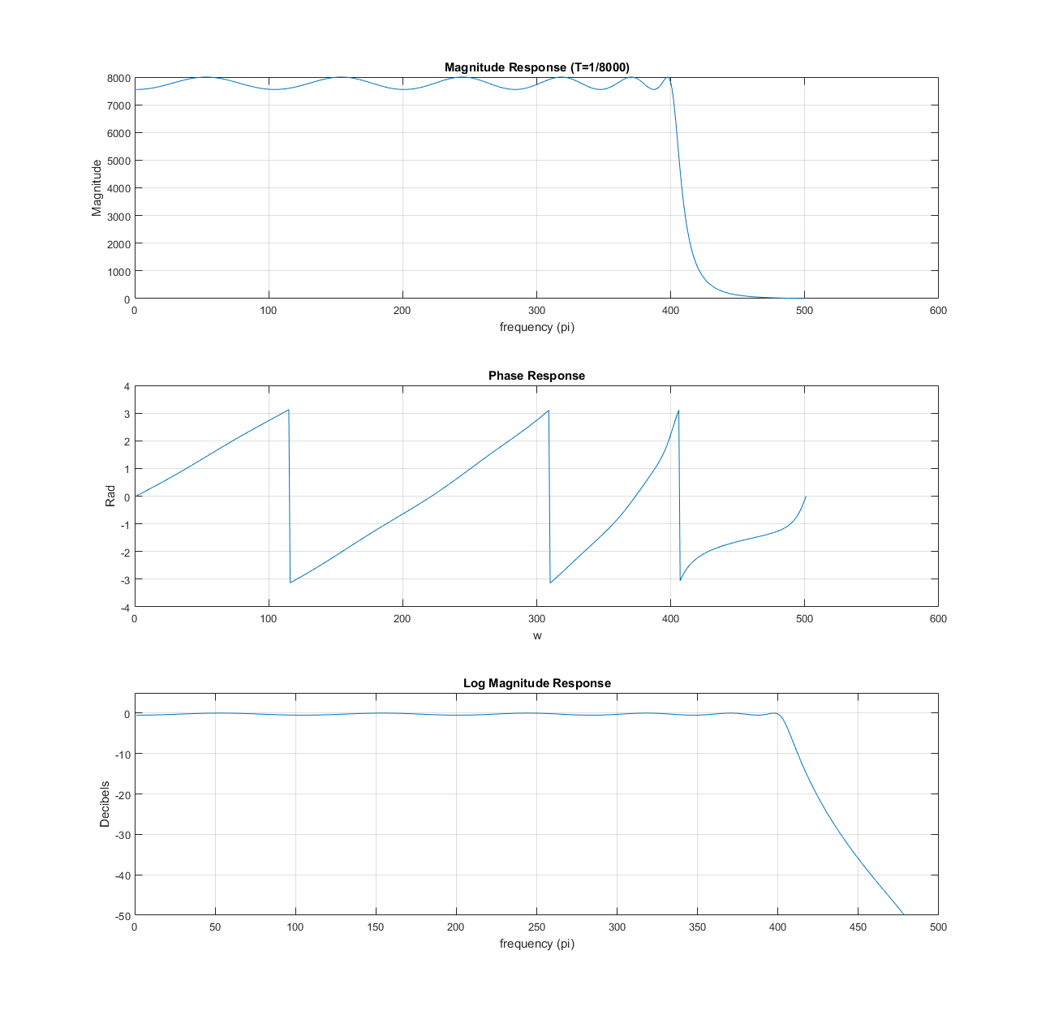

**%% Question 2**

% Bilinear Transform

% Initialize

Op = (2/T(1))*tan(wp/2);

Os = (2/T(1))*tan(ws/2);

% Build cheb filter and bilinear transformation

[cs, ds] = afd_chb1(Op, Os, Rp, As);

[b, a] = bilinear(cs, ds, T(1));

[dbl,magl,phal,grdl,w] = freqz_m(b,a);

% Plots

figure;

plot(w/pi,dbl); title('Lowpass Digital Filter Magnitude in dB');

xlabel('frequency (pi)'); ylabel('dB'); axis([0 1 -30 5]);

figure; subplot(2, 1, 1); plot(impulse(tf(b, a))); title('Digital Impulse')

xlabel('time (n)'); ylabel('Amplitude');

subplot(2, 1, 2); plot(impulse(tf(cs, ds))); title('Analog Impulse')

xlabel('time (t)'); ylabel('Amplitude');

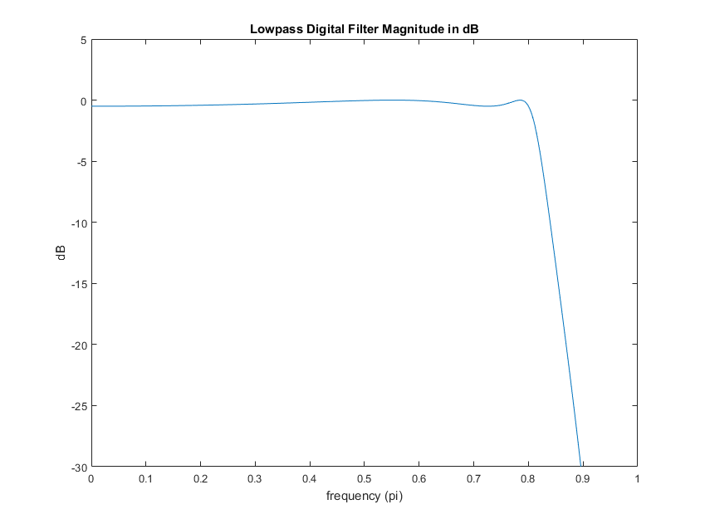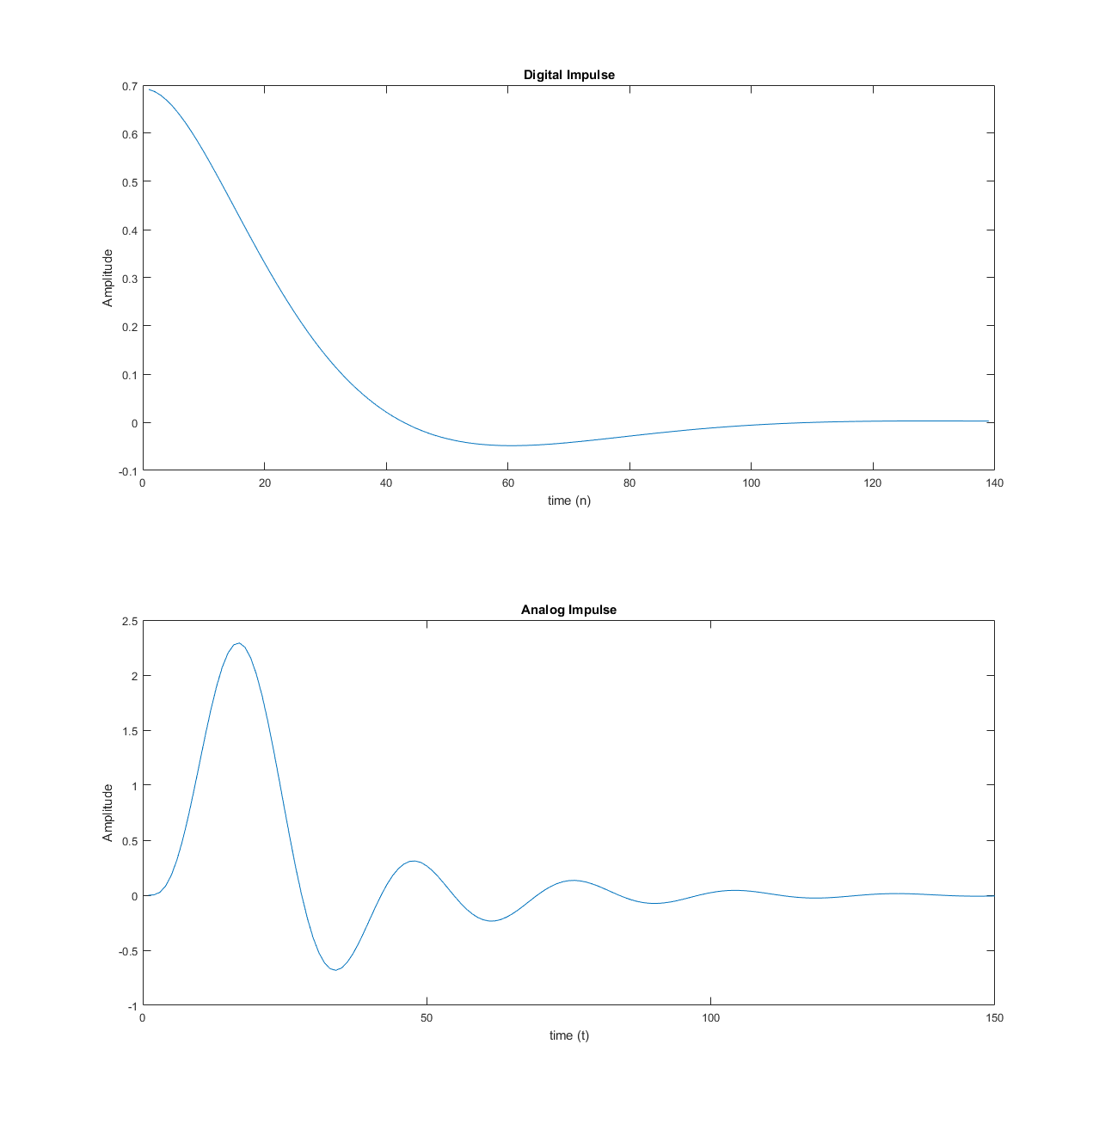

Compared to the analog impulse response, the digital one seems to be missing peaks. I suppose this may be due to the sampling time being too slow such that certain peaks are missed. It almost looks like the digital version is a smoother version of the analog equivalent.

**%% Question 3**

% Initialize

w1p = 0.2*pi; w1s = 0.3*pi;

w2s = 0.7*pi; w2p = 0.8*pi;

w0 = (w1s + w2s)/2; bw = w2p - w1p; % bandwidth and center

Rp = 1; As = 50;

% Build cheb filter

[N, Wc] = cheb1ord([0.2 0.8], [0.3 0.7], Rp, As, 's');

[Z, P, K] = cheb1ap(N, Rp);

[num,den] = zp2tf(Z,P,K);

[numt, dent] = lp2bs(num, den, w0, bw);

% Bilinear transformation

[nt, dt] = bilinear(numt, dent, 1);

[db,mag,pha,grd,w] = freqz_m(nt,dt);

% Plot

figure;

subplot(3,1,1); plot(w, mag); axis([0 pi 0 1]);

title('Magnitude Response'); grid;

xlabel('frequency (pi)'); ylabel('Magnitude');

subplot(3,1,2); plot(pha); axis([0 500 -pi pi]);

title('Phase Response'); grid

xlabel('w'); ylabel('Rad')

subplot(3,1,3); plot(db); grid; axis([0 500 -300 50]);

title('Log Magnitude Response'); xlabel('frequency (pi)');

ylabel('dB');

