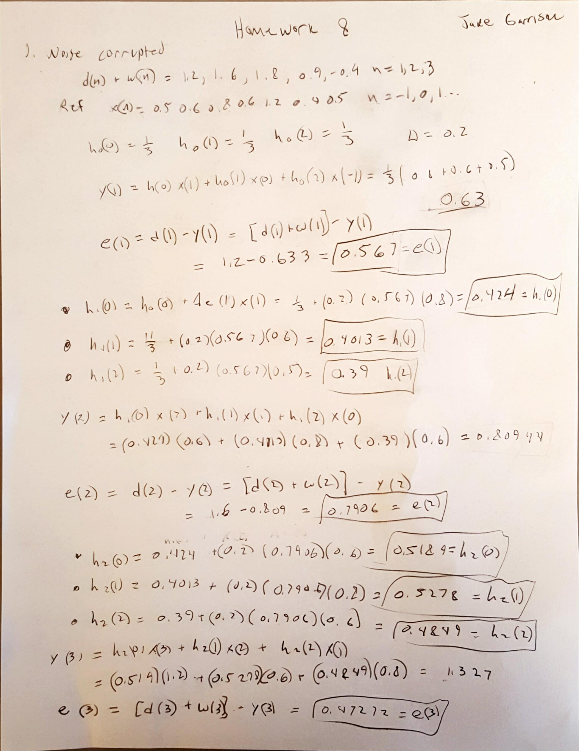

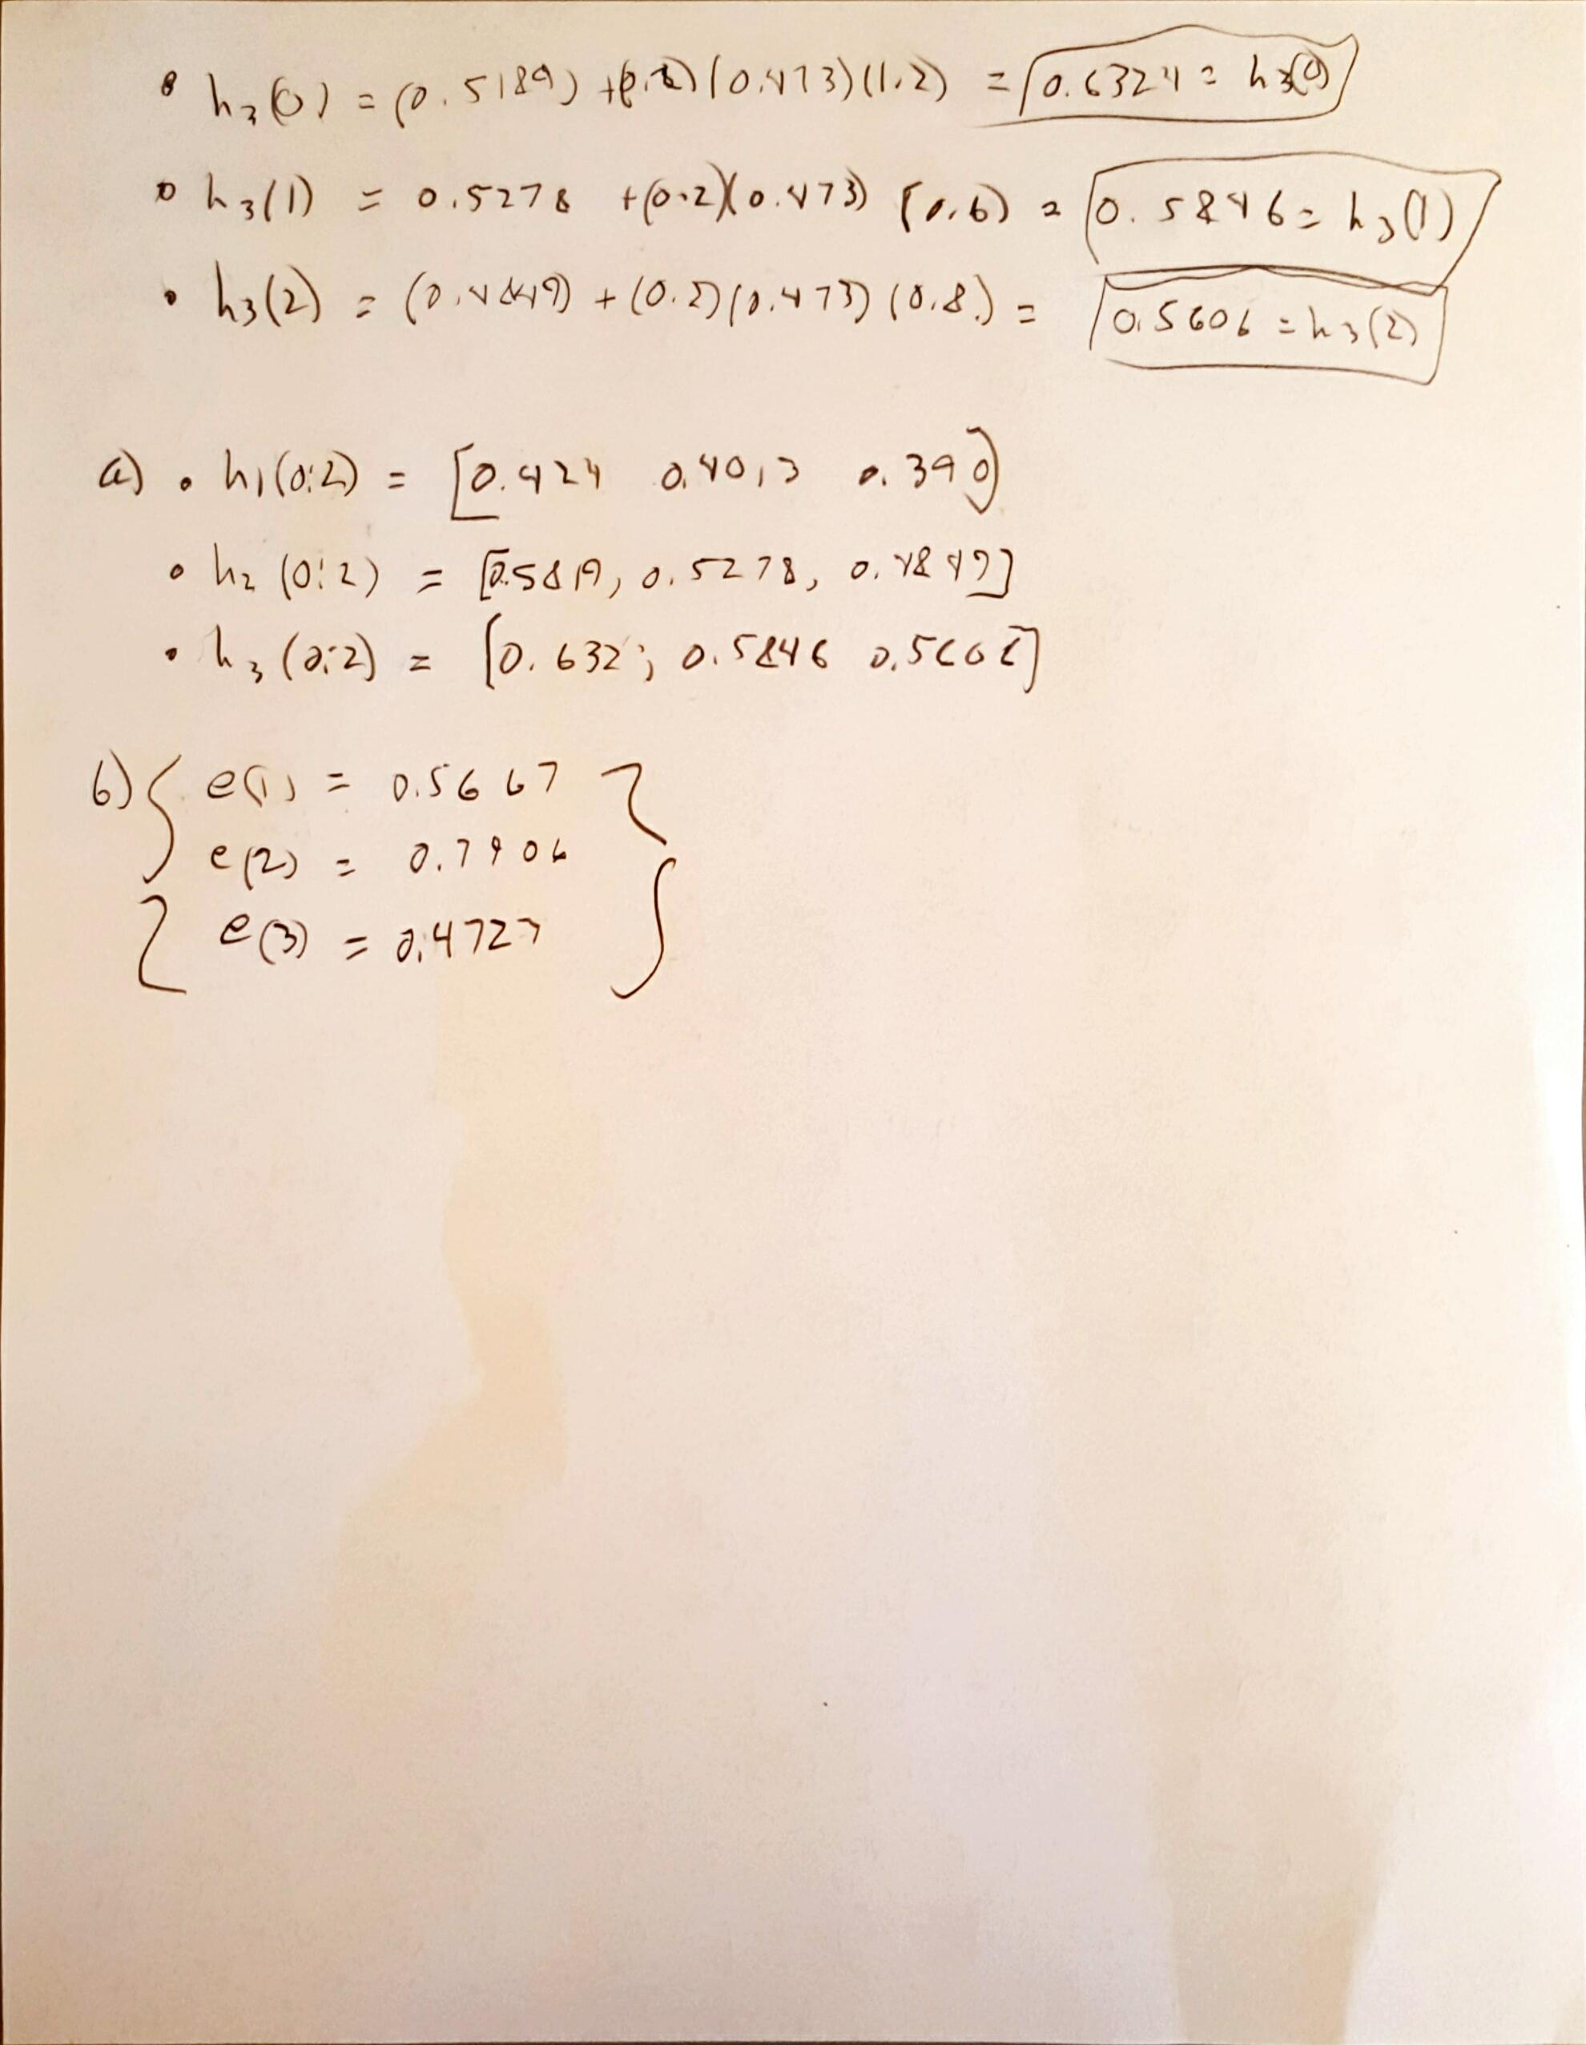

**CODE AND PLOTS**

**%% Question 2**

clear all; close all; clc

n = 50;

x = rand(n,1)*4 - 2;

P = mean(x.^2);

Ns = [8 16 32];

deltas = 1./(10.*Ns.*P);

%% Create Black Box Filter

% Black Box

b = [1 4 -1];

a = [1 -0.3 0.1];

d = filter(b,a,x);

% Plots

% figure

% freqz(b,a)

% title('Filter Response')

figure

n_plts = 2+2*length(deltas);

subplot(n_plts,1,1); plot(x)

title('Random Input Data (x)'); grid;

xlabel('n'); ylabel('Amplitude');

subplot(n_plts,1,2); plot(d)

title('Unknown Filtered Data (d)'); grid;

xlabel('n'); ylabel('Amplitude');

%% Try each N for Adaptive Filter

for i = 1:length(Ns)

N = Ns(i);

del = deltas(i);

%LMS Adaptive Filter

h=zeros(N,1); %inital values: 0

M=length(x); %number of samples of the input signal

e = zeros(N,1);

for n=N:M

xvec=x(n:-1:n-N+1);

e(n) = d(n) - h' * xvec;

h=h + del * xvec * conj(e(n));

end

d_aprx = filter(h,1,x);

% Error

e = e(e~=0); % clean up 0s

mse = immse(d,d_aprx);

%% Plots

subplot(n_plts,1,2+i*2-1); plot(d_aprx)

title(sprintf('Adaptive Filtered Data for N = %d, delta = %0.2d', N, del)); grid;

xlabel('n'); ylabel('Amplitude');

subplot(n_plts,1,2+i*2); plot(e.^2)

title(sprintf('Adaptive Filter Squared Error for N = %d, mse = %0.2d', N, mse)); grid;

xlabel('n'); ylabel('e^2');

end

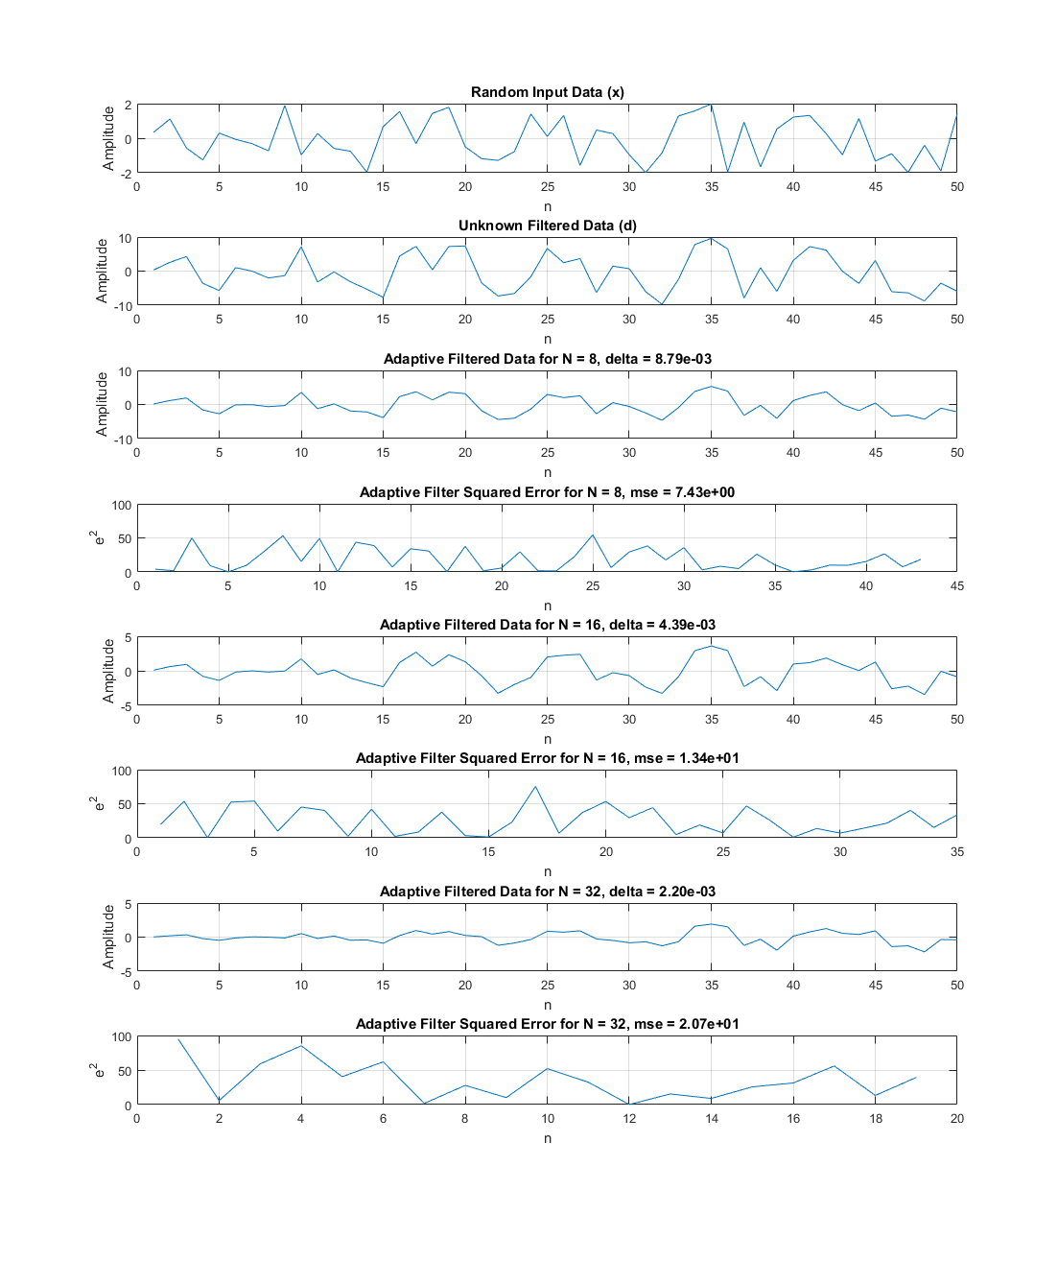s