This document explains data resources provided covering Seattle paid parking transactions from January 2011 to March 2015. For more information contact Jonathan Williams at [jonathan.williams2@seattle.gov](mailto:jonathan.williams2@seattle.gov) or 206-733-9026

**Transaction Data:**

This data is provided in the file /Transaction Data. It is separated into Pay by Phone and Pay Stations Transaction data and each grouping is further divided into months of data. The Transaction Data folder provides a key understanding the values contained in this data.

**Crossreferencesheet.xls:**

This sheet provides a list of pay station IDs, pay by phone codes, and element keys (blockface ID). Note that pay station locations come in and out of service and we do not have a master list of pay station IDs. You will likely find data in transactions that you cannot match back to a pay station due to it being out of service. Below is a diagram relating how blockfaces, pay station, and pay by phone codes relate.

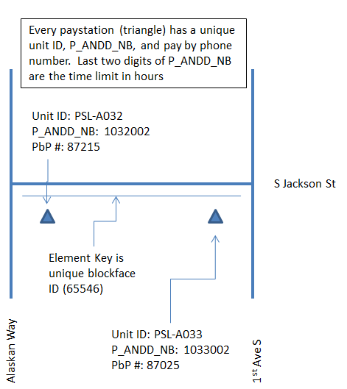

P_ANDD_NB means pay and display number.

**Paid Space Supply:** The number of paid spaces on a blockface can vary by the day as spaces come in and out of service due to construction, utility work, etc. We track these changes nightly. This spreadsheet contains a start (EFF_START_DATE) and end date (EFF_END_DATE) for paid space supply (PARKING_SPACES) changes as they occur. Each blockface may have multiple supply change entries.

**Shapefiles:** There are two shapefiles provided. One is a point file of pay stations as of 6/22/15. The other is a line file of blockfaces citywide that can be matched to the element key.