Module 05 Activity - Testing Screen Display Sizes

Jacob Hanson

Rasmussen College

Testing Screen Display Sizes

Christopher Mattie

May 10th, 2020

Moto G4

Layout issues: Images are not properly aligning with the paragraphs. The sections are not properly aligning so the break between the two paragraphs is not clean.

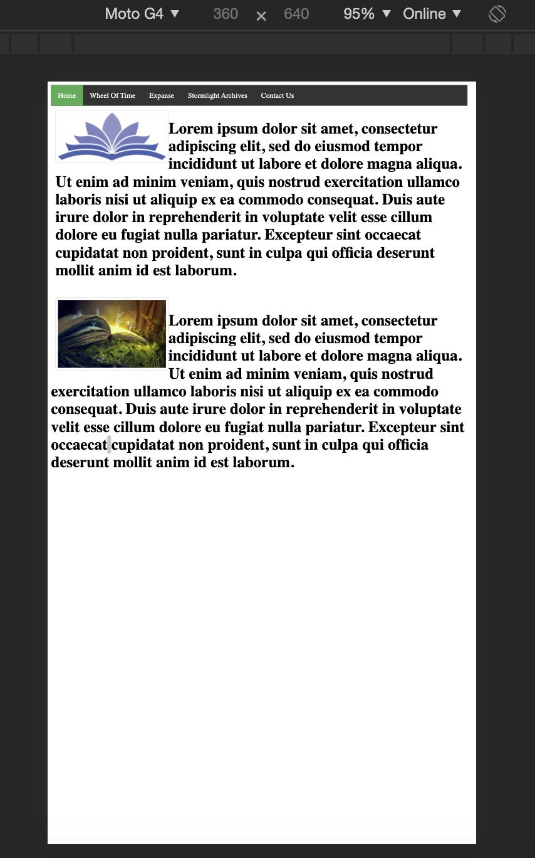

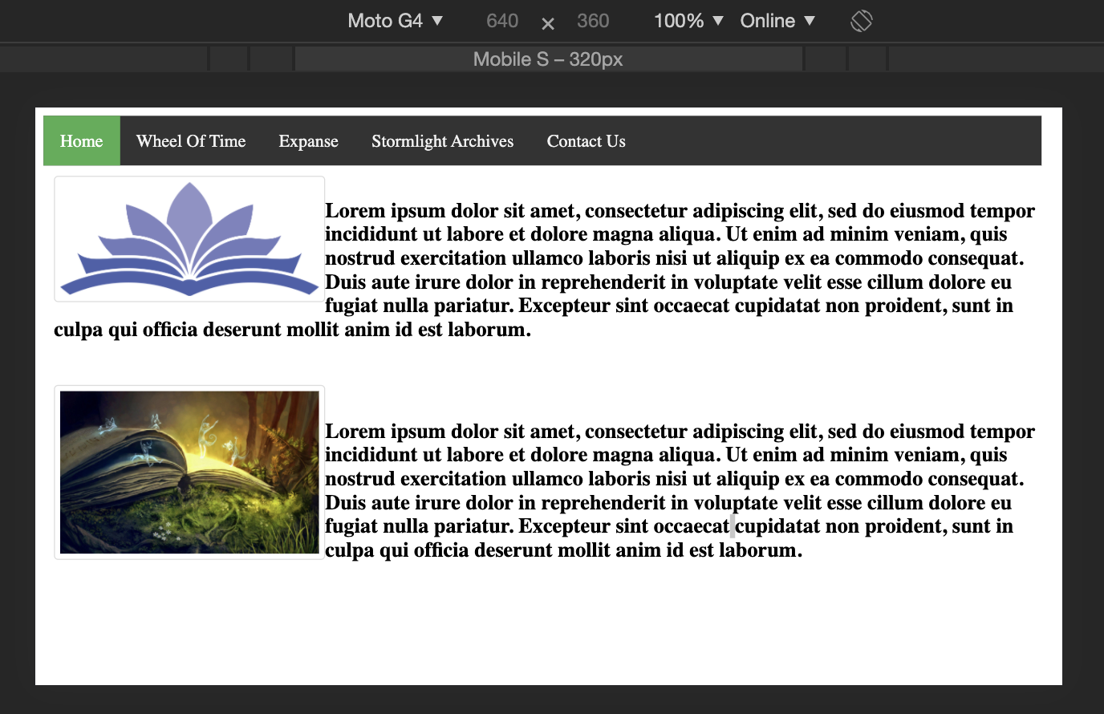

Pixel 2 XL

Layout Issues: There is far much blank space at the bottom of the page, with no footer it appears that the page goes on forever. With landscape, this appears to not be an issue.

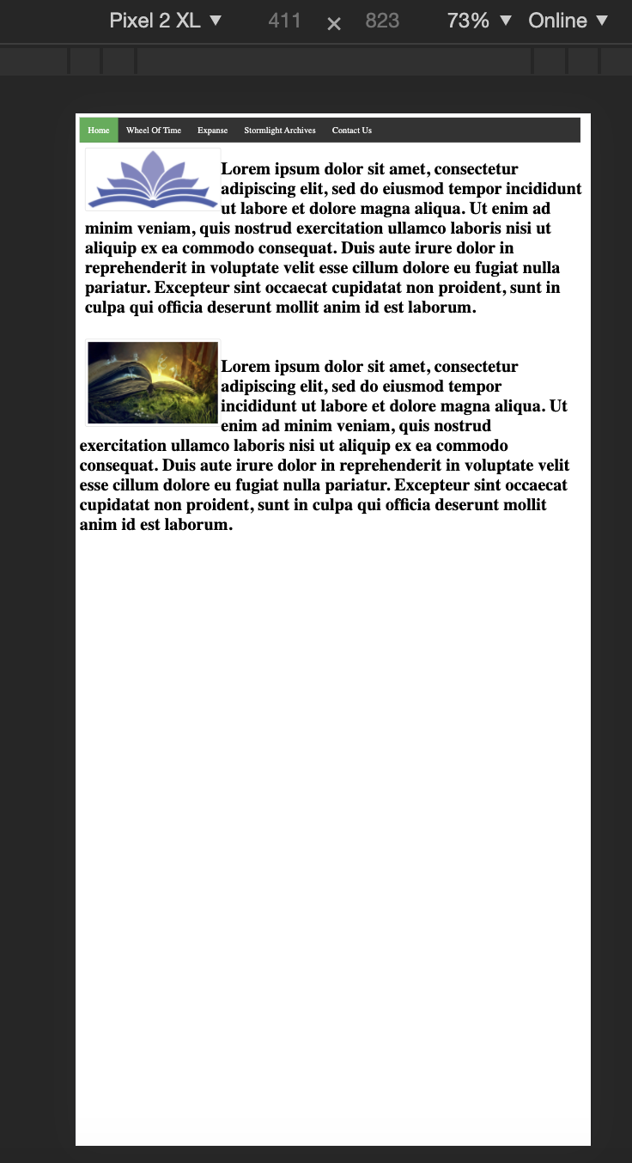

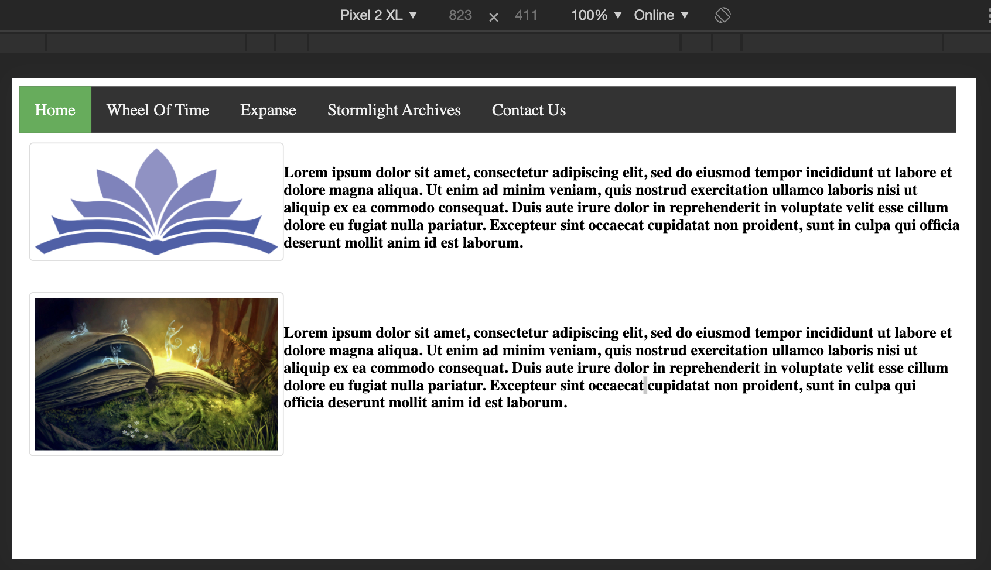

Iphone 5/6/7/8

Layout Issue: Images I selected don’t show up clearly on mobile screen , I need to choose better images that clearly display on mobile devices

