Module 05 Course Project - Editing CSS Using Developers' Tools

Jacob Hanson

Rasmussen College

Editing CSS Using Developers' Tools

Christopher Mattie

May 10th, 2020

Changes

Change Color of top nav bar, and action button to show what page is active

Removed code that aligns photos a certain way to better show the photos disconnected from the paragraphs.

Better changing the color allows users to clearly see the difference of the Nav bar to the page itself, while also displaying what page the user is on. This will help the users navigate around the site and clearly tell them where they are in relations to the site.

Removed code:

.leftPhoto

{

display: block;

padding: 10px;

clear: right;

width: 100%;

border-radius: 5px;

border-width: 3px;

border-color: red;

}

img {

float: left;

border: 1px solid #ddd;

border-radius: 4px;

padding: 5px;

width: 250px;

}

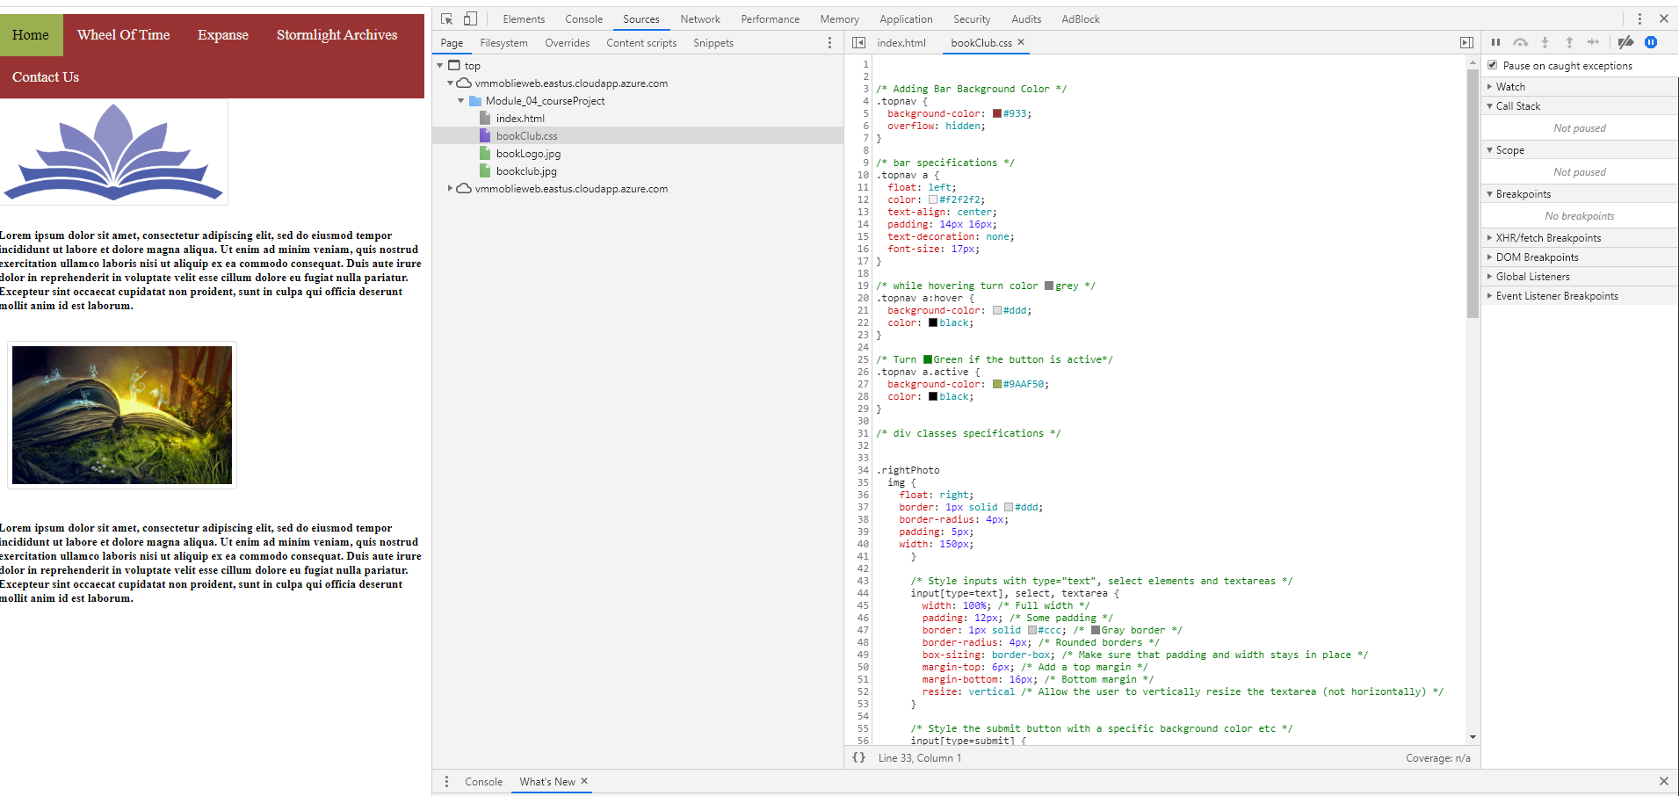

Yes, I feel that the changes that I made will make it into the final edition of the website, they do a create job of breaking up the photos and the paragraphs and clearly breaking the page up so users can easily read the page. Also with the changes to the color of the nav bar users can clearly see what page they are on, and where they are going throughout the website.