Insurance Pricing and Risk Analytics Project
1. Introduction
1.1 Project Overview
The insurance industry relies heavily on data-driven decision making to accurately assess risk, determine appropriate premiums, and maintain portfolio profitability. The objective of this project was to design and implement a complete insurance analytics pipeline that demonstrates the full lifecycle of insurance data management, from database creation and validation through to actuarial pricing and risk modelling.
The project combines SQL and Python to create a realistic motor insurance portfolio containing customers, vehicles, policies, and claims. The dataset was generated using synthetic data techniques and stored within a relational SQLite database. Following data generation, extensive validation checks were performed to ensure data quality and consistency before exploratory analysis and actuarial modelling were undertaken.
The final stages of the project focused on developing a pricing framework based on claim frequency and claim severity modelling. Additional stress testing and Monte Carlo simulation techniques were then applied to evaluate portfolio risk under adverse scenarios.
1.2 Project Objectives
The key objectives of the project were:
- Design and implement a relational insurance database.
- Generate a realistic insurance portfolio.
- Validate data quality using SQL and Python.
- Identify claim trends and risk factors through exploratory analysis.
- Engineer useful predictive features.
- Develop claim frequency and severity pricing models.
- Estimate pure premiums for individual policyholders.
- Evaluate portfolio performance under stress scenarios.
- Quantify portfolio risk using Monte Carlo simulation.
- Demonstrate advanced SQL analytical techniques.
1.3 Technology Stack
The project utilised the following technologies:
Technology | Purpose
SQLite | Relational database management
SQL | Data validation and analytics
Python | Data cleaning and modelling
Pandas | Data manipulation
Statsmodels | GLM actuarial modelling
Matplotlib | Visualisation
Seaborn | Statistical visualisation
Faker | Synthetic data generation

2. Database Design and Data Generation
2.1 Database Structure
The insurance portfolio was modelled using four primary tables:
Customers
The Customers table stores demographic information for policyholders.

Field
CustomerID
Name
Age
Gender
Location
DatePassedDrivingTest

Vehicle
The Vehicle table stores information relating to insured vehicles.

Field
VehicleID
CustomerID
Brand
Age
Mileage
Value
Policy
The Policy table stores policy-level information.

Field
PolicyID
CustomerID
VehicleID
StartDate
EndDate
LengthOfPolicy
CoverageType
Excess
Premium

Claims
The Claims table stores all submitted claims.

Field
ClaimsID
PolicyID
ClaimDate
ClaimType
ClaimStatus
Amount
2.2 Primary and Foreign Keys
To ensure referential integrity, primary and foreign key relationships were established throughout the database.
- CustomerID uniquely identifies each customer.
- VehicleID uniquely identifies each vehicle.
- PolicyID uniquely identifies each policy.
- ClaimsID uniquely identifies each claim.
Foreign key relationships include:
- Vehicle.CustomerID → Customers.CustomerID
- Policy.CustomerID → Customers.CustomerID
- Policy.VehicleID → Vehicle.VehicleID
- Claims.PolicyID → Policy.PolicyID
This structure ensures that all policies are linked to valid customers and vehicles while every claim is linked to a valid policy.

2.3 Data Generation Process
Synthetic data was generated using Python and the Faker library.
The customer population consisted of approximately 10,000 policyholders. Customer ages were generated using a beta distribution to create a realistic concentration of younger and middle-aged drivers while maintaining smaller proportions of older drivers.
Vehicle values were determined using:
- Vehicle brand
- Vehicle age
- Annual mileage
- Depreciation factors
Luxury vehicle brands such as Ferrari, Lamborghini and Porsche were assigned substantially higher base values than standard vehicle brands.
Policy premiums were generated using an expected loss framework based on:
Expected Loss = Frequency × Severity
Additional premium adjustments were applied for:
- Driver age
- Coverage level
- Vehicle value
- Policy excess
Claims were generated probabilistically with approximately 18% of policies experiencing at least one claim.

3. Data Cleaning and Validation
3.1 Validation Framework
A comprehensive validation framework was implemented using SQL queries and Python scripts to ensure the generated dataset remained realistic and internally consistent.
Validation checks focused on:
- Duplicate records
- Missing values
- Referential integrity
- Range validation
- Business rule validation

3.2 Duplicate Record Checks
Duplicate primary keys were investigated across all tables using SQL aggregation queries.
No duplicate primary key values were identified within:
- Customers
- Vehicle
- Policy
- Claims
This confirmed successful implementation of primary key constraints.

3.3 Missing Value Analysis
All critical fields were assessed for missing values.
The following attributes were validated:
- Customer demographics
- Vehicle characteristics
- Policy information
- Claims information
No missing values were detected within mandatory fields.

3.4 Customer Validation
Customer ages were assessed to ensure values remained within realistic boundaries.
Validation confirmed:
- Minimum age exceeded legal driving age requirements.
- No customers exceeded the maximum expected age threshold.
- Driver test dates remained consistent with customer ages.

3.5 Vehicle Validation
Vehicle values and mileage records were validated.
Checks confirmed:
- No vehicles possessed negative mileage.
- No vehicles possessed zero or negative values.
- Vehicle values remained consistent with depreciation assumptions.

3.6 Policy Validation
Policy start and end dates were validated.
Checks confirmed:
- Policy end dates always occurred after policy start dates.
- Policy durations were correctly calculated.
- Premiums remained within expected commercial ranges.

3.7 Claims Validation
Claims data was validated using multiple business rules.
Checks confirmed:
- No negative claim amounts.
- No denied claims received positive payments.
- Claim payments never exceeded vehicle values.
- Approved claims followed coverage restrictions.
These checks provided confidence that the claims portfolio accurately reflected realistic insurance behaviour.
4. Exploratory Data Analysis
4.1 Introduction
Following successful validation of the dataset, exploratory data analysis (EDA) was performed to identify patterns within the insurance portfolio. The objective of this stage was to understand the distribution of claims, identify high-risk customer segments, and investigate how claim behaviour varied across different demographic and policy characteristics.
The analysis focused on:
- Claim type distributions
- Customer age profiles
- Vehicle brand performance
- Claims trends over time
- Portfolio profitability indicators

4.2 Claim Type Distribution
The first stage of the analysis examined how total claim costs were distributed across different claim categories.
Figure 1: Distribution of Total Claim Amount by Claim Type
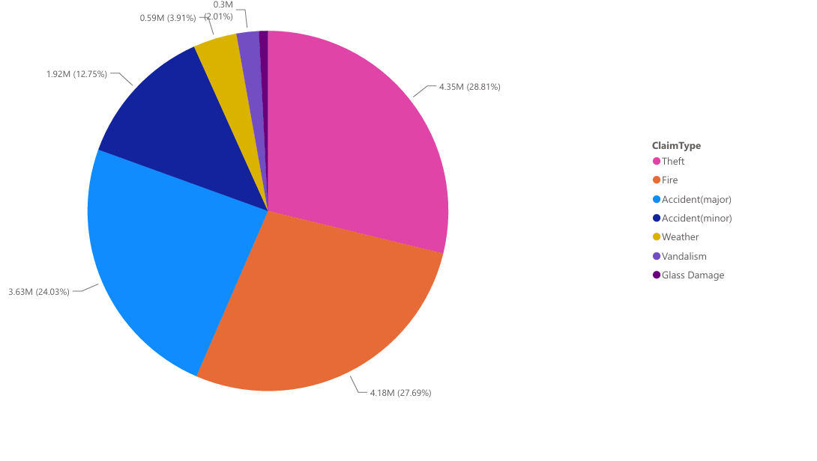
The results show that theft-related claims represented the largest proportion of total claim costs, accounting for 28.81% of all claims (£4.35 million). Fire claims were the second largest contributor, representing 27.69% (£4.18 million), followed closely by major accidents at 24.03%(£3.63 million).
While weather accounted for the most number of claims, it only amounted 3.91% of the total claim amount.
These findings indicate that although theft and fire claims occur less frequently than minor accidents, their significantly higher severity causes them to dominate overall claim expenditure. This observation supports the need for severity modelling within the pricing framework, as claim frequency alone would underestimate portfolio risk.
Key Findings
- Theft generated the largest share of losses.
- Fire claims represented a substantial source of severity risk.
- Major accidents contributed almost one-quarter of all claim costs.
- Lower-severity claim types had limited impact on overall portfolio losses.

4.3 Claim Amount by Customer Age
The relationship between age and total claim cost was investigated to determine whether particular age groups represented elevated levels of risk.
Figure 2: Total Claim Amount by Customer Age
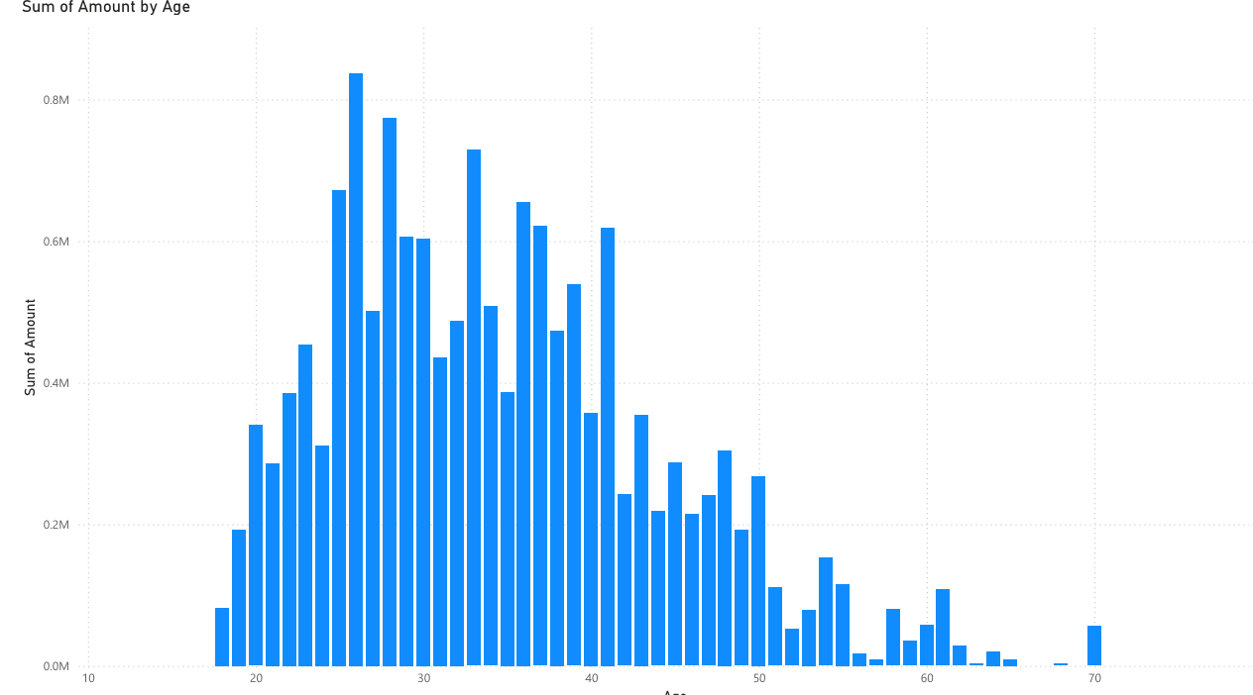
The analysis revealed a clear concentration of claim costs among younger drivers. Total claims peaked at age 26, reaching approximately £825,000. Following this peak, claim amounts gradually declined as driver age increased.
The distribution was noticeably right-skewed, with the majority of claims concentrated between ages 25 and 40. Drivers aged over 60 generated the lowest total claim costs across the portfolio.
This trend is consistent with established insurance theory, where younger drivers generally possess less driving experience and therefore exhibit higher accident frequencies and claim costs.
Key Findings
- Age 26 generated the highest total claim amount.
- Most claims were concentrated between ages 25 and 40.
- Older drivers exhibited significantly lower claim costs.
- Age appears to be an important rating factor for pricing purposes.

4.4 Claim Amount by Vehicle Brand
Vehicle brands were analysed to determine whether certain manufacturers generated disproportionately high claim costs.
Figure 3: Total Claim Amount by Vehicle Brand
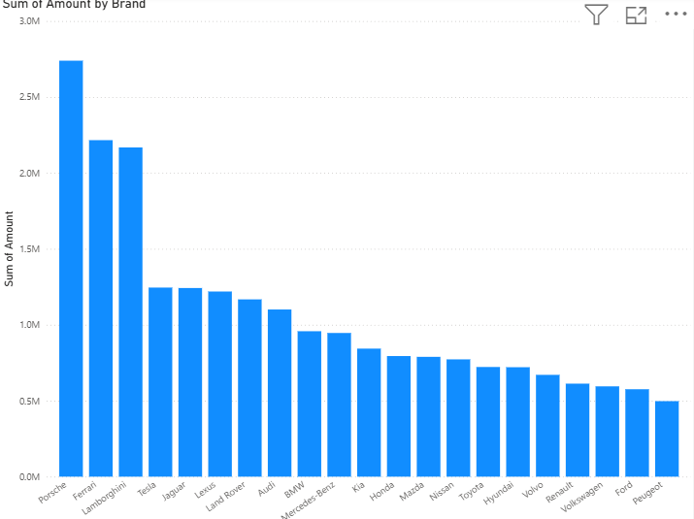
The results demonstrate substantial variation between vehicle brands.
Porsche generated the highest total claim costs, followed by Ferrari and Lamborghini. These luxury vehicle manufacturers produced claim totals ranging between approximately £2 million and £3 million.
In contrast, Volkswagen, Ford and Peugeot generated the lowest claim costs within the portfolio.
Most vehicle brands generated total claims between £500,000 and £1 million, suggesting relatively stable loss experience among standard vehicle categories. The substantially higher losses associated with luxury vehicles likely reflect their greater repair costs, higher replacement values and increased claim severity.
Key Findings
- Porsche represented the highest-risk vehicle brand.
- Ferrari and Lamborghini also generated exceptionally high losses.
- Standard vehicle brands produced relatively stable claim costs.
- Luxury vehicles appear significantly more expensive to insure.

4.5 Claims Over Time
Claim frequency was analysed over time to identify any emerging trends or unusual patterns.
Figure 4: Number of Claims by Year
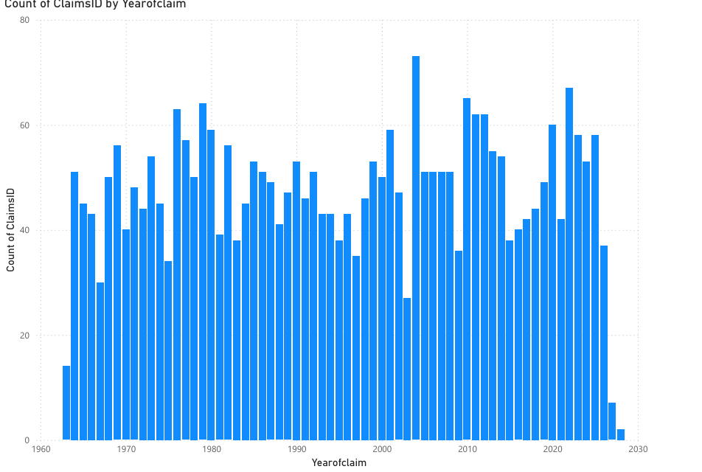
Annual claim frequency remained relatively stable throughout most of the observation period, averaging approximately 40 claims per year.
The highest claim frequency occurred in 2004, when 73 claims were recorded. The lowest frequency occurred in 2003, with 27 claims.
A noticeable decline occurs after 2026. This reduction is attributable to the synthetic nature of the dataset and the policy generation process rather than an actual reduction in risk.
Overall, the relatively stable claim frequency suggests that the portfolio does not exhibit substantial temporal volatility.
Key Findings
- Claims remained broadly stable over time.
- Peak frequency occurred in 2004.
- Lowest frequency occurred in 2003.
- No sustained upward or downward trend was observed.

4.6 Portfolio Profitability Analysis
The relationship between premiums collected, claims paid and resulting profit was examined to assess portfolio performance.
Figure 5: Net Profit, Earned Premium and Claims Paid
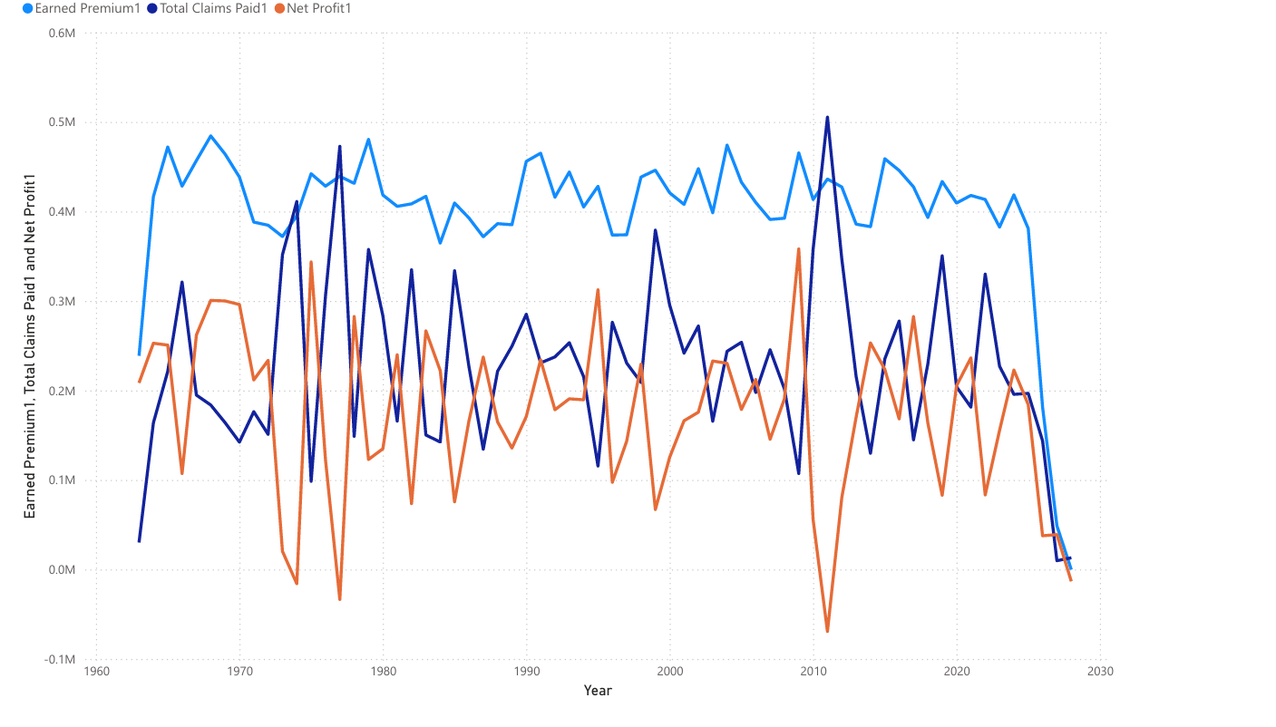
The analysis indicates that the portfolio remained profitable for the majority of the observation period.
Net profit reached its highest level in 2009, generating approximately £350,000. The largest loss occurred in 2011, where portfolio profitability fell to approximately negative £70,000.
Additional periods of negative profitability were observed during parts of the 1970s. However, these periods were relatively infrequent and limited in magnitude.
Overall, earned premium generally exceeded claims paid, demonstrating that the pricing framework generated a sustainable level of profitability.
Key Findings
- Portfolio profitability was positive in most years.
- Largest profit occurred in 2009.
- Largest loss occurred in 2011.
- Premium income generally exceeded claims expenditure.

4.7 Loss Ratio Analysis
Loss ratio represents one of the most important performance indicators within insurance pricing.
Loss Ratio = Claims Paid / Premium Earned
Figure 6: Loss Ratio by Year
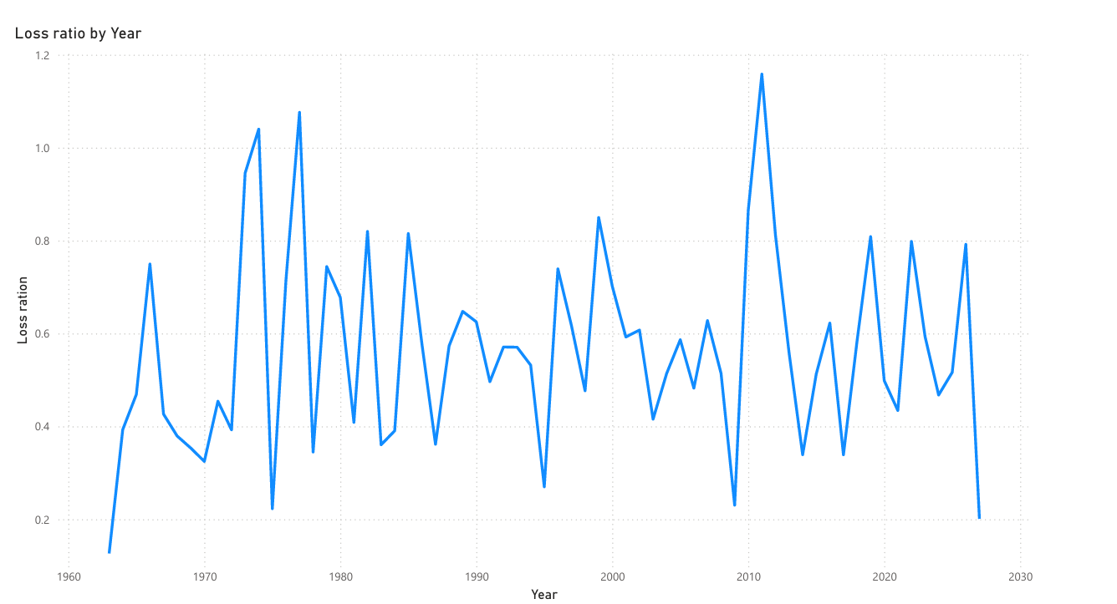
Loss ratios ranged between approximately 0.10 and 1.18 throughout the analysis period.
The highest loss ratio values occurred during the same periods where profitability was lowest, while the lowest loss ratios coincided with the most profitable years.
A loss ratio above 1 indicates that claims exceeded premium income, resulting in underwriting losses. Conversely, loss ratios below 1 indicate profitable underwriting performance.
The majority of observations remained below 1, supporting the conclusion that the portfolio was generally profitable.
Key Findings
- Loss ratios ranged between 0.10 and 1.15.
- Most years remained below the critical threshold of 1.
- Higher loss ratios corresponded with reduced profitability.
- Portfolio pricing remained broadly adequate.

4.8 Summary of Exploratory Analysis
The exploratory analysis identified several important risk characteristics within the portfolio.
The strongest drivers of claim cost were:
- Vehicle brand.
- Customer age.
- Claim type.
- Coverage level.
Luxury vehicles generated significantly higher losses than standard vehicles, while younger drivers consistently produced larger claim totals than older drivers. Theft, fire and major accident claims dominated portfolio losses due to their high severity.
These findings provide a strong foundation for the actuarial pricing models developed in the next stage of the project.
5. Feature Engineering and Pricing Model Development
5.1 Introduction
Following exploratory analysis, additional predictive variables were created to improve the quality of the actuarial pricing models. Feature engineering is a critical stage within insurance analytics because raw transactional data often does not directly capture underlying risk characteristics.
The objective of this stage was to derive meaningful indicators of policyholder behaviour and claims experience which could subsequently be incorporated into pricing models.
The engineered features were created using SQL views and stored within the database to allow efficient retrieval and future reuse.

5.2 Feature Engineering
Several new variables were developed from the underlying claims and policy data.
Customer Claim Frequency
Customer claim frequency measures the total number of claims submitted by each customer.
SQL View
CREATE VIEW customer_claim_frequency AS
SELECT
p.customerid,
COUNT(c.claimsid) AS claim_frequency
FROM policy p
INNER JOIN claims c
ON p.policyid = c.policyid
GROUP BY p.customerid;
Claim frequency is widely used within actuarial pricing because historical claims behaviour often provides insight into future risk.

Customer Claim Summary
A customer-level summary was created to consolidate overall claims performance.
The summary included:
- Total number of claims
- Total claim cost
- Average claim cost
This view provides a concise measure of individual policyholder risk.
SQL View
CREATE VIEW customer_claim_summary AS
SELECT
p.customerid,
COUNT(c.claimsid) AS number_of_claims,
SUM(c.amount) AS total_claim_amount,
AVG(c.amount) AS avg_claim_amount
FROM policy p
INNER JOIN claims c
ON p.policyid = c.policyid
GROUP BY p.customerid;

Policy Claim Summary
A policy-level view was created to measure claims experience for each individual policy.
SQL View
CREATE VIEW policy_claim_summary AS
SELECT
policyid,
COUNT(claimsid) AS number_of_claims,
SUM(amount) AS total_claim_amount,
AVG(amount) AS avg_claim_amount
FROM claims
GROUP BY policyid;
This view provides a convenient summary for underwriting and portfolio monitoring purposes.

Average Claim Severity
Average claim severity was calculated across the portfolio.
SQL View
CREATE VIEW average_claim_severity AS
SELECT
AVG(amount) AS avg_claim_severity
FROM claims;
Claim severity represents the average financial impact of a claim and forms one of the two core components of actuarial pricing.

5.3 Pricing Framework
The pricing methodology adopted within this project follows a standard actuarial pure premium approach.
Expected claim costs are estimated by combining:
- Claim frequency
- Claim severity
The expected loss is therefore calculated as:
Expected Loss = Claim Frequency x Claim Severity
This approach separates the probability of a claim occurring from the expected cost of that claim, allowing each component to be modelled independently.

6. Claim Frequency Modelling
6.1 Poisson Regression Model
Claim frequency represents count data and therefore lends itself naturally to Poisson regression techniques.
A Generalised Linear Model (GLM) with a Poisson distribution was fitted using:
- Age
- Gender
- Coverage type
as explanatory variables.
The model estimates the expected number of claims for each policyholder.
Model Inputs
Variable | Type
Age | Numeric
Gender | Categorical
Coverage Type | Categorical
The target variable was:
Number of Claims

6.2 Frequency Model Results
The Poisson model successfully estimated claim frequencies across the portfolio.
A dispersion analysis was also performed to assess whether the Poisson assumption was appropriate.
The variance of claim counts was found to be reasonably consistent with the mean, suggesting that the Poisson framework provided an acceptable representation of claim frequency behaviour.
Figure 7: Frequency Model Summary Output
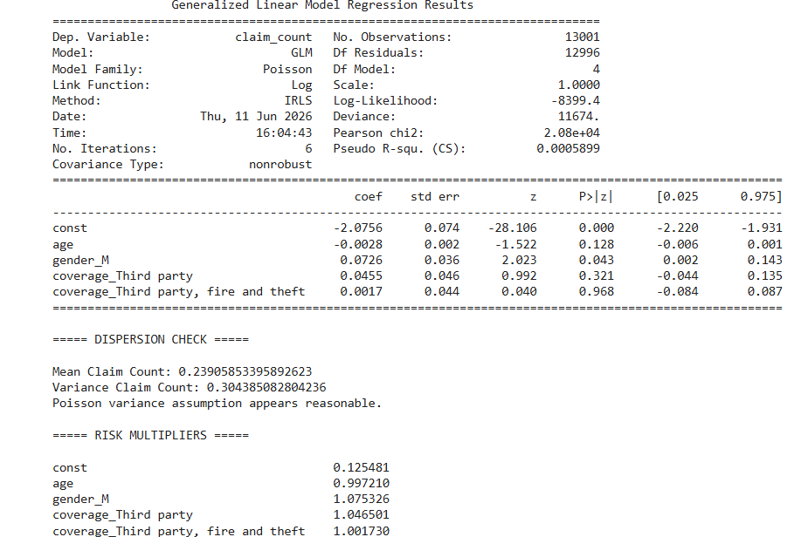The model identified meaningful relationships between customer characteristics and expected claim frequency.
Younger drivers generally exhibited higher predicted claim frequencies, while coverage type also influenced expected claim counts.

6.3 Frequency Predictions
Predicted claim frequencies were generated for every customer within the portfolio.
These predictions form the first component of the pure premium calculation.

7. Claim Severity Modelling
7.1 Gamma Regression Model
Claim severity was modelled using a Gamma Generalised Linear Model with a logarithmic link function.
The Gamma distribution is widely used in insurance because claim amounts are:
- Positive
- Continuous
- Right-skewed
The model used:
- Age
- Gender
- Coverage Type
- Number of Claims
as explanatory variables.

7.2 Severity Model Results
The severity model estimated expected claim costs for individual customers.
Figure 8: Gamma Severity Model Summary
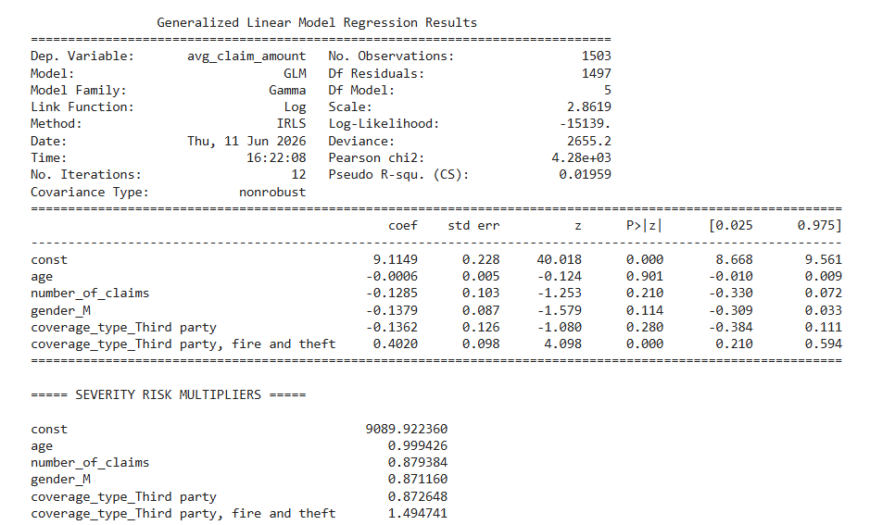The model demonstrated expected insurance behaviour, with claim severity increasing for certain customer and policy characteristics.
Because very large claims occur relatively infrequently, some prediction error remained within the highest severity observations.
This behaviour is common within insurance modelling and reflects the difficulty of predicting rare catastrophic losses.

7.3 Actual vs Predicted Severity
The predictive performance of the severity model was assessed by comparing actual claim amounts against predicted values.
Figure 9: Actual vs Predicted Claim Severity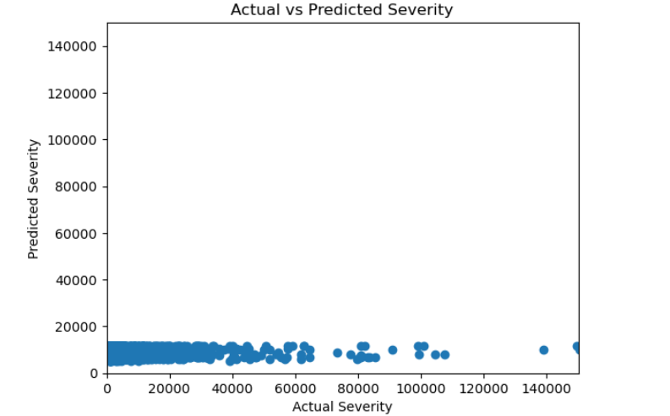
The results indicate that the model captures overall severity patterns reasonably well.
Predictions generally increase alongside actual claim amounts, demonstrating that the model successfully identifies broad severity trends.
However, the model tends to underestimate a small number of extremely large claims. This is a common characteristic of insurance pricing models because catastrophic claims occur infrequently and contain limited historical information.
Key Findings
- Strong relationship between actual and predicted values.
- Good performance for typical claims.
- Slight underestimation of extreme losses.
- Suitable for portfolio-level pricing applications.

8. Pure Premium Modelling
8.1 Pure Premium Calculation
The final pricing metric was calculated by combining frequency and severity predictions.
Pure Premium = Predicted Frequency × Predicted Severity
This represents the expected annual claim cost for each policyholder.

8.2 Pure Premium Distribution
The distribution of predicted pure premiums was examined to understand overall portfolio risk.
Figure 10: Pure Premium Distribution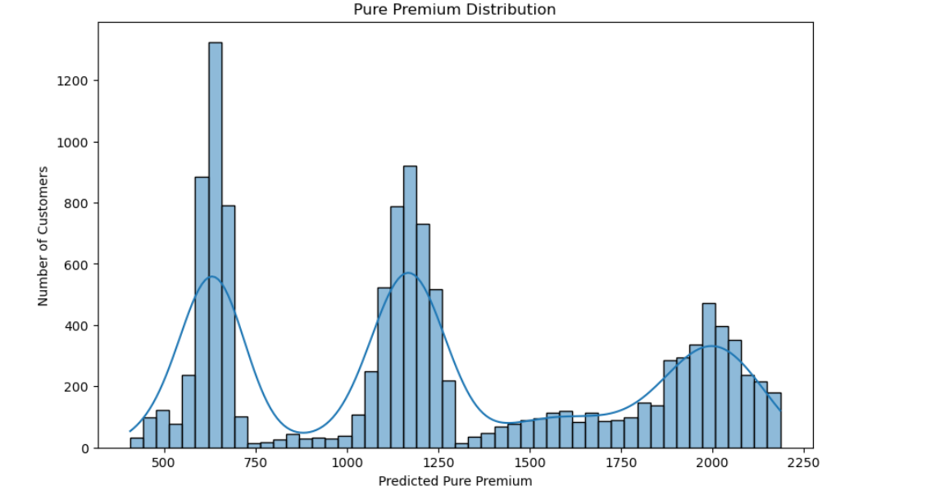
The distribution displays a clear concentration of customers within lower and medium-risk categories, with a smaller proportion of customers exhibiting substantially higher expected losses.
This pattern is typical of insurance portfolios where a relatively small number of policyholders account for a disproportionately large share of expected claims costs.

8.3 Risk Band Classification
Customers were segmented into three risk categories:
- Low Risk
- Medium Risk
- High Risk
using quantile-based thresholds.
Figure 11: Pure Premium by Risk Band
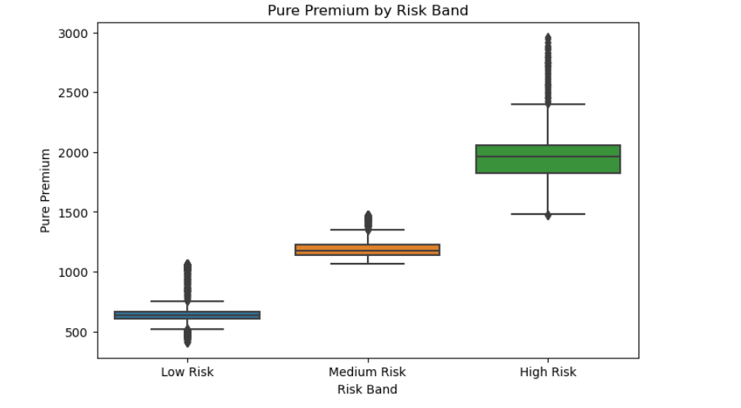The resulting segmentation clearly differentiates customers according to expected loss.
Low-risk customers possess significantly lower expected costs, while high-risk customers generate considerably larger expected losses.
This segmentation could be used directly within a commercial pricing framework to support underwriting decisions and premium differentiation.
Key Findings
- Clear separation between risk groups.
- High-risk customers exhibit substantially larger expected losses.
- Pure premium provides an effective measure of customer risk.
- Risk segmentation supports targeted pricing strategies.

8.4 Pricing Model Summary
The pricing framework successfully combines claim frequency and claim severity modelling to estimate expected future losses.
The resulting pure premium metric provides a practical foundation for insurance pricing and demonstrates how actuarial modelling techniques can be applied to real-world insurance portfolios.
The next stage of the project investigates how this pricing framework performs under adverse scenarios and extreme events.
9. Advanced SQL Analytics
9.1 Introduction
The purpose of the advanced SQL analytics stage was to move beyond simple aggregation and explore more sophisticated methods of identifying risk patterns within the insurance portfolio.
Window functions were used to rank customers, age groups, policy characteristics and coverage types according to multiple risk measures, whilst complex joins allowed claims experience to be analysed alongside policyholder and policy information.
These techniques replicate many of the analytical processes used within actuarial and insurance reporting environments.

9.2 Customer Risk Ranking
Customers were ranked using three separate measures:
- Total number of claims
- Total claim cost
- Average claim severity
The objective was to identify policyholders contributing the greatest level of portfolio risk.
Figure 12: Top Customers by Total Claims
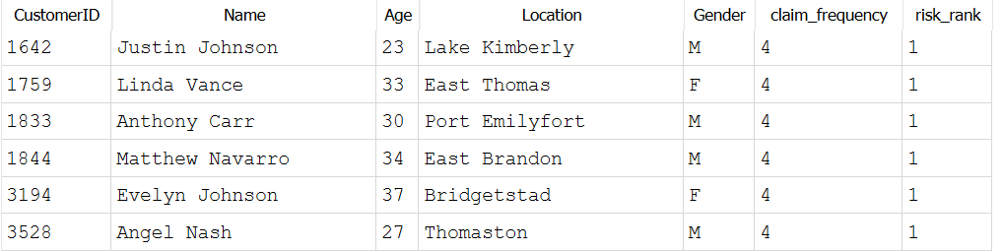Customers with multiple claims consistently appeared at the top of the ranking. This suggests that previous claims behaviour may be a useful indicator of future claims activity.

Figure 13: Top Customers by Total Claim Cost
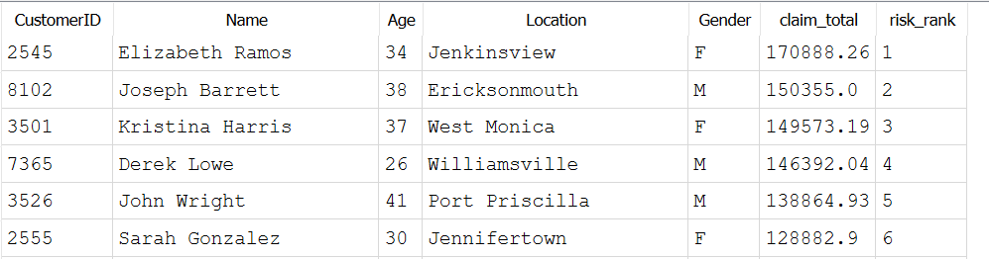A relatively small number of customers generated substantially higher losses than the remainder of the portfolio.
This finding supports a common insurance principle that losses are often concentrated amongst a small subset of policyholders.

Figure 14: Top Customers by Average Claim Severity
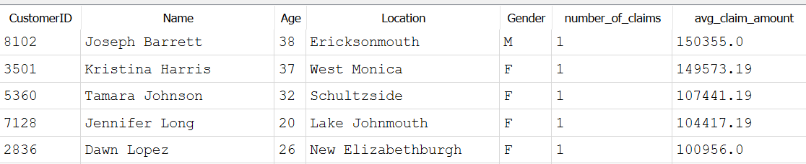Customers exhibiting high average claim severity represent a significant source of underwriting risk, even if claim frequency remains relatively low.
This demonstrates the importance of modelling both frequency and severity separately within actuarial pricing.

9.3 Age-Based Risk Analysis
Age is one of the most widely used rating factors within motor insurance because driver behaviour often changes throughout the lifecycle.
Age groups were ranked using:
- Claim frequency
- Total claims generated
- Loss ratio
Figure 15: Claim Amount by Age
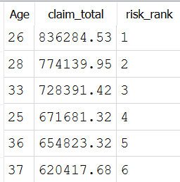
The analysis shows a pronounced concentration of claim costs amongst younger drivers.
Claim amounts peak at approximately age 26, where total claims exceed £825,000.
Following this peak, claim costs gradually decline as age increases.
The distribution is positively skewed, with most claims occurring between ages 25 and 40, whilst customers aged over 60 generate comparatively low levels of claims activity.
This result is consistent with established insurance experience, where younger drivers generally exhibit higher risk due to reduced driving experience and more frequent accident involvement.

9.4 Coverage Type Risk Analysis
Coverage types were analysed to determine whether certain products generated greater claims experience than others.
The analysis compared:
- Claim frequency
- Claim severity
- Loss ratio
Figure 16: Coverage Type Risk Ranking
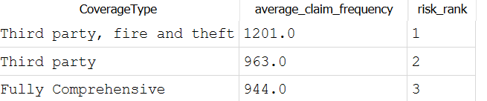
Coverage products offering broader protection generally generated higher claim frequencies and greater average claim severities.
This outcome is expected because comprehensive policies cover a wider range of loss events than third-party products.
The findings demonstrate how product design directly influences portfolio risk exposure.

9.5 Relative Risk Analysis
Relative risk analysis was performed to identify groups performing above or below the portfolio average.
The analysis compared:
- Customers versus average customer loss
- Age groups versus portfolio average loss
- Coverage types versus baseline loss
Figure 17: Relative Risk Classification
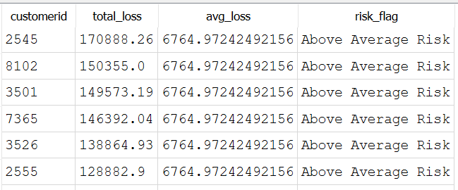
The analysis successfully identified customer segments operating above the portfolio average risk level.
These segments could be targeted for:
- Premium adjustments
- Enhanced underwriting review
- Additional risk management controls

9.6 Claim Intensity Analysis
Policy duration was investigated to determine whether longer policy periods generated greater claims activity.
Figure 18: Claims by Policy Duration
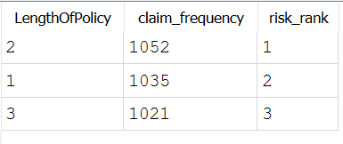
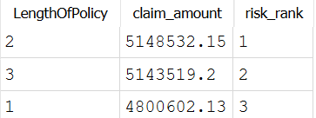
The results are very equal and there does not seem to be any correlation between policy length and the claim frequency/severity.

9.7 Rolling Average Analysis
A rolling average of claims was calculated using SQL window functions.
Figure 19: Rolling Average Claims
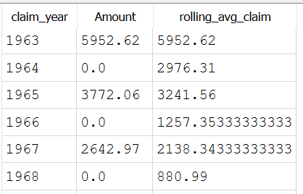
The rolling average smooths short-term fluctuations and highlights longer-term trends within claims behaviour.
This technique is commonly used in insurance reporting to distinguish underlying trends from random year-to-year variation.

10. Stress Testing and Scenario Analysis
10.1 Introduction
Insurance companies must understand how changes in claims behaviour impact profitability.
To assess portfolio resilience, several stress-testing scenarios were applied to the pricing model.
The scenarios examined:
- Increased claim frequency
- Increased claim severity
- Catastrophic events

10.2 Frequency Stress Testing
The first scenario increased expected claim frequencies by:
- 10%
- 20%
- 50%
Expected losses were recalculated under each scenario.
Figure 20: Frequency Stress Testing Results
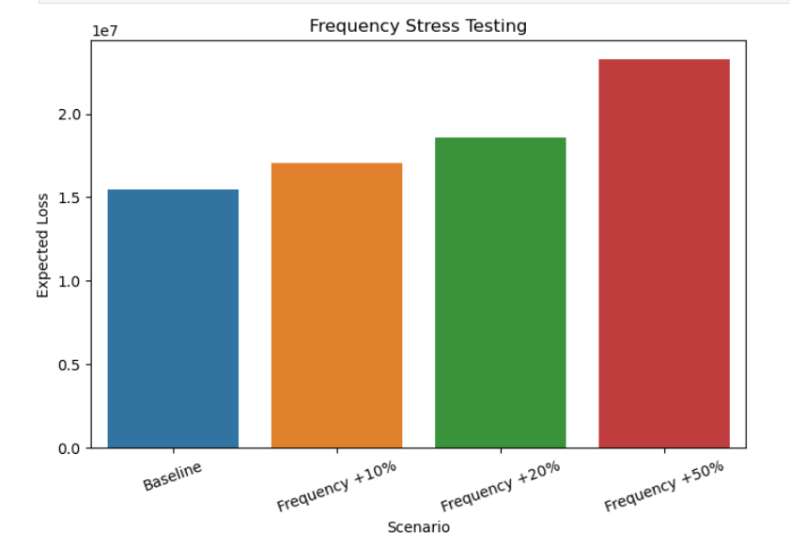
As expected, portfolio losses increased proportionally with claim frequency.
A 10% increase in claim frequency produced an approximately 10% increase in expected losses.
The results demonstrate the sensitivity of insurer profitability to changes in claim occurrence rates.
Even relatively small increases in frequency can have a significant financial impact when applied across an entire portfolio.

10.3 Severity Stress Testing
A separate scenario increased claim severity by 25%.
Figure 21: Severity Stress Testing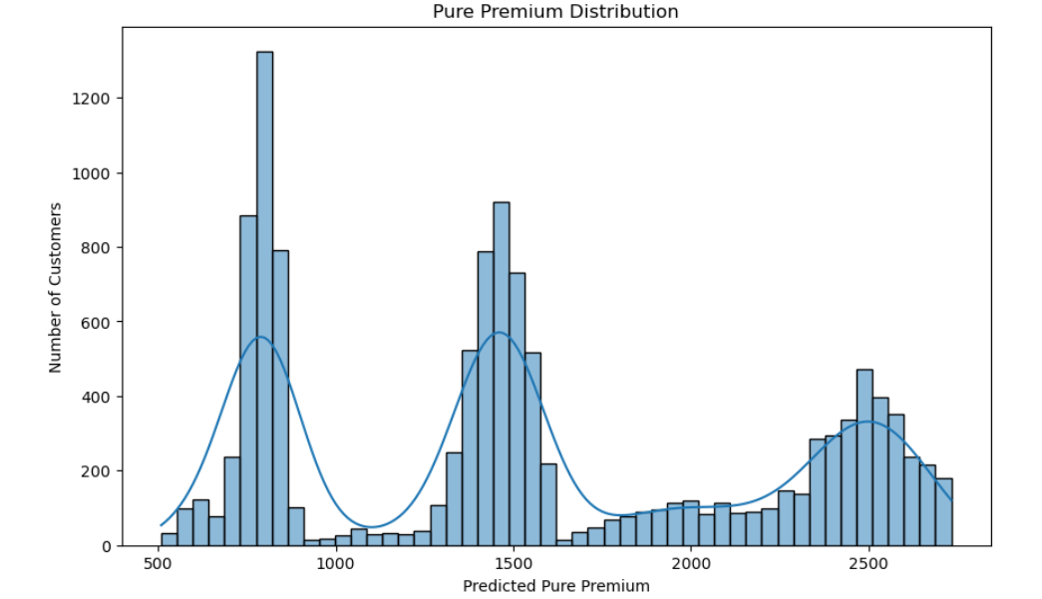The distribution maintained a similar shape to the baseline model but shifted noticeably upward.
The peak of the distribution increased from approximately £650 to around £800, reflecting the direct effect of larger average claim costs.
The results demonstrate that claim severity inflation can significantly increase expected losses, even when claim frequency remains unchanged.

11. Catastrophe Modelling
11.1 Introduction
Catastrophic events represent low-frequency, high-severity occurrences capable of generating substantial losses across an insurance portfolio.
Examples include:
- Severe storms
- Flooding
- Major fire events
- Widespread theft incidents
To simulate this type of event, 5% of customers were randomly selected and their predicted claim severity was increased by 400%.

11.2 Catastrophe Scenario Results
Figure 22: Catastrophe Scenario Distribution
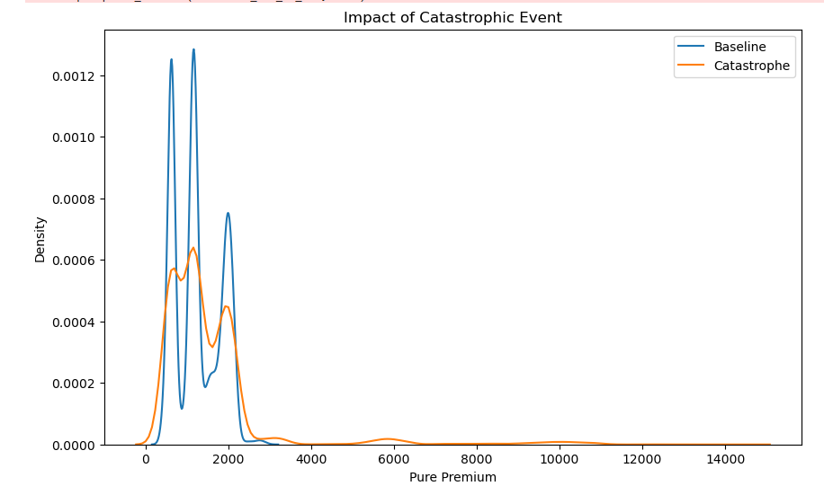The catastrophe scenario produced a significant upward shift in portfolio losses.
Portfolio Impact
Metric | Value
Baseline Loss | £15,502,664
Catastrophe Loss | £18,672,005
Increase | £3,169,341
The catastrophe event increased expected portfolio losses by over £3.1 million.
Although only a small proportion of customers were affected, the large increase in severity generated a substantial financial impact.
This highlights the importance of catastrophe modelling, capital management and reinsurance arrangements within insurance operations.

12. Monte Carlo Simulation
12.1 Introduction
Whilst stress testing evaluates specific scenarios, Monte Carlo simulation allows the full distribution of potential outcomes to be examined.
The simulation combines:
- Poisson claim frequency
- Gamma claim severity
to generate thousands of possible future portfolio loss outcomes.
A total of 10,000 simulations were performed.

12.2 Simulation Results
Figure 23: Monte Carlo Portfolio Loss Distribution
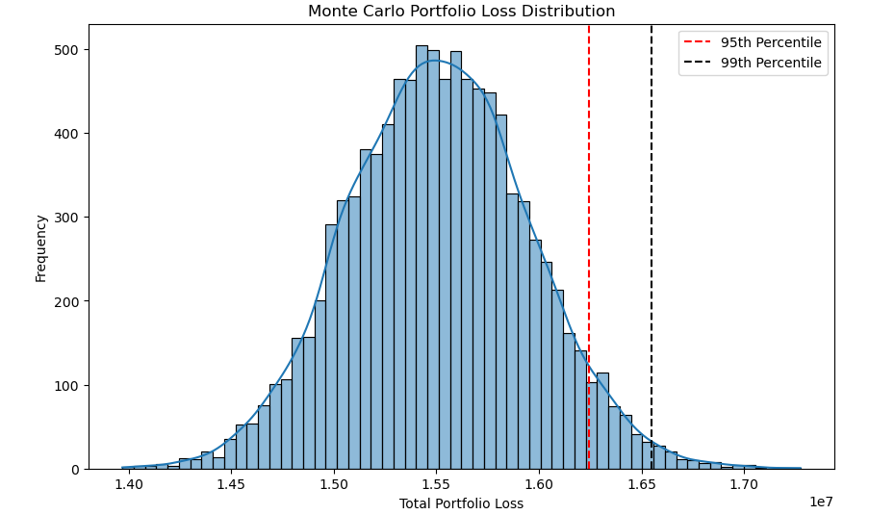The distribution exhibits the expected bell-shaped pattern, centred around the portfolio's expected loss level.
Key Results
Measure | Value
Mean Loss | £15,510,454
95% VaR | £16,242,516
99% VaR | £16,548,647

12.3 Value at Risk Analysis
Value at Risk (VaR) estimates the loss level expected to be exceeded only within a specified percentage of outcomes.
The results indicate:
- 95% of simulated outcomes fall below approximately £16.24 million.
- 99% of simulated outcomes fall below approximately £16.55 million.
This suggests that extreme portfolio losses remain reasonably contained relative to the expected loss level.
The simulation therefore indicates that the portfolio exhibits a moderate level of risk under the model assumptions.

12.4 Importance of Monte Carlo Modelling
Monte Carlo simulation provides several advantages:
- Captures uncertainty in future claims experience.
- Quantifies tail risk.
- Supports capital modelling.
- Provides insight into extreme loss scenarios.
These techniques are widely used within actuarial reserving, pricing and enterprise risk management.
13. Conclusions and Recommendations
13.1 Project Summary
The aim of this project was to design and develop a complete insurance analytics and pricing framework using SQL and Python. The project replicated many of the processes undertaken within actuarial and insurance data teams, including database design, data validation, exploratory analysis, feature engineering, predictive modelling and risk assessment.
A relational database containing customer, vehicle, policy and claims information was created and populated with over 10,000 customers and associated policy records. SQL was used extensively throughout the project to manage, validate and analyse the data, while Python was used for statistical modelling, simulation and visualisation.
The project successfully demonstrated how raw insurance data can be transformed into actionable insights capable of supporting pricing and risk management decisions.

13.2 Key Findings
Claims Analysis
Analysis of claim types revealed that theft and fire claims generated the largest proportion of losses within the portfolio.
- Theft accounted for approximately 28.8% of all claim costs.
- Fire accounted for approximately 27.7%.
- Major accidents represented approximately 24.0%.
Together, these three claim categories generated more than 80% of all claim costs, indicating that a relatively small number of severe claim types dominate portfolio losses.
Driver Age and Risk
The analysis identified a clear relationship between age and claims experience.
Claim costs peaked at age 26, where total claims exceeded £825,000. Claim amounts remained elevated throughout the 25–40 age range before gradually declining with age. Drivers aged over 60 generated substantially lower claim costs.
These findings support established insurance industry evidence that younger drivers typically represent a higher-risk customer segment.
Vehicle Characteristics
Luxury vehicle brands such as Porsche, Ferrari and Lamborghini generated the highest total claim costs across the portfolio.
In contrast, brands such as Volkswagen, Ford and Peugeot generated significantly lower claims totals.
This suggests that vehicle value and repair costs play an important role in determining overall claims severity.
Pricing Model Performance
The pricing framework successfully combined:
- Poisson frequency modelling
- Gamma severity modelling
to estimate expected future losses.
The resulting pure premium model produced clear separation between low-risk, medium-risk and high-risk customers.
The actual versus predicted severity analysis showed that the model captured overall claims behaviour effectively, although it tended to underestimate a small number of extremely severe claims. This limitation is common within insurance pricing models because very large losses occur infrequently and are therefore difficult to predict accurately.

13.3 Stress Testing Results
Stress testing demonstrated the sensitivity of portfolio performance to changes in claims behaviour.
Increasing claim frequency produced a near proportional increase in expected losses across the portfolio.
Similarly, increasing claim severity by 25% shifted the pure premium distribution upwards and increased expected claim costs across all customer segments.
These results highlight the importance of maintaining adequate pricing margins to absorb unexpected changes in claims experience.

13.4 Catastrophe Modelling Results
The catastrophe scenario simulated a severe event affecting 5% of customers and increasing claim severity by 400%.
The results showed:
Metric | Value
Baseline Portfolio Loss | £15.50 million
Catastrophe Portfolio Loss | £18.67 million
Increase | £3.17 million
Although only a small proportion of policyholders were affected, the financial impact on the portfolio was substantial.
This demonstrates the importance of catastrophe modelling within insurance pricing and highlights why insurers rely on capital reserves and reinsurance arrangements to protect against extreme events.

13.5 Monte Carlo Simulation Results
Monte Carlo simulation provided a probabilistic assessment of future portfolio performance.
The simulation produced:
Measure | Value
Mean Portfolio Loss | £15.51 million
95% VaR | £16.24 million
99% VaR | £16.55 million
The relatively narrow difference between the mean loss and extreme percentile losses suggests that the portfolio remains reasonably stable under the assumptions used within the model.
The simulation demonstrates how actuarial techniques can be used to quantify uncertainty and support risk management decisions.

13.6 Limitations
Several limitations should be acknowledged.
Firstly, the dataset was synthetically generated rather than obtained from a real insurer. While realistic distributions were incorporated, actual insurance portfolios may exhibit more complex behavioural patterns.
Secondly, the pricing model used a relatively limited set of explanatory variables. Commercial pricing models would typically include additional rating factors such as:
- Driving history
- Vehicle usage
- Geographic risk scores
- Previous convictions
- No-claims discounts
Thirdly, the severity model showed some underestimation of extreme losses. More advanced modelling techniques, such as Gradient Boosting Machines or Extreme Value Theory approaches, may improve predictive performance for large claims.
Finally, the catastrophe scenario was based on simplified assumptions and therefore should be viewed as illustrative rather than representative of real-world catastrophe exposure.

13.7 Recommendations
Based on the findings of this project, several recommendations can be made.
Recommendation 1: Enhance Data Collection
Additional customer and vehicle characteristics should be collected to improve pricing accuracy and strengthen predictive performance.
Recommendation 2: Develop More Advanced Pricing Models
Future work could compare traditional actuarial GLMs with machine learning approaches such as:
- Random Forests
- XGBoost
- LightGBM
to evaluate whether predictive accuracy can be improved.
Recommendation 3: Expand Risk Monitoring
The advanced SQL analytics developed within this project could be incorporated into a reporting dashboard to provide continuous monitoring of:
- High-risk customers
- Loss ratios
- Emerging claims trends
- Portfolio profitability
Recommendation 4: Introduce Reinsurance Modelling
Future analysis could incorporate reinsurance structures to evaluate how catastrophic losses would be shared between insurers and reinsurers.

13.8 Final Conclusion
This project successfully developed an end-to-end insurance analytics and pricing framework using SQL and Python. Through database design, data validation, exploratory analysis, feature engineering, actuarial pricing models and risk simulations, the project demonstrated how insurance data can be transformed into meaningful business insights.
The results identified key risk drivers across claim types, customer demographics and vehicle characteristics while demonstrating the practical application of actuarial modelling techniques such as Poisson frequency models, Gamma severity models and Monte Carlo simulation.
Overall, the project provides a strong demonstration of both data analytics and actuarial modelling skills and reflects many of the core processes used within modern insurance pricing and risk management environments.

