Name: Jacob Eazarsky UVUID: 10851827 Date: 4/17/2023 Course: ECE3710

1. Graphical user interface, text

   Description automatically generated
2. Graphical user interface, text

   Description automatically generated with medium confidence

1. Text

   Description automatically generated
2. Discuss 1-3
3. Graphical user interface

   Description automatically generated with medium confidence
4. Text

   Description automatically generated
5. Chart

   Description automatically generated

8.

Outliers?

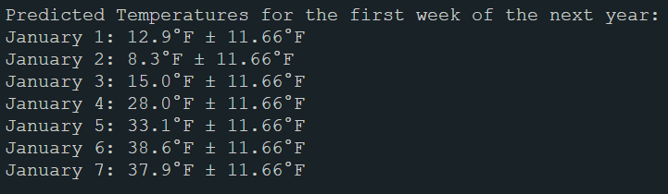10.